Title: **Large upward shifts in cold-adapted, montane mammals as temperature warms**

**Running head:** Large upward shifts in montane mammals

**Authors:** Christy M. McCain1,2*, Sarah R. B. King2,3, Tim M. Szewczyk1,4,5

**Authors Affiliation:** 1Department of Ecology & Evolutionary Biology and 2CU Museum of Natural History, University of Colorado, Boulder, CO 80309 USA; 3Natural Resource Ecology Laboratory, Colorado State University, Fort Collins, CO 80523, USA; 4Department of Natural Resources and the Environment, University of New Hampshire, Durham, NH 03824 USA; 5Department of Computer Science, University of New Hampshire, Durham, NH 03824 USA

**Keywords:** climate change, elevation, range contractions, range shifts, rodents, shrews

**Type of Paper:** Article

**\***christy.mccain@colorado.edu

**Abstract:** The largest and tallest mountain range in the contiguous United States, the southern Rocky Mountains, has warmed considerably in the past several decades due to anthropogenic climate change. Herein we examine how the elevational ranges of 47 mammal species (42 rodents, 5 shrews) have changed from their historical distributions (1886–1979) to their contemporary distributions (post–2005) along the 2400 m elevational gradients in the Front Range and San Juan Mountains of Colorado. Historical elevational ranges were based on more than 4580 geo-referenced museum specimen and publication records. Contemporary elevational ranges were based on 7444 records from systematic sampling efforts and museum specimen records. We constructed Bayesian models to estimate the probability a species was present, but undetected, due to undersampling at each 50 m elevational bin for each time period and mountain range. These models leveraged individual-level detection probabilities, the number and patchiness of detections across 50 m bands of elevation, and a decaying likelihood of presence from last known detections. The 95% likelihood elevational ranges were then compared between historical and contemporary time periods to detect directional change. Responses were variable as 23 mammals shifted upward, 10 did not change, 10 shifted downward, and 4 were extirpated locally. The average range shift was 122 m upward, while exclusively montane species shifted upward more often (83%) and displayed larger average range shifts (337 m). Changes in upper range limits were best predicted by increases associated with (a) montane species, (b) species with higher maximum latitude in their geographic range, and (c) the study mountain in the southern edge of their geographic range (stepwise multivariate linear regression: r2 = 0.4705, p < 0.0001). Thus, mammals in the Southern Rocky Mountains serve as harbingers of more changes to come particularly for montane, cold-adapted species in the southern portion of their ranges.

**Introduction**

Earth is warming at an unprecedented rate from human-created emissions (Trenberth et al. 2007, USGCRP 2009, Duffy and Tebaldi 2012). Anthropogenic impacts are also affecting precipitation trends as well as increasing the variability and severity of extreme weather events (Trenberth et al. 2007, USGCRP 2009, Duffy and Tebaldi 2012). Essentially the planet and all its inhabitants are in a climate crisis of unknown magnitude. One urgent imperative is tracking the impacts of these climate changes on living organisms to better mitigate the damages and to improve predictions of foreseeable conservation catastrophes. Unfortunately, there are still more publications predicting rather than measuring species’ responses (e.g., Dawson et al. 2011, review in McCain and King 2014). Reasons for this disconnect are many-fold, but foremost are the rarity of detailed historical and repeatable surveys across gradients of change (e.g., latitude, elevation, depth), and the significant, long term effort and quantity of data needed to detect organismal responses. As a research community we need to embrace innovative ways to compile historical and contemporary records to robustly track how organisms are currently changing and monitor these changes through time (Dawson et al. 2011, Grytnes et al. 2014).

Temperature cools as elevation increases, and species are expected to track temperatures by shifting to higher elevations as average temperatures increase in a region (Fig. 1a; e.g., McDonald and Brown 1992, Pauli et al. 1996, Inouye et al. 2000). Such tracking could include an upward shift of just the lower or upper end of the species’ range, or both range limits depending on the location on the montane gradient and the consistency of the response between the range edges. The published resurveys of historical montane gradients do provide strong evidence that some organisms are shifting their ranges to higher elevations. For example, many small mammals have shifted upwards in the western United States (Moritz et al. 2008, Rowe et al. 2010, Rowe et al. 2015). Many alpine plants in Europe have shifted higher with climate change (Grabherr et al. 1994, Pauli et al. 1996, Lenoir et al. 2008, Engler et al. 2011), moths in the Asian tropics have shifted upwards by an average of 67 m (Chen et al. 2009), and a review of montane shifts detected an 11 m increase in elevational ranges per decade across organisms (Chen et al. 2011). But the upward shifts are not the whole story; one critical element is the variability in responses on these gradients. Overall the shifts are upward, but individual species also demonstrate unexpected responses like downward shifts or no detectable change (Fig. 1b; Lenoir et al. 2010, Crimmins et al. 2011, McCain and King 2014, Rowe et al. 2015). The location of the mountain appears important. For example, American pika on small, isolated sky islands in the western US are experiencing local extirpations linked to higher temperatures, decreased precipitation, and lack of rock ice features (Beever et al. 2003, Beever et al. 2010, Millar and Westfall 2010, Beever et al. 2011). However, the same species in the more expansive, taller, and interconnected southern Rocky Mountains appear to have few, if any, local extirpations (Erb et al. 2011).

Other important biogeographic factors mediating responses may include the latitude of the mountain, the location of the mountain in relationship to the species’ geographic range, and the size, height and isolation of the mountain (e.g., McCain and King 2014). Traits of the species themselves like body size, activity times, and physiology may also mediate which species respond as predicted to climate change and which do not (e.g., Moritz et al. 2008, Angert et al. 2011, McCain and King 2014). So far, such mediating traits are rarely detected in individual montane gradient studies. Despite some initial lack of trait detection in mammals (e.g., Angert et al. 2011), McCain and King (2014) found that the North American mammal species most likely to exhibit expected responses were large, strictly nocturnal or diurnal, or at higher elevations and latitudes. We would expect that if traits were important to mediating responses, we would also detect them on individual mountain gradients or particular regional studies encompassing multiple species as long as sufficient variability in the traits was exhibited among the species. Strong associations between species traits and climate change responses would enable better predictions and improve conservation outcomes for the types of species most at risk from large, detrimental environmental change.

Thus, herein, we examine how 47 mammal elevational ranges have changed in response to warming in two regions of the largest, tallest and most interconnected mountains in the contiguous US, the Southern Rocky Mountains. We compile historical elevational ranges for each species based on museum specimens and literature before 1980, and contemporary elevational ranges based on more than a decade of extensive trapping surveys and supplemental museum specimens after 2005. We develop Bayesian undersampling models to accommodate species-, mountain-, and time-period-specific 95% likelihood elevational ranges. Then we assess how elevational ranges have changed, testing for biogeographic and species-trait effects that may mediate which species are and are not moving higher in elevation with increasing temperatures.

**Methods**

The Rocky Mountains extend from the southwestern USA to western Canada reaching their highest elevations in Colorado, USA. Temperatures in the two mountainous regions studied in the Colorado Rockies (Fig. 2), the San Juan Mountains (1414–4286 m) and the Front Range Mountains (1438–4346 m), have increased since the 1980s (Trenberth et al. 2007, USGCRP 2009, McGuire et al. 2012). However, the San Juans are getting increasingly wetter, while the Front Range is becoming increasingly drier (Mote et al. 2005).

*Historical Mammal Data—*We amassed specimen data from all museums with Colorado mammal specimens, which included 58,709 specimens from 45 museums (2009–2012; Appendix S1). Nomenclature was updated following Wilson and Reeder (2005), and georeferencing following the MaNis protocols (Wieczorek et al. 2004, Chapman and Wieczorek 2006). For quality assurance, we restricted analyses to rodent and shrew specimens (Fig. 2 circles) with (1) a reliable species-level identification by an expert, re-verified by CMM, or in a robust locality for the species (core elevations in the local distribution); (2) a documented year or time period of collection; (3) an elevation provided by the collector or a locality specific enough to be georeferenced (latitude, longitude, elevation) with a horizontal error <1000 m (designated as usable) or <5000 m (designated as marginal) with the strictest criteria used in the final lowest and highest known sites; and (4) a location within the northeast portion of the Front Range (Boulder and Larimer counties) or the southwestern portion of the San Juans (Dolores, La Plata, Montezuma, San Juan counties). These data were augmented by lowest and highest elevational records in the historical literature, including from the *Colorado Biological Survey* (Cary 1911), *Mammals of Mesa Verde National Park, Colorado* (Anderson 1961), and *Distribution of Mammals in Colorado* (Armstrong 1972). The most rigorous vetting focused on the lowest and highest localities for each species, only using records without significant, plausible error in the locality, elevation, or identification.

*Contemporary Mammal Data—*All specimens that met the accuracy criteria and were documented after 2005 were included in the contemporary data (Fig. 2 stars). The Colorado database was augmented in 2018 under the same vetting protocol using a search of the Global Biodiversity Information Facility (www.gbif.org) for more recent specimens (2006–2018). For systematic, contemporary mammal surveys, two elevational transects were established in the southwestern San Juan Mountains and two in the northeastern Front Range (Fig. 2; Fig. S1.1; McCain et al. 2018). Each transect consisted of eight sites placed every 200−300m in elevation between the base of the range (1400−1700m) and the upper limit of vegetation on the mountain top (3600−3800m) (Fig. S1.1). At each of these 32 anthropogenically undisturbed sites, we conducted small mammal surveys between 2010 and 2012 using live-trapping, pitfall trapping and visual surveys across all habitats. Trapping was extensive (5100 trap-nights per site; 163,200 total trap-nights) and equal among sites. Additional mammal survey data for the San Juans included seven sites from a pilot study (2007) and 13 sites in Mesa Verde National Park (2018) for a total additional 7,550 trap-nights (Fig. S1.1). Similarly for the Front Range (2017), contemporary sampling also included 2430 trap-nights across three low elevation sites. Species were identified in-hand, with specimens, or DNA sequences (McCain et al. 2018). IACUC vertebrate handling protocols were approved by CU Boulder (08-07-McC-02; 1103.02; 2548).

*Bayesian Undersampling Models—*The documented elevational range of each species was assumed to be between the lowest and highest known localities per time period, as species are not always detected when present (MacKenzie et al. 2002). But the sampling along each elevational gradient in each time period was patchily distributed (Fig. 2, S1.2). Therefore, to estimate elevations in which each species had a high probability of occurrence beyond the observed range, we developed a Bayesian model. Occupancy models typically rely on repeated surveys and local environmental data to predict a species’ probability of presence when undetected in a particular locality (MacKenzie et al. 2002, Kéry and Royle 2008, Szewczyk and McCain 2019). Such data are unavailable in many cases, including for typical compiled, historical datasets. Consequently, we employed a modified conceptual framework for occupancy to evaluate the probability of sampling error rather than directly considering species’ environmental preferences.

Within each time period, mountain range, and elevational bin, we considered the detected individuals as a draw from a multinomial distribution (Fig. S1.2), representing a sample from the community of individuals at those elevations. The number of observed individuals from each species depends on the species’ relative abundance and the probability of detecting a given individual of the species. Thus, for each elevational bin *i*, the number of observed individuals belonging to species 1–*J*, represented as vector ***yi***, was modeled as: where ***pj*** is a vector of the probabilities that a random observed individual from elevational bin *i* belongs to each species, and *Yi* is the total number of individuals detected across all species in elevational bin *i*. For each species, , where *λij* is the relative abundance of species *j* in elevational bin *i*, *Zij* is a latent binary parameter indicating the true presence (1) or absence (0) of species *j* in elevational bin *i*, and *δj* is the probability of detecting a given individual of species *j*. Note that *pij* is a probability ranging from 0 (species *j* is not present at elevation *i*) to 1 (only species *j* is present at elevation *i*). We used the repeated, mark and recapture survey data in the contemporaneous dataset to calculate the individual-level detection probability, *δj*, for each species. If there were too few recaptures for robust estimation in a particular species, then we used an average from the clade (e.g., *Sorex*).

The unobserved parameter *Zij* is Bernoulli distributed with probability , which is the probability that species *j* was present but unobserved due to sampling error beyond its interpolated range, and is calculated as a function of the elevational distance to the observed elevational limits, the patchiness of the interpolated range (i.e., the proportion of elevational bins without detections within the interpolated range), and their interaction: where *aj* is the species-specific intercept and *β* are the slopes. The intercepts among species were distributed normally with community-level mean *α* and standard deviation *σ*, while the slopes were community-level with one value for all species.

For each elevational bin beyond each species’ interpolated range, we calculated the probability of occurrence as the posterior probability of *Zij* = 1. A species was assumed absent at an elevation if the probability of occurrence was < 5%, indicating ≥ 95% posterior probability of absence. Based on this dichotomy, we calculated Bayesian interpolated ranges incorporating sampling uncertainty to then use as the elevational range of each species for each mountain in each time period. For the range shift analyses, we only included species with at least 10 historical records per mountain and detected in the contemporary sampling. The model was run with JAGS 4.3.0 in R 3.6.1 using the *rjags* package (Plummer 2017, 2019). For each model, we ran 3 chains for 20,000 iterations, discarding the first 10,000 iterations as burn-in, and then retaining every 10th iteration for the final posterior distributions. We used uninformative prior distributions for *α*, *β*, and *σ*, and a diffuse normal prior distribution constrained to be positive for each *λij* where the mean was the overall abundance of each species (Appendix S1).

*Statistical Analyses—*A significant change from the Bayesian historical to the Bayesian contemporary elevational range limits was determined if the change was ≥ 100m. The size of the shift upward or downward was calculated for the (1) lower limit; (2) upper limit; and (3) overall change based on the range midpoint (Fig. 1). Occassionally (i.e., Fig. 3: Tqua (*Tamias quadrivittatus*) in San Juans), a large contraction in a contemporary range to just a small portion of the middle elevations of the historical range can result in a slightly lower midpoint. In those rare cases, the shift direction is the range limit with the largest shift. With warming temperatures, species’ ranges are predicted to shift to higher, cooler elevations (Fig. 1a). Unexpected responses to warming would be either no change, where both range limits change by less than 100m, or a downward shift in one or both limits such that the new range midpoint is lower (Fig. 1b).

Most range gains will occur at mid- to high-elevations under a scenario of general warming. Thus, we expect range gains to increase with elevation, whereas range losses would be spread across the gradient more or less evenly in accordance with the wide elevational spread in historical lower limits. In contrast, anthropogenic habitat change declines with elevation on both mountains, although most pronounced in the Front Range. Thus, if the reduction of available habitat is the predominant factor influencing the elevational distribution of the community, then the expectation would be a concentration of range losses at the lowest portion of the gradients that decreases toward the highest elevations. To assess these trends, we calculated the number of species losing or gaining range at their lower and upper limits within each 50m band up each mountain. Because the number of species per elevational band differs, we examined the percentage of range losses and range gains for each 50m elevational band on each mountain gradient by dividing the species counts by the historical number of species present in each band. We tested for elevational trends using Spearman’s rank correlations.

To assess how species traits influenced the responses to anthropogenic climate change, we examined several traits empirically linked or hypothesized to be important to differential responses to climate change in mammals (e.g., Moritz et al. 2008 and references therein, Angert et al. 2011, McCain and King 2014). These included body size, activity times, elevational affiliations, high latitude ranges, location of study area within the species biogeographic range (i.e., southern third, middle third or northern third of its range), or whether the study area was near the species’ range edge (e.g., western-most populations of a plains species). Many more traits were possible, but we were limited by our species sample size as well as the correlation in traits (e.g., body size and reproductive traits). Trait data were from the PanTHERIA and MOM databases (Smith et al. 2003, Jones et al. 2009), species accounts in the journal *Mammalian Species*, and additional literature sources (e.g., Hall 1981, Nowak 1991, Armstrong et al. 2011, IUCN 2018). Each species was denoted as a low elevation species, a montane species, or cosmopolitan (across most habitats and elevations on the mountain) by its known habitat affinities in Colorado (Armstrong et al. 2011), but also based on its individual historical distribution on each mountain.

To detect if particular traits were associated with differential increases or decreases of the upper or lower range limits on using on each mountain, we used stepwise, multivariate linear regressions models, the lowest AICc weights, and all variables that were individually significant to detect the best-fit model (Burnham and Andersen 2002). Similarly, a second set of trait analyses were conducted on expected (upward) and non-expected responses (downward, no change) on each mountain using logistic regressions. Because phylogenetic relatedness could impact the robustness of these analyses (e.g., Blomberg and Garland 2002, Blomberg et al. 2003), we estimated a phylogenetic signal in the lower and upper range shifts using the mammal supertree (Bininda-Emonds et al. 2007) pruned to the taxa included in each mountain dataset. Phylogenetic signal was calculated with *phylosignal* (Keck et al. 2016) in *R* using all five significance tests (*Cmean*, *I*, *K*, *K.star*, and *Lambda*). No significant phylogenetic signal was detected (p >> 0.05; Table S1.1); thus, we present non-phylogenetically corrected analyses.

**Results**

Our compiled databases for historical and contemporary distributions of small mammals (rodents, shrews) included 35 species in the Front Range Mountains (FR) and 33 species in the San Juan Mountains (SJ). Those species used in the analyses (28 FR, 19 SJ) were well sampled both historically and contemporarily with a per-mountain average of 97 specimens historically and 158 specimens contemporarily (Appendix S2). The empirical elevational ranges for each species were based on these data for each mountain and time period (Fig. 3: thick bars). Several species were not used in the range shift analyses because they were deemed to be insufficiently detected historically (<10 specimens; 6 FR, 13 SJ) or under-sampled with contemporary trapping methods (3 FR, 1 SJ; see Fig. S3.1). The sampling across each elevational gradient in each time period was not uniform (Fig. 2; Fig. S1.2). This is expected given the historically compiled efforts across multiple generations of researchers. Nonetheless, the number of specimens and localities is quite high both historically (4580 specimen-localities) and contemporarily (7444 specimen-localities) for these two regions. Importantly, the sampling effort is underestimated from these specimen sums. It represents only the successful captures of our target species, but not the captures of non-target mammals, any individuals not saved as specimens, nor the trapping efforts that resulted in no or few specimens. To compensate for the patchy distribution of specimens and sampling, we constructed Bayesian undersampling models.

The Bayesian undersampling models utilized the number of observations per 50m elevational band, the estimated probability of detection based on our mark-recapture statistics, the patchiness of the elevational distribution for the species, and a declining probability of undersampling away from the last known detection to estimate a probability of distribution. The changes in the range limits between the empirical data and the Bayesian model varied from 0 to 392 m historically and 60 to 657 m contemporarily. Based on the 95% probable ranges (Fig. 3: thin bar extensions; Appendix S2), species that significantly changed their lower or upper elevational limit contemporarily (≥100m change) included 23 species that shifted upwards and 10 species that shifted downward (Fig. 3 blue and red bars, respectively). Another 10 species did not significantly change either range limit (Fig. 3 grey bars), and 4 species known historically were undetected contemporarily and thus considered locally extirpated (zeros in place of contemporary range bars). In comparison to the expected and unexpected range changes (Fig. 1), the majority of upward changes were shifts, while the majority of downward changes were contractions (Fig. 3c). The changes indicated by the empirical elevational ranges without the Bayesian model additions were similar, but even more skewed toward upward changes (32 upward, 6 downward, 0 no change), and the percentage of upward contractions was higher (50% versus 30% (the latter in Fig. 3c)).

With the Bayesian models, the average elevational range change across all species was upward by 122 m. The Front Range species shifted higher on average (152 m) than did the San Juan species (80 m). These shifts varied across species with both losses and gains in lower limits and upper limits (Fig. 3). The percentage of range gains increased significantly with elevation on both gradients (Fig. S3.3; Spearman’s rank correlations: FR r = 0.42, p = 0.0399; SJ r = 0.53, p = 0.0077); whereas, the percentage of elevational losses occurred across both elevational gradients rather uniformly (Spearman’s rank correlation FR r = -0.23, p = 0.2827; SJ r = 0.24, p = 0.2485). Thus, on both gradients, net range gains increase with elevation (elevational heat map: Fig. S3.3). All four species detected as locally extinct were low elevation rodents with small elevational ranges and dry desert, grassland or canyon habitat associations.

A combination of species traits and biogeography influenced the trajectory and magnitude of the range changes, particularly for the shifts in the upper range limits (Fig. 4). Montane species shifted higher more often (83%) and with larger upward shifts (337 m) than low elevation (31%, -31 m) or cosmopolitan species (42%, 150 m). The best multivariate linear regression model for the upper range limit shifts (r2 = 0.4705, p < 0.0001, AICc weight = 605.2) included an increase in upward shifts for montane species (Fig. 4a), for species with high maximum latitude in their geographic range (Fig. 4a), and species in which the study mountains were at the southern edge of their geographic range (Fig. 4b). The best multivariate linear regression model for the lower range limit shifts (r2 = 0.1025, p < 0.0363, AICc weight 626.9) only included an increase in upward shifts for species where the study mountain was at the eastern edge of their geographic range (Fig. 4c). Lastly, the best multivariate logistic regression model for the expected responses to climate change (upward changes) versus the unexpected responses (downward changes, no responses) detected a greater preponderance of unexpected responses in the low elevation species compared to the montane and cosmopolitan species (χ2 = 8.5582, p < 0.0136, AICc weight = 57.4).

**Discussion**

Small mammals are moving to higher elevations in the Colorado Rocky Mountains on average by over 120 m with slightly larger upward shifts in the northwestern Front Range Mountains (180 m) than the southwestern San Juan Mountains (80 m). Since temperatures have warmed across Colorado and within each of these mountains over the past several decades (Mote et al. 2005, Trenberth et al. 2007, USGCRP 2009, McGuire et al. 2012), this confirms the expected response to anthropogenic climate change—species sensitive to temperature will track cooler temperatures at higher elevations as temperatures increase (Fig. 1; Pauli et al. 1996, Parmesan and Yohe 2003, Thomas et al. 2004, Walther et al. 2005). This trend is most pronounced in the montane mammals—those with elevational ranges predominately at mid- to high-elevations—who are shifting upward by an average of over 330m (Fig. 3, 4). These montane shifts are nearly 8 times the average upward shifts detected in other studies (84 m per decade vs 11 m per decade in a review; Chen et al. 2011).

Physiological and biogeographic traits mediate which species are responding as expected by shifting higher and which are not responding as expected by shifting downward or not changing. In particular, the distance shifted upward by small mammals appears to be a function of cold-adaption. This is inferred by the factors associated with increased upper range limits, including species with (a) a montane affiliation, (b) geographic ranges extending to higher maximum latitudes, and (c) the Front Range and San Juan Mountains occurring in their southern, lower geographic limits (Fig. 4a,b; r2 = 0.4705, p < 0.0001). The species least likely to respond as expected were the lower elevation species, which in these areas include mostly semi-arid desert, canyonland, and grassland species adapted to higher temperatures and lower rainfall than their montane counterparts (Armstrong et al. 2011) (χ2 = 8.5582, p < 0.0136). Changes in lower range limits were more enigmatic and variable across species than upper limits. Species in which these mountains were at the eastern edge of their geographic range moved their lower elevational limit higher (Fig. 4c; r2 = 0.1025, p < 0.0363). Again, this is an indication of montane, cold-adapted species, since most of the species with the southern Rockies as their eastern geographic range edge are distributed only in the intermountain west or western North America (Armstrong 1972, Hall 1981, Armstrong et al. 2011). For example, some of the eastern edge species that shifted their lower limit upward include Red-back voles (*Myodes gapperi*), Water shrews (*Sorex palustris*), Yellow-bellied marmots (*Marmota flaviventris*), and Golden-mantled ground squirrels (*Callospermophilus lateralis*) (see Appendix S2). Another factor potentially obscuring the lower range edge changes was contemporary undersampling at the lowest elevations, particularly <1600m in the Front Range, due to lack of remaining intact habitat. The empirical ranges detected many more upward contracting lower limits, than did the Bayesian models that compensated for this low sampling effort. Thus, the results here are a conservative estimate of lower limit contractions, and consequently, overall range contractions.

Most resurveys designed to detect elevational range shifts take advantage of well-sampled, historical studies of a single set of sites along an elevational gradient (e.g., Moritz et al. 2008, Nufio et al. 2010, Rowe et al. 2010, Tingley et al. 2012). The contemporary researchers resurvey those particular sites as best as possible to detect change. But those ideal historical datasets are rare and if we limit ourselves to such studies, we will not proceed in detecting climate change effects much beyond published work. Herein we used a more regionally expansive methodology by building a dataset of historical elevational distributions for two mountain slopes, based on specimens and records of multiple generations of researchers. Then, we compared these historical datasets to contemporarily collected data through an extensive trapping effort augmented by specimens and records of additional researchers. This methodology has advantages as the elevational ranges are based on many more sites, potentially capturing the elevational ranges on a mountain more completely and reducing stochastic effects of a particular year or two of sampling (McCain et al. 2016). Further, because the historical ranges are determined by the highest and lowest observations across nearly 100 years of sampling, detecting changes may be a higher statistical bar than detecting changes at single sites sampled briefly. However, there are also disadvantages as the comparisons are not at known single sites, and the sampling is broader spatially and temporally, and thus patchier. There is also more potential error in the species identifications and locality information than in a single gradient study.

We combat these sampling issues in multiple ways. First, the specimens, their identifications, their localities, and elevations were vetted extensively with particular emphasis on records near the elevational margins for each species since historical and contemporary comparisons are essentially comparisons of the range limit samples. Difficult to identify species (i.e., shrews, chipmunks, voles, and *Peromyscus*) received special emphasis on re-identifications, molecular analyses, and quantitative morphological models (King and McCain 2015, e.g., Chinn 2018, McCain et al. 2018). Second, we built Bayesian models to estimate sampling-based uncertainty across each gradient tailored to the species’ detections and detectability as well as the overall distribution of samples. This led to 95% Bayesian limits that were robustly extended beyond the empirical ranges for comparisons between time periods by accounting for the influence of patchy sampling. The maximum contemporary elevation for many species was higher than any historical record for either region (southwest quadrant or northeast quadrant of Colorado), making it unlikely that the upward shifts were due to historical undersampling of high elevations in each of these two mountains. Similarly, many of the upward shifting species had changes in both their lower and upper limits that were well below the highest elevations on each mountain. The Front Range Mountains were the better sampled of the historical gradients, and showed stronger elevational shifts while detecting similar patterns as the lesser sampled San Juan Mountains. The conclusions remain unchanged within either mountain range.

Anthropogenic land use change is not absent from these gradients (Szewczyk and McCain 2019), and has been shown to influence other small mammal elevational studies (e.g., Rowe 2007, Rowe et al. 2010). But along these gradients it is most concentrated at the lowest elevations, particularly at the base of the Front Range Mountains, and declines with elevation. It is likely that the three local extirpations in the Front Range, which were all at the lowest elevations, were predominantly due to direct reduction of their habitat. These three heteromyid species (*Dipodomys ordii, Perognathus flavescens, P. flavus*) were previously detected in areas around the cities of Boulder and Loveland that are now almost completely developed. But despite these localized influences, the effect of land use on the broader gradient appears to be limited. There is no signal of greater numbers of range reductions in the lowest elevations that then decline with elevation on either mountain. In fact, range reductions occur rather evenly across both gradients, while range gains do increase with elevation as expected with climate change (Fig. S3.3). But, as stated earlier, some low elevation contraction due to habitat reduction is compensated for in the Bayesian undersampling models. And likely, fewer small mammals now reside in the lowest elevations (<1600m) in the Front Range than did historically due to human development, but more sampling is needed in remaining habitat patches.

Other small mammal studies along elevational gradients similarly observed a mixture of species shifting higher and lower as well as those not showing much change (Moritz et al. 2008, Rowe et al. 2010, Rowe et al. 2015). They each also detected some legacies of land use change. But unlike those studies, we detected species traits that strongly mediated which species shifted upward as expected by climate change and which did not (Fig. 4). This may be due to the larger, more connected, and more diverse mammal community of the southern Rocky Mountains studied here, or potentially the span of variation in key traits across the included species. When many of those species and their responses from previous studies were analyzed together, upward contractions were supported in montane species, larger bodied mammals, and obligately diurnal species (McCain and King 2014). In this dataset we did not detect an influence of body size, but likely this was because (a) only smaller sized mammals were included, and all shrews (the smallest terrestrial mammals) in our dataset shifted their elevational ranges upward.

These data are clear evidence that small mammals, particularly montane and cold-adapted species, are rapidly and drastically shifting their ranges to higher elevations as temperatures warm regionally. They shifted upward by an average of 337m or 16% of the 2400m gradient in four decades; a trend that if it continues will reduce their available habitat so much they will be at risk of local extinction. The lower limit shift upward appears to be a less pronounced trend than upper limit extensions. This lag may indicate the temporal variability in climate change conditions year to year allowing some populations to exist despite their low viability long-term, but also indicates that more sampling is needed at the lowest elevations in existing patches of intact habitat to confirm empirical absences. Clearly, the type of species and where a species is studied within their range are important. Thus, cold-adapted, montane species in the southern edge of their geographic ranges are consequential species of conservation concern as temperature continues to warm, based on both these data and previous analyses (McCain and King 2014). Take heed—it is only going to continue.

**Acknowledgments**

This work was supported by the US National Science Foundation (McCain: DEB 0949601) and the CU Museum of Natural History. We thank all researchers and museum collections’ staff whose data were used in this study as well as all the field and lab assistants, and the land managers across all the contemporary sites (Appendix S1).

**Literature Cited**

Anderson, S. 1961. Mammals of Mesa Verde National Park, Colorado. University of Kansas Publications, Museum of Natural History **14**:29–67.

Angert, A. L. et al. 2011. Do species’ traits predict recent shifts at expanding range edges? Ecology Letters **14**:677–689.

Armstrong, D. M. 1972. Distribution of mammals in Colorado. Monograph of the Museum of Natural History, The University of Kansas **3**:415.

Armstrong, D. M., J. P. Fitzgerald, and C. A. Meaney. 2011. Mammals of Colorado. 2nd edition, Denver, CO, USA.

Beever, E. A., P. F. Brussard, J. Berger, and T. O'Shea. 2003. Patterns of apparent extirpation among isolated populations of pikas (*Ochotona princeps*) in the Great Basin. Journal of Mammalogy **84**:37–54.

Beever, E. A., C. Ray, P. W. Mote, and J. L. Wilkening. 2010. Testing alternative models of climate-mediated extirpations. Ecological Applications **20**:164–178.

Beever, E. A. et al. 2011. Contemporary climate change alters the pace and drivers of extinction. Global Change Biology **17**:2054–2070.

Bininda-Emonds, O. R. P. et al. 2007. The delayed rise of modern mammals. Nature **444**:93–96.

Blomberg, S. P., and T. Garland. 2002. Tempo and mode in evolution: phylogenetic inertia, adaptation and comparative methods. Journal of Evolutionary Biology **15**:899–910.

Blomberg, S. P., T. Garland, and A. R. Ives. 2003. Testing for phylogenetic signal in comparative data: behavioral traits are more labile. Evolution **57**:717–745.

Burnham, K. P., and D. R. Andersen. 2002. Model selection and multi-model inference: a practical information-theoretic approach. 2nd edition. Springer-Verlag, Heidelberg.

Cary, M. 1911. A biological survey of Colorado. North American Fauna: Report 33.

Chapman, A. D., and J. Wieczorek. 2006. Guide to best practices for georeferencing. Global Biodiversity Information Facility, Copenhagen.

Chen, I.-C. et al. 2011. Rapid range shifts of species associated with high levels of climate warming. Science **333**:1024–1026.

Chen, I. -C. et al. 2009. Elevation increases in moth assemblages over 42 years on a tropical mountain. Proceedings of the National Academy of Sciences of the United States of America **106**:1479–1483.

Chinn, A. 2018. Identification error in museum legacy data for Coloradan *Tamias* chipmunk specimens. Masters thesis. University of Colorado Boulder, Colorado.

Crimmins, S. M. et al. 2011. Changes in climatic water balance drive downhill shifts in plant species' optimum elevations. Science **331**:324–327.

Dawson, T. P. et al. 2011. Beyond predictions: biodiversity conservation in a changing climate. Science **332**:53–58.

Duffy, P. B., and C. Tebaldi. 2012. Increasing prevalence of extreme summer temperatures in the U.S. Climatic Change **111**:487–495.

Engler, R. et al. 2011. 21st century climate change threatens mountain flora unequally across Europe. Global Change Biology **17**:2330–2341.

Erb, L. P., C. Ray, and R. Guralnick. 2011. On the generality of a climate-mediated shift in the distribution of the American pika (Ochotona princeps). Ecology **92**:1730–1735.

Grabherr, G., M. Gottfried, and H. Pauli. 1994. Climate effects on mountain plants. Nature **369**:448.

Grytnes, J.-A. et al. 2014. Identifying the driving factors behind observed elevational range shifts on European mountains. Global Ecology and Biogeography **23**:876–884.

Hall, E. R. 1981. Mammals of North America. John Wiley & Sons, New York.

Inouye, D. W., B. Barr, K. B. Armitage, and B. D. Inouye. 2000. Climate change is affecting altitudinal migrants and hibernating species. Proceedings of the National Academy of Sciences of the United States of America **97**:1630–1633.

IUCN (International Union for Conservation of Nature). 2018. IUCN red list of threatened species. www.iucnredlist.org.

Jones, K. E. et al. 2009. PanTHERIA: a species-level database of life history, ecology, and geography of extant and recently extinct mammals. Ecology **90**:2648–2648.

Keck, F., F. Rimet, A. Bouchez, and A. Franc. 2016. phylosignal: an R package to measure, test, and explore the phylogenetic signal. Ecology and Evolution **6**:2774–2780.

Kéry, M., and J. A. Royle. 2008. Hierarchical Bayes estimation of species richness and occupancy in spatially replicated surveys. Journal of Applied Ecology **45**:589–598.

King, S. R. B., and C. M. McCain. 2015. Robust discrimination of *Reithrodontomys megalotis* and *R. montanus* (Mammalia: Rodentia) from Colorado, using cranial morphology and external characteristics within age classes. Proceedings of the Biological Society of Washington **128**:1–10.

Lenoir, J. et al. 2010. Going against the flow: potential mechanisms for unexpected downslope range shifts in a warming climate. Ecography **33**:295–303.

Lenoir, J. et al. 2008. A significant upward shift in plant species optimum elevation during the 20th century. Science **320**:1768–1771.

MacKenzie, D. I. et al. 2002. Estimating site occupancy rates when detection probabilities are less than one. Ecology **83**:2248–2255.

McCain, C., T. Szewczyk, and K. Bracy Knight. 2016. Population variability complicates the accurate detection of climate change responses. Global Change Biology **22**:2081–2093.

McCain, C. M., and S. R. B. King. 2014. Body size and activity times mediate mammalian responses to climate change. Global Change Biology **20**:1760–1769.

McCain, C. M., S. R. B. King, T. Szewczyk, and J. Beck. 2018. Small mammal species richness is directly linked to regional productivity, but decoupled from food resources, abundance, or habitat complexity. Journal of Biogeography **45**:2533–2545.

McDonald, K. A., and J. H. Brown. 1992. Using montane mammals to model extinctions due to global change. Conservation Biology **6**:409–415.

McGuire, C. R., C. R. Nufio, M. D. Bowers, and R. P. Guralnick. 2012. Elevation-dependent temperature trends in the Rocky Mountain Front Range: Changes over a 56- and 20-year record. PLOS ONE **7**:e44370.

Millar, C. I., and R. D. Westfall. 2010. Distribution and climatic relationships of the American pika (*Ochotona princeps*) in the Sierra Nevada and western Great Basin, U.S.A.; periglacial landforms as refugia in warming climates. Arctic, Antarctic, and Alpine Research **42**:76–88.

Moritz, C. et al. 2008. Impact of a century of climate change on small-mammal communities in Yosemite National Park, USA. Science **322**:261–264.

Mote, P. W., A. F. Hamlet, M. P. Clark, and D. P. Lettenmaier. 2005. Declining mountain snowpack in western North America. Bulletin of the American Meteorolgical Society **86**:39–49.

Nowak, R. M. 1991. Walker's Mammals of the World. 5th ed. John Hopkins Press, London.

Nufio, C. R., C. R. McGuire, M. D. Bowers, and R. P. Guralnick. 2010. Grasshopper community response to climatic change: variation along an elevational gradient. PLOS ONE **5**:e12977.

Parmesan, C., and G. Yohe. 2003. A globally coherent fingerprint of climate change impacts across natural systems. Nature **421**:37–42.

Pauli, H., M. Gottfried, and G. Grabherr. 1996. Effects of climate change on mountain ecosystems: upward shifting of mountain plants. World Resource Review **8**:382–390.

Plummer, M. 2017. JAGS: a program for analysis of Bayesian graphical models using Gibbs sampling. Version 4.3.0.

Plummer, M. 2019. Package rjags. Version 4.9.

Rowe, K. C. et al. 2015. Spatially heterogeneous impact of climate change on small mammals of montane California. Proceedings of the Royal Society B: Biological Sciences **282**.

Rowe, R. J. 2007. Legacies of land use and recent climatic change: the small mammal fauna in the mountains of Utah. The American Naturalist **170**:242–257.

Rowe, R. J., J. A. Finarelli, and E. A. Rickart. 2010. Range dynamics of small mammals along an elevational gradient over an 80-year interval. Global Change Biology **16**:2930–2943.

Smith, F. A. et al. 2003. Body mass of late Quaternary mammals. Ecology **84**:3403.

Szewczyk, T. M., and C. M. McCain. 2019. Disentangling elevational richness: a multi-scale hierarchical Bayesian occupancy model of Colorado ant communities. Ecography **42**:977–988.

Thomas, C. D. et al. 2004. Extinction risk from climate change. Nature **427**:145–148.

Tingley, M. W. et al. 2012. The push and pull of climate change causes heterogeneous shifts in avian elevational ranges. Global Change Biology **18**:3279–3290.

Trenberth, K. E. et al. 2007. Observations: Surface and Atmospheric Climate Change *in* S. Solomon, et al, editors. Climate Change 2007: The Physical Science Basis. Contribution of Working Group I to the Fourth Assessment Report of the Intergovernmental Panel on Climate Change. Cambridge University Press, Cambridge, UK and New York, NY, USA.

USGCRP. 2009. Global climate change impacts in the United States. United States Global Change Research Program, New York, NY, USA.

Walther, G. R., S. Berger, and M. T. Sykes. 2005. An ecological 'footprint' of climate change. Proceedings of the Royal Society B-Biological Sciences **272**:1427–1432.

Wieczorek, J., Q. Guo, and R. Hijmans. 2004. The point-radius method for georeferencing locality descriptions and calculating associated uncertainty. International Journal of Geographical Information Science **18**:745–767.

Wilson, D. E., and D. M. Reeder, editors. 2005. Mammal Species of the World. A Taxonomic and Geographic Reference. 3rd edition. Johns Hopkins University Press.

**Supporting Information: Appendix S1.** Supplementary Methods; **Appendix S2.** Dataset of species, traits, samples, range limits and shifts; **Appendix S3**. Supplementary Results**.**

**Figure Legends**

**Figure 1.** Expected (a) and unexpected (b) responses to anthropogenic warming on mountains.a. Expected: potential upward elevational range contractions and shifts based on changes in the lower range limit, the upper range limit or both range limits. b. Unexpected: potential lack of change or downward elevational range contractions and shifts based on changes in one or both range limits. Triangle depicts montane temperature variation from warm (red) to cool (blue). Black lines = historical ranges; blue lines = contemporary upward responses; red lines = contemporary downward responses); and grey lines = no contemporary change.

**Figure 2.** A map of historical (circles) and contemporary (stars) sampling localities within the two mountainous regions: a. San Juan Mountains and b. Front Range Mountains in Colorado, USA (greyscale inset). The thin black lines denote county boundaries in each region. Elevational variation grades from dark pink at the lowest elevations to dark green as the highest elevations. For the authors’ contemporary sampling sites only, see Figure S1.1.

**Figure 3.** Paired historical (left bar) and contemporary (right bar) elevational ranges of the included small mammal species on the (a) Front Range Mountains, and the (b) San Juan Mountains. c. The sum of the range shifts and contractions for upward or downward change is shown in panel C. Thick bars = empirical ranges; thin extensions = Bayesian range limits. Species names are abbreviated; for complete taxonomic names, see Appendix S2.

**Figure 4.** Species traits and range shifts. Upward change in upper range limits was larger for species (a) whose geographic ranges extended to higher latitudes, particularly for montane and cosmopolitan species; and (b) for which the studied mountain range was at the southern edge of their geographic range. c. Upward change in lower range limits was larger for species at the eastern edge of their geographic range. Non-edge = middle of range.

Figure 1.

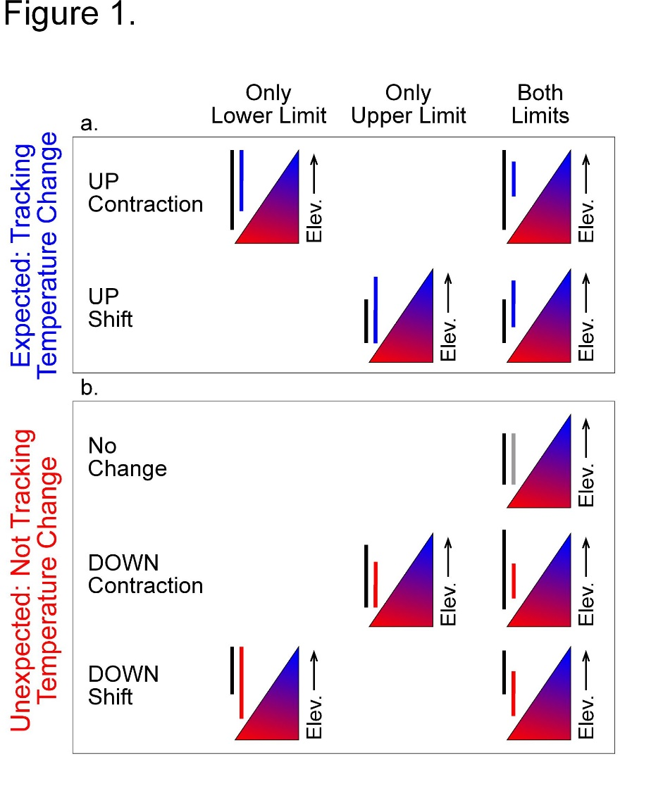

Figure 2.

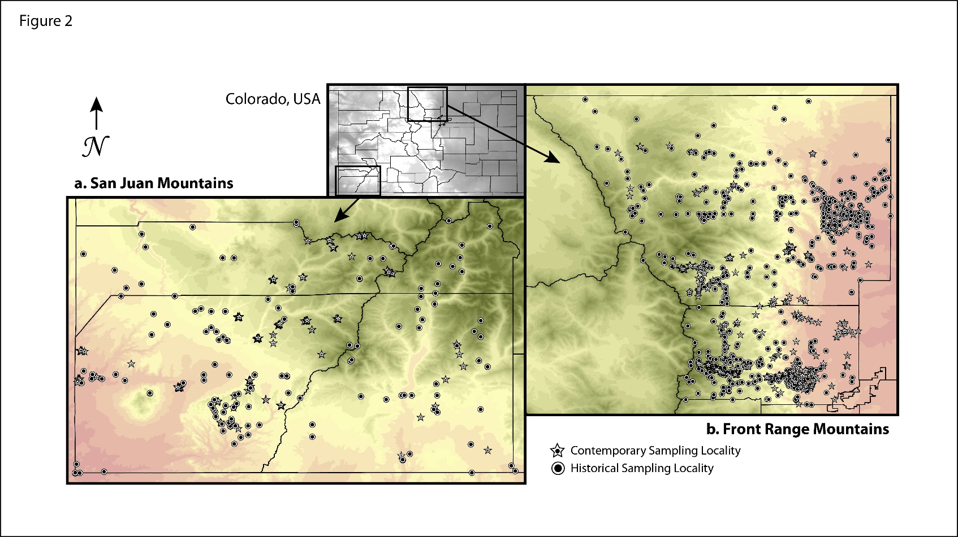

Figure 3.

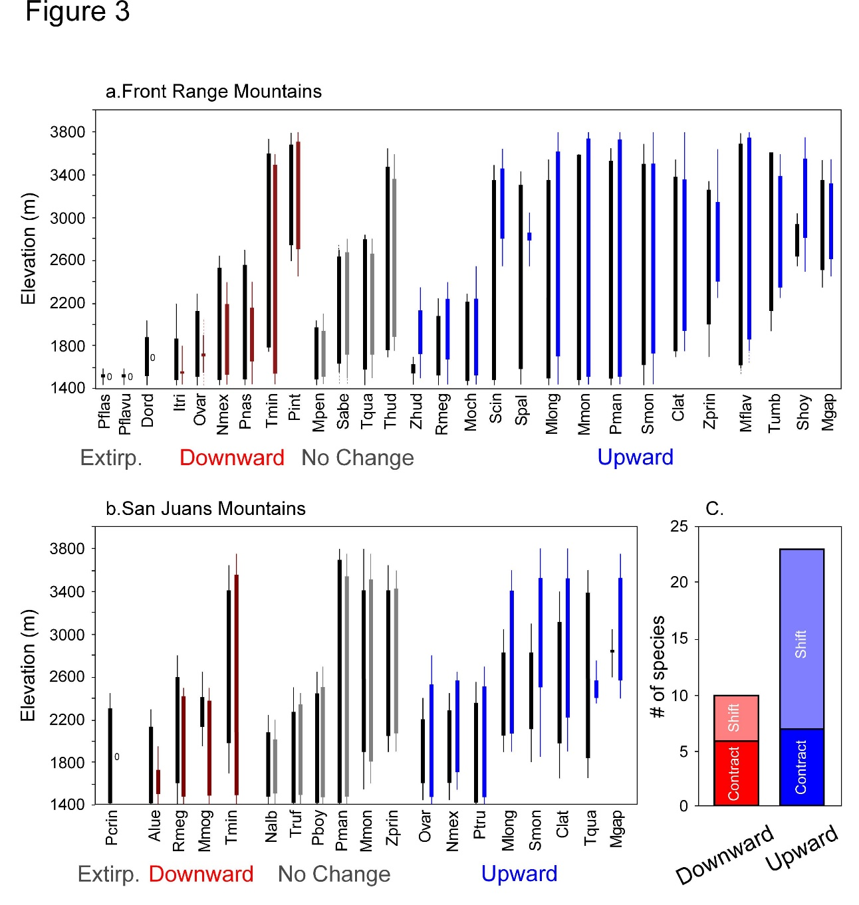

Figure 4.

