# Range size and ant communities across elevations

# Introduction

Patterns of species richness and community composition are directly determined by the overlap and delineation of species ranges. Ants are no exception. Discovering the patterns of overlapping ranges, the dynamics of range boundaries, and the underlying determinants is a key step in understanding the macroscale distribution of ant diversity. Elevational gradients provide useful study systems to investigate these patterns (McCain, 2009a, 2010). Mountains, occurring on every continent, act as compact, globally replicated systems that vary across many characteristics that may affect richness, including climate, history, and geography (Rahbek, 1995; Lomolino, 2001; McCain and Grytnes, 2010). Detailing how ant communities change along elevational gradients, and at different taxonomic levels, may yield insight into processes affecting ant species diversity across spatiotemporal scales.

Despite comprising the majority of animal species, insects have received relatively little focus in such macroecological studies (Diniz-Filho et al., 2010; Beck et al., 2012). Given the astonishing array of insect diversity, no picture of biodiversity would be complete without their inclusion. Ants in particular have a number of advantages for global studies of diversity. As predators, competitors, scavengers, and dispersers, they have major ecological impacts in a wide variety of systems (Hölldobler and Wilson, 1990). In contrast to many insect taxa, the individuals used for identification are wingless with consequently restricted movement from the nest, reducing the impact of accidentals. Additionally, because of historic interest across many decades, ants are relatively well-described compared to other insect taxa.

Ants are an incredibly diverse taxon by nearly any ecological metric. Dietary breadth ranges from specialist predators in the subfamily Amblyoponinae to generalist omnivores in the subfamily Myrmicinae. Nesting habits and structures are highly varied, with differences in site preferences among genera, among species, and even variability within species (Hölldobler and Wilson, 1990; Anderson and McShea, 2001). Ant species differ in worker body size (Cushman et al., 1993), degree of polymorphism (Wilson, 1953), colony size (Kaspari and Vargo, 1995), caste ratios (McGlynn et al., 2012), level of aggression and dominance (Andersen, 1997; Cerdá et al., 2013), and number of queens (Hölldobler and Wilson, 1977) among many other traits. Given this tremendous range of biological characteristics in addition to the hugely disparate number of species among subtaxa, it seems reasonable to expect that factors shaping the distribution of ant species vary among subfamilies or genera. In such a diverse and numerically heterogeneous taxon as ants, patterns of species richness and compositional change may be driven primarily by the most speciose subfamily or genus rather than reflecting the combined tendencies of each subtaxon.

Understanding the distribution of biodiversity necessitates a comprehensive, global perspective. Here, I review the work to date on ant communities across elevations, investigating patterns and evaluating latitudinal trends at the species, genus, and subfamily level. Using well-sampled elevational datasets, I sequentially explore the variation in elevational range size among and along gradients, the variation in the ant community composition across elevations, the elevational patterns of species richness, and the congruency of the most speciose subtaxon in each dataset with the remaining subtaxa.

# Datasets

To identify ant elevational distribution datasets at local spatial scales, I performed a literature search with Web of Knowledge and Google Scholar, using combinations of the keywords 'ant', 'elevation*', 'altitud*', 'gradient', 'diversity', and 'insect'. This search primarily returned studies along discrete elevational transects with sampling sites interspersed along the gradient. To identify ant elevational distribution datasets at regional spatial scales, I searched for publications with 'ants of' in the title. This search returned guides to the ant fauna of particular geopolitical regions. Such guides typically compile museum records and many years of collections across the region, detailing the recorded occurrences of each ant species. Elevational ranges were interpolated. That is, each species was assumed present between its lowest and highest recorded occurrence within a dataset.

To restrict the analysis to robust, well-sampled datasets, I required that a dataset provide ant elevational data within a mountainous region or along a gradient and meet five *a priori* criteria: (1) sufficient, even sampling effort with standardized methods across the gradient; (2) sampling of at least 70% of the gradient; (3) sampling within the lowest 400m of the gradient; (4) no elevational sampling gaps greater than 500m; and (5) relatively little anthropogenic disturbance. These criteria, adapted from previous studies (McCain, 2009a, 2010), are required to ensure the accurate description of the naturally occurring pattern (McCoy, 2002; McCain, 2005; Rahbek, 2005; Nogués-Bravo et al., 2008). The common richness patterns, however, differ primarily across the lower portion of the elevational gradient (Nogués-Bravo et al., 2008). Consequently, violations of the second criterion were allowed when the majority of the unsampled region was at high elevations where declining richness had been demonstrated.

A total of 68 candidate datasets were identified (Appendix). A number of publications used non-independent datasets or sampled geographically disparate sites, leaving 47 independent datasets that detailed ant distributions or richness within a single region or along a gradient. There were 20 that met all five *a priori* sampling criteria, with 16 of those providing species-level elevational range data. Thus, the majority of published studies describing ant richness across elevations did not employ sampling regimes sufficient to confidently capture the underlying richness pattern. Nevertheless, the robust datasets included local and regional scales, tropical and temperate zones, mainland and island gradients, and wet and arid climates (Appendix).

Using definitions from the literature (McCain, 2009a, 2010), I classified the ant elevational richness pattern along each gradient into one of six categories: (1) decreasing, where richness is highest at the mountain base, declining steadily with increasing elevation; (2) low plateau, where richness is consistently high across at least the lowest 300m before declining; (3) mid-peak, where richness peaks >300m from the mountain base and with >25% greater richness than at the base; (4) low plateau with a mid-peak, where richness peaks > 300m from the base, but is also high across the lowest 300m; (5) increasing, where richness increases with elevation; and (6) no pattern, where richness did not show a consistent pattern across elevations.

# Elevational range size

Seasonal temperature variation is more dramatic in temperate locations than in tropical locations. Consequently, tropical organisms experience a narrower range of temperatures annually and are expected to have narrower thermal tolerances (Janzen, 1967). On mountains, this results in smaller predicted elevational ranges in tropical species (Janzen, 1967; Ghalambor et al., 2006; McCain, 2009b). Latitudinal trends in thermal tolerances and elevational range sizes have been detected in both vertebrate and invertebrate taxa (McCain, 2009b; Sunday et al., 2011; Sheldon and Tewksbury, 2014; Sheldon et al., 2015). While ants have not been evaluated comprehensively, small elevational range sizes have been noted along several tropical mountains, with many species detected at only one sampled elevation (Olson, 1994; Samson et al., 1997; Fisher, 1998; Brühl et al., 1999; Longino and Colwell, 2011).

Because the largest possible elevational range size is the entire gradient, comparisons among gradients may be sensitive to gradient height (McCain, 2009b). To minimize the influence of disparate gradient heights, I analysed truncated gradients (McCain, 2009b) in addition to complete gradients (*n*=16). For each of three truncation heights (1600m: *n*=13; 1800m: *n*=12; 2000m: *n*=10), I excluded gradients shorter than the threshold. The remaining datasets were truncated at the threshold such that only the lowest 1600m, 1800m, or 2000m were included. Mean elevational ranges were then calculated for each truncated gradient.

Mean elevational range significantly increases with latitude in all four sets of gradients (Fig. 1; all: *n*=16, *P*=0.009, *R2*=0.353; 1600m subset: *n*=13, *P*=0.021, *R2*=0.344; 1800m subset: *n*=12, *P*=0.012, *R2*=0.437; 2000m subset: *n*=10, *P*=0.033, *R2*=0.384). Ant species elevational ranges do, therefore, appear to be larger in the tropics, consistent with other taxa (McCain, 2009b; Sheldon and Tewksbury, 2014; Sheldon et al., 2015) and with the seasonality hypothesis (Janzen, 1967). However, this latitudinal trend in elevational range size does not hold at larger taxonomic scales in ants. Neither the mean genus elevational range size nor the mean subfamily elevational range size changes across latitudes (genus: *n*=16, *P*=0.22; subfamily: *n*=16; *P*=0.40). This suggests that, while individual species may be constrained by thermal tolerance, the variability in thermal tolerance among species within each genus is great enough to encompass the increased annual variation at high latitudes.

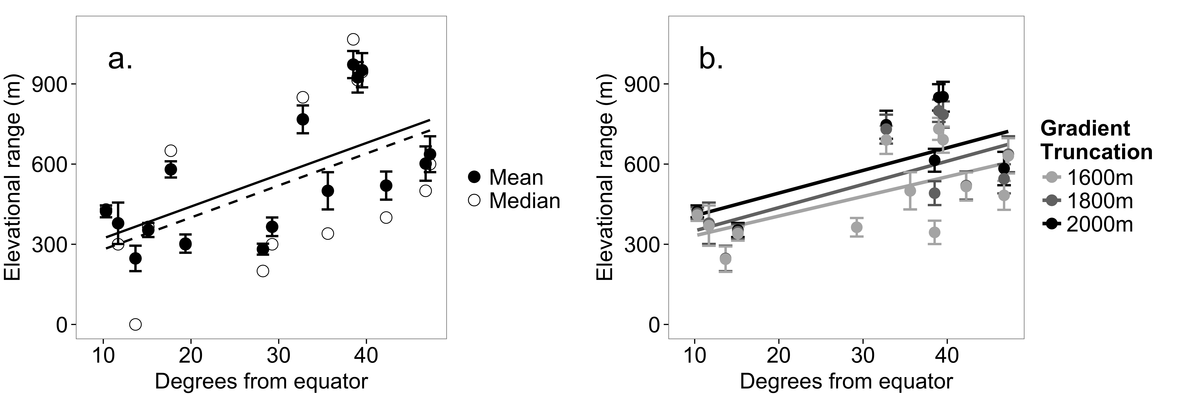Because high elevations, like high latitudes, also experience increased climatic variability, the mean elevational range size may increase with elevation along each gradient (Stevens, 1992). To avoid the disproportionate influence and non-independence of large-ranged species, I estimated mean range size at each elevation using two methods (Rohde et al., 1993; Gaston et al., 1998; McCain and Bracy Knight, 2013). With midpoint method, the mean range size at each elevation is estimated as the average range size of all species whose midpoints occur at that elevation. With the quartile method, only species with ranges < 1/4 of the gradient are used. Contrary to expectations, there is little evidence that the mean ant species range size increases along elevational gradients using either method (Midpoint: SLR *b*>0 with *P*< 0.05 in only 2/16 gradients, *R2* mean: 0.15, median: 0.03; Quartile: SLR *b*>0 with *P*< 0.05 in 3/16 gradients, *R2* mean: 0.20, median: 0.14).

**Fig. 1** Ant species elevational range sizes increase with latitude. (a) Both the mean (solid; ± 1 standard error) and median (open) elevational range size increases with distance from the equator (mean: *n*=16, *P*=0.009, *R2*=0.353; median: *n*=16, *P*=0.04, *R2*=0.208). (b) This trend does not appear to be driven by the height of the mountain. The mean elevational range size increases with latitude with all three truncation heights (1600m subset: black, *n*=13, *P*=0.021, *R2*=0.344; 1800m subset: dark gray, *n*=12, *P*=0.012, *R2*=0.437; 2000m subset: light gray, *n*=10, *P*=0.033, *R2*=0.384).

Thus, though ant elevational range sizes do not show a consistent pattern along single elevational gradients, they do tend to increase with latitude. The thermal tolerances of tropical ant species may, in fact, be narrower than those of temperate species. Alternatively, smaller elevational ranges are also consistent with stronger interspecific competition in the tropics (Pianka, 1966; Willig et al., 2003), though of course these hypotheses are not mutually exclusive. Regardless, the smaller elevational ranges in the tropics should lead to more pronounced changes in the ant community composition along tropical elevational gradients.

# Species composition & beta diversity

Beta diversity was originally defined as the ratio of regional diversity () to local diversity () where (Whittaker, 1960). Over the ensuing decades, definitions and indices for estimating beta diversity have proliferated (Tuomisto, 2010). In a broad sense, however, beta diversity quantifies the variation in the species composition across space or time (Anderson et al., 2011). That variation can occur either through the replacement of one species for another, called *turnover*, or through the loss or addition of species, called *nestedness* (Baselga, 2010, 2012; Legendre, 2014). Total beta diversity can be partitioned into turnover and nestedness to compare the proportion of compositional change resulting from the replacement or addition of species, respectively (Baselga, 2010).

Turnover and nestedness are likely driven by different processes. Understanding the elevational pattern of each can clarify the importance of ecological filtering, biotic interactions, and neutral processes in structuring ant communities (Svenning et al., 2011; Dapporto et al., 2014). In this section, I examine ant community variation across taxonomic levels at the scale of entire gradients () as well as between adjacent elevational bands. Further, I partition that variation into turnover and nestedness to investigate whether ant communities differ across elevations due to the replacement of taxa or to the addition and loss of taxa.

To summarize and compare the total variation in ant communities across entire elevational gradients, I calculated gradient-wide beta diversity as:

where is the total richness along the gradient and is the average richness of the sampled elevational bands (Tuomisto, 2010). Because this method is affected by the number of sampled elevational bands, I standardized as:

where *N* is the number of elevational bands (Chao et al., 2012). To explore gradient-wide turnover and nestedness as well as the change in ant communities between adjacent elevations along each gradient, I used the Sørensen-family metrics in the R package *betapart* to calculate beta diversity, turnover, and nestedness (Baselga, 2010, 2012; Baselga and Orme, 2012). These indices allow for unbiased comparisons among communities of differing richness (Baselga, 2012). I calculated each component using the species composition, genus composition, and subfamily composition at each elevation.

### Species

At the species level, gradient-wide beta diversity () decreases significantly with latitude (Fig. 2, black; *n*=20, *P*<0.001, *R2*=0.49). Consistent with the smaller elevational ranges at low latitudes, the ant species composition changes more rapidly across elevations at low latitudes. The proportion of gradient-wide beta diversity due to turnover rather than nestedness does not vary significantly between tropical and temperate mountains (Fig. 3; Wilcoxon rank sum test: *W*=41, *P*=0.26). Overall, turnover constitutes a greater proportion of gradient-wide beta diversity than does nestedness at the species level (Fig. 3; Paired t-test: *t15*=5.63, *P*<0.001). That is, when all pairs of elevations are compared, communities at two different elevations each commonly have distinct species rather than one being a subset of the other.

**Fig. 2** Gradient-wide beta diversity () decreases with latitude at the species and genus level. Total species beta diversity across each elevational gradient, standardized for the number of sampled elevations, declines with latitude (black; *n*=20, *P*<0.001, *R2*=0.49). This pattern diminishes at broader taxonomic scales with a weaker trend for genus beta diversity (gray; *n*=16, *P*=0.03, *R2*=0.25) and no trend for subfamily beta diversity (white; *n*=16, *P*=0.15, *R2*=0.08).

This is not the case, however, at a narrower spatial resolution. Rather, nestedness tends to be higher than turnover between adjacent elevations along most gradients. This seemingly contradictory pattern emphasizes the importance of spatial scale to patterns of beta diversity. Comparing sites across the entire gradient, species replace each other and high elevation communities are distinct from low elevation communities. But this replacement occurs gradually across elevations. Species are more often distributed individually, with overlapping ranges, rather than occurring as distinct abutting communities. In exception, several tropical datasets show high turnover between adjacent elevations for a large portion of the gradient (Samson et al., 1997; Fisher, 1998; Longino and Colwell, 2011), consistent with a high degree of elevational specialization resulting from some combination of competition and abiotic constraints.

### Genus

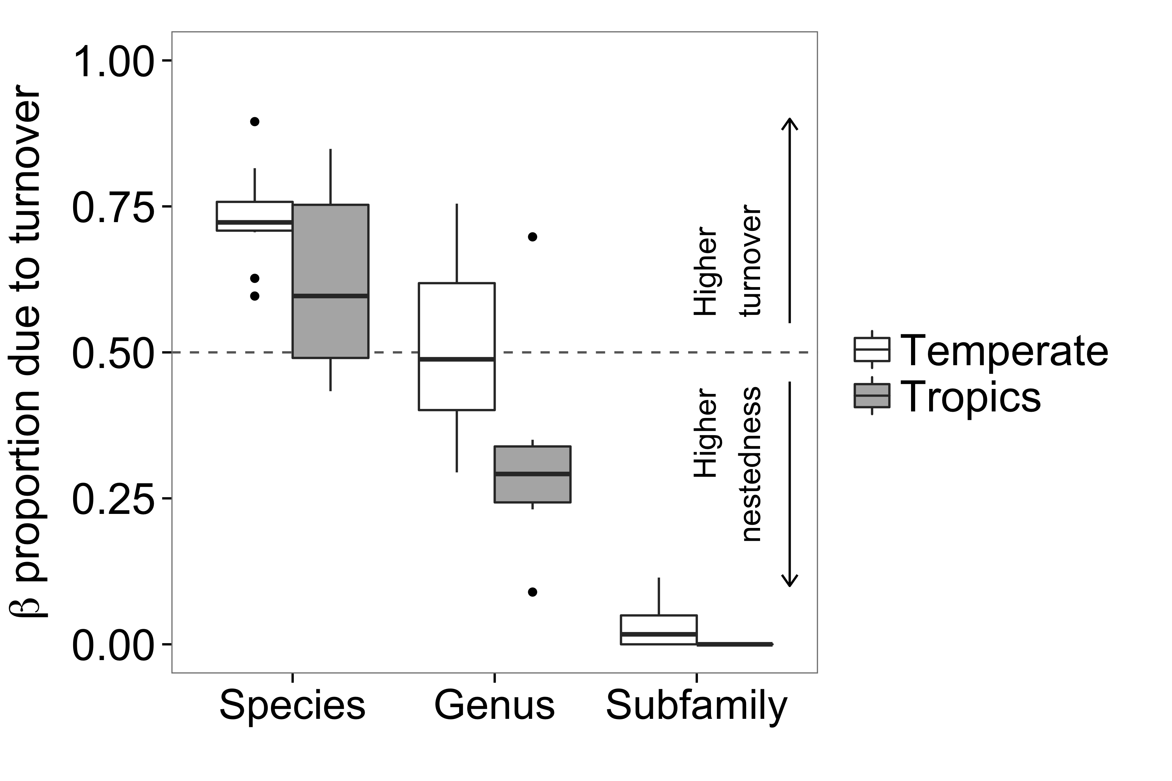At the genus level, gradient-wide beta diversity () also declines with latitude (Fig. 2, gray; *n*=16, *P*=0.03, *R2*=0.25). The genus composition changes more rapidly across elevations at low latitudes, though the trend is weaker than at the species level. The proportion of gradient-wide genus beta diversity due to turnover is significantly higher in temperate regions (Fig. 3; Wilcoxon rank sum test: *W*=49, *P*=0.042). However, there is high variability in the genus turnover proportion among both temperate and tropical gradients; this apparent difference may be spurious. Nonetheless, at the gradient scale, genus communities vary due to comparable proportions of turnover and nestedness (Fig. 3; Paired t-test: *t15*=-0.67, *P*=0.51). When all elevations along a given gradient are compared pairwise, the difference in genus composition results from both the replacement of one genus for another and the loss of genera without replacement.

**Fig. 3** Proportion of gradient-wide beta diversity due to turnover decreases with taxonomic resolution. In both temperate (white) and tropical (gray) gradients, the proportion of beta diversity due to turnover (i.e., replacement) rather than nestedness decreases at higher taxonomic levels. At 0.5 (dotted line), turnover and nestedness contribute equally to the change in community composition.

However, between elevationally adjacent sites, ant genera, like ant species, tend to be nested; adjacent communities differ due to the loss of genera between elevations rather than the replacement of one genus with another. Along many gradients, turnover at the genus level is nearly zero between the majority of adjacent elevations. The primary exceptions are in the Philippines (Samson et al., 1997), where turnover is higher than nestedness except at the highest elevations, and in the McPherson Range in Australia (Burwell and Nakamura, 2011), where turnover is higher than nestedness along the lower half of the gradient.

### Subfamily

At the subfamily level, gradient-wide beta diversity () shows no relationship with latitude (Fig. 2, white; *n*=16, *P*=0.15, *R2*=0.08). The elevational change in subfamily composition does not vary latitudinally. The proportion of gradient-wide subfamily beta diversity due to turnover is not different between tropical and temperate mountains (Fig. 2b; Wilcoxon rank sum test: *W*=45; *P*=0.08) and in fact, nearly all of the change in subfamily composition is due to nestedness rather than turnover (Fig. 3; Paired t-test: *t15*=-11.04, *P*<0.001). That is, subfamilies rarely replace one another among sites, but rather the subfamily composition of each elevation is either identical to or a subset of the composition at other elevations.

Between adjacent elevations, there is no subfamily turnover along any gradient. Instead, there is a high degree of elevational overlap among subfamilies, resulting in communities that are nested subsets across elevations. Often, subfamilies are progressively excluded at higher elevations, consistent with environmental filtering (Dapporto et al., 2014). With highly nested subfamily communities, there is little evidence for competitive exclusion across elevations at the subfamily level.

Thus, latitudinal trends in elevational beta diversity are contingent on taxonomic level. Community differences across elevations are most extreme between tropical ant species. Moreover, beta diversity between adjacent elevations declines as taxonomic resolution decreases. The species dissimilarity is higher than genus dissimilarity which, in turn, is higher than subfamily dissimilarity. Most dramatically, turnover across elevations declines at higher taxonomic levels irrespective of latitude. Communities become increasingly nested as the differences are due not to the replacement of one taxon with another, but to the loss or addition of taxa. This taxonomic trend may occur because competition is most intense among congeners, though heightened sensitivity to abiotic conditions at the species level and resultant elevational specialization could also produce this pattern (Machac et al., 2011; Dapporto et al., 2014).

# Richness patterns

### Species richness

Ant species richness shows a variety of patterns across elevational gradients. In the robust datasets, species richness most often peaks at intermediate elevations (14/20), though decreasing (3/20) and low plateau (3/20) patterns also occur (Fig. 4, black bars). Despite strong latitudinal trends in range size and beta diversity, the richness pattern distribution of tropical gradients is not significantly different than that of temperate gradients (Fisher's Exact Test: *n*=20, *P*=0.30). In the excluded datasets, the patterns are 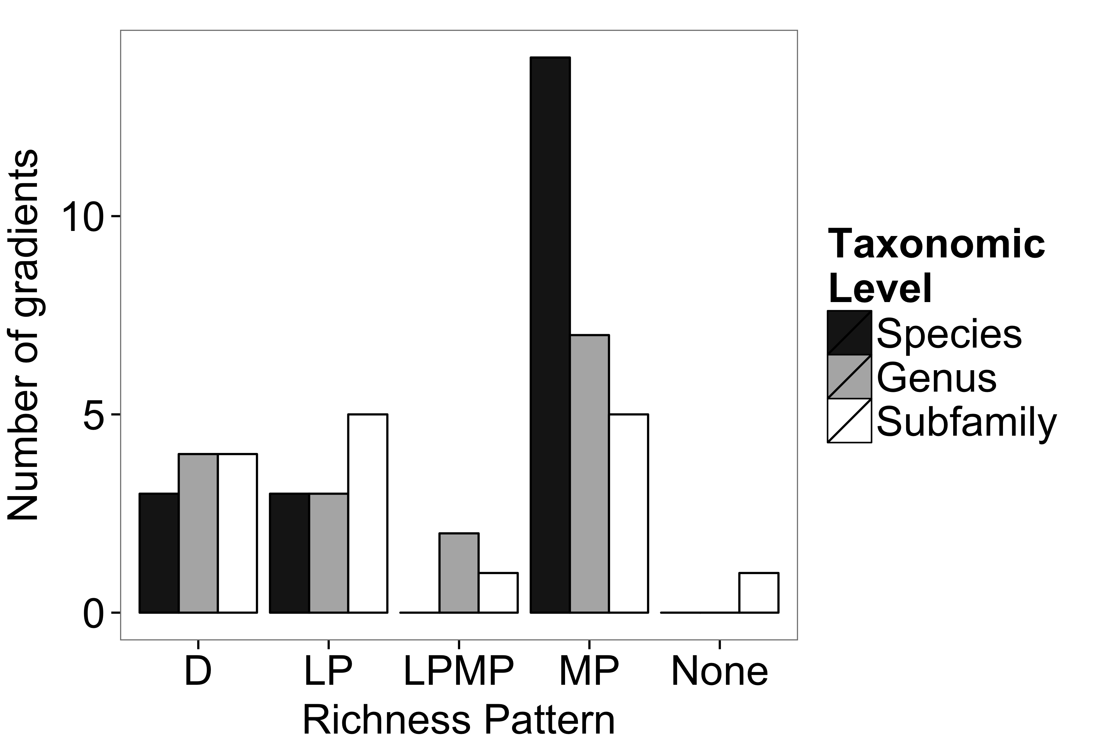more variable, with mid-peaks, decreases, low plateaus, increases, and no identifiable pattern reported. Furthermore, decreasing patterns were roughly as common as mid-peaks in these datasets. This is likely an artefact of sampling bias, however. Of the excluded gradients detecting decreases, the majority did not sample within the lowest 400m, failing to capture the portion of the gradient where the common patterns differ the most. At the species level, therefore, ant elevational richness is variable among mountain ranges, though frequently highest at intermediate elevations.

**Fig. 4** Robust patterns of ant elevational richness patterns across taxonomic scales. Observed patterns included declines (D), low plateaus (LP), low plateaus with mid-peaks (LPMP), mid-peaks (MP), and no pattern (None). A variety of species richness patterns (black, *n*=20) occur, though mid-elevational peaks are most common. The pattern distribution is similar for both species (black) and genus (gray, *n*=16) richness (Fisher's Exact Test: *nspecies*=20, *ngenus*=16, *P*=0.28). Though the subfamily (white, *n*=16) richness patterns are less discernible due to the small number of subfamilies along many gradients, the distribution of patterns is not significantly different (Fisher's Exact Tests: *nspecies*=20, *nsubfamily*=16, *P*=0.10; *ngenus*=16, *nsubfamily*=16, *P*=0.84).

### Genus richness

The number of genera across elevations typically mirrors the number of species; the genus richness pattern is the same as the species richness pattern in 11/16 gradients. Moreover, the distribution of genus richness patterns does not differ significantly from the species richness patterns (Fig. 4, black and gray bars; Fisher's Exact Tests: *nspecies*=20, *ngenus*=16, *P*=0.28; *nspecies*=16, *ngenus*=16, *P*=0.39), though there is a tendency for the peak in genus richness to be less pronounced, resulting in several low plateaus with mid-peaks not seen at the species level. The distribution of genus richness patterns does not vary significantly between tropical and temperate datasets (Fisher's Exact Test: *n*=16, *P*=0.11). The log number of species increases quite predictably with the log number of genera (*R2* mean: 0.96), lending further evidence that ant richness patterns are similar at the species and genus scales.

### Subfamily richness

The richness pattern of ant subfamilies along each gradient is coarsely similar to the species and genus richness patterns, though less distinct due to the smaller number of subfamilies. The distribution of subfamily richness patterns is not significantly different from that of the species richness patterns (Fig.4, black and white bars; Fisher's Exact Tests: *nspecies*=20, *nsubfamily*=16, *P*=0.10; *nspecies*=16, *nsubfamily*=16, *P*=0.20) nor from that of the genus richness patterns (Fig. 4, gray and white bars; Fisher's Exact Test: *n*=16, *P*=0.84). As at the species and genus levels, the distribution of subfamily richness patterns does not vary significantly between tropical and temperate gradients (Fisher's Exact Test: *n*=16, *P*=0.28). The log number of subfamilies does predict the log number of species, though less reliably than does the number of genera (*R2* mean: 0.79).

Ant richness, therefore, is often high at intermediate elevations whether measured at the species, genus, or subfamily level. Consequently, it appears that the underlying ecological or evolutionary factors driving richness are creating similar patterns at multiple taxonomic scales. While it may seem intuitive that the number of species would increase with the number of genera, in fact species communities can be over- or under-dispersed phylogenetically (Webb et al., 2002), with the degree phylogenetic dispersion likely arising from the interplay of environmental filtering, neutral processes, and competition (Webb et al., 2002; Kembel and Hubbell, 2006; Machac et al., 2011). The similarity in richness patterns across taxonomic levels suggests that species across the many genera and subfamilies of ants along each gradient may be responding similarly to the combination of processes affecting speciation and community assembly. Nonetheless, given the disparate number of species within each ant genus or subfamily, the pattern of species richness may simply result from the richness pattern of the most speciose genus or subfamily along the gradient.

# Dominant taxa

### Most speciose genus

The numerical dominance of the most speciose genus is highly variable among mountain ranges. The most speciose genus along each gradient comprises 7–31% of the total species richness of that gradient (mean ± SE: 20.0 ± 1.57%). These genera include *Camponotus* (Sabu et al., 2008), *Formica* (Gregg, 1963; Allred, 1982; Wheeler and Wheeler, 1986; Hellrigl, 2003; Glaser, 2006), *Lasius* (Karaman, 2011), *Pheidole* (Moody and Francke, 1982; Van Pelt, 1983; Samson et al., 1997; Fisher, 1998; Araújo and Fernandes, 2003; Burwell and Nakamura, 2011; Longino and Colwell, 2011), *Stenamma* (Lessard et al., 2007), and *Strumigenys* (Sarnat and Economo, 2012). The proportion of species within the most speciose genus does not vary predictably across latitudes (*n*=16, *P*=0.15, *R2*=0.08).

The species richness of the most speciose genus, of course, strongly predicts richness across elevations (*R^2* mean: 0.79). However, the overall pattern is not driven solely by this single genus. Instead, the species richness pattern of the most speciose genus is typically similar to the richness pattern of the remaining species. Along most gradients, the richness of the most speciose genus predicts the richness of the remaining genera quite well (Fig. 5a; *R2* mean: 0.69), though the relationship is variable among gradients (*b* mean: 3.5, range: -0.9–10.8). Many of the non-dominant genera are neither speciose nor widespread enough to reliably discern a species richness pattern. Those that are, however, tend to show a qualitatively similar elevational richness pattern both to the overall pattern and to that of the most speciose genus.

### Most speciose subfamily

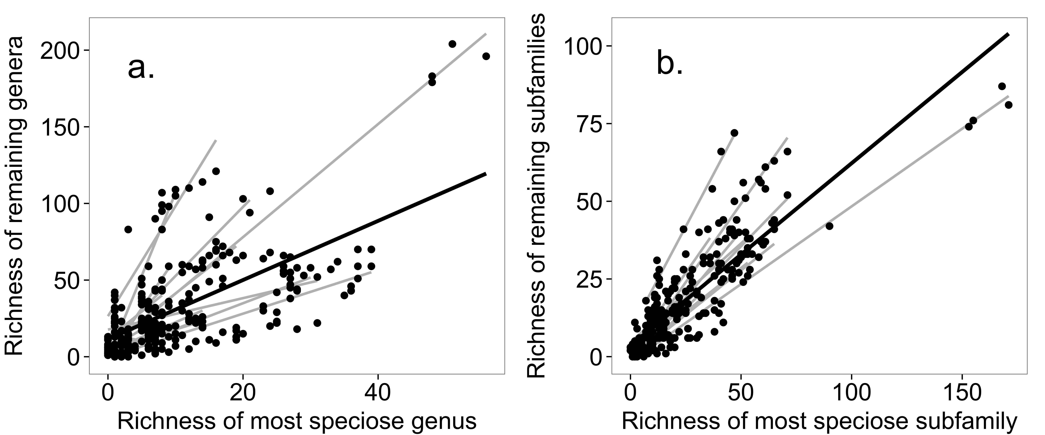The numerical dominance of the most speciose subfamily is highly variable among mountain ranges. The most speciose subfamily along each gradient comprises 39–73% of the total species richness (mean ± SE: 54.5 ± 2.04%). Along a given gradient, one of two subfamilies are dominant: Formicinae (Gregg, 1963; Allred, 1982; Wheeler and Wheeler, 1986; Hellrigl, 2003; Glaser, 2006) or Myrmicinae (Moody and Francke, 1982; Van Pelt, 1983; Samson et al., 1997; Fisher, 1998; Araújo and Fernandes, 2003; Lessard et al., 2007; Sabu et al., 2008; Burwell and Nakamura, 2011; Karaman, 2011; Longino and Colwell, 2011; Sarnat and Economo, 2012). There is no latitudinal trend in the proportion of species contained within the most speciose subfamily (*n*=16, *P*=0.38, *R2*=0.06).

**Fig 5** Richness of the most speciose genus or subfamily predicts the richness of the remaining species. (a) The elevational richness pattern of the most speciose genus is nested within the richness pattern of the remaining species for most gradients. The trend is apparent with all datasets combined (black line) and within each gradients (gray lines). There is, however, much variability in the slope of the relationship among gradients. (b) The nestedness of the richness patterns becomes stronger at the subfamily level. The relationship is strong with all datasets combined (black line) and much less variable among transects (gray lines) compared to the genus level.

As with the dominant genus, the species richness within the most speciose subfamily is remarkably similar across elevations both to the richness of all species (*R2* mean: 0.97) and to the richness of species in non-dominant subfamilies (Fig. 5b; *R2* mean: 0.81). Thus, the total species richness pattern is not simply a product of the most speciose subfamily. Rather, the dominant subfamily shows the same richness pattern as the remaining subfamilies. Furthermore, the richness pattern of each subfamily is often qualitatively similar both to the overall richness pattern and to the pattern of the most speciose subfamily.

Ant species richness patterns across elevations are not, therefore, driven by a single subtaxon, but rather emerge from the congruent, nested richness patterns of many genera and subfamilies. The richness pattern within each subtaxon tends to be broadly similar to that of the whole. This suggests that the key factors shaping the richness of ants across a given elevational gradient may act on the majority of ant subtaxa similarly, regardless of ecological differences.

# Research gaps

Because elevational richness patterns tend to differ primarily at the mountain base (Diniz-Filho et al., 2010), sampling within the lowest 400m is critical to reliably detect the underlying pattern. Additionally, though a multitude of hypotheses have been proposed as drivers of ant community structure and diversity along elevational gradients (Samson et al., 1997; Botes et al., 2006; e.g., Longino and Colwell, 2011), the data required to rigorously evaluate many of these hypotheses are lacking at a broad scale. In particular, habitat complexity, such as vegetation structure or leaf litter depth, has been suggested as a driver of ant diversity (Lassau and Hochuli, 2004; Sarty et al., 2006; Pacheco and Vasconcelos, 2011; Bharti et al., 2013). Such data have not been widely collected across elevational gradients with ant species data. Further, we know little about the ranges and less about the basic natural history of many ant species (Lanan, 2014). Dietary, foraging, and nesting habits can vary dramatically within a genus and even within a species (Hölldobler and Wilson, 1990). Understanding how biotic interactions and variation in their strength affect ant communities across elevations relies on thoroughly detailing behavior and interactions across a wide taxonomic variety of ant species. Ant communities can also vary substantially across seasons and years (Bishop et al., 2014), variation that has rarely been accounted for. A greater focus on seasonal and annual fluctuations will inform mechanistic approaches to understanding patterns of ant communities. Finally, a recent phylogenetic analysis of tropical ants across elevations found that the ant communities were phylogenetically clustered, suggesting a strong role of environmental filtering (Smith et al., 2014). Increased focus on phylogenetic patterns may help to disentangle the interplay of ecological and evolutionary processes in shaping ant communities (Machac et al., 2011; Smith et al., 2014).

# Conclusion

In summary, ant elevational ranges are narrowest at tropical latitudes, leading to higher gradient-wide beta diversity and high species turnover. This trend becomes less distinct at higher taxonomic levels where elevational ranges become broader and communities become increasingly nested. The elevational species richness patterns, which, in contrast to elevational ranges and beta diversity, do not vary systematically across latitudes, are a conglomerate property across subfamilies and genera rather than just a function of the most speciose subtaxon. The broad similarity of richness patterns along a given gradient, including among species, within and among genera, and within and among subfamilies, suggests that despite large biological differences, similar factors may influence the elevational distribution of ant species across many genera and subfamilies. Thus, while range sizes and changes in species composition are inherently tied to variation in species richness, they perhaps are not as directly relevant to richness patterns at the scale of elevational gradients.

# References

Allred, D. 1982. Ants of Utah. *The Great Basin Naturalist* **42**: 415–511

Andersen, A.N. 1997. Functional groups and patterns of organization in North American ant communities: a comparison with Australia. *Journal of Biogeography* **24**: 433–460

Anderson, C., and McShea, D.W. 2001. Intermediate-level parts in insect societies: Adaptive structures that ants build away from the nest. *Insectes Sociaux* **48**: 291–301

Anderson, M.J., Crist, T.O., Chase, J.M., Vellend, M., Inouye, B.D., Freestone, A.L., Sanders, N.J., Cornell, H.V., Comita, L.S., Davies, K.F., Harrison, S.P., Kraft, N.J.B., Stegen, J.C., Swenson, N.G., and Others 2011. Navigating the multiple meanings of beta diversity: A roadmap for the practicing ecologist. *Ecology Letters* **14**: 19–28

Araújo, L.L., and Fernandes, G.G. 2003. Altitudinal patterns in a tropical ant assemblage and variation in species richness between habitats. *Lundiana* **4**: 103–109

Baselga, A. 2010. Partitioning the turnover and nestedness components of beta diversity. *Global Ecology and Biogeography* **19**: 134–143

Baselga, A. 2012. The relationship between species replacement, dissimilarity derived from nestedness, and nestedness. *Global Ecology and Biogeography* **21**: 1223–1232

Baselga, A., and Orme, C.D.L. 2012. Betapart: An R package for the study of beta diversity. *Methods in Ecology and Evolution* **3**: 808–812

Beck, J., Ballesteros-Mejia, L., Buchmann, C.M., Dengler, J., Fritz, S.A., Gruber, B., Hof, C., Jansen, F., Knapp, S., Kreft, H., Schneider, A.-K., Winter, M., and Dormann, C.F. 2012. What’s on the horizon for macroecology? *Ecography* **35**: 673–683

Bharti, H., Sharma, Y., Bharti, M., and Pfeiffer, M. 2013. Ant species richness, endemicity and functional groups, along an elevational gradient in the Himalayas. *Asian Myrmecology* **5**: 79–101

Bishop, T.R., Robertson, M.P., Rensburg, B.J. van, and Parr, C.L. 2014. Elevation-diversity patterns through space and time: Ant communities of the Maloti-Drakensberg Mountains of southern Africa

Botes, A., McGeoch, M., Robertson, H., Niekerk, A. van, Davids, H., and Chown, S.L. 2006. Ants, altitude and change in the northern Cape Floristic Region. *Journal of Biogeography* **33**: 71–90

Brühl, C.A., Mohamed, M., and Linsenmair, K.E. 1999. Altitudinal distribution of leaf litter ants along a transect in primary forests on Mount Kinabalu, Sabah, Malaysia. *Journal of Tropical Ecology* **15**: 265–277

Burwell, C., and Nakamura, A. 2011. Distribution of ant species along an altitudinal transect in continuous rainforest in subtropical Queensland, Australia. *Memoirs of the Queensland Museum* **55**: 391–412

Cerdá, X., Arnan, X., and Retana, J. 2013. Is competition a significant hallmark of ant (Hymenoptera: Formicidae) ecology? *Myrmecological News* 131–147

Chao, A., Chiu, C.H., Hsieh, T.C., and Inouye, B.D. 2012. Proposing a resolution to debates on diversity partitioning. *Ecology* **93**: 2037–2051

Cushman, J.H., Lawton, J.H., and Manly, B.F.J. 1993. Latitudinal patterns in European ant assemblages: variation in species richness and body size. *Oecologia* **95**: 30–37

Dapporto, L., Fattorini, S., Vodă, R., Dincă, V., and Vila, R. 2014. Biogeography of western Mediterranean butterflies: combining turnover and nestedness components of faunal dissimilarity. *Journal of Biogeography* **41**: 1639–1650

Diniz-Filho, J.A.F., De Marco, P., and Hawkins, B.A. 2010. Defying the curse of ignorance: perspectives in insect macroecology and conservation biogeography. *Insect Conservation and Diversity* **3**: 172–179

Fisher, B. 1998. Ant diversity patterns along an elevational gradient in the Réserve Spéciale d’Anjanaharibe-Sud and on the western Masoala Peninsula, Madagascar. *Fieldiana Zoology* **90**: 39–67

Gaston, K.J., Blackburn, T.M., and Spicer, J.I. 1998. Rapoport’s rule: Time for an epitaph? *Trends in Ecology and Evolution* **13**: 70–74

Ghalambor, C.K., Huey, R.B., Martin, P.R., Tewksbury, J.J., and Wang, G. 2006. Are mountain passes higher in the tropics? Janzen’s hypothesis revisited. *Integrative and Comparative Biology* **46**: 5–17

Glaser, F. 2006. Biogeography, diversity, and vertical distribution of ants (Hymenoptera: Formicidae) in Vorarlberg, Austria. *Myrmecological News* **8**: 263–270

Gregg, R. 1963. *The Ants of Colorado*. University of Colorado Press, Denver, CO

Hellrigl, K. 2003. Faunistik der Ameisen und Wildbienen Südtirols (Hymenoptera: Formicidae et Apoidea). *Gredleriana* **3**: 143–208

Hölldobler, B., and Wilson, E.O. 1977. The number of queens: An important trait in ant evolution. *Naturwissenschaften* **64**: 8–15

Hölldobler, B., and Wilson, E.O. 1990. *The Ants*. Belknap Press of Harvard University Press, Cambridge

Janzen, D.H. 1967. Why mountain passes are higher in the tropics

Karaman, M. 2011. Zoogeography, diversity and altitudinal distribution of ants (Hymenoptera: Formicidae) in the Mediterranean and the oro-Mediterranean parts of Montenegro. *North-Western Journal of Zoology* **7**: 26–34

Kaspari, M., and Vargo, E.L. 1995. Colony size as a buffer against seasonality: Bergmann’s Rule in social insects. *The American Naturalist* **145**: 610–632

Kembel, S.W., and Hubbell, S.P. 2006. The phylogenetic structure of a neotropical forest tree community. *Ecology* **87**: 86–99

Lanan, M. 2014. Spatiotemporal resource distribution and foraging strategies of ants (Hymenoptera: Formicidae). *Myrmecological News* **20**: 53–70

Lassau, S., and Hochuli, D. 2004. Effects of habitat complexity on ant assemblages. *Ecography* **2**: 157–164

Legendre, P. 2014. Interpreting the replacement and richness difference components of beta diversity. *Global Ecology and Biogeography* 1–11

Lessard, J.J., Dunn, R.R., Parker, C.C., and Sanders, N.N. 2007. Rarity and diversity in forest ant assemblages of Great Smoky Mountains National Park. *Southeastern Naturalist* **0**: 215–228

Lomolino, M. 2001. Elevation gradients of species-density: historical and prospective views. *Global Ecology and Biogeography* **10**: 3–13

Longino, J.T., and Colwell, R.K. 2011. Density compensation, species composition, and richness of ants on a neotropical elevational gradient. *Ecosphere* **2**: art29

Machac, A., Janda, M., Dunn, R.R., and Sanders, N.J. 2011. Elevational gradients in phylogenetic structure of ant communities reveal the interplay of biotic and abiotic constraints on diversity. *Ecography* **34**: 364–371

McCain, C.M. 2005. Elevational gradients in diversity of small mammals. *Ecology* **86**: 366–372

McCain, C.M. 2009a. Global analysis of bird elevational diversity. *Global Ecology and Biogeography* **18**: 346–360

McCain, C.M. 2009b. Vertebrate range sizes indicate that mountains may be ‘higher’in the tropics. *Ecology Letters* **12**: 550–560

McCain, C.M. 2010. Global analysis of reptile elevational diversity. *Global Ecology and Biogeography* **19**: 541–553

McCain, C.M., and Bracy Knight, K. 2013. Elevational Rapoport’s rule is not pervasive on mountains. *Global Ecology and Biogeography* **22**: 750–759

McCain, C.M., and Grytnes, J.A. 2010. Elevational gradients in species richness. In: *Encyclopedia of Life Sciences*, pp. 1–10

McCoy, E. 2002. The “veiled gradients” problem in ecology. *Oikos* **99**: 189–192

McGlynn, T.P., Diamond, S.E., and Dunn, R.R. 2012. Tradeoffs in the evolution of caste and body size in the hyperdiverse ant genus Pheidole. *PLoS ONE* **7**: 1–5

Moody, J., and Francke, O.F. 1982. *The ants (Hymenoptera, Formicidae) of western Texas Part I. Subfamily Myrmicinae*. Texas Tech Press, Lubbock, TX

Munyai, T.C., and Foord, S.H. 2012. Ants on a mountain: spatial, environmental and habitat associations along an altitudinal transect in a centre of endemism. *Journal of Insect Conservation* **16**: 677–695

Nogués-Bravo, D., Araújo, M.B., Romdal, T., and Rahbek, C. 2008. Scale effects and human impact on the elevational species richness gradients. *Nature* **453**: 216–219

Olson, D.M. 1994. The distribution of leaf litter invertebrates along a neotropical altitudinal gradient. *Journal of Tropical Ecology* **10**: 129–150

Pacheco, R., and Vasconcelos, H.L. 2011. Habitat diversity enhances ant diversity in a naturally heterogeneous Brazilian landscape. *Biodiversity and Conservation* **21**: 797–809

Pianka, E. 1966. Latitudinal gradients in species diversity: a review of concepts. *American Naturalist* **100**: 33–46

Rahbek, C. 1995. The elevational gradient of species richness: a uniform pattern? *Ecography* **18**: 200–205

Rahbek, C. 2005. The role of spatial scale and the perception of large-scale species-richness patterns. *Ecology Letters* **8**: 224–239

Rohde, K., Heap, M., and Heap, D. 1993. Rapoport’s rule does not apply to marine Teleosts and cannot explain latitudinal gradients in species richness

Sabu, T., Vineesh, P., and Vinod, K. 2008. Diversity of forest litter-inhabiting ants along elevations in the Wayanad region of the Western Ghats. *Journal of Insect Science* **8**: 1–14

Samson, D.A., Rickart, E.A., and Gonzales, P.C. 1997. Ant diversity and abundance along an elevational gradient in the Phillippines. *Biotropica* **29**: 349–363

Sanders, N. 2002. Elevational gradients in ant species richness: area, geometry, and Rapoport’s rule. *Ecography* **1**: 25–32

Sarnat, E., and Economo, E. 2012. *The ants of Fiji*. UC Publications in Entomology, University of California Press, Berkeley; Los Angeles, CA

Sarty, M., Abbott, K.L., and Lester, P.J. 2006. Habitat complexity facilitates coexistence in a tropical ant community. *Oecologia* **149**: 465–473

Sheldon, K.S., and Tewksbury, J.J. 2014. The impact of seasonality in temperature on thermal tolerance and elevational range size. *Ecology* **95**: 2134–2143

Sheldon, K.S., Leaché, A.D., and Cruz, F.B. 2015. The influence of temperature seasonality on elevational range size across latitude : a test using Liolaemus lizards. *Global Ecology and Biogeography* n/a–a

Smith, M.A., Hallwachs, W., and Janzen, D.H. 2014. Diversity and phylogenetic community structure of ants along a Costa Rican elevational gradient. *Ecography* no–o

Stevens, G.C. 1992. The elevational cradient in altitudinal range: An extension of Rapoport’s latitudinal rule to altitude. *The American Naturalist* **140**: 893–911

Sunday, J.M., Bates, A.E., and Dulvy, N.K. 2011. Global analysis of thermal tolerance and latitude in ectotherms. *Proceedings. Biological Sciences / The Royal Society* **278**: 1823–1830

Svenning, J.-C., Fløjgaard, C., and Baselga, A. 2011. Climate, history and neutrality as drivers of mammal beta diversity in Europe: insights from multiscale deconstruction. *The Journal of Animal Ecology* **80**: 393–402

Tuomisto, H. 2010. A consistent terminology for quantifying species diversity? Yes, it does exist. *Oecologia* **164**: 853–860

Van Pelt, A. 1983. Southwestern Association of Naturalists Ants of the Chisos Mountains, Texas (Hymenoptera: Formicidae). *The Southwestern Naturalist* **28**: 137–142

Webb, C., Ackerly, D., McPeek, M., and Donoghue, M. 2002. Phylogenies and community ecology. *Annual Review of Ecology and Systematics* **33**: 475–505

Wheeler, G., and Wheeler, J. 1986. *The ants of Nevada*. Natural History Museum of Los Angeles County, Los Angeles, CA

Whittaker, R.H. 1960. Vegetation of the Siskiyou Mountains, Oregon and California. *Ecological Monographs* **30**: 279–338

Willig, M., Kaufman, D., and Stevens, R. 2003. Latitudinal gradients of biodiversity: Pattern, process, scale, and synthesis. *Annual Review of Ecology, Evolution, and Systematics* **34**: 273–309

Wilson, E.O. 1953. The origin and evolution of polymorphism in ants. *The Quarterly Review of Biology* **28**: 136–156