Description of the European Power Market Model (EPMM)

General description
The EPMM is a unit commitment and economic dispatch model covering the electricity systems of 41 European countries. It simultaneously determines the equilibrium values of the wholesale electricity and reserve markets for each hour and market, taking into account the projected weather-dependent renewable generation, the electricity demand, the reserve requirements for each country, and the technological constraints and costs (minimum operating and offtime, minimum / maximum load level, start-up / shut-down costs, variable costs of generation) for electricity generation and transmission. Using these inputs, the model predicts the operating status of the power plants every hour of the modelled week (covering almost 3,500 power plants), the volume of generation at the operating units, the amount of capacities set aside for upward-regulation and downward-regulation, the operation of reservoir hydropower plants, the flows on all cross-border interconnectors, and the wholesale market price of electricity and the price of the upward and downward reserve capacities in each country.
There are 41 countries modelled in EPMM: in these countries (indicated with an orange background on the following figure) prices are derived from the demand-supply balance, while on outside markets (indicated with yellow background) exogenous prices are assumed.
Figure 1: Countries modelled in EPMM
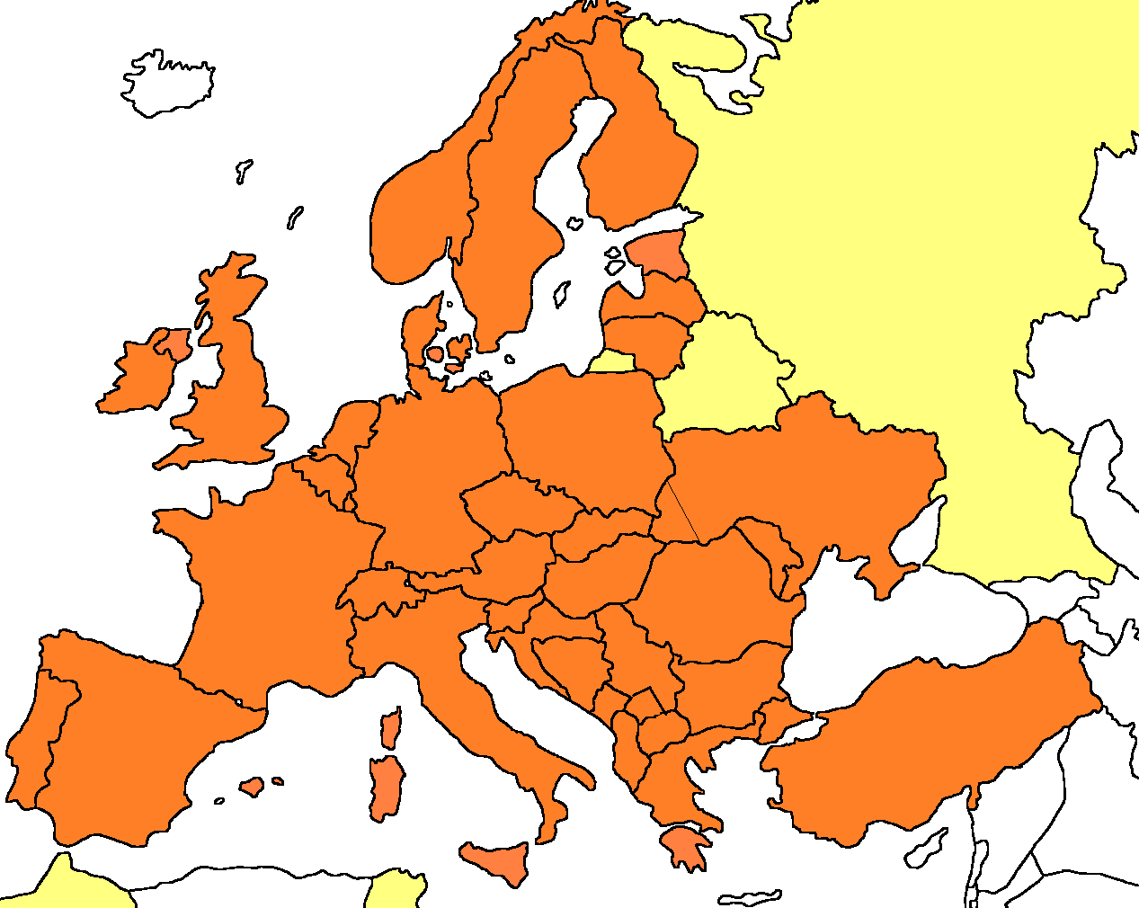
There are three types of market participants in the model: producers, consumers, and traders. All of them behave in a price-taking manner: they take the prevailing market price as given and assume that their actions have a negligible effect on this price.
The EPMM models 3500 power plant units operated with 12 different fuels: natural gas, coal, lignite, heavy fuel oil (HFO), light fuel oil (LFO), nuclear, biomass, geothermal, hydro, wind, solar and tide and wave. Each plant is characterised with a specific marginal cost of production, which is constant at the unit level. In addition, generation capacity is constrained at the level of available capacity.
Power flow is ensured by 110 interconnectors between the countries, where each country is treated as a single node, thus no domestic power system constraint is taken into account. NTC values are used to indicate trading possibilities, seasonal differences are included in the modelling based on historical data from ENTSO-E Transparency Platform. Future investments are assumed based on data from ENTSO-E’s latest Ten-Year Network Development Plan (TYNDP).
Consumers are represented in the model in an aggregated way: by different price-sensitive demand curves for each modelled market. The inverse relationship between prices and the quantity consumed is approximated by a downward sloping linear function. Traders connect the production and consumption sides of a market, through exporting electricity to more expensive countries from cheaper ones.
Figure 2: Functioning of the model
Merit order curves are calculated for each market, taking into account the short-term marginal cost for all available power plant units. Using the demand curve and international trade constraints, all input parameters are set. The model then maximizes the total welfare of all the covered countries. The model provides the equilibrium (wholesale) electricity prices for each market, the trade on each interconnector and the production of each power plant unit as output.

Supply side of the model
The following figure presents the methodology for calculating marginal cost of power plant units. The supply curve is formed under a perfect competition assumption; therefore all units provide their production on a marginal cost basis. The marginal cost is calculated by summing CO₂ emission cost, energy tax (if any), fuel cost and variable OPEX.
Figure 3: Methodology for marginal cost calculation
For all given technologies (e.g. OCGT, CCGT, thermal) commissioning date defines the efficiency, the self-consumption and the variable OPEX cost for all units. Using the fuel prices as an input, total fuel costs are calculated taking into account the above parameters. CO₂ costs are based on the calculated emission levels and the CO₂ quota prices. These costs are then added to the total energy tax paid and the variable OPEX.
It is important to acknowledge that only short-term marginal costs are considered, the model does not analyse the long-term profitability of the power plants. It is possible, that some units remain operational even if they provide electricity in a few hours per year. Power plant units are available until the end of their (pre-defined) lifetimes.
In the case of renewable power plants (biomass, geothermal, hydro, wind, solar, tidal), marginal cost on the product market is assumed as zero, production depends solely on availability. The estimation is based on historical production data from previous years (2006-2017). Renewable production (at a predetermined cost) can be curtailed. In the case of participation in the reserve market, we assume linear growth for wind and solar, with wind plants participating in the downward regulation up to 25% of their production and solar plants up to 15% of their production by the mid-2030s. The situation for hydropower is distinctive. With the exception of run-of-river plants, all hydropower plants (reservoir and pumped storage) optimise their production and reserve market participation for a full week, taking into account as a limit the maximum available production expected based on historical production data from previous years. These are used to determine the reserve market prices, while the marginal cost of the product market is zero on the supply curve.
A regression model is used to forecast the future level of required reserve capacities: based on 5 years and 16 countries of data, upward and downward reserve requirements are forecast for each modelled country and each modelled hour, as a function of system load and weather-dependent renewable generation capacity.

Demand side of the model
Demand per country is an exogenous input to the model. Historical data are used to assume a specific demand pattern for each modelled country over the year, and assumptions are made about the actual level of demand based on forecasts from international institutions, literature and strategy documents. Between years, the initial demand path is unchanged, but it is endogenously shaped by (pumped) storage and demand side management (DSM) in each modelled year. For DSM, based on literature, it is assumed that by 2050, 25% of the average hourly consumption in a given year can be reallocated to other hours, and 10-10% of this amount can provide for upward and downward reserve capacity services. Between 2020 and 2050 we assume linear growth.

Equilibrium
Based on the capacity and marginal cost values of the generating units, and considering which units are in reserve, the supply function is determined for each modelled hour in each country. Demand can be met from neighbouring countries in addition to domestic supply, up to the limit of cross-border capacity. In the model, each market (country) is represented by a node, and the cross-border capacities are represented by estimated NTC (net transfer capacity).

