<https://github.com/Szabo-Mark/FLCD>

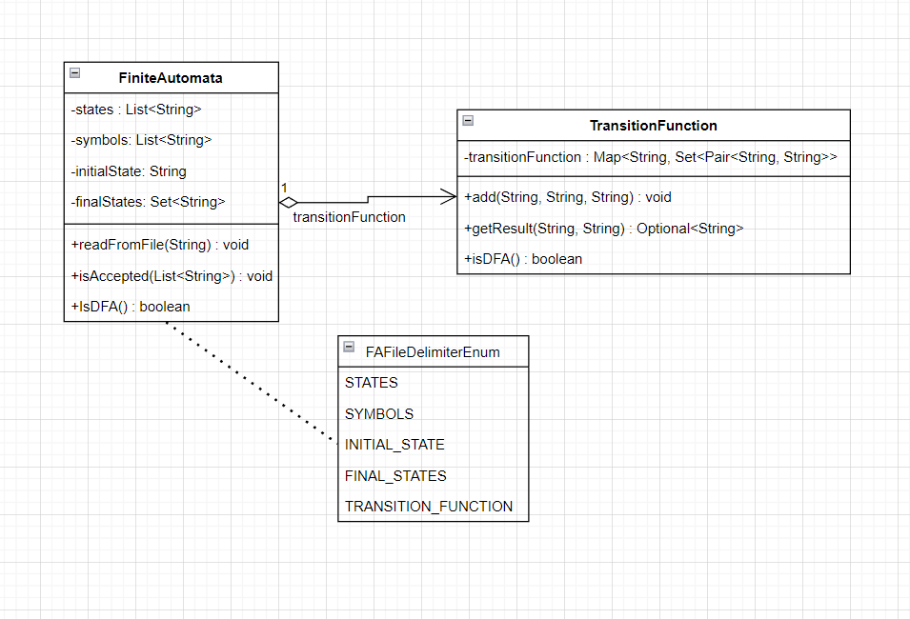

# Finite Automata:

-the states are represented by a set of strings.

-the symbols are represented by a set of strings.

-the initial state is a string.

-the final states are a set of strings.

-the transition function has its own class: TransitionFunction

-the readFromFile(String pathToFile) function will print the errors and their line numbers (if there are any).

-the in-file delimitors are : STATES, SYMBOLS, INITIAL_STATE, FINAL_STATES, TRANSITION_FUNCTION

# Transition Function:

-a wrapper over a Map<String, Set<Pair<String, String>>> in which:

-the key is the source state

-the value is a set of pairs in which the first element of a pair is the symbol and the second one is the destination state.

# FA.in

* The EBNF of the input file is:

FA.in = “STATES” {state} “SYMBOLS” {symbol} “INITIAL_STATE” [state] “FINAL_STATES” {state} “TRANSITION_FUNCTION” {transition};

character = letter | digit | special_char;

state = character;

symbol = character;

transition = state ”,” symbol ”=” state;