**Funtions and methods:**

**map()**

**Function returns a map object(which is an iterator) of the results after applying the given function to each item of a given iterable (list, tuple etc.). Without list it would return map object.**

Result:



**“”.join**

**is an inbuilt string function in Python used to join elements of the sequence separated by a string separator. This function joins elements of a sequence and makes it a string.**

**Result:**



**Binary summing**

**If I have a binary string of for example: number “11”, if I use:**



**Just int() will give us number 11, however if I use int( x, 2) I will receive 3 as a binary sum.**

**, 2: The second argument specifies the base of the number. In this case, it's 2, indicating that the input string x is in binary form.**

**Rest is simple: int_a + int_b = X, and then bin(X)[2:]. We add [2:] to remove python ob witch is added at the beginning.**

**Single Linked-List**

**Most important thing is to understand how to operate with the first part of list and next one.**

**Current is the first part of list -> ListNode[0], in while neext is second connected part to list, so current.next.**

**Exception:**

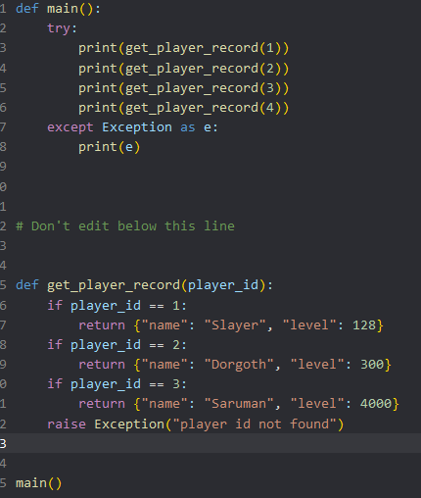

Przy naszym własnym if statment tworzymy exception, które może zostać wyłapane przez:

except Exception as „e” i zwrócić wyłapaną wartość zwrotną z Exsception.

Raczej nie należy stosować class variables bo ponieważ class variable jest współdzielona pomiędzy wszystkimi instancjami.