Program.cs

namespace JakubSzaredkoEFProducts

{

class Program

{

public static void Main(string[] args)

{

Console.WriteLine("Enter a new product name");

string productName = Console.ReadLine();

ProductContext productContext = new ProductContext();

Product product = new Product { ProductName = productName };

productContext.Products.Add(product);

productContext.SaveChanges();

Console.WriteLine("\nList of all products stored in the database:");

IQueryable<string> query = from prod in productContext.Products select prod.ProductName;

foreach (string pName in query)

{

Console.WriteLine(pName);

}

}

}

}

Product.cs

namespace JakubSzaredkoEFProducts

{

internal class Product

{

public int ProductID { get; set; }

public string ProductName { get; set; }

public int UnitsOnStock { get; set; }

}

}

ProductContext.cs

namespace JakubSzaredkoEFProducts

{

internal class ProductContext : DbContext

{

public DbSet<Product> Products { get; set; }

protected override void OnConfiguring(DbContextOptionsBuilder optionsBuilder)

{

base.OnConfiguring(optionsBuilder);

optionsBuilder.UseSqlite("Datasource=ProductsDatabase");

}

}

}

ProductsDatabase

sqlite > .tables

Products __EFMigrationsHistory

sqlite> .schema Products

CREATE TABLE IF NOT EXISTS "Products" (

"ProductID" INTEGER NOT NULL CONSTRAINT "PK_Products" PRIMARY KEY AUTOINCREMENT,

"ProductName" TEXT NOT NULL,

"UnitsOnStock" INTEGER NOT NULL

);

sqlite > PRAGMA table_info(Products);

0 | ProductID | INTEGER | 1 || 1

1 | ProductName | TEXT | 1 || 0

2 | UnitsOnStock | INTEGER | 1 || 0

Uruchomienie końcowego programu

Zadanie domowe

1.

a i b)

sqlite> SELECT * FROM Suppliers;

1|Krakow Speed|Nawojki|Krakow

sqlite> SELECT * FROM Products;

1|Strawberries|1|0

Dodałem dostawcę, po czym produkt, ponieważ wcześniej kopiowałem zawsze bazę danych, co za czym idzie dane nie były przechowywane.

class Program

{

public static void Main(string[] args)

{

ProductContext productContext = new ProductContext();

Console.WriteLine("Enter a new supplier [company name;street;city]");

string[] supplierData = Console.ReadLine().Split(';');

Supplier supplier = new Supplier {

CompanyName = supplierData[0], Street = supplierData[1], City = supplierData[2]

};

Console.WriteLine("Enter a new product name");

string productName = Console.ReadLine();

Product product = new Product { ProductName = productName };

productContext.Products.Add(product);

supplier.Products.Add(product);

productContext.Suppliers.Add(supplier);

productContext.SaveChanges();

Console.WriteLine("\nList of all products stored in the database:");

IQueryable<string> query = from prod in productContext.Products select prod.ProductName;

foreach (string pName in query)

{

Console.WriteLine(pName);

}

}

}

2.

internal class Supplier

{

public int SupplierID { get; set; }

public string CompanyName { get; set; }

public string? Street { get; set; }

public string? City { get; set; }

public Product? Product { get; set; }

public Supplier()

{

}

}

internal class Product

{

public int ProductID { get; set; }

public string ProductName { get; set; }

public int UnitsOnStock { get; set; }

public ICollection<Supplier> Suppliers { get; set; }

public Product()

{

Suppliers = new List<Supplier>();

}

}

class Program

{

public static void Main(string[] args)

{

ProductContext productContext = new ProductContext();

Console.WriteLine("Enter a new supplier [company name;street;city]");

string[] supplierData = Console.ReadLine().Split(';');

Supplier supplier = new Supplier

{

CompanyName = supplierData[0],

Street = supplierData[1],

City = supplierData[2]

};

Console.WriteLine("Enter a new product name");

string productName = Console.ReadLine();

Product product = new Product { ProductName = productName };

product.Suppliers.Add(supplier);

productContext.Products.Add(product);

supplier.Product = product;

productContext.Suppliers.Add(supplier);

productContext.SaveChanges();

}

}



3.

internal class Supplier

{

public int SupplierID { get; set; }

public string CompanyName { get; set; }

public string? Street { get; set; }

public string? City { get; set; }

public List<Product> Products { get; } = new();

}

internal class Product

{

public int ProductID { get; set; }

public string ProductName { get; set; }

public int UnitsOnStock { get; set; }

public List<Supplier> Suppliers { get; } = new();

public Product()

{

ProductName = string.Empty;

}

public Product(string productName)

{

ProductName = productName;

}

}

class Program

{

public static void Main(string[] args)

{

ProductContext productContext = new ProductContext();

List<Product> products = new();

products.Add(new Product("Yogurt"));

products.Add(new Product("Beer"));

products.Add(new Product("Hard drugs"));

Supplier supplier = new Supplier() {

CompanyName = "Krakow Trans", City = "Czestochowa", Street = "Jasnogorska 333"

};

foreach (Product product in products)

{

supplier.Products.Add(product);

product.Suppliers.Add(supplier);

productContext.Products.Add(product);

}

productContext.Suppliers.Add(supplier);

productContext.SaveChanges();

}

}

}



4.

internal class Product

{

public int ProductID { get; set; }

public string ProductName { get; set; }

public int UnitsOnStock { get; set; }

public List<Supplier> Suppliers { get; } = new();

public List<Invoice> Invoices { get; } = new();

public Product()

{

ProductName = string.Empty;

}

public Product(string productName, int unitsOnStock)

{

ProductName = productName;

UnitsOnStock = unitsOnStock;

}

}

internal class Invoice

{

public int InvoiceID { get; set; }

public int Quantity { get; set; }

public List<Product> Products { get; } = new();

public Invoice(int quantity)

{

this.Quantity = quantity;

}

}

public static void Main(string[] args)

{

ProductContext productContext = new ProductContext();

List<Product> products = new();

products.Add(new Product("Yogurt", 2137));

products.Add(new Product("Beer", 50));

products.Add(new Product("Hard drugs", 3));

List<Invoice> invoices = new();

invoices.Add(new Invoice(1));

invoices.Add(new Invoice(4));

Supplier supplier = new Supplier() {

CompanyName = "Krakow Trans", City = "Czestochowa", Street = "Jasnogorska 333"

};

products[0].Invoices.Add(invoices[0]);

products[1].Invoices.Add(invoices[0]);

products[1].Invoices.Add(invoices[1]);

products[2].Invoices.Add(invoices[1]);

invoices[0].Products.Add(products[0]);

invoices[0].Products.Add(products[1]);

invoices[1].Products.Add(products[1]);

invoices[1].Products.Add(products[2]);

foreach (Product product in products)

{

supplier.Products.Add(product);

product.Suppliers.Add(supplier);

productContext.Products.Add(product);

}

foreach (Invoice invoice in invoices)

{

productContext.Invoices.Add(invoice);

}

productContext.Suppliers.Add(supplier);

productContext.SaveChanges();

}

}

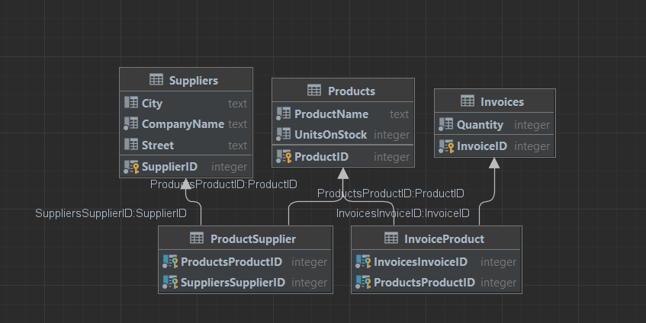

Produkty, które są zawarte w fakturze o ID 1

SELECT P.* FROM Products P  
JOIN InvoiceProduct IP on P.ProductID = IP.ProductsProductID  
JOIN Invoices I on IP.InvoicesInvoiceID = I.InvoiceID  
WHERE I.InvoiceID = 1;

Faktury, które zawierają produkty o ID 2

SELECT I.* FROM Invoices I  
JOIN InvoiceProduct IP on I.InvoiceID = IP.InvoicesInvoiceID  
JOIN Products P on P.ProductID = IP.ProductsProductID  
WHERE P.ProductID = 2;

5.

internal class Company

{

[Key]

public int CompanyID { get; set; }

public string CompanyName { get; set; }

public string Street { get; set; }

public string City { get; set; }

public string ZipCode { get; set; }

}

internal class Customer : Company

{

public float Discount;

}

internal class Supplier : Company

{

public string BankAccountNumber;

public List<Product> Products { get; } = new();

}

class Program

{

public static void Main(string[] args)

{

ProductContext productContext = new ProductContext();

List<Product> products = new();

products.Add(new Product("Yogurt", 2137));

products.Add(new Product("Beer", 50));

products.Add(new Product("Hard drugs", 3));

List<Invoice> invoices = new();

invoices.Add(new Invoice(1));

invoices.Add(new Invoice(4));

Supplier supplier = new Supplier()

{

CompanyName = "Krakow Trans",

Street = "Jasnogorska 333",

City = "Czestochowa",

ZipCode = "21-370",

BankAccountNumber = "000000"

};

Customer customer = new Customer()

{

CompanyName = "Krowodrza Pirates",

Street = "Krowoderska 100",

City = "Mszana Dolna",

ZipCode = "34-730",

Discount = .2f

};

products[0].Invoices.Add(invoices[0]);

products[1].Invoices.Add(invoices[0]);

products[1].Invoices.Add(invoices[1]);

products[2].Invoices.Add(invoices[1]);

invoices[0].Products.Add(products[0]);

invoices[0].Products.Add(products[1]);

invoices[1].Products.Add(products[1]);

invoices[1].Products.Add(products[2]);

foreach (Product product in products)

{

supplier.Products.Add(product);

product.Suppliers.Add(supplier);

productContext.Products.Add(product);

}

foreach (Invoice invoice in invoices)

{

productContext.Invoices.Add(invoice);

}

productContext.Suppliers.Add(supplier);

productContext.Customers.Add(customer);

productContext.SaveChanges();

}

}



6.

Projekt nie zmienił się oprócz zmiany ProductsContext

internal class ProductContext : DbContext

{

public DbSet<Product> Products { get; set; }

public DbSet<Invoice> Invoices { get; set; }

public DbSet<Company> Companies { get; set; }

public DbSet<Supplier> Suppliers { get; set; }

public DbSet<Customer> Customers { get; set; }

protected override void OnModelCreating(ModelBuilder modelBuilder)

{

base.OnModelCreating(modelBuilder);

modelBuilder.Entity<Company>().UseTpcMappingStrategy();

}

protected override void OnConfiguring(DbContextOptionsBuilder optionsBuilder)

{

base.OnConfiguring(optionsBuilder);

optionsBuilder.UseSqlite("Datasource=ProductsDatabase");

}

}



Różnica między Table per Hierarchy a Table per Type jest taka, że przy pierwszej opcji tworzona jest jedna wspólna tabela dla wszystkich klas dziedziczącej po klasie bazowej.