User Manual



A close up of a sign

Description generated with very high confidence

Contents

Contents 2

Table of Figures 2

1.Introduction 3

2. Getting Started 3

2.1 First Time Launch 3

2.2 Starting the application 3

3. Application Features 4

3.1 Main Menu 4

3.2 Play and Selection of Levels 5

3.3 New Equation 6

3.4 Submitting the Answer 7

3.2 Practise Level 8

3.5 Statistics 8

3.6 Custom Lists 9

3.6.1 Naming the list 9

3.6.2 Adding comments 10

3.6.3 Adding Equations 11

3.7 Helper Mascot (Tāhi) 12

Table of Figures

Figure 1: Main Menu 3

Figure 2: Main Menu 4

Figure 4: Start 5

Figure 5: Inserting Custom List 5

Figure 3: Levels 5

Figure 6: Equation Display 6

Figure 7 : Exit Pop-up 6

Figure 8: Second Incorrect Answer 7

Figure 9: Statistics 8

Figure 10 Custom Lists 9

Figure 11: Naming lists 9

Figure 12: Comments on Lists 10

Figure 13: Adding Equations 11

Figure 14: Help Button 12

Figure 15: Helper Mascot Tāhi 12

1.Introduction

Welcome to the user manual for Tātai, a math learning aid designed for children between the ages of 7-10 who are native Maori speakers.

This manual introduces the application and a step-by-step guide on how to set-up and run Tātai.

2. Getting Started

2.1 First Time Launch

The following packages are required to run Tatai:

* FFmpeg
* Aplay
* Java 8
* Java FX – 8.0.141
* HTK (voice recognition software)

To install these packages, open the terminal in Linux and enter the following commands:

* sudo apt-get install ffmpeg
* sudo apt-get install oracle-java8-installer
* sudo apt-get install aplay

Make sure that when installing Oracle Java 8, it includes the package, Java FX 8.0.141. In the supplied zip file there should be a “HMMs” and “user” folder which both belong HTK. There should also be a “Recout.mlf” file. These files/folders should all be in the same level as the runnable Tātai jar.

2.2 Starting the application

Extract the zip file into an empty folder. The zip file should contain all the required files to make the application run correctly, a README file, and Tatai.jar to run the application.

1. 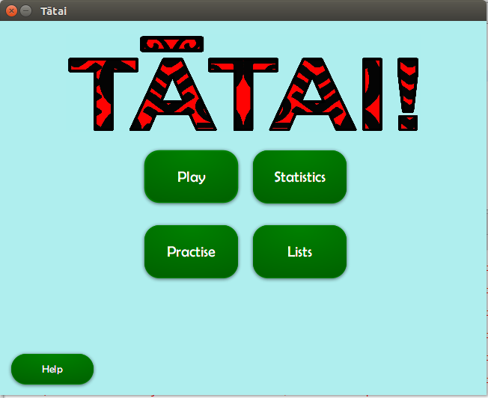Open the terminal in linux.
2. Change the location of the directory to the directory of Tatai.jar.
3. In the terminal type the following:

Java -jar Tatai.jar 2>/dev/null. If all the

Instructions have been followed correctly the screen shown by *Figure 1* will appear.

Figure 1: Main Menu

3. Application Features

3.1 Main Menu



3

1

4

2

5

Figure 2: Main Menu

1. Pressing the play button will take the user to the level page where they can select to play from “Easy”, “Medium”, “Hard” or “Custom” levels.
2. This is the statistics button. It will open the statistics page which has all the scores from the current and previous games.
3. This is the practise button. It takes the user to the starting page for the practise level.
4. The List button is for the user to generate their own custom lists. They click this button if they would like to create new lists, edit old ones or delete existing ones.
5. This button brings up our helper mascot, Tāhi. Tāhi leads the user around the screen and introduces different features. More information about Tāhi can be found later in the user manual.

3.2 Play and Selection of Levels

Upon selecting the “Play” button from the “Main Menu” page, the screen changes to the “Levels” page. On this page the user can choose between the four levels: “Easy”, “Medium”, “Hard” or “Custom”. Each level has 10 questions. Clicking the “Easy” button will take the user to the scene shown by *Figure 4*. Clicking “Medium” or “Hard” will take the user to a similar screen. Clicking “Custom” will take the user to the scene shown by *Figure 5.*

Figure 3: Levels

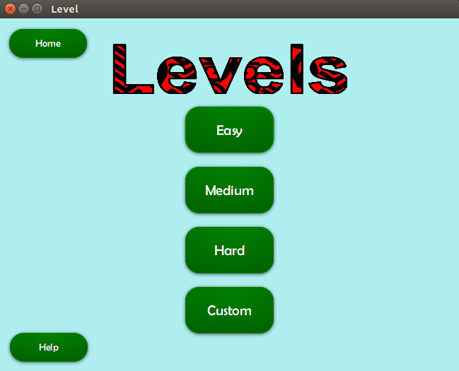

1

2

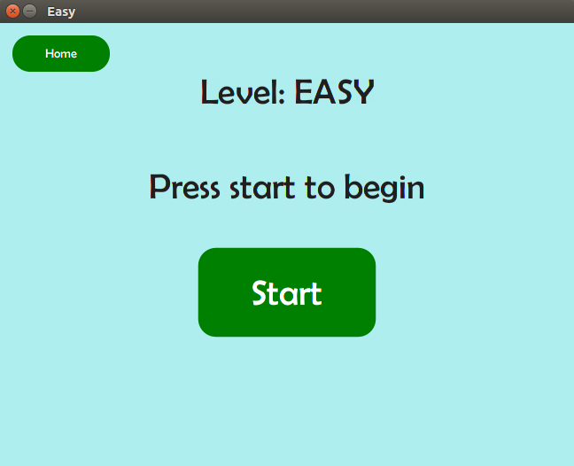

Figure 4: Start

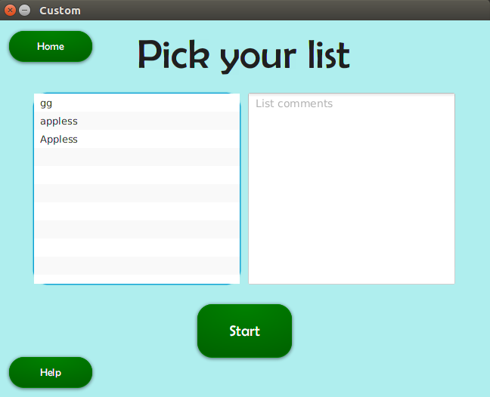

Figure 5: Inserting Custom List

Easy: The questions will be automatically generated equations where the answer is between 1-9. Operations include addition and subtraction.

Medium: The questions will be automatically generated equations where the answer is between 1-99. Operations include addition and subtraction.

Hard: The questions will be automatically generated equations where the answer is between 1-99 for addition, subtraction and multiplication operations or 1-9 for division operations.

Custom: Allows the user to select and play any list that they have created.

1. The “Home” button takes the user back to the “Main Menu” page.
2. The “Help” button shows Tāhi, the helper mascot, who leads the user around the screen, introducing the different features. Please refer to 3.7 Helper Mascot Tāhi.

3.3 New Equation

Upon clicking the “Start” button, the user will be taken to the screen shown in *Figure 6*.

Question number indicator

Score indicator

Level indicator



1

A screenshot of a cell phone

Description generated with very high confidence

2

4

3a

3b

Figure 6: Equation Display

1. This is the “Home” button which allows the user to quit mid-game. After clicking it, a pop-up will appear as seen in *Figure 7.* The pop-up will ask the user if they’re sure they wish to exit and that all progress will be lost if they choose to leave. Clicking “Yes” will take the user back to the “Main menu” page and the pop-up will close. Clicking “No” will close the pop-up and the user may resume playing.

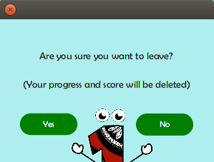

Figure 7 : Exit Pop-up

1. This is where the question is shown. Depending on the level, the equations and their operations will differ.

3a. These are the buttons for answering the question. After loading a new question, the “Play” and “Submit” buttons will be disabled (As in *4a*). To answer the user needs to hold the “Record” button and say their answer while the button is still held down. Once the recording has been successfully made, the buttons “Play” and “Submit” will be available (As in *3b*.)

3b. The user will be able to hear the recording they have just made by pressing the “Play” button. If they are happy with their recording, the user may press the “Submit” button to submit their recording for answer checking. Otherwise, if they are unhappy, they may choose to record again by pressing “Record” again.

1. Please refer to 3.7 Helper Mascot Tāhi

3.4 Submitting the Answer

When the user clicks “Submit”, the recording is checked to see if it is correct. The user has two chances to submit the correct answer.

If the answer is correct, then the scene shown in *Figure 8* will appear. The user will be able to see the correct answer along with their recorded answer. They can then choose to hear their recording again or move on to the next question. The question number and score will then increase by one.

If it is incorrect the first time, the scene shown in *Figure 9* will appear and the user will be able to see what the application recorded them saying and choose to retry the same question.

If it is incorrect the second time, the scene shown in *Figure 10* will appear. The user will be able to see their answer and the correct answer. Once they click “Next”, a new question will appear and question number will increase by one.

Any time during a game, if the user chooses to quit they will lose their current score.

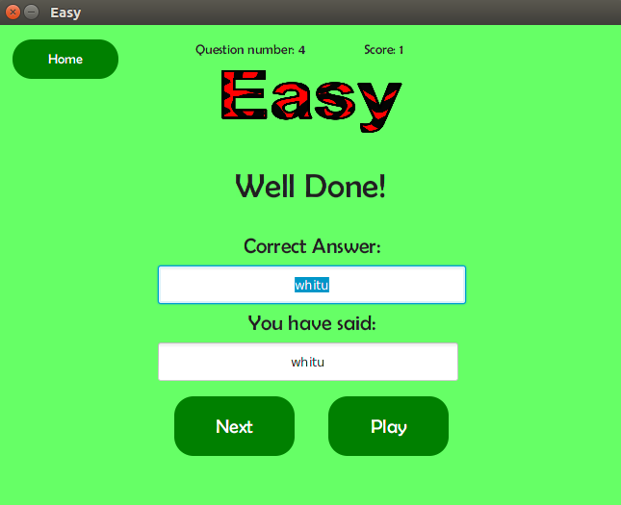

Figure 8: Correct Answer

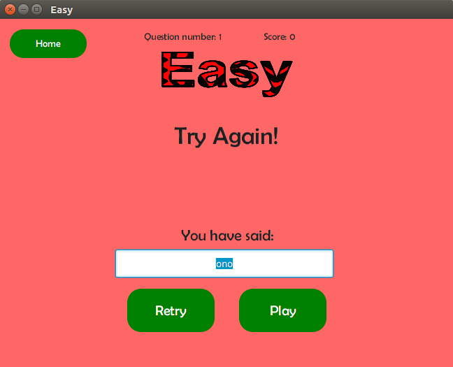

Figure 9: First Incorrect Answer

Figure 8: Second Incorrect Answer

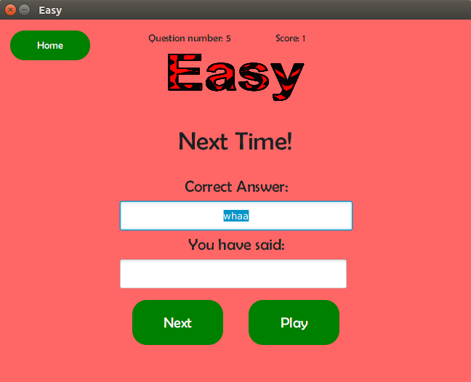

3.2 Practise Level

The practise level is essentially the same as the “Play” option. However instead of the question being an equation, it will instead be a single number from 1-99. The purpose of practise is for the user to practice their pronunciation and help the user learn how to use application.

3.5 Statistics

The “Statistics” scene as shown by *Figure 11* shows the user the past scores that they have achieved. If the user has played the game previously then previous scores will also show up on this page.

A screenshot of a cell phone

Description generated with very high confidence

3

2

1

Figure 9: Statistics

1. This is the tab bar which allows the user to see the statistics of different levels. When the user changes tabs, the graph, average score and high score will display accordingly.
2. This displays the average score and the high score from all the games played. This includes all previously played sessions.
3. This graph shows the scores of the last 10 played games. However, scores are only recorded here once a game is complete. Games which have been exited before completion are not added to this graph. On the Y-axis it indicates the score received in the game.

Please refer to 3.7 Helper Mascot Tātai for instructions on the help button.

3.6 Custom Lists

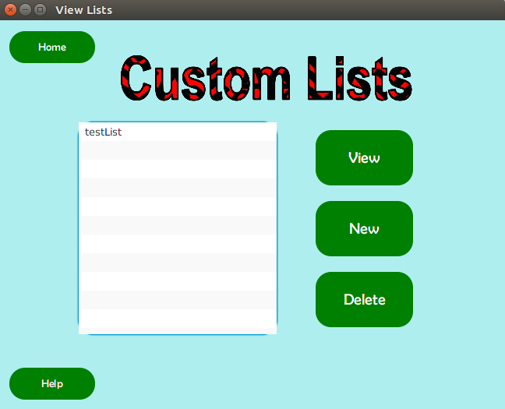

Figure 10 Custom Lists

Seen in *Figure 12* is the page shown when the user clicks the “Lists” button on the “Main menu” page. In Tātai, users may create their own lists of questions and play those questions through the custom level button on the level page. They may use either addition, subtraction, multiplication or division operands. However, the answer must still be a whole number between 1 and 99.

The following steps will guide the user on how to create a new custom list of equations.

1. To view a list, select its name and then click the “View” button.
2. To create a new list, click the “New” button.
3. To delete a list, select a list and then click the “Delete” button. A pop-up will then open asking the user to confirm the deletion. If they select the “Yes” button, the list will be removed and the pop-up will close. Otherwise if the user clicks the “No” button, the pop-up will close and the list will not be deleted.
   * 1. Naming the list

After clicking the “View” or “Edit” button on the “Custom Lists” page, the scene shown by *Figure 13* will appear. In this scene the user can choose the name of the list. Without a name, it is not possible to save the list to the program. In addition the name must follow a number of rules. The name of the list can only consist of alphabets, numbers, underscores or dashes. It also cannot be the same name as a previously made list.

Figure 11: Naming lists

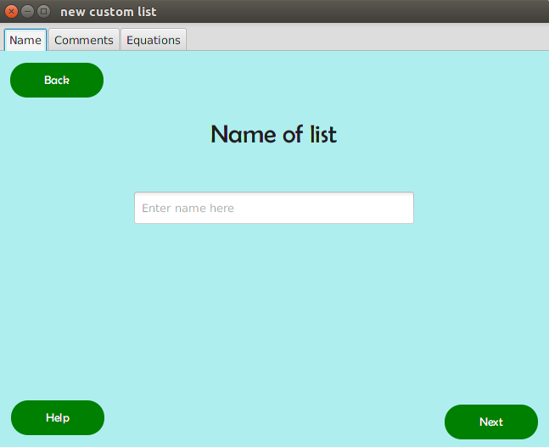

3

1

2

1. Clicking this button will cause the scene to switch back to the “Custom Lists” scene (*Figure 13*).
2. This is the text field where the user may enter the name of the list.
3. Clicking this button will cause the scene to switch to the scene of the next tab which is to add comments to the list (*Figure 14*).
   * 1. Adding comments

The scene shown by *Figure 14* is where the user may enter comments about the list. These comments are optional and are intended to provide the user extra information about the list.

Figure 12: Comments on Lists

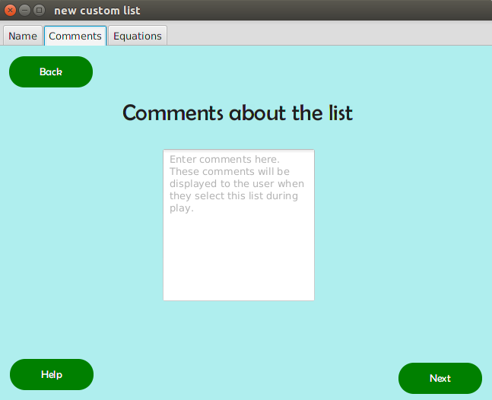

1

3

2

1. Clicking this button will take the user back to the scene shown by *Figure 12*.
2. In this text area is where the user can enter any comments that are related to the list. This can be notes from the teacher indicating what kind of questions this list consists of, or simply something to remind the user about equations that this list contains for example.
3. This button will take the user to the page where they can add equations to the custom list as seen by *Figure 15*.
   * 1. Adding Equations

The scene shown by *Figure 15* is where the user may add equations to the list. The list must contain at least one equation in order to be creates successfully.

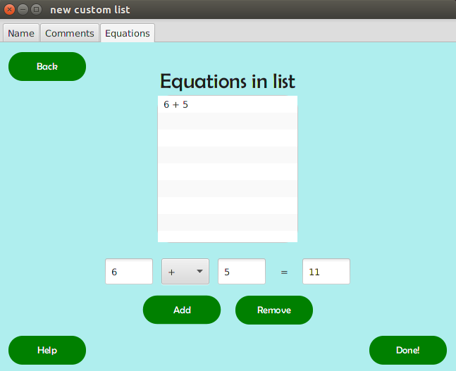

3

2

4

6

5

Figure 13: Adding Equations

1

1. Clicking this button will take the user back to the scene shown by *Figure 12*.
2. This is where all of the equations which have been added to the list are shown.
3. This is where the user can create custom equations. To create a custom equation, the user must enter a number each into the two separate text fields on the left. They must also select an operand from the drop-down list. The text field to the right is where the answer to the equation will appear once the user clicks the “Add” button.
4. Once the user is satisfied with their equation, they may click the “Add” button to add it to the list. Upon clicking “Add” the answer to the equation will appear. If the answer is not a whole number between 1 and 99 or already exists in the list then the equation will not be accepted. If the equation is accepted then the list showing all the equations will update accordingly.
5. If an equation is selected and this button is clicked then the selected equation will be removed from the list. In addition the list showing all the equations will update accordingly.
6. Once the user have is satisfied with the list they can click the “Done” button to save the list and return to the “Custom List” scene as shown by *Figure 12*.

A screenshot of a cell phone

Description generated with high confidence3.7 Helper Mascot (Tāhi)

Figure 14: Help Button

On every page (except for the start page), there is a help button on the lower left corner as seen in *Figure 16*.

A close up of text on a white background

Description generated with high confidence

Figure 15: Helper Mascot Tāhi

If at any point the user requires assistance about the functionality of the buttons, they may click on the “Help” button and the program’s helper mascot Tāhi, will appear.

Tāhi will point to different sections of the page and introduce all the features. Tāhi has a speech bubble that contains instructions on how to use Tātai.

There is a small “Next” button in the bottom right corner of his speech bubble that changes the text. Once all the instructions are given, a “Done” button will appear and that will cause Tāhi to disappear.