**SPRAWOZDANIE**

Zajęcia: Grafika komputerowa

Prowadzący: prof. dr hab. Vasyl Martsenyuk

**Laboratorium II**

Data

**Temat: Podstawy Three.js**

**Wariant 8 + 4**

Jakub Bąk

Informatyka I stopień,

stacjonarne,

4 semestr,

Gr.3b

# Polecenie

Celem jest konstruowanie złożonego modelu za pomocą three.js - animowanej karuzeli (podstawa karuzeli jest wielokątem odpowiednio z konfiguracją zadania) i co najmniej jednego innego wybranego modelu (patrz Fig.). Pliki do pobrania znajdują się poniżej. Głównym plikiem jest lab9.html. Podfolder zasobów resources zawiera dwa pliki JavaScript używane przez program oraz model konia, którego używamy w karuzeli. Zawiera również kilka plików graficznych, które można wykorzystać jako tekstury

# Wyniki zadania:

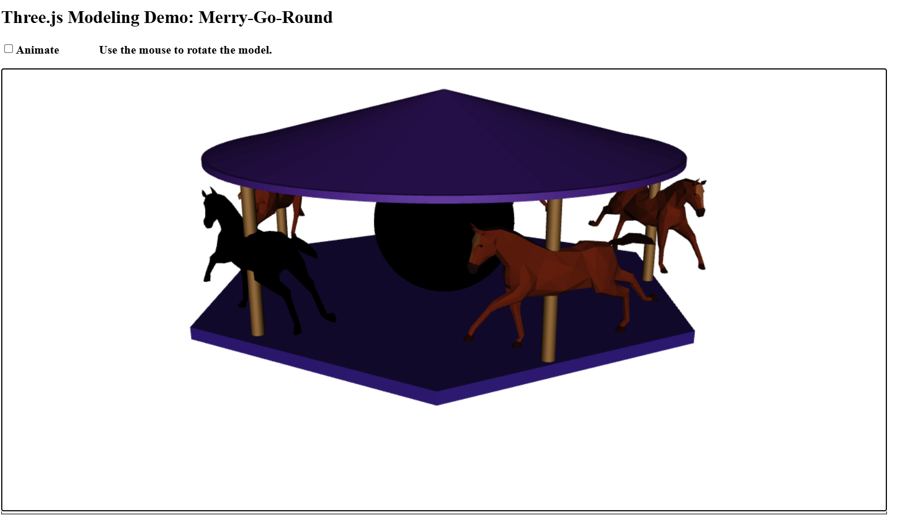

# Wykorzystane komendy:

Link do github: <https://github.com/Szeladin/grafika.git>

Kod Programu:

1. <!DOCTYPE html>

2. <head>

3. <meta charset="UTF-8">

4. <title>9</title>

5. <script src="https://cdn.jsdelivr.net/npm/three@0.115/build/three.js"></script>

6. <script src="https://cdn.jsdelivr.net/npm/three@0.115/examples/js/controls/OrbitControls.js"></script>

7. <script src="https://cdn.jsdelivr.net/npm/three@0.115/examples/js/loaders/GLTFLoader.js"></script>

8. <script>

9.

10. "use strict";

11.

12. var canvas, renderer, scene, camera;

13.

14. var controls;

15.

16. var animating = false;

17. var frameNumber = 0;

18.

19. var floor;

20. var pole1,pole2,pole3,pole4,pole5;

21. var pivot1,pivot2,pivot3,pivot4,pivot5;

22. var roof;

23. var roof2;

24. var k1,k2,k3,k4,k5,k6;

25.

26. function render() {

27. renderer.render(scene, camera);

28. }

29.

30. function createWorld() {

31.

32. renderer.setClearColor("white");

33. scene = new THREE.Scene();

34.

35. camera = new THREE.PerspectiveCamera(30, canvas.width/canvas.height, 0.1, 100);

36. camera.position.z = 40;

37. camera.position.y = 20;

38. var light;

39. light = new THREE.DirectionalLight();

40. light.position.set(0,0,1);

41. camera.add(light);

42. scene.add(camera);

43.

44. floor = new THREE.Mesh(

45. new THREE.CylinderGeometry(13.5,13.5,0.6,6,1),

46. new THREE.MeshPhongMaterial({

47. color: 0x331c84,

48. specular: 0x222222,

49. shininess: 16,

50. shading: THREE.FlatShading

51. })

52. );

53. floor.rotation.y = Math.PI/12;

54. scene.add(floor);

55.

56. var geometry = new THREE.SphereGeometry( 3.7, 32, 32 );

57. var material = new THREE.MeshBasicMaterial( { map: new THREE.TextureLoader().load('resources/earth.jpg') });

58. var sphere = new THREE.Mesh(geometry, material);

59. sphere.position.y=3.8;

60. scene.add(sphere);

61.

62. pole1 = new THREE.Mesh(

63. new THREE.CylinderGeometry(0.3,0.3,7.5,30,1),

64. new THREE.MeshPhongMaterial({

65. color: 0x7c5426,

66. specular: 0x222222,

67. shininess: 8,

68. shading: THREE.FlatShading

69. })

70. );

71. pole1.position.x=11.2;

72. pole1.position.y=3.9;

73. pole1.position.z=0.55;

74. pole1.rotation.y = Math.PI/12;

75. scene.add(pole1);

76.

77. pole2 = new THREE.Mesh(

78. new THREE.CylinderGeometry(0.3,0.3,7.5,30,1),

79. new THREE.MeshPhongMaterial({

80. color: 0x7c5426,

81. specular: 0x222222,

82. shininess: 8,

83. shading: THREE.FlatShading

84. })

85. );

86. pole2.position.x=-9.5;

87. pole2.position.y=3.9;

88. pole2.position.z=6.2;

89. pole2.rotation.y = Math.PI/12;

90. scene.add(pole2);

91.

92. pole3 = new THREE.Mesh(

93. new THREE.CylinderGeometry(0.3,0.3,7.5,30,1),

94. new THREE.MeshPhongMaterial({

95. color: 0x7c5426,

96. specular: 0x222222,

97. shininess: 8,

98. shading: THREE.FlatShading

99. })

100. );

101. pole3.position.x=2.95;

102. pole3.position.y=3.9;

103. pole3.position.z=11;

104. pole3.rotation.y = Math.PI/12;

105. scene.add(pole3);

106.

107. pole4 = new THREE.Mesh(

108. new THREE.CylinderGeometry(0.3,0.3,7.5,30,1),

109. new THREE.MeshPhongMaterial({

110. color: 0x7c5426,

111. specular: 0x222222,

112. shininess: 8,

113. shading: THREE.FlatShading

114. })

115. );

116. pole4.position.x=4;

117. pole4.position.y=3.9;

118. pole4.position.z=-10.5;

119. pole4.rotation.y = Math.PI/12;

120. scene.add(pole4);

121.

122.

123. pole5 = new THREE.Mesh(

124. new THREE.CylinderGeometry(0.3,0.3,7.5,30,1),

125. new THREE.MeshPhongMaterial({

126. color: 0x7c5426,

127. specular: 0x222222,

128. shininess: 8,

129. shading: THREE.FlatShading

130. })

131. );

132. pole5.position.x=-8.7;

133. pole5.position.y=3.9;

134. pole5.position.z=-7.1;

135. pole5.rotation.y = Math.PI/12;

136. scene.add(pole5);

137.

138. roof = new THREE.Mesh(

139. new THREE.CylinderGeometry(0.1,12,3,30,1),

140. new THREE.MeshPhongMaterial({

141. color: 0x441c84,

142. specular: 0x222222,

143. shininess: 8,

144. shading: THREE.FlatShading

145. })

146. );

147. roof.position.y=9.1;

148. scene.add(roof);

149.

150. roof2 = new THREE.Mesh(

151. new THREE.CylinderGeometry(12,12,0.3,200,1),

152. new THREE.MeshPhongMaterial({

153. color: 0x441c84,

154. specular: 0x222222,

155. shininess: 8,

156. shading: THREE.FlatShading

157. })

158. );

159. roof2.position.y=7.5;

160. scene.add(roof2);

161.

162. var loader = new THREE.GLTFLoader();

163.

164. var horse1 = loader.load( 'https://threejs.org/examples/models/gltf/Horse.glb', function ( gltf ) {

165. gltf.scene.scale.multiplyScalar( 0.03 );

166. gltf.scene.position.x = 11;

167. gltf.scene.position.z = 1;

168. gltf.scene.position.y = 1;

169. gltf.scene.traverse(function (child) {

170. if (child.isMesh) {

171. child.material = new THREE.MeshStandardMaterial({ color: 0xff0000 });

172. }

173. });

174. scene.add( gltf.scene );

175. });

176.

177. var horse2 = loader.load( 'https://threejs.org/examples/models/gltf/Horse.glb', function ( gltf ) {

178. gltf.scene.scale.multiplyScalar( 0.03 );

179. gltf.scene.position.x =3;

180. gltf.scene.position.z = 11;

181. gltf.scene.position.y = 1;

182. gltf.scene.rotation.y = -1;

183. scene.add( gltf.scene );

184. });

185.

186. var horse3 = loader.load( 'https://threejs.org/examples/models/gltf/Horse.glb', function ( gltf ) {

187.

188. gltf.scene.scale.multiplyScalar( 0.03 );

189. gltf.scene.position.x =4;

190. gltf.scene.position.z = -10.5;

191. gltf.scene.position.y = 1;

192. gltf.scene.rotation.y = 1.2;

193. scene.add( gltf.scene );

194. });

195. var horse4 = loader.load( 'https://threejs.org/examples/models/gltf/Horse.glb', function ( gltf ) {

196. gltf.scene.scale.multiplyScalar( 0.03 );

197. gltf.scene.position.x =-10;

198. gltf.scene.position.z = 6;

199. gltf.scene.position.y = 1;

200. gltf.scene.rotation.y = -2.5;

201. scene.add( gltf.scene );

202. });

203. var horse5 = loader.load( 'https://threejs.org/examples/models/gltf/Horse.glb', function ( gltf ) {

204. gltf.scene.scale.multiplyScalar( 0.03 );

205. gltf.scene.position.x =-9;

206. gltf.scene.position.z = -7;

207. gltf.scene.position.y = 1;

208. gltf.scene.rotation.y = -3.5;

209. scene.add( gltf.scene );

210. });

211.

212.

213.

214. var box1 = new THREE.Box3().setFromObject(pole1,horse1);

215. var box2 = new THREE.Box3().setFromObject(pole2);

216. var box3 = new THREE.Box3().setFromObject(pole3);

217. var box4 = new THREE.Box3().setFromObject(pole4);

218. var box5 = new THREE.Box3().setFromObject(pole5);

219.

220. box1.center( pole1.position );

221. box2.center( pole2.position );

222. box3.center( pole3.position );

223. box4.center( pole4.position );

224. box5.center( pole5.position );

225.

226. pivot1 = new THREE.Group();

227. pivot2 = new THREE.Group();

228. pivot3 = new THREE.Group();

229. pivot4 = new THREE.Group();

230. pivot5 = new THREE.Group();

231.

232. scene.add(pivot1);

233. scene.add(pivot2);

234. scene.add(pivot3);

235. scene.add(pivot4);

236. scene.add(pivot5);

237.

238.

239. pivot1.add(pole1);

240. pivot2.add(pole2);

241. pivot3.add(pole3);

242. pivot4.add(pole4);

243. pivot5.add(pole5);

244. pivot3.add(horse1);

245.

246. }

247.

248. function updateForFrame() {

249.

250. floor.rotation.y += 0.01;

251. roof.rotation.y += 0.01;

252. roof2.rotation.y += 0.01;

253.

254. pivot1.rotation.y += 0.01;

255. pivot2.rotation.y += 0.01;

256. pivot3.rotation.y += 0.01;

257. pivot4.rotation.y += 0.01;

258. pivot5.rotation.y += 0.01;

259.

260. }

261.

262. function installOrbitControls() {

263. controls = new THREE.OrbitControls(camera,canvas);

264. controls.noPan = true;

265. controls.noZoom = true;

266. controls.staticMoving = true;

267. function move() {

268. controls.update();

269. if (! animating) {

270. render();

271. }

272. }

273. function down() {

274. document.addEventListener("mousemove", move, false);

275. }

276. function up() {

277. document.removeEventListener("mousemove", move, false);

278. }

279. function touch(event) {

280. if (event.touches.length == 1) {

281. move();

282. }

283. }

284. canvas.addEventListener("mousedown", down, false);

285. canvas.addEventListener("touchmove", touch, false);

286. }

287.

288. function doAnimateCheckbox() {

289. var run = document.getElementById("animateCheckbox").checked;

290. if (run != animating) {

291. animating = run;

292. if (animating) {

293. requestAnimationFrame(doFrame);

294. }

295. }

296. }

297.

298. function doFrame() {

299. if (animating) {

300. frameNumber++;

301. updateForFrame();

302. render();

303. requestAnimationFrame(doFrame);

304. }

305. }

306.

307. function init() {

308. try {

309. canvas = document.getElementById("glcanvas");

310. renderer = new THREE.WebGLRenderer({

311. canvas: canvas,

312. antialias: true,

313. alpha: false

314. });

315. }

316. catch (e) {

317. document.getElementById("message").innerHTML="<b>Sorry, an error occurred:<br>" +

318. e + "</b>";

319. return;

320. }

321. document.getElementById("animateCheckbox").checked = false;

322. document.getElementById("animateCheckbox").onchange = doAnimateCheckbox;

323. createWorld();

324. installOrbitControls();

325. render();

326. }

327.

328. </script>

329. </head>

330. <body onload="init()">

331.

332. <h2>Three.js Modeling Demo: Merry-Go-Round</h2>

333.

334. <noscript>

335. <p style="color: #AA0000; font-weight: bold">Sorry, but this page requires JavaScript!</p>

336. </noscript>

337.

338. <p style="color:#AA0000; font-weight: bold" id="message">

339. </p>

340.

341. <p>

342. <label><input type="checkbox" id="animateCheckbox"><b>Animate</b></label>

343. <b style="margin-left:50px">Use the mouse to rotate the model.</b>

344. </p>

345.

346. <div id="canvas-holder" style="float:left; border: thin solid black; background-color: white">

347. <canvas width=1200 height=600 id="glcanvas"></canvas>

348. </div>

349.

350. </body>

351. </html>

352.

# Wnioski:

Three.js jest narzędziem do tworzenia interaktywnych scen 3D w przeglądarce. Dzięki jego szerokim możliwościom, takim jak obsługa geometrii, materiałów, świateł i animacji, można łatwo tworzyć złożone modele, jak np. karuzela w tym projekcie. Biblioteka oferuje również wsparcie dla zaawansowanych funkcji, takich jak ładowanie modeli 3D czy kontrola kamery (OrbitControls), co znacząco ułatwia pracę.