Alexander Szelestey

March 8, 2020

Project 4 – WebGL 3D Project

CMSC 405 6380

**Overview**

For Project 4 I created a unique 3D animated scene composed of WebGL graphics components. The scene includes the use of animation, lighting, texture, and frame buffers and multiple objects.

**Users Guide**

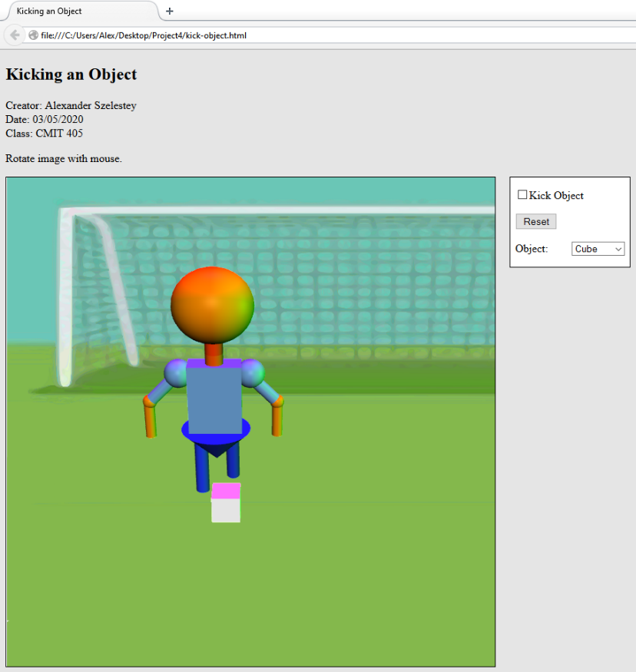 To run this project all you need to do is open “kick-object.html” in a browser that supports WebGL. You have to keep the extensions in the same folder as the HTML file. You will be prompted with a screen that will resemble Figure 1. On the main page I included operation instructions. You can rotate the model with your mouse to see the model kicking the various objects. The objects update instantly so even when the model is kicking you can go through the various objects, even a teapot (Figure 4)! The reset button makes everything return to the same position as shown in Figure 1.

Figure : Initial start up

**Test Case**

|  |  |  |  |  |  |
| --- | --- | --- | --- | --- | --- |
| **Test Case** | **Input** | **Expected Output** | **Actual Output** | **Pass/Fail** | **Figure** |
| 1 | Load “kick-object.html” | A html page is loaded with a very nice figure that’s about to kick an object | A html page is loaded with a very nice figure that’s about to kick an object | Pass | 1 |
| 2 | (Check) “Kick Object | Leg will swing forward and kick object and repeat. | Leg swings forward to kick object and repeats. | Pass |  |
| 3 | (Uncheck) “Kick Object” | Leg and ball will stop moving | Leg and ball stopped moving | Pass | 2 |
| 4 | (Click) “Reset” | Puts model and object back to their starting locations | Puts model and object back to their starting locations | Pass | 3 |
| 5 | Select and object from the combo box | Corresponding object will display. I chose Teapot. | A Teapot was displayed | Pass | 4 |

**Screenshots**

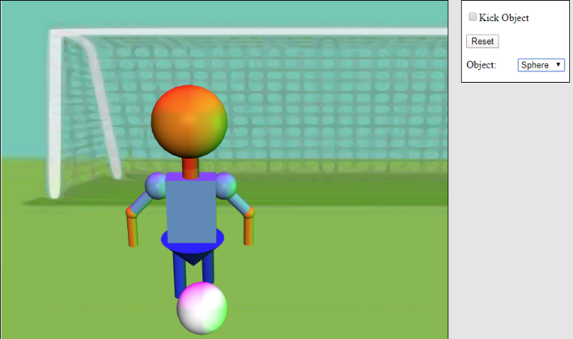

Figure 3: Reset button puts model and object to their starting positions.

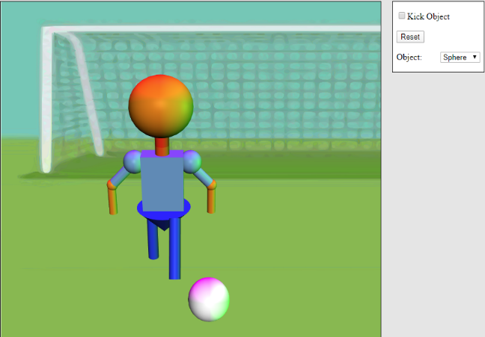

Figure 2: Object will stop anytime “Kick Object” isn’t selected

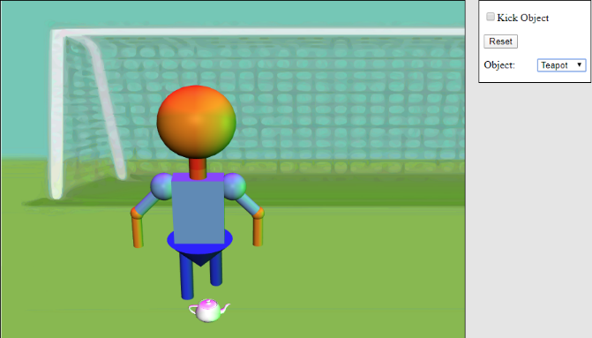

Figure : Selected a Teapot from Object combo box

**Lessons Learned**

Well here we are the last project and I feel proud and disappointed. I am so happy how this program runs and looks. However, I am disappointed in my lack of knowledge on implementing textures correctly. I swear I tried everything to texture the object to look like a soccer ball. I spent two days trying to make it work when I finally read someone’s discussion and it turns out my internet browser was the problem. I switched to a new browser but there was no luck getting my soccer ball pattern on the objects. There was just no luck, it still looks cool because of the lighting on the white-colored object. I wanted to produce a realistic design, but I ran out of time, sadly.

**References:**

10.4 - texture mapping using images¶. (n.d.). Retrieved March 07, 2020, from http://learnwebgl.brown37.net/10_surface_properties/texture_mapping_images.html

Color. (n.d.). Retrieved March 06, 2020, from https://tug.org/pracjourn/2007-4/walden/color.pdf

Colors. (n.d.). Retrieved March 07, 2020, from https://www.color-hex.com/color/ffff00

How can I draw a fullscreen background image in WebGL like sketchfab? (1967, November 01). Retrieved March 07, 2020, from https://stackoverflow.com/questions/48124131/how-can- i-draw-a-fullscreen-background-image-in-webgl-like-sketchfab

WebGL textures. (n.d.). Retrieved March 07, 2020, from https://webglfundamentals.org/webgl/lessons/webgl-3d-textures.html