Alexander Szelestey

February 22, 2020

Project 3 – Three js Project

CMSC 405 6380

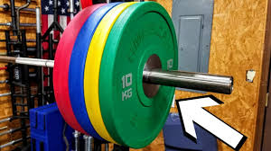**Overview**

Figure 1: Compound plates

This project created a unique 3d animated scene that is composed of Three.js graphic components. The scene is a deadlift platform with a barbell that is loaded with compound plates. Figure 1 is a real-life example.

**Users Guide**

To run this project all you need to do is open “Deadlift” in any browser. You have to keep the extensions in the same folder. You will be prompted with a screen that will resemble Figure 2. On the main page I included operation instructions. You can rotate the model with the arrow keys, pageUp, pageDown, and home key. You can also use your mouse to drag around the image. The bar comes already loaded with weight on it. Then you can click on the Unload radiobutton to watch the animation move the weight off the barbell. If it doesn’t work just click the image. The total animation time should take three seconds. After that you can keep clicking between “Load” and “Unload”.

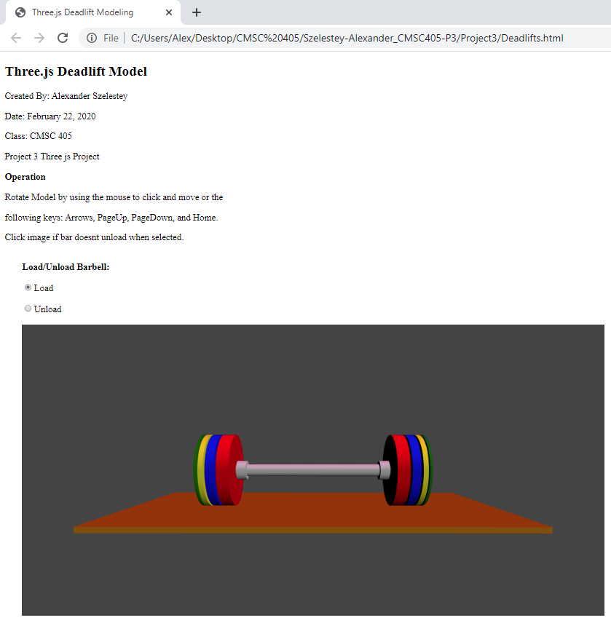

Figure : Main

**Test Case**

|  |  |  |  |  |  |
| --- | --- | --- | --- | --- | --- |
| **Test Case** | **Input** | **Expected Output** | **Actual Output** | **Pass/Fail** | **Figure** |
| 1 | Load “Deadlifts.html” | A html page is loaded with a deadlift platform and a loaded barbell | A html page is loaded with a deadlift platform and a loaded barbell | Pass | 2 |
| 2 | Radiobutton “Unload” | Weights move off the barbell | Weights move off the barbell | Pass | 3 |
| 3 | Radiobutton “Load” | Weight goes back on barbell | Weight goes back on barbell | Pass | 4 |

**Screenshots**

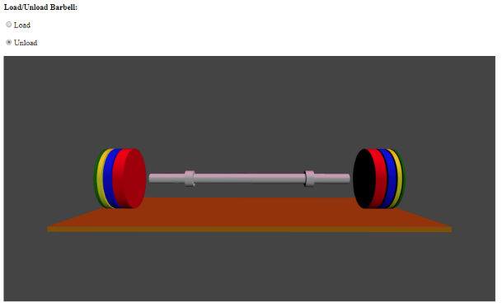

Figure 3: Unload

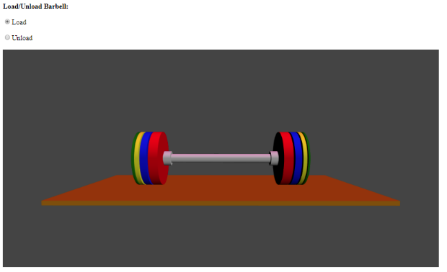

Figure 4: Load

**Lessons Learned**

I learned a ton of stuff! Prior to this week I had no clue what three.js was. I used way more references than I have below, but I included the websites that made the biggest impact. I really went overboard on this project in my opinion. It took me about 64 hours, maybe more. I showed this off to a few friends and they looked at me and said, “That’s it”. Man, if they only knew. But I didn’t know what a tween was or even how to implement it. So, in order to animate I messed around with many options before I finally got tween to work. Lots of trial and errors!! Now I didn’t go overboard on the lighting because I put so much time into making the weights come on and off the bar. I did add in a dim light shining from above and a light to shine in the direction of the camera. I am super happy with my creation and I could tinker with this code for weeks and continue to improve it. Some of the programs written on threejs.org are insane and I just can’t imagine the number of hours that went into some of them.

**References:**

Dmytro, K. (n.d.). Html css color hex #000000black. Retrieved February 20, 2020, from https://www.htmlcsscolor.com/hex/000000

Lee, C. (1962, July 01). How to clone an object3d in Three.js? Retrieved from https://stackoverflow.com/questions/11919694/how-to-clone-an-object3d-in-three-js

Rogue lb competition plates. (2020, January 12). Retrieved February 20, 2020, from https://www.roguefitness.com/rogue-competition-plates

Three.js. (n.d.). Retrieved February 20, 2020, from https://threejs.org/docs/#api/en/geometries/BoxGeometry