**Overview**

An implementation of the **Mediator** pattern for managing air traffic on a single runway. All aircraft interact through the ControlTower, which acts as a centralized dispatcher.

**Key Classes**

**TowerMediator**: mediator interface.

**ControlTower**: concrete mediator that maintains landing and takeoff queues, and handles emergency MAYDAY events.

**Aircraft**: abstract colleague; concrete subclasses PassengerPlane, CargoPlane, and Helicopter implement receive(...).

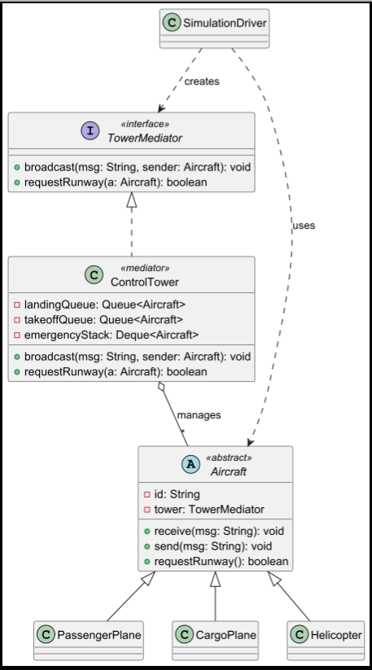**SimulationDriver**: demonstrates normal and emergency requests.

**Puml:**

**s**

**Why use Mediator?**

**Decoupling**: aircraft are unaware of each other — they only communicate with the dispatcher.

**Centralized rules**: priority logic for queues and emergency landings is stored in one place.

**Extensibility**: new aircraft types or rules can be added without modifying colleague code.

**Drawback**

**Mediator growth**: all complexity will accumulate in the ControlTower, which may lead to a large "god" class.

**Run**  
1, 2,  
3 and 4 ….

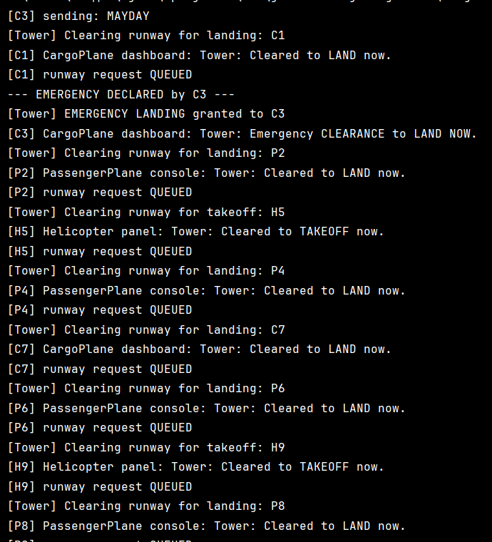Изображение выглядит как текст, снимок экрана, Шрифт

Контент, сгенерированный ИИ, может содержать ошибки.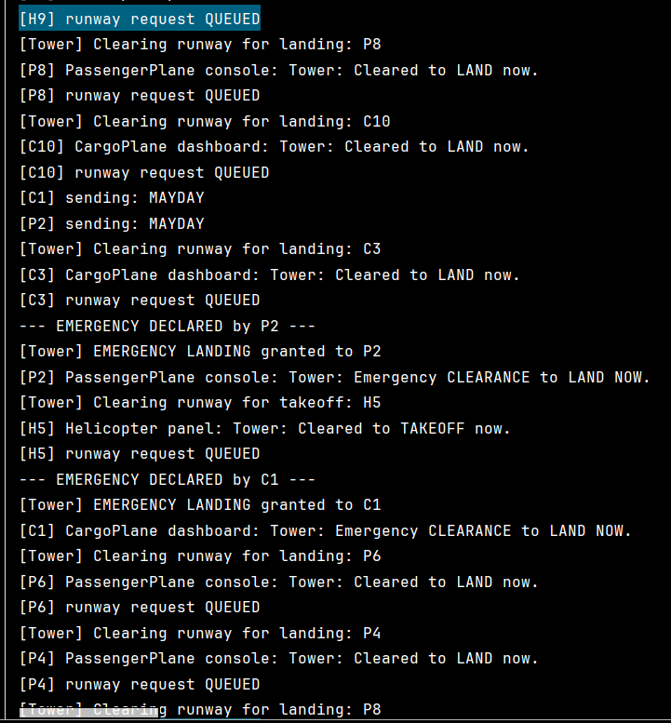Изображение выглядит как текст, снимок экрана, Шрифт

Контент, сгенерированный ИИ, может содержать ошибки.Изображение выглядит как текст, снимок экрана, программное обеспечение, Шрифт

Контент, сгенерированный ИИ, может содержать ошибки.Изображение выглядит как текст, снимок экрана, Шрифт

Контент, сгенерированный ИИ, может содержать ошибки.Изображение выглядит как текст, снимок экрана, Шрифт, программное обеспечение

Контент, сгенерированный ИИ, может содержать ошибки.Изображение выглядит как текст, снимок экрана

Контент, сгенерированный ИИ, может содержать ошибки.Изображение выглядит как текст, снимок экрана, меню

Контент, сгенерированный ИИ, может содержать ошибки.Изображение выглядит как текст, снимок экрана, Шрифт

Контент, сгенерированный ИИ, может содержать ошибки.Изображение выглядит как текст, снимок экрана, Шрифт

Контент, сгенерированный ИИ, может содержать ошибки.Изображение выглядит как текст, снимок экрана, меню, Шрифт

Контент, сгенерированный ИИ, может содержать ошибки.Изображение выглядит как текст, снимок экрана, Шрифт

Контент, сгенерированный ИИ, может содержать ошибки.Изображение выглядит как текст, снимок экрана, программное обеспечение

Контент, сгенерированный ИИ, может содержать ошибки.Изображение выглядит как текст, снимок экрана, программное обеспечение, Шрифт

Контент, сгенерированный ИИ, может содержать ошибки.Изображение выглядит как текст, снимок экрана

Контент, сгенерированный ИИ, может содержать ошибки.Изображение выглядит как текст, снимок экрана, программное обеспечение

Контент, сгенерированный ИИ, может содержать ошибки.Изображение выглядит как текст, снимок экрана, Шрифт

Контент, сгенерированный ИИ, может содержать ошибки.

[C3] sending: MAYDAY

[Tower] Clearing runway for landing: C1

[C1] CargoPlane dashboard: Tower: Cleared to LAND now.

[C1] runway request QUEUED

--- EMERGENCY DECLARED by C3 ---

[Tower] EMERGENCY LANDING granted to C3

[C3] CargoPlane dashboard: Tower: Emergency CLEARANCE to LAND NOW.

[Tower] Clearing runway for landing: P2

[P2] PassengerPlane console: Tower: Cleared to LAND now.

[P2] runway request QUEUED

[Tower] Clearing runway for takeoff: H5

[H5] Helicopter panel: Tower: Cleared to TAKEOFF now.

[H5] runway request QUEUED

[Tower] Clearing runway for landing: P4

[P4] PassengerPlane console: Tower: Cleared to LAND now.

[P4] runway request QUEUED

[Tower] Clearing runway for landing: C7

[C7] CargoPlane dashboard: Tower: Cleared to LAND now.

[C7] runway request QUEUED

[Tower] Clearing runway for landing: P6

[P6] PassengerPlane console: Tower: Cleared to LAND now.

[P6] runway request QUEUED

[Tower] Clearing runway for takeoff: H9

[H9] Helicopter panel: Tower: Cleared to TAKEOFF now.

[H9] runway request QUEUED

[Tower] Clearing runway for landing: P8

[P8] PassengerPlane console: Tower: Cleared to LAND now.

[P8] runway request QUEUED

[Tower] Clearing runway for landing: C10

[C10] CargoPlane dashboard: Tower: Cleared to LAND now.

[C10] runway request QUEUED

[Tower] Clearing runway for landing: C1

[C1] CargoPlane dashboard: Tower: Cleared to LAND now.

[C1] runway request QUEUED

[Tower] Clearing runway for landing: C3

[C3] CargoPlane dashboard: Tower: Cleared to LAND now.

[C3] runway request QUEUED

[Tower] Clearing runway for landing: P2

[P2] PassengerPlane console: Tower: Cleared to LAND now.

[P2] runway request QUEUED

[Tower] Clearing runway for takeoff: H5

[H5] Helicopter panel: Tower: Cleared to TAKEOFF now.

[H5] runway request QUEUED

[Tower] Clearing runway for landing: P4

[P4] PassengerPlane console: Tower: Cleared to LAND now.

[P4] runway request QUEUED

[Tower] Clearing runway for landing: C7

[C7] CargoPlane dashboard: Tower: Cleared to LAND now.

[C7] runway request QUEUED

[Tower] Clearing runway for landing: P6

[P6] PassengerPlane console: Tower: Cleared to LAND now.

[P6] runway request QUEUED

[Tower] Clearing runway for takeoff: H9

[H9] Helicopter panel: Tower: Cleared to TAKEOFF now.

[H9] runway request QUEUED

[Tower] Clearing runway for landing: P8

[P8] PassengerPlane console: Tower: Cleared to LAND now.

[P8] runway request QUEUED

[Tower] Clearing runway for landing: C10

[C10] CargoPlane dashboard: Tower: Cleared to LAND now.

[C10] runway request QUEUED

[C1] sending: MAYDAY

[P2] sending: MAYDAY

[Tower] Clearing runway for landing: C3

[C3] CargoPlane dashboard: Tower: Cleared to LAND now.

[C3] runway request QUEUED

--- EMERGENCY DECLARED by P2 ---

[Tower] EMERGENCY LANDING granted to P2

[P2] PassengerPlane console: Tower: Emergency CLEARANCE to LAND NOW.

[Tower] Clearing runway for takeoff: H5

[H5] Helicopter panel: Tower: Cleared to TAKEOFF now.

[H5] runway request QUEUED

--- EMERGENCY DECLARED by C1 ---

[Tower] EMERGENCY LANDING granted to C1

[C1] CargoPlane dashboard: Tower: Emergency CLEARANCE to LAND NOW.

[Tower] Clearing runway for landing: P6

[P6] PassengerPlane console: Tower: Cleared to LAND now.

[P6] runway request QUEUED

[Tower] Clearing runway for landing: P4

[P4] PassengerPlane console: Tower: Cleared to LAND now.

[P4] runway request QUEUED

[Tower] Clearing runway for landing: P8

[P8] PassengerPlane console: Tower: Cleared to LAND now.

[P8] runway request QUEUED

[Tower] Clearing runway for landing: C7

[C7] CargoPlane dashboard: Tower: Cleared to LAND now.

[C7] runway request QUEUED

[Tower] Clearing runway for landing: C10

[C10] CargoPlane dashboard: Tower: Cleared to LAND now.

[C10] runway request QUEUED

[Tower] Clearing runway for takeoff: H9

[H9] Helicopter panel: Tower: Cleared to TAKEOFF now.

[H9] runway request QUEUED

[Tower] Clearing runway for landing: C1

[C1] CargoPlane dashboard: Tower: Cleared to LAND now.

[C1] runway request QUEUED

[Tower] Clearing runway for landing: C3

[C3] CargoPlane dashboard: Tower: Cleared to LAND now.

[C3] runway request QUEUED

[Tower] Clearing runway for landing: P2

[P2] PassengerPlane console: Tower: Cleared to LAND now.

[P2] runway request QUEUED

[Tower] Clearing runway for takeoff: H5

[H5] Helicopter panel: Tower: Cleared to TAKEOFF now.

[H5] runway request QUEUED

[Tower] Clearing runway for landing: P4

[P4] PassengerPlane console: Tower: Cleared to LAND now.

[P4] runway request QUEUED

[Tower] Clearing runway for landing: C7

[C7] CargoPlane dashboard: Tower: Cleared to LAND now.

[C7] runway request QUEUED

[Tower] Clearing runway for landing: P6

[P6] PassengerPlane console: Tower: Cleared to LAND now.

[P6] runway request QUEUED

[Tower] Clearing runway for takeoff: H9

[H9] Helicopter panel: Tower: Cleared to TAKEOFF now.

[H9] runway request QUEUED

[Tower] Clearing runway for landing: P8

[P8] PassengerPlane console: Tower: Cleared to LAND now.

[P8] runway request QUEUED

[Tower] Clearing runway for landing: C10

[C10] CargoPlane dashboard: Tower: Cleared to LAND now.

[C10] runway request QUEUED

[Tower] Clearing runway for landing: C1

[C1] CargoPlane dashboard: Tower: Cleared to LAND now.

[C1] runway request QUEUED

[C3] sending: MAYDAY

[Tower] Clearing runway for landing: P2

[P2] PassengerPlane console: Tower: Cleared to LAND now.

[P2] runway request QUEUED

--- EMERGENCY DECLARED by C3 ---

[Tower] EMERGENCY LANDING granted to C3

[C3] CargoPlane dashboard: Tower: Emergency CLEARANCE to LAND NOW.

[P6] sending: MAYDAY

[Tower] Clearing runway for landing: P4

[P4] PassengerPlane console: Tower: Cleared to LAND now.

[P4] runway request QUEUED

--- EMERGENCY DECLARED by P6 ---

[Tower] EMERGENCY LANDING granted to P6

[P6] PassengerPlane console: Tower: Emergency CLEARANCE to LAND NOW.

[P8] sending: MAYDAY

[Tower] Clearing runway for takeoff: H5

[H5] Helicopter panel: Tower: Cleared to TAKEOFF now.

[H5] runway request QUEUED

--- EMERGENCY DECLARED by P8 ---

[Tower] EMERGENCY LANDING granted to P8

[P8] PassengerPlane console: Tower: Emergency CLEARANCE to LAND NOW.

[Tower] Clearing runway for landing: C7

[C7] CargoPlane dashboard: Tower: Cleared to LAND now.

[C7] runway request QUEUED

[Tower] Clearing runway for landing: C10

[C10] CargoPlane dashboard: Tower: Cleared to LAND now.

[C10] runway request QUEUED

[Tower] Clearing runway for takeoff: H9

[H9] Helicopter panel: Tower: Cleared to TAKEOFF now.

[H9] runway request QUEUED

[Tower] Clearing runway for landing: C1

[C1] CargoPlane dashboard: Tower: Cleared to LAND now.

[C1] runway request QUEUED

[Tower] Clearing runway for landing: C3

[C3] CargoPlane dashboard: Tower: Cleared to LAND now.

[C3] runway request QUEUED

[Tower] Clearing runway for landing: P2

[P2] PassengerPlane console: Tower: Cleared to LAND now.

[P2] runway request QUEUED

[Tower] Clearing runway for takeoff: H5

[H5] Helicopter panel: Tower: Cleared to TAKEOFF now.

[H5] runway request QUEUED

[Tower] Clearing runway for landing: P4

[P4] PassengerPlane console: Tower: Cleared to LAND now.

[P4] runway request QUEUED

[Tower] Clearing runway for landing: C7

[C7] CargoPlane dashboard: Tower: Cleared to LAND now.

[C7] runway request QUEUED

[Tower] Clearing runway for landing: P6

[P6] PassengerPlane console: Tower: Cleared to LAND now.

[P6] runway request QUEUED

[Tower] Clearing runway for takeoff: H9

[C10] sending: MAYDAY

[H9] Helicopter panel: Tower: Cleared to TAKEOFF now.

[H9] runway request QUEUED

[Tower] Clearing runway for landing: P8

[P8] PassengerPlane console: Tower: Cleared to LAND now.

[P8] runway request QUEUED

--- EMERGENCY DECLARED by C10 ---

[Tower] EMERGENCY LANDING granted to C10

[C10] CargoPlane dashboard: Tower: Emergency CLEARANCE to LAND NOW.

[Tower] Clearing runway for landing: C1

[C1] CargoPlane dashboard: Tower: Cleared to LAND now.

[C1] runway request QUEUED

[Tower] Clearing runway for landing: C3

[C3] CargoPlane dashboard: Tower: Cleared to LAND now.

[C3] runway request QUEUED

[Tower] Clearing runway for landing: P2

[P2] PassengerPlane console: Tower: Cleared to LAND now.

[P2] runway request QUEUED

[Tower] Clearing runway for takeoff: H5

[H5] Helicopter panel: Tower: Cleared to TAKEOFF now.

[H5] runway request QUEUED

[Tower] Clearing runway for landing: P4

[P4] PassengerPlane console: Tower: Cleared to LAND now.

[P4] runway request QUEUED

[Tower] Clearing runway for landing: C7

[C7] CargoPlane dashboard: Tower: Cleared to LAND now.

[C7] runway request QUEUED

[Tower] Clearing runway for landing: P6

[P6] PassengerPlane console: Tower: Cleared to LAND now.

[P6] runway request QUEUED

[Tower] Clearing runway for takeoff: H9

[H9] Helicopter panel: Tower: Cleared to TAKEOFF now.

[H9] runway request QUEUED

[Tower] Clearing runway for landing: P8

[P8] PassengerPlane console: Tower: Cleared to LAND now.

[P8] runway request QUEUED

[Tower] Clearing runway for landing: C10

[C10] CargoPlane dashboard: Tower: Cleared to LAND now.

[C10] runway request QUEUED

[Tower] Clearing runway for landing: C1

[C1] CargoPlane dashboard: Tower: Cleared to LAND now.

[C1] runway request QUEUED

[Tower] Clearing runway for landing: C3

[C3] CargoPlane dashboard: Tower: Cleared to LAND now.

[C3] runway request QUEUED

[Tower] Clearing runway for landing: P2

[P2] PassengerPlane console: Tower: Cleared to LAND now.

[P2] runway request QUEUED

[Tower] Clearing runway for takeoff: H5

[H5] Helicopter panel: Tower: Cleared to TAKEOFF now.

[H5] runway request QUEUED

[Tower] Clearing runway for landing: C7

[C7] CargoPlane dashboard: Tower: Cleared to LAND now.

[C7] runway request QUEUED

[Tower] Clearing runway for landing: P4

[P4] PassengerPlane console: Tower: Cleared to LAND now.

[P4] runway request QUEUED

[Tower] Clearing runway for takeoff: H9

[H9] Helicopter panel: Tower: Cleared to TAKEOFF now.

[H9] runway request QUEUED

[Tower] Clearing runway for landing: C10

[C10] CargoPlane dashboard: Tower: Cleared to LAND now.

[C10] runway request QUEUED

[Tower] Clearing runway for landing: P8

[P8] PassengerPlane console: Tower: Cleared to LAND now.

[P8] runway request QUEUED

[Tower] Clearing runway for landing: P6

[P6] PassengerPlane console: Tower: Cleared to LAND now.

[P6] runway request QUEUED

[Tower] Clearing runway for landing: P2

[P2] PassengerPlane console: Tower: Cleared to LAND now.

[P2] runway request QUEUED

[Tower] Clearing runway for landing: C3

[C3] CargoPlane dashboard: Tower: Cleared to LAND now.

[C3] runway request QUEUED

[Tower] Clearing runway for takeoff: H5

[H5] Helicopter panel: Tower: Cleared to TAKEOFF now.

[H5] runway request QUEUED

[Tower] Clearing runway for landing: P6

[P6] PassengerPlane console: Tower: Cleared to LAND now.

[P6] runway request QUEUED

[Tower] Clearing runway for landing: C7

[C7] CargoPlane dashboard: Tower: Cleared to LAND now.

[C7] runway request QUEUED

[Tower] Clearing runway for landing: P8

[P8] PassengerPlane console: Tower: Cleared to LAND now.

[P8] runway request QUEUED

[Tower] Clearing runway for takeoff: H9

[H9] Helicopter panel: Tower: Cleared to TAKEOFF now.

[H9] runway request QUEUED

[Tower] Clearing runway for landing: C1

[C1] CargoPlane dashboard: Tower: Cleared to LAND now.

[C1] runway request QUEUED

[Tower] Clearing runway for landing: C10

[C10] CargoPlane dashboard: Tower: Cleared to LAND now.

[C10] runway request QUEUED

[Tower] Clearing runway for landing: P4

[P4] PassengerPlane console: Tower: Cleared to LAND now.

[P4] runway request QUEUED

[Tower] Clearing runway for landing: C1

[C1] CargoPlane dashboard: Tower: Cleared to LAND now.

[C1] runway request QUEUED

[Tower] Clearing runway for landing: C3

[C3] CargoPlane dashboard: Tower: Cleared to LAND now.

[C3] runway request QUEUED

[Tower] Clearing runway for takeoff: H5

[H5] Helicopter panel: Tower: Cleared to TAKEOFF now.

[H5] runway request QUEUED

[Tower] Clearing runway for landing: P2

[P2] PassengerPlane console: Tower: Cleared to LAND now.

[P2] runway request QUEUED

[Tower] Clearing runway for landing: P6

[P6] PassengerPlane console: Tower: Cleared to LAND now.

[P6] runway request QUEUED

[Tower] Clearing runway for landing: P4

[P4] PassengerPlane console: Tower: Cleared to LAND now.

[P4] runway request QUEUED

[Tower] Clearing runway for landing: P8

[P8] PassengerPlane console: Tower: Cleared to LAND now.

[P8] runway request QUEUED

[Tower] Clearing runway for landing: C7

[C7] CargoPlane dashboard: Tower: Cleared to LAND now.

[C7] runway request QUEUED

[Tower] Clearing runway for landing: C10

[C10] CargoPlane dashboard: Tower: Cleared to LAND now.

[C10] runway request QUEUED

[Tower] Clearing runway for takeoff: H9

[H9] Helicopter panel: Tower: Cleared to TAKEOFF now.

[H9] runway request QUEUED

[Tower] Clearing runway for landing: C1

[C1] CargoPlane dashboard: Tower: Cleared to LAND now.

[C1] runway request QUEUED

[Tower] Clearing runway for landing: C3

[C3] CargoPlane dashboard: Tower: Cleared to LAND now.

[C3] runway request QUEUED

[Tower] Clearing runway for takeoff: H5

[H5] Helicopter panel: Tower: Cleared to TAKEOFF now.

[H5] runway request QUEUED

[Tower] Clearing runway for landing: P2

[P2] PassengerPlane console: Tower: Cleared to LAND now.

[P2] runway request QUEUED

[Tower] Clearing runway for landing: P6

[P6] PassengerPlane console: Tower: Cleared to LAND now.

[P6] runway request QUEUED

[Tower] Clearing runway for landing: P4

[P4] PassengerPlane console: Tower: Cleared to LAND now.

[P4] runway request QUEUED

[Tower] Clearing runway for landing: P8

[P8] PassengerPlane console: Tower: Cleared to LAND now.

[P8] runway request QUEUED

[Tower] Clearing runway for landing: C7

[C7] CargoPlane dashboard: Tower: Cleared to LAND now.

[C7] runway request QUEUED

[Tower] Clearing runway for landing: C10

[C10] CargoPlane dashboard: Tower: Cleared to LAND now.

[C10] runway request QUEUED

[Tower] Clearing runway for takeoff: H9

[H9] Helicopter panel: Tower: Cleared to TAKEOFF now.

[H9] runway request QUEUED

[Tower] Clearing runway for landing: P2

[P2] PassengerPlane console: Tower: Cleared to LAND now.

[P2] runway request QUEUED

[Tower] Clearing runway for landing: C1

[C1] CargoPlane dashboard: Tower: Cleared to LAND now.

[C1] runway request QUEUED

[Tower] Clearing runway for landing: C3

[C3] CargoPlane dashboard: Tower: Cleared to LAND now.

[C3] runway request QUEUED

[Tower] Clearing runway for takeoff: H5

[H5] Helicopter panel: Tower: Cleared to TAKEOFF now.

[H5] runway request QUEUED

[Tower] Clearing runway for landing: P4

[P4] PassengerPlane console: Tower: Cleared to LAND now.

[P4] runway request QUEUED

[Tower] Clearing runway for landing: C7

[P8] sending: MAYDAY

[C7] CargoPlane dashboard: Tower: Cleared to LAND now.

[C7] runway request QUEUED

[Tower] Clearing runway for landing: P6

[P6] PassengerPlane console: Tower: Cleared to LAND now.

[P6] runway request QUEUED

[Tower] Clearing runway for takeoff: H9

[H9] Helicopter panel: Tower: Cleared to TAKEOFF now.

[H9] runway request QUEUED

--- EMERGENCY DECLARED by P8 ---

[Tower] EMERGENCY LANDING granted to P8

[P8] PassengerPlane console: Tower: Emergency CLEARANCE to LAND NOW.

[Tower] Clearing runway for landing: C10

[C10] CargoPlane dashboard: Tower: Cleared to LAND now.

[C10] runway request QUEUED

[Tower] Clearing runway for landing: P2

[P2] PassengerPlane console: Tower: Cleared to LAND now.

[P2] runway request QUEUED

[Tower] Clearing runway for landing: P4

[P4] PassengerPlane console: Tower: Cleared to LAND now.

[P4] runway request QUEUED

[Tower] Clearing runway for takeoff: H5

[H5] Helicopter panel: Tower: Cleared to TAKEOFF now.

[H5] runway request QUEUED

[Tower] Clearing runway for landing: P6

[P6] PassengerPlane console: Tower: Cleared to LAND now.

[P6] runway request QUEUED

[Tower] Clearing runway for landing: C7

[C7] CargoPlane dashboard: Tower: Cleared to LAND now.

[C7] runway request QUEUED

[Tower] Clearing runway for landing: P8

[P8] PassengerPlane console: Tower: Cleared to LAND now.

[P8] runway request QUEUED

[Tower] Clearing runway for takeoff: H9

[H9] Helicopter panel: Tower: Cleared to TAKEOFF now.

[H9] runway request QUEUED

[Tower] Clearing runway for landing: C10

[C10] CargoPlane dashboard: Tower: Cleared to LAND now.

[C10] runway request QUEUED

[Tower] Clearing runway for landing: C3

[C3] CargoPlane dashboard: Tower: Cleared to LAND now.

[C3] runway request QUEUED

[Tower] Clearing runway for landing: C1

[C1] CargoPlane dashboard: Tower: Cleared to LAND now.

[C1] runway request QUEUED

[Tower] Clearing runway for landing: C1

[C1] CargoPlane dashboard: Tower: Cleared to LAND now.

[C1] runway request QUEUED

[Tower] Clearing runway for landing: C3

[C3] CargoPlane dashboard: Tower: Cleared to LAND now.

[C3] runway request QUEUED

[P4] sending: MAYDAY

[Tower] Clearing runway for takeoff: H5

[H5] Helicopter panel: Tower: Cleared to TAKEOFF now.

[H5] runway request QUEUED

[Tower] Clearing runway for landing: P2

[P2] PassengerPlane console: Tower: Cleared to LAND now.

[P2] runway request QUEUED

[C7] sending: MAYDAY

[Tower] Clearing runway for landing: P6

[P6] PassengerPlane console: Tower: Cleared to LAND now.

[P6] runway request QUEUED

[Tower] Clearing runway for landing: P8

[P8] PassengerPlane console: Tower: Cleared to LAND now.

[P8] runway request QUEUED

[Tower] Clearing runway for takeoff: H9

[H9] Helicopter panel: Tower: Cleared to TAKEOFF now.

[H9] runway request QUEUED

[Tower] Clearing runway for landing: C10

[C10] CargoPlane dashboard: Tower: Cleared to LAND now.

[C10] runway request QUEUED

--- EMERGENCY DECLARED by P4 ---

[Tower] EMERGENCY LANDING granted to P4

[P4] PassengerPlane console: Tower: Emergency CLEARANCE to LAND NOW.

--- EMERGENCY DECLARED by C7 ---

[Tower] EMERGENCY LANDING granted to C7

[C7] CargoPlane dashboard: Tower: Emergency CLEARANCE to LAND NOW.

[Tower] Clearing runway for landing: C1

[C1] CargoPlane dashboard: Tower: Cleared to LAND now.

[Tower] Clearing runway for landing: C3

[C3] CargoPlane dashboard: Tower: Cleared to LAND now.

[C3] runway request QUEUED

[Tower] Clearing runway for landing: P4

[P4] PassengerPlane console: Tower: Cleared to LAND now.

[P4] runway request QUEUED

[Tower] Clearing runway for takeoff: H5

[H5] Helicopter panel: Tower: Cleared to TAKEOFF now.

[H5] runway request QUEUED

[Tower] Clearing runway for landing: P6

[P6] PassengerPlane console: Tower: Cleared to LAND now.

[P6] runway request QUEUED

[C1] runway request QUEUED

[Tower] Clearing runway for landing: C7

[C7] CargoPlane dashboard: Tower: Cleared to LAND now.

[C7] runway request QUEUED

[Tower] Clearing runway for landing: P8

[P8] PassengerPlane console: Tower: Cleared to LAND now.

[P8] runway request QUEUED

[Tower] Clearing runway for landing: P2

[P2] PassengerPlane console: Tower: Cleared to LAND now.

[P2] runway request QUEUED

[Tower] Clearing runway for landing: C10

[C10] CargoPlane dashboard: Tower: Cleared to LAND now.

[C10] runway request QUEUED

[Tower] Clearing runway for takeoff: H9

[H9] Helicopter panel: Tower: Cleared to TAKEOFF now.

[H9] runway request QUEUED

[Tower] Clearing runway for landing: C1

[C1] CargoPlane dashboard: Tower: Cleared to LAND now.

[C1] runway request QUEUED

--- Simulation ended ---