Review
Technological Innovations and Research Frontiers in Interventional Therapy for Mitral Regurgitation
Shuang Wang^{1†},Aili Wang^{1†},Yuna Huang¹, Jinping Liu ², Bin Wang^{1*}
†The first two authors contributed equally to the study.

¹Department of Cardiovascular Ultrasound, Zhongnan Hospital of Wuhan University, Wuhan 430071, China
²Department of Cardiovascular Surgery, Zhongnan Hospital of Wuhan University, Wuhan 430071, China

Correspondences:
Bin Wang, Department of Cardiovascular Ultrasound, Zhongnan Hospital of Wuhan University, Wuhan University, Wuhan 430071, China.
Email: wangbin87098429@126.com

ORCID:
Shuang Wang: 0009-0004-8148-7152
Bin Wang: 0000-0003-0201-9154

Abstract
Mitral regurgitation (MR) is a common valvular heart disease, and its prevalence is continuously rising with the aging population, posing a serious threat to human health in the advanced stages of the disease. Sole reliance on medication and traditional surgical treatments can no longer meet the therapeutic needs of all patients. Transcatheter interventional therapy is gradually emerging as a new and ideal alternative treatment option. In recent years, the technology for transcatheter interventional treatment of mitral regurgitation has flourished, with expanding indications and a continuous stream of new devices. It has entered the fast lane in the treatment of structural heart disease, showcasing prospects for broad clinical application. This article reviews the key technologies and developmental trends in the current transcatheter interventional treatment of mitral regurgitation, aiming to provide the theoretical basis and rationale for the safe and standardized implementation and promotion of this series of technologies.

Keywords
Mitral regurgitation; Transcatheter intervention; Structural heart disease; Medical devices

Abbreviations and Acronyms
MR, mitral regurgitation; TMVI, Transcatheter mitral valve interventions; TMVr, transcatheter mitral valve repair; TMVR, transcatheter mitral valve replacement; TEER, transcatheter edge-to-edge repair; FDA, Food and Drug Administration; NMPA, National Medical Products Administration; CE,European Conformity; MV, mitral valve; COPD, chronic obstructive pulmonary disease; COAPT, cardiovascular outcomes assessment of the MitraClip percutaneous therapy; EVEREST, Endovascular Valve Edge-to-Edge Repair Study; EXPAND G4, A Post-Market Study Assessment of the Safety and Performance of the MitraClip G4 System; DMR, degenerative mitral regurgitation; FMR, functional mitral regurgitation; AFMR,atrial functional mitral regurgitation; GDMT, guideline-directed medical therapy; LVOT, left ventricular outflow tract; MAC, mitral annular calcification; mPG, mean pressure gradient; NYHA, New York Heart Association; PISA, proximal isovelocity surface area; RF, regurgitant fraction; RVol: regurgitant volume; SLDA,single leaflet device attachment; TTE, transthoracic echocardiography; TEE, transesophageal echocardiography; M-TEER, mitral valve transcatheter edge-to-edge repair; VCW, vena contracta width; 3D: three-dimensional; VCA, vena contracta area; HFH, heart failure hospitalization; KCCQ,Kansas City Cardiomyopathy Questionnaire; STS,Society of Thoracic Surgeons; ViV, valve-in-valve; ViR, valve-in-ring; ViMAC,valve-in-calcified annulus; ESC/EACTS, European Society of Cardiology/European Association for Cardio-Thoracic Surgery; HR, Hazard Ratio; CI: Confidence Interval

1. Introduction
Mitral regurgitation (MR) is a clinically common valvular heart disease that poses a serious threat to human health in its advanced stages. According to statistics [1], the prevalence of MR reaches 9.3% among individuals aged 75 and older in the United States, while hospital-based data in Europe report an MR prevalence of 24.4%, with moderate to severe MR accounting for 5.2%. The prevalence of MR increases significantly with age, and it is estimated that approximately 7.5 million patients in China require interventional treatment for MR [2]. Over two-thirds of patients are ineligible for surgical treatment due to high-risk factors such as advanced age and comorbidities, with a five-year mortality rate as high as 50% [3].
With the rising number of MR cases, pharmacological therapies have proven ineffective in altering disease progression, while traditional surgical repair or replacement cannot be performed on all patients because of underlying comorbidities [4,5]. Transcatheter mitral valve interventions (TMVI) have seen rapidly growing demand due to their advantages, including lower risk, minimal invasiveness, and fewer postoperative complications[6-8]. A comparison of various techniques is presented in Table 1. With technological advancements, the indications for TMVI continue to expand, and innovative devices are constantly emerging [9-13]. TMVI has now become a highly promising procedure in the field of structural heart disease [14-18]. This review provides a comprehensive review of the key technologies and recent advances in transcatheter mitral valve interventions for MR, aiming to promote the safe and standardized application of these techniques and to offer a theoretical foundation and evidence for their role in clinical practice.

Table 1. Comparison Summary of TEER, TMVR, and Annuloplasty
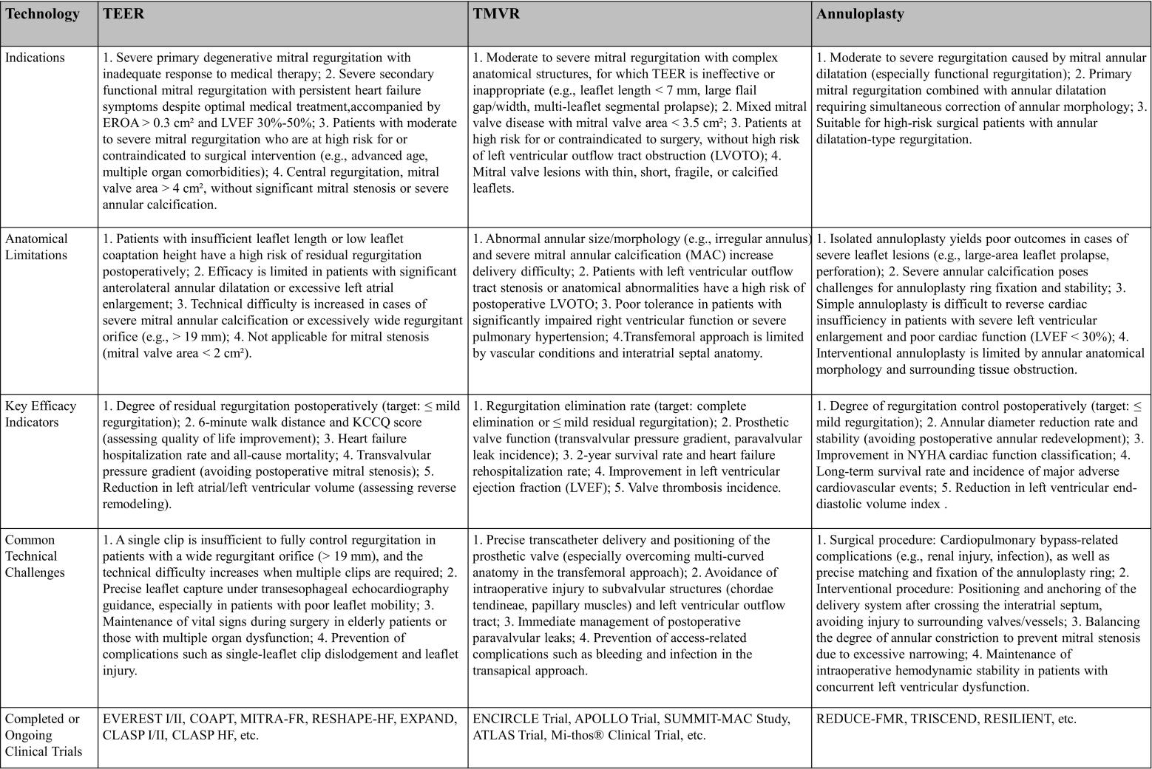
.

2. Transcatheter Mitral Valve Repair
Interventional techniques for MR include two major categories: transcatheter mitral valve repair (TMVr) and transcatheter mitral valve replacement (TMVR) [19-23]. The studies and instruments involved in this article are shown in the graphical abstract. TMVr is further subdivided into transcatheter edge-to-edge repair (TEER), annuloplasty, and artificial chordae repair. Currently, a total of 6 TMVr products have obtained the European Conformity (CE) certification internationally. Among them, TEER products are the most mature, represented by MitraClip and PASCAL, both of which have received CE certification. MitraClip is the only product approved by three authorities: the US Food and Drug Administration (FDA), the China National Medical Products Administration (NMPA), and CE. It is also the most evidence-based, widely used, and mature technology. The historical evolution process of MitraClip is shown in Figure 1 (Fig. 1). In China, two domestic devices, ValveClamp and DragonFly, were approved for marketing by NMPA in 2023.
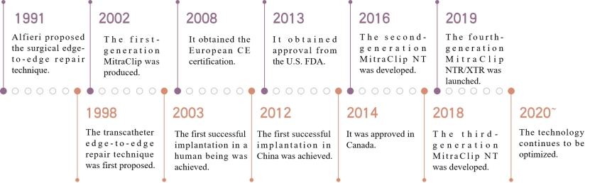
Fig. 1. The historical evolution process of MitraClip.

2.1 TEER Leads in Mitral Valve Interventional Therapy, with Product Iteration Expanding Patient Population and Optimizing Clinical Efficacy
2.1.1 MitraClip Achieves Favorable Safety and Efficacy in Real-World Cohort Studies
Since the first human implantation of MitraClip in 2003, a large number of clinical studies on transcatheter edge-to-edge repair (TEER) have been conducted over the past two decades, continuously verifying its clinical efficacy and expanding patient indications. The Endovascular Valve Edge-to-Edge Repair Study(EVEREST) I [24] and EVEREST II [25] trials have laid the foundation for its clinical application. The EVEREST II trial was a multicenter, randomized study that allocated 279 patients with severe (3+ or 4+) mitral regurgitation (MR) to the MitraClip percutaneous repair group (n=178) or the conventional mitral valve (MV) surgery group (n=80) at a 2:1 ratio, with a 5-year follow-up. The results demonstrated that the surgery group achieved superior outcomes at 5 years in terms of the composite endpoint of "no death, no MV surgery/reoperation, and no severe (3+ or 4+) MR" (64.3% vs. 44.2%, p=0.01), reduction in severe MR (1.8% vs. 12.3%, p=0.02), and lower rates of surgery/reoperation (8.9% vs. 27.9%, p=0.003). However, there was no significant difference in 5-year mortality between the two groups (26.8% vs. 20.8%, p=0.4). Additionally, the incidence of MV dysfunction requiring surgery during the 1-5 year follow-up period was low in both groups (76.2% vs. 77.7%; p=0.77), confirming that both repair techniques exhibit durability in MR reduction and favorable long-term safety profiles. The EVEREST II trial further identified functional MR as the strongest predictor of mortality (HR=2.7 [95% CI 1.4-5.0, p=0.003]). Other factors associated with increased mortality risk included chronic obstructive pulmonary disease (COPD) (HR=2.9 [95% CI 1.5-5.6, p=0.001]), age (HR=1.1 per 1-year increase [95% CI 1.0-1.1, p<0.001]), diabetes mellitus (HR=2.3 [95% CI 1.0-5.1, p=0.05]), and peripheral arterial disease (HR=2.1 [95% CI 0.99-4.5, p=0.05]). Based on prior clinical trials, the 2025 ESC/EACTS Guidelines for the Management of Valvular Heart Disease[19] have substantially upgraded the recommendations for TEER in the interventional treatment of mitral regurgitation. For symptomatic severe secondary mitral regurgitation, the 2025 ESC Guidelines have upgraded TEER to a Class I recommendation (the highest level of recommendation). In patients with severe primary degenerative mitral regurgitation (DMR) who are at high surgical risk and have suitable anatomical characteristics, TEER was categorized as a Class IIb indication in the 2021 ESC Guidelines [26], and this recommendation has been updated to Class IIa in the new guidelines. For details, please refer to Section 9.1.4 of the new guidelines. Elderly patients with high - risk chronic degenerative mitral regurgitation may benefit from minimally invasive TEER. For patients with atrial functional mitral regurgitation (AFMR) who remain symptomatic despite guideline - directed medical therapy (GDMT), TEER has been included in the indications for the first time (Class IIb recommendation, emerging recommendation level), while surgical intervention for such patients is recommended as a Class IIa indication. Relevant details can be found in Section 9.2.4 of the new guidelines.
● Key Updates Compared with Previous Guidelines
The recommendation level of transcatheter edge-to-edge repair (TEER) for patients with surgically high-risk primary mitral regurgitation (PMR) has been upgraded from Class IIb to Class IIa.
The recommendation level of TEER for patients with symptomatic ventricular secondary mitral regurgitation (vSMR) has been upgraded from Class IIa (Level B) to Class I (Level A).
The subsequent COAPT study[27] focused on the comparison between MitraClip and drug therapy. A total of 614 patients with heart failure and moderate-to-severe secondary MR who still had symptoms after receiving maximum-tolerated GDMT, were randomly assigned to the MitraClip + GDMT group (n=302) and the GDMT alone group (n=312). At 5-year follow-up, the rate of heart failure rehospitalization in the MitraClip + GDMT group was significantly lower than that in the GDMT alone group, and the all-cause mortality in the MitraClip + GDMT group was significantly lower than that in the GDMT alone group within 5 years. The results suggest that the 5-year outcomes of the cardiovascular outcomes assessment of the MitraClip percutaneous therapy(COAPT) study are generally positive, and the device can bring benefits to patients [28]. Another study, the MITRA-FR trial, yielded different outcomes compared with the COAPT trial. It is hypothesized that the discrepancy between the two studies stems from differences in their inclusion criteria: MITRA-FR enrolled patients with less severe secondary mitral regurgitation (SMR), more significant left ventricular dilatation and dysfunction, and more advanced heart failure [16]. Although the MITRA-FR trial did not show that TEER combined with GDMT was superior to GDMT alone in endpoint outcomes, the COAPT-PAS study[29] emerged to fill this gap. This study evaluated the safety and efficacy of the MitraClip device in patients with heart failure and secondary MR in real-world settings, covering the research results of two subgroups of patients who met the criteria of the COAPT and MITRA-FR trials. Compared with patients receiving GDMT alone, patients receiving combined MitraClip therapy showed a similar or lower incidence of clinical events, similar rates of significant and sustained reduction in MR, and similar incidence of adverse events in the overall COAPT-PAS cohort, COAPT-like subgroup, and MITRA-FR-like subgroup. The application of MitraClip in real-world settings has significantly improved the quality of life and further reduced the rate of heart failure rehospitalization [30].
● Key Points
As the first TEER device approved by the three major authoritative institutions, MitraClip has established the clinical status of the TEER technology based on evidence-based medicine, promoted the upgrading of TEER recommendation levels in clinical guidelines, and set a benchmark for the research and development of similar devices in the future.
The eligible population includes patients with symptomatic severe ventricular secondary mitral regurgitation; patients with severe primary DMR who are at high surgical risk and have suitable anatomical structures; and patients with AFMR who remain symptomatic despite receiving GDMT.
.
2.1.2 The New-Generation MitraClip G4 Achieves Favorable Efficacy in Real-World Cohort Studies
The MitraClip G4 system has an improved clip arm design to achieve independent grasping of valve leaflets, and two wider models (NTW/XTW) have been added to meet the needs of TEER in MR patients with different anatomical structures. A Post-Market Study Assessment of the Safety and Performance of the MitraClip G4 System(EXPAND G4 )study on the fourth-generation device is a prospective, multicenter, single-arm, real-world study, which included 1164 cases of primary or secondary MR treated with the MitraClip G4 system. The 30-day results[31] of the EXPAND G4 study demonstrated that the implantation success rate and acute procedural success rate were 98.0% and 96.2%, respectively. The device time and surgical time were significantly reduced compared with those in the EXPAND study. At 1 year[32], there was a durable reduction in MR to mild or less in 92.6% and to none or trace in 44.2% (p < 0.0001 vs baseline). Few subjects had major adverse events through 1 year (<2% for myocardial infarction, surgical reintervention, or single-leaflet device attachment). The 1-year Kaplan-Meier estimates for all-cause mortality and heart failure hospitalization were 12.3% and 16.9%. There were significant improvements in functional capacity, NYHA functional class I or II in 82%; p < 0.0001 vs baseline, and quality of life (18.5-point KCCQ overall summary score improvement; p<0.0001) were observed. The study showed that mitral valve repair using the fourth-generation TEER device is a safe and effective treatment strategy, which not only reduces the degree of MR in patients with NYHA class IV acute heart failure but also improves clinical outcomes [33]. After repair with the fourth-generation device, the subjects were divided into the heart failure hospitalization (HFH) group and the non-HFH group. All groups maintained MR ≤1+, significant improvement in KCCQ score and NYHA classification at 1 year, and the 1-year all-cause mortality in the HFH group was significantly lower than that in the non-HFH group. Compared with the 1 year before treatment, the incidence of HFH in the 1 year after MitraClip treatment significantly decreased. The study showed that treatment with the fourth-generation device can significantly reduce HFH and improve patients’ symptoms and quality of life [34].
● Key Points
The optimized clip arm design and newly added models of the MitraClip G4 System have improved its adaptability to different anatomical structures, shortened the surgical time, enhanced the operational efficiency, and further expanded the application of the TEER technology.
It is suitable for patients with primary or secondary MR with various anatomical structures, including patients with NYHA Class IV acute heart failure, and patients with wide valve leaflets who are ineligible for the conventional MitraClip models.
The efficacy in patients with extremely complex anatomical structures still needs to be further verified. The durability of long-term (more than 1 year) efficacy and device longevity remains to be confirmed by longer-term follow-up, and the prognosis of some elderly patients with multiple comorbidities is still unsatisfactory.

2.1.3 Indications for TEER Technology Continue to Expand, Achieving Breakthroughs in Unsuitable Anatomical Structures and Heart Failure
In the early stage, due to the lack of experience, TEER technology was proposed for "unsuitable" anatomical and clinical criteria. However, based on the echocardiographic and clinical results of the EXPAND G4 real-world post-marketing study, the scope of TEER suitability was explored(Figure 2 ). According to the definition of the Heart Valve Collaboration TEER unsuitability criteria, three groups were defined: 1) risk of stenosis(RoS); 2) risk of insufficient MR reduction（RoIR）; 3) subjects with baseline MR of moderate or lower(MMR). In addition, those without these characteristics were defined as the TEER suitable group(TS). All groups had a high 30-day MR reduction rate (≤1+), safely achieved 30-day NYHA functional improvement (RoS 94% vs 29%, RoIR 88% vs 30%, MMR 79% vs 26%, TS 83% vs 33%) and quality of life improvement (RoS +27 ±26, RoIR +16 ±26, MMR +19 ±26, TS +19 ±24), with low rates of major adverse events and all-cause mortality. The study showed that with the continuous progress of techniques and devices, patients previously considered unsuitable for TEER treatment can be safely and effectively treated with the fourth-generation device[35]. The RESHAPE-HF2 study is a prospective, randomized, parallel-controlled, multicenter clinical trial aimed at evaluating the safety and efficacy of the MitraClip device combined with optimal standard therapy (Device Group) versus optimal standard therapy alone (Control Group) in the treatment of MR. The patients in this trial represent the third unique population in the MitraClip trials, which consists of patients with moderate to severe functional FMR, while only moderate to severe patients were included in the COAPT and MITRA-FR trials [36]. The results of the study showed that the proportion of patients with MR≤2+ in the MitraClip device group at 12 months was significantly higher than that in the control group. The composite risk of heart failure hospitalization and cardiovascular death was significantly reduced, the rate of heart failure rehospitalization was significantly decreased, and the quality of life was significantly improved [37]. The successful application of this trial provides a new treatment option for patients with heart failure and FMR, especially those who cannot accept or are unwilling to undergo open-heart surgery. The RESHAPE-HF2 study has promoted technological progress in the field of heart failure treatment and provided new ideas for the design of future clinical trials and treatment strategies.
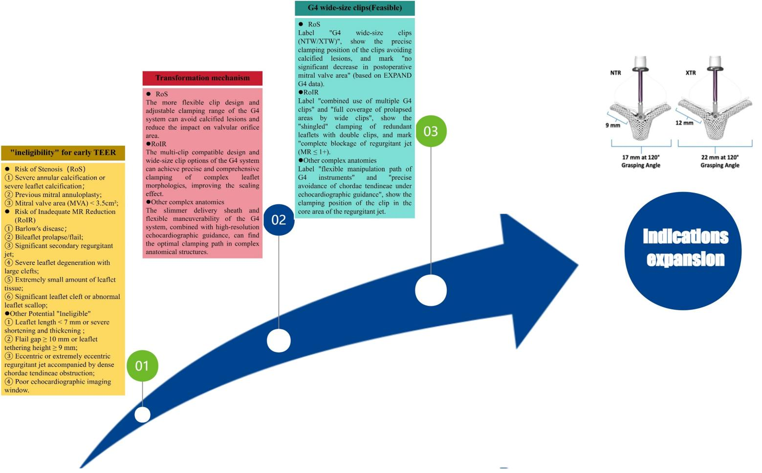
Fig. 2. Anatomical Transition from "Ineligible" to "Eligible"
● Key Points
It breaks through the limitations of ineligible patient populations associated with early TEER technologies, expands the indications to patients with moderate-to-severe FMR, and provides minimally invasive treatment opportunities for more patients with MR.
It is suitable for the following MR patients: those previously deemed anatomically ineligible for TEER treatment; patients with moderate-to-severe functional FMR who remain symptomatic despite GDMT; and heart failure patients complicated with FMR who are unable or unwilling to undergo surgery.
The long-term benefits for patients with baseline moderate or less severe MR remain unclear; there is still room for improvement in the surgical success rate among patients with complex anatomical structures; and long-term efficacy data for subgroups of FMR patients with different etiologies are lacking.

2.1.4 TEER Devices Continue to Upgrade, Covering Populations with Various Etiologies of MR and Complex Anatomical Structures
PASCAL is another trans-femoral vein-transseptal mitral valve clipping system based on the "Alfieri Stitch" technique. Its clipping arms are wider and longer than those of the traditional MitraClip, and can be independently clamped. The isolation ball in the middle is beneficial to reduce valve tension. PASCAL obtained CE certification in 2020 and has performed well in the European market. PASCAL Precision received FDA approval in 2022 for the treatment of DMR patients. The CLASP IID randomized controlled trial, a clinical study of PASCAL Precision, is a prospective, multicenter randomized controlled trial that included 300 patients with 3+ or 4+ DMR and surgical contraindications from 57 centers in multiple countries, randomly divided into the PASCAL group and the MitraClip group. At 1-year follow-up, there were no statistically significant differences in all-cause mortality, heart failure rehospitalization, and major adverse event rates between the PASCAL group and the MitraClip group. 95.8% of patients in the PASCAL group had MR ≤2+ at 1 year after surgery, which was not inferior to the MitraClip group. Both groups had significant improvements in cardiac function classification and quality of life. The results of the study confirmed that the PASCAL system is an effective treatment device for patients with severe DMR who have increased surgical risk and symptoms [38]. The PASCAL IID trial is a single-arm trial belonging to CLASP IID, which evaluated the safety, echocardiographic, and clinical outcomes of PASCAL and MitraClip in patients with severe DMR and complex mitral valve anatomy who have surgical contraindications. The implantation success rate was 92.9%, and the 30-day composite major adverse event rate was 11.2%. At 6-month follow-up, the proportion of patients with MR ≤2+ was 97.7% in the PASCAL group and 98.1% in the MitraClip group, achieving statistical non-inferiority. The proportion of patients with MR ≤1+ was 83.7% in the PASCAL group and 71.2% in the MitraClip group, with the PASCAL group showing a trend of being superior to the MitraClip group. There was no statistically significant difference in major adverse events between the two groups (3.4% in the PASCAL group vs. 4.8% in the MitraClip group). In addition, left ventricular remodeling and improved cardiac function were observed in both groups, with no statistically significant differences between the groups. The study confirmed that the PASCAL system is a treatment option suitable for DMR patients with complex mitral valve anatomy and high surgical risk [39].
The MiCLASP Study is a prospective, multicenter clinical study aimed at evaluating the safety and efficacy of the Edwards PASCAL device in the treatment of MR patients with significant clinical symptoms. Following its marketing in Europe, 59% of the patients had functional MR, and 30% had degenerative MR. The results of the study showed that the 30-day incidence of composite major adverse events was 6.8%, including cardiovascular mortality (1.1%), stroke (0.9%), myocardial infarction (0.2%), mitral valve reintervention rate (1.3%), major cardiac structural complications (0.4%), device embolization (0.2%), renal complications requiring dialysis (1.1%), severe bleeding (4%), and major puncture site and vascular complications (1.1%). Compared with baseline, MR was significantly reduced at discharge and remained stable at 1 year, with 98% of patients having MR ≤2+ and 82.6% having MR ≤1+. The 1-year Kaplan-Meier survival rate was 87.3%, and the rate of no heart failure hospitalization was 84.3%. In addition, patients’ function and quality of life were significantly improved within 1 year. The study showed that the PASCAL system is safe and effective in the treatment of FMR and DMR, which provides strong evidence for TEER as a feasible option for the treatment of MR [40].
● Key Points
The unique clip arm design and isolation balloon structure of PASCAL improve the adaptability to complex anatomical structures, provide a novel therapeutic option for patients with FMR and DMR, and form a complementary alternative to MitraClip.
It is indicated for the following patients: symptomatic patients with severe DMR who are at excessively high surgical risk; patients with severe DMR accompanied by complex mitral valve anatomy, and patients with FMR.
Comparative data regarding the durability of long - term efficacy between PASCAL and MitraClip are limited; the therapeutic effect in patients with extremely severe complex anatomical structures needs further verification; and there is a lack of dedicated studies on patients with multiple comorbidities.

2.1.5 Domestic Devices Show an Increasing Trend, with a Number of Innovative Devices with Different Pathways Emerging
ValveClamp is the first domestic transapical TEER device to be marketed. The marketing of this device is based on the results of the multicenter CLAMP-2 study, which showed an acute surgical success rate of 97%, 88% of patients only needed to implant one clip device to achieve the treatment goal, and the effective endpoint at 1 year after surgery was 87.3% [41]. DragonFly is China’s first trans-femoral vein edge-to-edge repair device, which was officially approved for marketing by NMPA in November 2023. The DRAGONFLY-DMR trial, aimed at evaluating the safety and efficacy of the DragonFly system, is a prospective, single-arm, multicenter clinical study that included 120 patients with clinical symptoms, MR ≥3+, and high surgical risk DMR from 27 centers in China. The clinical success rate at 1 year was 87.5%, and the rates of major adverse events, all-cause mortality, mitral valve reintervention, and heart failure hospitalization were 9.0%, 5.0%, 0.8%, and 3.4%, respectively. The rates of MR ≤2+ at 1 month and 1 year were 90.4% and 92.0%, respectively, and patients’ cardiac function and quality of life were significantly improved. The study showed that the DragonFly system helps to provide more evidence supporting the safety and efficacy of TEER therapy for the treatment of chronic symptomatic 3+ to 4+ DMR patients at high surgical risk [42].
● Key Points
ValveClamp adopts a transapical approach, while DragonFly uses a transfemoral venous approach. These two devices expand the options for TEER devices in China and are more compatible with the anatomical characteristics and clinical needs of Chinese patients.
ValveClamp is indicated for high risk surgical patients with FMR or DMR, especially those with restricted transfemoral venous access; DragonFly is indicated for symptomatic high - surgical - risk patients with DMR and MR ≥3+.
Long - term efficacy and durability data of the two devices still need to be obtained; clinical experience in treating MR patients with complex anatomical structures and special etiologies is insufficient; head - to - head comparative studies with imported devices are relatively scarce.
2.1.6 The Efficacy of the TEER-Specific Risk Scoring System is Superior to Traditional Risk Scores
With the rapid advancement of the application of TEER, the risk assessment of TEER surgery has attracted increasing attention. The MitraScore [43] is a scoring system specifically used for risk stratification of TEER surgery, based on data from 1119 TEER surgeries in the multinational international registry study MIVNUT. The MitraScore includes 8 independent predictors of patient death: age ≥75 years, anemia, glomerular filtration rate <60 mL/min/1.73 m², left ventricular ejection fraction <40%, peripheral artery disease, chronic obstructive pulmonary disease, high-dose diuretics (≥80 mg furosemide/day or use of ≥2 diuretics other than anti-aldosterone drugs), and no use of renin-angiotensin system inhibitor therapy. Each factor is assigned 1 point, and for each additional point, the relative risk of all-cause death in patients increases by 55% (HR 1.55, 95%CI 1.44~1.67; p<0.001). The overall mortality rate increases by 20 times from the lowest score to the highest score. The discrimination and calibration effects of this score in predicting mortality are superior to the current EuroSCORE Ⅱor STS scores. Thus, the MitraScore is a simple prediction algorithm that can be used to predict the mortality of patients undergoing TEER treatment.

3 Other Transcatheter Mitral Valve Repair Technologies
Compared to TEER, mitral valve annuloplasty has increased technical barriers and operational difficulty, and a long learning curve, so its development is relatively slow. According to different mechanisms, annuloplasty can be divided into direct annuloplasty and indirect annuloplasty. Currently, marketed products include the direct annuloplasty device Cardioband and the indirect annuloplasty device Carillon. Cardioband is a direct annuloplasty device delivered via transseptal puncture, which obtained European CE certification in 2015. A one-year follow-up of 60 patients with moderate to severe FMR from 11 institutions in Europe treated with the Cardioband System showed that the 1-year overall survival rate, survival rate without heart failure re-admission, and survival rate without reintervention were 87%, 66%, and 78%, respectively. 95% of patients who underwent transthoracic echocardiography at 1 year had moderate or less MR, and NYHA classification, quality of life, and exercise capacity were significantly improved [44]. Carillon is an indirect annuloplasty device placed in the coronary sinus, which reduces FMR by narrowing the annulus. The REDUCE-FMR study showed that Carillon implantation reduced the regurgitant volume and left ventricular volume in patients with severe FMR [45]. DragonRing is China’s first trans-femoral vein interventional annuloplasty system that simulates atrioventricular annuloplasty technology and is independently developed. It can be used for patients with functional mitral and tricuspid regurgitation caused by annulus dilatation, leading to the loss of leaflet coaptation height. The world’s first human implantation was completed by Professor Chen Mao’s team [46].
Due to technical difficulties, transcatheter chordae repair devices are currently in animal experiments or early clinical stages, including NeoChord NeXuS, CardioMech, and Pipeline. Transcatheter chordae repair devices consist of an implant and a delivery system. The implant includes an artificial chordae suture device, a papillary muscle anchor piece, and leaflet anchor pieces connected at both ends. Rogers et al. [47] first reported a human trial in 2020, but the papillary muscle anchor piece fell off before discharge, and the patient finally underwent mitral valve replacement. Latib et al. [48] completed the first FIFH clinical trial and reported results at 6-month follow-up, which successfully reduced MR, ensuring that the papillary muscle was firmly anchored without displacement. Transcatheter chordae repair devices may be a feasible option for the treatment of isolated single-leaflet prolapse in the future, with a good risk-benefit ratio.
● Key Points
Annuloplasty targets annular dilatation, the key pathological mechanism, offering a precise treatment strategy for patients with FMR. Chordal repair devices simulate the anatomical repair concept, which is expected to achieve curative treatment for leaflet prolapse and enrich the technical system of TMVr.
Annuloplasty is indicated for patients with FMR caused by annular dilatation, especially those with suboptimal outcomes after TEER. Chordal repair devices are indicated for patients with DMR induced by isolated single-leaflet prolapse.
Annuloplasty involves complex procedures and a long learning curve, making it difficult to promote in primary hospitals. Chordal repair devices are still in the early stage of research and development, and their long-term efficacy, device durability, and safety require further verification in more clinical trials.

4 Transcatheter Mitral Valve Replacement
Compared with TEER, transcatheter mitral valve replacement (TMVR) has the advantage of being able to completely cure MR. The flowchart for the selection of various transcatheter mitral valve replacement (TMVR) procedures is shown in Figure 3. According to the type of native mitral valve, TMVR can be divided into four types: (1) valve-in-valve (ViV) after bioprosthesis failure; (2) valve-in-ring (ViR); (3) valve-in-calcified annulus (ViMAC); (4) valve-in-native valve.
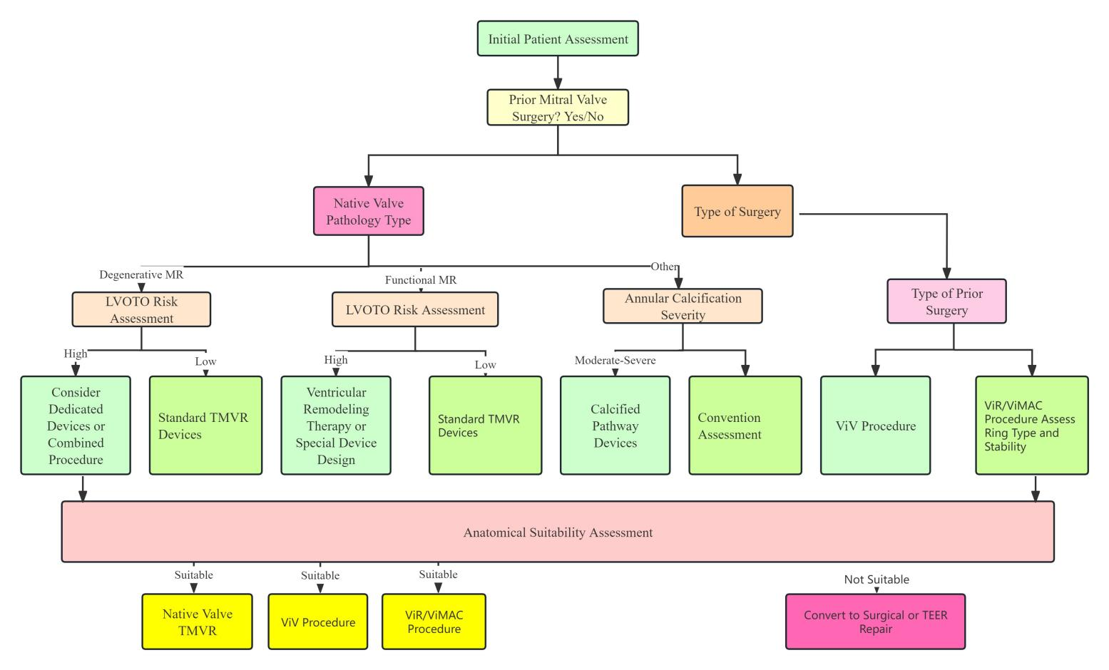
Fig. 3. Flowchart of TMVR Procedure Selection
4.1 TMVR Has a Wide Range of Applications and Shows Excellent Therapeutic Effects in Different Clinical Settings
4.1.1 ViV, ViR, and ViMAC TMVR Are Reasonable Choices in Patients at High Surgical Risk
The MITRAL trial is the first prospective study aimed at evaluating the early feasibility of transseptal ViV, ViR, and ViMAC using balloon-expandable valves SAPIEN XT/3. A total of 91 patients with severe mitral stenosis or MR, NYHA class II or higher, or assessed as high surgical risk by the heart team were included and assigned to three treatment strategies: ViV (N=30), ViR (N=30), and ViMAC (N=31). The 5-year follow-up results showed that the all-cause mortality rates in the ViV, ViR, and ViMAC groups were 21.4%, 65.5%, and 67.9%, respectively, and the proportions of NYHA class I-II were 94.7%, 50%, and 55.6%, respectively. The Kansas City Cardiomyopathy Questionnaire scores in the three groups continued to improve compared with baseline, and the function of mitral bioprostheses in all groups remained stable. The study showed that ViV, ViR, and ViMAC are reasonable choices for mitral valve patients at high surgical risk [49].
4.1.2 Compared with TEER, Patients with Severe FMR Undergoing TMVR Have Better MR Reduction and Symptom Improvement
The CHOICE-MI study conducted a propensity score matching analysis between 262 FMR patients who underwent TMVR and 1065 FMR patients who underwent TEER in the EuroSMR registry study. The results showed that there was no statistically significant difference in all-cause mortality between TMVR and TEER at 30 days and 1 year. TMVR had better MR reduction (the proportions of patients with residual MR ≤1 at discharge in TMVR and TEER groups were 95.8% and 68.8%, respectively, p<0.001) and symptom improvement (the proportions of patients with NYHA ≤II at 1 year were 77.8% and 64.3%, respectively, p<0.001). The study showed that TMVR is associated with better MR reduction and symptom improvement [50].
4.1.3 Compared with GDMT Alone, FMR Patients Undergoing TMVR Have Better MR Reduction and Symptom Improvement
A propensity score matching analysis aimed at comparing the effects of TMVR and GDMT in the treatment of MR included 97 FMR patients who underwent TMVR in the CHOICE-MI registry study and 97 patients who received GDMT in the COAPT trial. The results showed that the 2-year heart failure rehospitalization rate in the TMVR group was significantly lower than that in the GDMT group (32.8% vs. 54.4%, HR 0.59, 95%CI 0.35~0.99, p=0.04). All patients in the TMVR group had residual MR ≤1+ at 1 year and 2 years, while those in the GDMT alone group were 6.9% and 7.7%, respectively. The proportions of patients in NYHA class I or II in the TMVR group were higher than those in the GDMT group at 1 year (78.2% vs. 59.7%, p=0.03) and at 2 years (77.8% vs. 53.2%, p=0.09). The 2-year mortality rates in the two groups were similar (36.8% vs. 40.8%; HR 1.01, 95%CI 0.62~1.64, p=0.98). The study showed that compared with GDMT, TMVR can significantly reduce the degree of MR, improve symptoms, and reduce the rate of heart failure rehospitalization [51].
4.1.4 TMVR Shows Lower Initial Risk After Mitral Bioprosthesis Failure
Currently, evidence on the prognosis of redo surgical mitral valve replacement (Redo SMVR) or TMVR after mitral bioprosthesis failure is limited, and a propensity score matching analysis fills this gap. A total of 4293 patients were included in the study (redo SMVR: 64%; TMVR: 36%). Landmark analysis showed that TMVR had a lower risk of MACE in the first 6 months (adjusted HR: 0.75; 95% CI: 0.63~0.88; p<0.001), but a higher risk after 6 months (adjusted HR: 1.28; 95% CI: 1.04~1.58; p=0.02). The study showed that the 3-year prognosis of Redo SMVR and TMVR is similar, with TMVR showing a lower initial risk but a higher risk of MACE after 6 months [52]. Patients undergoing ViV-TMVR are mostly at high surgical risk, with an average Society of Thoracic Surgeons (STS) score > 8 points. Short-term outcomes show that the 30-day mortality rate ranges from 3.2% to 7.5%, the incidence of stroke is < 3%, and the incidence of postoperative left ventricular outflow tract (LVOT) obstruction is relatively low. Long-term outcomes indicate a 1-year mortality rate of approximately 15% and a 4-year mortality rate of 37.5% [53,54，55,56,57,58,59,60,61]. High STS score, advanced age, poor left ventricular function, and moderate to severe tricuspid regurgitation before surgery are the main factors associated with increased long-term all-cause mortality.
The mitral annulus has a saddle-shaped structure with a three-dimensional and dynamically changing morphology. In patients with MR, the annulus often exhibits mild or no calcification. These factors usually hinder the anchoring of interventional devices, leading to poor adherence and thereby increasing the risks of device embolization and paravalvular leak. In addition, the complex anatomical morphology of the subvalvular apparatus of the mitral valve further increases the difficulty of interventional procedures. LVOT is the most feared complication of ViV-TMVR and is an independent predictor of early adverse outcomes in patients[60]. Compared with surgeries involving transcatheter mitral valve-in-ring implantation or mitral annular calcification, the incidence of LVOT obstruction in ViV-TMVR is lower (≤5%). The reasons include: the anterior leaflet has been resected during the original mitral valve replacement; most surgical bioprosthetic valves are visible under fluoroscopy, enabling precise positioning of the transcatheter heart valve; and surgical bioprosthetic valves can serve as an anchoring system for the new valve, avoiding valve displacement or embolization.
● Key Points
Compared with the palliative treatment effect of TEER, TMVR can completely correct MR, offering a more effective therapeutic option for patients with severe FMR, especially those with suboptimal MR relief after TEER.
It is indicated for patients with severe FMR, particularly those with anticipated poor TEER outcomes or unsuitable anatomical conditions for TEER, and FMR patients who still present with obvious symptoms despite GDMT.
The surgical procedure is more technically demanding than TEER with a longer learning curve; the risks of postoperative complications, such as paravalvular leak and LVOTO, are slightly higher than those of TEER; the long-term efficacy, durability, and device longevity need further verification.
4.2 A Variety of TMVR Devices Have Entered Clinical Trials and Achieved Favorable Preliminary Follow-Up Results
Transcatheter mitral valve replacement (TMVR) devices are diverse in type and at different stages of research and development, as illustrated in Table 2. The Tendyne Mitral Valve Replacement System was the first commercially available transcatheter mitral valve replacement (TMVR) device approved in Europe in 2020. The Tendyne System has the most extensive clinical data among TMVR devices; existing research [61] has demonstrated that this system is safe and feasible, and enables the complete elimination of mitral regurgitation (MR). In addition, several relevant clinical studies are currently underway, including the SUMMIT Trial (NCT03433274), the Mitral Annular Calcification Study (NCT03539458), and the Expanded Access Study (NCT02321514). In addition, the 1-year follow-up data from the investigator-initiated TENDER registry in real-world settings showed that the 30-day cardiovascular mortality and all-cause mortality of Tendyne TMVR were 7% and 9%, respectively, and the 1-year cardiovascular mortality and all-cause mortality were 17% and 29%, respectively. The rate of reintervention or surgery after discharge was 4%, while the rate of heart failure rehospitalization decreased from 68% to 25%. 98% of patients achieved sustained reduction of MR to ≤1+, and 83% of patients achieved NYHA functional class I or II at 1 year. This large-scale, real-world observational registry study reported that Tendyne TMVR has a high technical success rate, lasting and complete elimination of MR, and significant clinical benefits, and that the results of on-label use are comparable to those in "real-world" use, providing a safe and effective treatment option for patients who previously had no alternative therapy [62].
Table 2. TMVR Devices in Clinical Trial Phase
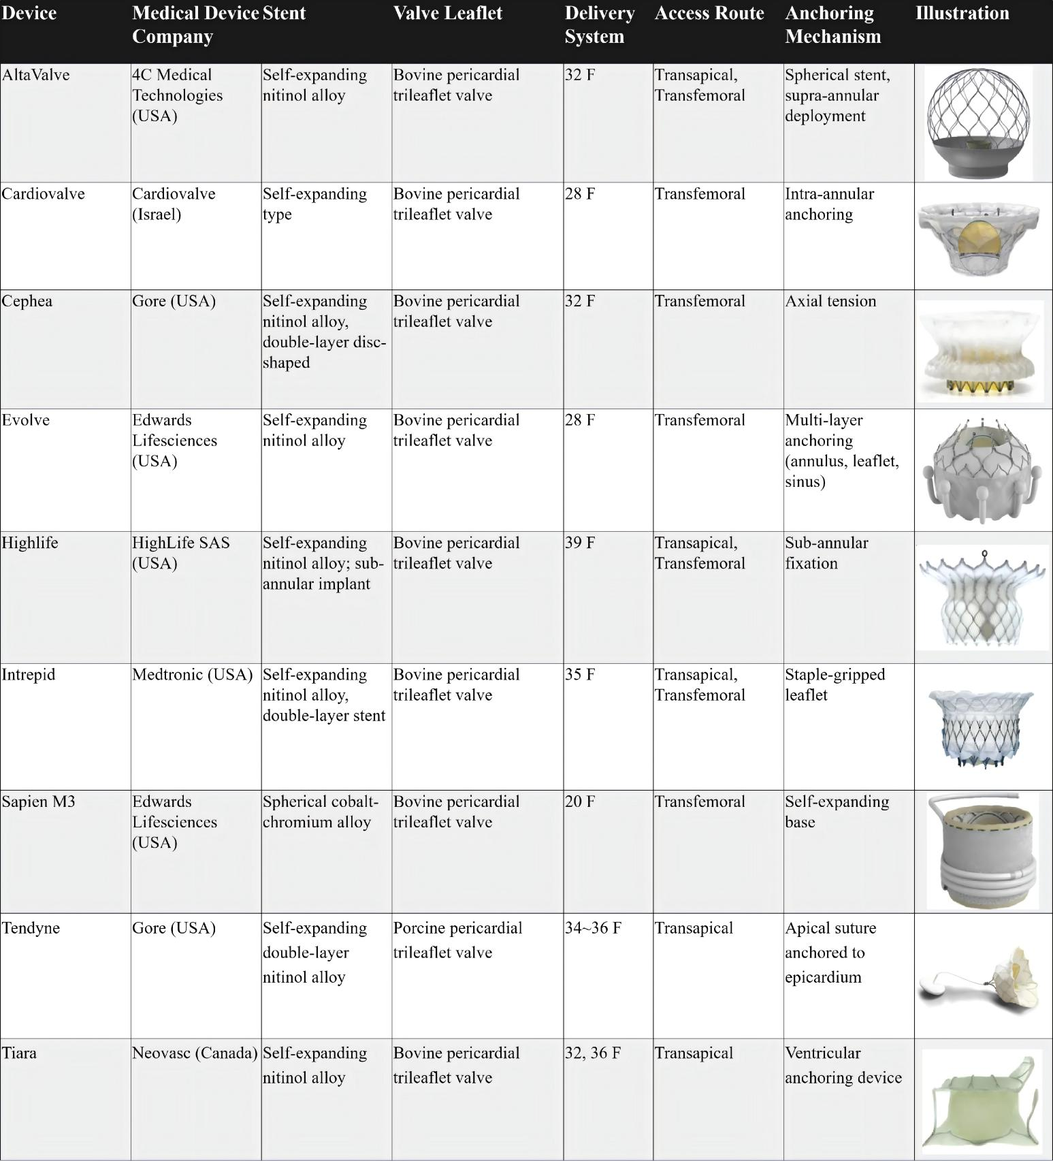
HighLife is a transseptal mitral valve replacement system with a unique "valve-in-ring" design, featuring self-adaptation and self-coaxiality. The results of an expanded study on the HighLife system in patients with severe MR who are unsuitable for surgery or transcatheter repair showed that the technical success rate of HighLife TSMVR system implantation in 30 patients was 90%, the device success rate within 30 days was 83%, and the mortality rate at 1 year was 17%. All implanted patients had no significant or mild MR, the mean postoperative pressure difference was 5.1 mmHg, and there was no left ventricular outflow tract obstruction. The study results showed that this technology has a high success rate, good valve function, no LVOTO, and no need for further mitral valve intervention [63].
Intrepid is one of the most widely implanted valves clinically. The results of a two-year clinical and echocardiographic follow-up of the transapical Intrepid System implantation showed that the all-cause mortality rates at 30 days, 1 year, and 2 years were 13.1%, 27.3%, and 36.2%, respectively, and the rates of heart failure rehospitalization at 30 days and 2 years were 9.6% and 36.2%, respectively. More than 50% of patients survived at 2 years with improved NYHA functional classification, and all patients who underwent echocardiography had MR ≤mild. This study is the largest reported experience of transapical TMVR and the longest follow-up analysis of high-risk patients with MR ≥moderate to severe. Although early mortality and heart failure rehospitalization rates were high, clinical outcomes improved and MR severity decreased significantly within 2 years [64].
The research and development of TMVR devices in China lagged behind that in other countries. To date, more than 10 types of TMVR valves have been developed, among which 6 have entered the clinical research phase (Table 3). Relevant early feasibility studies and confirmatory trials for further assessment of safety and efficacy are currently underway. Among these devices, the MitraFix, Mi-thos, TruDelta, and AltaValve systems have been reported in several case series, demonstrating favorable clinical outcomes. The one-year follow-up results of the MitraFix study showed a 100% procedural success rate. Mitral regurgitation (MR) was completely eliminated in 90% of patients after surgery, while the remaining patients had their MR reduced to grade 1+. Moreover, 75% of the surviving patients achieved improvement in New York Heart Association (NYHA) functional class to grade I or II. No complications such as left ventricular outflow tract obstruction or mitral stenosis were observed during the follow-up period, and the 6-minute walk distance was significantly increased. These findings indicate that the MitraFix system exhibits increased advantages in terms of procedural success rate and patient prognosis, providing a novel, safe, and effective therapeutic option for high-risk patients with severe MR [65].

Table 3. China’s Investigational TMVR Devices

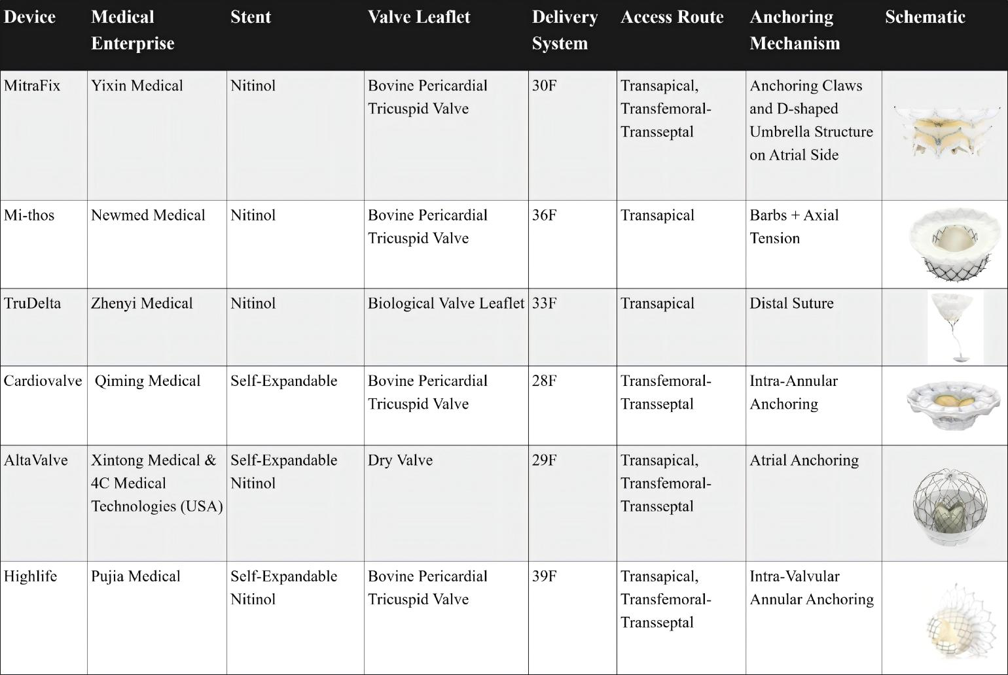

●Key Points
Various TMVR devices address the anatomical challenges of native MV replacement through a unique design, which improves the surgical success rate and safety and promotes the popularization of TMVR technology.
It is indicated for high-surgical-risk patients with severe MR, including those with DMR and FMR; patients with complex anatomical MR who are ineligible for surgical treatment or transcatheter repair; Chinese devices are applicable to Chinese MR patients who meet the enrollment criteria of clinical studies.
Most devices are still in the clinical trial phase with limited data on long-term efficacy and durability; the risk of postoperative complications associated with some devices still needs to be reduced; clinical data of Chinese devices is insufficient, and there are relatively few comparative studies with other international devices.
- Imaging Evaluation and Intraoperative Operational Strategies
Imaging evaluation is the core support for transcatheter intervention in MR, running through the entire process of preoperative plan formulation, intraoperative precise operation, and postoperative efficacy assessment. Transesophageal echocardiography (TEE) and computed tomography (CT) serve as key imaging tools, and their accurate measurement results directly drive the selection of treatment plans. The key intraoperative verification points are the core links to ensure surgical success and reduce the risk of complications.
Preoperatively, multi-dimensional and multi-parameter measurements using TEE and CT are required to comprehensively assess the anatomical characteristics of the heart, providing support for treatment plans and device selection. TEE excels in evaluating valve function, leaflet motion, and hemodynamics, while CT has advantages in three-dimensional anatomical reconstruction, precise size measurement, and assessment of calcification. The core measurement indicators are detailed in Table 4 [66].
Table 4. Core Preoperative Measurement Indicators
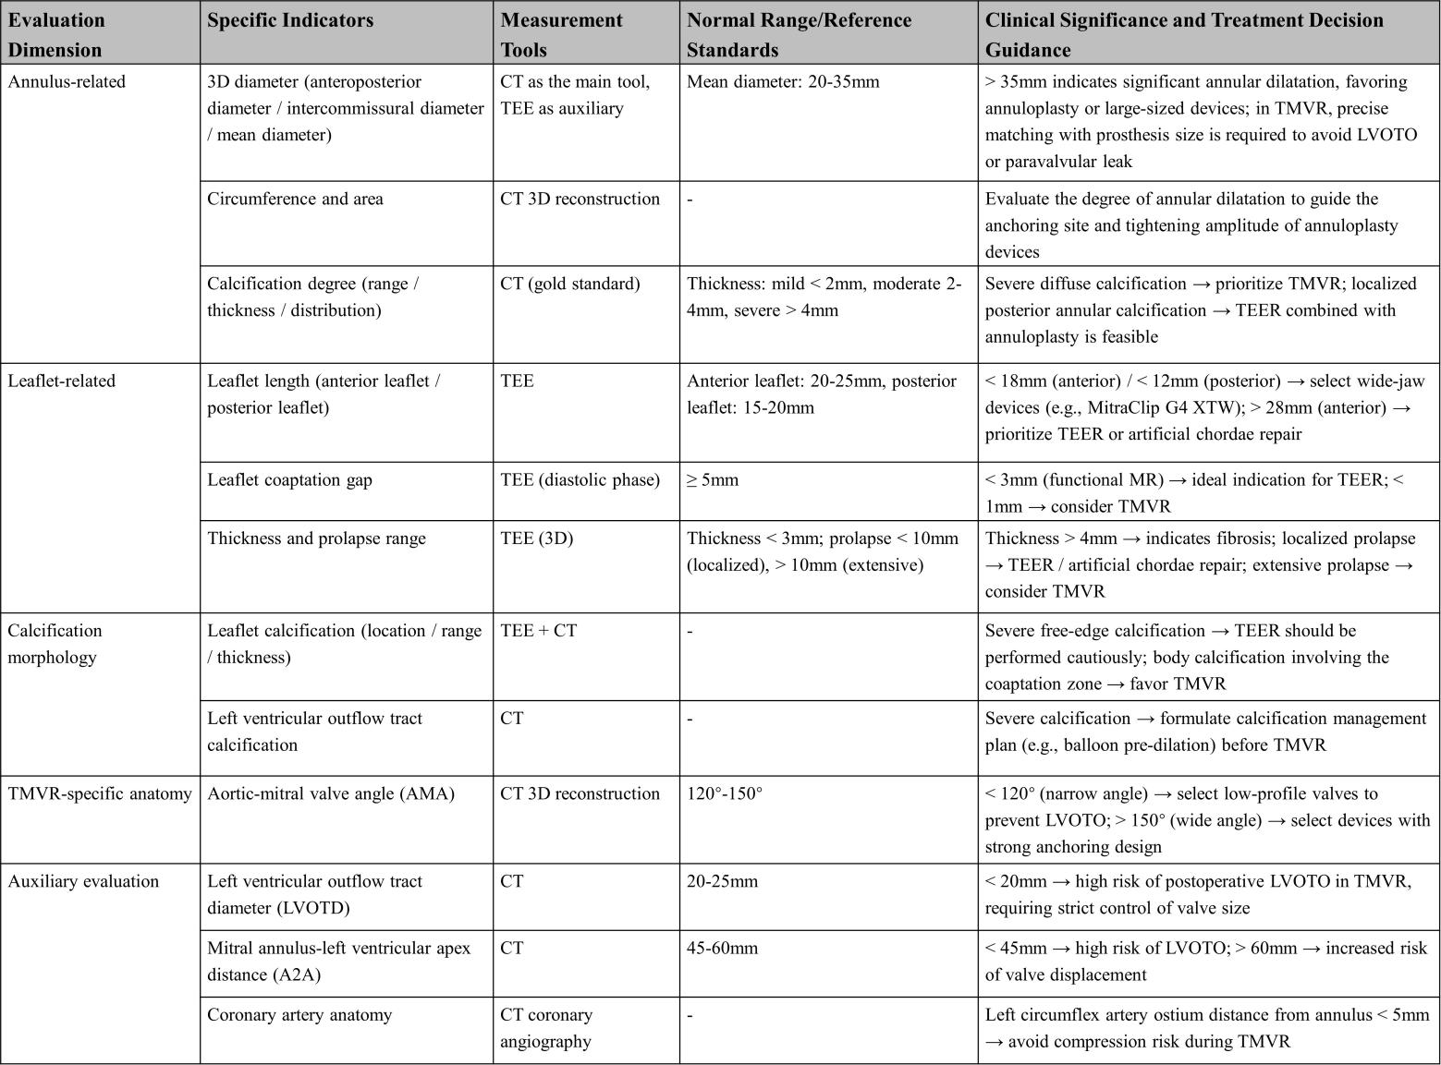
Intraoperatively, real-time imaging monitoring and operational verification should be combined to ensure accurate device positioning, good valve function, and reduce the risk of immediate complications. Key verification points are confirmed in stages according to the operational process, as detailed in Table 5[67].
Table 5. Verification of Puncture Path and Device Placement
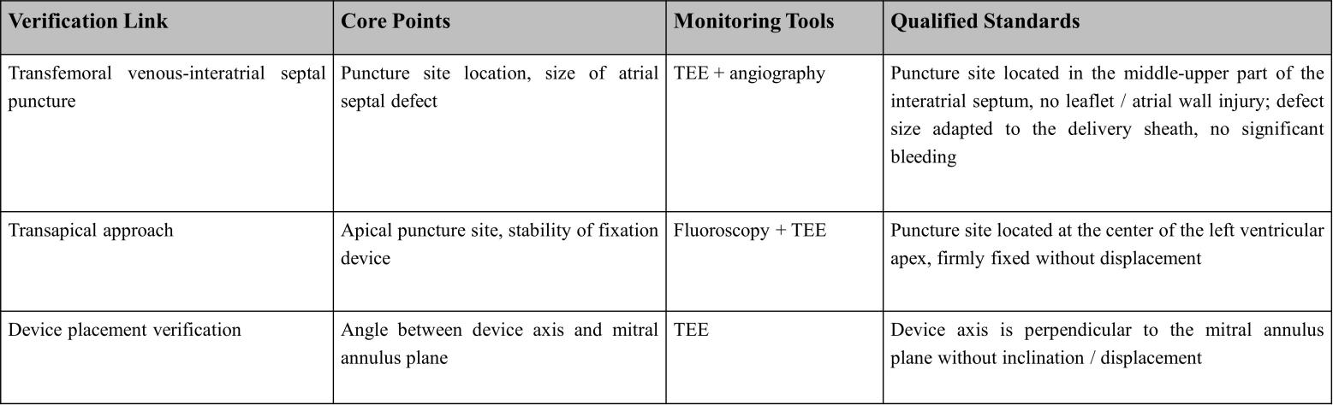
TTE is routinely used for follow-up after TEER. When TTE imaging is limited, device-related complications are suspected, or MR worsening requires precise assessment of pathological mechanisms, further TEE can be performed and compared with intraoperative data. Common evaluation indicators are detailed in Table 6[66]. Clip stability is also an important part of postoperative TEER evaluation, and its assessment points are detailed in Table 7[68].
Table 6. TEER Postoperative MR Grading Indicators
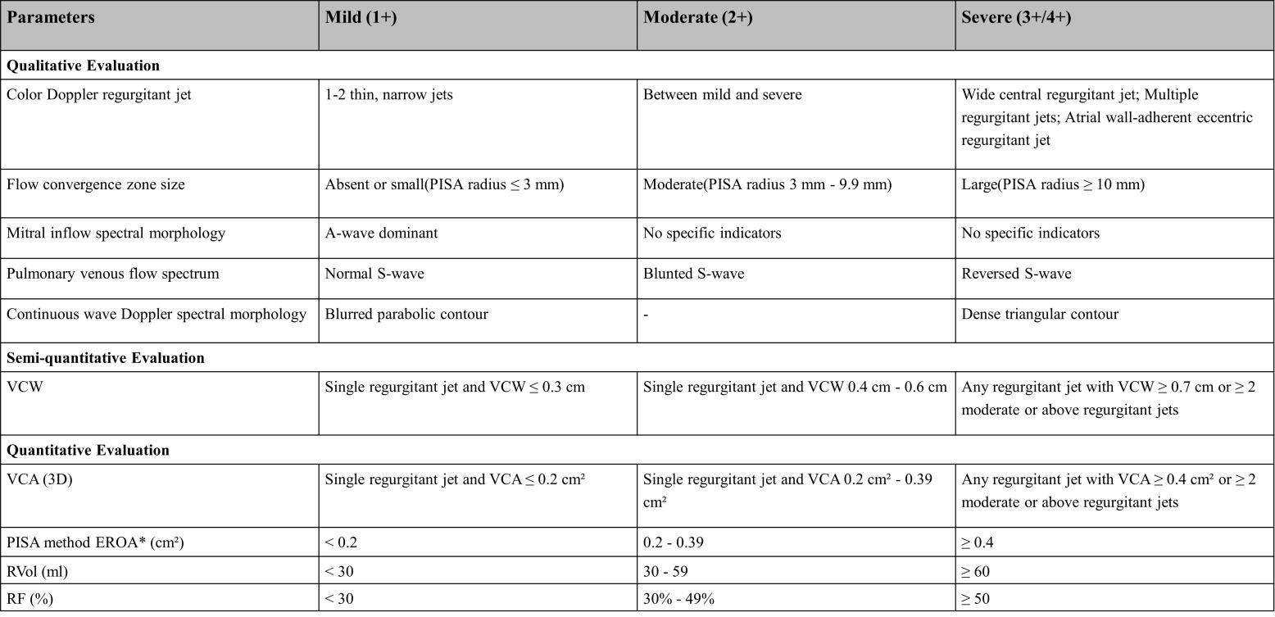
Table 7. Key Points for Evaluating Device Stability During Postoperative TEER Follow-up
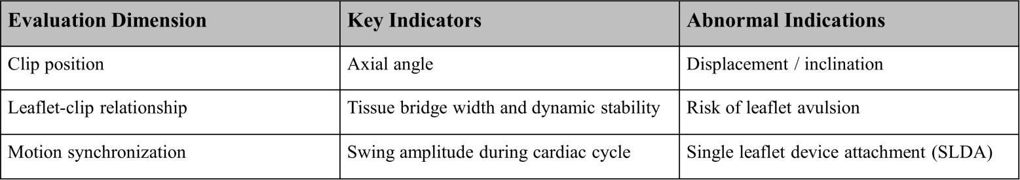

Major postoperative complications of TEER include inadequate attachment of single-leaflet devices, iatrogenic mitral stenosis, leaflet injury, device embolization, left ventricular outflow tract obstruction, thrombosis, and infective endocarditis. Their evaluation points are detailed in Table 8[69].
Table 8. Postoperative TEER Complications and Ultrasonic Features
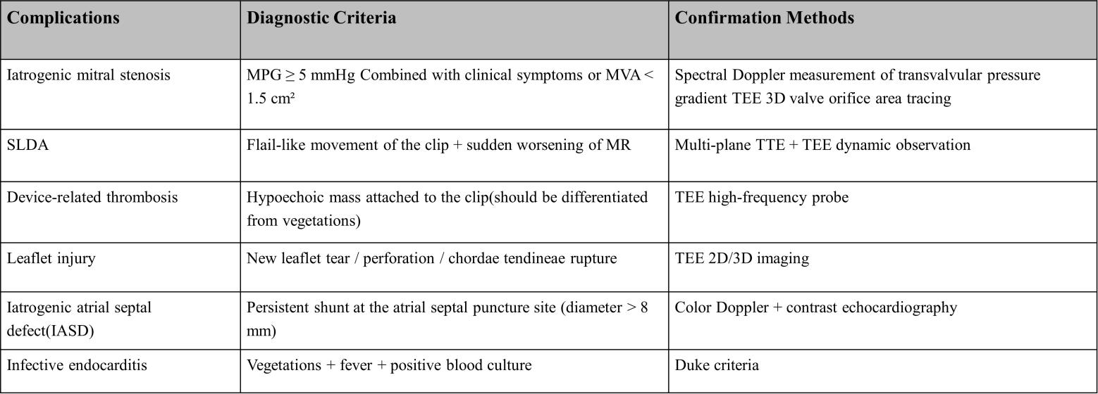

6. Conclusions
In recent years, interventional therapy for MR has developed rapidly with prospects for broad application. The clinical pathway flowchart for transcatheter intervention of mitral regurgitation, as shown in Figure 4, covers the complete process from patient phenotype classification, key points of imaging assessment, device selection strategy, intraoperative operation techniques, and postoperative follow-up protocols. After 20 years of accumulated clinical evidence, TEER has continuously expanded its application and maintained its dominant position. The research and development of other innovative repair devices continue to evolve. A variety of TMVR systems have entered clinical trials and achieved satisfactory preliminary follow-up results. In the future, MR patients will have more minimally invasive, safer, and more effective treatment options. However, mitral valve interventional therapy also faces many challenges, such as difficulties in positioning and fixing artificial valves, and various complications after surgery, such as left ventricular outflow tract obstruction, artificial valve thrombosis, and pericardial tamponade. Therefore, further optimization of devices, more high-level research evidence, and accumulation of experience from interventional physicians are still needed. It is believed that with the increasing improvement of mitral valve interventional therapy, this field will continue to undergo more comprehensive development, the results of which will benefit an increasing number of MR patients.
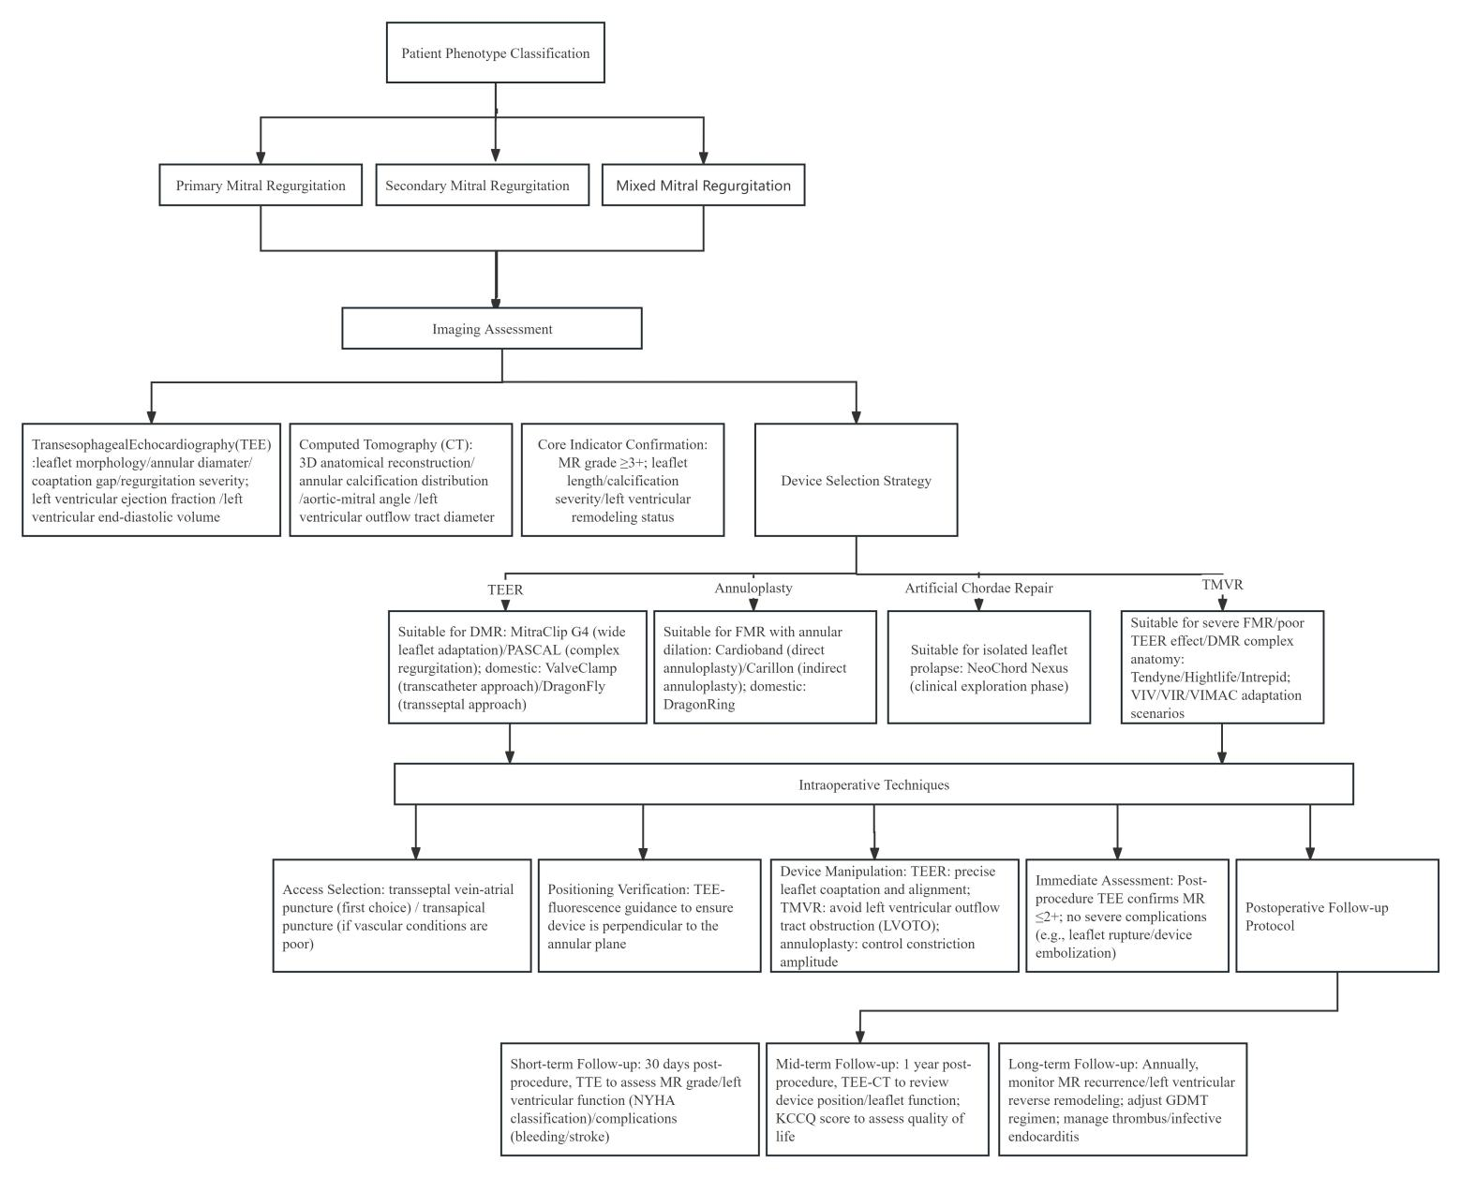
Fig. 4. The clinical pathway flowchart for the transcatheter intervention of mitral regurgitation

References
[1]Nkomo VT, Gardin JM, Skelton TN, Gottdiener JS, Scott CG, Enriquez-Sarano M. Burden of valvular heart diseases: a population-based study. Lancet. 2006; 368(9540):1005-1011.
[2]Zhong L, Deng Q, Wang Y, Song H, Chen J, Zhou Q, Xiao J, Cao S. A fully convolutional neural network for the quantification of mitral regurgitation in echocardiography. Quant Imaging Med Surg. 2024;14(12):8707-8719.
[3]Xu H, Liu Q, Cao K, Ye Y, Zhang B, Li Z, Hao J, Qi X, Zhao Q, Liu S, Gao R, Wu Y. Distribution，characteristics，and management of older patients with valvular heart disease in China:China-DVD study.JACC Asia. 2022;2(3): 354-365.
[4]Shiwaku Y, Aonuma T, Kitani Y, Takeuchi T, Naoki N. Successful transcatheter mitral valve repair for mitral regurgitation complicating fulminant eosinophilic myocarditis: a case report. Eur Heart J Case Rep. 2025;9(8):ytaf353.
[5]Yan L, Wujin H, Hairong W, Mei Z, Farong L, Wei Y, Qi Z. MitraClip intervention for Sheehan syndrome complicated by dilated cardiomyopathy and valvular insufficiency: a case report and literature review. Front Endocrinol (Lausanne). 2025;16:1593741.
[6]Waggoner T, Garcia S, Chakravarty T, Makar M, Latib A, Kipperman RM, Zahr F, Hanson I, Sinha AK, Sharma RP, Depta JP, Castellanos JA, Kodali S, Krishnaswamy A, Whisenant B, Menees D, Lim DS, Gilani F, Sanchez CE, Gheewala N, Gada H, Kapadia S, Ramanathan PK, Shah PB, Renard B, Theodos G, Yaryura R, Gardner B, Steinberg DH, Gnall E, Kaddissi G, Chhatriwalla AK, Frangieh AH, Eleid MF, Géneréux P, Saxon JT, Villablanca P, Matar F, Agarwal H, Chetcuti S, Frisoli T, Makkar R. Early U.S. Commercial Experience With a Novel Transcatheter Edge-to-Edge Repair System: Insights From Real-World Data. JACC Cardiovasc Interv. 2025;18(16):2036-2046.
[7]Danesh S, Schaff HV, Holst KA, Tang PC, Sawma T, Dearani JA, Todd A, Sularz A, Greason KL, Crestanello JA, Alkhouli M, Arghami A. Transcatheter Edge-to-Edge Repair versus Mitral Valve Surgery in Octogenarians: Comparative Analysis of Safety, Durability, and Survival. J Thorac Cardiovasc Surg. 2025:S0022-5223(25)00670-1.
[8]Tang GHL, Price MJ, Rottbauer W, Mahoney PD, Hausleiter J, Raake PW, Rollefson WA, Lurz P, Denti P, Chehab BK, Dong M, Huang R, Asch FM, Zamorano JL, von Bardeleben RS, Maisano F, Kar S, Rodriguez E. Transcatheter Edge-to-Edge Repair in Secondary Mitral Regurgitation With Extended Non-COAPT-Like Features: From the EXPANDed Studies. JACC Heart Fail. 2025;13(9):102565.
[9]Khatib D, Neuburger PJ, Pan S, Rong LQ. Transcatheter Mitral Valve Interventions for Mitral Regurgitation: A Review of Mitral Annuloplasty, Valve Replacement, and Chordal Repair Devices. J Cardiothorac Vasc Anesth. 2022;36(10):3887-3903.
[10]Zorman MJ, Dangas K, Vibhishanan J, Castle J, Eastwick-Jones K, Coronelli M, Alabdaljabar MS, Foster K, Silva D, Patel P, Johns E, Piankova P, Ordóñez-Mena J, Dawkins S, Newton J, Eleid MF, Guerrero ME, Cahill TJ. Transcatheter Mitral Valve Replacement Using Contemporary Dedicated Devices: A Systematic Review and Meta-Analysis. Struct Heart. 2025;9(9):100702.
[11]Ferro CD, Praz F, Brugger N, Reineke D, Sandra T, Setzer F, Windecker S, Erdoes G. Interdisciplinary periprocedural management of patients undergoing transapical tmvi with the tendyne™ system: A narrative review and institutional experience. Interdiscip Cardiovasc Thorac Surg. 2025:ivaf181.
[12]Hellhammer K, Schindhelm F, Geisler T, Kast I, Goldschmied A, Gerçek M, Rudolph F, Rudolph V, Totzeck M, Luedike P, Rassaf T, Mahabadi AA. Predictability of post-delivery mitral regurgitation with a new generation transcatheter edge-to-edge device. Clin Res Cardiol. 2025.
[13]Eleid MF, Krishnaswamy A, Kapadia S, Yadav P, Rajagopal V, Makkar R, Stinis C, Chetcuti S, Morse A, Frisoli T, Frangieh AH, Abbas AE, Whisenant B, O’Neill WW, Guerrero ME, Rodriguez E, Kodali S, Ailawadi G, Rihal CS. 3-Year Outcomes of Mitral Valve-in-Valve Therapy Using Balloon-Expandable Transcatheter Valves in the United States. JACC Cardiovasc Interv. 2025;18(11):1454-1466.
[14]Vo NM, Bax JJ, Delgado V. Editorial commentary: Future of transcatheter mitral valve interventions for secondary mitral regurgitation. Trends Cardiovasc Med. 2021;31(8):495-496.
[15]Partida RA, Elmariah S. Transcatheter Mitral Valve Interventions: Current Therapies and Future Directions. Curr Treat Options Cardiovasc Med. 2017;19(5):32.
[16]Metra M, Tomasoni D, Adamo M, Anker SD, Bayes-Genis A, von Bardeleben RS, Böhm M, Donal E, Filippatos GS, Maisano F, Ponikowski P, Savarese G, Praz F, Butler J. Evidence Generation and Implementation of Transcatheter Interventions for Atrioventricular Valvular Heart Disease in Heart Failure: Current Status and Future Directions. Circulation. 2025;151(18):1342-1363.
[17]von Stein P, Iliadis C. Transcatheter edge-to-edge repair for mitral regurgitation. Trends Cardiovasc Med. 2025;35(5):320-325.
[18]Asgar AW, Tang GHL, Rogers JH, Rottbauer W, Morse MA, Denti P, Mahoney P, Rinaldi MJ, Asch FM, Zamorano JL, Dong M, Huang R, Lindenfeld J, Maisano F, von Bardeleben RS, Kar S, Rodriguez E. Evaluating Mitral TEER in the Management of Moderate Secondary Mitral Regurgitation Among Heart Failure Patients. JACC Heart Fail. 2025;13(2):213-225.
[19]Praz F, Borger MA, Lanz J, Marin-Cuartas M, Abreu A, Adamo M, Ajmone Marsan N, Barili F, Bonaros N, Cosyns B, De Paulis R, Gamra H, Jahangiri M, Jeppsson A, Klautz RJM, Mores B, Pérez-David E, Pöss J, Prendergast BD, Rocca B, Rossello X, Suzuki M, Thiele H, Tribouilloy CM, Wojakowski W; ESC/EACTS Scientific Document Group. 2025 ESC/EACTS Guidelines for the management of valvular heart disease. Eur Heart J. 2025:ehaf194.
[20]Colombo A, Mangieri A. At the Edge of Percutaneous Mitral Valve Repair. JACC Cardiovasc Interv. 2025;18(16):2047-2048.
[21]Dragona VM, Sideris K, Liori S. The role of transcatheter edge-to-edge repair in functional mitral regurgitation: key takeaways from the MATTERHORN and RESHAPE-HF2 trials. Heart Fail Rev. 2025;30(5):1133-1138.
[22]Alnasser S, Attumalil T, Alkasab M, Patrascu A, Almalki Y, Ong G, Latter D, Fam NP. Transcatheter Mitral Valve Replacement in Severe Mitral Annular Calcification: BATMAN and ROBIN, the Dynamic Duo. JACC Cardiovasc Interv. 2025;18(7):948-949.
[23]Guo B, Shi S, Guo Y, Xiong J, Wang B, Dong Z, Gao D, Tu Y. Interventional therapies for chronic heart failure: An overview of recent developments. ESC Heart Fail. 2025;12(2):1081-1094.
[24]Mauri L, Foster E, Glower DD, Apruzzese P, Massaro JM, Herrmann HC, Hermiller J, Gray W, Wang A, Pedersen WR, Bajwa T, Lasala J, Low R, Grayburn P, Feldman T; EVEREST II Investigators. 4-year results of a randomized controlled trial of percutaneous repair versus surgery for mitral regurgitation. J Am Coll Cardiol. 2013;62(4):317-28.
[25]Feldman T, Kar S, Elmariah S, Smart SC, Trento A, Siegel RJ, Apruzzese P, Fail P, Rinaldi MJ, Smalling RW, Hermiller JB, Heimansohn D, Gray WA, Grayburn PA, Mack MJ, Lim DS, Ailawadi G, Herrmann HC, Acker MA, Silvestry FE, Foster E, Wang A, Glower DD, Mauri L; EVEREST II Investigators. Randomized Comparison of Percutaneous Repair and Surgery for Mitral Regurgitation: 5-Year Results of EVEREST II. J Am Coll Cardiol. 2015 ;66(25):2844-2854.
[26]Praz F, Borger MA, Lanz J, Marin-Cuartas M, Abreu A, Adamo M, Ajmone Marsan N, Barili F, Bonaros N, Cosyns B, De Paulis R, Gamra H, Jahangiri M, Jeppsson A, Klautz RJM, Mores B, Pérez-David E, Pöss J, Prendergast BD, Rocca B, Rossello X, Suzuki M, Thiele H, Tribouilloy CM, Wojakowski W; ESC/EACTS Scientific Document Group. 2025 ESC/EACTS Guidelines for the management of valvular heart disease. Eur Heart J. 2025;46(44):4635-4736.
[27]Vahanian A, Beyersdorf F, Praz F, Milojevic M, Baldus S, Bauersachs J, Capodanno D, Conradi L, De Bonis M, De Paulis R, Delgado V, Freemantle N, Gilard M, Haugaa KH, Jeppsson A, Jüni P, Pierard L, Prendergast BD, Sádaba JR, Tribouilloy C, Wojakowski W; ESC/EACTS Scientific Document Group. 2021 ESC/EACTS Guidelines for the management of valvular heart disease. Eur Heart J. 2022;43(7):561-632.
[28]Giustino G, Camaj A, Kapadia SR, Kar S, Abraham WT, Lindenfeld J, Lim DS, Grayburn PA, Cohen DJ, Redfors B, Zhou Z, Pocock SJ, Asch FM, Mack MJ, Stone GW. Hospitalizations and Mortality in Patients With Secondary Mitral Regurgitation and Heart Failure: The COAPT Trial. J Am Coll Cardiol. 2022;80(20):1857-1868.
[29]Stone GW, Abraham WT, Lindenfeld J, Kar S, Grayburn PA, Lim DS, Mishell JM, Whisenant B, Rinaldi M, Kapadia SR, Rajagopal V, Sarembock IJ, Brieke A, Marx SO, Cohen DJ, Asch FM, Mack MJ; COAPT Investigators. Five-Year Follow-up after Transcatheter Repair of Secondary Mitral Regurgitation.N Engl J Med. 2023; 388(22): 2037-2048.
[30]Metra M, Tomasoni D, Adamo M, Anker SD, Bayes-Genis A, von Bardeleben RS, Böhm M, Donal E, Filippatos GS, Maisano F, Ponikowski P, Savarese G, Praz F, Butler J. Evidence Generation and Implementation of Transcatheter Interventions for Atrioventricular Valvular Heart Disease in Heart Failure: Current Status and Future Directions. Circulation. 2025;151(18):1342-1363.
[31]Goel K, Lindenfeld J, Makkar R, Naik H, Atmakuri S, Mahoney P, Morse MA, Thourani VH, Yadav P, Batchelor W, Rogers J, Whisenant B, Rinaldi M, Hermiller J, Lindman BR, Barker CM. Transcatheter Edge-to-Edge Repair in 5,000 Patients With Secondary Mitral Regurgitation: COAPT Post-Approval Study. J Am Coll Cardiol. 2023;82(13):1281-1297.
[32]Shuvy M, von Bardeleben RS, Grasso C, Raake P, Lurz P, Zamorano JL, Asch F, Kar S, Maisano F; EXPAND Investigators.Safety and efficacy of MitraClip in acutely ill (NYHA Class IV) patients with mitral regurgitation: Results from the global EXPAND study.ESC Heart Fai. 2023;10(2):1122-1132.
[33]von Bardeleben RS, Rogers JH, Mahoney P, Price MJ, Denti P, Maisano F, Rinaldi M, Rollefson WA, De Marco F, Chehab B, Williams MR, Asch FM, Rodriguez E. Real-World Outcomes of Fourth-Generation Mitral Transcatheter Repair: 30-Day Results From EXPAND G4. JACC Cardiovasc Interv. 2023;16(12):1463-1473.
[34]von Bardeleben RS, Mahoney P, Morse MA, Price MJ, Denti P, Maisano F, Rogers JH, Rinaldi M, De Marco F, Rollefson W, Chehab B, Williams M, Leurent G, Asch FM, Rodriguez E. 1-Year Outcomes With Fourth-Generation Mitral Valve Transcatheter Edge-to-Edge Repair From the EXPAND G4 Study. JACC Cardiovasc Interv. 2023;16(21):2600-2610.
[35]Kessler M, Rottbauer W, von Bardeleben RS, Grasso C, Lurz P, Mahoney P, Price M, Williams M, Denti P, Estevez-Loureiro R, Kar S, Maisano F.Impact of heart failure hospitalizations on clinical outcomes after mitral transcatheter edge-to-edge repair: Results from the EXPAND study.Eur J Heart Fail. 2024;26(7):1495-1503.
[36]Rogers JH, Asch F, Sorajja P, Mahoney P, Price MJ, Maisano F, Denti P, Morse MA, Rinaldi M, Bedogni F, De Marco F, Rollefson W, Chehab B, Williams MR, Leurent G, Morikawa T, Asgar AW, Rodriguez E, von Bardeleben RS, Kar S.Expanding the Spectrum of TEER Suitability: Evidence From the EXPAND G4 Post Approval Study.JACC Cardiovasc Interv. 2023;16(12):1474-1485.
[37]Anker SD, Friede T, von Bardeleben RS, Butler J, Khan MS, Diek M, Heinrich J, Geyer M, Placzek M, Ferrari R, Abraham WT, Alfieri O, Auricchio A, Bayes-Genis A, Cleland JGF, Filippatos G, Gustafsson F, Haverkamp W, Kelm M, Kuck KH, Landmesser U, Maggioni AP, Metra M, Ninios V, Petrie MC, Rassaf T, Ruschitzka F, Schäfer U, Schulze PC, Spargias K, Vahanian A, Zamorano JL, Zeiher A, Karakas M, Koehler F, Lainscak M, Öner A, Mezilis N, Theofilogiannakos EK, Ninios I, Chrissoheris M, Kourkoveli P, Papadopoulos K, Smolka G, Wojakowski W, Reczuch K, Pinto FJ, Zmudka K, Kalarus Z, Adamo M, Santiago-Vacas E, Ruf TF, Gross M, Tongers J, Hasenfuß G, Schillinger W, Ponikowski P.Percutaneous repair of moderate-to-severe or severe functional mitral regurgitation in patients with symptomatic heart failure: Baseline characteristics of patients in the RESHAPE-HF2 trial and comparison to COAPT and MITRA-FR trials. Eur J Heart Fail. 2024;26(7):1608-1615.
[38]Anker SD, Friede T, von Bardeleben RS, Butler J, Fatima K, Diek M, Heinrich J, Hasenfuß G, Schillinger W, Ponikowski P.Randomized investigation of the MitraClip device in heart failure: Design and rationale of the RESHAPE-HF2 trial design.Eur J Heart Fail,2024;26(4):984-993.
[39]Zahr F, Smith RL, Gillam LD, Chadderdon S, Makkar R, von Bardeleben RS, Ruf TF, Kipperman RM, Rassi AN, Szerlip M, Goldman S, Inglessis-Azuaje I, Yadav P, Lurz P, Davidson CJ, Mumtaz M, Gada H, Kar S, Kodali SK, Laham R, Hiesinger W, Fam NP, Keßler M, O’Neill WW, Whisenant B, Kliger C, Kapadia S, Rudolph V, Choo J, Hermiller J, Morse MA, Schofer N, Gafoor S, Latib A, Mahoney P, Kaneko T, Shah PB, Riddick JA, Muhammad KI, Boekstegers P, Price MJ, Praz F, Koulogiannis K, Marcoff L, Hausleiter J, Lim DS; CLASP IID Pivotal Trial Investigators. One-Year Outcomes From the CLASP IID Randomized Trial for Degenerative Mitral Regurgitation. JACC Cardiovasc Interv. 2023; S1936-8798(23)01358-4.
[40]Hausleiter J, Lim DS, Gillam LD, Zahr F, Chadderdon S, Rassi AN, Makkar R, Goldman S, Rudolph V, Hermiller J, Kipperman RM, Dhoble A, Smalling R, Latib A, Kodali SK, Lazkani M, Choo J, Lurz P, O’Neill WW, Laham R, Rodés-Cabau J, Kar S, Schofer N, Whisenant B, Inglessis-Azuaje I, Baldus S, Kapadia S, Koulogiannis K, Marcoff L, Smith RL; PASCAL IID Registry Investigators. Transcatheter Edge-to-Edge Repair in Patients With Anatomically Complex Degenerative Mitral Regurgitation. J Am Coll Cardiol. 2023;81(5):431-442.
[41]Lurz P, Schmitz T, Geisler T, Hausleiter J, Eitel I, Rudolph V, Lubos E, von Bardeleben RS, Brambilla N, De Marco F, Berti S, Nef H, Linke A, Hengstenberg C, Baldus S, Spargias K, Denti P, Nickenig G, Möllmann H, Rottbauer W, Praz F, Butter C, Reinthaler M, Van Mieghem NM, Sherif M, Swaans M, Witkowski A, Buch M, Seidler T, Iñiguez A, Thiele H, Eißmann M, Schreieck J, Näbauer M, Marcoff L, Koulogiannis K, Rassaf T, Luedike P; MiCLASP Study Investigators. Mitral Valve Transcatheter Edge-to-Edge Repair: 1-Year Outcomes From the MiCLASP Study. JACC Cardiovasc Interv. 2024 ;17(7):890-903.
[42]Li W, Long Y, Pan W, Wei L, Pan C, Guan L, Zhou D, Ge J. Transcatheter edge to edge repair using the ease-of-use valve clamp system for functional mitral regurgitation: a primary report. Surg Today. 2023;53(1):90-97.
[43]Wang J, Liu X, Pu Z, Chen M, Fang Z, Jin J, Dong J, Guo Y, Cheng B, Xiu J, Luo J, Tang Y, Wang Y, Chen X, Zhang G, Shao Y, Song G, Hong L, Jiang H, Wu Y, Yuan Y, Chen L, He B, Wang J, Xu K, Yang Y, Zhou D, Zhang Q, Li Y, Ma K, Lam YY, Han Y, Ge J, Lim DS, Pivotal Trial Investigators FTD. Safety and efficacy of the DragonFly system for transcatheter valve repair of degenerative mitral regurgitation: one-year results of the DRAGONFLY-DMR trial. EuroIntervention. 2024;20(4):e239-e249.
[44]Raposeiras-Roubin S, Adamo M, Freixa X, Arzamendi D, Benito-González T, Montefusco A, Pascual I, Nombela-Franco L, Rodes-Cabau J, Shuvy M, Portolés-Hernández A, Godino C, Caneiro-Queija B, Lupi L, Regueiro A, Li CH, Fernández-Vázquez F, Frea S, Avanzas P, Tirado-Conte G, Paradis JM, Peretz A, Moñivas V, Baz JA, Galasso M, Branca L, Sanchís L, Asmarats L, Garrote-Coloma C, Angelini F, León V, Pozo E, Alperi A, Beeri R, Cani D, Sabaté M, Fernández-Peregrina E, Gualis J, Bocchino PP, Curello S, Abu-Assi E, Íñiguez-Romo A, Bedogni F, Rubbio AP, Testa L, Grasso C, Estévez-Loureiro R. A Score to Assess Mortality After Percutaneous Mitral Valve Repair. J Am Coll Cardiol. 2022 Feb 15;79(6):562-573.
[45] D’Amario D, Laborante R, Mennuni M, Adamo M, Metra M, Patti G. Efficacy and safety of trans-catheter repair devices for mitral regurgitation: A systematic review and meta-analysis. Int J Cardiol. 2024;411:132245.
[46]Messika-Zeitoun D, Nickenig G, Latib A, Kuck KH, Baldus S, Schueler R, La Canna G, Agricola E, Kreidel F, Huntgeburth M, Zuber M, Verta P, Grayburn P, Vahanian A, Maisano F. Transcatheter mitral valve repair for functional mitral regurgitation using the Cardioband system: 1 year outcomes. Eur Heart J. 2019;40(5):466-472.
[47]Zhu ZK, Zhao ZG, Zhang TC, Chen F, Wei X, Liang YJ, Feng Y, Chen M. First-in-human experience with a novel transcatheter direct annuloplasty system for severe atrial functional mitral regurgitation. EuroIntervention. 2023;19(11):e953-e954.
[48]Rogers JH, Ebner AA, Boyd WD, Lim S, Reardon MJ, Smith TW, Bolling SF. First-in-Human Transfemoral Transseptal Mitral Valve Chordal Repair. JACC Cardiovasc Interv. 2020;13(11):1383-1385.
[49]Latib A, Ho EC, Scotti A, Modine T, Shaburishvili T, Zirakashvili T, Von Bardeleben RS, Chitwood WR Jr. First-in-Human Transseptal Transcatheter Mitral Chordal Repair. JACC Cardiovasc Interv. 2022;15(17):1768-1769.
[50]Guerrero ME, Eleid MF, Wang DD, Pursnani A, Kodali SK, George I, Palacios I, Russell H, Makkar RR, Kar S, Satler LF, Rajagopal V, Dangas G, Tang GHL, McCabe JM, Whisenant BK, Fang K, Balan P, Smalling R, Kaptzan T, Lewis B, Douglas PS, Hahn RT, Thaden J, Oh JK, Leon M, O’Neill W, Rihal C. 5-Year Prospective Evaluation of Mitral Valve-in-Valve, Valve-in-Ring, and Valve-in-MAC Outcomes: MITRAL Trial Final Results. JACC Cardiovasc Interv. 2023 Sep 25;16(18):2211-2227.
[51]Ludwig S, Kalbacher D, Ali WB, Weimann J, Adam M, Duncan A, Webb JG, Windecker S, Orban M, Giannini C, Coisne A, Karam N, Scotti A, Sondergaard L, Adamo M, Muller DWM, Butter C, Denti P, Melica B, Regazzoli D, Garatti A, Schmidt T, Andreas M, Dahle G, Taramasso M, Nickenig G, Dumonteil N, Walther T, Flagiello M, Kempfert J, Fam N, Ruge H, Rudolph TK, Wyler von Ballmoos MC, Metra M, Redwood S, Granada JF, Tang GHL, Latib A, Lurz P, von Bardeleben RS, Modine T, Hausleiter J, Conradi L; the CHOICE-MI and the EuroSMR Investigators (see online Appendix S1). Transcatheter mitral valve replacement or repair for secondary mitral regurgitation: a propensity score-matched analysis. Eur J Heart Fail. 2023;25(3):399-410.
[52]Ludwig S, Conradi L, Cohen DJ, Coisne A, Scotti A, Abraham WT, Ben Ali W, Zhou Z, Li Y, Kar S, Duncan A, Lim DS, Adamo M, Redfors B, Muller DWM, Webb JG, Petronio AS, Ruge H, Nickenig G, Sondergaard L, Adam M, Regazzoli D, Garatti A, Schmidt T, Andreas M, Dahle G, Walther T, Kempfert J, Tang GHL, Redwood S, Taramasso M, Praz F, Fam N, Dumonteil N, Obadia JF, von Bardeleben RS, Rudolph TK, Reardon MJ, Metra M, Denti P, Mack MJ, Hausleiter J, Asch FM, Latib A, Lindenfeld J, Modine T, Stone GW, Granada JF; CHOICE-MI and the COAPT Trial Investigators. Transcatheter Mitral Valve Replacement Versus Medical Therapy for Secondary Mitral Regurgitation: A Propensity Score-Matched Comparison. Circ Cardiovasc Interv. 2023;16(6):e013045.
[53]Ueyama HA, Miyamoto Y, Watanabe A, Gotanda H, Lerakis S, Latib A, Kaneko T, Kuno T, Tsugawa Y. Cardiac Reoperation or Transcatheter Mitral Valve Replacement for Patients With Failed Mitral Prostheses. J Am Coll Cardiol. 2024;83(2):317-330.
[54]Conradi L, Ludwig S, Sorajja P, Duncan A, Bethea B, Dahle G, Babaliaros V, Guerrero M, Thourani V, Dumonteil N, Modine T, Garatti A, Denti P, Leipsic J, Chuang ML, Blanke P, Muller DW, Badhwar V. Clinical outcomes and predictors of transapical transcatheter mitral valve replacement: the Tendyne Expanded Clinical Study. EuroIntervention. 2024;20(14):e887-e897.
[55]Eleid MF, Whisenant BK, Cabalka AK, et al. Early outcomes of percutaneous transvenous transseptal transcatheter valve implantation in failed bioprosthetic mitral valves, ring annuloplasty, and severe mitral annular calcification. JACC Cardiovasc Interv. 2017;10(19):1932-1942.
[56]Yoon SH, Whisenant BK, Bleiziffer S, et al. Transcatheter mitral valve replacement for degenerated bioprosthetic valves and failed annuloplasty rings. J Am Coll Cardiol. 2017;70(9):1121-1131.
[57]Kamioka N, Babaliaros V, Morse MA, et al. Comparison of clinical and echocardiographic outcomes after surgical redo mitral valve replacement and transcatheter mitral valve-in-valve therapy. JACC Cardiovasc Interv. 2018;11(12):1131-1138.
[58]Hu J, Chen Y, Cheng S, et al. Transcatheter mitral valve implantation for degenerated mitral bioprostheses or failed surgical annuloplasty rings: a systematic review and meta-analysis. J Card Surg. 2018;33(9):508-519.
[59]Yoon SH, Whisenant BK, Bleiziffer S, et al. Outcomes of transcatheter mitral valve replacement for degenerated bioprostheses, failed annuloplasty rings, and mitral annular calcification. Eur Heart J. 2019;40(5):441-451.
[60]Whisenant B, Kapadia SR, Eleid MF, et al. One-year outcomes of mitral valve-in-valve using the SAPIEN 3 transcatheter heart valve. JAMA Cardiol. 2020;5(11):1245-1252.
[61]Simonato M, Whisenant B, Ribeiro HB, et al. Transcatheter mitral valve replacement after surgical repair or replacement: comprehensive midterm evaluation of valve-invalve and valve-in-ring implantation from the VIVID registry. Circulation. 2021;143 (2):104-116.
[62]Alperi A, Garcia S, Rodés-Cabau J. Transcatheter valve-in-valve implantation in degenerated surgical aortic and mitral bioprosthesis: Current state and future perspectives. Prog Cardiovasc Dis. 2022;72:54-65.
[63]Conradi L, Ludwig S, Sorajja P,et al.Clinical outcomes and predictors of transapical transcatheter mitral valve replacement: the Tendyne Expanded Clinical Study[J].EuroIntervention, 2024,20(14):e887-e897.
[64]Hell MM, Wild MG, Baldus S, Rudolph T, Treede H, Petronio AS, Modine T, Andreas M, Coisne A, Duncan A, Franco LN, Praz F, Ruge H, Conradi L, Zierer A, Anselmi A, Dumonteil N, Nickenig G, Piñón M, Barth S, Adamo M, Dubois C, Torracca L, Maisano F, Lurz P, von Bardeleben RS, Hausleiter J; TENDER Investigators. Transapical Mitral Valve Replacement: 1-Year Results of the Real-World Tendyne European Experience Registry. JACC Cardiovasc Interv. 2024;17(5):648-661.
[65]Schneider LM, Worthley S, Nickenig G, Huczek Z, Wojakowski W, Tchetche D, Dubois C, Nasr M, Verhees L, Rothman M, Piazza N, Buithieu J, Yeow WL, Keßler M, Rottbauer W. 1-Year Outcomes Following Transfemoral Transseptal Transcatheter Mitral Valve Replacement: The HighLife TSMVR Feasibility Study. JACC Cardiovasc Interv. 2023;16(23):2854-2865.
[66]Wunderlich NC, Beigel R, Ho SY, Nietlispach F, Cheng R, Agricola E, Siegel RJ. Imaging for Mitral Interventions: Methods and Efficacy. JACC Cardiovasc Imaging. 2018;11(6):872-901.
[67]Ge Z, Pan C, Li W, Zhou D, Pan W, Wei L, Chen H, Shu X, Ge J. Real-Time Monitoring and Step-by-Step Guidance for Transapical Mitral Valve Edge-to-Edge Repair Using Transesophageal Echocardiography. J Interv Cardiol. 2021;2021:6659261.
[68]Gheorghe L, Ielasi A, Rensing BJWM, Eefting FD, Timmers L, Latib A, Swaans MJ. Complications Following Percutaneous Mitral Valve Repair. Front Cardiovasc Med. 2019;6:146.
- Freitas-Ferraz AB, Rodés-Cabau J, Junquera Vega L, Beaudoin J, O'Connor K, Turgeon PY, Paradis JM, Ferreira-Neto A, Asmarats L, Champagne J, O'Hara G, Bernier M. Transesophageal echocardiography complications associated with interventional cardiology procedures. Am Heart J. 2020;221:19-28.

