Article

How do age and the development of need for urgent surgical aortic valve replacement affect hospital mortality and long-term survival? A stratified analysis.

Wilhelm Mistiaen¹, Karl Dossche², Anthony Vanermen², Ivo Deblier².

Faculty of Medicine and Health Sciences, University of Antwerp, 2650 Antwerp
Department of Cardiovascular Surgery, ZAS Middelheim, 2020 Antwerp

Address for correspondence

Wilhelm Mistiaen
University of Antwerp
Faculty of Medicine and Health Sciences
Building R, 3rd floor
Campus Drie Eiken
Universiteitsplein 1
2610 Antwerp
Belgium
Wilhelm.mistiaen@uantwerpen.be

Submission Date: 15 / 12 / 2025 |
Last Revision Date: 26 / 03 / 2026 |
Last Action Date: 30 / 03 / 2026

学编：Isaac George

Abstract
Age and the development of need for urgent surgical aortic valve replacement (SAVR) could affect 30-day mortality and long-term survival. These factors are assessed in a stratified way for their effect on these outcomes. A retrospective file study was performed in patients undergoing SAVR. Urgent SAVR was defined as a need for surgery during the admission in which the diagnosis of aortic valve disease was made. Preoperative predictors for urgent SAVR were identified by entering significant factors in a logistic regression analysis. Predictors for 30-day mortality were identified in parallel stratified analyses according to age (younger than 80 years, 80 to 85 years and older than 85 years), and according to elective status (elective vs. urgent). The effect of age classes on long-term mortality, stratified for elective status was performed by a Kaplan-Meier analysis. Predictors for this outcome were identified by a Cox’ proportional hazard analysis. The need for urgent SAVR was mainly predicted by cardiac factors. Age had only an effect in univariate analysis. Thirty-day mortality rose significantly with age over 80 years, which was pivotal as level for further analysis by stratification for age classes. Need for urgent SAVR was the dominant predictor for mortality in all age classes. Conversely, age over 80 was the dominant predictor for 30-day mortality in patients undergoing elective and urgent SAVR. High age and need for urgent SAVR reduced long-term survival in a comparable degree, but only age was identified as an independent predictor. Need for urgent surgery in patients older than 85 years shows a very poor outcome with respect to short-term mortality and long-term survival. The need for urgent SAVR represents an exhaustion of cardiac compensatory mechanisms to maintain adequate circulation. With increasing age, patients become more vulnerable to the effects of need for urgent SAVR. This condition should be avoided by timely valve replacement.

Key words:
aortic valve replacement; urgent surgery; age; survival

Introduction
The incidence of aortic valve stenosis (AS) increases with age. This condition affects up to 10% of the population older than 70 years and is highly fatal once it becomes symptomatic [1]. With the decrease of rheumatic origin as main cause, the patient age at onset of severe obstruction has changed from the sixth decade to the eighth decade. Although the onset of symptoms is an important determinant of outcome, high age could make it more difficult to make a distinction between symptoms of valvular origin and those from other age-related comorbidities [2]. The development of left ventricular hypertrophy and decrease in aortic valve area were identified as predictors for symptoms. Although asymptomatic patients could be considered as having a low risk, the course of the condition at this stage is not benign because of myocardial fibrosis [1]. Once symptoms of AS have developed, life expectancy without adequate treatment is reduced drastically. Only aortic valve replacement improves prognosis [2]. Furthermore, the burden of clinically relevant AS on the left ventricle might be underestimated [3]. A metanalysis indicated that the baseline severity of AS was predictive for the disease progression with respect to mean transvalvular gradient, peak velocity and aortic valve calcium score. Patients with rapid progress of the disease might benefit from early valve replacement, even if they are still asymptomatic [4]. SAVR has been the gold standard treatment for decades and is the oldest mode of prognosis altering treatment. However, over the last 10 to 15 years transcatheter aortic valve implantation (TAVI) replacement has emerged as an attractive, less-invasive option for appropriately selected patients [5]. A marked and rapid growth in the annual volume of combined SAVR and TAVI volume was observed over an 18-year study period which started in 2000. This increase was parallel to a rapid growth in the number of patients with an indication for valve replacement. This observation might point to a significant underutilization of valve replacement for severe AS, especially in patients with low-gradient severe AS. Given the mortality rate of untreated symptomatic severe AS, the recognition of the risk posed by undertreatment of severe valve disease should prompt timely intervention [6]. Although TAVI has been introduced as a less invasive alternative, SAVR is still employed as treatment, even in elderly patients. We observed an increase in elderly and very elderly patients referred for surgery until recently [7], which could be related to the reimbursement policy for TAVI in Belgium. Postoperative results with respect to 30-day mortality and long-term survival are generally favorable. However, the outcome decreases with age and with a need for urgent valve replacement [8]. Initial observations indicate that the need for urgent SAVR was higher in elderly patients, making disentanglement of the effect of age and of elective status more difficult. The importance of this problem is illustrated by a recently observed need for urgent SAVR in 16% of the patients [9]. Reports dealing with the effect of stratified age and selective status are scanty. For this reason, following research questions need to be solved: What is the distribution of need for urgent SAVR distributed across age categories. Which factors predict the need for urgent SAVR. What is the dominant predictor for 30-day mortality and long-term survival for separate age categories. How does the need for urgent SAVR influence the effect of age on outcome.

Methods
This is a retrospective file study of 2500 consecutive patients undergoing 2538 SAVR operations with or without concomitant procedures such as coronary artery bypass graft (CABG), mitral valve repair and a procedure on the ascending aorta. Patients with mechanical valves and prosthetic valves in another position were excluded. Urgent SAVR was defined as the need for surgery during the admission in which the diagnosis of valve disease was made (i.e. within days) or when SAVR could not be postponed. Patients needing SAVR on an emergency basis (i.e. needing SAVR on the same day were) also included in this definition but were not analyzed as a separate entity. Patients in whom this status was uncertain were also excluded. Chronic kidney disease (CKD) was defined as a creatinine clearance < 60 ml/min, chronic obstructive pulmonary disease (COPD) was defined as forced expiratory volume at one second below 70% of the predicted value. Diabetes was defined by plasma glucose over 126 mg% or being on antidiabetic treatment, while arterial hypertension was documented by blood pressure over 140/90 mm Hg or being on antihypertensive treatment. Peripheral and coronary artery disease (PAD, CAD) were defined as lesions of > 50% on angiography or needing invasive treatment. Left ventricular ejection fraction (LVEF) and severity of valve disease were documented by echocardiography while atrial fibrillation and conduction defects were diagnosed by electrocardiography. The diagnosis of endocarditis was established by Duke’s criteria, and myocardial infarction was documented by electrocardiography and by elevated heart enzymes. Cardiopulmonary bypass (CPB) and aortic cross-camp (ACC) were measured in minutes. The outcomes under scrutiny were 30-day and long-term mortality.
This analysis was performed in several steps. In a first step, associations of preoperative and operative factors with need for urgent versus elective SAVR were made by a chi-square analysis for categorical variables and by a student’s t-test for continuous variables. The latter test was selected because of the large sample size, allowing the calculation of Cohen’s D as measure for the effect size. A logistic regression analysis was used to identify the predictors for the need for urgent SAVR. The effect of the need for urgent SAVR on postoperative adverse events and need for resources was analyzed with a chi-square analysis. This was followed by a univariate analysis of 30-day mortality in stratified age categories according to elective status. Predictors for 30-day mortality were identified in parallel multivariate logistic regression analyses for 1) the whole group, 2) separate age categories and 3) urgent versus elective SAVR. Ages over 80 and over 85 years were identified as important thresholds in this respect, and were used in earlier investigations [7,8]. In a last step, the effect of age and elective status on long-term survival was analyzed by a Kaplan-Meier analysis with a log rank test. These data are also shown as curves. To emphasize the combined effect of age with elective status, additional curves show the outcome as 30-day added to long-term mortality. The predictors for long-term mortality according to elective status were identified by a Cox’ proportional hazard analysis. The software used was SPSS version 31. The research was approved by the ZNA ethical committee under the protocol N° 2656.

Results
The elective status could be documented in 2252 patients. In 417 (18.5%) of these patients, SAVR was performed urgently. Table one shows the associations of the need for urgent SAVR with preoperative factors. The most important of these factors were cardiac in nature and were ranked according to the chi-square value, representing the strength of the association. Prior congestive heart failure showed the strongest association. Infective endocarditis was another important factor in the decision to operate on an urgent basis. Of the 134 patients with preoperative myocardial infarction, 88 were recent events, i.e. three weeks or less before surgery. A LVEF below 50% was also an important factor, but the effect of left ventricular function on the outcome was visible at an earlier stage: an ejection fraction of less than 65% was present in 604/1237 (48.8%) of the patients undergoing elective SAVR versus 163/257 (63.4%) undergoing urgent surgery with p<0.001 but a lower value of X²=8.1. The difference in LVEF was 62.7±15.1% vs. 54.4±17.8% (p<0.001 and Cohen’s D of 0.535). The difference of severity of valve disease in terms of aortic valve area did not differ significantly (75.0±24.7 mm² vs. 73.1±27.0 mm², p=0.295 and Cohen’s D of 0.076). The presence of CAD showed an effect if a significant left main stem lesion was present. The significant non-cardiac factors were CKD and COPD, with a difference of plasma creatinine of 1.04±0.42 mg% vs. 1.36±1.04 mg% (p<0.001 and a Cohens’ D of 0.553) and a forced expiratory volume at 1 second of 93.9±20.9% vs. 81.5±22.7% (p<0.001 and Cohen’s D of 0.584). There was also an increase in need for urgent SAVR in patients older than 80 and even more so in those older than 85 years. Diabetes had a borderline effect. The difference in Euro score II between both groups was large (4.9±4.8% vs. 14.6±12.4%, with p<0.001 and Cohen’s D of 1.405), which is to be expected since the need for urgent surgery is a part of this score.

Table 1: comparison of preoperative factors between patients undergoing elective and urgent SAVR.
Preoperative factor elective SAVR (%) urgent SAVR (%) p X²
Demographic
Age <0.001 22.3
< 70 years 281/343 (81.9) 62/343 (18.1)
70-75 years 477/563 (84.7) 86/563 (15.3)
75-80 years 566/679 (83.4) 113/679 (16.6)
80-85 years 406/515 (78.8) 109/515 (21.2)
> 85 years 105/151 (69.5) 46/151 (30.5)
Era > 2008 1011/1835 (55.1) 241/415 (58.1) 0.270
Male gender 1061/1835 (57.8) 230/416 (55.3) 0.346
Cardiovascular
Congestive heart failure 263/1833 (19.8) 244/415 (58.8) <0.001 261.0
Endocarditis 27/1833 (1.5) 39/417 (9.4) <0.001 74.1
Myocardial infarction 236/1831 (12.9) 134/413 (32.4) <0.001 93.6
LV ejection fraction < 50% 232/1332 (17.4) 110/293 (37.5) <0.001 58.5
Atrial fibrillation 415/1832 (22.7) 146/414 (35.3) <0.001 28.7
Left main CAD 177/1835 (9.6) 66/415 (15.9) <0.001 13.8
Pulmonary artery hypertension 350/1259 (27.8) 12/298 (40.3) <0.001 17.8
Ischemic neurologic event 255/1835 (13.9) 73/414 (17.6) 0.052
Prior cardiac surgery 188/1833 (10.3) 55/417 (13.2) 0.082
Peripheral artery disease 362/1729 (20.9) 92/390 (23.6) 0.249
Conduction defects 584/1829 (31.9) 126/414 (30.4) 0.555
Arterial hypertension 1308/1831 (71.4) 296/411 (72.0) 0.813
Permanent pacemaker 79/1832 (4.3) 17/414 (4.1) 0.852
Non-cardiac
CKD 286/1830 (15.6) 126/411 (30.7) <0.001 50.5
COPD 476/1794 (26.5) 154/384 (40.1) <0.001 28.3
Diabetes mellitus 380/1835 (20.7) 128/415 (30.8) <0.001 19.9
BMI > 30 kg/m² 338/1236 (27.3) 73/284 (25.7) 0.574
Malignancy 293/1827 (16.0) 69/414 (16.7) 0.753
BMI: body mass index; CKD: chronic kidney disease; CAD: coronary artery disease; COPD: chronic obstructive pulmonary disease; LV: left ventricular; X²: chi-square

Table two shows that the need for urgent SAVR was significantly associated with a CPB time of 120 minutes (min) or more. The CPB run was almost 20 minutes longer (118.2±41.5 min versus 137.8±49.4 min with p<0.001 and a Cohen’s D of 0.455). The same observation, although less strong, was made for an ACC time of over 60 min. The ACC time was about 8 minutes longer (67.3±21.5 min vs. 75.2±29.3 min with p<0.001 and Cohen’s D of 0.345). These observations correspond with the need for 2 or more procedures, particularly for mitral valve repair.

Table 2: Comparison of operative factors between patients undergoing elective and urgent SAVR.
Operative factor elective (%) urgent (%) p X²
CPB time > 120 min 582/1647 (35.3) 199/373 (53.4) <0.001 41.6
ACC time > 60 min 860/1449 (59.4) 226/316 (71.5) <0.001 16.2
2 or more procedures 1137/1835 (62.0) 299/417 (71.7) <0/001 14.0
Mitral valve repair 63/1835 (3.4) 26/416 (6.3) 0.008
Concomitant CABG 1069/1835 (58.3) 266/416 (63.9) 0.033
Incomplete revascularization 214/1831 (11.7) 52/404 (12.9) 0.506
Procedure ascending aorta 156/1833 (8.5) 33/516 (7.7) 0.701
ACC: aortic cross-clamp; CABG: coronary artery bypass graft; CPB: cardiopulmonary bypass graft, min: minutes

The development towards the need for urgent SAVR could be considered as an endpoint in the preoperative trajectory. Its predictors are presented in table three. The three factors with an odds ratio of over 2 were all cardiac in nature. For endocarditis, the reasons for urgent SAVR were protracted sepsis, structural damage to the heart and heart failure; for most patients who suffered a recent myocardial infarction, presence of severe CAD, as comorbid condition, prompted the decision for urgent surgery. The fourth cardiac factor, left coronary main stem disease, did not reach an odds ratio of two, but was still highly significant. Chronic renal and pulmonary dysfunction also were predictive, but age could not be identified as such.

Table 3: predictors for urgent SAVR
Predictor OR 95%CI p
Endocarditis 6.67 3.64-11.86 <0.001
Congestive heart failure 4.50 3.50-5.78 <0.001
Myocardial infarction 2.28 1.72-3.03 <0.001
Left main CAD 1.77 1.25-2.51 0.001
CKD 1.39 1.04-1.85 0.027
COPD 1.33 1.03-1.72 0.028
CAD: coronary artery disease, 95%CI: 95% confidence interval; CKD: chronic kidney disease; COPD: chronic obstructive pulmonary disease; OR: odds ratio; 95%CI: 95% confidence interval.

Table four shows the association of need for urgent SAVR with the need for resources, lab exam values, clinical parameters and adverse postoperative events. The need for urgent SAVR was associated with a five-fold increase in 30-day mortality. This outcome is the most impactful in current and prior research [8]. The Euro score II overestimated the observed mortality in the elective group (4.9% vs. 3.3%) but underestimated this outcome in the urgent group (14.6% vs. 16.4%). The current results also suggest that the increase in mortality is associated with low cardiac output syndrome, acute renal injury and pulmonary complications. The need for urgent SAVR resulted in a significantly higher postoperative peak glucose level (plus 22 mg%), a lower peak partial oxygen pressure (minus 7 mm Hg), a higher peak plasma creatinine (plus 0.5 mg%) coupled with an increase of plasma creatinine almost twice as high (0.34 mg% vs. 0.62 mg%) and a need for renal replacement therapy of three times higher. The reduction of glomerular filtration rate was also higher in patients needing urgent SAVR, but this was less pronounced. The difference in lowest postoperative hematocrit between both groups was smaller, yet still significant. The rate of postoperative bleeding and need for reintervention did not differ between the groups, but the increased need for packed cells after urgent SAVR (about 1.7 units) was significant. The need for urgent SAVR was also associated with an increased length of stay in the intensive care unit (two more days) and postoperative stay (three more days). The mechanical ventilation time was increased by 16 hours. All these differences were significant.

Table 4: associations between urgent surgery and need for resources, adverse postoperative events and lab exam values
Factor elective (%) urgent (%) p X²
Need for resources
LOS-ICU > 1day 414/1521 (27.2) 200/351 (57.0) <0.001 114.6
>4 units packed cells 225/1237 (18.2) 97/281 (34.5) <0.001 36.5
Renal replacement therapy 59/1831 (3.2) 41/513 (9.9) <0.001 35.6
Mechan vent > 8h 443/1231 (36.0) 147/284 (51.8) <0.001 24.1
Thrombocyte conc. 129/1237 (10.4) 58/279 (20.8) <0.001 22.6
Plasma derivatives 330/1236 (26.7) 106/279 (38.0) <0.001 14.2
Permanent PM implantation 50/1833 (2.7) 16/416 (3.8) 0.222
Reintervention 63/1835 (3.4) 10/415 (2.4) 0.288
Adverse events
Mortality 61/1833 (3.3) 68/415 (16.4) <0.001 106.7
Low cardiac output 107/1831 (5.8) 69/414 (16.7) <0.001 54.7
Acute renal injury 339/1833 (18.5) 126/412 (30.6) <0.001 29.9
Pulmonary complications 229/1834 (12.5) 94/414 (22.7) <0.001 28.7
Delirium 172/1749 (9.8) 59/378 (15.6) 0.001
Atrial fibrillation 746/1833 (40.7) 147/414 (35.5) 0.051
Bleeding 117/1832 (6.4) 34/414 (8.2) 0.180
Thromboembolism 63/1832 (3.4) 18/414 (4.3) 0.370
Lab values
Plasma creatinine (mg%) 0.99 (0.76-1.48) 1.31 (0.92-2.23) <0.001
Plasma glucose (mg%) 156 (135-181) 175 (152-212) <0.001
Increase in creatinine (mg%) 0.20 (0.06-0.55) 0.27 (0.11-1.09) <0.001
Arterial pO₂ (mm Hg) 80 (63-99) 75 (63-88) <0.001
Hematocrit (%) 24.3 (2.18-26.8) 23.9 (21.7-26.3) <0.001
Reduction of GFR (ml/min) 14 (8-22) 17 (8-31) 0.017
Clinical parameters
Left atrial pressure (cm H₂0) 16 (12-19) 17 (13-20) <0.001
Peak TVG (mm Hg) 17 (10-20) 16 (11-18) 0.623
Mean TVG (mm Hg) 9 (6-13) 9 (7-13) 0.497

Need for resources
Units packed cells 1 (0-3) 3 (1-6) <0.001
Postoperative LOS (days) 8 (7-10) 8 (7-10) <0.001
Mechan vent time (hours) 6 (4-9) 8 (5-13) <0.001
LOS in ICU (days) 1 (1-2) 1(1-3) <0.001
GFR: glomerular filtration rate, ICU: intensive care unit; LOS: length of stay; Mechan vent: mechanical ventilation; TVG: transvalvular gradient

Table five shows the univariate association of age class with 30-day mortality, for all patients and after stratification for elective status. This association was highly significant (p<0.001) for all age groups. The overall 30-day mortality was 138/2538 or 5.4%. This outcome increased hardly with age in patient age groups younger than 80 years. Mortality doubled in patients aged between 80 and 85 years. The observed four-fold mortality in patients over 85 years (16.1%) was matched by the effect of the need for urgent SAVR on mortality, which was 68/417 or 16.4% for all age classes. The mortality after non-elective SAVR matched well that in patients under 80 years. These observations justified the stratification of age groups and elective status, whereby the levels of 80 and 85 years were chosen for their impact on outcome.

Table 5: 30-day mortality in different age groups and according to the elective status
Age group all (%) elective (%) urgent (%)
Below 70 years 13/343 (3.3) 5/281 (1.8) 8/62 (12.9)
Between 70 and 75 years 22/662 (3.1) 11/576 (2.3) 7/86 (8.1)
Between 75 and 80 years 34/678 (4.5) 14/565 (2.5) 17/113 (15.0)
Between 80 and 85 years 44/514 (8.3) 22/406 (5.4) 20/108 (18.5)
Above 85 years 25/151 (16.1) 9/105 (8.6) 16/46 (34.8)
SAVR: surgical aortic valve replacement

Table six shows the predictors for 30-day mortality for all patients. Age, as potential predictor, was entered in the analysis at a level of >70, >75, >80 and >85 years as sensitivity analysis. This analysis did not show a significant effect of age at any level, except for age over 80 years. This is strengthened by the observation that the need for urgent SAVR and 30-day mortality increased from >80 years.

Table 6: predictors for 30-day mortality for all patients as one group
Predictor OR 95%CI p
Urgent SAVR 4.03 2.63-6.17*** <0.001
Age over 80 2.53 1.66-3.85*** <0.001
COPD 2.00 1.31-3.04** 0.001
Diabetes 1.96 1.27-3.02** 0.002
CPB time > 120 min 1.92 1.25-2.94** 0.003
Atrial fibrillation 1.82 1.19-2.78** 0.006
Incomplete revasc. 2.02 1.21-3.38** 0.007
CKD 1.76 1.13-2.73* 0.013
CPB: cardiopulmonary bypass; CKD: chronic kidney disease; COPD; chronic obstructive pulmonary disease, OR: odds ratio, SAVR: surgical aortic valve replacement; 95%CI: 95% confidence interval; ***: p<0.001, **: p <0.01, *: p<0.05

Table seven shows the predictors stratified for each of the three age categories. For each age category, the need for urgent SAVR remains the most important predictor, with an odds ratio of over four. It is also the only consistent predictor, while diabetes, COPD and CPB time are predictive in only one or two of the age categories, and with a lower odds ratio.

Table 7: predictors for 30-day mortality in patients in different age groups
< 80 years 80-85 years > 85 years
Predictor OR 95%CI OR 95%CI OR 95%CI
Urgent SAVR 4.45 2.45-8.07*** 5.08 2.14-12.07*** 4.97 1.90-13.01**
Diabetes 2.80 1.58-4.98*** - - - -
COPD 2.26 1.27-4.03** 2.64 1.18-5.94* - -
CPB time > 120 min 2.25 1.23-4.09** - - 3.43 1.26-9.31*
CPB: cardiopulmonary bypass; COPD; chronic obstructive pulmonary disease, OR: odds ratio, SAVR: surgical aortic valve replacement; 95%CI: 95% confidence interval; ***: p<0.001, **: p <0.01, *: p<0.05

A parallel analysis, stratified for elective status, is shown in table eight. It compares the predictors in patients undergoing elective versus urgent SAVR. In this model, the age above 80 was used for the reasons given earlier.

Table 8: predictors for 30-day mortality in patients operated under urgent versus elective conditions
Urgent SAVR Elective SAVR
Predictor OR 95%CI OR 95%CI
Age > 80 2.51 1.47-4.31*** 2.63 1.54-4.50**
COPD 2.24 1.30-3.83** 2.28 1.33-3.92**
Atrial fibrillation 2.05 1.18-3.55* 2.03 1.17-3.52*
Incomplete revasc 2.01 1.05-3.84* - -
COPD; chronic obstructive pulmonary disease; OR: odds ratio; 95%CI: 95% confidence interval; revasc: revascularization; ***: p <0.001; **: p<0.01, *: p<0.05

Table nine, with figures 1 and 2, shows the effect of age stratified for the elective status on long-term survival, which was significant (p<0.001) for all groups. From this table, the effect of the increase of age category can be derived. In the elective SAVR group the mean survival decreases by 23 to 30 months, except in the highest age category. In the urgent SAVR group, the decrease in mean survival was 17 to 23 months, even in the highest age categories. Conversely, the decrease in survival associated with the need for urgent SAVR in almost each age category was comparable: 33 months for the lowest age category, followed by 20, 20, 12, and 25 months for the higher age categories respectively. This seems to indicate that the effect of the need for urgent SAVR on long-term survival is comparable to the effect of age.

Table 9: effect of age and elective status on long-term survival
Months 95%CI difference 60 months 120 months 180 months
Elective SAVR
Below 70 years 170 (158-182) 89.0 ± 1.9% 73.4 ± 3.8% 47.1 ± 4.2%
70-75 years 140 (133-147) 30 86.6 ± 1.6% 59.8 ± 2.3% 28.0 ± 2.5%
75-80 years 117 (112-123) 23 78.1 ± 1.8% 48.0 ± 2.2% 17.3 ± 1.9%
80-85 years 89 (84-94) 28 70.3 ± 2.3% 29.2 ± /2.4% 3.9 ± 1.4%
Over 85 years 84 (73-95) 5 63.5 ± 4.9% 19.5 ± 4.3% 2.9 ± 2.6%
Urgent SAVR
Below 70 years 137 (113-161) 77.4 ± 5.1% 53.7 ± 7.7% 39.4 ± 11.0%
70-75 years 120 (104-136) 17 72.2 ± 5.0% 52.7 ± 5.7% 24.1 ± 5.7%
75-80 years 97 (85-109) 23 67.6 ± 4.8% 34.4 ± 5.0% 7.9 ± 3.5%
80-85 years 77 (67-87) 20 55.2 ± 5.3% 15.5 ± 4.1% 5.4 ± 2.9%
Over 85 years 59 (45-74) 18 46.7 ± 9.1% 6.7 ± 4.6% none
SAVR: surgical aortic valve replacement; 95%CI: 95% confidence interval

Figure 1: effect of age categories for elective SAVR: long-term mortality
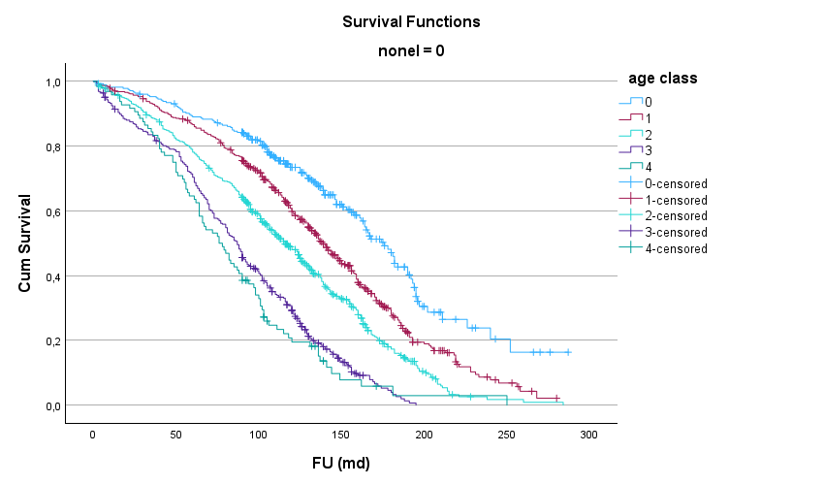
1 month 60 months 120 months 180 months
0 274 242 138 44
1 465 399 245 71
2 552 431 222 53
3 384 270 103 6
4 95 61 15 2

Cum survival: cumulative survival; FU (md): follow-up in months; nonel=0: elective; age class 0: below 75y, age class 1: 70-75y; age class 2: 75-80y, age class 4: 80-85y, age class 5: 85 and older

Figure 2: effect of age categories for urgent SAVR: long-term mortality
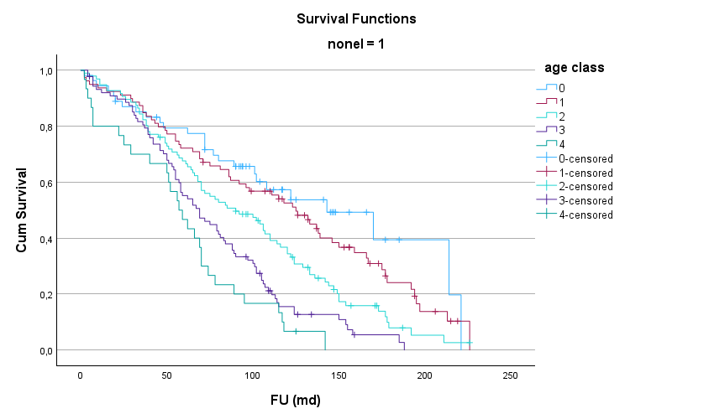
1 month 60 months 120 months 180 months
0 53 41 16 4
1 78 57 36 10
2 95 64 30 4
3 87 48 11 2
4 29 14 2 none
Cum survival: cumulative survival; FU (md): follow-up in months; nonel=1: urgent; age class 0: below 75y, age class 1: 70-75y; age class 2: 75-80y, age class 4: 80-85y, age class 5: 85 and older

Figures 3 and 4 demonstrate, stratified for elective status, the effect of age on 30-day and long-term mortality combined. In elective conditions, there is no significant age effect in the younger age categories (groups 0-2) on short-term outcome, while there is an age effect on hospital mortality in the older age (groups 3-4) categories. In urgent conditions, a higher 30-day mortality is observed for all age groups, but the results are catastrophic for patients of 85 years and older (category 5).

Figure 3: effect of age categories for elective SAVR: 30-day plus long-term mortality
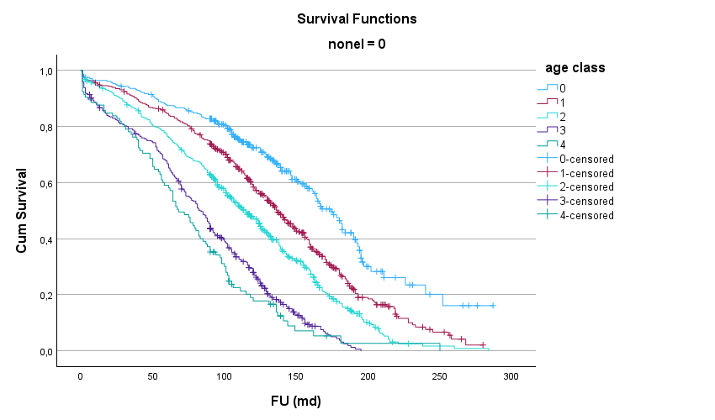
1 month 60 months 120 months 180 months
0 279 242 136 43
1 476 399 245 71
2 564 431 222 53
3 405 270 103 6
4 104 62 15 2
Cum survival: cumulative survival; FU (md): follow-up in months; nonel=0: elective; age class 0: below 75y, age class 1: 70-75y; age class 2: 75-80y, age class 4: 80-85y, age class 5: 85 and older

Figure 4: effect of age categories for urgent SAVR: 30-day plus long-term mortality

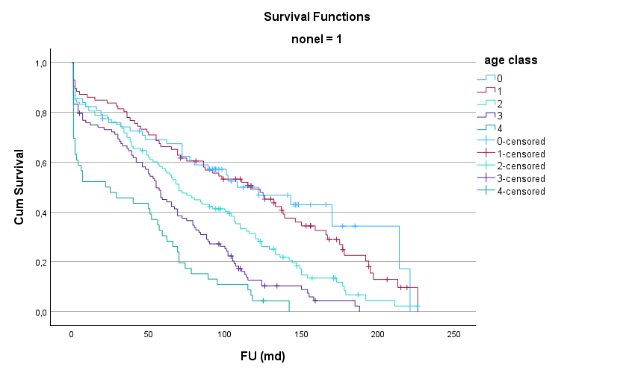
1 month 60 months 120 months 180 months
0 61 41 16 3
1 85 57 36 10
2 112 64 30 4
3 107 48 11 1
4 45 14 2 0
Cum survival: cumulative survival; FU (md): follow-up in months; nonel=1: elurgent; age class 0: below 75y, age class 1: 70-75y; age class 2: 75-80y, age class 4: 80-85y, age class 5: 85 and older

Table ten shows the predictors for long-term mortality for the whole patient group and after stratification for elective status. Age over 80 and COPD were the only consistent predictors. Age over 80 years remained the dominant predictor, with an odds ratio over two.

Table 10: predictors for long-term mortality according to elective status
All patients Elective SAVR Urgent SAVR
Predictor OR 95%CI OR 95%CI OR 95%CI
Age > 80 years 2.19 1.82-2.63*** 2.25 1.83-2.76*** 2.11 1.55-2.87***
Malignancy 1.26 1.00-1.58* 1.31 1.02-1.69* -
COPD 1.35 1.08-1.70** 1.36 1.05-1.74* 1.73 1.23-2.42**
LVEF < 50% 1.33 1.09-1.64** 1.51 1.20-1.91*** -
PAD 1.58 1.29-1.93*** 1.60 1.29-2.00*** -
CKD 1.43 1.15-1.78** 1.53 1.21-1.94*** -
NYHA class III/IV 1.46 1.20-1.78*** 1.45 1.18-1.79*** -
Atrial fibrillation 1.25 1.03-1.53* - - 1.62 1.20-2.20**
Incomplete revascularization 1.34 1.03-1.75* - - 1.79 1.04-3.08*
CKD: chronic kidney disease; COPD: chronic obstructive pulmonary disease, LVEF: left ventricular ejection fraction; NYHA: New York Heart Association; OR: odds ratio; 95%CI: 95% confidence interval; ***: p<0.001; **: p<0.01, *: p<0.05

Discussion
Several observations can be made from this investigation. The rate of need for urgent surgery resembled closely those in recently performed studies [9,10]. The development towards a need for urgent SAVR was higher in patients older than 80 years and more so with age over 85 years, but only in a univariate analysis. This age effect was observed earlier [7]. The main predicting factors for the need for urgent SAVR were endocarditis, prior episodes of congestive heart failure, myocardial infarction and involvement of the left main coronary artery. For the latter two factors, severe CAD was often the driver for a cardiac surgical procedure, which also included CABG. In the current series, chronic kidney and pulmonary disease were non-cardiac predictors. The need for urgent SAVR was associated with an increased need for resources, most postoperative adverse events and most significantly with 30-day mortality. Thirty-day mortality increased significantly in patients over 80 years and even more in patients over 85 years. Stratification for elective status showed that the increase of mortality with age in patients undergoing elective SAVR was less sharp. In the urgent patient group, 30-day mortality was much higher at any age, but the level became catastrophic for patients above 85 years. The need for urgent SAVR was the dominant predictor for 30-day mortality, followed by age over 80 years. A comparable observation was made earlier for patients undergoing SAVR with and without CABG [11]. In the subsequently performed logistic regression analysis, stratified for the three age groups, the need for urgent SAVR was the strongest and only common predictor for 30-day mortality. Conversely, after stratification for elective status, age over 80 years was its strongest predictor. Unsurprisingly, long-term survival is affected by age but also by the need for urgent SAVR. The incremental decrease in survival by 5-year age classes is comparable to the decreased survival caused by the need for urgent SAVR. Additionally, the effect of a need for urgent surgery has had a devastating effect on global postoperative mortality in older patients, especially in patients of 85 years and older.
The importance of a timely aortic valve replacement is illustrated by the risk for rapid functional deterioration in patients with untreated severe aortic stenosis and should therefore be advocated [12]. There is a reasonable assumption that a delayed diagnosis or treatment of aortic valve disease is also an important factor in the decrease of compensatory mechanisms of the left ventricle to maintain an adequate circulation, which would result in a need for urgent valve replacement. A recent review showed that only about half of the patients with symptomatic severe aortic stenosis underwent aortic valve replacement within 2 years of diagnosis. Of the patients with a normal LVEF and a class I indication for aortic valve replacement, either by TAVI or by SAVR, only 70% received a timely valve prosthesis. For patients with reduced LVEF, this was only 53%. For patients with a low-flow low-gradient AS, the percentages were even lower [13]. Several reasons for delayed valve replacement have been observed. These include diagnostic barriers, such as an uncertain symptomatic status, a doubtful significance of cardiac murmur, and a delay in transferring to a cardiac center after a transthoracic echocardiography ordered by a non-cardiologist. Treatment barriers such as delay in transfer, inadequate reimbursement, unavailability of ICU beds, or a perceived futility of valve replacement could contribute to a delayed valve replacement [13,14]. Patient-related factors such as high age, and comorbid conditions such as a history of stroke, COPD, low LVEF, CAD, diabetes, obesity [15,16], as well as refusal of surgery by patients [17] could also delay an adequate treatment of the valve disease. Deprivation, accompanied by low health index scores has been a serious issue in some regions and countries [9,10,18]. The delay of SAVR in patients with AS can result in a higher preoperative mortality rate [14,19]. Earlier published results showed that a delayed SAVR, high New York Heart Association (NYHA) functional class and old age, resulted in an increased postoperative early and long-term mortality. This effect was already apparent with a delay of effective treatment of three months. The functional NYHA class seems to operate independently from delay of treatment. The effect of delay is more pronounced in patients who also suffer from CAD [14].
Factors associated with the need for urgent valve replacement seem to run parallel to the factors associated with delayed valve replacement. Heart failure, within or without the context of endocarditis, reduced LVEF and cardiogenic shock were reasons for urgent intervention [9,20-22]. In case of TAVI as choice of treatment, the procedural success and the adjusted 30-day mortality were comparable to the outcome in elective cases, but the 1-year mortality was higher in urgent cases [23]. The urgency for TAVI can be illustrated by the IMPACT score, which enables accurate risk stratification, identifying patients who require urgent intervention [24]. The presence of advanced symptoms and need for urgent or emergent intervention was associated with an increased postoperative mortality rate [9,10]. The overall length of stay and in the ICU with financial cost was also higher, while discharge to home was lower [9]. The need for urgent TAVI resulted in a higher 30-day mortality [20,25,26] and 1-year mortality [25]. An initial refusal of TAVI also resulted in worse outcome. However, age, surgical risk scores, and frailty were higher in the refusal group than in the non‐refusal group [17] which makes interpretation of the results more difficult. Nevertheless, valve replacement by either method is feasible in urgent conditions.
This is a retrospective series with all its inherent limitations. The risk of selection bias has been reduced by consecutive inclusion of all patients undergoing SAVR with a biological valve. Patients with an unknown elective status were excluded from this analysis. This group underwent SAVR before 2000, which could introduce a bias. However, the rate of the need for urgent SAVR and the long-term outcome did not change significantly over time, thereby reducing this risk for inclusion bias. Most important preoperative comorbid conditions were included in this analysis. This could raise the issue of unadjusted multiple comparisons. This is addressed by the identification of the independent predictors for urgent SAVR. Patients needing urgent SAVR were not separated from those needing emergency surgery (i.e. within hours after admission), which would have complicated the analysis. The changes in operative techniques and improvement in perioperative care throughout the long inclusion period were not considered in the analysis. Earlier published results [27] showed that over time, patient age, comorbidity rate and complexity of surgery increased, with a concomitant non-significant increase in early mortality, but without affecting long-term survival. These findings were true for both isolated SAVR and SAVR combined with another procedure such as CABG. However, the effect of increased complexity of surgery and those of improved operative techniques and perioperative care could not be disentangled. Patient refusal, any index for health deprivation, ethnicity or socio-economic status as reason for delay were not investigated. The major strengths of the paper are the large patient numbers, the stratified analysis, the long follow-up duration and parallel identification of predictors for the outcome in different age categories, with respect to elective status.

Conclusions
The need for urgent SAVR was predicted mainly by cardiac factors. The need for urgent SAVR was associated with an increased 30-day mortality, postoperative complication rate and need for resources. The effect on mortality was most marked in the older age groups. Age and need for urgent SAVR were the most important independent predictors for 30-day mortality. Need for urgent SAVR also reduced the long-term survival with about 2 years for all age classes. The effect of the need for urgent SAVR has devastating effects on elderly patients who seem to be more vulnerable to this condition. Improved screening efforts for aortic valve disease and timely treatment may reduce adverse postoperative outcomes, the need for postoperative resources and improve long-term survival. Especially in elderly patients, valve replacement, once indicated should not be postponed until all cardiac mechanisms to maintain an adequate circulation are exhausted.

Author Contributions: Conceptualization, W.M.; methodology, W.M. and I.D.; formal analysis,
W.M. and I.D.; investigation, W.M., I.D., K.D. and A.V.; data curation, W.M., I.D., K.D. and A.V.
writing—original draft preparation, W.M.; writing—review and editing, W.M., I.D., K.D. and A.V. All
authors have read and agreed to the published version of the manuscript.

This study was approved by the ZNA ethical committee under the protocol N° 2656

There was no funding to perform this study.

There are no acknowledgements to be made

There are no conflicts of interest to declare

References
[1] Pellikka PA, Sarano ME, Nishimura RA, Malouf JF, Bailey KR, Scott CG, Barnes ME, Tajik AJ. Outcome of 622 adults with asymptomatic, hemodynamically significant aortic stenosis during prolonged follow-up. Circulation. 2005 Jun 21;111(24):3290-5. doi: 10.1161/CIRCULATIONAHA.104.495903.
[2] Carabello BA. Introduction to aortic stenosis. Circ Res. 2013;113:179–185. doi: 10.1161/circresaha.113.300156
[3] Owens DS, Bartz TM, Buzkova P, Massera D, Biggs ML, Carlson SD, et al. Cumulative burden of clinically significant aortic stenosis in community-dwelling older adults. Heart. 2021;107:1493-1502. doi: 10.1136/heartjnl-2021-319025.
[4] Willner N, Prosperi-Porta G, Lau L, Nam Fu AY, Boczar K, Poulin A, et al. Aortic Stenosis Progression: A Systematic Review and Meta-Analysis. JACC Cardiovasc Imaging. 2023;16:314-328. doi: 10.1016/j.jcmg.2022.10.009.
[5] Joseph J, Naqvi SY, Giri J, Goldberg S. Aortic Stenosis: Pathophysiology, Diagnosis, and Therapy. Am J Med. 2017;130:253-263. doi: 10.1016/j.amjmed.2016.10.005.
[6] Li SX, Patel NK, Flannery LD, Selberg A, Kandanelly RR, Morrison FJ, Kim J, Tanguturi VK, Crousillat DR, Shaqdan AW, et al. Trends in utilization of aortic valve replacement for severe aortic stenosis. J Am Coll Cardiol. 2022;79:864–877. doi: 10.1016/j.jacc.2021.11.060
[7] Mistiaen W, Deblier I, Dossche K, Vanermen A. Clinical Outcomes after Surgical Aortic Valve Replacement in 681 Octogenarians: A Single-Center Real-World Experience Comparing the Old Patients with the Very Old Patients. Geriatrics (Basel). 2024;9:44. doi: 10.3390/geriatrics9020044.
[8] Mistiaen W, Van Cauwelaert P, Muylaert P, Wuyts F, Harrisson F, Bortier H. Risk factors and survival after aortic valve replacement in octogenarians. J Heart Valve Dis. 2004;13:538-44. PMID: 15311858.
[9] Ebinger JE, Gupta A, Huang TY, Kelley MA, Thompson C, Platanis M, et al. Differential Characteristics and Outcomes of Urgent/Emergent Versus Elective Aortic Valve Replacement. J Am Heart Assoc. 2025;14:e041148. doi: 10.1161/JAHA.125.041148.
[10] Omoregbee BI, Kesieme EB, Ngaage DL. Postcode health inequalities in aortic valve surgery in North East England: retrospective study of disparities in presentation and hospital outcomes. BMJ Public Health 2025;3:e001336. doi:10.1136/ bmjph-2024-001336
[11] Deblier I, Dossche K, Vanermen A, Mistiaen W. The effect of coronary ischaemia associated with aortic valve disease: outcome of treatment modalities. Acta Cardiol. 2025;80:774-784. doi: 10.1080/00015385.2024.2431760.
[12] Rosenhek R, Zilberszac R, Schemper M, Czerny M, Mundigler G, Graf S, et al. Natural history of very severe aortic stenosis. Circulation. 2010;121:151-156. doi: 10.1161/circulationaha.109.894170
[13] Reisman AM, Elmariah S. A Review of "Access to Care" Issues in Aortic Stenosis Patients: A Negative Report Card. Struct Heart. 2024;9:100351. doi: 10.1016/j.shj.2024.100351.
[14] Gjertsson, P., Caidahl, K., Odén, A., & Bech-Hanssen, O. Diagnostic and referral delay in patients with aortic stenosis is common and negatively affects outcome. Scandinavian Cardiovascular Journal, 2007;41,12–18. https://doi.org/10.1080/14017430601115935
[15] Ram C, Yousef S, Ma WG, Vallabhajosyula I, Singh S, Agarwal R, et al. Living in disadvantaged neighborhoods linked to less intervention for severe aortic stenosis. Sci Rep. 2024;14:4952. doi: 10.1038/s41598-024-52660-w.
[16] Ro R, Khera S, Tang GHL, Krishnamoorthy P, Sharma SK, Kini A, et al. Characteristics and outcomes of patients deferred for Transcatheter aortic valve replacement because of COVID-19.
JAMA Netw Open. 2020;3:e2019801–e2019801. doi: 10.1001/jamanetworkopen.2020.19801
[17] Shimura T, Yamamoto M, Kano S, Hosoba S, Sago M, Kagase A, et al; OCEAN‐TAVI Investigators. Patients Refusing Transcatheter Aortic Valve Replacement Even Once Have Poorer Clinical Outcomes. J Am Heart Assoc. 201818;7:e009195. doi: 10.1161/JAHA.118.009195.
[18] Gupta A, Mori M, Wang Y, Pawar SG, Vahl T, Nazif T, et al. Racial/Ethnic Disparities in Aortic Valve Replacement Among Medicare Beneficiaries in the United States, 2012-2019. Am J Med. 2024;137:321-330.e7. doi: 10.1016/j.amjmed.2023.12.026.
[19] Crousillat DR, Amponsah DK, Camacho A, Kandanelly RR, Bapat D, Chen C, et al. Racial and Ethnic Differences in the Clinical Diagnosis of Aortic Stenosis. J Am Heart Assoc. 2022; 11:e025692. doi: 10.1161/JAHA.122.025692.
[20] Slade JJ, Ambrosy AP, Leong TK, Sung SH, Garcia EA, Ku IA, et al. Outcomes of Adults with Severe Aortic Stenosis Undergoing Urgent or Emergent vs. Elective Transcatheter Aortic Valve Replacement Within an Integrated Health Care Delivery System. Struct Heart. 2023;7:100166. doi: 10.1016/j.shj.2023.100166.
[21] de la Cuesta M, Marin-Cuartas M, de Waha S, Milojevic M, Myers PO, Misfeld M, Quintana E, et al. Surgical Implications of the 2023 ESC Endocarditis Guidelines Endorsed by EACTS: Bridging Guidelines and Practice. Eur J Cardiothorac Surg. 2025;67:ezaf225. doi: 10.1093/ejcts/ezaf225.
[22] Mistiaen WP. What are the main predictors of in-hospital mortality in patients with infective endocarditis: a review. Scand Cardiovasc J. 2018;52:58-68. doi: 10.1080/14017431.2018.1433318.
[23] Zhou JY, Nanayakkara S, Johnston R, Gardner E, Gartner E, Fernando R, et al. Urgent vs Elective Transcatheter Aortic Valve Replacement in Patients With Severe Aortic Stenosis. JACC Adv. 2025;4:102039. doi: 10.1016/j.jacadv.2025.102039.
[24] Shamekhi J, Ebert M, Lorek A, Eckardt I, Al-Kassou B, Basha MM, et al. Fighting time: the critical importance of pre-TAVR mortality risk prediction. Clin Res Cardiol. 2025;114:1565-1573. doi: 10.1007/s00392-025-02698-1.
[25] Kolte D, Khera S, Vemulapalli S, Dai D, Heo S, Goldsweig A, et al. Outcomes Following Urgent/Emergent Transcatheter Aortic Valve Replacement: Insights From the STS/ACC TVT Registry. JACC Cardiovasc Interv. 2018;1:1175-1185. doi: 10.1016/j.jcin.2018.03.002.
[26] Apostolos A, Ktenopoulos N, Chlorogiannis DD, Katsaros O, Konstantinou K, Drakopoulou M, et al. Mortality rates in patients undergoing urgent versus elective transcatheter aortic valve replacement: a meta-analysis. Angiology. 2024;33197241245733. doi: 10.1177/00033197241245733
[27] Deblier I, Dossche K, Vanermen A, Mistiaen W. The Outcomes for Different Biological Heart Valve Prostheses in Surgical Aortic Valve Replacement before and after the Introduction of Transcatheter Aortic Valve Implantation. Prosthesis 2024, 6, 708-725. https://doi.org/10.3390/prosthesis6030050

