Szombathy Zoltán
April 2026
Table of Contents

Tourism Real Estate and AI-Based Hospitality: How Algorithmic Operations Are Reshaping the Value Stack in Southeast Europe
A thought leadership paper on the convergence of artificial intelligence, hospitality operations and tourism property investment across Serbia, Montenegro, Croatia and the Mediterranean periphery.

Standfirst
Southeast Europe's tourism economy has emerged from the post-pandemic cycle stronger than almost any other European subregion, with foreign arrivals in Serbia running roughly 40% above Q2 2019 levels in Q2 2024 and Montenegro capturing a 31% larger share of the European market than it held before the pandemic. In parallel, artificial intelligence is moving from marketing novelty to operational infrastructure inside hotels, serviced apartments and short-term rentals. In this paper we assess how that convergence — rapid demand growth meeting algorithmic operations — is beginning to reset the value stack for tourism real estate in the region. We examine revenue management, short-term rentals, guest experience, destination-level data systems, and what all of this means for cap rates and asset selection.

Key Takeaways
- Demand is running hot but margins, not arrivals, will decide the next cycle. Southeast Europe posted stronger post-pandemic recovery than the European average, but operating leverage is where AI is moving the needle. Dynamic pricing, automated guest communications and predictive labour scheduling are already visible in regional portfolios — and they disproportionately benefit well-capitalised, professionally managed assets.
- The short-term rental segment is professionalising faster than the branded hotel stock. AirDNA's European data shows record demand in 2024 with Croatia's occupancy rising 10.6% year-on-year in 2025 despite flat supply, while Greece's active listings have overtaken Croatia at 130,000-plus. AI pricing and property management tools are closing the operational gap with branded hotels and changing the investment case for residential-to-tourism conversion.
- Investor discipline will matter more than ever. European hotel transactions reached €22.4 billion in 2024 — the highest since 2019 — and Cushman & Wakefield has explicitly flagged a "restart" of deal flow in Central, Eastern and South Eastern Europe. In a market where algorithmic revenue management can lift RevPAR meaningfully, underwriting that does not adjust for AI-enabled operating uplift will either misprice risk or leave returns on the table.

The region entered 2025 with a tailwind few investors anticipated
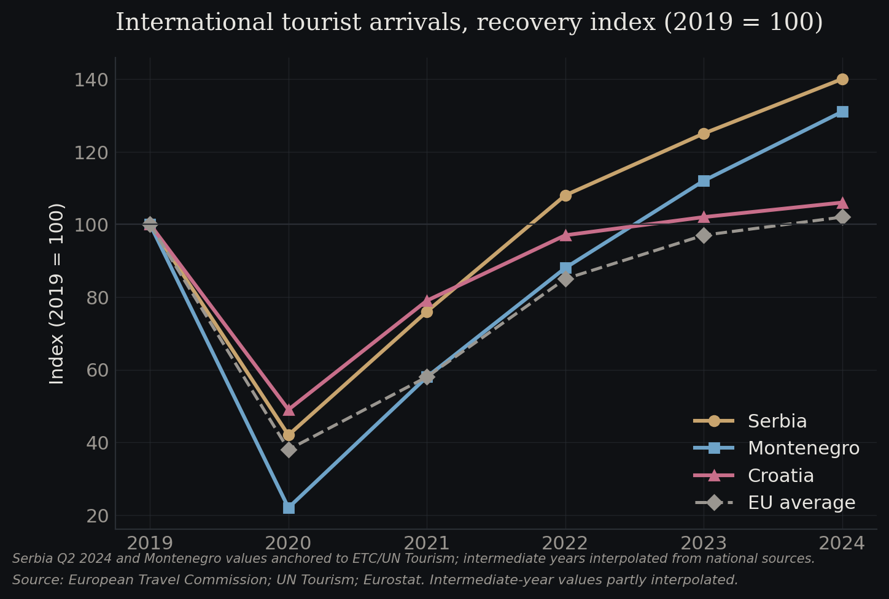
Figure 1.1 — International tourist arrivals, recovery index (2019 = 100)
Source: European Travel Commission; UN Tourism; Eurostat. Intermediate-year values partly interpolated.
Southeast Europe's tourism fundamentals have strengthened faster than the continental average. According to the European Travel Commission, foreign arrivals to Serbia in Q2 2024 stood approximately 40% above the same quarter of 2019, with overnight stays up 69% on the pre-pandemic benchmark; full-year 2024 foreign arrivals grew 11.7% year-on-year to 2.38 million. Montenegro's share of European arrivals was up 31% relative to 2019 over the same window. Croatia, the regional bellwether, continued to record the highest tourism intensity of any Mediterranean EU member, at 24 nights per inhabitant in 2023, with travel receipts representing 18.7% of GDP — a figure that dwarfs both Greece (9.1%) and the EU average. In Q2 2025, international tourist arrivals across Europe grew a further 3.3% year-on-year, with U.S. inbound to Croatia, Montenegro and Greece each growing 16–18%.
This is not a story of broad European recovery; it is a story of differential performance. The SEE arc — from the Croatian coast through Montenegro, into Serbia's urban hubs and onward to the Greek islands — has outperformed because it combines price positioning (still well below Western Mediterranean benchmarks), cultural programming (Novi Sad's European Capital of Culture cycle, the EXIT festival that continues to draw ~200,000 attendees to Petrovaradin Fortress each July), and proximity to source markets in Germany, Austria and the Nordics.
That demand backdrop matters because it sets the stage for what AI can and cannot do. In a structurally weak market, algorithmic revenue management at best defends margin. In a structurally growing market, it converts occupancy into disproportionate RevPAR gains and, by extension, into higher NOI and lower exit cap rates. SEE is increasingly the latter.

Revenue management is quietly becoming the dominant source of operating alpha
The 2024 Deloitte European Hotel Industry and Investment Survey found that only about one in ten European hoteliers had fully implemented AI solutions, with another fifth in pilot phase. The remainder were either exploring or not yet considering the technology. That headline conceals a more important shift: among the adopters, revenue management is consistently the first workflow to be AI-enabled. Deloitte's own case material cites a global chain lifting RevPAR after deploying a machine-learning revenue management tool that ingests historical bookings, competitor rates and local event calendars to generate granular pricing recommendations in near real time.
For SEE, the implications are specific. Properties in Belgrade, Novi Sad, Split, Dubrovnik and the Bay of Kotor face some of the most extreme seasonality and event-driven demand spikes in Europe — EXIT week in Novi Sad, Ultra Europe in Split, the summer yachting season in Tivat. Static pricing grids leave material revenue on the table in these windows and erode occupancy in the shoulder months. AI-driven revenue management systems, whether embedded in IDeaS, Duetto, Atomize or the in-house platforms of regional chains, compress that gap.
Deloitte's UK hospitality team further notes that roughly a quarter of hospitality executives now see generative AI as a lever for the finance function — anomaly detection, forecasting, stress testing cashflow models. For an investor underwriting a hotel in Kotor or a serviced-apartment complex in Belgrade's Dorćol, the practical question is no longer whether the incoming operator uses a modern revenue management system, but how mature their data infrastructure is, how clean the historical pickup data is, and whether the property management system exposes the API surface needed for these tools to function. This is a due diligence dimension that barely existed five years ago.

The short-term rental segment is reorganising itself around software
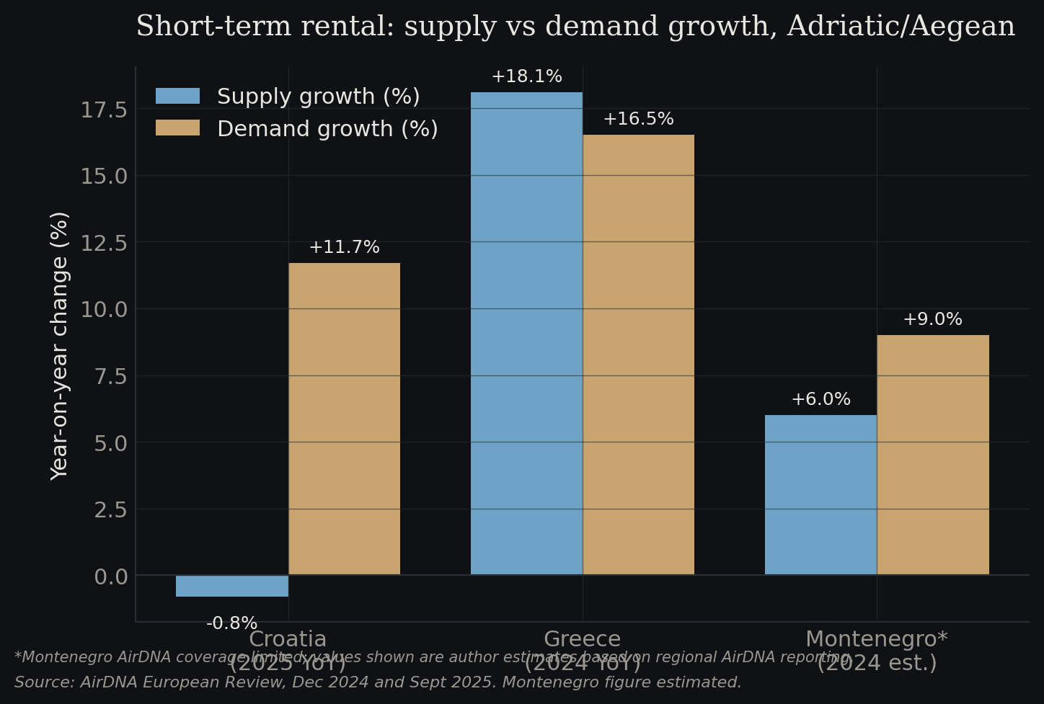
Figure 1.2 — Short-term rental: supply vs demand growth, Adriatic/Aegean
Source: AirDNA European Review, Dec 2024 and Sept 2025. Montenegro figure estimated.
AirDNA's December 2024 European review described the year as one of record demand and resilient occupancy despite slowing ADR growth as supply caught up with post-pandemic travel. Within the European set, the SEE corridor is among the most dynamic. In Croatia, 2025 data shows supply falling 0.8% while demand rose 11.7%, pushing occupancy up 10.6% year-on-year — a tightening that is difficult to engineer deliberately and that reflects both regulatory friction on new listings and the continued professionalisation of existing stock. Greece has pushed past 130,000 active listings, overtaking Croatia in total supply and moving toward the status of Europe's sixth-largest short-term rental market.
The operators capturing the upside are increasingly software-native. AI-driven dynamic pricing tools (PriceLabs, Wheelhouse, Beyond) have moved from a power-user niche to mainstream deployment. Automated guest communication platforms handle the multilingual check-in flow that a regional market serving German, Austrian, French, Israeli, Turkish and Anglophone travellers demands. Predictive maintenance alerts, smart-lock integrations and dynamic cleaning schedules are collapsing the operational distance between a thirty-unit STR portfolio and a three-star hotel.
For real estate investors, this changes the calculus of residential-to-tourism conversion. A Belgrade city-centre apartment or a Budva seafront unit is a different asset when it is operated by a platform that can extract near-hotel-level yield with sub-hotel-level overhead. It also means that the gap between sophisticated and unsophisticated STR operators is widening rather than narrowing: regulatory tightening across the Adriatic is reducing supply growth, and the operators who can extract the most yield per available night are the ones best positioned to absorb higher acquisition costs.

Guest experience automation is reframing the operating model
Southeast Europe has a structural labour problem. Seasonal hospitality workers are scarce and becoming more expensive; Croatia has imported tens of thousands of workers from South and Southeast Asia to fill summer roles. Montenegro faces a similar constraint with a narrow labour base on the coast. In this context, AI-driven guest experience automation is not a technology story, it is a margin story.
Chatbots for pre-arrival communication, AI concierge interfaces in-room, contactless check-in kiosks and automated upsell engines are each individually small. Together they shift the front-office labour requirement meaningfully — Deloitte and HRS International have both noted that European hoteliers report 15–30% reductions in specific front-office tasks after AI deployment, though headcount reductions are less dramatic because the labour freed is often redeployed to higher-touch roles. The resulting GOP margin uplift compounds with revenue management gains and flows directly into valuation multiples.
Regional examples are still emerging rather than established. Hunguest Hotels in Hungary and CEE-focused operators like Radisson CEE have rolled out AI-assisted guest platforms across properties in Budapest, Belgrade and the Adriatic. Lustica Bay in Montenegro and Porto Montenegro in Tivat — the latter a TYHA Platinum-accredited superyacht marina with 460 berths today and an anticipated build-out to around 850 berths — have integrated digital guest journeys as part of the luxury proposition. The investment implication is that new-build tourism real estate is being specified with the data and connectivity infrastructure to support these systems natively, while older stock will require a meaningful capex cycle to catch up. In underwriting, this is becoming a standalone line item.

Destination-level data is the next frontier, and it is uneven
Individual properties can only optimise so far. The next layer of value comes from destination-level data: visitor flow models that predict when Dubrovnik's old town will hit saturation, arrival forecasts that let Montenegro's border authorities stage capacity, seasonality management that nudges demand from the August peak into May and October. Barcelona, Amsterdam and Venice have each invested in AI-driven destination management platforms; Dubrovnik's overtourism controls have drawn on similar thinking.
In SEE, adoption is patchy. Croatia's National Tourist Board has invested in digital analytics, and the Istria region operates one of the more mature destination data platforms in the region. Belgrade and Novi Sad, having absorbed the European Capital of Culture cycle, are developing event-led visitor data capabilities. Serbia's Tourism Organisation has partnered on digitalisation projects funded through EU IPA instruments. Montenegro, with tourism representing around a quarter of GDP, has the greatest economic incentive but the most limited institutional capacity.
For investors, destination-level data matters because it shapes the regulatory environment in which their assets operate. A destination that can predict and manage overcrowding is less likely to impose blunt caps on new hotel capacity or STR licences. A destination without that capacity is more likely to regulate by instinct — a risk vector that is increasingly material across the Adriatic as political pressure on short-term rentals intensifies.

Investment implications: cap rates, asset selection and the underwriting delta
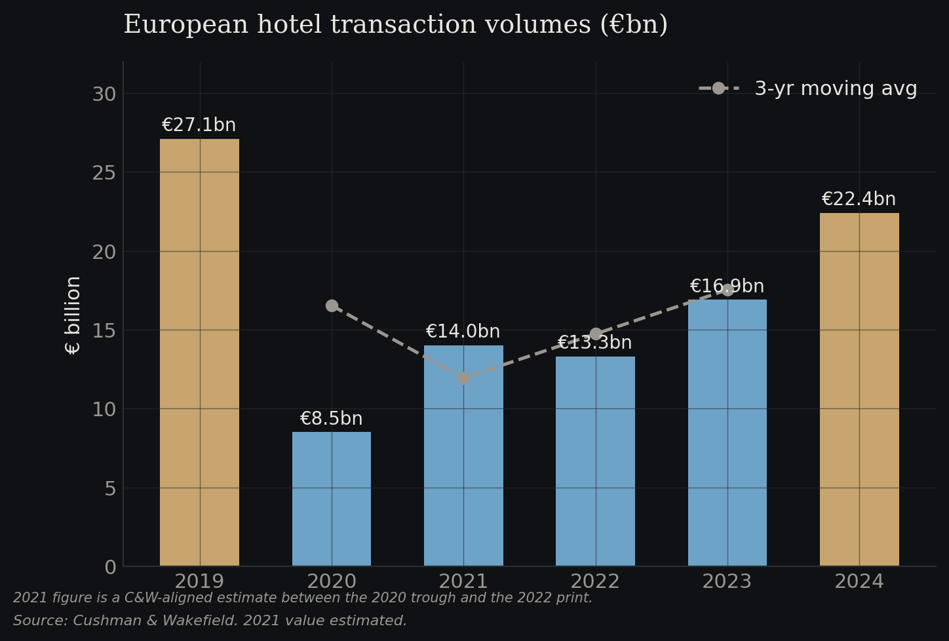
Figure 1.3 — European hotel transaction volumes (€bn)
Source: Cushman & Wakefield. 2021 value estimated.
European hotel transaction volumes reached €22.4 billion in 2024 — a 37% year-on-year increase and the strongest print since 2019 — with the UK, Spain and France accounting for 59% of flow. Cushman & Wakefield noted that while Western Europe dominated, there was a visible "restart" of deal activity in Central, Eastern and South Eastern Europe, driven by improved financing conditions and attractive yields relative to core markets. In Montenegro, foreign real estate investment totalled approximately €455 million in 2024, with top source markets being Serbia, Turkey, Germany, Russia and the United States, and national property prices rising 20.8% — more than five times the EU average of 3.6%.
Three investment implications follow.
First, AI-enabled operating uplift should be explicitly modelled in underwriting. A property operated by a franchise using modern revenue management and guest automation will outperform an identical asset under legacy operations by enough to justify a different entry price. The simplistic "same hotel, same cap rate" comparison is increasingly misleading.
Second, asset selection should weight data and connectivity infrastructure more heavily. Older hotel stock in Belgrade, Split or Thessaloniki may offer headline yield attractiveness, but the capex required to bring the property into an AI-ready operating environment — PMS integration, connectivity, smart-room specification — is non-trivial and often underestimated at acquisition.
Third, residential-to-tourism conversion opportunities in Adriatic and Aegean secondary locations should be assessed in the context of the STR platform ecosystem rather than as standalone assets. The yield differential between an owner-managed STR and a platform-operated one, using AI pricing and automated guest communications, is widening. Aggregation plays — portfolios of 30–200 units under a single management platform — are becoming a distinct asset class and are increasingly financeable.

Outlook
The SEE tourism real estate story for the next five years is fundamentally constructive. The demand backdrop is among the strongest in Europe, the regional cost base remains competitive, and the operational technology stack is maturing rapidly. AI is not the reason this market will grow — demographics, lifestyle shifts and price differentials would carry it regardless — but AI is likely to be the reason that some operators and some investors capture disproportionate returns while others underperform.
The central uncertainty is regulatory. Short-term rental regulation is tightening across the Adriatic, destination-level overtourism pressure is rising in Dubrovnik, Kotor and the most popular Greek islands, and the political economy of tourism is shifting as local populations push back against displacement and seasonality pressures. A well-designed AI and data infrastructure at the destination level can ease that pressure; a poorly managed one will intensify it. Investors should track regulatory trajectory as carefully as they track RevPAR.
Our directional view is that, over the next cycle, the dispersion of returns across SEE tourism assets will widen materially — and AI adoption, both at the property and destination level, will be one of the strongest explanatory variables for that dispersion. Passive exposure to the region will deliver solid returns on the strength of the demand backdrop alone. Active, operationally aware exposure, with underwriting that explicitly prices the AI operating delta, will deliver meaningfully better ones.

Sources
- European Travel Commission, European Tourism: Trends & Prospects (Q4 2024 and Q2 2025 reports). etc-corporate.org
- Eurostat, Tourism statistics and Housing in Europe – 2025 edition. ec.europa.eu/eurostat
- Deloitte, European Hotel Industry and Investment Survey 2024 and 2025 edition. deloitte.com/uk
- Deloitte UK, Embracing the future: AI revolutionising operations and consumer engagement. deloitte.com/uk
- AirDNA, European Review December 2024: Record Demand Caps a Strong Year for STRs and subsequent monthly reviews through 2025. airdna.co/blog
- Cushman & Wakefield, European Hotel Deal Volumes Surge to Five-Year High (2024) and Hospitality Market Beat. cushmanwakefield.com
- Henley & Partners, Centi-Millionaire Report 2024 — Porto Montenegro. henleyglobal.com
- Global Property Guide, Montenegro's Residential Property Market Analysis 2025. globalpropertyguide.com
- UN Tourism, World Tourism Barometer. unwto.org
- Hospitality Net / Statista, AI in hospitality adoption statistics (2024–2025).

