Szombathy Zoltán
April 2026
Table of Contents

PropTech and Property Valuation in the Western Balkans: How Algorithms, Digital Cadastres and EU Accession Are Unlocking a Previously Opaque Market
A thought leadership paper on the interaction between PropTech, automated valuation, land registry reform and institutional capital across Serbia, Bosnia & Herzegovina, Montenegro, North Macedonia, Albania and Kosovo.

Standfirst
The Western Balkans have long sat at the bottom of European real estate transparency rankings — a market structured around informal transactions, incomplete data, and investor trust built on relationships rather than records. That is now changing, driven by a convergence of digital cadastre reform, EU accession-linked regulatory harmonisation, and a young PropTech ecosystem that is beginning to fill the data vacuum. In this paper we assess how AI-enabled valuation, transaction analytics and registry digitalisation are reshaping the investment case for the region, what remains unresolved, and what this means for the institutional capital that has so far largely stayed on the sidelines.

Key Takeaways
- The data problem is finally being addressed at source. Serbia's Republic Geodetic Authority (RGZ) has fully digitised its real estate cadastre, reducing average case resolution times from 45 days to four and processing twenty-five times more cases with the same headcount as a decade ago. Comparable, if less advanced, reforms are under way in Montenegro, North Macedonia and Albania. Without this foundation, PropTech and AI valuation in the region would have nothing to build on.
- PropTech is emerging, but it is narrow and fragmented. The Western Balkans have produced credible names — City Expert and Kredium in Serbia, Rubik (Kosovo-founded), Hobsido (Balkans AVM), OTA Sync — but no regional platform has yet achieved the scale that would allow institutional investors to rely on algorithmic valuation as a primary underwriting tool. The ecosystem is roughly where Poland and Czechia stood in 2010.
- EU accession and institutional capital will co-move. Serbia and Montenegro's accession timelines — with 22 of 35 chapters opened for Serbia and a more advanced trajectory for Montenegro — anchor the regulatory convergence that institutional investors require. The EBRD has invested over €10.6 billion across nearly 400 projects in Serbia since 2001, and the EU accounts for nearly 40% of Serbia's total FDI stock. As transparency improves, institutional allocations to the region will follow on a lag.

The transparency problem is the first-order constraint
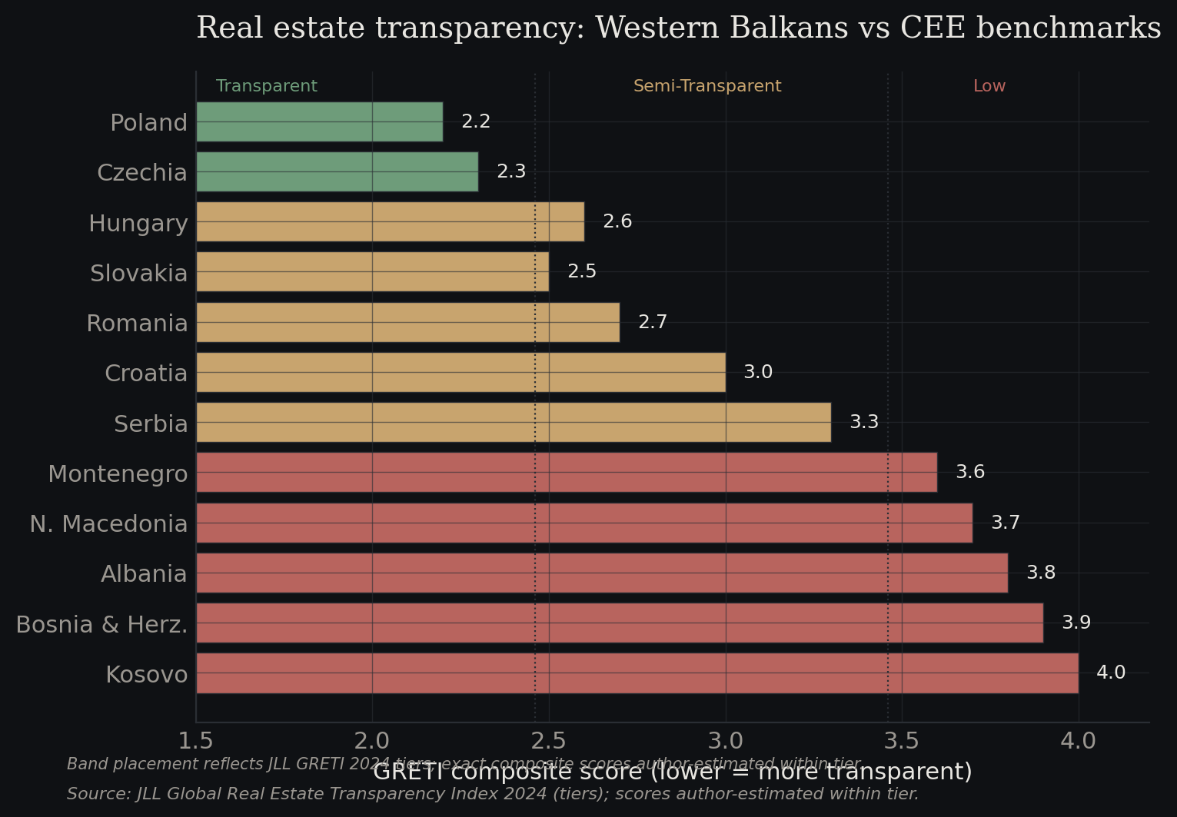
Figure 2.1 — Real estate transparency: Western Balkans vs CEE benchmarks
Source: JLL Global Real Estate Transparency Index 2024 (tiers); scores author-estimated within tier.
JLL's Global Real Estate Transparency Index, which covers 89 countries across six sub-indices and 256 underlying metrics, has consistently classified the Western Balkan markets in the "Semi-Transparent" or "Low Transparency" bands. Serbia tends to outperform its neighbours and sits at the higher end of that group; Bosnia and Herzegovina, Albania and Kosovo cluster lower. The practical effect of these rankings is visible in capital flows: institutional real estate allocators — large pension funds, insurance balance sheets, core and core-plus fund vehicles — have a hard floor of transparency below which they cannot deploy, and most of the Western Balkans sits below it.
This is not a minor technical issue. It determines whether a market is the object of institutional underwriting or of opportunistic, relationship-driven private capital. The CEE transparency catch-up story of the 2000s and 2010s — Poland, Czechia and, later, Romania moving from "Semi-Transparent" to "Transparent" status — was the precondition for core European real estate capital entering those markets at scale. The Western Balkans are attempting the same transition, but with structurally smaller market size and a more complex political geography.
The transparency deficit has three practical components: inconsistent or incomplete land and mortgage registries; limited published transaction data, particularly for commercial assets; and a valuation profession that is uneven in training, standards and enforcement. PropTech and AI interact with each of these, but only if the underlying administrative infrastructure exists.

Serbia's cadastre reform is the regional benchmark
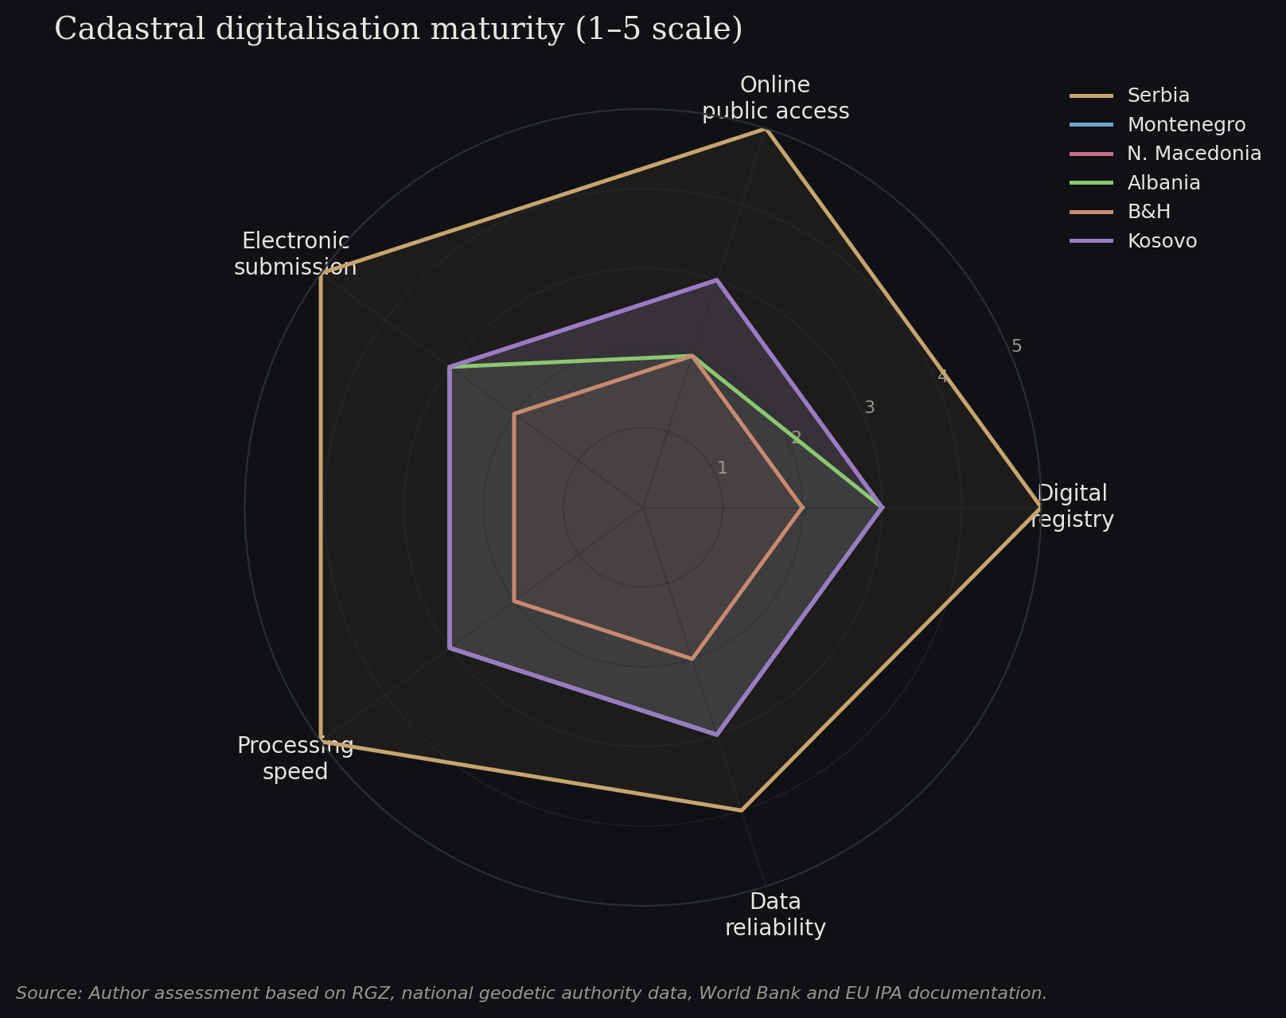
Figure 2.2 — Cadastral digitalisation maturity (1–5 scale)
Source: Author assessment based on RGZ, national geodetic authority data, World Bank and EU IPA documentation.
Serbia's Republic Geodetic Authority (RGZ) has, quietly, delivered one of the more impressive public-sector digitalisation programmes in the region. The real estate cadastre is now fully digital. As of 4 November 2023, all applications must be submitted electronically through professional users via the e-counter system. According to RGZ's own figures, the average resolution time for a cadastral case has fallen from 45 days to four, twenty-five times more cases are processed annually with the same headcount as in 2015, and an estimated €36 million in administrative fees has been saved for citizens over three years. The e-Cadastre public access portal allows users to query property data, registered rights and encumbrances without physical office visits.
Montenegro, North Macedonia and Albania have each advanced their cadastral systems, with varying coverage and data quality. Bosnia and Herzegovina's fragmented administrative structure — two entities and a district, each with separate registries — has made comprehensive reform more difficult, but entity-level digitalisation has progressed with World Bank and EU support. Kosovo has made material progress on a unified cadastre with ongoing donor assistance.
The importance of these reforms for PropTech cannot be overstated. Automated valuation models, transaction comparables analytics and due diligence platforms all require structured, queryable, reliable data at the property level. Without a digital cadastre, there is nothing for AI to analyse. With one, the door opens to a sequence of higher-order applications: AVMs, mortgage portfolio analytics, collateral monitoring, urban planning models, and cross-border investment platforms.

AVMs in a market with thin comparable data
Automated Valuation Models function by training on large, clean datasets of transaction comparables and property attributes. In mature markets — the UK, where over 70% of lenders reportedly use AVMs for low-risk residential mortgage origination, or the Netherlands, where AVMs are deeply embedded in the mortgage process — the data base is deep enough to allow high-confidence algorithmic outputs. In the Western Balkans, it is not.
The 2025 Joint Paper on the Use of Automated Valuation Models in Europe, published via the European Mortgage Federation, makes this explicit: in Serbia, Montenegro, Greece, Italy, Spain and Ukraine, AVMs are not currently used in mortgage origination. In Serbia, AVMs are deployed by official external valuers for re-evaluation of mortgages on housing loans as a form of mass statistical valuation, but without plans to use them as a primary model. TEGoVA's European Valuation Standards, effective from 1 January 2025 in their 10th edition, are explicit that AVM output cannot constitute a valuation without the approval of a qualified expert — a position echoed by RICS's 2024 Red Book updates around automation, AI and ESG.
This means that AVMs in the Western Balkans will, for the foreseeable future, operate as decision-support tools rather than standalone valuation instruments. That is not a ceiling on their utility — it is a design constraint. Decision-support AVMs can compress the time qualified valuers spend on routine residential work, standardise collateral assessment across mortgage portfolios, and surface outliers for closer review. Hobsido, a Balkans-focused AVM platform operating in Serbia, Croatia and Bulgaria, targets exactly this use case: property owners and intermediaries obtain instant indicative valuations, which then feed into a professional valuation workflow.
The more interesting algorithmic applications in the region are adjacent to AVMs rather than AVMs themselves: price index construction from listing and transaction data, yield surface mapping across micro-markets, and predictive models for liquidity and time-on-market. These require less data density than a robust AVM and can deliver meaningful analytical lift even where the underlying transaction record is incomplete.

A thin but credible PropTech ecosystem is forming
The Western Balkans have produced a PropTech cohort that, while small, is beginning to cover the main functional layers. Serbia and Romania together drove more than 50% of new startup projects in the CEE-Balkans region in 2024–2025, according to regional ecosystem trackers. Within Serbia, City Expert has built one of the more sophisticated residential transaction platforms in the region, combining virtual property tours, professional photography, 360-degree views and structured listing data. Kredium has extended from Serbia into the USA and UAE, providing a mortgage and real estate transaction infrastructure that begins to bridge domestic and cross-border buyers. OTA Sync offers a full property management and channel management system, used across accommodation providers regionally.
In Kosovo, Rubik — a PropTech platform focused on modernising real estate investment workflows — raised $3.5 million in 2024, a signal that international venture capital is beginning to look past the region's structural headwinds. Hobsido, covering Serbia, Croatia and Bulgaria, illustrates the cross-border approach that is likely to define scale in a region where individual markets are small.
What is missing is institutional scale. None of the Western Balkan PropTech names has yet reached the scale of, for example, Poland's Otodom (OLX Group), the Czech Sreality, or Hungary's Ingatlan.com — the dominant platforms with extensive traffic leads in their home markets. The resulting data asymmetry is one of the reasons Western Balkan markets remain dependent on international portals and consultant-led research rather than platform-generated market intelligence.

The role of EBRD, IFC and EU instruments
The multilateral development banks are playing a larger role in Western Balkan real estate than the headlines suggest. The EBRD has now invested over €10.6 billion across 404 projects in Serbia since 2001, with annual new commitments around €800 million sustained for three consecutive years, and has deployed a €100 million debt package to support sustainable commercial real estate development across the region. The Western Balkans Investment Summit, hosted by the EBRD in London in 2024, positioned real estate and infrastructure as core channels for institutional engagement.
The IFC, World Bank Group entities, and the Western Balkans Investment Framework (a joint EBRD / EIB / European Commission vehicle) are active across cadastre modernisation, municipal infrastructure and, indirectly, the data environment that PropTech and AVM platforms depend on. EU pre-accession instruments — IPA III for Serbia at €219.9 million for 2025–2027, of which €139.4 million is non-refundable grant — are increasingly targeting digital infrastructure. The Growth Plan for the Western Balkans, with an indicative €1.59 billion envelope through 2027, is explicitly linked to regulatory convergence milestones.
For private investors, the practical implication is that the regulatory and data environment is converging toward EU norms on a relatively predictable trajectory. A real estate thesis premised on that convergence — that transparency improves, that institutional capital follows, and that cap rates compress as a function of risk perception rather than cash flow — is now underwritable in a way it was not five years ago.

EU accession is the anchor of the institutional thesis
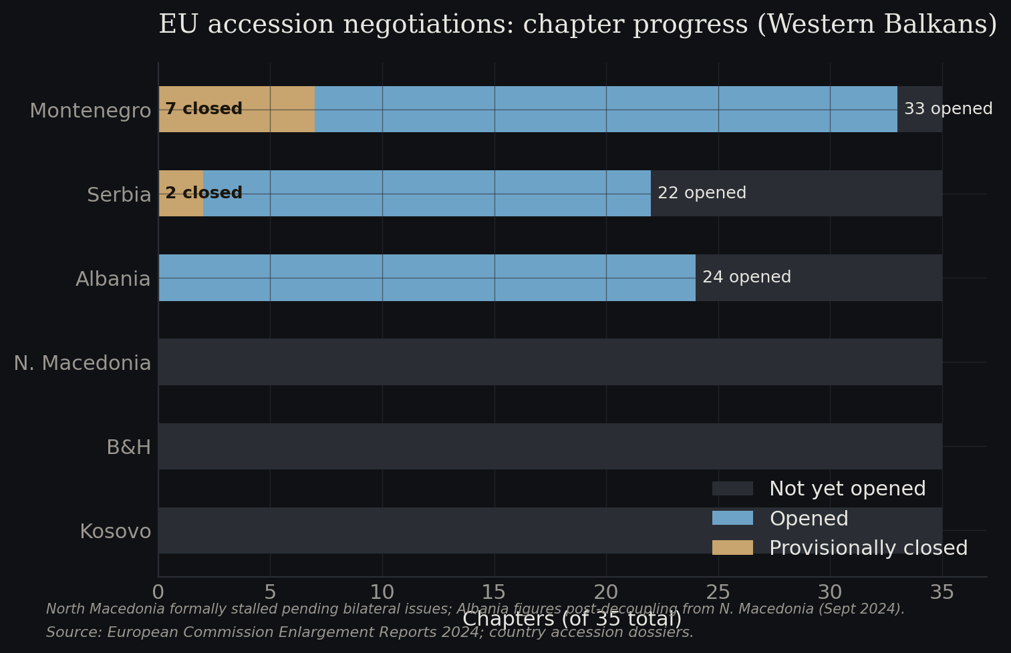
Figure 2.3 — EU accession negotiations: chapter progress (Western Balkans)
Source: European Commission Enlargement Reports 2024; country accession dossiers.
Serbia has opened 22 of 35 accession negotiation chapters, with two provisionally closed. The Serbian government's publicly stated ambition is to meet accession criteria by 2026–2027, though the actual accession date will depend on the EU enlargement cycle and cluster-level progress rather than domestic political timing. Montenegro is further advanced and remains the most likely next entrant. North Macedonia's trajectory has been slowed by bilateral disputes but remains open. Albania is on a parallel track to Montenegro. Bosnia and Herzegovina and Kosovo face longer horizons.
EU accession is not a single event; it is a multi-year convergence process in which regulatory harmonisation happens well before formal membership. For real estate, the accession-driven changes that matter most are land registry standards, valuation profession regulation, mortgage law, foreign ownership rules, and anti-money-laundering controls on property transactions. Each of these is already in progress.
Institutional capital tends to follow accession with a lag. Core-plus and value-add allocations to Poland accelerated in the mid-2000s, to the Czech Republic in the late 2000s, and to Romania from around 2013. The pattern is recognisable: opportunistic private capital enters a market several years before institutional capital, often capturing the largest risk-adjusted returns, while institutional capital arrives once transparency and liquidity thresholds are crossed and then compresses yields. The Western Balkans are in the early phase of that cycle.

Implications for investors
Three conclusions follow.
First, investors should distinguish between data problems that are structural and data problems that are transient. The Western Balkans' transparency deficit is partly structural — small market size, informal transaction history — but much of it is transient, being addressed in real time by cadastre reform, PropTech platform growth and EU convergence. Underwriting a long-hold position today implicitly requires a view on that trajectory.
Second, PropTech and AVM tools should be used as supplements to, not substitutes for, regional expertise. The data base is still too thin for algorithmic valuation to stand alone, but it is robust enough that refusing to use these tools leaves analytical value on the table. Serious investors in the region will increasingly combine local market intelligence with platform-generated price indices, yield surfaces and comparables analytics.
Third, the structural winners will be platforms that aggregate data across the region rather than operate in a single country. The Western Balkans are, in platform economics, a single market fragmented across six jurisdictions. Hobsido's tri-country footprint, Kredium's cross-border expansion and the regional ambitions of City Expert point to the direction that scale will take.

Outlook
The Western Balkans are transitioning from a market that international institutional capital could not reasonably analyse to one that it can — slowly, unevenly, but directionally. The transparency catch-up is real, it is policy-backed, and it is increasingly visible in the data infrastructure. AI and PropTech are not the drivers of this transition; cadastre reform, EU convergence and the growing sophistication of the domestic valuation profession are. But they are the accelerators, and they determine how quickly the improved data environment translates into improved pricing signals and institutional-grade investment vehicles.
The principal risks are political rather than technological. Serbian political volatility, the fragmented governance of Bosnia and Herzegovina, and episodic tensions along the Kosovo-Serbia axis can each interrupt the convergence trajectory. A regression on rule-of-law reforms in any of these jurisdictions would have a disproportionate impact on investor sentiment relative to its direct economic effect.
Our directional view is that the Western Balkans will, over the next five to seven years, move from the bottom of the JLL transparency index toward the middle band, and that this repricing of risk perception — not changes in cash flows — will be the dominant driver of capital returns in the region. Investors positioned ahead of that repricing, using both local expertise and the emerging PropTech toolkit, will capture the bulk of the upside.

Sources
- JLL, Global Real Estate Transparency Index 2024. jll.com
- Republic Geodetic Authority of Serbia (RGZ), e-Cadastre and agency publications. rgz.gov.rs
- European Mortgage Federation, Joint Paper on the Use of Automated Valuation Models in Europe, May 2025. hypo.org
- TEGoVA, European Valuation Standards, 10th edition (2025). tegova.org
- RICS, Valuation – Global Standards (Red Book), Basis for Conclusions, December 2024. rics.org
- European Bank for Reconstruction and Development, Western Balkans Investment Summit 2024 and country assessments. ebrd.com
- European Commission, Enlargement and Eastern Neighbourhood — Serbia. enlargement.ec.europa.eu
- U.S. Department of State, 2025 Investment Climate Statements: Serbia. state.gov
- The Recursive, 45+ Proptech Startups Transforming Real Estate in CEE and Balkan ecosystem reports. therecursive.com
- KPMG, Property Lending Barometer 2024. kpmg.com/rs

