Szombathy Zoltán
April 2026
Table of Contents

Residential Markets and AI: Predictive Pricing, Risk Modelling and the Data Stack Across Central and Eastern Europe
A thought leadership paper on how machine learning is reshaping residential valuation, demand forecasting and mortgage risk across Poland, Czechia, Hungary, Romania, Serbia, Slovakia and Croatia.

Standfirst
Central and Eastern Europe has been, for the better part of a decade, the strongest residential price-growth story in the European Union — with Poland, Bulgaria and Hungary posting double-digit annual increases through much of 2024 while the EU average hovered in the low single digits. That growth has created both opportunity and risk: opportunity in the form of a large, liquid market for AI-driven valuation, demand forecasting and portfolio analytics; risk in the form of potential mispricing, overheating and a mortgage stock growing faster than the underlying income base in several markets. In this paper we assess how AI is being deployed by developers, banks and consumer-facing platforms across CEE, where the data infrastructure supports robust modelling and where it does not, and what the regulatory frame looks like as European valuation standards formally absorb AVM technology.

Key Takeaways
- CEE residential growth is fast, but uneven in a way that rewards algorithmic analysis. In Q3 2024, Bulgaria (+16.5%), Poland (+14.4%) and Hungary (+13.4%) posted the highest year-on-year house price growth in the EU; Czechia's cumulative growth since 2010 exceeded 131%. Within each market, micro-level dispersion is high — district, building vintage, floor level and energy rating now explain price differentials that were invisible a decade ago. AI-driven pricing models are the only practical way to capture that dispersion at scale.
- Banks are moving from discretionary to algorithmic collateral assessment — carefully. Czech mortgage origination grew 83% year-on-year in 2024 to CZK 228 billion (~€9 billion), with the total market including refinancing reaching CZK 275 billion. Against that backdrop, CEE banks are piloting AVMs for collateral re-valuation and portfolio monitoring, though TEGoVA and RICS standards continue to require qualified-valuer oversight for primary valuation.
- Data infrastructure, not algorithmic sophistication, is the binding constraint. Mature CEE markets — Poland, Czechia, Hungary — have the cadastral and transaction data to support credible machine learning applications. Romania, Slovakia and Croatia are intermediate cases; Serbia lags but is improving. The competitive advantage for property portals, developers and banks now sits in data strategy and pipeline quality, not in model architecture.

CEE's residential cycle has become a dispersion story
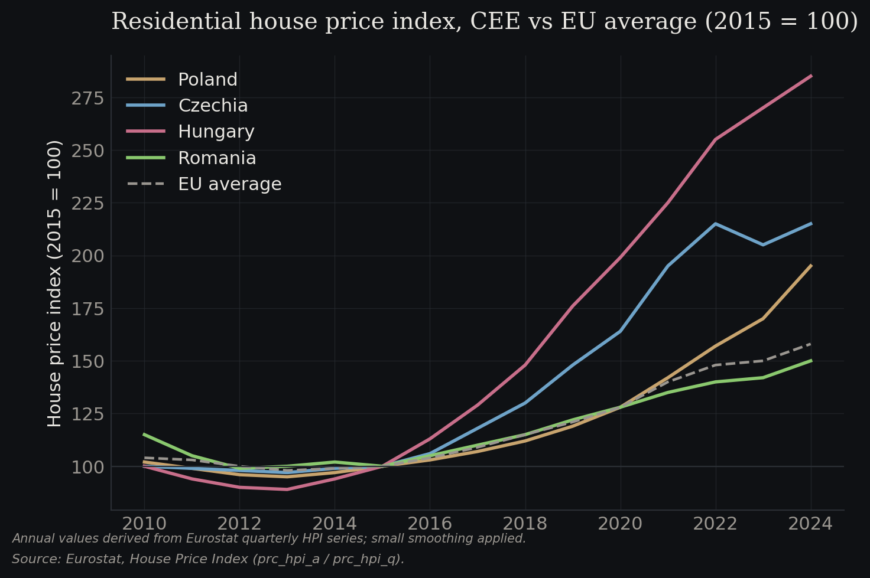
Figure 3.1 — Residential house price index, CEE vs EU average (2015 = 100)
Source: Eurostat, House Price Index (prc_hpi_a / prc_hpi_q).
Eurostat's house price data through 2024 tells a consistent story across the region: CEE prices have outpaced the EU average by a wide margin, with 2010–2024 cumulative growth of +131% in Czechia and comparably strong performance in Hungary and Poland. In Q2 2024, Poland recorded the highest annual price growth of any EU member at +17.7%. Q3 2024 saw Bulgaria (+16.5%), Poland (+14.4%) and Hungary (+13.4%) lead; by Q4 2024 Hungary topped the table at +13.0%. In 2025, Eurostat's continuing releases confirmed that the region remained among the strongest in Europe, with euro-area averages rising 4.2% in Q4 2024 and 5.4% in Q1 2025.
The headline aggregates, however, mask a shift that is more important for investors and banks: the dispersion of outcomes within each CEE market has widened. In Warsaw and Kraków, the price-per-square-metre differential between a well-located, energy-efficient new-build and an older panel-building apartment in a peripheral district is larger in both absolute and relative terms than a decade ago. The same is true in Budapest between District V and District XX, in Prague between the historic centre and the communist-era outer districts, and in Bucharest between Primăverii and Colentina. This dispersion is partly driven by income polarisation and partly by the emergence of ESG and energy-performance pricing — but in analytical terms, it means that simple market averages are increasingly misleading, and granular, model-based pricing is increasingly valuable.
For AI-driven residential analytics, this is the single most important context point. The return on algorithmic pricing is a function of how much within-market dispersion there is to capture. In CEE, that return is rising.

The data stack determines what AI can actually do
The maturity of residential AI tools in each CEE market maps closely to the maturity of its underlying data stack. Three layers matter: the cadastre and transaction registry, the listings and portal data layer, and the analytics and modelling layer.
Poland has the most developed combination of the three. The land and mortgage register (Księgi Wieczyste) is digitally accessible; Otodom, owned by OLX Group, is the dominant residential portal and offers a property valuation tool that produces an automated market-value estimate for residential units; Otomoto, also OLX, captures adjacent transaction behaviour. The Czech Republic's Sreality, operated by Seznam, plays a similar role, with extensive listing data feeding both consumer-facing valuation features and back-end analytics. Hungary's Ingatlan.com has one of the largest traffic leads of any property portal in any European market, giving it an unusually rich listing dataset.
Romania, Slovakia and Croatia are intermediate. Listing platforms (Imobiliare.ro, Nehnutelnosti.sk, Njuškalo, Index.hr) are substantial but the cadastral and registered-transaction data is less accessible and, in some cases, less reliable. Serbia sits at the back of the CEE set but, as discussed in the companion Western Balkans paper, the RGZ digital cadastre reform is closing the gap quickly.
The investment and modelling consequence is that the quality of any CEE residential AI application is constrained by the weakest link in this stack. A developer using machine learning to forecast sales velocity for a new Kraków project has significantly better input data than one attempting the same exercise in Zagreb or Belgrade.

Developers are using AI for demand forecasting and unit-mix optimisation
CEE residential developers — from Polish listed names to the CPI and HB Reavis portfolios active across multiple countries — have begun to deploy machine learning for demand forecasting, unit-mix optimisation, launch pricing and sales velocity prediction. The most mature applications are in Poland, where development volumes and transaction data density are highest. Polish developers now routinely use models that ingest postcode-level demographic data, historical absorption rates from comparable projects, mortgage availability proxies and macro indicators to generate expected sales curves for new launches.
The operational value is twofold. First, unit-mix optimisation — the balance between one-bedroom, two-bedroom and family units, and the specification and pricing of each — can be iterated on a data-backed basis rather than by experience heuristics. Second, dynamic pricing on release is increasingly common: unit prices are adjusted weekly or even daily during the sales phase based on observed conversion rates and remaining inventory, in a pattern analogous to airline yield management.
In Czechia, Hungary and Romania, similar applications exist but with less maturity. Several factors — developer fragmentation in some markets, less structured data pipelines, and the high share of sales through independent agents rather than direct from developer — slow adoption. Croatian and Serbian markets are earlier still, though the rapid growth of City Expert-type platforms in Serbia is compressing the data gap.

Banks are deploying AVMs carefully, guided by European standards
CEE's mortgage market has been a significant driver of residential demand growth. In Czechia alone, new mortgage origination reached CZK 228 billion (~€9 billion) in 2024, up 83% year-on-year, with the total market including refinancing at CZK 275 billion (~€10.9 billion). Mortgage volumes increased by 53% to around 62,000 new loans, and the average loan size rose 20% to CZK 3.7 million. Poland, Hungary and Slovakia saw similar if less dramatic mortgage market rebounds as interest rates stabilised through 2024 and 2025.
Against this backdrop, CEE banks are increasingly deploying AVMs, but in specific, well-defined use cases rather than as primary valuation instruments. The European Mortgage Federation's 2025 AVM survey documents this pattern: AVMs are widely used for portfolio monitoring, collateral re-valuation, stress testing and IFRS 9 staging, but remain complementary to expert valuation for new originations. The TEGoVA European Valuation Standards 10th edition (effective 1 January 2025) is explicit that AVM output requires qualified-valuer oversight to constitute a valuation; RICS's 2024 Red Book updates echo this requirement with specific guidance on AI-enabled valuation workflows.
The practical consequence for CEE mortgage books is a shift in the cost structure and cadence of collateral assessment. Portfolio-wide re-valuation, which a decade ago was a once-a-cycle exercise dependent on physical inspection, can now be run algorithmically at quarterly or monthly frequency. This matters for NPL identification, capital allocation and stress testing — all of which are under heightened regulatory focus given the CEE mortgage market's growth. Polish and Czech banks are, based on public disclosures and industry reporting, furthest advanced in integrating AVM outputs into their risk infrastructure.

Consumer-facing tools are commoditising price discovery
The most visible AI-driven residential tool in CEE is the consumer-facing price estimator embedded in major property portals. Otodom's automatic valuation tool in Poland, similar features on Sreality in Czechia and Ingatlan.com in Hungary, and the growing set of standalone valuation platforms like Hobsido in the Balkans have, collectively, changed what price discovery looks like for a typical buyer or seller.
The consequences are subtle but material. First, these tools compress information asymmetries between seller, buyer and agent — a long-standing source of transaction friction in CEE markets. Second, they create a high-frequency, publicly visible price signal that is harder to ignore than privately held broker assessments. Third, they generate a feedback loop: as more users interact with valuation tools, the platforms accumulate behavioural data (clicks, saves, enquiries, time-on-listing) that can improve the underlying models.
The accuracy of these consumer-facing estimators remains variable. In dense, high-volume urban markets — central Warsaw, Prague, Budapest — the error bands are narrow enough to be genuinely useful. In smaller cities, secondary markets and rural areas, the same tools produce estimates with wide confidence intervals that can mislead rather than inform. Sophisticated users increasingly treat them as a first-cut indication rather than a valuation, which is exactly the role TEGoVA's standards anticipate.

The overheating question: can AI help identify mispricing?
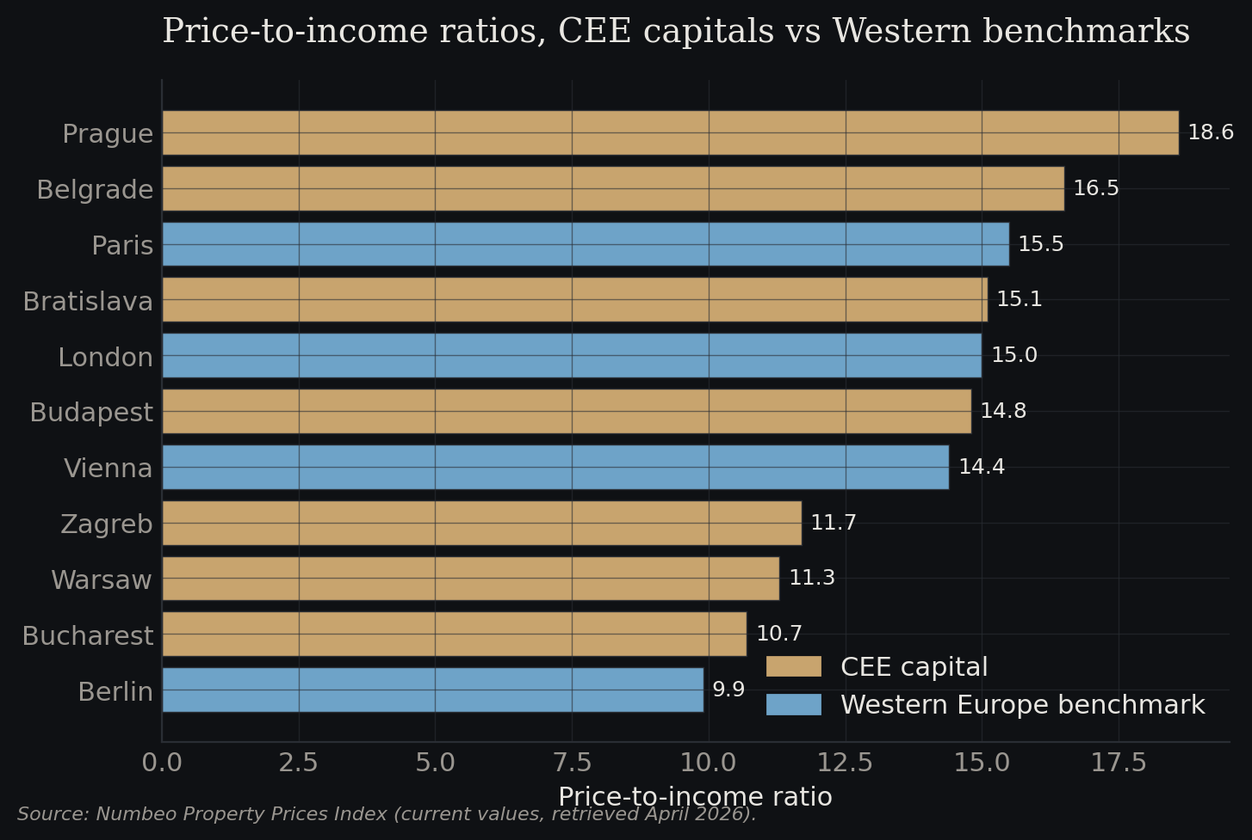
Figure 3.2 — Price-to-income ratios, CEE capitals vs Western benchmarks
Source: Numbeo Property Prices Index (current values, retrieved April 2026).
CEE's residential price growth has outpaced income growth in several markets, raising the question of whether AI-driven analytics can help identify overheating and mispricing at a useful moment. House price-to-income ratios have risen materially in Poland, Hungary and Czechia; in Prague and Warsaw in particular, the ratio sits above levels seen in several Western European capitals. The IMF, OECD and national central banks have each noted the development.
AI is not a silver bullet here. Identifying a bubble in real time is among the hardest problems in financial economics, and machine learning models trained on past price dynamics are particularly vulnerable to extrapolating trend growth. What AI can do more credibly is support early-warning systems: models that combine mortgage affordability indicators, transaction velocity, listing-to-sale ratios, price dispersion within markets and micro-level inventory dynamics to flag deviations from typical cycle patterns. Several CEE central banks — notably the Czech National Bank and the National Bank of Poland — have built increasingly sophisticated real estate monitoring toolkits that incorporate such indicators.
For investors, the practical implication is to treat AI-driven price forecasts with calibrated scepticism. The models are most reliable on short horizons, in stable segments, and in data-rich markets; they are least reliable on long horizons, in volatile segments and in data-thin markets — precisely the situations in which investors most want forecasts. A blended approach — using AI for the granular dispersion analysis where it excels, and judgment for the macro cycle call where it does not — is the right frame.

Regulatory context: RICS, TEGoVA and the EU framework
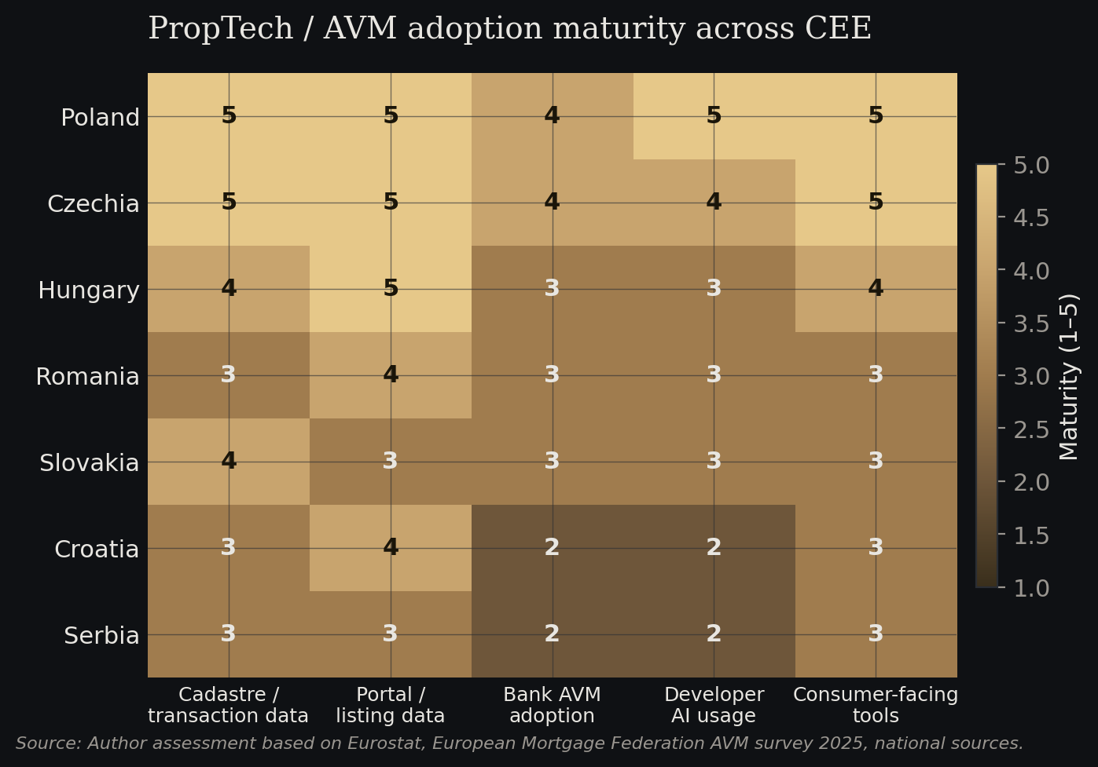
Figure 3.3 — PropTech / AVM adoption maturity across CEE
Source: Author assessment based on Eurostat, European Mortgage Federation AVM survey 2025, national sources.
The regulatory frame around AVM use in CEE is shaped primarily by TEGoVA's European Valuation Standards and, for members, RICS's Red Book Global Standards. The 10th edition of European Valuation Standards, effective 1 January 2025, codifies AVMs as a permitted tool in the valuation process but requires qualified-valuer oversight. Specific standards — EVS 1 on Market Value, EVS 3 on the Qualified Valuer, EVS 4 on the Valuation Process, and EVS 6 on Valuation and Energy Efficiency — each bear on how AI-enabled workflows integrate with traditional valuation practice.
RICS's 2024 updates, reflected in the December 2024 Basis for Conclusions publication, were explicit in adding mandatory standards around automation, AI and ESG. The direction of travel is clear: professional valuation in CEE is being reshaped around a model in which algorithmic tools do more of the routine work, while qualified valuers focus on judgment, adjustment and sign-off. This is both a threat to the traditional valuation profession and an opportunity — valuers who build AVM-enabled workflows can serve larger portfolios with higher throughput.
EU-level frameworks — the AI Act, forthcoming sustainability and energy performance regulations, and the revised Mortgage Credit Directive discussions — will further shape this landscape over 2025–2027. For CEE, where regulatory convergence with the EU core is already high, these frameworks will apply in full and will likely accelerate the formalisation of AI-driven residential analytics.

Outlook
The CEE residential market over the next three to five years is likely to see a gradual normalisation of price growth as affordability constraints bite and mortgage rates stabilise at levels above pre-2022 norms. Within that slower aggregate growth, within-market dispersion is likely to widen further — driven by ESG pricing, demographic shifts toward capital cities and energy-efficient stock, and a continued gap between prime and secondary locations. AI-driven analytics are well-placed to capture the implications of that dispersion.
Adoption will remain uneven. Poland and Czechia will likely continue to set the regional standard, with Hungary close behind. Romania, Slovakia and Croatia will progress but with persistent data-quality constraints. Serbia, as discussed in the Western Balkans paper, is closing the gap from behind. The competitive advantage for banks, developers and investors in the region will sit increasingly with those who invest in data infrastructure and modelling capacity, not with those who simply license off-the-shelf tools.
Our directional view is that AI-driven residential analytics in CEE will shift over this period from a marketing feature on property portals to a core part of bank risk management, developer pricing and institutional investment underwriting. This transition is already underway; it is not yet complete. Investors and operators that move early — particularly those that build data pipelines rather than buying output — will capture disproportionate returns. Those that treat AI as a checkbox exercise will not.

Sources
- Eurostat, Housing Price Statistics — House Price Index and Euro indicators releases, 2024–2025. ec.europa.eu/eurostat
- Eurostat, Housing in Europe — 2025 edition. ec.europa.eu/eurostat
- European Mortgage Federation, Joint Paper on the Use of Automated Valuation Models in Europe, May 2025. hypo.org
- TEGoVA, European Valuation Standards, 10th edition (2025). tegova.org
- RICS, Valuation – Global Standards (Red Book), Basis for Conclusions, December 2024. rics.org
- Property Forum, Czech mortgage loan volume grows (2025). property-forum.eu
- Online Marketplaces, Top Property Portals of Central and Eastern Europe 2023. onlinemarketplaces.com
- AIM Group, Otodom promotes new property-valuation service. aimgroup.com
- Czech National Bank and National Bank of Poland, financial stability reports 2024. cnb.cz; nbp.pl
- KPMG, Property Lending Barometer 2024. kpmg.com

