南京理工大学紫金学院

《Android应用开发》实验报告



课程编号： | 03409031
课程名称： | Android应用开发
学 院： | 计算机与人工智能学院
专 业： | 计算机科学与技术
学 号： | 2315302125
姓 名： | 崔子霖
指导教师： | 任 凯

2026年2月

实验三 广播机制
一、实验目的
- 掌握广播接收者的创建方式，能够独立创建广播接收者；
- 掌握自定义广播的方式；
- 掌握广播的类型，归纳有序广播与无序广播的工作流程。
二、实验原理及说明
1. 在Android系统中，广播是一种运用在组件之间传递消息的机制，例如电池电量低时会发送一条提示广播。如果要接收并过滤广播中的消息，则需要使用BroadcastReceiver（广播接收者），广播接收者是Android四大组件之一，通过广播接收者可以监听系统中的广播消息，实现在不同组件之间的通信。
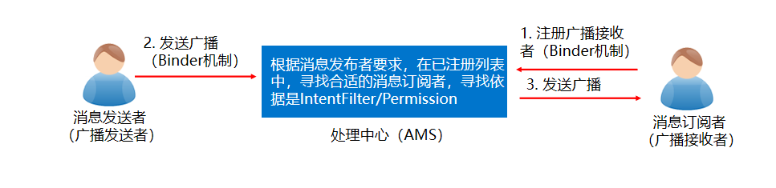
- 创建广播接收者的两种方式：
- 在应用程序中创建一个类继承BroadcastReceiver并重写onReceive()方法来实现。
- 通过选中应用程序中的包，右击选择“New”“Other”“Broadcast Receiver”选项来创建。
- 注册广播接收者的两种方式：动态注册、静态注册
- 动态注册广播代码样例：
receiver = new MyBroadcastReceiver(); //实例化广播接收者
//实例化过滤器并设置要过滤的广播
String action = "android.provider.Telephony.SMS_RECEIVED";
IntentFilter intentFilter = new IntentFilter();
intentFilter.addAction(action);
registerReceiver(receiver,intentFilter); //注册广播
- Android系统提供了两种广播类型，有序广播和无序广播，开发者可根据需求为程序设置不同的广播类型。
- 无序广播：无序广播是完全异步执行，发送广播时所有监听这个广播的广播接收者都会接收到此消息，但接收的顺序不确定。
- 有序广播：按照接收者的优先级接收，只有一个广播接收者能接收消息，在此广播接收者中逻辑执行完毕后，才会继续传递。可以使用IntentFilter对象的setPriority()方法设置优先级别，属性值越大，优先级越高。如果两个广播接收者的优先级相同，则先注册的广播接收者优先级高。
- 如果想要拦截一个有序广播，则必须在优先级较高的广播接收者中拦截接收到的广播，添加一个abortBroadcast()方法拦截广播。
三、实验内容
通过“数鸭子”案例实现无序/有序广播发送功能、并根据广播接收者的优先级顺序接收广播、拦截广播以及指定广播接收者。
四、程序设计和说明：（详细给出各个界面的设计思路，类的说明和运行界面截图）
四、程序设计和说明
本实验新建模块 broadcastApp，包名为 cn.itcast.broadcast。程序围绕“数鸭子”案例完成五类广播操作：无序广播、有序广播（优先级不同）、有序广播（优先级相同）、拦截有序广播、指定广播接收者。界面上方提供五个按钮，点击后在下方运行结果区域显示广播发送内容和接收者接收顺序。
动态广播接收者通过 registerReceiver() 注册，并通过 IntentFilter.setPriority() 设置有序广播优先级；拦截广播时，高优先级接收者在 onReceive() 中调用 abortBroadcast()；指定接收者功能使用 ComponentName 将广播发送给 StaticDuckReceiver。
类/文件 | 作用说明
MainActivity | 负责界面初始化、动态注册广播接收者、发送无序广播、有序广播、拦截广播和指定接收者广播，并将接收顺序显示到运行结果区域。
DuckReceiver | 继承 BroadcastReceiver，通过构造参数区分接收者名称、是否拦截广播，并在 onReceive() 中回调显示接收结果。
StaticDuckReceiver | 在 AndroidManifest.xml 中静态声明，用于演示通过 ComponentName 指定某一个广播接收者。
activity_main.xml | 设计实验界面，包含五个功能按钮、运行结果显示框和清空按钮。
五、运行结果
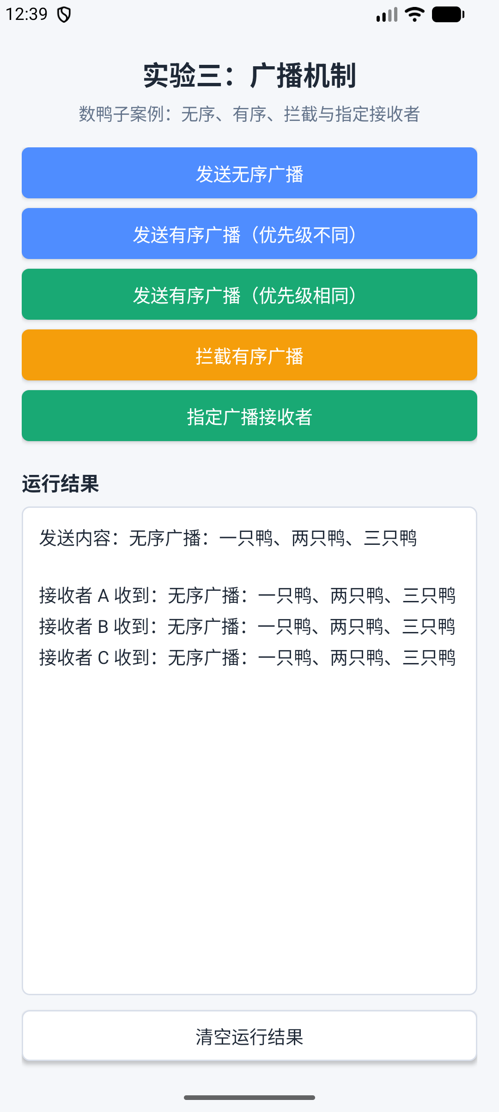
图1 发送无序广播的效果
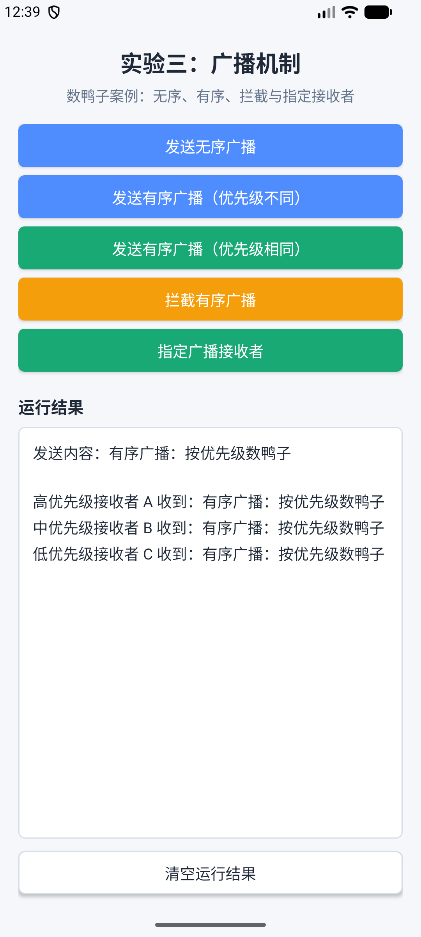
图2 发送有序广播的效果（优先级均不同）
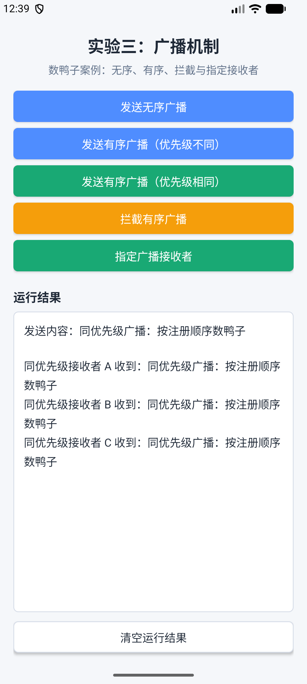
图3 发送有序广播的效果（优先级相同）
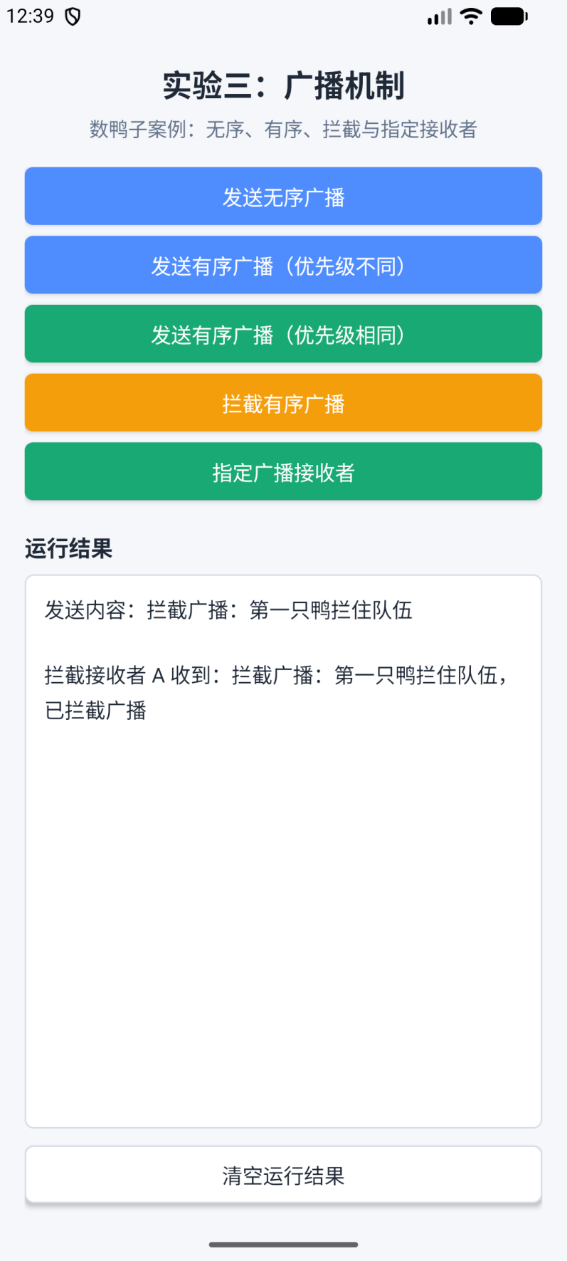
图4 拦截广播的效果
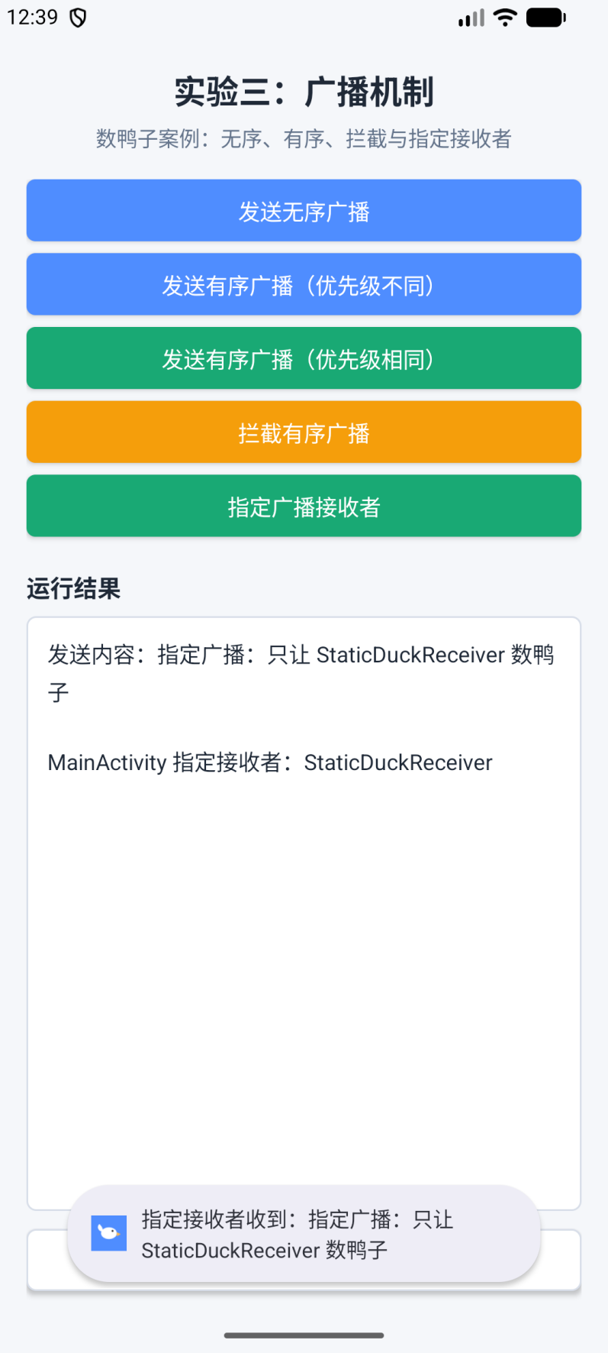
图5 指定广播接收者效果

六、核心源码
MainActivity.java
package cn.itcast.broadcast;

import android.content.ComponentName;
import android.content.Context;
import android.content.Intent;
import android.content.IntentFilter;
import android.os.Build;
import android.os.Bundle;
import android.view.View;
import android.widget.Button;
import android.widget.TextView;

import androidx.appcompat.app.AppCompatActivity;

public class MainActivity extends AppCompatActivity {
public static final String ACTION_UNORDERED = "cn.itcast.broadcast.UNORDERED_DUCK";
public static final String ACTION_ORDERED = "cn.itcast.broadcast.ORDERED_DUCK";
public static final String ACTION_SAME_PRIORITY = "cn.itcast.broadcast.SAME_PRIORITY_DUCK";
public static final String ACTION_INTERCEPT = "cn.itcast.broadcast.INTERCEPT_DUCK";
public static final String ACTION_STATIC = "cn.itcast.broadcast.STATIC_DUCK";
public static final String EXTRA_DUCK_TEXT = "duck_text";

private TextView tvResult;
private final StringBuilder resultBuilder = new StringBuilder();

private DuckReceiver unorderedOne;
private DuckReceiver unorderedTwo;
private DuckReceiver unorderedThree;
private DuckReceiver orderedOne;
private DuckReceiver orderedTwo;
private DuckReceiver orderedThree;
private DuckReceiver sameOne;
private DuckReceiver sameTwo;
private DuckReceiver sameThree;
private DuckReceiver interceptOne;
private DuckReceiver interceptTwo;
private DuckReceiver interceptThree;

@Override
protected void onCreate(Bundle savedInstanceState) {
super.onCreate(savedInstanceState);
setContentView(R.layout.activity_main);
applySystemBarInsets();
initView();
registerDuckReceivers();
}

@Override
protected void onDestroy() {
super.onDestroy();
unregisterReceiver(unorderedOne);
unregisterReceiver(unorderedTwo);
unregisterReceiver(unorderedThree);
unregisterReceiver(orderedOne);
unregisterReceiver(orderedTwo);
unregisterReceiver(orderedThree);
unregisterReceiver(sameOne);
unregisterReceiver(sameTwo);
unregisterReceiver(sameThree);
unregisterReceiver(interceptOne);
unregisterReceiver(interceptTwo);
unregisterReceiver(interceptThree);
}

private void initView() {
tvResult = findViewById(R.id.tv_result);
Button btnUnordered = findViewById(R.id.btn_unordered);
Button btnOrdered = findViewById(R.id.btn_ordered);
Button btnSamePriority = findViewById(R.id.btn_same_priority);
Button btnIntercept = findViewById(R.id.btn_intercept);
Button btnStatic = findViewById(R.id.btn_static);
Button btnClear = findViewById(R.id.btn_clear);

btnUnordered.setOnClickListener(v -> sendDuckBroadcast(ACTION_UNORDERED, false,
"无序广播：一只鸭、两只鸭、三只鸭"));
btnOrdered.setOnClickListener(v -> sendDuckBroadcast(ACTION_ORDERED, true,
"有序广播：按优先级数鸭子"));
btnSamePriority.setOnClickListener(v -> sendDuckBroadcast(ACTION_SAME_PRIORITY, true,
"同优先级广播：按注册顺序数鸭子"));
btnIntercept.setOnClickListener(v -> sendDuckBroadcast(ACTION_INTERCEPT, true,
"拦截广播：第一只鸭拦住队伍"));
btnStatic.setOnClickListener(v -> sendStaticReceiverBroadcast());
btnClear.setOnClickListener(v -> {
resultBuilder.setLength(0);
tvResult.setText(R.string.result_empty);
});
}

private void registerDuckReceivers() {
unorderedOne = new DuckReceiver("接收者 A", false, this::appendResult);
unorderedTwo = new DuckReceiver("接收者 B", false, this::appendResult);
unorderedThree = new DuckReceiver("接收者 C", false, this::appendResult);
registerDuckReceiver(unorderedOne, ACTION_UNORDERED, 0);
registerDuckReceiver(unorderedTwo, ACTION_UNORDERED, 0);
registerDuckReceiver(unorderedThree, ACTION_UNORDERED, 0);

orderedOne = new DuckReceiver("高优先级接收者 A", false, this::appendResult);
orderedTwo = new DuckReceiver("中优先级接收者 B", false, this::appendResult);
orderedThree = new DuckReceiver("低优先级接收者 C", false, this::appendResult);
registerDuckReceiver(orderedOne, ACTION_ORDERED, 900);
registerDuckReceiver(orderedTwo, ACTION_ORDERED, 600);
registerDuckReceiver(orderedThree, ACTION_ORDERED, 300);

sameOne = new DuckReceiver("同优先级接收者 A", false, this::appendResult);
sameTwo = new DuckReceiver("同优先级接收者 B", false, this::appendResult);
sameThree = new DuckReceiver("同优先级接收者 C", false, this::appendResult);
registerDuckReceiver(sameOne, ACTION_SAME_PRIORITY, 500);
registerDuckReceiver(sameTwo, ACTION_SAME_PRIORITY, 500);
registerDuckReceiver(sameThree, ACTION_SAME_PRIORITY, 500);

interceptOne = new DuckReceiver("拦截接收者 A", true, this::appendResult);
interceptTwo = new DuckReceiver("拦截接收者 B", false, this::appendResult);
interceptThree = new DuckReceiver("拦截接收者 C", false, this::appendResult);
registerDuckReceiver(interceptOne, ACTION_INTERCEPT, 900);
registerDuckReceiver(interceptTwo, ACTION_INTERCEPT, 600);
registerDuckReceiver(interceptThree, ACTION_INTERCEPT, 300);
}

private void registerDuckReceiver(DuckReceiver receiver, String action, int priority) {
IntentFilter filter = new IntentFilter(action);
filter.setPriority(priority);
if (Build.VERSION.SDK_INT >= Build.VERSION_CODES.TIRAMISU) {
registerReceiver(receiver, filter, Context.RECEIVER_NOT_EXPORTED);
} else {
registerReceiver(receiver, filter);
}
}

private void sendDuckBroadcast(String action, boolean ordered, String duckText) {
appendHeader(duckText);
Intent intent = new Intent(action);
intent.setPackage(getPackageName());
intent.putExtra(EXTRA_DUCK_TEXT, duckText);
if (ordered) {
sendOrderedBroadcast(intent, null);
} else {
sendBroadcast(intent);
}
}

private void sendStaticReceiverBroadcast() {
String duckText = "指定广播：只让 StaticDuckReceiver 数鸭子";
appendHeader(duckText);
appendResult("MainActivity 指定接收者：StaticDuckReceiver");
Intent intent = new Intent(ACTION_STATIC);
intent.setComponent(new ComponentName(this, StaticDuckReceiver.class));
intent.putExtra(EXTRA_DUCK_TEXT, duckText);
sendBroadcast(intent);
}

private void appendHeader(String text) {
resultBuilder.setLength(0);
resultBuilder.append("发送内容：").append(text).append("\n\n");
tvResult.setText(resultBuilder.toString());
}

private void appendResult(String text) {
resultBuilder.append(text).append('\n');
tvResult.setText(resultBuilder.toString());
}

private void applySystemBarInsets() {
View root = findViewById(R.id.main_root);
root.setOnApplyWindowInsetsListener((view, insets) -> {
view.setPadding(view.getPaddingLeft(), insets.getSystemWindowInsetTop(),
view.getPaddingRight(), insets.getSystemWindowInsetBottom());
return insets;
});
root.requestApplyInsets();
}
}
DuckReceiver.java
package cn.itcast.broadcast;

import android.content.BroadcastReceiver;
import android.content.Context;
import android.content.Intent;

public class DuckReceiver extends BroadcastReceiver {
public interface OnDuckReceiveListener {
void onReceiveDuck(String message);
}

private final String name;
private final boolean intercept;
private final OnDuckReceiveListener listener;

public DuckReceiver(String name, boolean intercept, OnDuckReceiveListener listener) {
this.name = name;
this.intercept = intercept;
this.listener = listener;
}

@Override
public void onReceive(Context context, Intent intent) {
String duckText = intent.getStringExtra(MainActivity.EXTRA_DUCK_TEXT);
String message = name + " 收到：" + duckText;
if (intercept && isOrderedBroadcast()) {
message += "，已拦截广播";
abortBroadcast();
}
if (listener != null) {
listener.onReceiveDuck(message);
}
}
}
StaticDuckReceiver.java
package cn.itcast.broadcast;

import android.content.BroadcastReceiver;
import android.content.Context;
import android.content.Intent;
import android.widget.Toast;

public class StaticDuckReceiver extends BroadcastReceiver {
@Override
public void onReceive(Context context, Intent intent) {
String duckText = intent.getStringExtra(MainActivity.EXTRA_DUCK_TEXT);
Toast.makeText(context, "指定接收者收到：" + duckText, Toast.LENGTH_SHORT).show();
}
}
AndroidManifest.xml
<?xml version="1.0" encoding="utf-8"?>
<manifest xmlns:android="http://schemas.android.com/apk/res/android">

<application
android:allowBackup="true"
android:dataExtractionRules="@xml/data_extraction_rules"
android:fullBackupContent="@xml/backup_rules"
android:icon="@drawable/ic_launcher_foreground"
android:label="@string/app_name"
android:roundIcon="@drawable/ic_launcher_foreground"
android:supportsRtl="true"
android:theme="@style/Theme.Broadcast">
<receiver
android:name=".StaticDuckReceiver"
android:exported="false" />

<activity
android:name=".MainActivity"
android:exported="true">
<intent-filter>
<action android:name="android.intent.action.MAIN" />

<category android:name="android.intent.category.LAUNCHER" />
</intent-filter>
</activity>
</application>

</manifest>
activity_main.xml
<?xml version="1.0" encoding="utf-8"?>
<LinearLayout xmlns:android="http://schemas.android.com/apk/res/android"
android:id="@+id/main_root"
android:layout_width="match_parent"
android:layout_height="match_parent"
android:background="@color/page_bg"
android:orientation="vertical"
android:paddingStart="18dp"
android:paddingEnd="18dp">

<TextView
android:layout_width="match_parent"
android:layout_height="wrap_content"
android:layout_marginTop="20dp"
android:gravity="center"
android:text="@string/app_title"
android:textColor="@color/text_main"
android:textSize="22sp"
android:textStyle="bold" />

<TextView
android:layout_width="match_parent"
android:layout_height="wrap_content"
android:layout_marginTop="6dp"
android:gravity="center"
android:text="@string/app_subtitle"
android:textColor="@color/text_sub"
android:textSize="14sp" />

<LinearLayout
android:layout_width="match_parent"
android:layout_height="wrap_content"
android:layout_marginTop="18dp"
android:orientation="vertical">

<Button
android:id="@+id/btn_unordered"
style="@style/DuckButton"
android:background="@drawable/btn_primary"
android:text="@string/send_unordered" />

<Button
android:id="@+id/btn_ordered"
style="@style/DuckButton"
android:background="@drawable/btn_primary"
android:text="@string/send_ordered" />

<Button
android:id="@+id/btn_same_priority"
style="@style/DuckButton"
android:background="@drawable/btn_secondary"
android:text="@string/send_same_priority" />

<Button
android:id="@+id/btn_intercept"
style="@style/DuckButton"
android:background="@drawable/btn_warning"
android:text="@string/send_intercept" />

<Button
android:id="@+id/btn_static"
style="@style/DuckButton"
android:background="@drawable/btn_secondary"
android:text="@string/send_static" />
</LinearLayout>

<TextView
android:layout_width="match_parent"
android:layout_height="wrap_content"
android:layout_marginTop="14dp"
android:text="@string/result_title"
android:textColor="@color/text_main"
android:textSize="16sp"
android:textStyle="bold" />

<ScrollView
android:layout_width="match_parent"
android:layout_height="0dp"
android:layout_marginTop="8dp"
android:layout_weight="1"
android:background="@drawable/result_bg"
android:fillViewport="true">

<TextView
android:id="@+id/tv_result"
android:layout_width="match_parent"
android:layout_height="wrap_content"
android:lineSpacingExtra="4dp"
android:padding="14dp"
android:text="@string/result_empty"
android:textColor="@color/text_main"
android:textSize="15sp" />
</ScrollView>

<Button
android:id="@+id/btn_clear"
android:layout_width="match_parent"
android:layout_height="42dp"
android:layout_marginTop="12dp"
android:layout_marginBottom="18dp"
android:background="@drawable/btn_clear"
android:text="@string/clear_result"
android:textColor="@color/text_main"
android:textSize="15sp" />

</LinearLayout>

