南京理工大学紫金学院
《移动应用开发工程实践》实验报告
课程编号：03417011
课程名称：移动应用开发工程实践
学 院：计算机与人工智能学院
专 业：计算机科学与技术
学 号：
姓 名：
任课教师：任 凯
2026年5月

实验一 记事本

一、实验目的
熟悉 SQLite 数据库在 Android 中的创建、插入、删除、修改和查询流程。
掌握 RecyclerView 列表控件的适配器编写和列表项点击、长按事件处理。
掌握通过 OkHttp 和 Gson 调用火山方舟 Ark Chat Completions 接口，对记事本内容进行在线文本润色。

二、实验环境
开发工具：Android Studio / Gradle 9.3.1，AGP 9.1.0。
运行环境：Android 模拟器 Medium Phone API 36.1。
主要依赖：AppCompat、Material、RecyclerView、OkHttp 4.12.0、Gson 2.10.1。
在线推理接口：https://ark.cn-beijing.volces.com/api/v3/chat/completions，模型接入点为实验中创建的 Ark 在线推理 endpoint。

三、功能设计与实现
程序主界面由标题栏、RecyclerView 和底部添加按钮组成。首次进入时显示空列表提示；新增或修改记录返回后，主界面重新查询 SQLite 数据库并刷新列表。
每条笔记包含 id、title、content、time 四个字段，数据库表 note 使用 id 自增主键。DBUtils 封装 queryNote、saveNote、updateNote 和 deleteNote 方法。
短按列表项进入修改界面，长按列表项弹出 AlertDialog 删除确认框。编辑页提供清空、保存和润色三个操作按钮。
点击润色按钮后，RecordActivity 在子线程中调用 VolcAiUtil.polishText，向火山方舟 Chat Completions 接口提交用户笔记内容，成功后回到 UI 线程更新 EditText。

四、运行截图

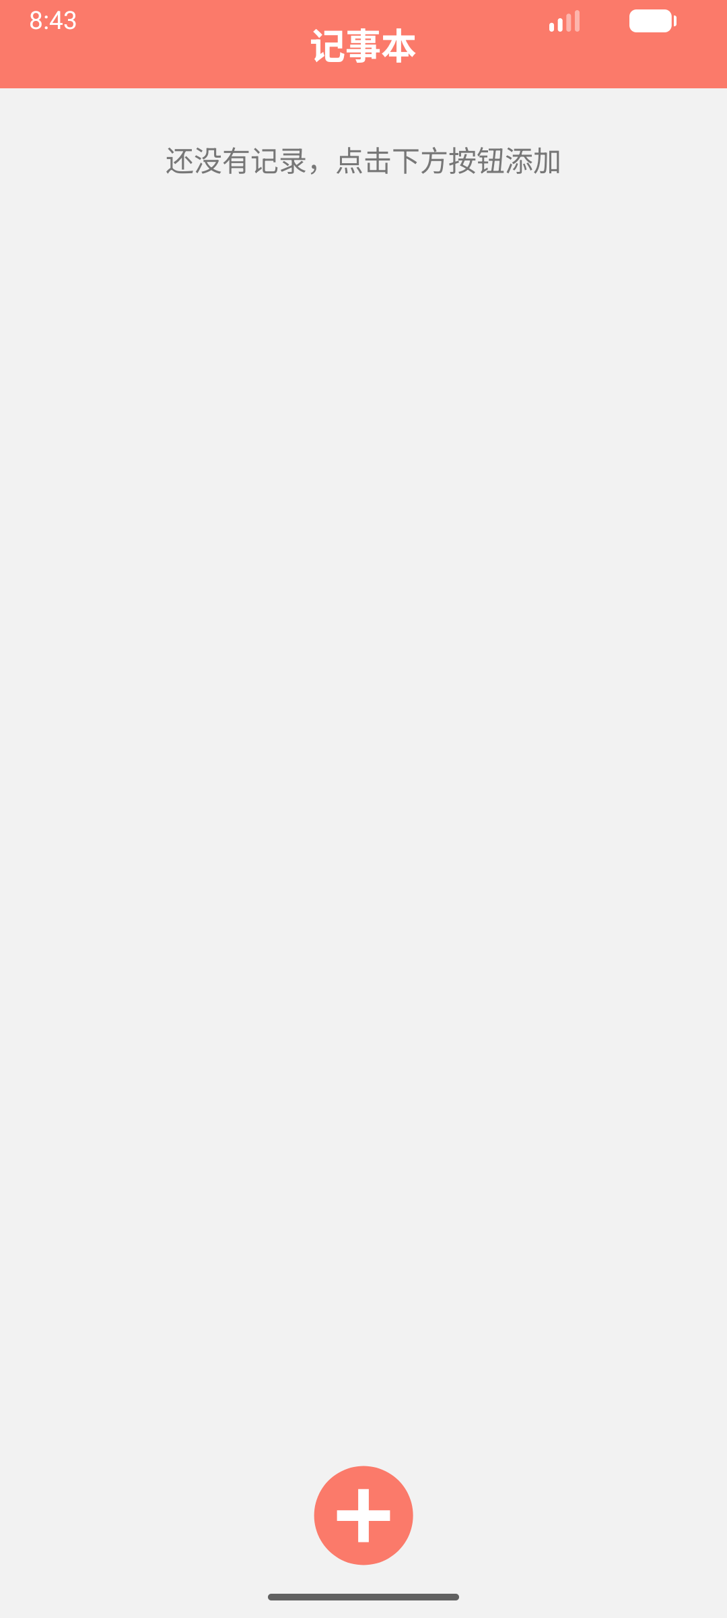
图1 主界面无记录状态

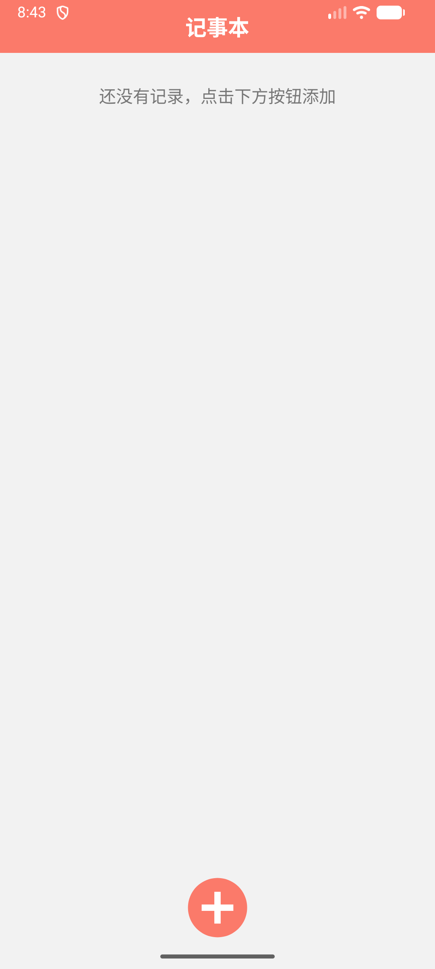
图2 添加记录界面

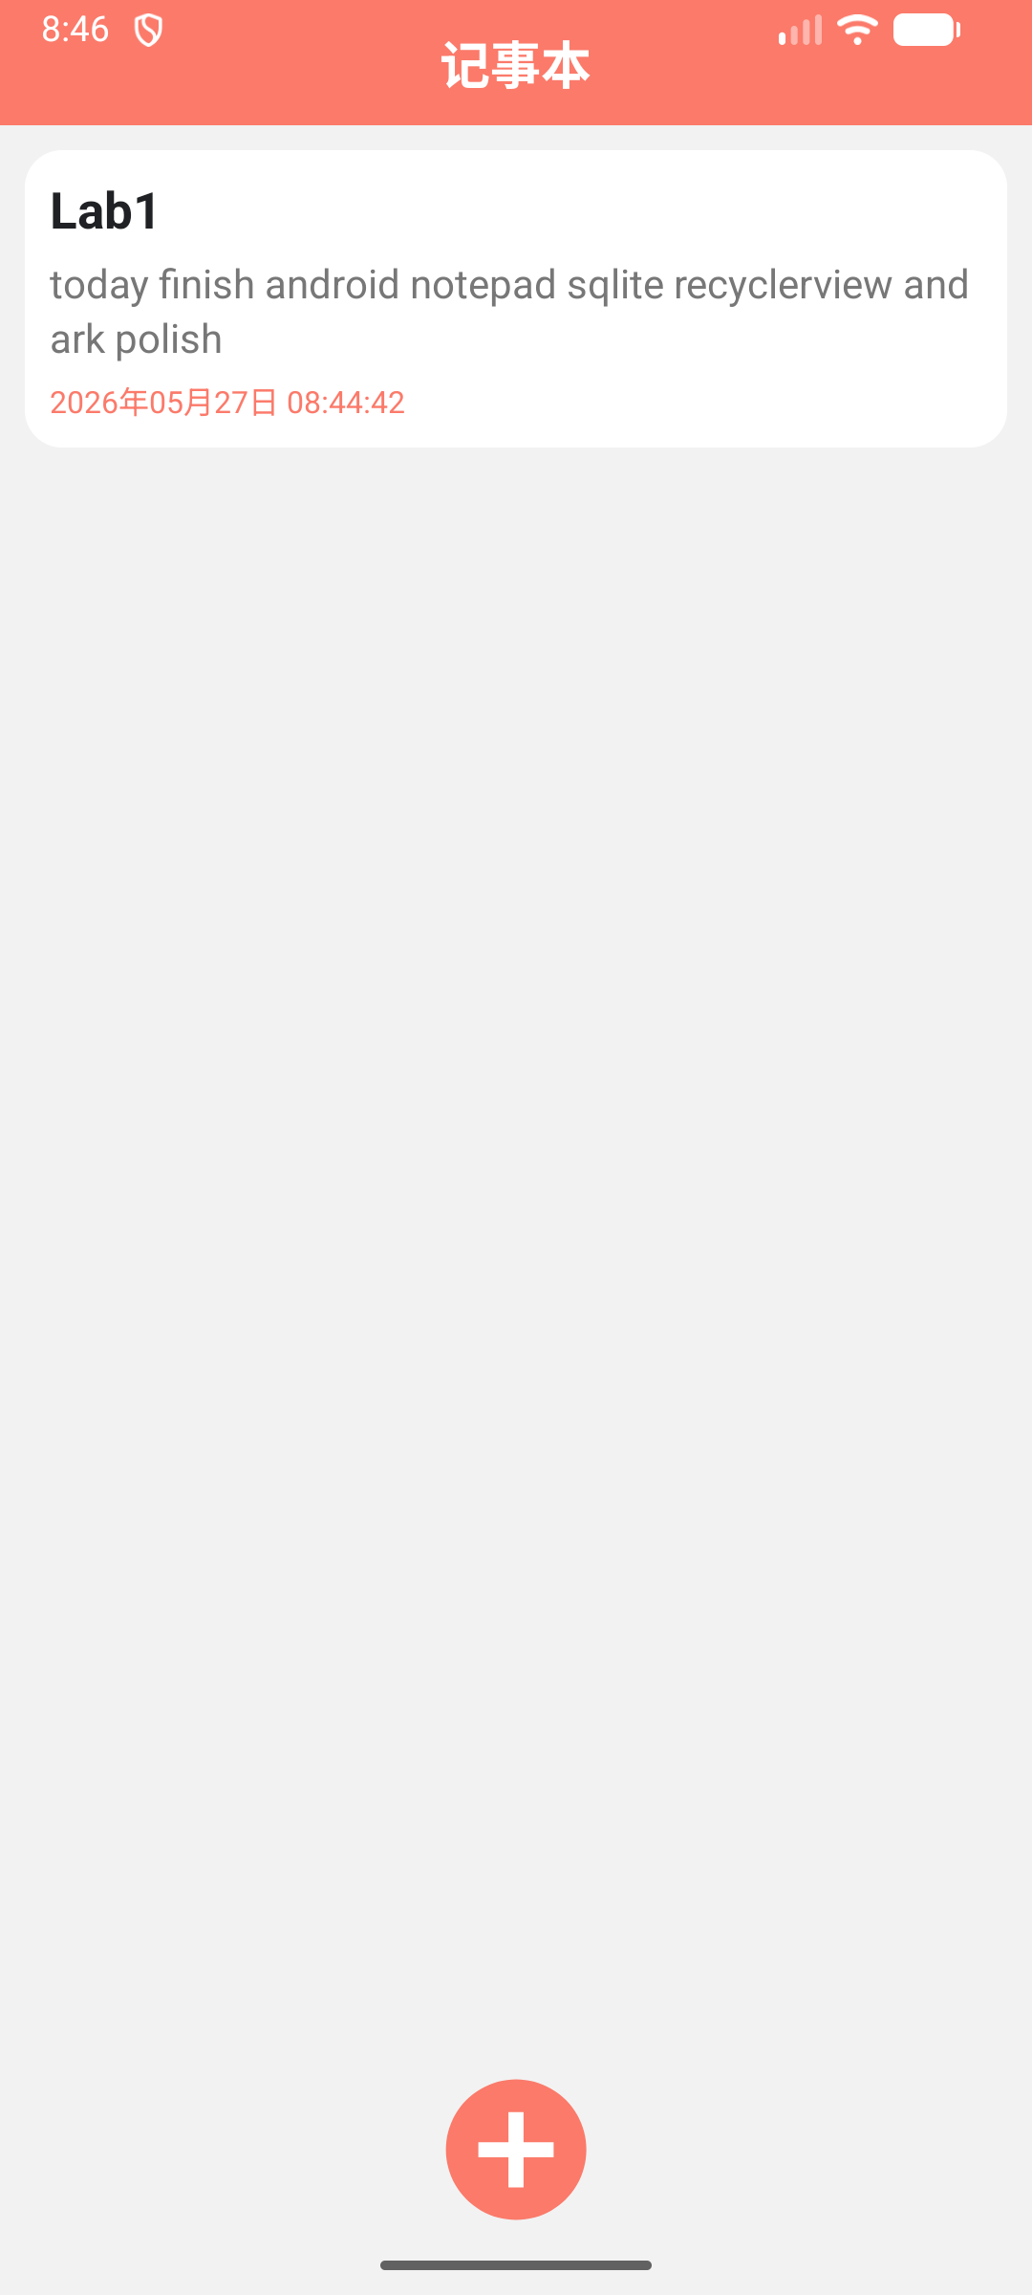
图3 保存后 RecyclerView 列表展示

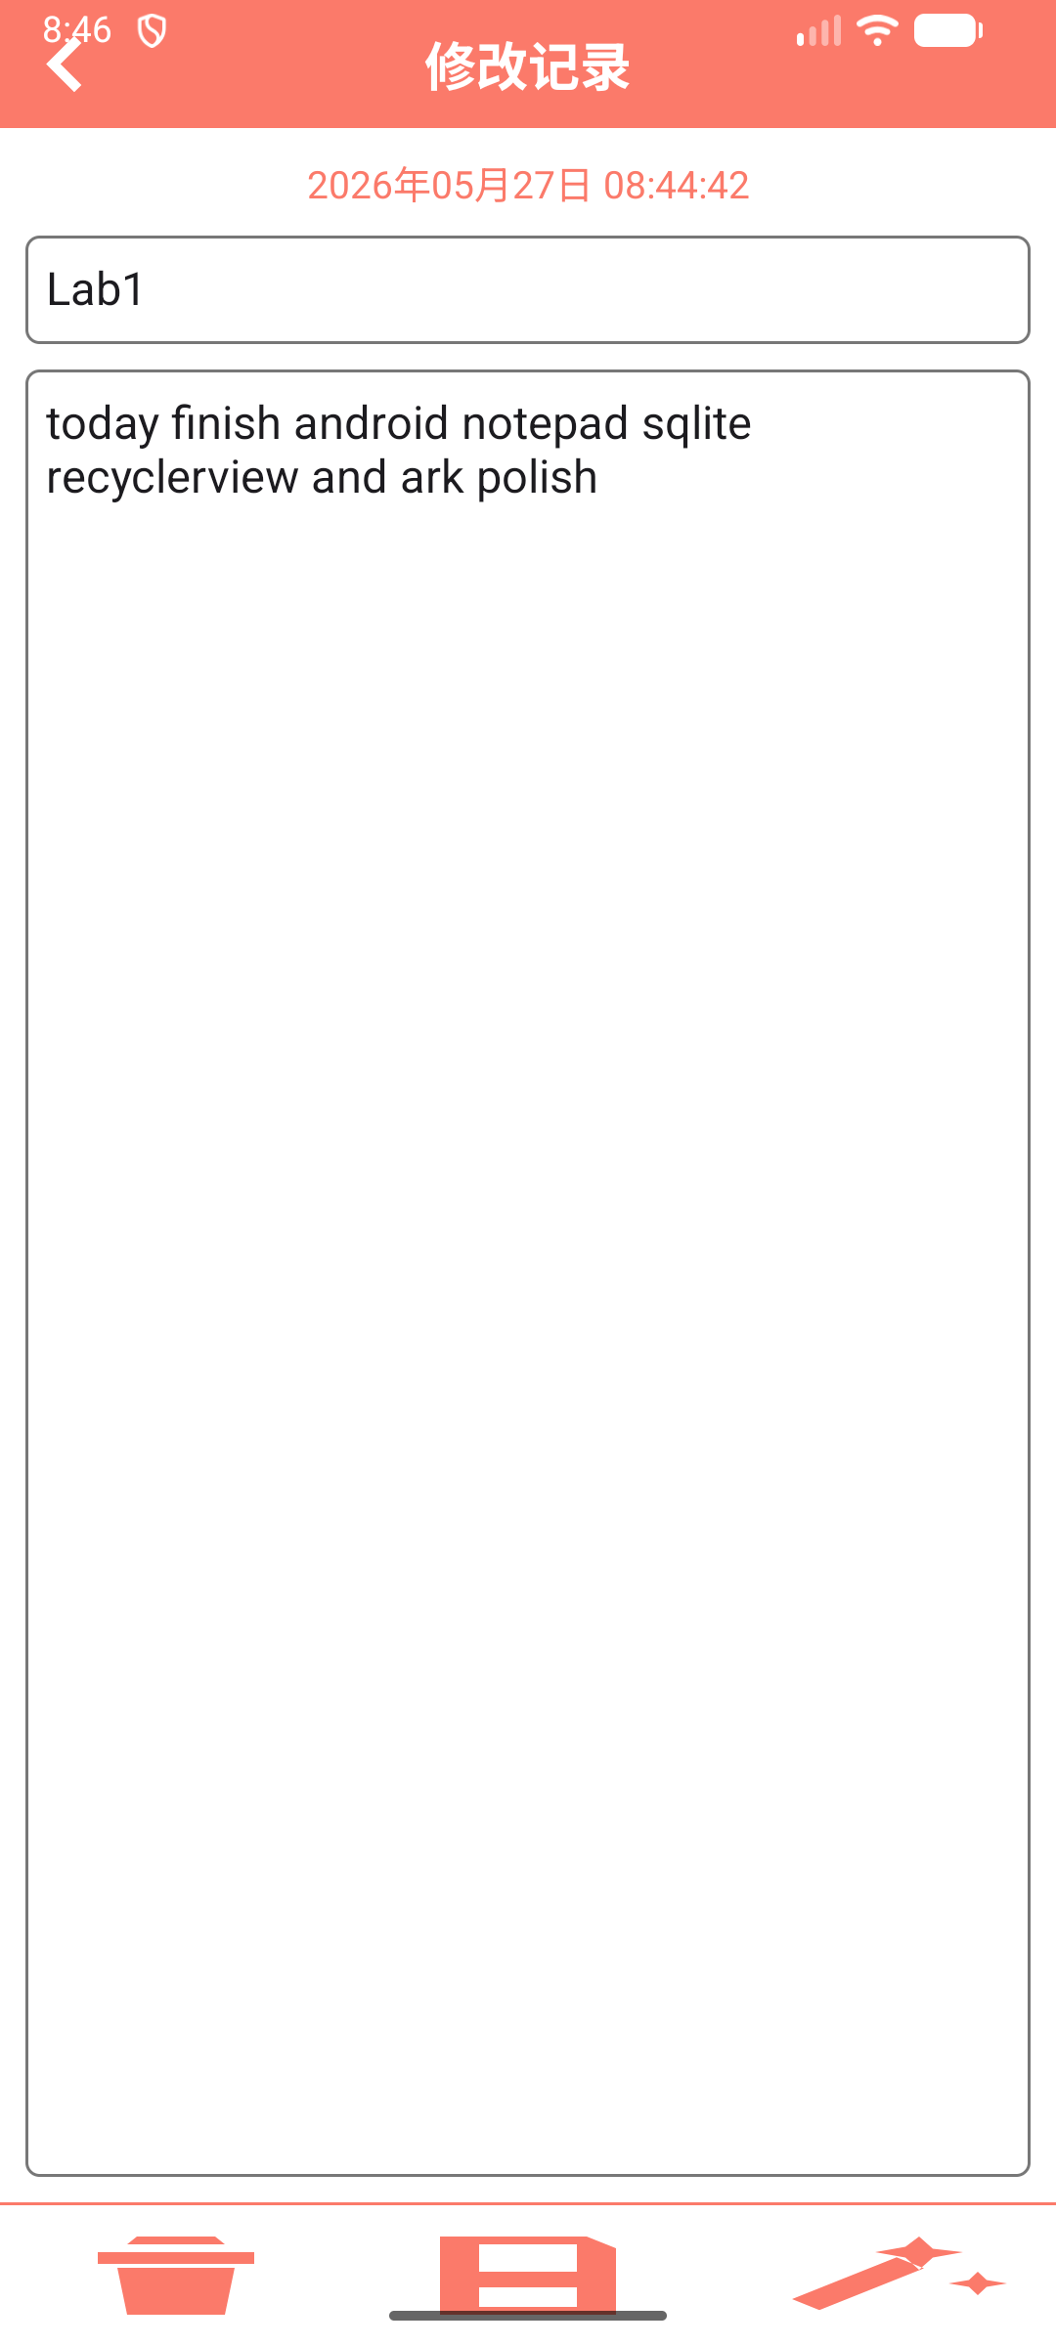
图4 修改记录界面

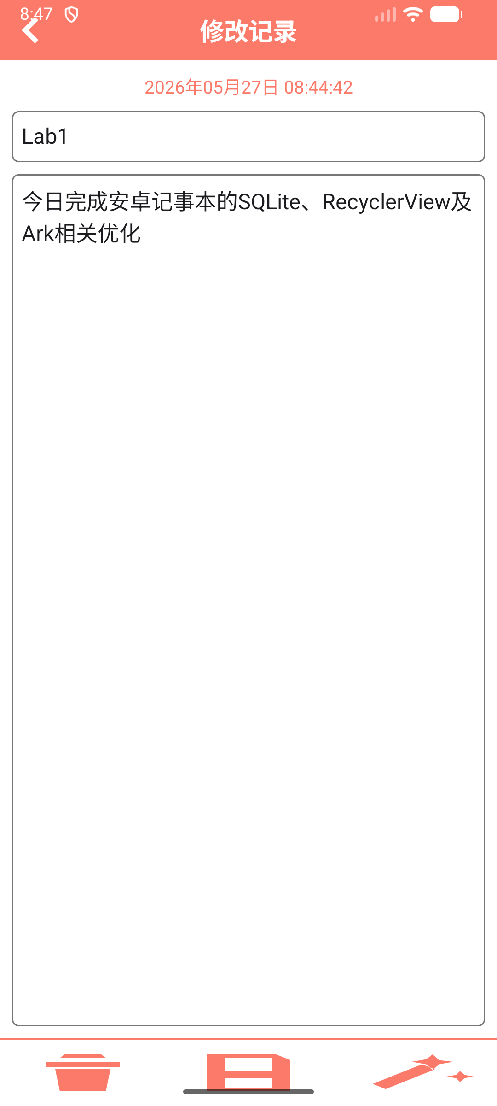
图5 点击润色后 Ark 在线推理返回结果

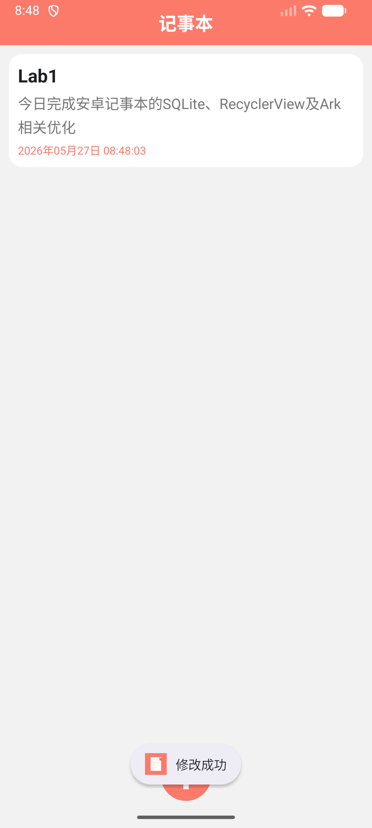
图6 保存润色结果后列表更新

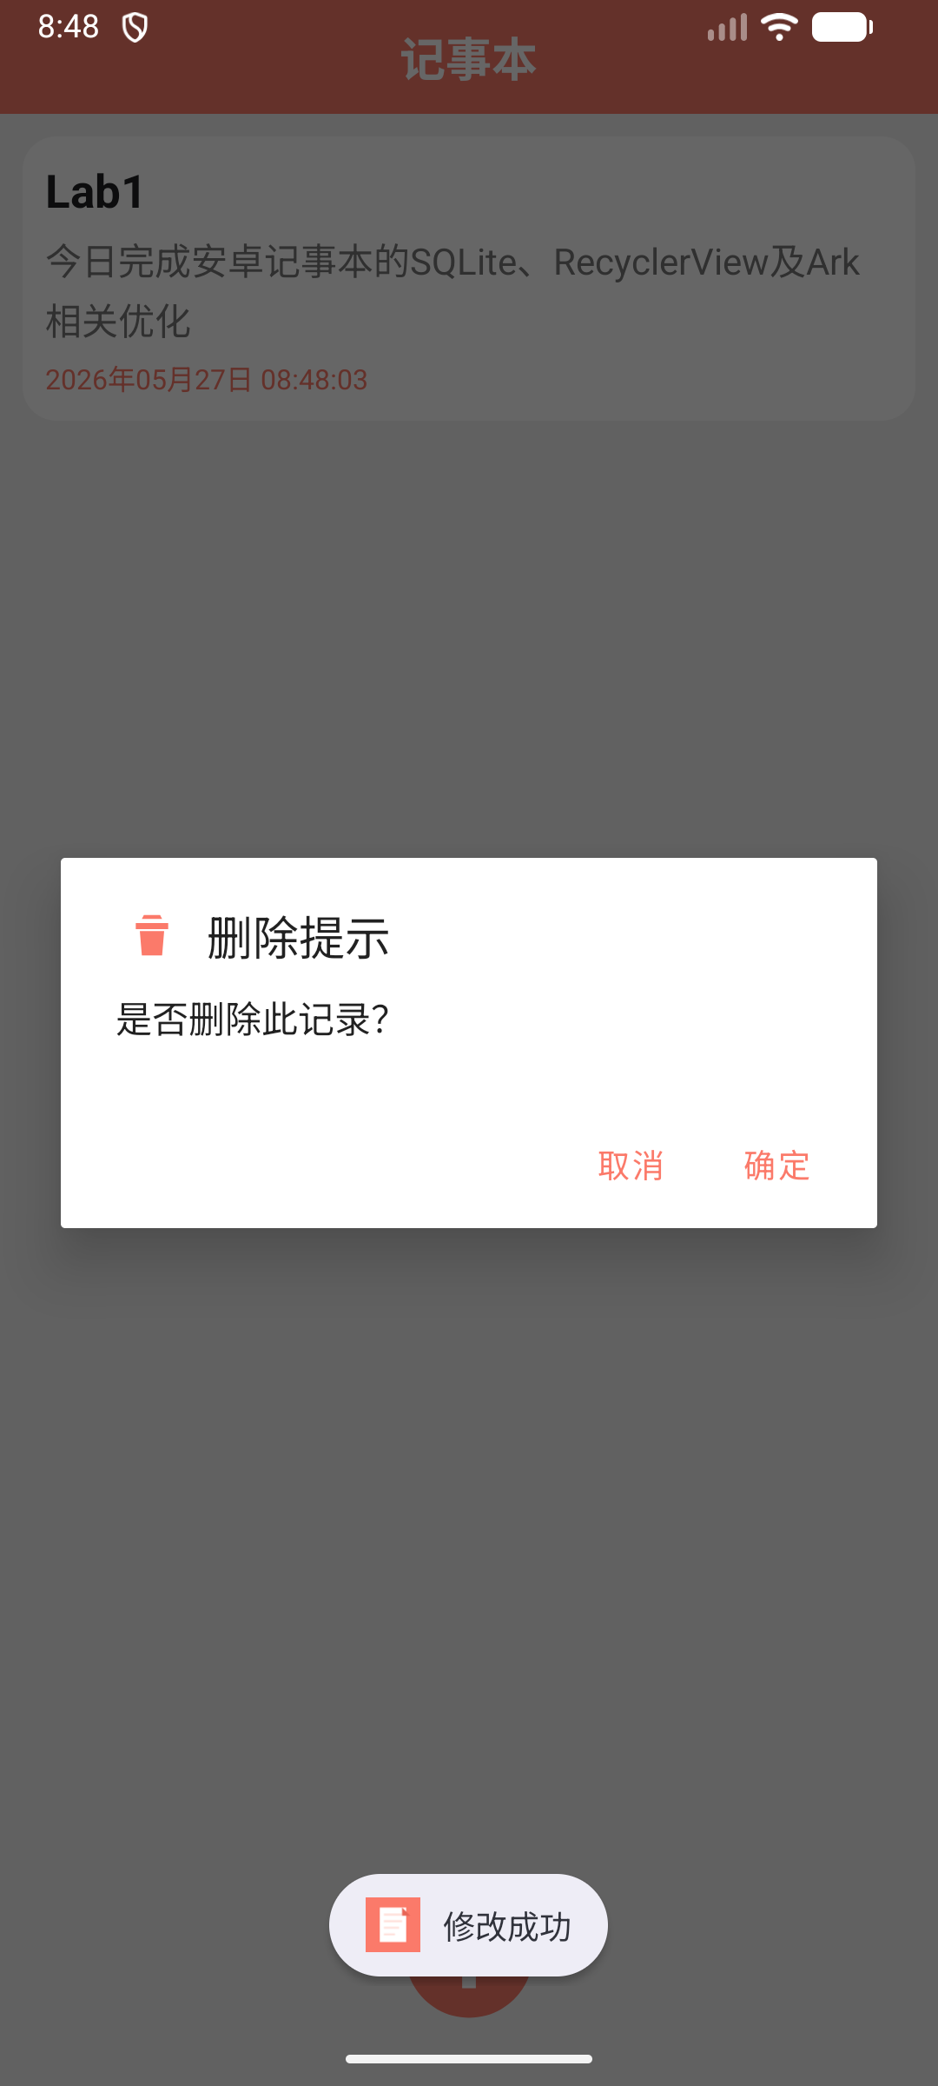
图7 长按记录弹出删除确认对话框

五、核心源码
完整源码位于提交材料中的 main目录源码.zip，以下列出本实验的核心 Java、Manifest、Gradle 和主要布局源码。

AndroidManifest.xml
<?xml version="1.0" encoding="utf-8"?>
<manifest xmlns:android="http://schemas.android.com/apk/res/android">

<uses-permission android:name="android.permission.INTERNET" />

<application
android:allowBackup="true"
android:dataExtractionRules="@xml/data_extraction_rules"
android:fullBackupContent="@xml/backup_rules"
android:icon="@drawable/ic_note_launcher"
android:label="@string/app_name"
android:roundIcon="@drawable/ic_note_launcher"
android:supportsRtl="true"
android:theme="@style/Theme.Notepad">
<activity
android:name=".RecordActivity"
android:exported="false" />
<activity
android:name=".MainActivity"
android:exported="true">
<intent-filter>
<action android:name="android.intent.action.MAIN" />

<category android:name="android.intent.category.LAUNCHER" />
</intent-filter>
</activity>
</application>

</manifest>

build.gradle
plugins {
alias(libs.plugins.android.application)
}

android {
namespace 'cn.edu.android.notepad'
compileSdk {
version = release(36) {
minorApiLevel = 1
}
}

defaultConfig {
applicationId "cn.edu.android.notepad"
minSdk 24
targetSdk 36
versionCode 1
versionName "1.0"

testInstrumentationRunner "androidx.test.runner.AndroidJUnitRunner"
}

buildTypes {
release {
minifyEnabled false
proguardFiles getDefaultProguardFile('proguard-android-optimize.txt'), 'proguard-rules.pro'
}
}
compileOptions {
sourceCompatibility JavaVersion.VERSION_11
targetCompatibility JavaVersion.VERSION_11
}
}

dependencies {
implementation libs.androidx.appcompat
implementation libs.material
implementation libs.androidx.activity
implementation libs.androidx.recyclerview
implementation("com.squareup.okhttp3:okhttp:4.12.0")
implementation("com.google.code.gson:gson:2.10.1")
testImplementation libs.junit
androidTestImplementation libs.androidx.junit
androidTestImplementation libs.androidx.espresso.core
}

MainActivity.java
package cn.edu.android.notepad;

import android.app.AlertDialog;
import android.content.Intent;
import android.os.Bundle;
import android.view.View;
import android.widget.ImageView;
import android.widget.TextView;
import android.widget.Toast;

import androidx.activity.result.ActivityResultLauncher;
import androidx.activity.result.contract.ActivityResultContracts;
import androidx.appcompat.app.AppCompatActivity;
import androidx.recyclerview.widget.LinearLayoutManager;
import androidx.recyclerview.widget.RecyclerView;

import java.util.ArrayList;
import java.util.List;

public class MainActivity extends AppCompatActivity {
private RecyclerView rvList;
private ImageView ivAdd;
private TextView tvMainTitle;
private TextView tvEmpty;
private NoteAdapter adapter;
private List<NoteBean> list = new ArrayList<>();
private DBUtils dbUtils;
private ActivityResultLauncher<Intent> launcher;

@Override
protected void onCreate(Bundle savedInstanceState) {
super.onCreate(savedInstanceState);
setContentView(R.layout.activity_main);
initLauncher();
init();
}

private void initLauncher() {
launcher = registerForActivityResult(
new ActivityResultContracts.StartActivityForResult(),
result -> {
if (result.getResultCode() == 2) {
showQueryData();
}
}
);
}

private void init() {
dbUtils = DBUtils.getInstance(this);
tvMainTitle = findViewById(R.id.tv_main_title);
tvEmpty = findViewById(R.id.tv_empty);
rvList = findViewById(R.id.rv_list);
ivAdd = findViewById(R.id.iv_add);
tvMainTitle.setText(R.string.notepad_title);
rvList.setLayoutManager(new LinearLayoutManager(this));

adapter = new NoteAdapter(this, new NoteAdapter.ItemClickListener() {
@Override
public void onItemClick(View v, int position) {
if (position < 0 || position >= list.size()) {
return;
}
NoteBean bean = list.get(position);
Intent intent = new Intent(MainActivity.this, RecordActivity.class);
intent.putExtra("id", bean.getId());
intent.putExtra("title", bean.getTitle());
intent.putExtra("content", bean.getContent());
intent.putExtra("time", bean.getTime());
launcher.launch(intent);
}

@Override
public void onItemLongClick(View v, int position) {
if (position < 0 || position >= list.size()) {
return;
}
showDeleteDialog(position);
}
});

ivAdd.setOnClickListener(v -> launcher.launch(new Intent(MainActivity.this, RecordActivity.class)));
rvList.setAdapter(adapter);
showQueryData();
}

private void showDeleteDialog(int position) {
new AlertDialog.Builder(MainActivity.this)
.setIcon(R.drawable.ic_delete)
.setTitle("删除提示")
.setMessage("是否删除此记录？")
.setPositiveButton("确定", (dialog, which) -> {
NoteBean noteBean = list.get(position);
if (dbUtils.deleteNote(noteBean.getId())) {
list.remove(position);
adapter.setData(list);
updateEmptyState();
Toast.makeText(MainActivity.this, "删除成功", Toast.LENGTH_SHORT).show();
} else {
Toast.makeText(MainActivity.this, "删除失败", Toast.LENGTH_SHORT).show();
}
})
.setNegativeButton("取消", (dialog, which) -> dialog.dismiss())
.show();
}

private void showQueryData() {
list = dbUtils.queryNote();
adapter.setData(list);
updateEmptyState();
}

private void updateEmptyState() {
tvEmpty.setVisibility(list == null || list.isEmpty() ? View.VISIBLE : View.GONE);
}
}

RecordActivity.java
package cn.edu.android.notepad;

import android.content.Intent;
import android.os.Bundle;
import android.view.View;
import android.widget.EditText;
import android.widget.ImageView;
import android.widget.TextView;
import android.widget.Toast;

import androidx.appcompat.app.AppCompatActivity;

public class RecordActivity extends AppCompatActivity implements View.OnClickListener {
private TextView tvTime;
private TextView tvMainTitle;
private TextView tvBack;
private EditText etTitle;
private EditText etContent;
private ImageView ivDel;
private ImageView ivSave;
private ImageView ivPolish;
private DBUtils dbUtils;
private int id;

@Override
protected void onCreate(Bundle savedInstanceState) {
super.onCreate(savedInstanceState);
setContentView(R.layout.activity_record);
initView();
initData();
}

private void initView() {
tvTime = findViewById(R.id.tv_time);
tvMainTitle = findViewById(R.id.tv_main_title);
tvBack = findViewById(R.id.tv_back);
etTitle = findViewById(R.id.et_title);
etContent = findViewById(R.id.et_content);
ivDel = findViewById(R.id.iv_del);
ivSave = findViewById(R.id.iv_save);
ivPolish = findViewById(R.id.iv_polish);

tvBack.setVisibility(View.VISIBLE);
tvBack.setOnClickListener(this);
ivDel.setOnClickListener(this);
ivSave.setOnClickListener(this);
ivPolish.setOnClickListener(this);
}

private void initData() {
dbUtils = DBUtils.getInstance(this);
Intent intent = getIntent();
id = intent.getIntExtra("id", 0);
if (id != 0) {
tvMainTitle.setText(R.string.edit_note);
etTitle.setText(intent.getStringExtra("title"));
etContent.setText(intent.getStringExtra("content"));
tvTime.setText(intent.getStringExtra("time"));
tvTime.setVisibility(View.VISIBLE);
} else {
tvMainTitle.setText(R.string.add_note);
tvTime.setVisibility(View.GONE);
}
}

@Override
public void onClick(View view) {
int viewId = view.getId();
if (viewId == R.id.tv_back) {
finish();
} else if (viewId == R.id.iv_del) {
etContent.setText("");
} else if (viewId == R.id.iv_save) {
saveRecord();
} else if (viewId == R.id.iv_polish) {
polishContent();
}
}

private void saveRecord() {
String title = etTitle.getText().toString().trim();
String content = etContent.getText().toString().trim();
if (content.isEmpty()) {
showToast(id == 0 ? "添加的内容不能为空!" : "修改内容不能为空!");
return;
}
if (title.isEmpty()) {
title = content.length() > 12 ? content.substring(0, 12) : content;
}

boolean success = id == 0
? dbUtils.saveNote(title, content, DBUtils.getTime())
: dbUtils.updateNote(id, title, content, DBUtils.getTime());
if (success) {
showToast(id == 0 ? "保存成功" : "修改成功");
setResult(2);
finish();
} else {
showToast(id == 0 ? "保存失败" : "修改失败");
}
}

private void polishContent() {
String content = etContent.getText().toString().trim();
if (content.isEmpty()) {
showToast("请先输入要润色的内容");
return;
}
ivPolish.setEnabled(false);
showToast("正在润色，请稍候");
new Thread(() -> {
try {
String result = VolcAiUtil.polishText(content);
runOnUiThread(() -> {
etContent.setText(result);
etContent.setSelection(etContent.getText().length());
ivPolish.setEnabled(true);
showToast("润色完成");
});
} catch (Exception e) {
runOnUiThread(() -> {
ivPolish.setEnabled(true);
showToast("接口调用出错：" + e.getMessage());
});
}
}).start();
}

private void showToast(String msg) {
Toast.makeText(this, msg, Toast.LENGTH_SHORT).show();
}
}

NoteBean.java
package cn.edu.android.notepad;

public class NoteBean {
private int id;
private String title;
private String content;
private String time;

public int getId() {
return id;
}

public void setId(int id) {
this.id = id;
}

public String getTitle() {
return title;
}

public void setTitle(String title) {
this.title = title;
}

public String getContent() {
return content;
}

public void setContent(String content) {
this.content = content;
}

public String getTime() {
return time;
}

public void setTime(String time) {
this.time = time;
}
}

SQLiteHelper.java
package cn.edu.android.notepad;

import android.content.Context;
import android.database.sqlite.SQLiteDatabase;
import android.database.sqlite.SQLiteOpenHelper;

public class SQLiteHelper extends SQLiteOpenHelper {
private static final int DB_VERSION = 1;
public static final String DB_NAME = "note.db";
public static final String U_NOTEPAD = "note";

public SQLiteHelper(Context context) {
super(context, DB_NAME, null, DB_VERSION);
}

@Override
public void onCreate(SQLiteDatabase sqLiteDatabase) {
sqLiteDatabase.execSQL("CREATE TABLE IF NOT EXISTS " + U_NOTEPAD + "( "
+ "id INTEGER PRIMARY KEY AUTOINCREMENT, "
+ "title VARCHAR, "
+ "content VARCHAR, "
+ "time VARCHAR "
+ ")");
}

@Override
public void onUpgrade(SQLiteDatabase sqLiteDatabase, int oldVersion, int newVersion) {
sqLiteDatabase.execSQL("DROP TABLE IF EXISTS " + U_NOTEPAD);
onCreate(sqLiteDatabase);
}
}

DBUtils.java
package cn.edu.android.notepad;

import android.content.ContentValues;
import android.content.Context;
import android.database.Cursor;
import android.database.sqlite.SQLiteDatabase;

import java.text.SimpleDateFormat;
import java.util.ArrayList;
import java.util.Date;
import java.util.List;
import java.util.Locale;

public class DBUtils {
private static DBUtils instance = null;
private static SQLiteDatabase db;

public DBUtils(Context context) {
SQLiteHelper helper = new SQLiteHelper(context.getApplicationContext());
db = helper.getWritableDatabase();
}

public static DBUtils getInstance(Context context) {
if (instance == null) {
instance = new DBUtils(context);
}
return instance;
}

public List<NoteBean> queryNote() {
List<NoteBean> list = new ArrayList<>();
String sql = "SELECT * FROM " + SQLiteHelper.U_NOTEPAD + " ORDER BY id DESC";
Cursor cursor = db.rawQuery(sql, null);
if (cursor != null) {
while (cursor.moveToNext()) {
NoteBean bean = new NoteBean();
bean.setId(cursor.getInt(cursor.getColumnIndexOrThrow("id")));
bean.setTitle(cursor.getString(cursor.getColumnIndexOrThrow("title")));
bean.setContent(cursor.getString(cursor.getColumnIndexOrThrow("content")));
bean.setTime(cursor.getString(cursor.getColumnIndexOrThrow("time")));
list.add(bean);
}
cursor.close();
}
return list;
}

public boolean deleteNote(int id) {
int rows = db.delete(SQLiteHelper.U_NOTEPAD, "id=?", new String[]{String.valueOf(id)});
return rows > 0;
}

public static String getTime() {
SimpleDateFormat simpleDateFormat = new SimpleDateFormat("yyyy年MM月dd日 HH:mm:ss", Locale.CHINA);
Date date = new Date(System.currentTimeMillis());
return simpleDateFormat.format(date);
}

public boolean saveNote(String title, String content, String time) {
ContentValues cv = new ContentValues();
cv.put("title", title);
cv.put("content", content);
cv.put("time", time);
long rowId = db.insert(SQLiteHelper.U_NOTEPAD, null, cv);
return rowId > 0;
}

public boolean updateNote(int id, String title, String content, String time) {
ContentValues cv = new ContentValues();
cv.put("title", title);
cv.put("content", content);
cv.put("time", time);
int rows = db.update(SQLiteHelper.U_NOTEPAD, cv, "id=?", new String[]{String.valueOf(id)});
return rows > 0;
}
}

NoteAdapter.java
package cn.edu.android.notepad;

import android.content.Context;
import android.view.LayoutInflater;
import android.view.View;
import android.view.ViewGroup;
import android.widget.TextView;

import androidx.annotation.NonNull;
import androidx.recyclerview.widget.RecyclerView;

import java.util.ArrayList;
import java.util.List;

public class NoteAdapter extends RecyclerView.Adapter<NoteAdapter.MyViewHolder> {
private List<NoteBean> list = new ArrayList<>();
private final Context mContext;
private final ItemClickListener itemClickListener;

public NoteAdapter(Context context, ItemClickListener itemClickListener) {
this.mContext = context;
this.itemClickListener = itemClickListener;
}

public void setData(List<NoteBean> list) {
this.list = list == null ? new ArrayList<>() : list;
notifyDataSetChanged();
}

@NonNull
@Override
public MyViewHolder onCreateViewHolder(@NonNull ViewGroup parent, int viewType) {
View itemView = LayoutInflater.from(mContext).inflate(R.layout.list_item, parent, false);
return new MyViewHolder(itemView);
}

@Override
public void onBindViewHolder(@NonNull MyViewHolder holder, int position) {
View itemView = holder.itemView;
NoteBean bean = list.get(position);
holder.tvTitle.setText(bean.getTitle());
holder.tvContent.setText(bean.getContent());
holder.tvTime.setText(bean.getTime());
itemView.setOnClickListener(v -> itemClickListener.onItemClick(itemView, holder.getBindingAdapterPosition()));
itemView.setOnLongClickListener(v -> {
itemClickListener.onItemLongClick(itemView, holder.getBindingAdapterPosition());
return true;
});
}

@Override
public int getItemCount() {
return list == null ? 0 : list.size();
}

public static class MyViewHolder extends RecyclerView.ViewHolder {
TextView tvTitle;
TextView tvContent;
TextView tvTime;

public MyViewHolder(View view) {
super(view);
tvTitle = view.findViewById(R.id.tv_title);
tvContent = view.findViewById(R.id.tv_content);
tvTime = view.findViewById(R.id.tv_time);
}
}

public interface ItemClickListener {
void onItemClick(View v, int position);

void onItemLongClick(View v, int position);
}
}

VolcAiUtil.java
package cn.edu.android.notepad;

import com.google.gson.Gson;
import com.google.gson.JsonArray;
import com.google.gson.JsonObject;

import java.io.IOException;
import java.util.concurrent.TimeUnit;

import okhttp3.MediaType;
import okhttp3.OkHttpClient;
import okhttp3.Request;
import okhttp3.RequestBody;
import okhttp3.Response;

public class VolcAiUtil {
private static final String API_KEY = "f69de4fa-1bb5-4d75-9f11-a1ed34c9b8de";
private static final String MODEL_NAME = "ep-20260527083139-fkcnp";
private static final String API_URL = "https://ark.cn-beijing.volces.com/api/v3/chat/completions";
private static final MediaType JSON = MediaType.get("application/json; charset=utf-8");
private static final OkHttpClient HTTP_CLIENT = new OkHttpClient.Builder()
.connectTimeout(30, TimeUnit.SECONDS)
.readTimeout(30, TimeUnit.SECONDS)
.writeTimeout(30, TimeUnit.SECONDS)
.build();
private static final Gson GSON = new Gson();

public static String polishText(String content) throws IOException {
String prompt = "请润色下面这段记事本内容，保持原意，只返回润色后的文字，不要解释：\n" + content;
return sendAiRequest(prompt);
}

private static String sendAiRequest(String userMsg) throws IOException {
JsonObject system = new JsonObject();
system.addProperty("role", "system");
system.addProperty("content", "你是专业笔记处理助手，负责把用户的笔记内容润色得自然、清晰、简洁。");

JsonObject userObj = new JsonObject();
userObj.addProperty("role", "user");
userObj.addProperty("content", userMsg);

JsonArray msgArr = new JsonArray();
msgArr.add(system);
msgArr.add(userObj);

JsonObject requestBody = new JsonObject();
requestBody.addProperty("model", MODEL_NAME);
requestBody.add("messages", msgArr);
requestBody.addProperty("temperature", 0.6);

RequestBody body = RequestBody.create(requestBody.toString(), JSON);
Request request = new Request.Builder()
.url(API_URL)
.header("Authorization", "Bearer " + API_KEY)
.header("Content-Type", "application/json")
.post(body)
.build();

try (Response response = HTTP_CLIENT.newCall(request).execute()) {
String resStr = response.body() == null ? "" : response.body().string();
if (!response.isSuccessful()) {
throw new IOException("请求失败：" + response.code() + " " + resStr);
}
JsonObject resJson = GSON.fromJson(resStr, JsonObject.class);
return resJson.getAsJsonArray("choices")
.get(0).getAsJsonObject()
.getAsJsonObject("message")
.get("content").getAsString()
.trim();
}
}
}

activity_main.xml
<?xml version="1.0" encoding="utf-8"?>
<RelativeLayout xmlns:android="http://schemas.android.com/apk/res/android"
android:layout_width="match_parent"
android:layout_height="match_parent"
android:background="@color/notepad_background">

<LinearLayout
android:layout_width="match_parent"
android:layout_height="match_parent"
android:orientation="vertical">

<include layout="@layout/title_bar" />

<TextView
android:id="@+id/tv_empty"
android:layout_width="match_parent"
android:layout_height="wrap_content"
android:gravity="center"
android:padding="28dp"
android:text="@string/empty_tip"
android:textColor="@color/notepad_muted"
android:textSize="16sp"
android:visibility="gone" />

<androidx.recyclerview.widget.RecyclerView
android:id="@+id/rv_list"
android:layout_width="match_parent"
android:layout_height="match_parent"
android:layout_margin="5dp"
android:clipToPadding="false"
android:paddingBottom="90dp" />
</LinearLayout>

<ImageView
android:id="@+id/iv_add"
android:layout_width="64dp"
android:layout_height="64dp"
android:layout_alignParentBottom="true"
android:layout_centerHorizontal="true"
android:layout_marginBottom="26dp"
android:background="@drawable/add_selector"
android:contentDescription="@string/add_note" />
</RelativeLayout>

activity_record.xml
<?xml version="1.0" encoding="utf-8"?>
<LinearLayout xmlns:android="http://schemas.android.com/apk/res/android"
android:layout_width="match_parent"
android:layout_height="match_parent"
android:background="@android:color/white"
android:orientation="vertical">

<include layout="@layout/title_bar" />

<TextView
android:id="@+id/tv_time"
android:layout_width="match_parent"
android:layout_height="wrap_content"
android:gravity="center"
android:paddingTop="10dp"
android:paddingBottom="5dp"
android:textColor="@color/notepad_primary"
android:textSize="15sp"
android:visibility="gone" />

<EditText
android:id="@+id/et_title"
android:layout_width="match_parent"
android:layout_height="wrap_content"
android:layout_marginStart="10dp"
android:layout_marginTop="5dp"
android:layout_marginEnd="10dp"
android:layout_marginBottom="5dp"
android:background="@drawable/edittext_bg"
android:gravity="top"
android:hint="@string/hint_title"
android:inputType="textCapSentences"
android:padding="8dp"
android:textColorHint="@color/notepad_muted" />

<EditText
android:id="@+id/et_content"
android:layout_width="match_parent"
android:layout_height="0dp"
android:layout_marginStart="10dp"
android:layout_marginTop="5dp"
android:layout_marginEnd="10dp"
android:layout_marginBottom="10dp"
android:layout_weight="1"
android:background="@drawable/edittext_bg"
android:gravity="top"
android:hint="@string/hint_content"
android:inputType="textMultiLine|textCapSentences"
android:minLines="8"
android:padding="8dp"
android:textColorHint="@color/notepad_muted" />

<View
android:layout_width="match_parent"
android:layout_height="1dp"
android:background="@color/notepad_primary" />

<LinearLayout
android:layout_width="match_parent"
android:layout_height="55dp"
android:orientation="horizontal">

<ImageView
android:id="@+id/iv_del"
android:layout_width="0dp"
android:layout_height="match_parent"
android:layout_weight="1"
android:background="@drawable/delete_selector"
android:contentDescription="@string/delete_note"
android:paddingTop="9dp"
android:paddingBottom="15dp" />

<ImageView
android:id="@+id/iv_save"
android:layout_width="0dp"
android:layout_height="match_parent"
android:layout_weight="1"
android:background="@drawable/save_selector"
android:contentDescription="@string/save_note"
android:paddingTop="9dp"
android:paddingBottom="15dp" />

<ImageView
android:id="@+id/iv_polish"
android:layout_width="0dp"
android:layout_height="match_parent"
android:layout_weight="1"
android:background="@drawable/polish_selector"
android:contentDescription="@string/polish_note"
android:paddingTop="9dp"
android:paddingBottom="15dp" />
</LinearLayout>
</LinearLayout>

list_item.xml
<?xml version="1.0" encoding="utf-8"?>
<LinearLayout xmlns:android="http://schemas.android.com/apk/res/android"
android:id="@+id/ll_item"
android:layout_width="match_parent"
android:layout_height="wrap_content"
android:layout_margin="5dp"
android:background="@drawable/item_bg_selector"
android:orientation="vertical"
android:padding="10dp">

<TextView
android:id="@+id/tv_title"
android:layout_width="match_parent"
android:layout_height="wrap_content"
android:singleLine="true"
android:textColor="@color/notepad_text"
android:textSize="20sp"
android:textStyle="bold" />

<TextView
android:id="@+id/tv_content"
android:layout_width="match_parent"
android:layout_height="wrap_content"
android:layout_marginTop="5dp"
android:ellipsize="end"
android:lineSpacingExtra="3dp"
android:maxLines="2"
android:textColor="@color/notepad_muted"
android:textSize="16sp" />

<TextView
android:id="@+id/tv_time"
android:layout_width="match_parent"
android:layout_height="wrap_content"
android:layout_marginTop="5dp"
android:textColor="@color/notepad_primary"
android:textSize="12sp" />
</LinearLayout>

六、实验小结
本次实验完成了一个具备增、删、改、查功能的 Android 记事本应用，主界面使用 RecyclerView 展示数据库中的记录，编辑界面使用 SQLite 完成数据持久化。
实验中需要注意网络请求不能在主线程执行，因此 Ark 在线推理调用放在线程中完成，并通过 runOnUiThread 更新界面，避免界面卡顿或 NetworkOnMainThreadException。
运行验证中完成了新增记录、修改记录、保存润色结果、长按删除提示等流程。在线推理成功返回“今日完成安卓记事本的SQLite、RecyclerView及Ark相关优化”，说明 REST API 调用链路可用。

