**CS 623 Summer I**

**Exercise on GitHub and Git**

In this project, we will be using GitHub for assignment submissions and code versioning.

The goal of this exercise is to get you started with Git and GitHub. Even if you are using Git and GitHub regularly you need to do this exercise and submit it. If you already did it, you need to create the required repository and fill out the required documents.

Please follow the instructions completely. Work that does not follow the instructions (including naming conventions) will NOT be accepted and will result in a grade of 0.

**Part 1:**

Create a GitHub account (if you do not have one)

<https://github.com>

Submit your GitHub username in the form here:

<http://bit.ly/2KI2guU>

as described in the file.

I will check your work directly from your GitHub account.

**Part 2:**

Install Git bash <http://git-scm.com/downloads> and browse the documentation.

**Part 3:**

Answer the following questions.

What is GitHub? When was it created? Why? By who? What similar platforms exist? Why would you use such a platform? (Answer between 2 and 3 lines)

GitHub is a service platform that utilizes git to provide version control and source code management. It was founded by Chris Wanstrath, PJ Hyet, and Tom Preston-Werner in 2008. The distributed version control system git however, was developed by Linus Torvalds for managing Linux kernel developments in 2005. Similar systems include Monotone and BitKeeper. Platforms would be used for source code version management and cooperation.

**Part 4:**

Go through the Git tutorial here: <https://try.github.io> (Git It). While doing the tutorial, save your work the *LastnameFirstnameGitTutorial-mm-dd-yyyy.docx* file.

While there is a GUI to use Git and GitHub, developers use the command line!

**Part 5:**

Become familiar with the following terms:

* Repository

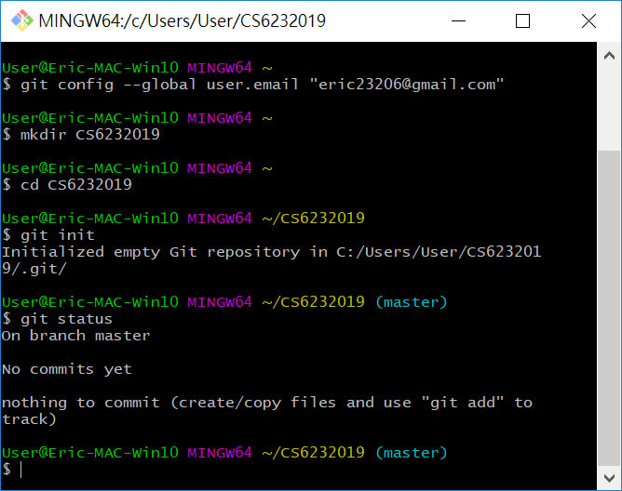

* Commit
* Push
* Branch

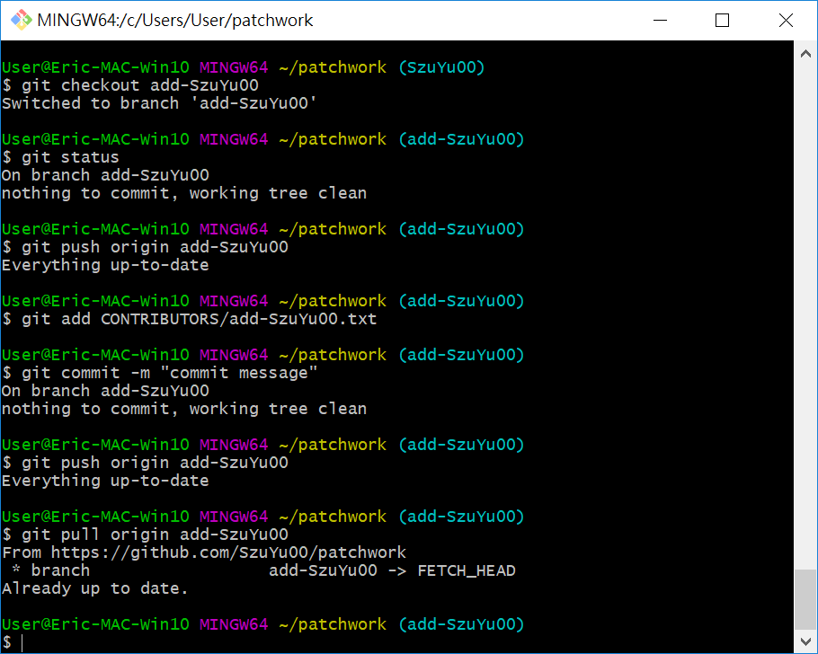

* Fork
* Merge
* Clone
* Pull
* Pull request

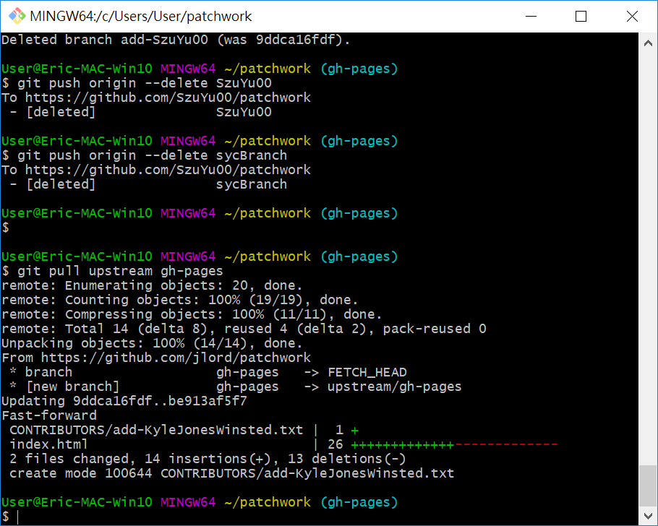

**Part 6:**

Push the Word file in **YOUR** GitHub account in a repository called ***CS6232019***. Please respect the naming conventions! You will use this repository for the project. Your repository will be accessible at: <https://github.com/SzuYu00/CS6232019>.

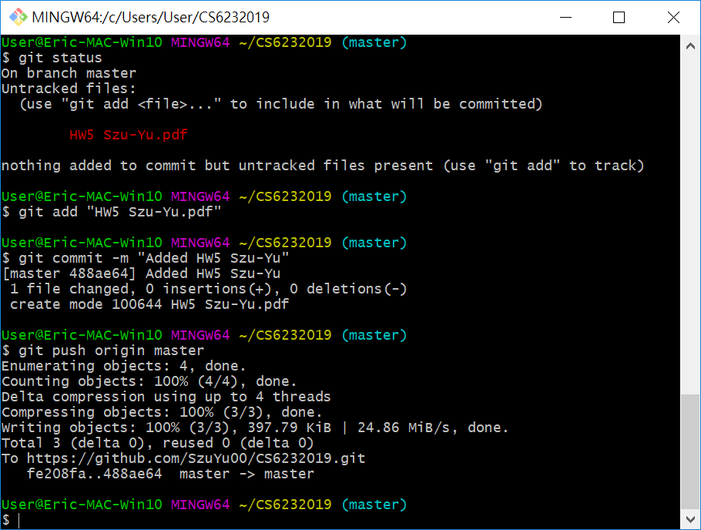

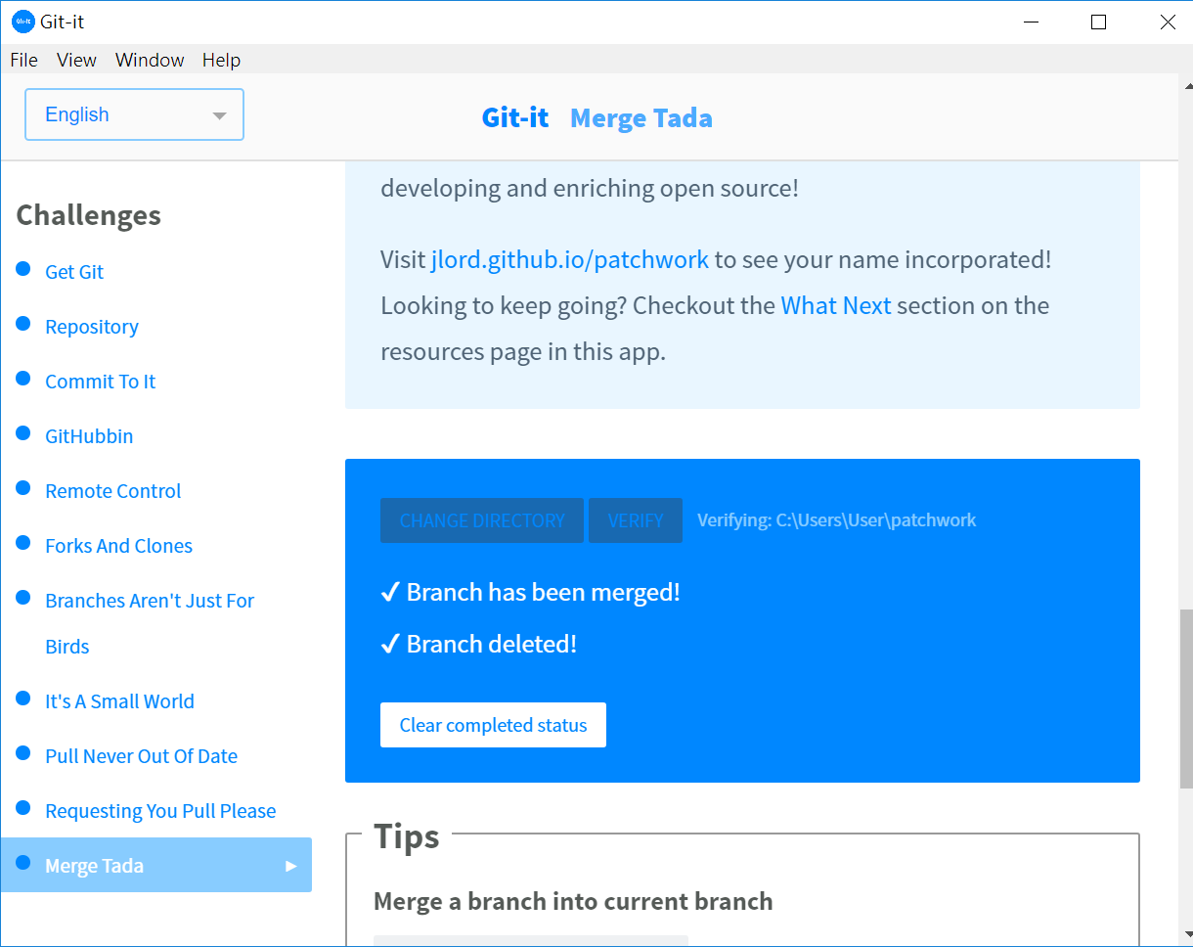

**Part 7:**

Add an issue with title “GitHub training” in your repository called CS6232019. Issues are used for tasks and bug reports.

**Part 8:**

Edit the main page of the wiki in your repository called CS6232019. Add the title “CS 629 2019” to the page (if you decide to do so).

You can also override Readme.md to document your work.