SHADOW FRAMES - TECHDOC
GROUP 22 | 2025
Team:
- Art: Daan Van Schuylenbergh, Roeland Van Sichem De Combe
- Dev: Ine Hocedez, Eitvile Petruseviciute, Hades Speranskaya
- Sound: Igor Szuniewicz

Contents
1. Introduction 4
2. Target Audience 5
3. Target Platform 6
4. Development Stack 7
4.1. Unreal Engine 5.5 7
4.2. Software Stack 8
4.3. Units and Metrics 9
5. Art Pipeline and Methods 10
5.1. Asset workflow 10
5.1.1. Custom Assets 12
5.1.2. External Assets 12
5.2. Export File Types 14
5.3. Grid Scale for Tiling Assets 14
5.4. Mesh Pivot Points 15
5.5. Shaders 15
5.6. Decals 17
5.7. Textures 17
6. Programming Specifics 18
6.1. Photoboard 18
6.2. Picture taking 18
7. Programming Guidelines 19
7.1. Language conventions 19
7.2. Naming conventions 19
7.3. Class Structure 20
7.4. Syntax 20
7.5. Const correctness 22
7.6. Formatting 22
7.7. Physical Dependencies 23
7.8. Comments 24
7.9. General 24
8. Folder Structure 25
8.1. In Perforce 25
8.1.1. Overview 25
8.1.2. ArtAssets 25
8.1.3. Dev 26
8.1.4. SoundAssets 27
9. Scene Structure 28
10. File Naming Conventions 29
10.1. Universal Guidelines 29
10.2. In Unreal 29
10.3. In ArtAssets 30
10.4. In SoundAssets 31
11. Other 32
11.1. Generating Visual Studio/Build Files 32
11.2. Visual Studio Required Installed Components 32
11.3. Unreal Plugins 33
11.4. Visual Studio Plugins 33
11.5. Blender Plugins 34

Introduction
"Shadow Frames" is a short, single-player psychological black-and-white horror game set in a 1960s pub environment. In this pub people have reported missing items, glasses, cutlery and plates suddenly falling off the tabletops and sightings of mysterious and unexplained shadows.
The player steps into the shoes of a curious investigative reporter, drawn by the consistency of these chilling accounts. The player’s task is to observe, capture, and connect the inexplicable anomalies that haunt the pub to unravel the mystery around them.
This document outlines our chosen development stack, project settings, folder structure and naming conventions as well as the reasoning behind them.

Target Audience
This game is designed for fans of short indie horror games - such as the “I’m on Observation Duty” franchise, “Chilla’s Art” short horror games, Iron Lung - and specifically those fans who enjoy horror games that feature unsettling, atmospheric gameplay with environmental storytelling and recourse-based horror mechanics. It is also meant to be enjoyable to streamers who focus on playing horror games and livestreaming their reactions of playing a certain game for the first time.
The target audience age range is 15-35, since the game deals with horror and mature themes (including alcoholism and depression), and is set in a bar. Players within this age bracket are often drawn to games that offer deeper narrative meaning, emotional atmosphere, and unique mechanics.

Target Platform
The target platform is PC with a Windows 11 OS. The game will require a keyboard and mouse.
The target resolution for the game is 1440p, and we want a sustained 60 FPS as absolute minimum. We will set the Medium scaling quality setting as the default but may raise it if we can keep the FPS at the desired level.
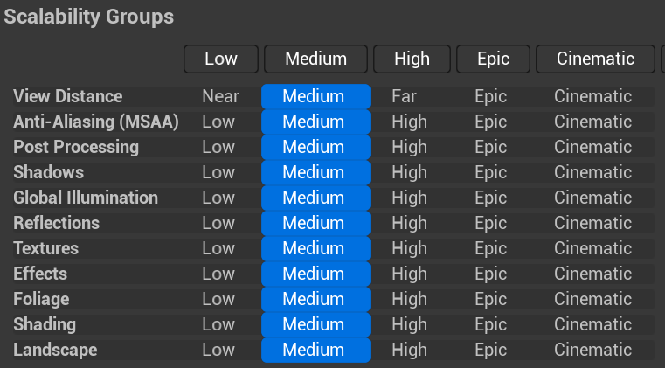
In order to achieve the FPS we desire, we may have to limit our use of ambient occlusion, volumetric fog, use of transparent textures and reflections. We will be disabling Nanite and Lumen as much as possible, as they do not fit art style and will impact performance.
The minimal technological specs we will be able to guarantee:
OS | Windows 11 64-bit
Processor | Intel Core i7 10870H or AMD Ryzen 9 7940HS
Memory | 8 GB RAM
Graphics | Nvidia GeForce RTX 3060 or AMD Radeon 780M

Ideally, the game will be able to run well on specs lower than those, but we are limited by the computers we own at present and will not be able to test the performance of the game on lower specs than the ones indicated above.
We want to be able to release our game on itch.io and Steam.

Development Stack

Unreal Engine 5.5
During the prototyping phase, we tested the implementation of the basic mechanics, audio, and visual style in both Unreal and Unity engine: the prototypes worked in both engines, and the only notable difference was that the Unity Art/Light test offered a stable 45 FPS on the lowest-spec machine we had, and Unreal Art/light test had a stable 59 FPS on that same machine.
We have chosen to use the Unreal Engine for the following reasons:
- We want the game to run well on lower-spec machines – preferably lower than the minimum targets set out in this document. The Lighting/Art prototypes suggest that Unreal will be more performant, as it had the higher stable FPS.
- Our game’s visual style is semi realistic and relies heavily on lighting and the metallic/roughness texture rendering to be legible to the player and create the desired mood. Unreal’s rendering and lighting capabilities are superior, even if we opt out of many features for the sake of performance, and setting up post-processing effects is more straightforward.
- As we only have two artists on the team, we will be using asset packs to fill out our environment, and Unreal has Fab, which is a large asset database that we can draw on for what we need.
- One of the main mechanics of the game requires a lot of interaction with UI elements, and it is very easy to implement this in Unreal due to its UMG and widget system.
- The majority of the team is more familiar with Unreal than Unity; it would be inefficient to teach them a new engine, especially as neither of the artists is familiar with it and would not be able to help the other. Additionally, the blueprint system of Unreal is simpler for artists to grasp and use if they want to quickly set up animations, visual effects, and so on.
- Using Unreal does add the complexity of using C++ as the programming language, but both of the programmers in the team are comfortable with using C++.

Software Stack
Description | Software | Version
Game Engine | Unreal Engine | 5.4.4
Programming Language | C++ | C++20
Integrated Development Environment | Microsoft Visual Studio 2022 – Community Edition | 17.14.16
Integrated Development Environment | Microsoft Visual Studio 2022 – Enterprise Edition | 17.14.16
Visual Studio Extension | P4VS – Helix Plugin for Visual Studio | 2024.2.270.7516
Source Control GUI | Perforce Helix Core (P4V) | 2024.4/2711678
Modelling, UV, Rigging | Blender | Latest
Texturing | Adobe Substance 3D Painter | 11.0.3
RFX, 2D Assets | Adobe Photoshop 2025 | 26.11
Reference Image Organization | PureRef | Latest
Sound Editing, Mixing, Mastering | REAPER | 7.34
Audio Middleware | Wwise | 2024.1.2.8726
Brainstorming | Miro | Latest
Project Management | HacknPlan | Latest
Documentation | Microsoft Office | Latest
Online Communication | Discord | Latest

The details of the required components for Visual Studio can be found in the other section of this document.
A list of required Blender plugins can be found in the Other section of this document.
We will make use of the following Unreal Engine plugin: HDRIBackdrop version 1.0.
The .uproject file will also include dependencies on UMG, SlateCore, and Slate, with additional modules possibly being included later on.

If a definitive version is specified for a software, then that version must be used for the duration of the project. If a version Is not specified, then it must be the latest stable release available for use.
An Engine update can only be permitted in exceptional circumstances, such as a security weakness that must be patched out as soon as possible, and everything refactored as necessary.

Units and Metrics
Blender uses meters as its units, and Unreal uses centimeters. To account for this, when exporting from Blender to Unreal, the scale must be set to 0.01 and the length set to meters, which will ensure a correctly sized mesh export and prevent scale discrepancies in the future.
Blender: Unreal:
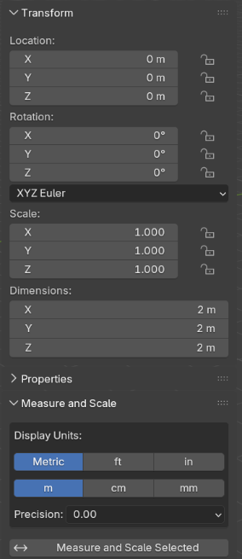 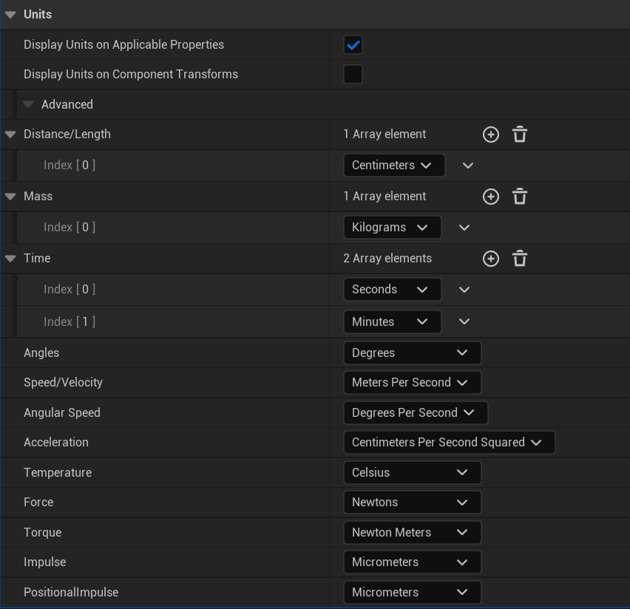
Use the following setting when exporting from Blender:
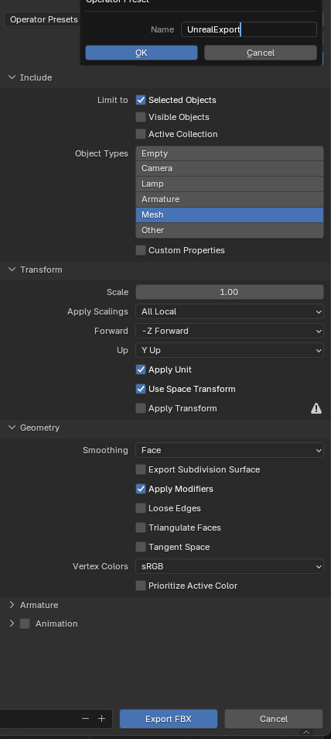

Art Pipeline and Methods

Asset workflow
For this project, we will be using a combination of custom assets, and assets sourced from Fab or Sketchfab that will be processed before being added to the game.
For a chair this would be about 30 minutes, if the complexity is a bit bigger then it would be about 15 minutes longer to work on. For the unwrapping of these props, it will take the same amount of time. If this would be a unique asset it will take a longer time to texture in substance painter 3D.
Below you’ll see how a unique asset should be unwrapped. Little to no repetition only where necessary. Since we want to save texture space make sure to mirror elements in your unwrap.
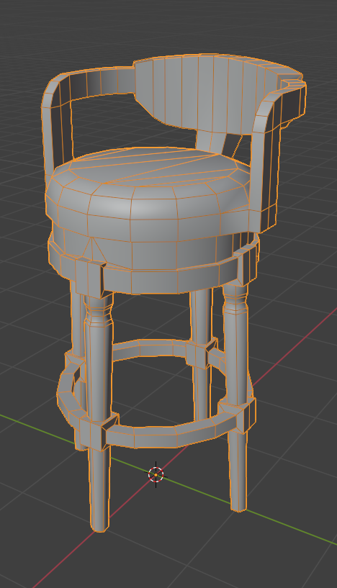
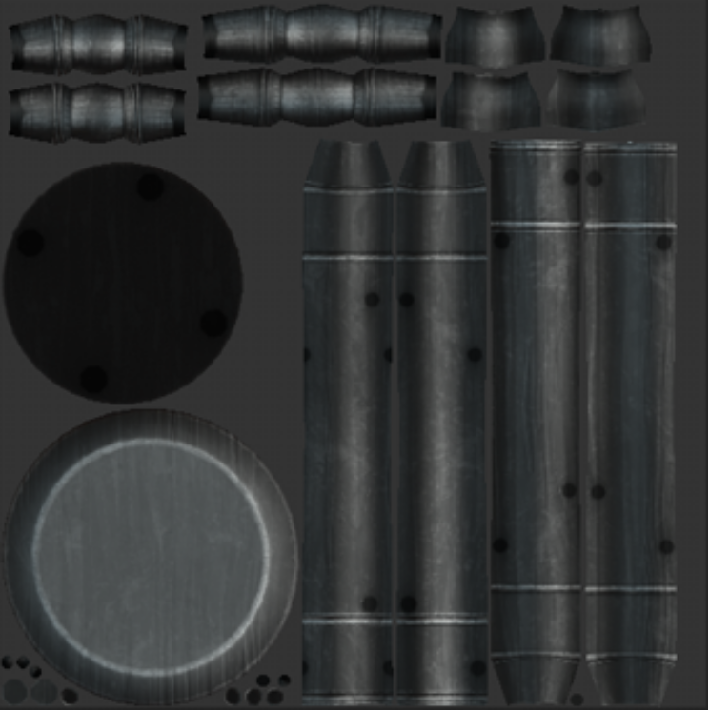

For the use of trim textures and how to space them accordingly, follow this guide https://www.artstation.com/blogs/jennifermcgarry/yd4Q/jenns-guide-to-trim-sheets

For a hero asset the time would take at least double to triple that amount.
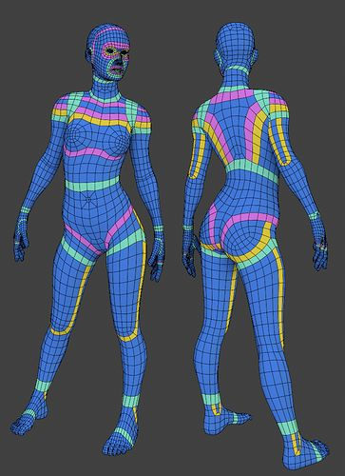
Same for the character and do make sure that it has the correct loops according to this picture:

And this guide will help you unwrap your characters smoothly.
https://blenderartists.org/t/solved-how-to-unwrap-face-for-texturing/1100507

Rank based of time needed:
- character
- setting up trims
- modeling custom assets
- adapting existing assets

Custom Assets

We will have a mix of modular props and unique props. Most of our props will be trim textured, props like characters and hero assets will be unique. Below is an example of how props would be categorized:
Env big pieces: modular kit (e.g. walls, wooden beams, doors...)
Env Bar area: trim
Medium sized assets: trim (e.g. tables, chairs, dressers.. )
Hero assets: unique (e.g. polaroid)
Characters: unique (e.g. Ghost)
Objects that need to be animated for anomalies, will have single bone attached so that they can be animated. And these need to be positioned on the world center.
For characters, to rig them, we will be using blenders "Rigify".
See picture below:
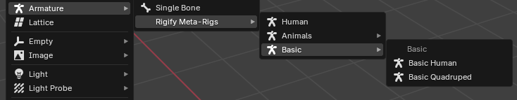
We will use Blender’s animation pipeline to animate the characters. You’re going to the rig to the base model and apply automatic weight painting, which you will highly likely have to manually hand-paint again after some test poses to see if something breaks.

External Assets
The criteria for choosing an existing asset to add are:
- It fits the environment of the game: it matches the time period, materials, architecture/culture style of the region.
- It fits the shape language and modelling style as described in the art bible.
Processing an asset will happen as follows:
- The asset is downloaded is an FBX file and imported into a Blender scene.
- The topology is assessed visually and by checking the poly count. If there are too many polygons, the Retopoflow add-on will be used to alter the asset until it is under the polygon limit – ideally, it should be significantly lower than the limit without losing the desired details. For non-hero props, the limit is 1k polygons; there may be some exceptions for larger assets. The polycount is determined based on how big the asset is in game as well as how many times it is featured in the scene. A big asset will use a higher polycount than a small asset because it takes more space in the scene.
- The model is then unwrapped in one of two ways:
  - Unique texture: It will be unwrapped with the expectation of being textured manually and having its own custom material.
  - Trim/tileable texture: It will be unwrapped using one of the trim/tileable texture layouts.
- The asset will be exported as FBX to be imported into Substance Painter – in Substance Painter, make a new file and import the FBX using DirectX. Do not use OpenGL.
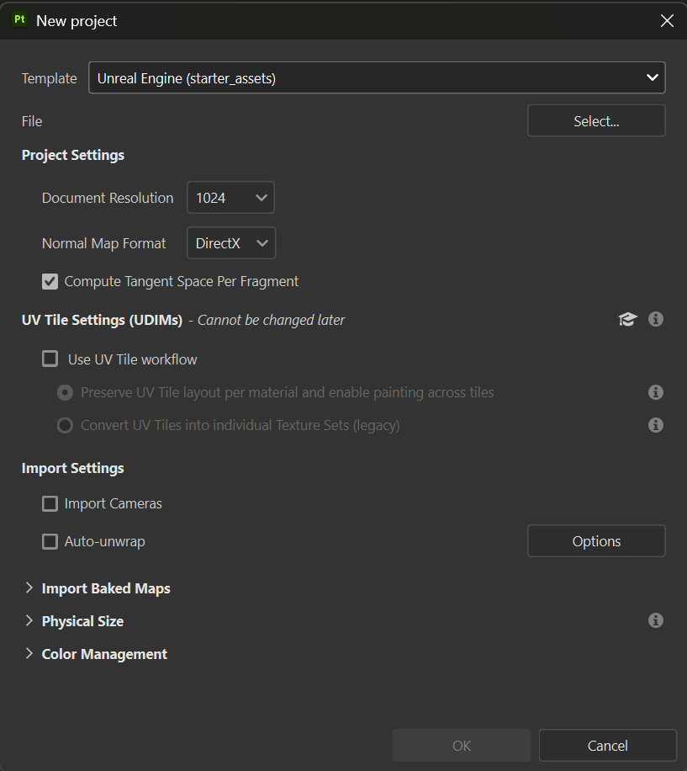
- Bake the model using the lowpoly model if a high poly model is not available. We do this because our texturing tool needs access to a normal map in order for the generators to work. When using existing assets, we can use the non-optimized as high poly and our reworked version as low poly, if the asset came with a normal map, we can also import that one if the UVs were not altered. Both unique and tiled textures need a normal map, but only the unique ones need to be baked as the tiled material already has its own normal map.
- Use the “SF_Base” smart material located in the ArtAssets folder in the depot.
- Do a manual pass on texturing, following the art bible guidelines.
- Export the textures following the unreal engine (packed) format. with the (Ambient) Occlusion, Roughness and Metallic packed into one texture:
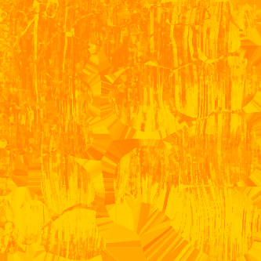
- The mesh and textures must then be imported into the Unreal project, following the standard folder structure. The exported FBX and texture files do not get added to the depot.

Export File Types
For textures, we use TGA and PNG, depending on use case: for 3D models we will be using TGA for the color map, and for the ORM and Normal maps we will be using PNG; for UI elements it will all be PNG files made in Adobe Photoshop.
The TGA format has a fourth channel to handle the alpha, while PNG stores the alpha within “unused” locations inside the RGB channels. This makes TGA files bigger and requires manually setting up and handling the fourth channel; however, it avoids certain visual artefacts when 3D meshes are rendered (such as white contour edges), and allows for fancy shader trickery such as adjusting cutoff or alpha values.
The white border can also be an issue for UI when using PNG textures, but there is a setting in Unreal engine to deal with that without having to use TGA files or change the textures manually.
All 3D models will be made in Blender (.blend) and exported as FBX; animations and rigs will also be exported in the FBX file along with the model.
For the texturing, we will be using Substance Painter, and exporting the textures as TGA for the color, and PNG for ORM and normal maps.

Grid Scale for Tiling Assets
For modular assets that are intended to tile, we will use a grid size of 0.5m: so, an acceptable asset may be 1.0m or 3.5m, but not 2.25m.

Mesh Pivot Points
Meshes that are not modular must have their pivot set to 0,0,0 in Blender, and the mesh itself should be standing ‘on top’ of that point; the lowest vertex of the mesh should not be lower than 0.
Modular assets will have the left bottom corner snapped to 0,0,0 - this way the left corner will be used as the pivot point in engine, allowing for easy snapping.
Exported meshes should not have any scale, rotation or transformation values when exporting.

Shaders
Below is our basic PBR shader with exposed parameters for roughness intensity and color/value tinting. This gives the artist some more control to tweak the material in engine.
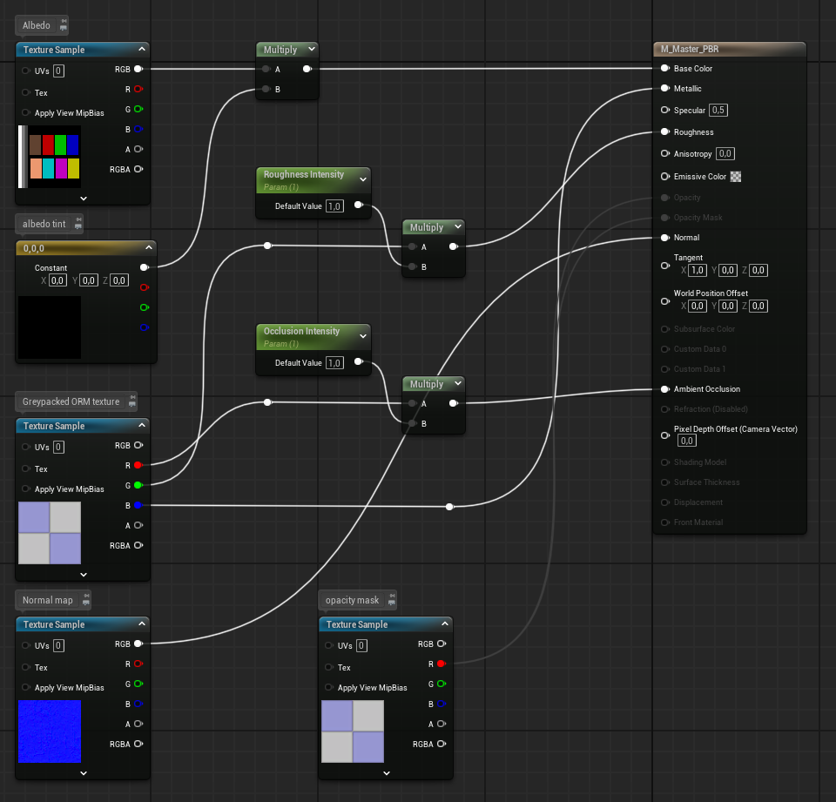
Below we see our shader graph for Flipbook materials, so our animated scribbles and other FX we will use sprite sheets for. 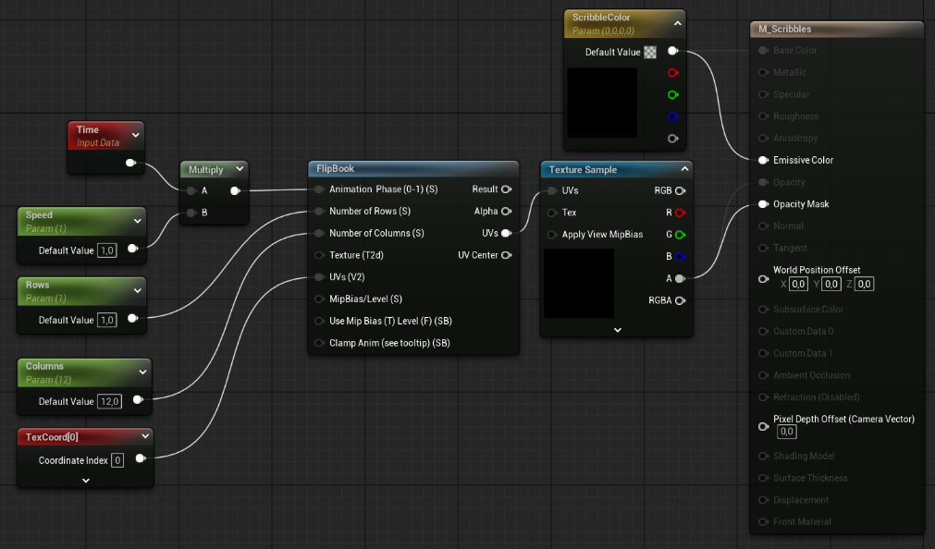
To make a flipbook:
- Import your sprite sheet texture in Unreal Engine.
- Right click your sprite texture, go to sprite actions and press extract sprites.
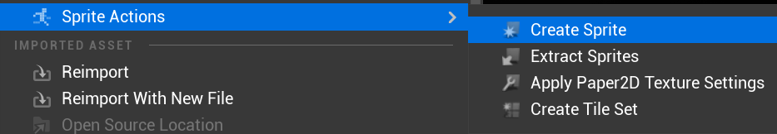
- You can choose to either use automatic mode to extract sprites or if you know the grid size, you can use grid mode. Then press extract.
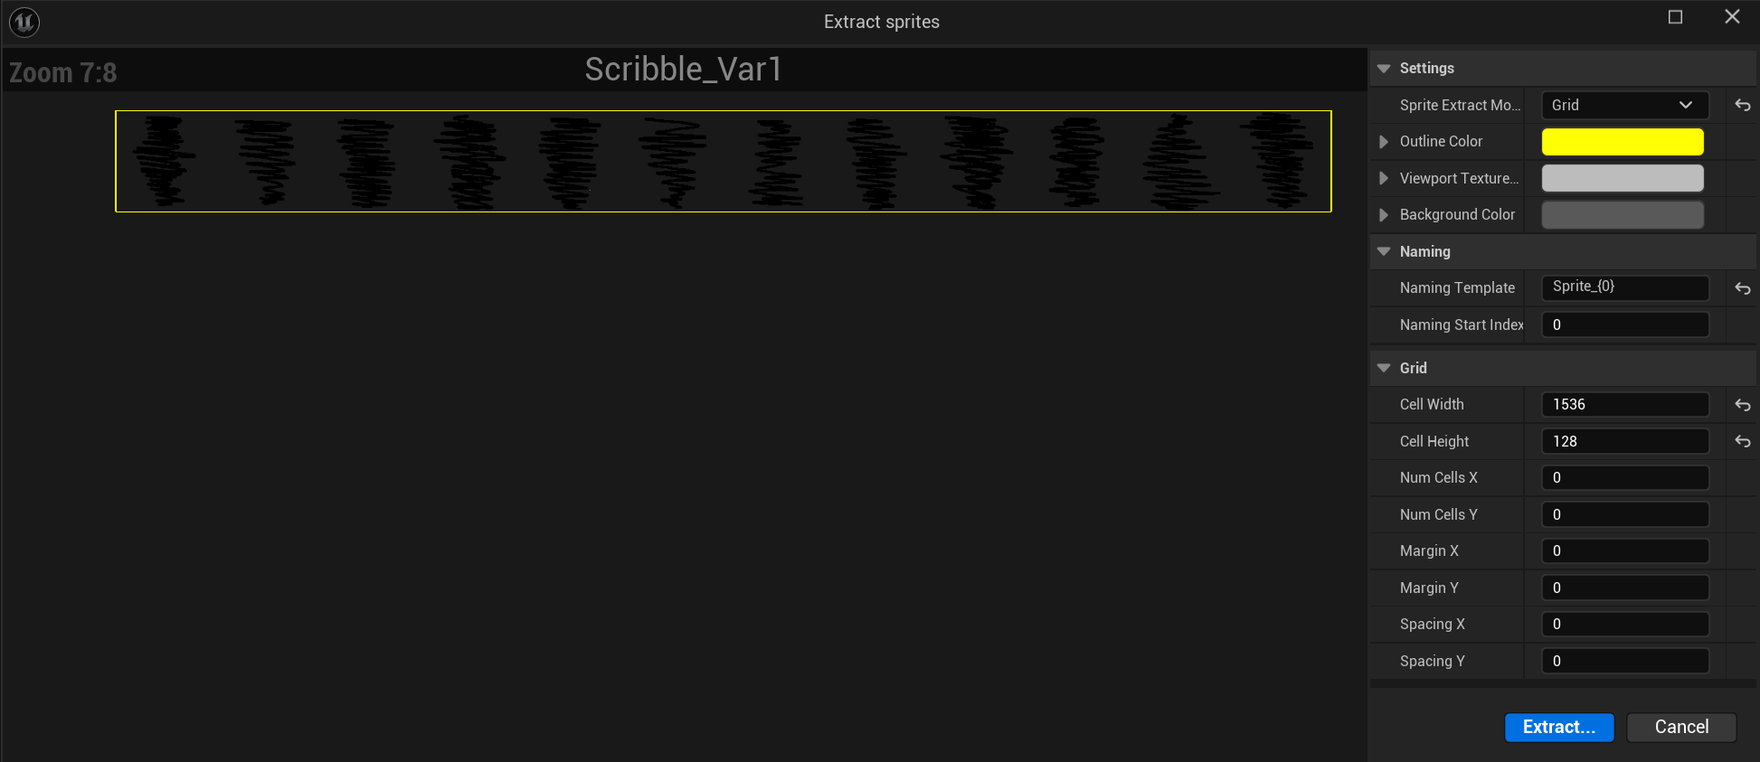
- Select the generated sprites in the content browser, press right click and select: Create flipbook.
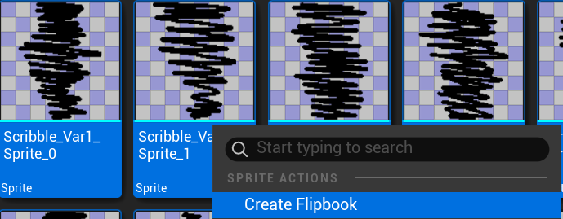

Decals
We will use several simple atlases for decals, filled with details like spiderwebs, stains, dirt, and so on. These decals will be used in corners and around tiled modular assets to break up the monotony and add detail.
We will also use a vertex paint material, one dirtier than the other and combine it with vertex painting the height map to make it pop out so we have variation in the tileable texture. In the link below is the workflow we will be using:
https://www.m3dsacademy.com/vertex-painting-materials-the-art-of-precision-painting-in-ue/

Textures
Like mentioned in an earlier section, we will have a mix of unique textures and trim based textures. All color maps will be TGA files, normal maps and grey packed maps will be PNG.
Hero asset (Polaroid): 1024x1024, using unique textures.
Architectural Props (walls, floors, ceiling, staircase, doors): 1024x1024, will be using a mix of trim textures and tileable textures. E.g. A wall piece will have its wooden pieces on a trim, but the big areas might use tileable textures.
Environment Props, Medium (tables, chairs, cupboards): 1024x1024, will be using a trim texture.
Environment Props, small (bottles, candles, cups, plates): 256-512 depending on the asset size. (a cup might have a smaller texture size than a light fixture.)

Programming Specifics
This is a C++ Unreal project, so the majority of the programming will be done in code files and not visual scripting; game logic will be fully done via code, and implemented into the game via blueprints that inherit from the C++ code classes, but add on no further game logic functionality by themselves – they are simply to provide an interface for setting default values to various parameters, adding purely visual elements (meshes, effects, animations).

Photoboard
The photoboard will be implemented using the UMG – it will be a widget that exists in the game in the form of a Widget Component on an actor blueprint, and will be added to/removed from viewport when the player interacts with that actor by approaching it and pressing a button. This will also swap the player input mode between regular input, and board-interacting input (selecting photos, deleting them, moving them around the board).
The interactions with the photos will be implemented by making a separate widget for the photos, which has overrides for the functions “On Mouse Button Down”, “On Drag”, “On Drop”, and anything else that may be relevant; these overrides can be implemented in either the base C++ code class for the widget, or in the visual scripting part of the widget blueprint.
The logic to check whether the photos are placed in the correct spots will be handled via code in the base C++ class for the photoboard, which will have a function to compare the actual contents of the photo slots to a list of the desired contents, and will be executed after a drag operation on a photo gets finished.

Picture taking
Taking photos is implemented fully via code and is executed when the player presses a specific button. A UsceneCapture2DComponent and a Render Target are used to render the scene to a new PNG file that is saved locally on the computer. That file is used to both spawn a new dynamic material instance, which is used when spawning a temporary mesh that display the photo to the player, and also to set the brush component of one of the photo widgets, so the photoboard can display all taken photos.
The saved photos persist past the game being stopped, so we are limiting their size and resolution to the smallest possible amount while preserving enough detail that they are useful for the player, and there will be a limit on the maximum number of photos a player can take and store.

Programming Guidelines
We will adhere to the Unreal Engine C++ coding standard. The full guidelines can be found here: https://dev.epicgames.com/documentation/en-us/unreal-engine/epic-cplusplus-coding-standard-for-unreal-engine?application_version=5.5.
Below is a list of selected rules we will pay special attention to as courage to keep our code clean, clear, and organized.

Language conventions
All code and comments in the code files should use US English spelling and grammar, e.g. color and not colour, behavior and not behaviour. This also applies to file/asset names across the project.

Naming conventions
Names for variables, methods, and classes must be:
- Clear
- Unambiguous
- Descriptive
All names are in PascalCase, multiple words concatenated together, without hyphens or underscores, and should avoid abbreviations. However, extremely common acronyms, like UI or HUD, are exceptions to the abbreviation and PascalCase rules – they can stay abbreviated and uppercase when used.
Good
AllPhotos = PlacedPhotos + ReservedPhotos

Bad
ap = pp + rp

Variables used for iteration in for-loops are allowed to be lowercase single letter.
for(int i{0}; i < TotalPhotos; ++i)

Private and protected member variables are prefixed with m_ e.g. m_MyVariable.
protected:
int m_PhotosTaken{0];
Type names must have a single-letter upper-case prefix to distinguish them from variable names e.g. FThing as a type name, Thing as an instance of type FThing.
APhotoboard m_Photoboard{];

Class Structure
All classes must be organized as follows: after the GeneratedBody() comes the public section, then the protected section, then the private section. In each section, the functions come before the variables. A blank line must be left between each section for visual clarity.
class PROJECTNAME_API AMyActor : public AActor
{
GENERATED_BODY()
public:
AMyActor();
float MyFloat;
protected:
void Foo();
int m_MyInt;
private:
void Bar();
FString m_MyString;
};

Syntax
Class members should almost always be declared private unless they are intended to be part of the public/protected interface of the class.
Class members used by child classes should be marked protected.
Class members that need to be accessed from outside the class should be marked public. If the getter and/or setter of a variable are non-trivial, that variable should remain private and only its getter/setter should be public. In the case of trivial getters and setters, the variable should be made public.

Good
class PROJECTNAME_API AMyActor : public AActor
{
public:
AMyActor();
float FloatIWantOtherClassesToAccess;
void SafelyAlterInt(int NewValue)
{
m_IntToAlter = NewValue % 100;
}
private:
float m_FloatIDoNotWantOtherClassesToAccess;
int m_IntToAlter;
};
Bad
class PROJECTNAME_API AMyActor : public AActor
{
public:
AMyActor();
float FloatIWantOtherClassesToAccess;
float m_FloatIDoNotWantOtherClassesToAccess;
int m_IntToAlter;
};
Prefer default member initialization where possible.
Good
class PROJECTNAME_API AMyActor : public AActor
{
public:
int Photos{0};
};
Keep methods concise – if a method is getting too long, split it into sub-methods.
Mark functions as override and classes as final wherever applicable.
Do not use auto unless:
- When binding a lambda to a variable.
- For iterators IF the type is verbose and would make the code harder to read.
- In template code where the expression type cannot be easily identified.
Avoid usage of the C++ standard library. Unreal has its own implementation of most of these functions: for example, Unreal has MoveTemp instead of std::move. Avoiding the standard library is especially important in the cases of strings and containers.

Const correctness
Pass function arguments by const pointer or const reference if those arguments are not intended to be modified by the function.
Flag methods as const if they do not modify the object.
Use const iteration over containers if the loop isn't intended to modify the container.
void SomeMutatingOperation(const TArray<Int32>& InArray)
{
// The InArray will not be modified, so it is marked const
}
void FClass::Foo() const
{
// This code will not modify the FClass object it is invoked on.
}
for (----- : Container)
{
// The body of this loop will not modify the elements of the container
}

Formatting
Braces always go on new lines. Always include braces in single-statement blocks. This applies to if-else statements as well.
Good
int32 GetSize() const
{
return Size;
}
Bad
int32 GetSize() const { return Size; }

A multi-way if statement should be indented with each else-if indented the same amount as the first if; this makes the structure clear to a reader.
Good
if()
{
}
else if()
{
}

Always include braces in single-statement blocks.
if (bThing)
{
return;
}

Function declarations should have at least one blank line between them.
Good
void AGrandmaCharacter::Foo()
{
}
void AGrandmaCharacter::Bar()
{
}
Bad
void AGrandmaCharacter::Foo()
{
}
void AGrandmaCharacter::Bar()
{
}

Switch case statements should explicitly label that a case falls through to the next case, unless it is an empty case.

Physical Dependencies
All headers should protect against multiple includes using #pragma once.
Forward declarations are preferred to include headers, and if headers must be used, they must be included when absolutely necessary and as specifically as possible. Do not rely on headers included in other headers.
Avoid prefixing file names if possible.

Comments
Only use comments when necessary – if they do not provide extra information that is not given by the code, they do not need to exist. Focus on writing self-documenting code. Rewrite bad code rather than relying on comments.
Good
//we know another photo was successfully taken and added to the board now
++Photos;
Bad
// increments photos
++Photos;
Comments should not contradict code.
Good
//we know another photo was successfully taken and added to the board now
++Photos;
Bad
// we delete a photo
++Photos;

General
Use int32 instead of int for all serialized variables, e.g. on UPROPERTY designated variables.
Always use TEXT() macro around string literals.
Leave a blank line at the end of the file.
Use intermediate variables to simplify complicated expressions.
Good
const bool variablesABSame = variableA == variableB;
const bool variables CDDifferent = variableC != variableD);
if(variablesABSame && CDDifferent)
Bad
if(variableA == variableB && (variableC != variableD))

Folder Structure

In Perforce

Overview

The following diagram illustrates the main folder structure found in the Depot.
grpprj22
├── ArtAssets
├── Design
├── Dev
├── Main
├── Prototype
└── SoundAssets

- ArtAssets: All source art files in the game (blender files, substance painter files, etc.)– but no exports.
- Design: Design documentation – sound bible, art bible, GDD, tech doc, narrative outline.
- Dev: Folder with the Unreal project where the game is developed. Only starts getting used once production begins.
- Main: A stable version of the game, Dev regularly gets merged into here at the end of each sprint once it is stable.
- Prototype: Used to store test projects made during the prototype phase. Nothing from here can be reused in the main project as-is (no copy pasting code files, uassets, so on). During production it can be used for little tests in order to avoid messing up the Dev project by submitting a bugged test to the depot.
- SoundAssets: All source sound files.

ArtAssets
ArtAssets
├── Characters
├── Effects
├── Environment
│ ├── Props
│ └── Architecture
├── Materials
└── UI

Dev
Unreal Content Browser and Perforce Dev folder structure will be the same. The Source folder is the C++ Classes folder in Unreal, but in Perforce it is saved as Source.
├── Content
│ │
│ ├── AI
│ │
│ ├── Animations
│ │ ├── Characters
│ │ ├── Montages
│ │ └── Blendspaces
│ │
│ ├── Audio
│ │ ├── Music
│ │ ├── SFX
│ │ └── VO
│ │
│ ├── Blueprints
│ │ ├── Anomalies
│ │ ├── Characters
│ │ ├── GameModes
│ │ ├── Inputs
│ │ ├── Interactables
│ │ ├── Lights
│ │ ├── Photoboard
│ │ ├── Player
│ │ └── Props
│ │
│ ├── FX
│ │ ├── Particles
│ │ ├── Niagara
│ │ └── Decals
│ │
│ ├── Maps
│ │ ├── MainMenu
│ │ └── Game
│ │ ├── *L_Anomalies
│ │ ├── *L_Audio
│ │ ├── *L_Main
│ │ └── *L_Main
│ │
│ ├── Materials
│ │ ├── Master
│ │ ├── Instances
│ │ ├── Functions
│ │ └── Textures
│ │
│ ├── Meshes
│ │ ├── Architecture
│ │ ├── Meshes
│ │ └── Props
│ │
│ └── UI
│ ├── Widgets
│ ├── Fonts
│ ├── Screens
│ └── UITextures
│
└── Source

SoundAssets
├── /SoundAssets
│ ├── /ReaperProjects (session files - NOT in Perforce)
│ ├── /ProcessedAssets (exported WAVs ready for Wwise)
│ │ ├── /SFX
│ │ ├── /MUS
│ │ ├── /AMB
│ │ └── /VOX
│ └── /SourceRecordings (raw Roeland vocals for enemy)

Scene Structure
We are going to be using Level Streaming. We are going to be setting up the following sublevels: Lighting; Audio; Anomalies; Main World.
Outliner structure:
└── L_MainMap
├── Anomalies /L_Anomalies
│ └── SpawnLocations /L_Anomalies
│
├── Audio /L_Audio
│
├── Environment /L_MainWorld
│ ├── Architecture /L_MainWorld
│ └── StaticProps /L_MainWorld
│
├── Lighting /L_Lighting
│ ├── LightFixtures /L_Lighting
│ └── Lamps /L_Lighting
│
├── DefaultLighting /L_MainWorld
│ ├── [DirectionalLight] /L_MainWorld
│ ├── [ExponentialHeightFog]/L_MainWorld
│ ├── [SkyAtmosphere] /L_MainWorld
│ ├── [SkyLight] /L_MainWorld
│ ├── [VolumetricCloud] /L_MainWorld
│
├── Effects /L_MainWorld
│
├── Enemy /L_MainWorld
│
└──Player
└── SpawnSpot /L_MainWorld

File Naming Conventions
The naming conventions should be consistent throughout the project. All structures, assets, and code should follow the guidelines with no deviations.

Universal Guidelines
In any identifier for any kind of asset or code, always use the following characters, and the following characters only:
- ABCDEFGHIJKLMNOPQRSTUVWXYZ
- Abcdefghijklmnopqrstuvwxyz
- 1234567890
- _ (underscore) but use it sparingly, avoid if possible
In any identifier for any kind of asset or code, never use the following:
- White spaces, of any kind
- No slashes, either forwards or backwards
- Any symbols other than an underscore
- Any Unicode characters

In Unreal
- Short folder names for content browser, max two words, preferred one.
- Everything in content browser needs to have a prefix to clarify what kind of file it is - the only exceptions are C++ classes, which must have no prefixes. Those must be named as clearly and concisely as possible, using as few words as possible.
- We are following the Unreal Directive’s Asset Naming Conventions, but we are primarily using the following file types:

Prefix | Purpose
ABP_ | Animation blueprint
AIC_ | AI controller
BB_ | Blackboard
BP_ | Blueprint
BS_ | Blend space
BT_ | Behavior tree
EMIT_ | Emitter
Font_ | Font
IA_ | Input action
IMC_ | Input mapping context
L_ | Level
M_ | Material
MI_ | Material instance
NS_ | Niagara system
RT_ | Render Target
SK_ | Skeleton Mesh
SM_ | Static mesh
T_ | Texture
WI_ | Widget

In ArtAssets
Naming conventions for File Explorer:
- No prefixes for ArtAsset files.
File Type | Example
Photoshop documents .psd | MyAssetName.psd
Substance Painter .spp | MyAssetName.spp
Blender .blend | MyAssetName.blend

Naming conventions in Engine:
[AssetTypePrefix]_[AssetName]_[Descriptor]_[OptionalVariantLetterOrNumber]
- [AssetTypePrefix] identifies the type of Asset, refer to an earlier subsection.
- [AssetName] is the Asset’s name.
- [Descriptor] provides additional context for the Asset, to help identify how it is used. For example, whether a texture is a normal map or an opacity map.
- [OptionalVariantLetterOrNumber] is optionally used to differentiate between multiple versions or variations of an asset.
File Type | Example
Material | M_Camera
Texture | T_Camera_Normal
Mesh | SM_Camera

In SoundAssets
File Naming Convention for files in depot and Unreal Project (the filename extension is not relevant to the Unreal files):
[Category]_[Descriptor]_[Variation].wav
Examples:
- SFX_Camera_Shutter_01.wav
- MUS_MainMenu_Loop.wav
- AMB_RoomTone_Bar.wav
- VOX_Enemy_Roar_Close_03.wav

Other

Generating Visual Studio/Build Files
To streamline the process of setting up the project on a new device or cleaning up and regenerating files on an existing device, we have added two .bat files, (created by Viktor Mendonck, files used with author permission) to the root folder of the project. Each time the project needs to be rebuilt for any reason, this needs to be used to do that; it will purge the existing temporary files and generate new ones.
It is not advised to go through generating files without using the .bat file, unless it is specifically to debug an issue that is happening during building/compiling steps.
The files need to be executed in this sequence: first the rebuild_vs.bat, then the build_editor.bat.

Visual Studio Required Installed Components
To make sure all required components are installed, it is necessary to open Visual Studio Installer, select the desired version to be used, and click on the Modify button.
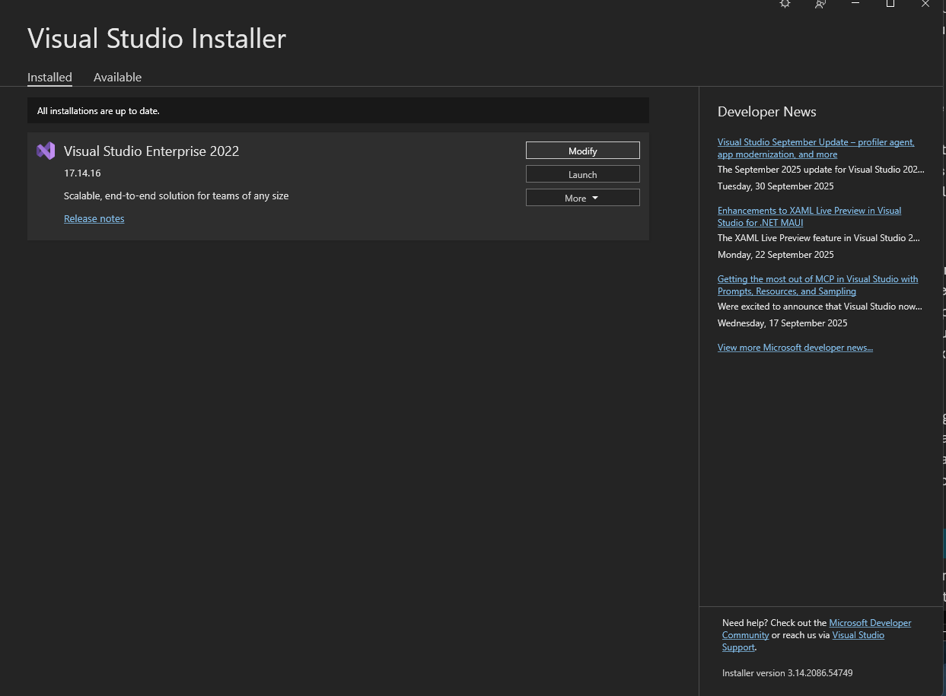
Install the following:
Workloads:
- .NET desktop development
- Desktop development with C++
- Game development with C++

Unreal Plugins
We use the following optional plug in for our project:

Visual Studio Plugins
The UnrealVS plugin can be installed following the instructions at this link: https://dev.epicgames.com/documentation/en-us/unreal-engine/using-the-unrealvs-extension-for-unreal-engine-cplusplus-projects
The P4VS – Helix Plugin is the following: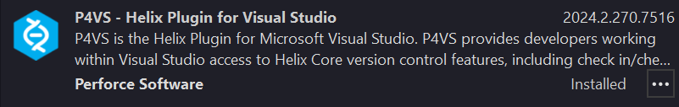
It can be installed via the Extensions tab in Visual Studio, by searching in the Browse section.
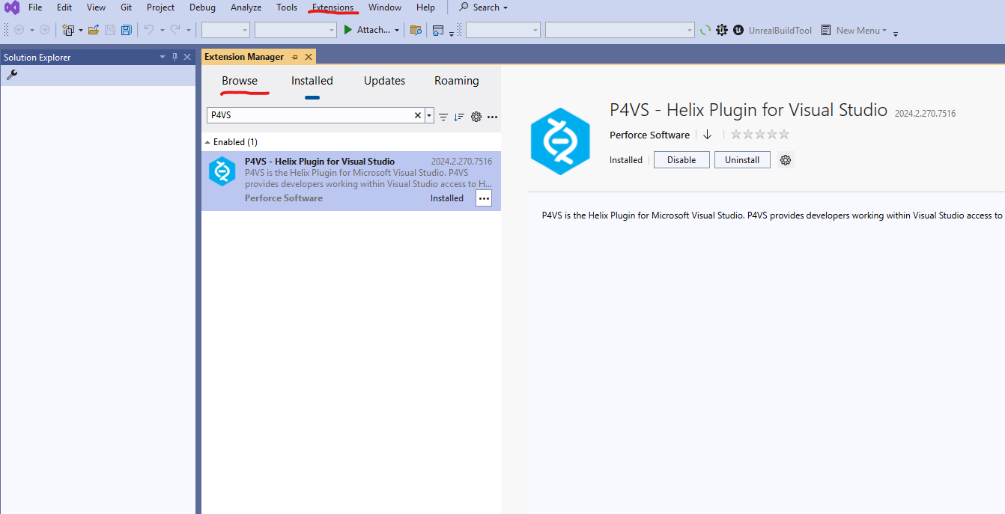

Blender Plugins
(Entries crossed out in orange are not required for this project.) 