Table of Contents

1 Overview
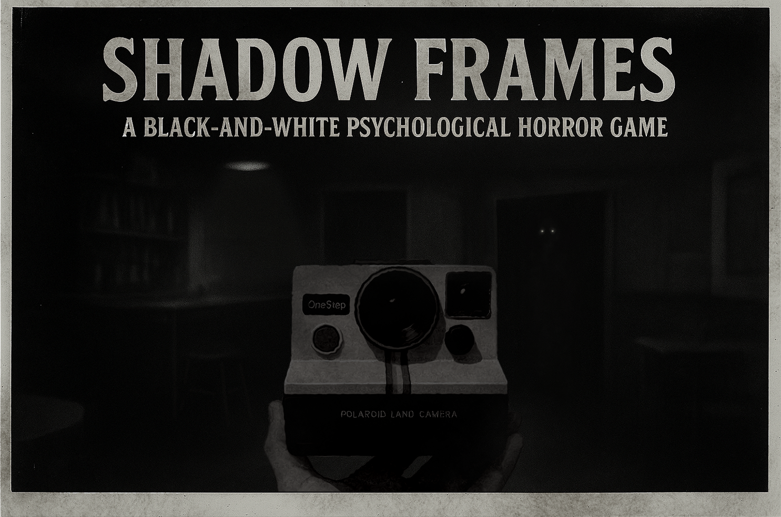

1.1 Chapter: Introduction
"Shadow Frames" is a psychological black-and-white horror game set in a 1960s Irish pub. In this pub people have reported missing items, glasses, cutlery and plates suddenly falling off the table tops, and sightings of mysterious and unexplainable shadows.
The player steps into the shoes of the pub owner that noticed these strange occurrences. The player’s task is to observe, capture, and connect the inexplicable anomalies that haunt the pub in order to understand what is going on.
This document outlines the foundation of the game, including core mechanics, story, characters, objects, items, interactables, HUD, UI, and menu systems.

1.2 Chapter: Target Audience

Age Range
15 – 35 years old
This age group represents the ideal demographic for Shadow Frames. The setting — a 1960s Irish pub — naturally carries mature themes such as alcohol and adult environments, while the psychological horror tone resonates strongly with young adults and mature teens.
Players within this age bracket are often drawn to games that offer deeper narrative meaning, emotional atmosphere, and unique mechanics over high-action gameplay. The mature but non-explicit tone makes the game suitable for a Teen (15+) rating, ensuring accessibility to a wide audience while maintaining thematic depth.

Primary Audience
Fans of short-form indie horror and psychological tension.
The game is designed for players who appreciate atmospheric horror, environmental storytelling, and slow-burn tension rather than gore or jump scares.
Shadow Frames appeals to those who enjoy uncovering mysteries through observation, piecing together clues, and interpreting subtle visual and auditory cues.
Comparable Titles & Inspirations:
- I’m on Observation Duty (series) — for the anomaly observation mechanic and passive horror design.
- Chilla’s Art games — for short, narrative-driven psychological horror with environmental immersion.
- Iron Lung — for minimalist tension, limited interaction, and oppressive atmosphere.
These players often seek memorable, replayable, and self-contained horror experiences that can be completed in a few sittings but leave a lasting emotional impression.

Secondary Audience
Content Creators, Streamers, and Horror Enthusiasts
The game’s structure and pacing are highly streamable — anomalies, eerie sound design, and visual storytelling create genuine moments of surprise and tension that lend themselves well to reaction-based entertainment.
YouTubers and Twitch streamers who focus on indie horror titles are likely to amplify the game’s reach. Their audiences often overlap with players who discover and purchase short horror experiences after watching them played online.
Additionally, fans of:
- Cinematic indie games
- Psychological thrillers
- Low-UI immersive experiences
will find Shadow Frames appealing for its grounded realism and unique monochrome presentation.

Audience Motivation
Players in this demographic are motivated by:
- The thrill of uncovering hidden truths and solving mysteries.
- The sense of immersion and vulnerability that comes from limited control and minimalist UI.
- The satisfaction of discovering connections between photos, anomalies, and story events.
- The desire to experience artful, narrative-driven horror in shorter, digestible sessions.

1.3 Chapter: Unique Selling Points
1. Black-and-White Psychological Horror
The monochrome visual style isn’t just aesthetic — it heightens tension by emphasizing lights and shadows. The darkness itself becomes an obstacle, forcing players to question what they truly see.
2. Observe–Capture–Connect Gameplay
Instead of relying on combat or cheap jump scares, Shadow Frames focuses on active investigation. Players must observe anomalies, capture them with a Polaroid camera, and connect the evidence to piece together the haunting’s hidden truth.
3. 1960s Pub with Psychological Unease
Set in a smoky 1960s pub, the environment blends cozy familiarity — creaking wood, clinking glasses, a jukebox’s low hum — with unsettling disturbances. The clash between warmth and dread amplifies the horror experience.

1.4 Chapter: Design Pillars

1. Psychological Impact through Subtlety
Shadow Frames creates fear through atmosphere, perception, and suggestion rather than direct confrontation.
The horror lies not in what is shown, but in what is implied — in the quiet dread of noticing something that shouldn’t be there, or the eerie calm before an unseen presence stirs.
The game’s black-and-white visual language, minimal UI, and grounded 1960s Irish pub setting immerse the player in a believable, human world that becomes deeply unsettling when it starts to distort.
Every element — camera movement, lighting, sound design, and pacing — works together to reinforce a sense of restrained, psychological tension. The player’s own perception becomes their greatest ally and their greatest source of fear.

2. Player Immersion and Realism
The game’s systems and presentation are designed to simulate realism as much as possible.
The first-person perspective, natural motion speed, authentic environmental audio, and tactile interactions create a deeply immersive experience that feels like inhabiting a real space rather than playing a traditional “game.”
- There are no exaggerated movements or HUD elements breaking immersion.
- Every sound, object, and interaction is grounded in physical logic.
- The Polaroid camera behaves believably, with reloading, limited film, and authentic sound feedback.
This realism heightens emotional impact — making every anomaly, shadow, or distortion feel personal and plausible, rather than fantastical.

3. Lighting & Grayscale as Emotional Tools
Light and shadow are not just visual components — they are mechanics of storytelling and emotion.
The grayscale palette focuses the player’s attention on contrast, form, and movement, removing the comfort of color and enhancing the unease of every visual change.
Lighting serves both gameplay and atmosphere:
- Subtle shifts in brightness guide the player’s eye toward anomalies.
- Harsh contrasts and dim corners evoke tension and uncertainty.
- Moments of balance — when light briefly restores clarity — become emotional relief.
The result is a visual world that feels both stark and intimate, where every shadow holds meaning and every flicker of light may reveal the truth… or something worse.

2 Gameplay

2.1 Chapter: Main Mechanics
The main mechanic of Shadow Frames revolves around capturing anomalies. These anomalies are semi-randomized events that disturb the pub’s environment. When an anomaly occurs, the player must locate and observe it closely. During this observation, if something in the surrounding area begins to move and/or distort, it lets the player know that whatever caused this anomaly is still around. In that moment, the player must use their Polaroid camera to take a picture of the anomaly. Capturing it not only serves as evidence but also acts to dispel the disturbance and reveal what is hidden to the naked eye.
Alongside this, the game introduces a secondary mechanic through the pin board. Every photo the player captures is automatically added here, creating a growing collection of evidence. The player can return to the pin board at any time to examine and organize these Polaroids. The ultimate goal is to arrange the photos in the correct sequence, and once aligned properly, they combine to form a larger hidden shape or symbol that unravels the deeper truth behind the haunting.
*MID GAME CUT SCENE

2.1.1 Mechanic: Capturing Anomalies
Capturing anomalies consists of multiple systems which are covered in this chapter.
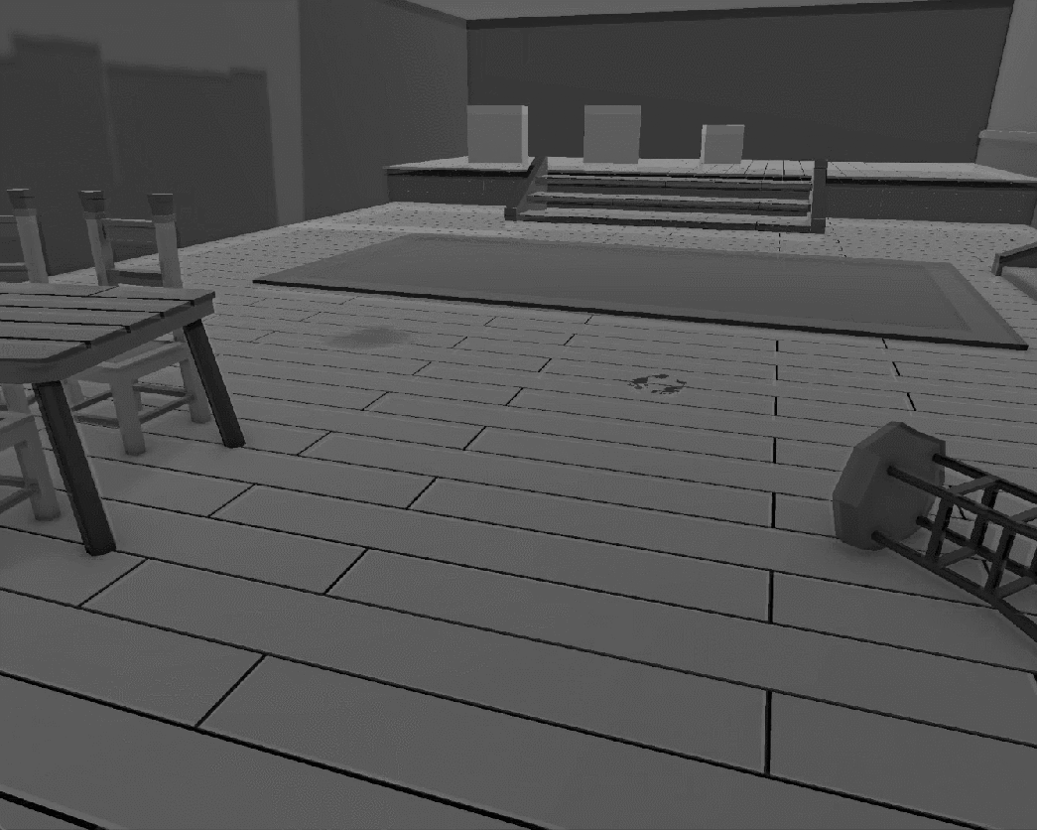

2.1.1.1 System: Anomaly Behaviour
To support the core mechanic of capturing anomalies, the game features a dynamic anomaly system. Multiple objects in the environment are assigned possible anomaly types, allowing them to behave in unexpected ways. For example, a chair may rotate, scale, change textures, or disappear entirely. These behaviours are scripted within logical limits to maintain believability and avoid overwhelming the player — not every object in the pub can become anomalous, ensuring disturbances remain noticeable and impactful.
Some anomalies are unique to specific objects or systems, adding variety and unpredictability. Examples include room-wide distortions, radio frequency stuttering, objects appearing suddenly, or everyday motions accelerating unnaturally — such as a clock ticking faster, a ceiling fan spinning out of control, or a record player skipping ahead. In addition, shadow figures may manifest or existing shadows may distort, reinforcing the game’s psychological horror tone.
Anomalies appear one at a time with a randomized interval of 30 to 50 seconds between each event, but they can stack up if the player does not capture and dispel them. Each anomaly is introduced with a distinct environmental sound cue, providing the player with both confirmation that something has occurred and an approximate direction or room in which it happened. As the game progresses the anomalies increase in severity and become more sinister. The shadow anomalies become more common.
At the start of the game, there is a three-minute safe period during which no anomalies appear. This gives the player the chance to explore the environment, learn the layout of the pub, and become familiar with its normal state before disturbances begin.
Anomalies can be divided into three main categories:
Object Anomalies:
These affect specific items in the environment. Not every object can become anomalous, but those chosen are designed to feel both noticeable and plausible within the setting.
- Rotation, scaling, or shifting position
- Texture or material changes (wood → metal, clean → worn)
- Disappearance or reappearance of objects
- Objects behaving unnaturally (glass floating, cutlery clattering)
Environmental Anomalies:
These impact larger parts of the room or the environment as a whole.
- Room distortion (walls bending, perspectives warping)
- Radio frequency stuttering, static bursts
- Ambient changes (jukebox malfunctioning, lights flickering)
- Speed manipulation of familiar movements (clock ticking too fast, ceiling fan accelerating, record player skipping)
Shadow Anomalies:
Unique to the game’s psychological horror focus, these play directly with the black-and-white art style and the player’s perception of light and darkness.
- Shadow figures appearing
- Shadows distorting unnaturally (stretching, detaching from objects)
- Movement in areas where no light source exists
- Silhouettes suggesting human forms but vanishing on closer inspection

2.1.1.2 System: Observation & Snapshots
Whenever the player suspects that an anomaly has appeared in the area, they can enter Observation Mode. In this mode, the gameplay camera zooms in and player movement and rotation are limited, creating the illusion that the player has raised their Polaroid camera and is looking through its viewfinder.
Through this narrowed perspective, the player can spot abnormalities around the anomaly site. If any object within that view begins to move, distort, or behave unnaturally, the player must take a snapshot to capture and dispel it.
Every anomaly area contains an abnormality as soon as it manifests. The associated movement or distortion persists until the next anomaly appears, ensuring that the player always has a visual cue when observing the correct area.
If the player fails to capture the anomaly within 1–2 minutes of its appearance, the event is marked as unresolved and added to the active anomaly count. As outlined in the System: Anomaly Behaviour, reaching a certain threshold of active anomalies will trigger the spawning of the enemy entity, significantly raising the stakes of neglecting disturbances.
All captured images are automatically transferred to the Pin Board at the player’s starting location. If the player takes a snapshot without actually observing movement or distortion in the anomaly area, the image is still added to the Pin Board, but it will not reveal anything new. However, this action will still reset the anomaly, preventing it from stacking into the active anomaly count. More about this is detailed in Mechanic: Pin Board section.
Observation Mode creates a constant trade-off for the player:
- Risk: By zooming in and restricting movement, the player is left vulnerable to the environment. Since the sound gets muffled to indicate the player focusing, the player loses situational awareness, which makes it harder to notice audio cues or sense the approach of the enemy.
- Reward: Successfully spotting and capturing an anomaly both prevents it from adding to the active anomaly count and dispels the disturbance, giving the player more breathing room before the enemy is triggered.
This tension ensures that every decision to enter Observation Mode carries weight — the player must balance immersion in the moment against the long-term survival pressure of leaving anomalies unresolved.

2.1.1.3 System: Snapshot Feedback
Capturing an anomaly provides immediate audio-visual feedback to reinforce the mechanic and immerse the player:
- Camera Flash: A brief, bright flash illuminates the anomaly, cutting sharply against the dark black-and-white environment. For a split second, it may also obscure the player’s view, adding tension.
- Shutter Sound: The distinct click and film winding of the Polaroid provide satisfying confirmation while grounding the mechanic in the 1960s setting.
- Revelation Effect: During the flash, the anomaly’s true form (shadowy figure, distorted object, etc.) is briefly revealed before being dispelled.
- Short Observation: The picture is shortly displayed on the screen to reveal to the player what they took a picture of and what has been revealed.
- Polaroid Print: A faint rustle or sound cue signifies that a new photo has been added to the player’s collection, reinforcing progression toward the pin board puzzle.

2.1.1.4 System: Resource Management & Reloading
The Polaroid camera is not unlimited — its film serves as a core resource that the player must manage carefully. Each cartridge contains 5 film sheets, and the player has access to a total of 5 cartridges for the entire playthrough. At any given time, the player can only carry one cartridge in the camera.
When a cartridge runs out, the player must return to their starting position, where the reporter’s belongings are stored, to retrieve a new cartridge from the bag. This creates a layer of tension, as film replenishment requires the player to leave their current location and potentially lose track of anomalies.
Reloading the Polaroid is designed as a mini-cutscene lasting approximately 5 seconds. During this time, the player is unable to move or look around, leaving them completely vulnerable. A distinct audio cue signals the completion of the reload, confirming that the camera is operational again.
To indicate that the camera is out of film, any attempt to take a picture without available sheets will result in a distinctively different shutter sound. No photo is taken, and no anomaly is dispelled, clearly communicating to the player that they need to reload.
This system creates deliberate resource management pressure, forcing players to balance when and where to use their limited film, and when to risk vulnerability by reloading.

2.1.2 System: Enemy
When the number of active anomalies reaches a certain threshold, an enemy entity is triggered. This enemy serves as the ultimate threat in the game, introducing the possibility of a game over.
The enemy cannot be seen directly in the real world. Instead, it lurks in the shadows and slowly follows the player whenever it is not being observed. Its presence is communicated entirely through audio cues, heightening the player’s reliance on sound over sight. Subtle footsteps, ghostly whispers, and a low demonic ambience signal its approach, with the intensity of these sounds increasing as the entity draws closer.
When the player is actively looking in the direction of the enemy, the footsteps cease, though the demonic ambience persists, serving as a chilling reminder that the entity is still there, waiting. If the anomaly count drops below the threshold, the enemy disappears and all associated sounds fade, giving the player a temporary reprieve.
This design builds a constant sense of paranoia and dread, forcing the player to stay alert while balancing the demands of documenting anomalies. The enemy’s invisible pursuit ensures that tension remains high, as the threat can only be tracked through sound cues and careful attention.
If the enemy successfully reaches the player, the game transitions to a game over screen, showing the consequences of neglecting anomalies and allowing the haunting to spiral out of control.

2.1.3 Mechanic: Pin Board
The game features a static Pin Board that the player can interact with at any time during the gameplay loop. When approached and activated, the screen zooms into the board, making it the central focus of the interface.
The Pin Board serves as both a progress tracker and a narrative puzzle. Every snapshot the player takes is automatically added to the board, creating a growing collection of Polaroid photos. The player’s task is to arrange these photos in the correct order, using visual clues embedded in each picture to determine their proper placement.
Correctly aligning the photos gradually reveals a hidden larger image or pattern, which ties directly into the mystery of the pub and the nature of the anomalies. Successfully completing the Pin Board sequence is a requirement for achieving the game’s good ending, reinforcing the importance of careful observation and resource management throughout the experience.

2.1.3.1 Mechanic: Picture Ordering
The Pin Board functions as a visual puzzle where players must organize their collected Polaroid snapshots into a predetermined order. The mechanic is designed to be intuitive, combining drag-and-drop interaction with visual feedback cues to guide the player.

Player Interaction:
- As anomalies are captured, the photos automatically appear around the central circle of the Pin Board.
- If there are more images than can fit around the circle, the extra ones are placed neatly along the bottom row of the board. These photos remain fully interactable and can be freely swapped with those already around the circle.
- The player can click and drag any photo from its current position and drop it into the circular arrangement. When released, the photo snaps to the nearest valid slot.
- Photos can be repositioned at any time, allowing players to refine the order as new evidence is collected.

Visual Indication of Order:
- The circular arrangement around the center acts as the framework for ordering.
- Each photo has a predetermined slot that is tied to the larger hidden image/pattern the photos combine to form.
- When the player correctly places a photo, it snaps neatly into place, giving a subtle visual confirmation. Incorrect placements will still snap into a slot but won’t reveal progress toward the hidden pattern.
- The design relies on visual clues inside the photographs themselves — torn edges, bends, scratches or stains on the polaroid — encouraging the player to carefully analyze each image to find its proper location in the sequence.
This system ensures that the act of ordering photos feels like piecing together a fragmented memory or truth, reinforcing the investigative and psychological themes of the game.
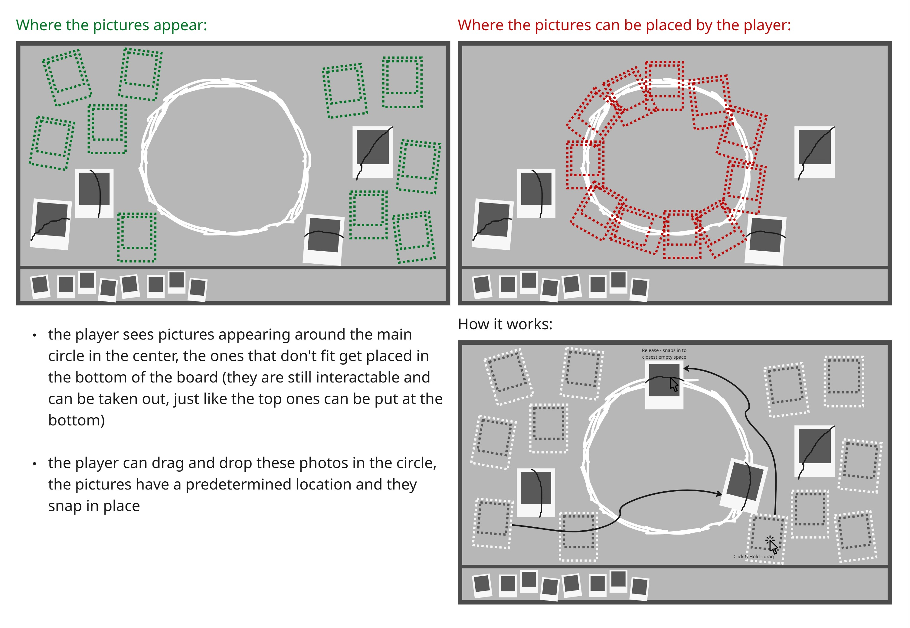

2.1.3.2 System: Picture Movement
While in the pin board view, when the player picks up a photo, the selected image smoothly moves closer to the camera, increasing in size to simulate physical depth — giving the impression that the player is holding the photo in front of them. The photo follows cursor movement in this pseudo-3D plane and snaps neatly into place when dropped into a valid slot on the board.

**Technical Implementation Notes:**
- Photo Pickup Depth: When a photo is selected, it moves forward along the Z-axis by 0.3–0.5 meters, increasing its on-screen scale by ~20–25%.
- Drag Sensitivity: Slight smoothing (lerp movement) on the photo to make it feel natural and weighted rather than instant.
- Snap-to-Slot System: Magnetic snapping radius (approx. 15–25px) ensures that photos lock into nearby valid slots with a subtle animation.

2.2 Chapter: Gameplay Loop
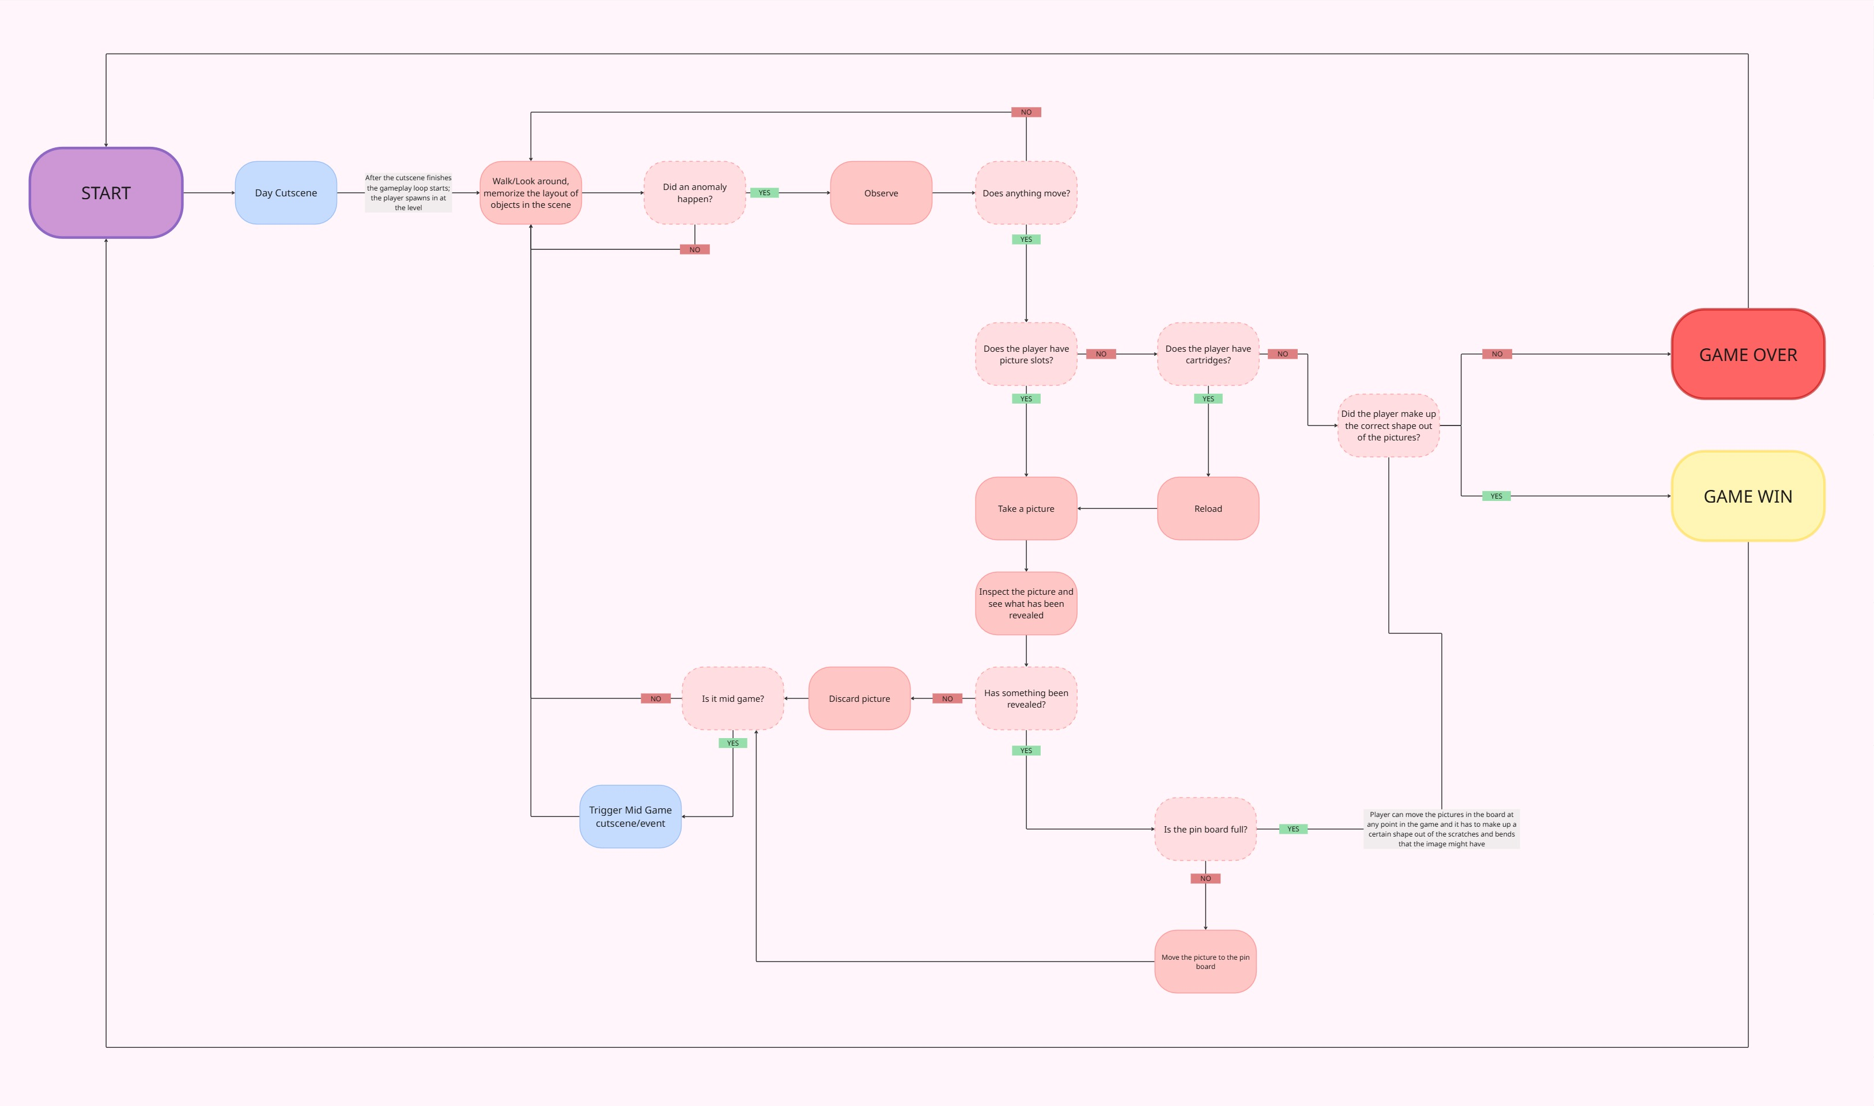

3 Controls
The game can be played with mouse and keyboard and with a controller. The game features two primary input modes: Exploration Mode and Photoboard Mode. Each offers context-specific interactions to support the core gameplay loop of observation, photography, and investigation.
Notes
- The player cannot access the Pin Board while in Observation Mode.
- Both input schemes are designed for smooth, deliberate control, emphasizing observation and precision over speed.
- Input prompts can dynamically update based on control device if controller support is added.

3.1 System: Keyboard

Main Menu Controls
In the Main Menu, the player navigates the interface using standard mouse controls:
- Mouse Movement – Move the on-screen cursor.
- Left Mouse Button – Select and confirm menu options.

In-Game Controls
Exploration Mode
Used during normal gameplay when the player freely explores the pub environment.
- W / A / S / D – Move the player character.
- Mouse Movement – Control the camera and look around.
- E – Interact with objects and items in the environment.
- R – Reload the Polaroid camera with a new cartridge.
- Space Bar – Enter Observation (Zoom) Mode.
- Right Mouse Button (in Zoom Mode) – Take a photo to capture and dispel anomalies.
Photoboard Mode
Activated when interacting with the Pin Board located near the starting area.
- Mouse Movement – Move the on-screen cursor.
- Left Mouse Button – Select a photo.
- Right Mouse Button (Hold + Drag) – Move the selected photo around the board.
- N Key – Delete the currently selected photo.
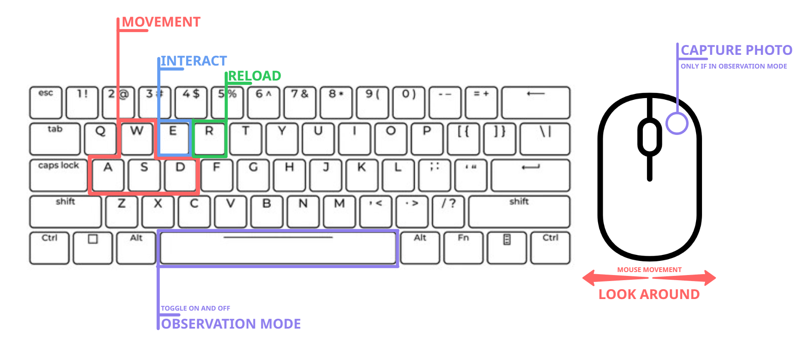

3.2 System: Controller (redundant)

Main Menu Controls
- Left Stick / D-Pad – Navigate menu options.
- A (Xbox) / X (PlayStation) – Confirm / Select.
- B (Xbox) / Circle (PlayStation) – Back / Cancel.

In-Game Controls
Exploration Mode
This is the player’s default control mode when freely exploring the pub environment.
- Left Stick – Move player.
- Right Stick – Control camera look.
- A (Xbox) / X (PlayStation) – Interact with objects.
- Left Trigger (LT / L2) – Enter Observation (Zoom) Mode.
- Right Trigger (RT / R2) – Take photo (when in Observation Mode).
Photoboard Mode
Activated when the player interacts with the Pin Board at their starting location.
- Left Stick – Move cursor.
- A (Xbox) / X (PlayStation) – Select / Confirm photo.
- Right Trigger (RT / R2) (Hold) – Grab and drag photo.
- B (Xbox) / Circle (PlayStation) – Deselect / Cancel.
- Y (Xbox) / Triangle (PlayStation) – Delete selected photo.
- image showing controller controls

4 Camera

4.1 System: Main Camera
The game uses a first-person camera to maximize immersion and place the player directly in the perspective of the bar owner. The camera movement is designed to feel smooth and responsive, accurately reflecting subtle mouse inputs. Its rotation speed is balanced — neither too sluggish nor overly sensitive — to maintain a realistic sense of control and tension.
To reinforce the game’s psychological and film-like atmosphere, the camera applies a slight grain filter, giving the visuals a tactile, analog feel reminiscent of 1960s photography and film. The default Field of View (FOV) ranges between 60 and 85, providing a natural perspective that enhances spatial awareness within the confined pub environment.
When entering Observation Mode, the camera dynamically adjusts to heighten focus and tension. The FOV narrows to 45–55, creating a zoomed-in, constrained perspective that simulates the player raising their Polaroid camera to their eye. During this mode, camera rotation and movement slow down significantly, guiding the player’s attention toward the suspected anomaly while simultaneously invoking a sense of vulnerability and unease.

Technical Implementation Notes
- Camera Transition Duration: 0.8–1.2 seconds between normal and observation mode to ensure a smooth but noticeable shift in perspective.
- Mouse Sensitivity Scaling: Rotation speed reduced by ~50% in Observation Mode to simulate slower, deliberate movement.
- Camera Smoothing: Subtle motion smoothing (lerp or damping) on both rotation and position to avoid abrupt movements.
- Grain Filter: Intensity 10–20% opacity; dynamically increases slightly in Observation Mode to amplify tension.
- Head Bobbing: Minimal, subtle bob to maintain realism without causing distraction or motion discomfort.
- FOV Transition: Linear interpolation (lerp) between 60–85 → 45–55 during Observation Mode entry and exit.

4.2 System: Picture Board Camera
The Picture Board Camera activates whenever the player interacts with the Pin Board. Its purpose is to provide a clear, cinematic, and tactile view of the board while maintaining immersion and spatial continuity with the first-person gameplay.
When the player approaches and activates the Pin Board, the camera transitions from the main first-person view to a static, 2.5D perspective centered directly on the board. This transition includes a short pan-and-zoom animation, subtly moving the camera forward and slightly upward to simulate the player leaning in to examine the evidence. This creates a seamless shift that maintains immersion without breaking the visual tone.
Once active, the camera remains locked in position, with no player movement or rotation allowed. The board and pinned photographs become fully interactable through the cursor or analog stick.
Exiting the Pin Board view triggers a reverse pan animation, returning the camera to its original first-person position and restoring standard controls.

Interaction Restrictions
- The player cannot open or interact with the Pin Board while in Observation Mode.
- The Pin Board is only accessible during normal exploration to maintain clear gameplay flow and avoid conflicting camera states.

Technical Implementation Notes
- Camera Transition Duration: 0.8–1.0 seconds for both entering and exiting the Pin Board view (smooth pan + FOV adjustment).
- Depth of Field: Enabled during Pin Board view — slight focus blur on background environment, sharp focus on the board and photos.
- FOV Adjustment: Slight zoom-in (e.g., from 70 → 55) to simulate leaning closer to the board.
- Camera Lock State: Player movement and rotation are disabled; UI interaction layer is activated exclusively for the Pin Board.
- Exit Animation: Reverse of the entry pan and zoom, re-enabling player control after a short 0.2-second delay for smooth transition timing.

5 Characters

5.1 Mechanic: Movement
The movement system prioritizes immersion, environmental awareness, and tension, rather than speed or agility. The player can move freely around the pub environment using standard first-person navigation controls. Movement speed is moderate, providing a sense of natural walking pace while allowing the player to carefully observe their surroundings. Smooth acceleration and deceleration ensure that motion feels weighted and realistic rather than gamey or floaty.
To maintain the game’s atmospheric focus and reduce unnecessary mechanical complexity, certain common movement features are intentionally omitted:
- No Sprinting:
Sprinting is disabled to preserve the game’s deliberate pacing and constant sense of vulnerability. It ensures the player cannot simply outrun danger and must instead rely on awareness and observation.
- No Crouching:
Crouching is not included, as it does not contribute to the core gameplay loop of observing and photographing anomalies. Removing this mechanic also reduces collision and animation complexity during development.
- No Jumping:
Jumping is unnecessary in the confined pub environment and would complicate navigation and level design. By restricting vertical movement, focus remains on horizontal exploration and visual scanning.
Overall, the movement system is intentionally simple and stable — allowing the player to focus fully on environmental storytelling, audio cues, and anomaly detection.

5.2 System: Player Actions
The player assumes the role of an pub owner trying to figure out why some things in his 1960s pub suddenly started to feel haunted/supernatural. Every mechanic is designed around observation, evidence collection, and environmental awareness.

Core Actions
- Move
- The player can move freely around the pub environment using standard first-person controls (WASD or joystick).
- Movement speed is moderate to encourage careful exploration rather than fast traversal.
- Sprinting is intentionally disabled to maintain tension and vulnerability.
- Look / Rotate Camera
- Controlled via mouse or right analog stick.
- Smooth, responsive movement lets the player scan the environment for subtle visual cues.
- Camera sensitivity is reduced during Observation Mode.
- Interact
- Used to interact with objects, anomalies, and the environment.
- Examples: picking up items, inspecting objects, opening doors, turning on lights, or activating the Pin Board.
- Interactions are contextual and only appear when the player is close enough to the object.
- Enter / Exit Observation Mode
- The player can toggle into Observation Mode when they suspect an anomaly.
- Entering this mode zooms the camera, restricts movement, and focuses on the area of interest.
- Exiting returns the player to normal first-person control.
- Take Snapshot
- While in Observation Mode, the player can take a Polaroid picture of an anomaly.
- Each snapshot consumes one film from the active cartridge.
- Correctly capturing an anomaly dispels it; incorrect shots still reset the anomaly but reveal nothing new.
- Reload Camera
- When the camera runs out of film, the player must return to their starting area to replace the cartridge.
- Reloading triggers a short animation (approx. 5 seconds) during which the player cannot move or look around.
- Audio cues indicate both film depletion and successful reloading.
- Open Pin Board
- The player can approach and interact with the Pin Board at any time.
- The screen zooms into the board, allowing them to drag and drop Polaroid photos into specific positions.
- Organizing the photos correctly reveals the overarching mystery and leads to the game’s good ending.

Passive / Contextual Actions
- Listen
- The player can use environmental sound cues (footsteps, ambience, object movement) to detect anomalies or the enemy’s proximity.
- Audio awareness becomes crucial as the enemy is invisible in the real world.
- Observe Environmental Changes
- The player constantly monitors the pub for visual or auditory hints of new anomalies — shifting chairs, flickering lights, distorted reflections, etc.
- Manage Anomaly Count
- The player indirectly manages danger by resolving anomalies before they accumulate and trigger the enemy’s spawn.
- Experience Fear Reactions (Visual / Audio Feedback)
- The player’s camera may subtly shake, blur, or distort when near strong paranormal activity or the enemy presence, enhancing immersion and tension.
The player’s toolkit in Shadow Frames is intentionally limited but precise. Every action — moving, observing, photographing, and connecting evidence — focuses on psychological horror through investigation rather than confrontation. Each mechanic supports the core loop:
Observe → Capture → Connect → Reveal.

6 Story

6.1 Chapter: Narrative
Summary
It’s the 1960’s, Dublin. It’s the end of a long evening for Aiden, a pub owner, when he notices strange anomalies occurring in his pub: a letter is shoved under the front door, a beer barrel comes up through the lift. He recognizes the anomalies from his own past.
As the photography lover that he is, and to have proof of what he is witnessing, he decides to take photographs of the anomalies.
He discovers that some of the pictures reveal a strange figure behind the activities, and begins to suspect that his dead father may be haunting the bar.
When the anomalies eventually lead to the bedroom upstairs, he sees himself hanging. He committed suicide.

6.1.1 Chapter: Main Character
Aiden, 39
Aiden was a pub owner in Dublin.
He lost his father at the age of 22, who died fighting for the British army in WW2. His father left his sons (Aiden and his brother Kieran) behind with one wish: to take care of the pub. Kieran saw their dad as a traitor for joining the British army instead of supporting Ireland's nominal neutrality, and didn’t want to have anything to do with the pub. Aiden couldn’t let go of the one thing that strongly reminded him of his father, and took over managing it. This broke the bond between Kieran and Aiden.
In the pub Aiden met Ciara, his wife. Shortly after they got married, she immigrated to the States for a chance at a better future and an escape from poverty. She found it difficult that Aiden was always in his pub, and had little time for her. She begged him to go with her when she left for the states, and continued to send letters to him afterwards.
Aiden eventually promised Ciara that he would find someone to take over the bar, and join her. But he found that he couldn’t leave his father's pub behind - and just as with his brother, he once again chose the pub over his loved ones.
The loneliness and guilt began to consume him, eventually leading to a drinking problem.
During one of his drunk nights, he accidentally started a fire in the pub. Luckily, his neighbors managed to extinguish it in time to save the building. But the damage was still immense, and the fire had devoured the old wooden bar that had Aiden's father's name engraved in it.
Aiden felt very guilty for destroying something that was not only so important to his father, but was also the only thing that Aiden himself had left in his life. He could not afford the repairs to restore the pub, and knew it would never again be what it once was.
He could not bear to live after losing the one thing for which he gave up everyone in his life, and committed suicide.

6.2 Cutscene: Start Cutscene (redundant)

Opening Cutscene – “Closing Time”
Scene Setup:
Dublin, 1960s. Late evening inside Aiden’s pub. Warm lamplight, the last echoes of laughter fading as the final patrons leave. The door shuts, and the world falls silent except for the faint hum of the jukebox.
[CAMERA:] Slowly pans across the empty bar — half-finished pints, smoke still curling from an ashtray, chairs slightly askew.
[SFX:] Glass clinks, a chair creaks, a clock ticks steadily in the background.
Aiden (VO, weary):
“Another night. Same four walls. Same ghosts.”
He collects empty glasses, humming faintly — an old Irish folk tune, maybe something his father used to sing. As he reaches the counter, he notices something: a folded letter slipped under the door.
[CAMERA:] Close-up of Aiden’s hand picking it up — his name written shakily in ink.
Aiden (murmuring):
“Not again…”
He opens it, revealing only a single phrase:
“You never left, Aiden.”
A sudden thump echoes from below — the sound of the beer lift activating by itself. Aiden’s head turns sharply.
[CAMERA:] Tracks Aiden as he walks toward the lift. The metal platform rises slowly, revealing a barrel, slick with condensation — and next to it, a wet Polaroid photo resting on top.
Aiden picks it up.
[CAMERA:] Over his shoulder, we see the photo: a faint silhouette standing behind the bar, where no one should be.
He lowers the photo — no one there.
[SFX:] A faint whisper of a man’s voice: “Son…”
Aiden stumbles back, breathing unevenly. He looks toward the bar’s mirror.
In the reflection — just for a moment — a second figure stands beside him.
Cut to black.
[TITLE CARD:] SHADOW FRAMES

6.3 Cutscene: End Cutscene

6.3.1 Cutscene: Good Ending

Good Ending – “The Last Photograph”
Scene Setup:
The player has successfully captured and arranged all the correct photos on the Pin Board, revealing the final pattern — an outline resembling Aiden and his father standing behind the bar together.
[CAMERA:] Slow zoom on the Pin Board as the final photo clicks into place. A quiet chime echoes, and the photos begin to glow faintly, merging into one unified image.
Aiden (VO, softly):
“You were always here… weren’t you?”
[SFX:] The pub creaks — then silence. The lights brighten slightly, the grayscale tones softening just a touch. For the first time, the pub feels peaceful.
Aiden walks toward the bar. The mirror behind it is cracked but faintly reflective. As he looks up, his father appears beside him — not ghostly or monstrous, but calm, watching him with quiet pride.
Father (VO, gentle, distant):
“You did your best, lad. You kept it alive.”
Aiden lowers his head.
Aiden (whispers):
“I’m sorry, Da.”
The father reaches out — a hand on Aiden’s shoulder.
[SFX:] A faint echo of the pub’s old laughter and music swells.
The reflection fades, leaving Aiden alone, but smiling faintly.
He turns, picks up his camera, and takes one last photo — the shutter sound echoes like closure.
[CAMERA:] Freeze on the final photo developing: the pub, whole again, no shadows.
[FADE OUT]
“For Ciara. For Da.”

6.3.2 Cutscene: Bad Ending

Bad Ending – “The Reflection”
Scene Setup:
The player failed to capture enough anomalies or place the photos correctly, leaving the Pin Board incomplete.
[CAMERA:] Close-up of the Pin Board — unfinished, disjointed, photographs overlapping chaotically. Aiden stares at it, breathing heavily.
Aiden (VO):
“No, that can’t be right… it doesn’t make sense…”
[SFX:] A deep, low rumble begins. Lights flicker. The anomalies intensify — chairs scraping, glasses falling, shadows writhing across the floor.
Aiden turns toward the bar. The mirror behind it now reflects a different scene — himself, hanging from the ceiling beam above the counter.
He drops his camera.
[SFX:] Shutter clicks as it hits the floor — a flash goes off.
For a moment, the reflection and reality blur. The hanging figure opens its eyes.
Voice (Father, distorted):
“You never left, Aiden.”
Aiden stumbles backward, clutching his head as the whispers rise into a deafening chorus of overlapping voices — his father, Ciara, Kieran, all echoing accusations and regrets.
[CAMERA:] Pushes in close as Aiden falls to his knees, then cuts abruptly to the developed Polaroid on the floor — the same image of Aiden hanging, frozen forever.
FADE TO BLACK.
[SFX:] The faint click of a Polaroid camera reloading.
[TEXT ON SCREEN:] Some frames are better left undeveloped.

7 Levels

7.1 Chapter: Floor Plan
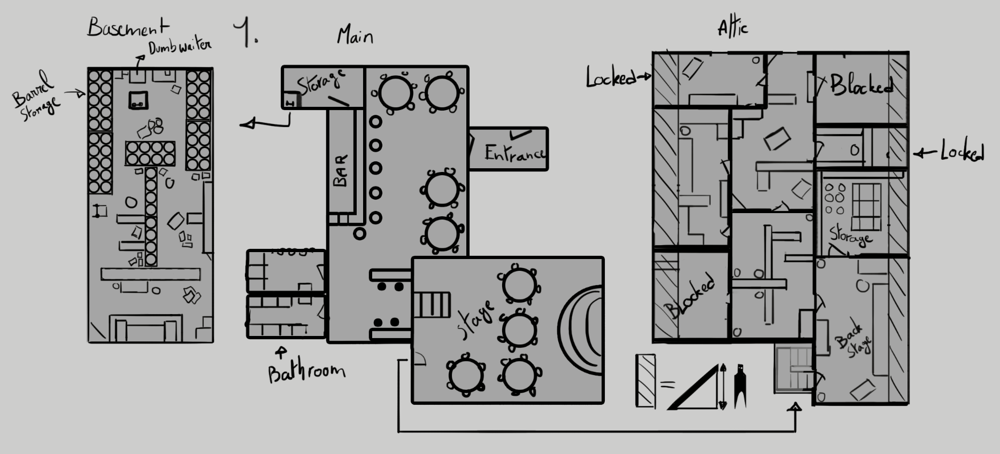

7.1.1 Level: Attic (Redundant)
In the attic you can find a room designed as a backstage for the artist that perform there. Beyond that point there will be rooms with spare furniture for the pub.
Some doors will be blocked for the player so we have an easier time filling the rooms.
Others will be unlocked through traversing/discovering the story.
The rest of the rooms will hold documents/ feel like a working room since the owner lives in his attic which we can have elements to work with.
One of the rooms will be the owners bedroom where he will be found hanging dead at the end of the game.
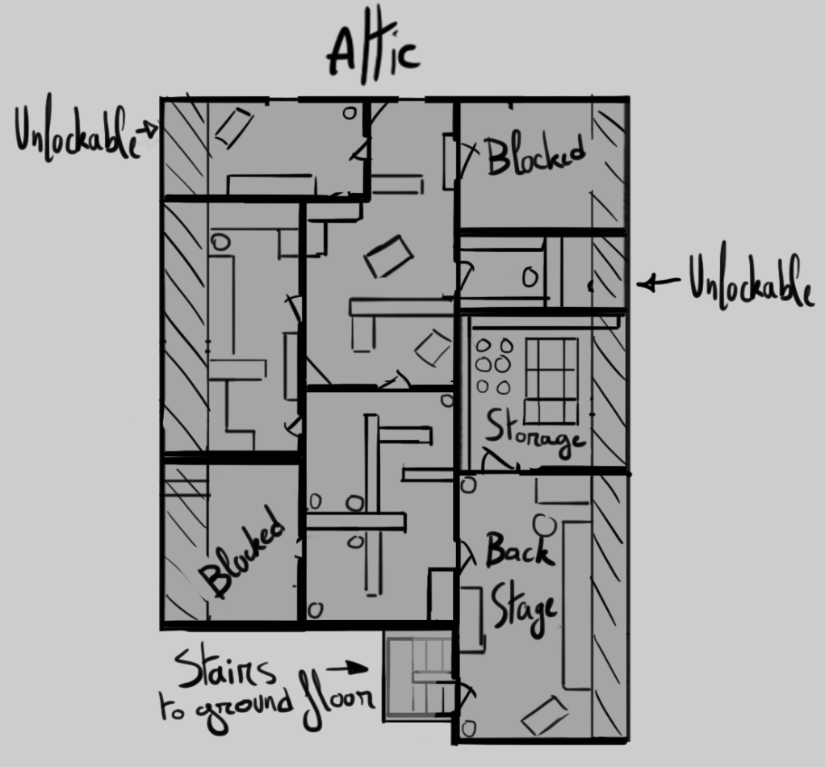

7.1.2 Level: Main Area / Pub
The Main Area is a classic Irish pub interior, serving as the central environment of Shadow Frames. This location is the heart of the gameplay experience — an intimate, character-filled space where the player observes, investigates, and unravels the supernatural occurrences haunting it.
The pub is designed to be memorable yet subtly challenging — the player should feel confident navigating the space but still experience uncertainty when small changes occur. The layout should reward attentiveness without ever making the player feel lost or confused.
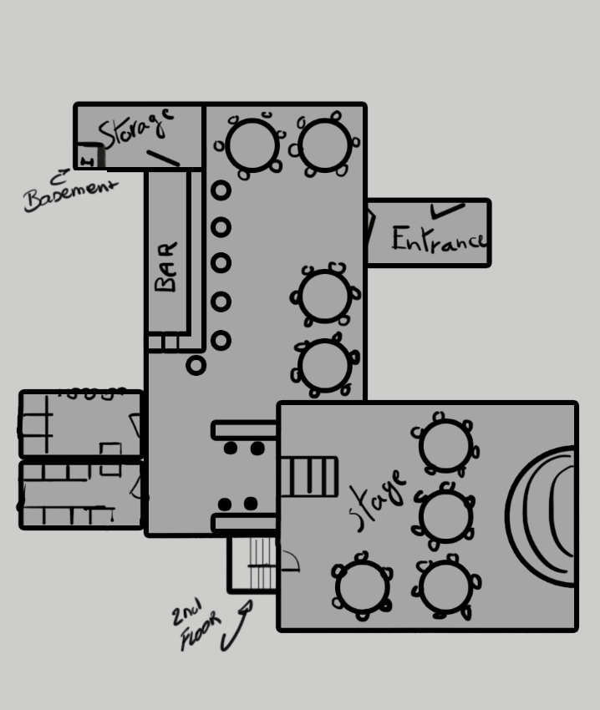

7.1.2.1 Level: Layout & Design
The pub’s design embodies cozy familiarity with an underlying unease. Every detail should feel lived-in and real, allowing the horror elements to contrast against warmth and comfort.
- Movement paths between key landmarks (the bar, the stage, and the starting area) should form a loop, allowing continuous exploration without dead ends or confusing geometry.
- Clear sightlines across the room help players spot visual changes, but furniture and columns** create small blind spots **to add tension.
- The goal is to make the space easy to remember while ensuring subtle object shifts or distortions remain believable and rewarding to notice.
- The space should feel lived-in and authentic, not overly stylized. Familiarity and realism amplify the unease when supernatural events begin to distort it.

7.1.2.2 Level: Key Areas & Features

7.1.2.2.1 Level: The Bar
The bar is the most prominent feature of the pub, running along one side of the main room. It should include era-accurate details like wooden stools, brass taps, mirrors, and shelves filled with bottles and glassware.
- This area also serves as the starting point for the player’s investigation.
- The Polaroid camera — the player’s main tool — is placed here on the counter, illuminated by a small overhead light to draw attention.
- Nearby, a note and a pre-taken Polaroid act as the player’s first storytelling cue, reading something like “I swear this moved!”, subtly teaching the player that photographing changes is the core mechanic.

7.1.2.2.2 Level: The Tables & Seating Area
A collection of round wooden tables and chairs populate the center and sides of the room. These are the primary anomaly zones — objects that might rotate, vanish, or fall during gameplay.
- Each table setup should be slightly distinct (different clutter, coaster placement, ashtrays, etc.) to help the player memorize the normal layout.
- Lighting here should be dim but warm, with shadows that can easily shift when anomalies occur.

7.1.2.2.3 Level: The Stage Area
Located in the back of the pub on the opposite side of the bar, the small stage is used for musical performances and events. It includes instruments, a microphone, and perhaps an old jukebox or record player.
- The stage area holds story significance and can serve as one of the most atmospheric or climactic locations later in the game.
- Visually, it should draw attention without being over-lit — a space that feels dormant but important.
- Early anomalies (such as the record player speeding up or the stage lights flickering) can originate here.

7.1.2.2.4 Level: Personalized Clutter & Atmosphere
The pub should tell a story of its own history — old framed photos on the walls, a chalkboard menu, cigarette smoke haze, worn-down floors, and personalized touches from the owner or staff.
- These environmental details reinforce the sense of place and authenticity, making every later disturbance feel significant.
- Small story pickups (notes, receipts, matchboxes, old newspaper clippings) should be placed throughout the environment to deepen the backstory and give the player reasons to explore beyond the core loop.

7.1.2.3 Level: Interactive Objects
- Polaroid Camera (Primary Tool):
Located on the bar counter, under a warm light. It is easily visible and acts as the player’s first major interaction point.
- Interaction with this object begins the gameplay loop and signals the start of the haunting sequence.
- Pin Board (Secondary Tool):
Placed within visual proximity of the bar area to clearly communicate its connection to the Polaroid camera.
- The player can easily transition between capturing photos and organizing them.
- The board should be mounted on a nearby wall — not hidden, but slightly off to the side to encourage natural discovery.
- **Story Pickups & Notes:**
Scattered through the environment to encourage exploration and provide hints about anomalies.
- One note near the Polaroid explicitly teaches the player how to interact with anomalies:
“I swear this moved! Took a photo to prove I’m not losing it.”
- Other notes can expand on the pub’s lore, hint at the entity’s origins, or document the gradual escalation of strange events.

7.1.3 Level: Basement (Redundant)
The basement will be filled with barrels of beer, duuh, with other beverages and light snacks.
There will be a generator present as well as a dumbwaiter. It's a type of elevator where you put food/supplies to bring up and down.
Other than that the area itself needs to be fun to explore, some scattering of these objects to make traversal more interesting instead of a simple straight path.
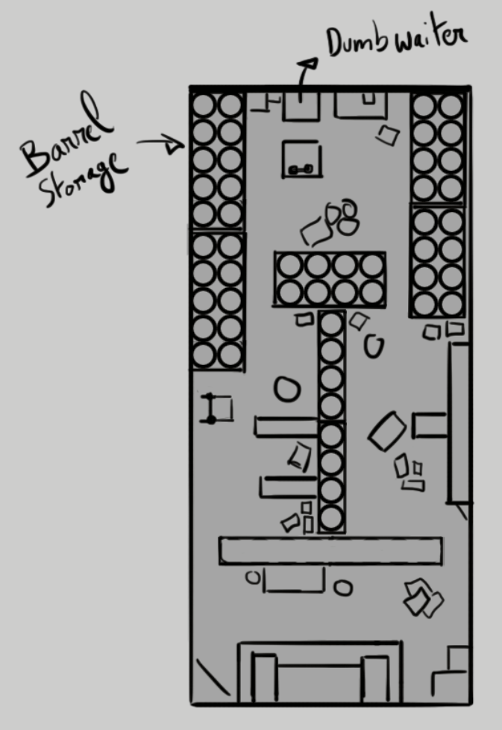

8 UI
The game’s UI is designed to be** minimal, intuitive,** and functional, supporting immersion. The interface consists of a small set of clearly defined screens and transitions, guiding the player smoothly from startup to gameplay and back.
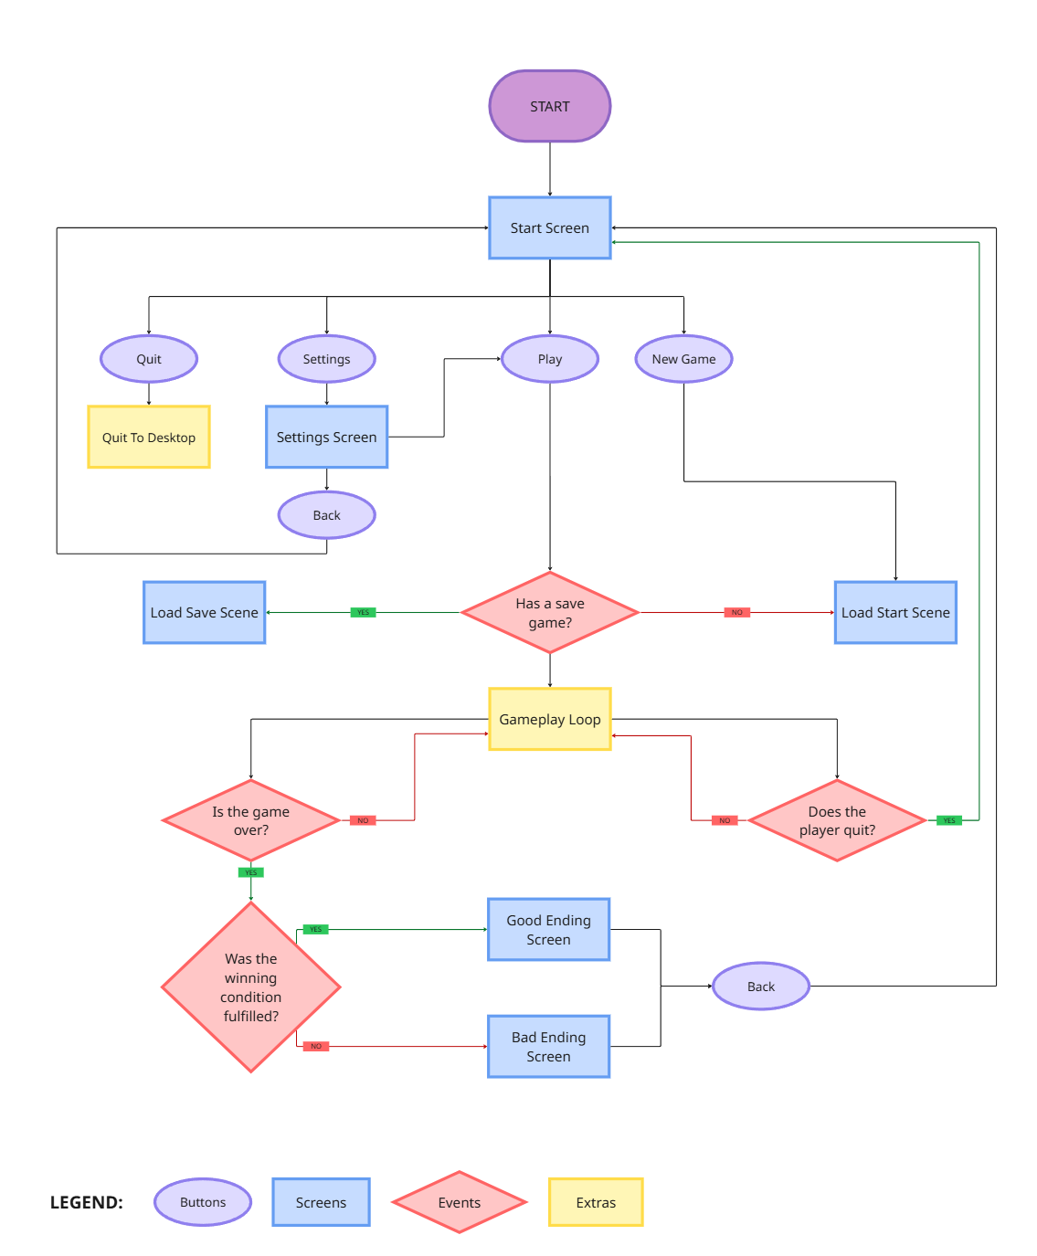

8.1 User Interface: Main Menu Screen

Main menu featuring:
- Continue
- New Game
- Settings
- Credits
- Quit
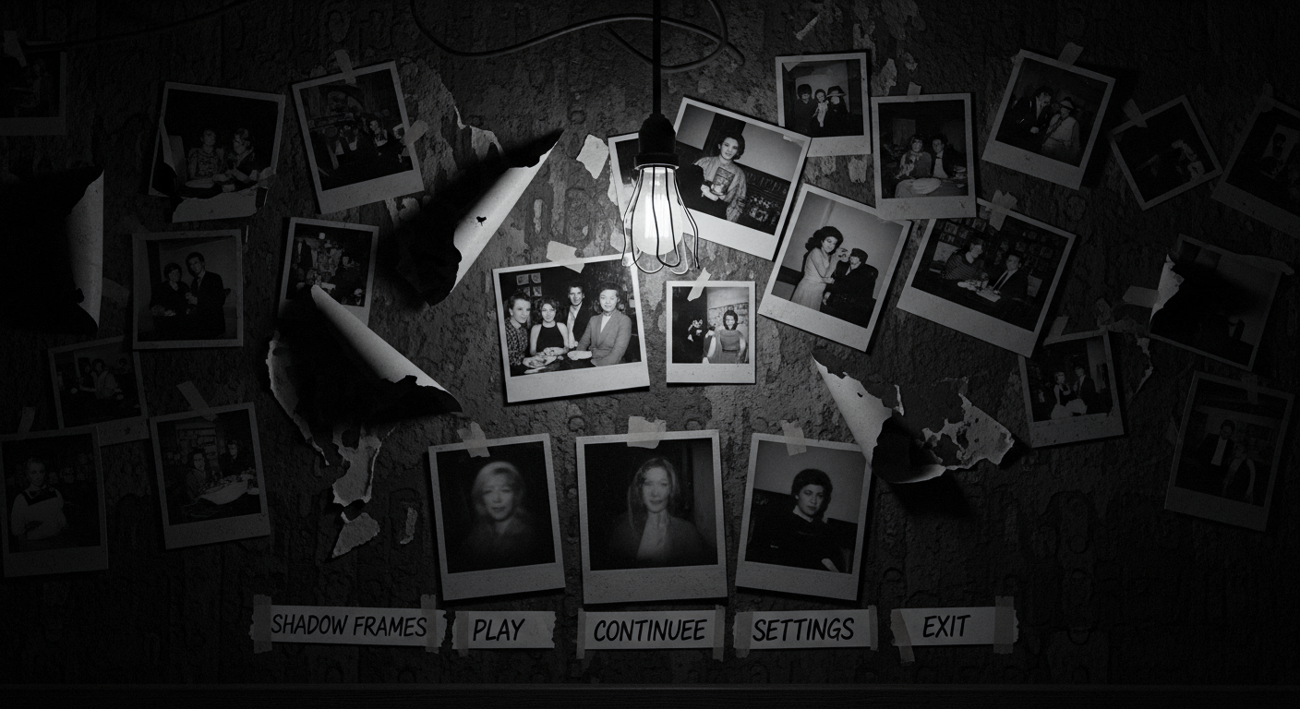

Continue
Resumes the game from the last save point the player reached

New Game
Starts the player in a new game without any save data

Settings
Opens up the settings panel/window. This has its own design element: Element User Interface: Settings Screen

Credits
Shows the credits to our game
- dev team
- writer
- composer

Quit
Closes the game.

8.2 User Interface: Game Over Screen
#### Overview
The game features two distinct endings, determined by the player’s level of investigation and the number of clues discovered.

Ending Variants
1. Complete Investigation Ending (All Clues Found)
- When the player successfully discovers all clues, the final screen will display a newspaper article revealing the truth about the anomalies.
- The article acknowledges the player’s findings and confirms the uncovering of the mysterious events.
- The tone of the article will validate the player’s investigative success, portraying them as a diligent and competent journalist.
- Visual elements may include:
  - A front-page headline referencing the anomalies.
  - Supporting imagery (e.g., Polaroids or case files) integrated into the layout.
  - Slight paper aging or texture variation to emphasize authenticity.
2. Incomplete Investigation Ending (Missing Clues)
- If the player fails to find all the clues, the final screen will also take the form of a newspaper article, but with a drastically different tone.
- In this version, the article presents a false conclusion, dismissing the anomalies as unfounded rumors or fabrication.
- The closing lines of the article indicate that the player’s character has been fired for failing to deliver credible results.
- This ending reinforces the consequence of incomplete exploration while maintaining immersion.

Presentation Details
- Both endings use the same visual template, ensuring stylistic continuity.
- Subtle differences in layout, headline wording, and tone communicate the outcome’s moral and investigative impact.
below is a placeholder


8.3 User Interface: Settings Screen
The Settings Menu provides players with control over core game parameters: sound, graphics, and gameplay accessibility.
The design philosophy prioritizes simplicity, immersion, and player comfort.

Sound
Adjusts all audio levels and categories.
Options:
- Master Volume (0–100%)
- Music Volume (0–100%)
- SFX Volume (0–100%)
- Dialogue Volume (0–100%)
- (Optional) Mute All / Mute in Background
_Notes:_
_ Each slider affects its respective mix channel in real time._
Values should persist between sessions.

Game
Controls narrative and accessibility options.
Options:
- Subtitles (On/Off)
- Subtitle Size (Small / Medium / Large)
- (Optional) Camera Sensitivity
_Notes:_
Subtitles display character name + dialogue (e.g., “Aiden: I can’t use this.”).
Subtitle background option may be added later for accessibility.

Graphics
Adjusts visual fidelity and display configuration.
Options:
- Display Mode (Fullscreen / Windowed / Borderless)
- Resolution (Auto-detect + Manual selection)
- Quality Preset (Low / Medium / High / Ultra)
- VSync (On/Off)
- Brightness (Slider)
- Contrast (Slider)
- (Optional) Post-Process Toggles (Motion Blur, Film Grain, DOF)
_Notes:
Visual settings apply immediately where possible.
All settings persist and are stored in a user configuration file.
Visual example:
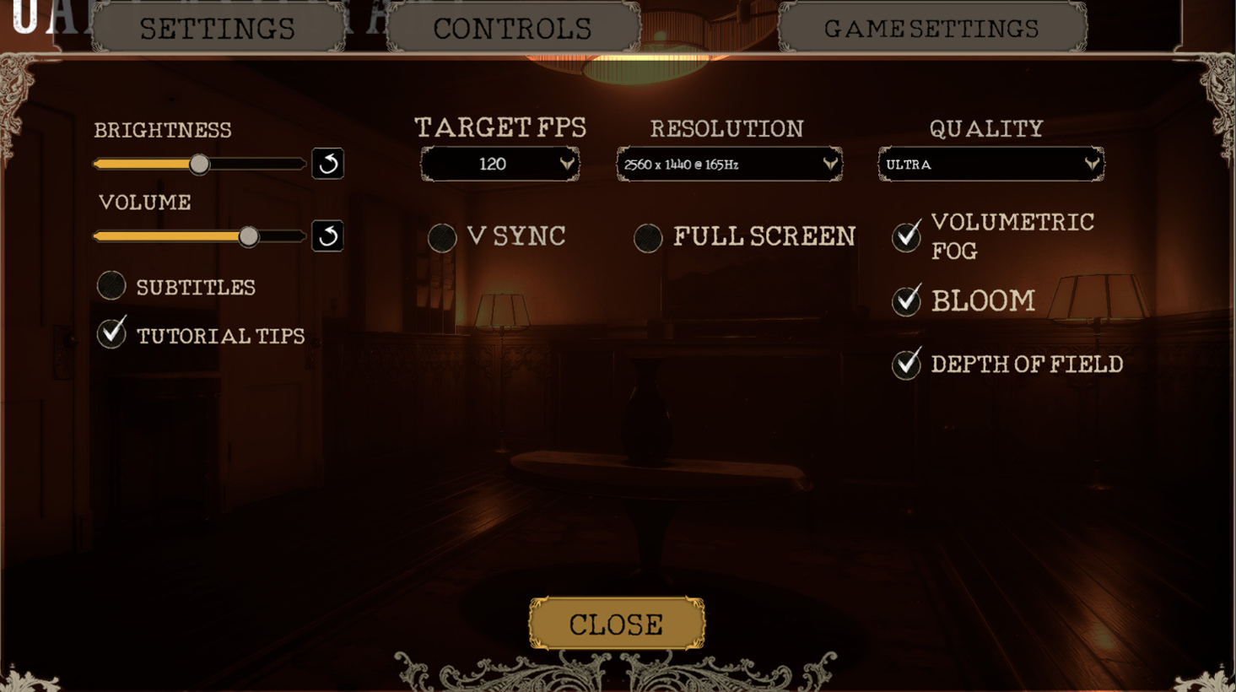

8.4 User Interface: In Game

Overview
The game will feature a minimalistic UI approach. There will be no traditional HUD or on-screen interface elements during gameplay. Instead, interaction and information delivery will occur through in-world objects. The Pinboard serves as the central and primary UI element.

The Pinboard
- The Pinboard is an in-game object that becomes an interactive UI screen when the player engages with it.
- It displays a series of Polaroid photographs captured by the player during gameplay.
- Players can drag and rearrange photos on the board. When a photo is placed in the correct position, it will lock into place.
- While dragging a photo:
  - The photo slightly enlarges to indicate active interaction (approximately +50% scale).
  - The image may dangle slightly, as though being held between the player’s fingers, to add tactile realism.
- This mechanic serves both a narrative and puzzle function, encouraging the player to piece together story elements through visual arrangement.
Pinboard example reference: 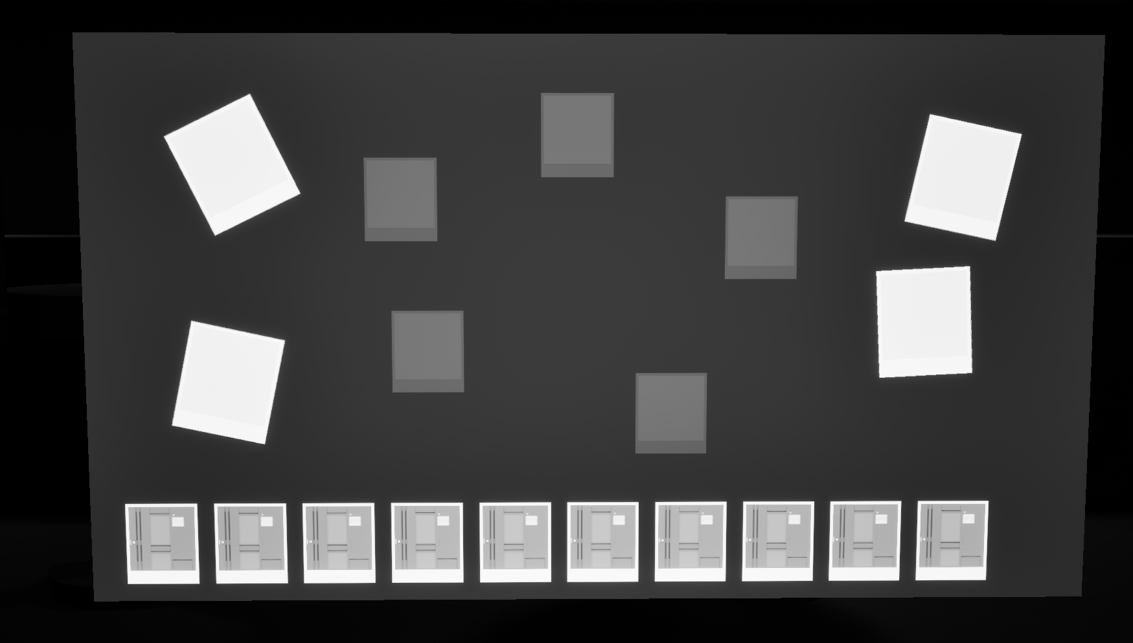

Interaction Feedback
If the player attempts to interact with an unavailable object, the character will provide a contextual voice line, such as:
You can’t use this right now.
This feature provides clear feedback without relying on visual indicators, maintaining the game’s immersive design philosophy.

** Subtitles**
Subtitles are the only other component of the in-game UI.
- They can be enabled or disabled via the settings menu (Toggle Option: Subtitles On/Off, Default: On).
- Subtitles appear as white floating text positioned at the bottom of the screen.
- Each line will display the character’s name followed by the dialogue, e.g.:
Aiden: I’m afraid I can’t use this.
Subtitles implementation reference:

Readable Notes
In addition to the Pinboard, players can find readable notes within the environment.
- These are physical objects placed in the scene.
- When interacted with, the note transitions to an on-screen readable UI for clarity and legibility.
- This maintains diegetic immersion while allowing for narrative delivery through discovered items.
Notes example reference: 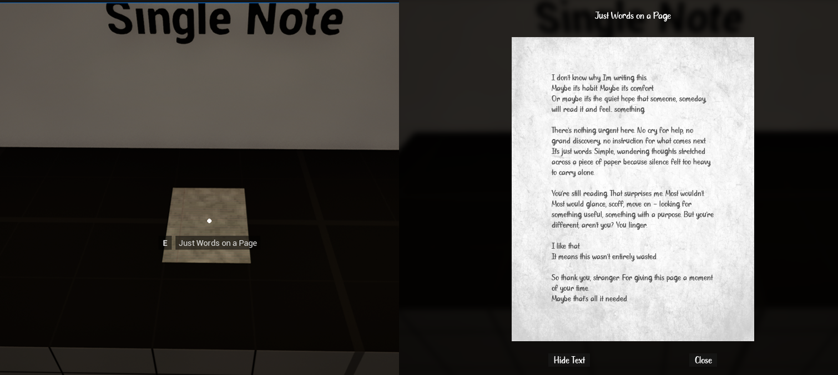

9 HUD
Shadow Frames maintains an almost HUD-less design to preserve immersion and realism.

Core HUD Elements
- Minimal Interaction Indicator:
The only HUD element present during gameplay is a small dot (crosshair) at the center of the screen that appears only when hovering over an interactable object.
- This subtle visual cue informs the player that the object in focus can be interacted with (e.g., picking up the Polaroid camera, reloading film, interacting with the pin board).
- When not looking at an interactable item, the dot disappears completely, keeping the screen clean and diegetic.

Design Intent
- Keeps the player’s attention on the environment rather than on interface elements.
- Reinforces the game’s psychological realism and focus on environmental observation.
- Ensures all necessary information is delivered through in-world feedback — sounds, lighting, and object reactions — rather than overlays or icons.
