- Current sensor
Components used:
- INA180A1IDBVR TEXAS INSTRUMENTS – Measure opamp - https://www.tme.eu/pl/details/ina180a1idbvr/wzmacniacze-operacyjne-smd/texas-instruments/
- WSL25121L000FEA – Shunt resistor - https://www.tme.eu/pl/details/wsl25121l000fea/rezystory-smd/vishay/
Used opamp data sheet typical application:
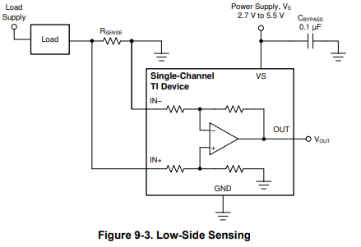
Cbypass – 0.1uF 0805
Added RC filter with fc = 1.6kHz to cutoff pwm noise.
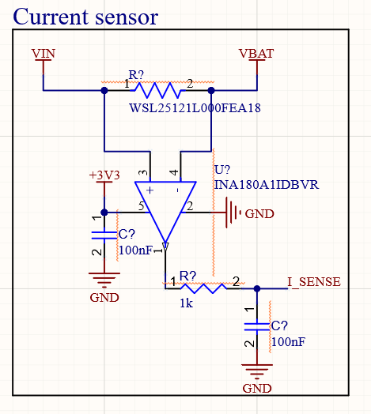

- Voltage sense

