RetailService Hub — Project Documentation

Title Page
Project Name: RetailService Hub – Technical Issue Submission System
Course: Software Engineering / Project Management
Authors: Szymon Kala, Mateusz Hofman
Version: 1.0
Date: May 18, 2026

Chapter 1: Business Description of the System

1.1 Introduction
The RetailService Hub is a web-based helpdesk application designed specifically for retail store networks and centralized distribution centers. The primary purpose of the system is to streamline, accelerate, and automate the technical issue reporting and management process. By automating data collection and optimizing the routing workflow, the platform minimizes human intervention, allowing issues to reach the correct internal or external engineering silos without administrative delays.

1.2 Motivation
In large retail networks, reporting facility malfunctions, infrastructure breakdowns, or IT issues traditionally involves manual data entry, phone calls, or unmonitored emails sent to incorrect departments. This operational friction leads to prolonged system downtime and data errors.
The core motivation behind RetailService Hub is the implementation of an automated facility identification mechanism. When a frontline worker encounters a technical issue, they are not required to search for dedicated technical contacts or fill out exhaustive location detail forms. Instead, by entering a unique localized facility identifier, the system handles the heavy lifting backend integration—instantly pulling structured address data and mapping predefined regional maintenance partners automatically.

1.3 Main Features & Modules
The application architecture is logically split into four isolated modules:
- Submission Module (User View): A simplified, lightweight reporting web portal designed for quick access by physical store and warehouse staff.
- Service Module (Technician Dashboard): A specialized, siloed workplace where internal engineering departments (divided into IT, Real Estate/Buildings, and Security) manage their respective operational queues. It enforces absolute visibility boundaries so distinct groups do not overlap tasks.
- Administration Module: The configuration command center used by system superusers to maintain the global database of facilities, track user permissions, and monitor organizational throughput metrics.
- External Services Portal: A dedicated external dashboard allowing outsourced third-party engineering contractors to claim, document, and resolve highly specialized or physical infrastructure tasks requiring complex on-site intervention.

1.4 Target Audience & Stakeholders
The platform recognizes four core user personas interacting within its ecosystems:
- Store & Warehouse Staff: Frontline operators logging real-time facility issues directly from retail points.
- Internal Technicians: Subject-matter experts (IT support, building engineers, security managers) processing issues isolated inside their technical domains.
- System Administrators: Central auditors managing global configurations, monitoring structural processes, and editing infrastructure data.
- External Service Vendors: Third-party outsourcing partners executing complex equipment or building repairs.

1.5 Expected Business Benefits
- Drastic Time Reductions: Instant ticket generation achieved via automated facility lookup algorithms.
- Elimination of Human Routing Errors: System logic systematically assigns issues to accurate technician departments.
- Bottleneck Transparency: Administrators pinpoint exactly where workflows slow down or breach Service Level Agreements (SLAs).
- Predictive Maintenance Core Data: Aggregated technical logs facilitate data analysis regarding which hardware types or store regions experience frequent failures.

Chapter 2: Software Requirements Specification (SRS)

2.1 Functional Requirements (FR)
The system functionalities are defined through specific structural requirements and User Stories:
Requirement ID | Requirement Name | User Story / Description
FR-01 | Automated Data Lookup | As a store employee reporting a fault, I want the system to auto-populate my market's name, address, and management contacts upon typing our facility number, so that I can submit issues in seconds without manual entry errors.
FR-02 | Inter-Department Ticket Transfer | As an IT technician, I want to seamlessly transfer an issue ticket over to the Real Estate/Buildings silo if a reported computer malfunction turns out to be caused by a broken electrical wall outlet, so that the issue is re-routed without requiring a new submission from the store.
FR-03 | Global Operational Overview | As a system administrator, I want a global real-time overview dashboard tracking all open tickets across all technical silos, so that I can observe network-wide maintenance statuses and vendor compliance.
FR-04 | Status Updates & Resolution Logs | As an external service provider, I need to upload resolution proofs (text remarks and photographic attachments) when completing a repair, so that my work can be validated and officially archived.

2.2 Non-Functional Requirements (NFR)
The technical parameters governing the operational environment are specified below:
- NFR-01: Verification Performance: The system must process database lookups for inputted facility numbers and populate all corresponding fields in less than 1.0 second.
- NFR-02: Infrastructure Availability: The server infrastructure must guarantee an uptime of 99.5% minimum, operating 24/7/365 to handle non-stop supermarket and distribution warehouse shifts.
- NFR-03: Data Privacy & Security: Sensitive employee records, direct manager phone numbers, and emails must be encrypted under strict GDPR standards. Bulk extraction of the facility database must automatically generate unalterable security audit logs.
- NFR-04: Structural Data Isolation: The core database schema must enforce multi-tenant style compartmentalization; internal IT support users must be strictly unauthorized from viewing data payloads or tickets assigned to the Security section.
- NFR-05: Hardware & Browser Compatibility: The responsive web user interface must render flawlessly on legacy corporate store workstations running older versions of Google Chrome/Microsoft Edge, as well as on rugged mobile Android data collectors.
- NFR-06: Network Disconnection Resilience: The submission engine must handle intermittent physical network dropouts; if an asset attachment upload (e.g., a large image file) is cut off, the form state and written text must remain cached, resuming data packet delivery immediately upon reconnect without clearing user fields.

Chapter 3: Models and Design of Projected System

3.1 Use Case Diagram
This diagram outlines the system boundaries and showcases how the three internal primary actors invoke system use cases.
- Actors mapped: Store Submitter (ACT-001), Internal Technician (ACT-002), System Administrator (ACT-003).
- Core Relationships: Submitter interacts with Ticket Creation and Status views. Technicians manage Silo views and handle outsourcing. Admins manipulate the global configuration database.
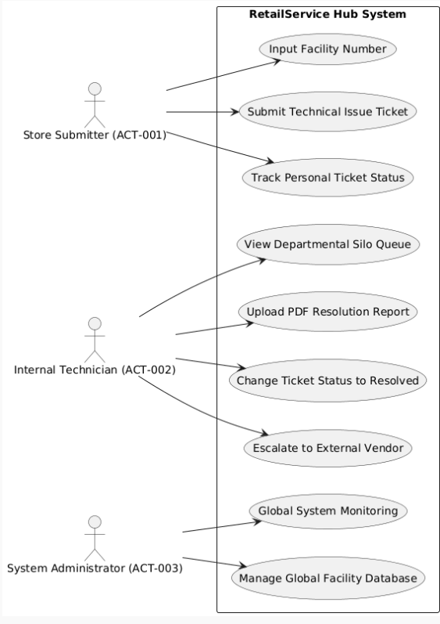

3.2 Activity Diagrams (Two Selected Operations)
Aspect 1: Ticket Creation & Automated Verification Process
This flow depicts the decision mechanism executed when an employee initiates a ticket submission. The system performs validation checking on the entered facility number, choosing whether to trigger automated lookup or require manual address input.
PlantUML Code (Copy to generate image):
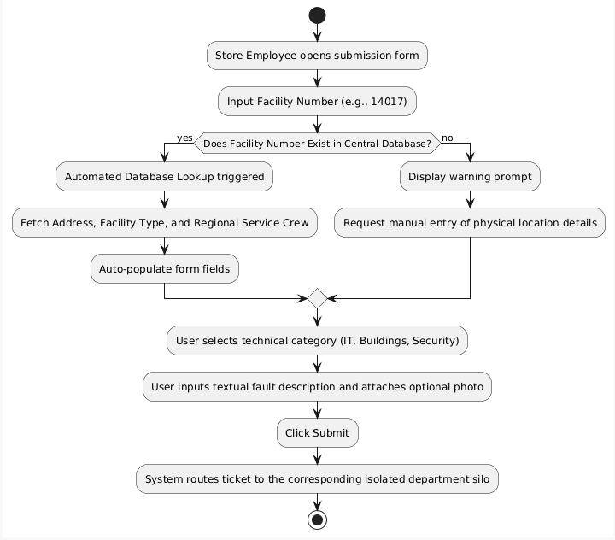

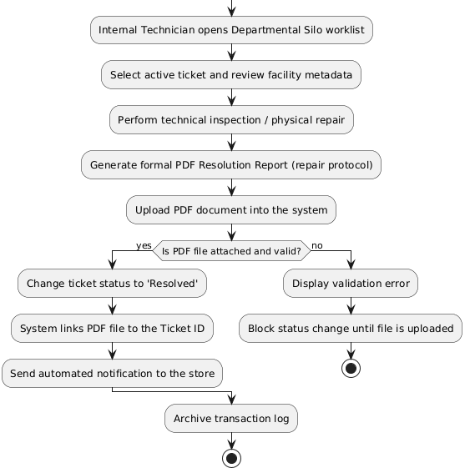
3.3 Class Diagram (Domain Model)
The domain structure models the relationships between objects within RetailService Hub. A Facility owns multiple Tickets. Each Ticket is bounded to a unique department type and can be overseen by a User entity possessing specific operational permissions.
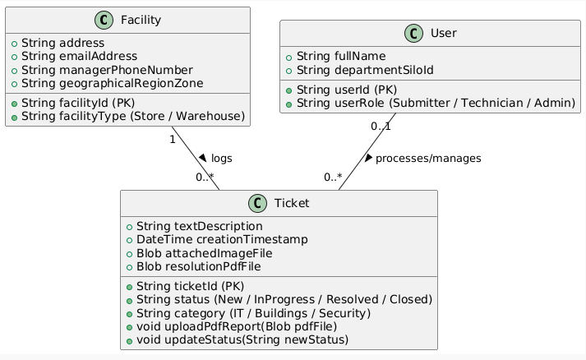
PlantUML Code (Copy to generate image):

3.4 Additional Diagram: Sequence Diagram (Form Auto-Population)
To provide structural completeness, this diagram demonstrates real-time interaction patterns between frontend user interfaces, backend APIs, and the database caching layer when executing the FR-01 lookups.
PlantUML Code (Copy to generate image):

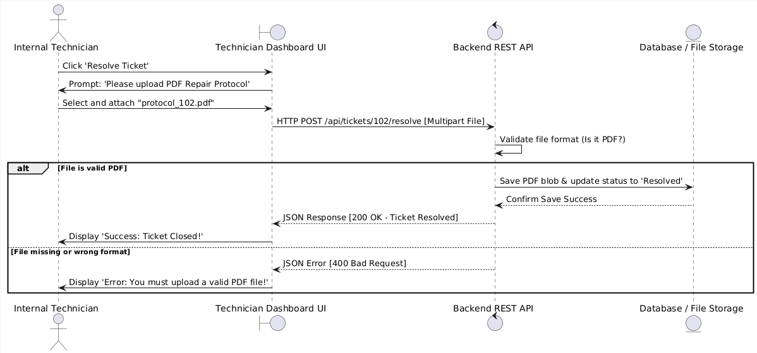

Chapter 4: System Prototype & Implementation

4.1 Technology Stack Description
The system prototype has been engineered using modern, enterprise-grade frameworks to ensure scalability, clean separation of concerns, and rapid development capabilities:
- Architecture Pattern: The backend logic strictly follows the Model-View-Controller (MVC) architectural pattern. This pattern isolates the domain data (Models), user interfaces (Views), and routing/business workflows (Controllers). This satisfies requirement NFR-04 by enforcing clear security logic boundaries at the controller level.
- Backend Framework & Language: Built using C# on the .NET Core (ASP.NET Core) framework. This provides high-performance asynchronous request handling, built-in dependency injection, and native middleware configuration architectures to manage session states and file upload validation policies.
- Data Access Layer (ORM): Database communication is abstracted using Entity Framework Core (EF Core) using the Code-First/DbSet approach, mapping data structures seamlessly to relational tables.
- Database Tier: Backed by a relational database engine (such as Microsoft SQL Server or PostgreSQL), optimized for handling indexing lookups on the global facility tables in under 1.0 second (NFR-01).
- Frontend Layer: Built using standard web technologies integrated into the ASP.NET Views (HTML5, CSS3, JavaScript, and Bootstrap), ensuring fully responsive layouts that render smoothly across legacy desktop monitors and mobile Android terminal devices (NFR-05).

4.2 Repository Architecture & ZIP Delivery
The source code structure is managed inside a localized Git repository using standard branch tracking practices. In strict compliance with submission requirements, the project package is assembled into a single compressed ZIP file attachment containing the written source files. To keep file sizes optimized, all temporary compilation directories (such as "bin" and "obj" folders) and local IDE configurations are excluded from the final archive via a .gitignore configuration.

4.3 Deployment & Verification Strategies
(Complete Code & Video): Insert your unlisted online video presentation screencast URL (e.g., Google Drive/YouTube link) directly here. The video must run for 3–5 minutes, showcasing a screen recording of your working system compiling, executing data popups, routing tickets through silos, and performing technical closures.

