A Study on the Effectiveness of Stress Level Classification Methods

Description of the Problem and Dataset
The goal of this part of the project is to classify students’ stress levels based on demographic data, academic performance, and psychological indicators. The analysis was carried out using the "University Students Mental Health" dataset from Kaggle, containing survey results collected from students at various universities.

Dataset and Preprocessing Characteristics
The dataset consists of 1,977 unique observations. The code implements the following data preparation process:
- Missing value imputation: All missing numerical data were replaced with the median of the corresponding column.
- Normalization: Min-Max scaling was applied, mapping all input values to the [0,1] range.
- Class balancing: To offset the unequal class distribution, oversampling was applied — randomly duplicating the minority-class cases. This step was performed only on the training set, so the network learns to recognize both classes with equal attention instead of taking the easy route and focusing on the majority group.
- Data leakage elimination: All features that would give the model a ready-made answer were deliberately removed from the input data. This included the "Stress Value" column and 10 survey questions that directly measured stress level, forcing the network to infer stress from the remaining indicators.

Input Variables
- Binary variables: Gender, Scholarship
- Ordinal variables: Age, Current CGPA, Academic Year, Anxiety Label, Depression Label
- Categorical variables: University, Department

Target Variable
Stress label — originally a multi-class variable, converted into a binary classification problem. This simplified the network’s decision task:
- Class 0: Students reporting low or moderate stress ("Low/Moderate Stress")
- Class 1: Students reporting objectively high stress levels ("High Perceived Stress")

Literature Review
The reference point for our project is the study by Suraj Arya, Anju, and Nor Azuana Ramli, “Predicting the Stress Level of Students Using Supervised Machine Learning and Artificial Neural Network (ANN).” The authors evaluated the effectiveness of various methods for predicting stress levels on a survey dataset similar to the one we obtained from Kaggle. Their analysis leads to the following conclusions:
- Classical machine learning algorithms achieved very high precision — the best-performing Naive Bayes model reached 90% accuracy, while the SVM model achieved around 85.5%.
- Artificial neural networks trained using ready-made libraries achieved results ranging from 86% to 89%.
However, it is important to consider the perspective presented in “How Can Machine Learning Be Used in Stress Management: A Systematic Literature Review of Applications in Workplaces and Education” by Shivani Mittal, Sumedha Mahendra, Viraj Sanap, and Prathamesh Churi. They point to a significant barrier in stress detection: models achieving results close to 90% under controlled conditions often show a drop in performance to around 76% when validated on independent research samples. This decline is a natural effect of the high variance in responses and the subjective nature of the data.

Artificial Neural Networks

Implementation and Architecture
Our network was built from scratch in Python. To fully understand what happens during the algorithms’ execution, we used the NumPy library. This gave us full control over every mathematical operation in the learning process.
- Model: We built a classic MLP (Multi-Layer Perceptron) network
- Training method: The network is trained using the backpropagation algorithm, and the accuracy of its predictions is evaluated using categorical Cross-Entropy
- Overfitting protection: To prevent the network from memorizing the data, we implemented additional safeguard mechanisms: L2 regularization, random neuron dropout, and Batch Normalization.

Detailed Analysis of Parameter Influence
We conducted tests examining the influence of individual parameters on the network’s performance on the training and test sets. To minimize the effect of random initial weights, results were averaged over 5 independent runs.
- Architecture and Network Size
- Number of hidden layers: The optimal model depth was investigated.
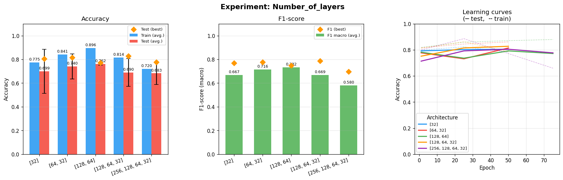
Conclusion: Adding more layers did not always improve prediction quality. Shallow, one- or two-layer networks performed optimally on structured data.
- Number of neurons: The information capacity of the layers was examined.
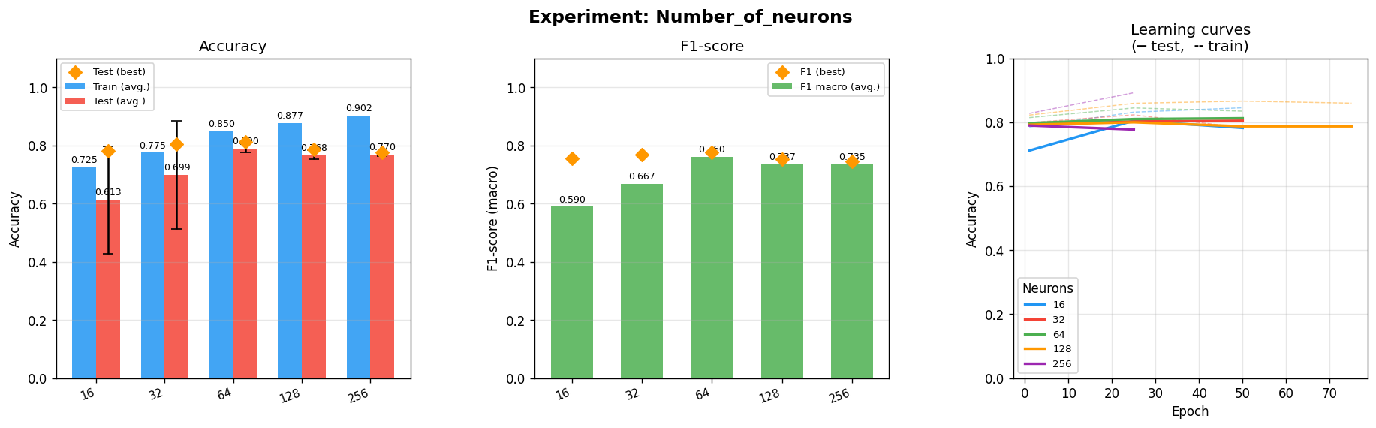
Conclusion: Too few neurons caused underfitting, while too many neurons made the network overly complex relative to the scale of the problem, causing it to start memorizing training samples.

- Optimization Process
- Optimizer type: Instead of the classic learning algorithm, we tested more modern methods.
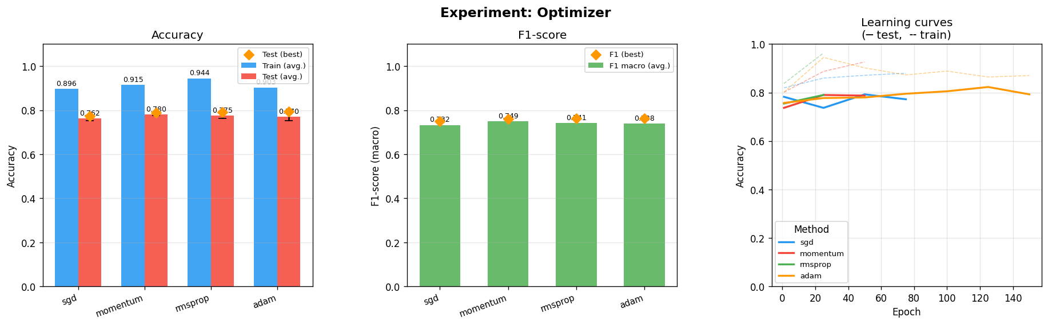
Conclusion: Advanced algorithms allowed the network to find the right rules much faster, even at the very beginning of training.
- Activation functions: We tested several mathematical functions for processing the signal within the network.
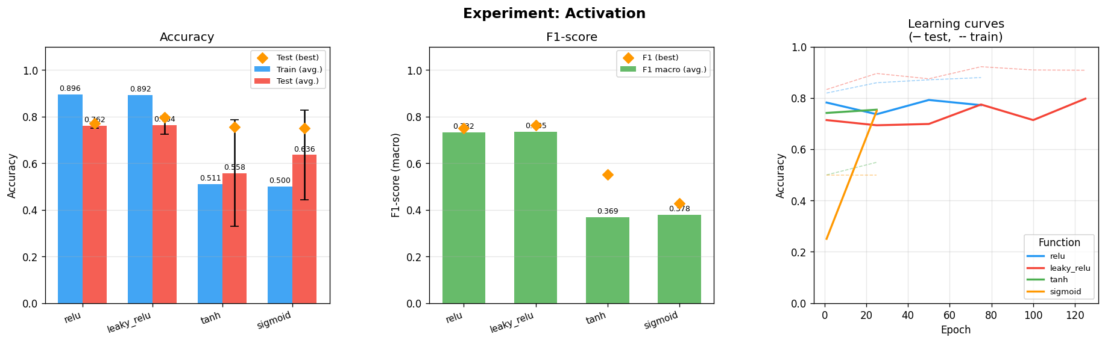
Conclusion: The ReLU function performed best. It prevented the network from losing information in deeper layers and allowed it to learn much more efficiently.
- Learning rate: We examined how large a step the network should take during learning.
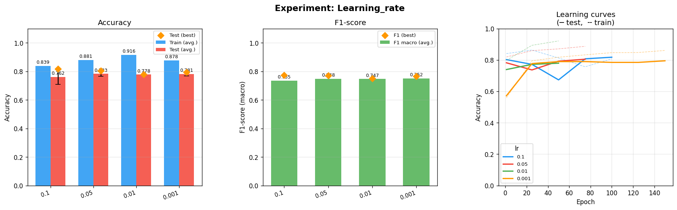
Conclusion: Too large a step caused the model to overshoot the ideal solution. Conversely, with too small a step, the network learned so slowly that it failed to achieve good results within the allotted time.

- Overfitting Prevention
- Batch Normalization
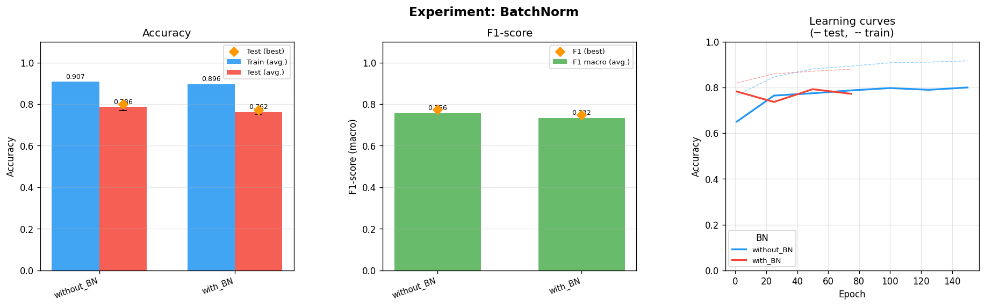
Conclusion: Organizing and standardizing the data passed within the network improved the entire learning process.
- L2 regularization and neuron dropout
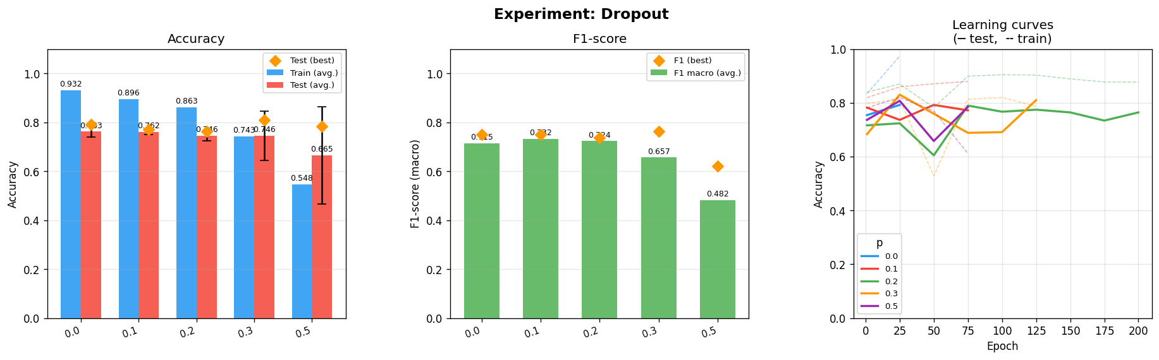
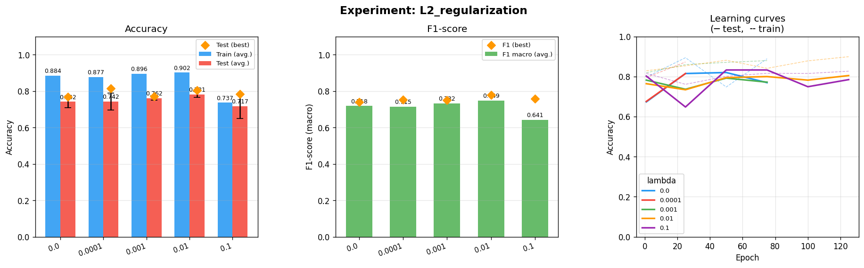
Conclusion: We forced the network to not rely on a single learned pathway but to search for many different dependencies. These two techniques protected the network from overfitting.

- Training Configuration
- Batch size and dataset split
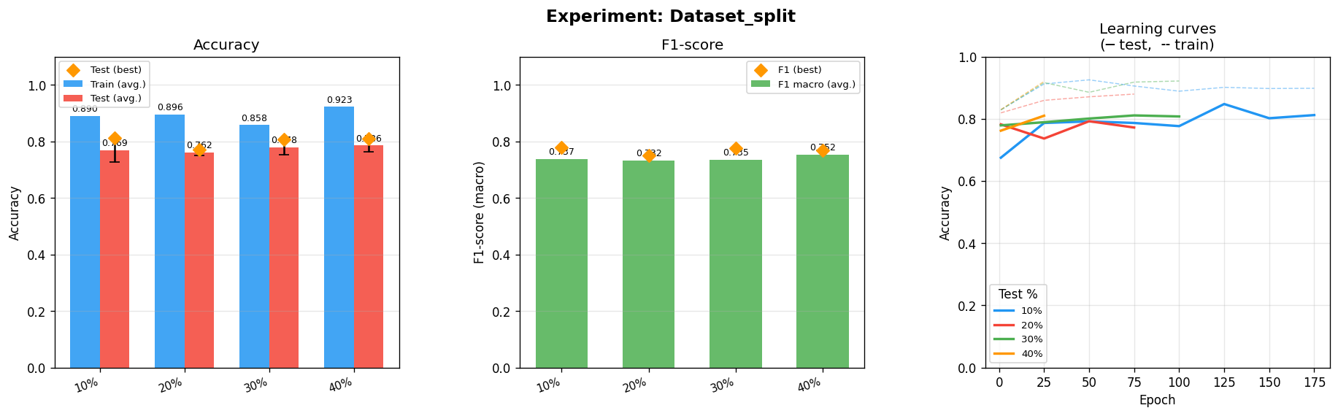
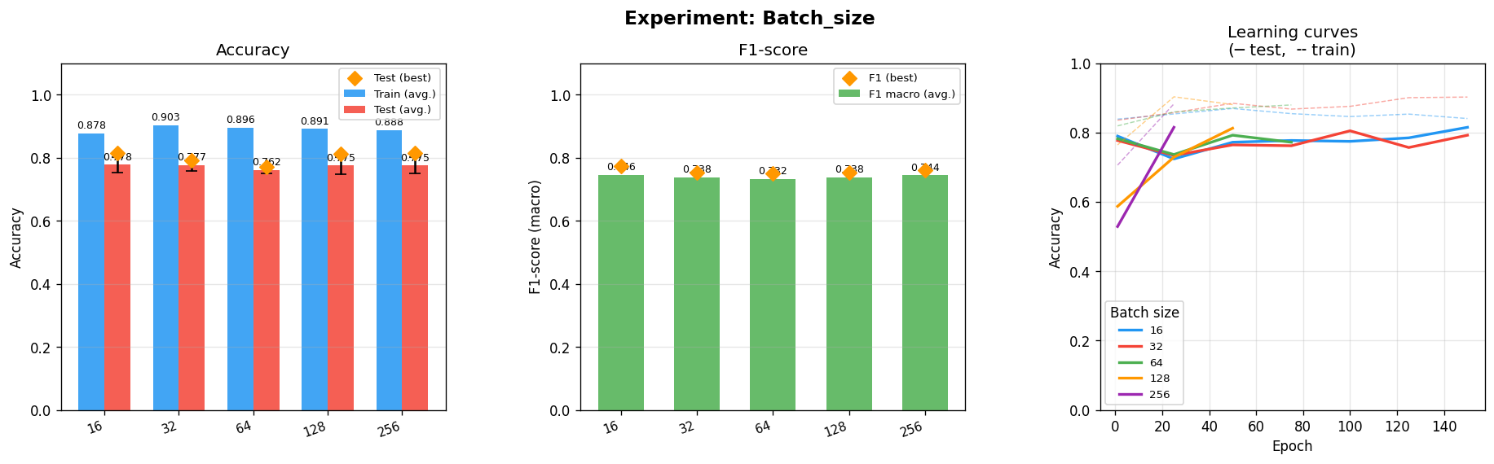
Conclusion: Feeding the network data in smaller batches forced greater flexibility and helped it escape so-called dead points. Meanwhile, an 80/20 train-test split proved to be the best choice.
- Number of epochs
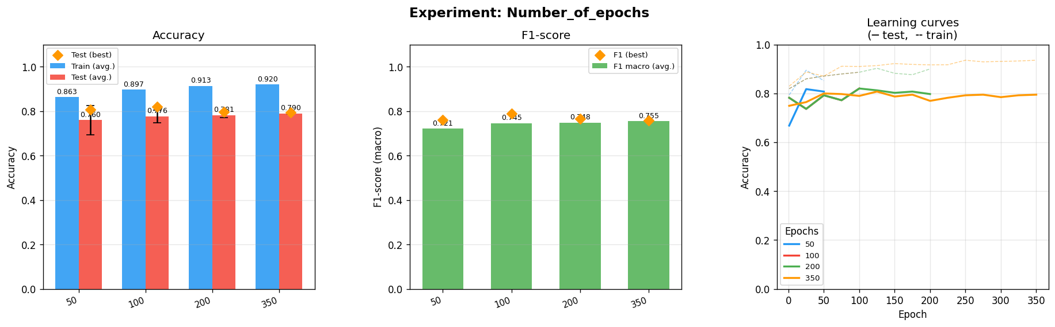
Conclusion: Analyzing the curves in the charts allowed us to identify the ideal moment to stop training. Further training only caused the model to start memorizing the data.

Advanced Experiment: Network Ensemble
To minimize the risk of error from a single model and ensure the final result is not accidental, we applied an ensemble modeling technique. Rather than relying on just one network, we trained as many as 10 independent models. Each one started with slightly different random parameters, so it learned to pay attention to somewhat different details.
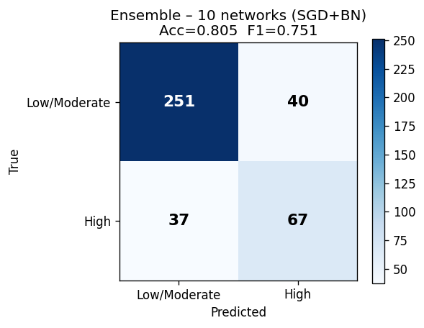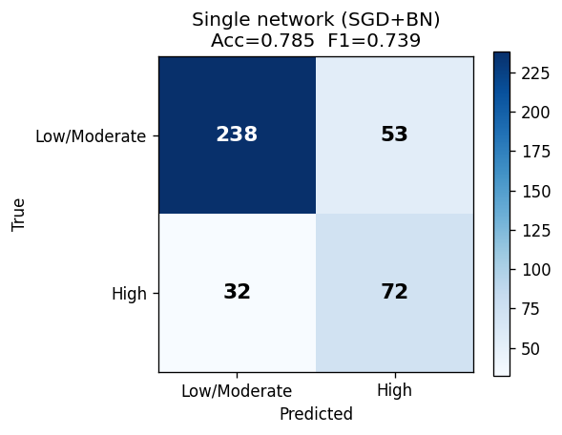
Conclusion: The 10 independent models proved to be significantly more stable and more resistant to misleading data.

