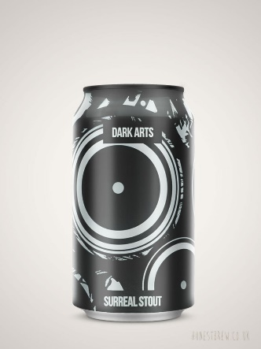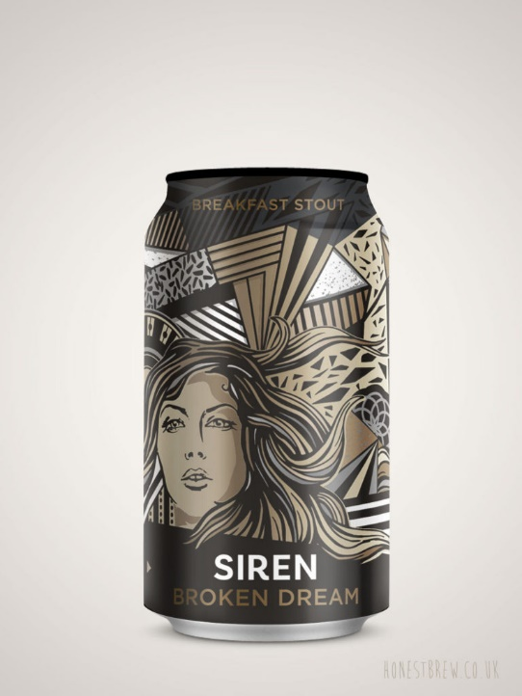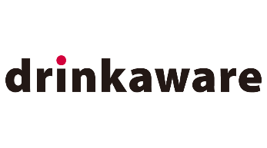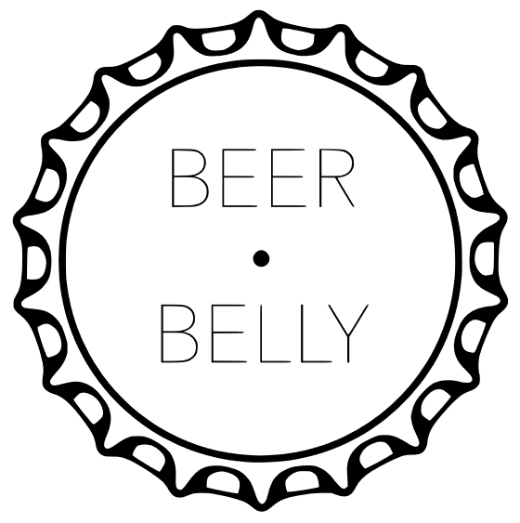

Siren’s Breakfast Stout packs an expertly brewed smooth combo of coffee and chocolate you’d be forgiven for thinking you were drinking a mocha with your corn flakes. Its silky, medium body brings dried fruits and a little liquorice, finishing with a light, coffee/caramel bitterness.

Recommended for you:

Magic Rock - Dark Arts Stout

ABV: 6.5% Country: UK

Volume: 330ml Style: Stout

Beers – Stout – Siren Craft – Broken Dream Breakfast Stout

Where’s my brewery?

Siren - Broken Dream Breakfast Stout 6.5**%**

Price: £3.99 /per Can

Add to Cart

Search

© Copyright 2020 Beer Belly all rights reserved

Beers | Other Drinks | Special Offers | About Us | Contact