

Multiscale Modelling

Simple Grain Growth Cellular Automaton

Grain Baundary Curvature

Author: Szymon Trela

Date: 13.12.2019

Contents

Short introduction 3

Used technology 3

GUI 4

Results 7

Inclusions 10

Summary 12

# Short introduction

The goal of this project was to implement application simulating grain growth of steel microstructure with use of Cellular Automata methods. Application allows modification of few simulation parameters, for example dimensions or number of initial grains. Report below contains:

* actual look of application with description of user interface
* a few kinds of results of example simulation

# Used technology

Implementation was done in **Python**. As the language is high-level and object-oriented there was a possibility to implement sophisticated algorithms relatively fast, what was crucial. Furthermore it supports number of libraries used for data structures manipulation and also computations of numerous types. Python offers an easiness of launching application on different systems without any additional tools.

As a version control system the Github is used, because of its reliability.

Link to Github: <https://github.com/SzymonIgor/MultiscaleModelling>

# GUI

Graphical User Interface (shown below) was prepared in single-window, which parameters can be chosen in, simulation can be started, results can be exported in 3 types of files, also loaded to continue simulation that has not been ended.

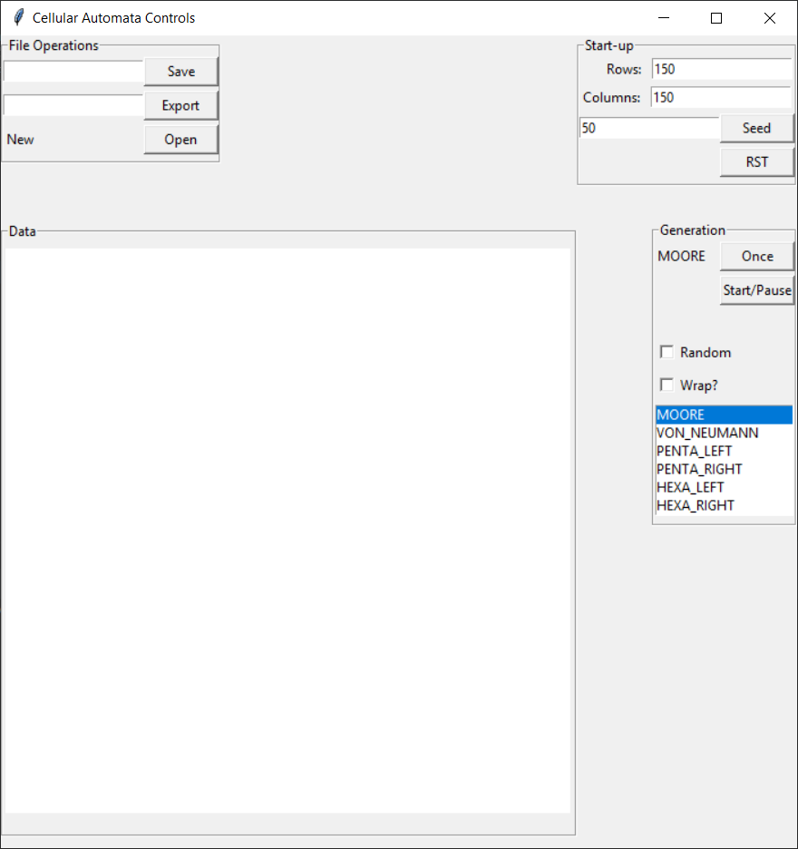

*Frames Description:*

* File Operations – it is a place where data can be saved1, exported2 and imported(opened3)
  1. Save – allows to save current state of simulation in order to open it later on. The file format is - .csv. Default name is:   
     CellularAutomata_YYYY-MM-DD_hhmmss  
     (e.g. CellularAutomata_2019-11-15_200358).
  2. Export” button – creates two files. One of them is .csv file that contains 3 columns: [row, column, grainID or 0 (when empty)]. The second one is .png file that displays imaged version of data, where colour is based on grainID. There can be up to 300 different colours. Default name is:   
     Export_YYYY-MM-DD_hhmmss  
     (e.g.Export_2019-11-15_200358.csv).
  3. Open” button – allows to import data file to continue computation. After clicking the button the dialog box is opened and filter is applied (.csv files shown only).

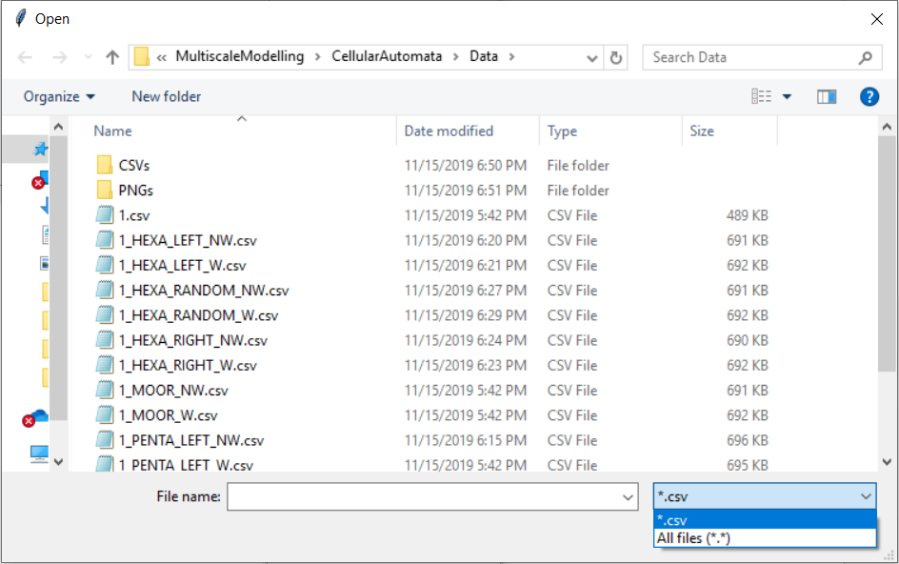

* Data – Canvas where data is visualised. Initialized image has 500x500 pixels. There is a possibility to calculate through smaller not rectangular shapes, however bigger are not permitted for now.
* Start-up – this panel shall be used when new generation of seeds is needed, then these parameters are to be set.
  1. “Rows” entry – number of rows to be generated
  2. Columns:” entry – number of columns to be generated
  3. “Seed” button – Generation of seeds that is given on the left side of the button, resetting of data is applied before generation
  4. “RST” button – reset of the data
* Generation – this panel is used to control the simulation
  + 1. “MOORE” label on the greyed background – current chosen mask that is used for simulating
    2. “Once” button – simulate one step
    3. “Start/Pause” button – Starting and Pausing the simulation steps
    4. “Random” checkbox – is considered when using masks: PENTA_LEFT, PENTA_RIGHT, HEXA_LEFT or HEXA_RIGHT. When is ticked left and right types are chosen randomly
    5. “Wrap?” checkbox – not ticked: zeros around the matrix. When ticked matrix is wrapped
    6. Listbox – list of masks available for usage

# Results

Pairs of results of simulating grain growth using same template (500x500 matrix, no. of grains = 300, same initial grains positions). On the left sides are images of generation without checkbox “Wrap?” ticked, on the right with this option choosen.

* MOORE

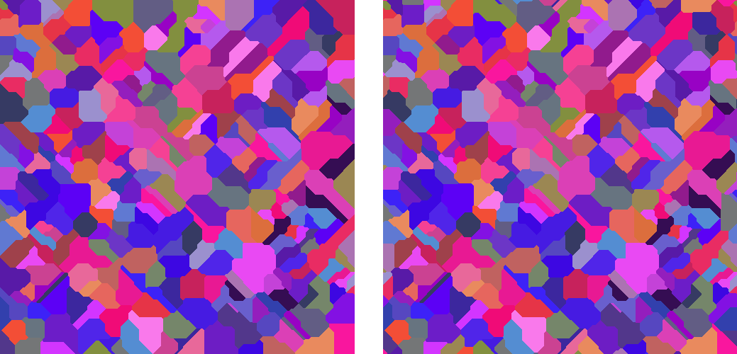

* VON NEUMANN



* PENTA_LEFT



* PENTA_RIGHT



* PENTA_RANDOM



* HEXA_LEFT



* HEXA _RIGHT



* HEXA _RANDOM



# Inclusions

Requirements:

* User can specify no. of inclusions – DONE
* Inclusions should have round shape – DONE
* User can specify min and max radius – DONE
* Each inclusion should have random radius in range between selected min and max – DONE
* Add another internal variable “phase” to the model of the cell – the inclusions are another phase, include the new variable in the import/export functionality – DONE

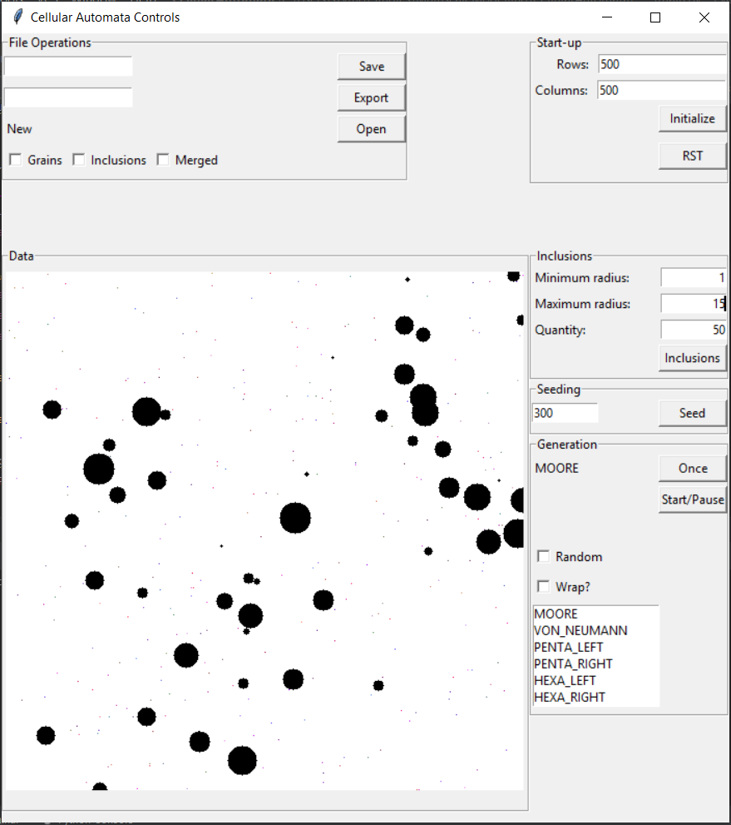

“Start-up” frame has been adjusted to functionalities – Seeding is in another, new one label frame called “Seeding”.

“Inclusions” label frame has been added. User can define minimal and maximal value that is going to be the range of randomly chosen radius of each and every inclusion. Number of inclusions also can be defined in this label frame.

“File Operations” label frame has been added three new checkboxes: *Grains*, *Inclusions* and *Merged*. User now can export/save data based on ones needs. Data are read the same way – one file at a time. Behaviour of opening can be changed - opening any number of files (one after another) and merging them - if there is a need and it would be useful – then, before opening, there is a required action from user – reset of the simulation (with the button). This approach is less “do-not-know-what-I-am-doing proof”. Should be discussed.

Below there are images of simulations of:

* Size: 500x500
* Grains: 50
* Inclusions: 15 in range from 1 to 20
* Kernel: MOORE
* Border conditions: 0s around

Images (starting from the left): merged, only grains and only inclusions.

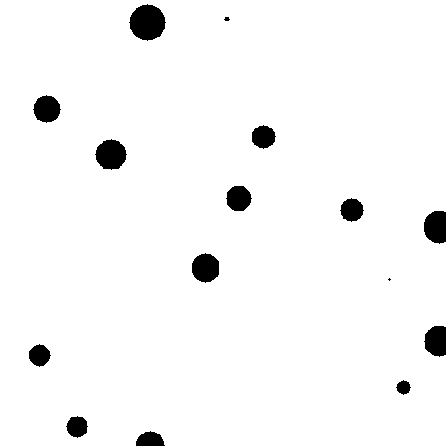

# Grain Boundary Curvature

Requirements:

* User can turn on / off the Grain Boundary Curvature (GBC) feature - DONE
* If GBC is turned on Boundary Condition selection component should be disabled with Moore option as pre-selected one – DONE
* User should be able to input threshold value for Rule no. 4   
  (X - probability of change) - DONE

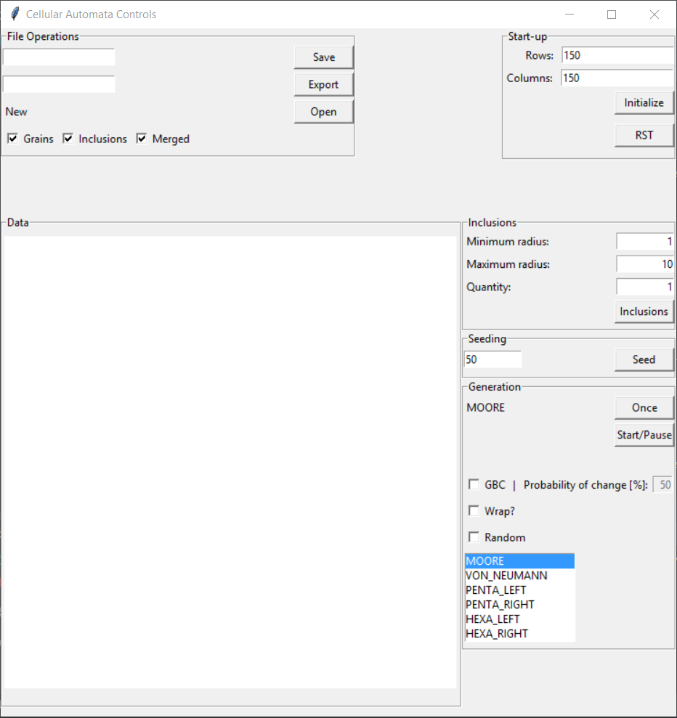

# Summary

The application is capable of simulating grain growth. Inclusion feature is also available. The Graphical User Interface is readable and user-friendly. Requirements are fulfilled. However, as time was crucial, there are a few possible improvements, such as: refactoring of the code, exception handling, GUI, optimization – multithreading / multiprocessing and probably some more – will be found during evolution of the program.

Grain Boundary Curvature option has been added.