# Research Report

Computer Game Development Year 4

Name: Szymon Piskorz

Student Number: C00242808

# Game Look

Similar to these.

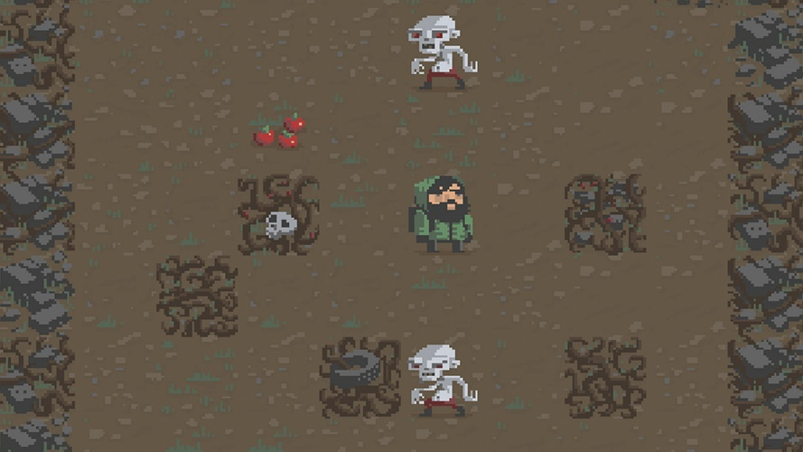

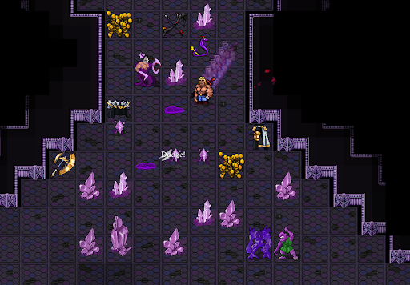

# Technical Challenges

Making the cryptocurrency and tokens for the game.

Integrating the cryptocurrency and tokens into the game for the users to be able to gather and collect the currency as well as spend it in game and add it to the user’s wallet.

# Project Abstract

Using crypto as a game mechanic.

# Project Introduction and/or Research Question

Blockchain technology have been growing in popularity recently and made its way into the gaming industry. Most of these games make use of the blockchain for profit and/or marketing with the main aspect of these games being that you earn money from playing them.

This project will try to look into the use of blockchain to better the experience for the player playing a game with this technology, instead of just giving them only one reason to play which is basically to earn money.

This game will use crypto tokens as a currency that the player can earn while playing the game and use for upgrades to be able to earn more tokens easier in the future. The use of this will add an extra level of difficulty as well as risk and reward as the player can upgrade their gear so that they can go deeper into the cave for bigger rewards but if they die, they will lose everything they had with them including their gear and tokens they gathered on their way.

# Literature Review

The Blockchain technology and games aren’t new as they have been around for several years, but their popularity started growing recently. Majority of the game use this in a way where the player is working for crypto rather then being awarded with it. This makes most of these games not put any focus on fun. Hence people don’t play these games for fun and enjoyment but just for the reason of earning some crypto or NFT’s.