The ‘Ask’ and ‘Prepare’ stages were combined into the ‘Scope of Work’ document to make tracking progress easier and goals more clearly defined. Additionally, the document provides a framework of the whole analysis as well as deliverables and their deadlines.

Data used for the project was picked based on the following criterias:
- Analysing a relatively big dataset based on real-life data
- focus on financial data
- High Kaggle score (ensures high data completeness, credibility and compatibility)
- Finding a universal problem (improving sales/further market scaling) to make the analysis reproducible in different scenarios
Chosen dataset (Brazilian E-Commerce Public Dataset by Olist) was selected thanks to its high Kaggle Usability score (10.0) as well as unique dataset schema and stellar data clarity.

The dataset was extracted into CSV files and then imported into Google’s BigQuery software to begin the ‘Process’ phase of the project.

Data extraction was completed using SQL queries. Relying on fundamental SQL knowledge like JOIN clauses to connect different datasets using provided keys. The process was streamlined by AI supplementation to make query creation more efficient, as well as by utilising the automatic Kaggle’s dataset schema visualisation, which improved navigation within the dataset.

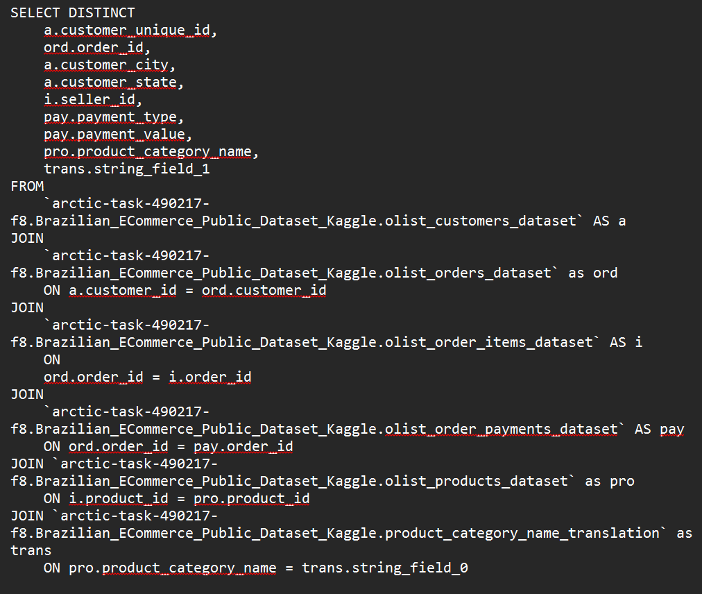
Example of one of the queries used

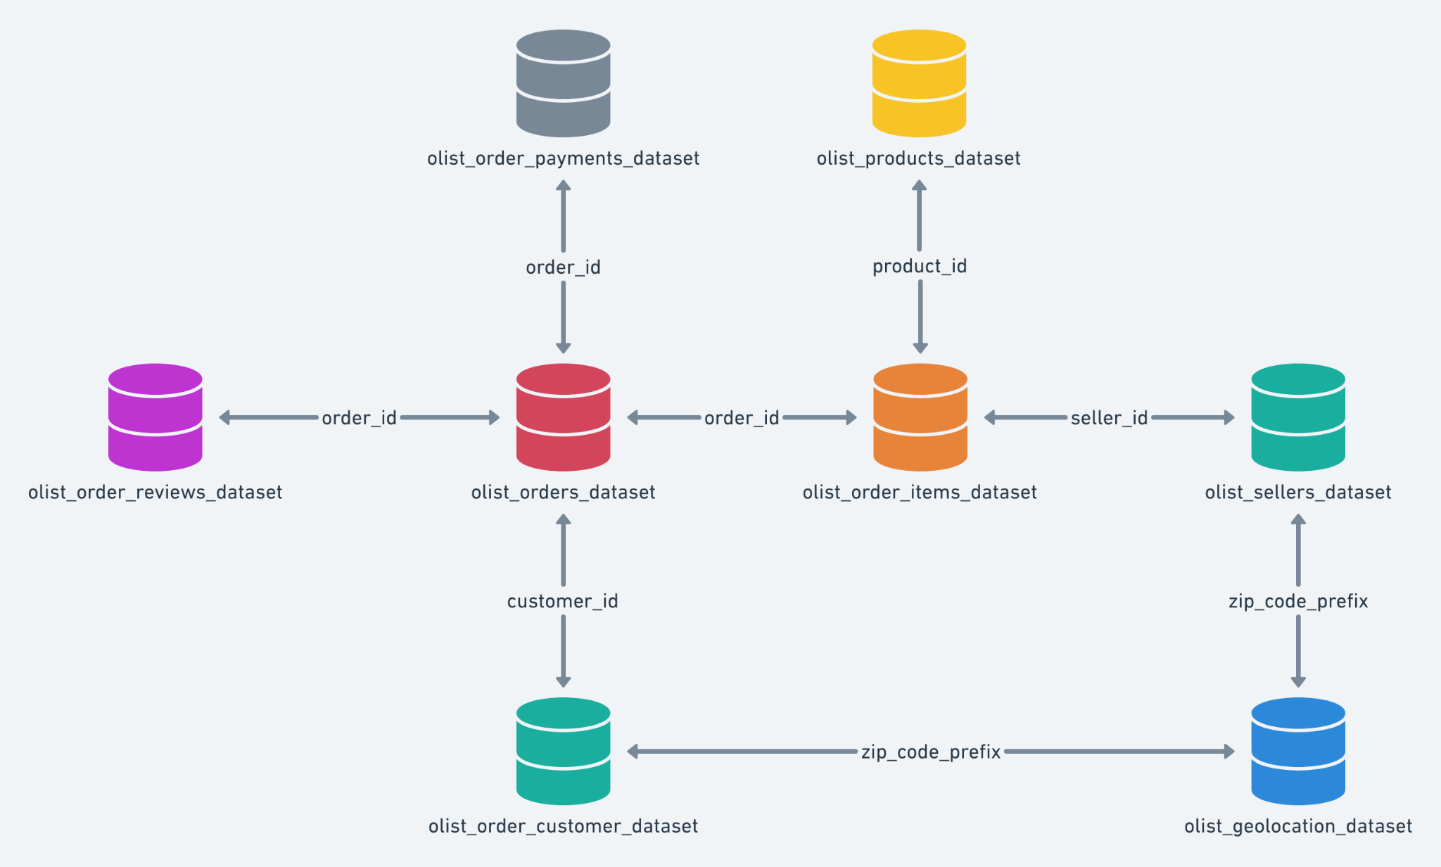
Kaggle’s automatic dataset schema

In the ‘Analyze’ phase, the analysis relied on a combination of Python, SQL and manual cleaning to derive desired metrics and identify key trends within the data. Due to the nature of the dataset, for numerical data dots had to be replaced with commas, and dataset names reformatted into strings without underlines. Moreover, spreadsheets had to be modified to effectively utilise visualisations within Tableau.

The provided presentation combines ‘Share’ and ‘Act’ stages to answer stakeholder expectations and provide possible business solutions as outlined in the ‘Scope of Work’ document. Moreover, the design has been carefully considered to adhere to ‘Google Data Analytics’ presentation pointers to ensure stakeholder satisfaction and high engagement. Presentation combines both Google sheets built in charts, Tableau visualisations. Curated speaker notes are implemented to answer audience questions both during and after the presentation. Additionally, they are used to provide greater context to the data shown. In order to improve presentation clarity, it was reviewed amongst colleagues and extensive speaker notes have been added. AI use supplemented presentation creation to identify shortcomings and adjust visual aspects (provide suggestions, introducing layout options).

To make the project pipeline more scalable, additional python code was provided to shortcut certain processes during follow-up analysis or similar projects.

