http://git-scm.com/book/pl/v1/Ga%C5%82%C4%99zie-Gita-Zarz%C4%85dzanie-ga%C5%82%C4%99ziami

*) For first time to initialize .git directory in ~/:
git init

*) to add your username and email to git's variables
git config --global user.name "username"
git config --global user.email "my@email.com"

*) For first time add a remote repository
git remote add origin https://github.com/try-git/try_git.git

0) pull everything that's on the server
git pull origin master

1) add files
git add filename

2) commit changes
git commit -m "message"

3) push files to the remote repository:
git push -u origin master
====================================

Podstawowy sposób pracy z Git wygląda mniej więcej tak:
- Dokonujesz modyfikacji plików w katalogu roboczym.
- Oznaczasz zmodyfikowane pliki jako śledzone, dodając ich bieżący stan (migawkę) do przechowalni. (git add file)
- Dokonujesz zatwierdzenia (commit), podczas którego zawartość plików z przechowalni zapisywana jest jako migawka projektu w katalogu Git. (git commit -m 'message')

INSTRUCTIONS FOR SETTING CUSTOM DIRECTORY AS WORKING DIRECTORY:

git config --global user.name "Szymzor"

git config --global user.email "krap@o2.pl"

git remote add origin https://github.com/Szymzor/A.git

cd /home/szymon/git-dir

git init

mkdir work

mkdir work/test

echo -n foo > work/test/foo.txt

git add /home/szymon/git-dir/work/test/foo.txt

git status

git commit -m "commit info"

git push -u origin master

#Then create file "File" through GitHub site, and use pull to sync your working directory:
git pull origin master

#to delete newly created file, type:
git rm File

git commit -m "commit info2"

git push -u origin master
====================================================================
ADDITIONAL COMMANDS:

#If we or someone made some additional changes to our remote repository, we can pull the changes to sync it with our HDD by /git pull origin master/. Then we can precisely check what is different:
git diff
OR:
git diff HEAD

Difference between 'diff' with and without parameters:
a) manually create blank new file in your working dir
b) add it to staged (git add FILENAME)
c) 'git diff --staged' will only work, because it will show files that are in staged queue
d) 'git diff' will work only when you'll modify your file and don't add it after that (so this command traces all modification in your files and will show you which lines were added or removed)

#Then after /git add/ some extra files or even all '*', we can see just staged changes (this will show us changes if we :
git diff --staged

#If we want to reset the stage queue, we can just reset staged files by:
git reset FILENAME
OR to reset HEAD file (contains information about staged files in this session):
git reset HEAD <file>

But then to completely remove it and change it back to how they were at the last commit of any 'filename' file in this folder we can use:
git checkout --FILENAME

IMPORTANT: this will revert the state of a directory to a state of last commit on FILENAME file in this directory

#To create new branch of your project type:
git branch branch_name

#To switch between branches we can use:
git checkout branch_name

#If you want to remove all txt files in your current branch you can use wildcards:
git rm '*.txt'

And then of course you must commit your changes

(for this excercise we can switch to 'master branch': git checkout master)
#To merge another branch with this we are currently in we can type:
git merge branch_name

To delete a branch type:
git branch -d branch_name

COMMITING CHANGES:
You can commit changes by doing:

git add --all
git commit -m 'MESSAGE'

OR adding all files which was previously traced file (you're not supposed to type 'git add'):
git commit -a

RENAMING FILE:
To rename file you must firstly remove it from git, and then add it:
git rm README
git add README2

OR you can use 'git mv present_name new_name':
git mv README README2

=============================

ADDITIONAL INFO:

#To show all performed commits (so history of changes), and some data about them (sha1, Author, Date, commit info):
git log

#To show changes made in every commit use -p option (it's like combination of log and diff –staged options):
git log -p

#To limit logging to your last 2 changes type:
git log -2

#You can also mix these 2 commands by:
git log -p -2

#To show shorten statistics (changes, insertions, deletions) for your commits use --stat as a additonal parameter:
git log -2 --stat

#To show log in a different ways, you can use --pretty parameter followed by additional options(oneline, short, full, fuller):
git log --pretty=oneline

#You can also set your own format by doing:
git log –pretty=format:'%h - %an, %ar : %s'

Opcja | Opis
%H | Suma kontrolna zmiany
%h | Skrócona suma kontrolna zmiany
%T | Suma kontrolna drzewa
%t | Skrócona suma kontrolna drzewa
%P | Sumy kontrolne rodziców
%p | Skrócone sumy kontrolne rodziców
%an | Nazwisko autora
%ae | Adres e-mail autora
%ad | Data autora (format respektuje opcję -date=)
%ar | Względna data autora
%cn | Nazwisko zatwierdzającego zmiany
%ce | Adres e-mail zatwierdzającego zmiany
%cd | Data zatwierdzającego zmiany
%cr | Data zatwierdzającego zmiany, względna
%s | Temat

#By command line you can also create ASCII --graph (showing commits, merges etc...):
git log –graph

#More graphical options can be found in gitk tool

#You can limit your log history by giving --since parameter:
git log --since=2.weeks

#The -u tells Git to remember the parameters (origin master), so that next time we can simply run git push and Git will know what to do:
git push -u origin master

So next time we can just do:
git push

#While we want to stage(to add) all files, instead of typing every file broken by space, we may type:
git add -all
OR if we want to add all files in current working directory:
git add .

#There are several way of adding files to staged (tracking) state:
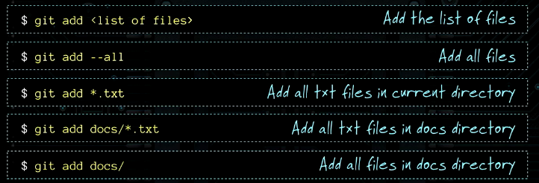
Getting help for specific command:
git help <polecenie>
git <polecenie> --help
man git-<polecenie>
git help config

To add all files from 'css' directory type:
git add css --all

While making changes to name and email for only one project currently working on type this below (it would not be saved after you'll quit the terminal):
git config --global user.name "Jan Nowak"

Setting up default merge.tool:
git config --global merge.tool kdiff3

To show all changes made to default config file:
git config --list

To clone existing repository:
git clone git://github.com/schacon/grit.git

To clone repository and put it in subdirectory of working dir:
git clone git://github.com/schacon/grit.git mygrit

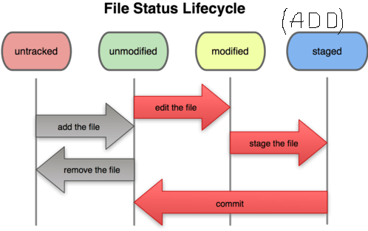
To ignore some sort of files that you don't want to track (build specific files, log files etc.), go to directory you want to set ignoring rules and create file named '.gitignore' and fill it with pattern like that:

# OS generated files #
######################
.DS_Store
.DS_Store?
._*
.Spotlight-V100
.Trashes
ehthumbs.db
Thumbs.db

If you want git to ignore files ended with *.o or *.a type:
*.[oa]
And if you want to ignore file names ended with '~' write:
*~

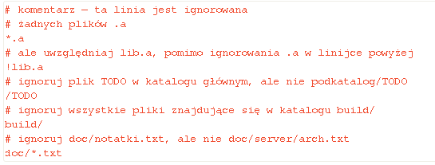
------------
PULLING ALL FILES FROM REMOTE REPOSITORY:
WARNING – THIS OPERATIONS WILL OVERWRITE ALL YOUR EXISTING FILES!!!!!!

git fetch --all
git reset --hard
git checkout master
git pull origin master

---------------

REMOVING ALL FILES FROM REPO:
WARNING!!!!!!!!!!!!!!!!!!!!!!!!!!!!!!!!!!!!!!!!!!!!!!!!!!!!!!!!!!!!!!!!!!!!!!!! NEVER USE THAT!!!!!!!
ONLY FOR TRAINING PURPOSES!!!!

rm -rf *
git rm -rf *
git reset --hard
git checkout master
git filter-branch --tree-filter 'rm -rf *' HEAD
git filter-branch -f --tree-filter 'rm -rf *'
rm -rf *
git filter-branch --index-filter 'git rm --cached --ignore-unmatch filename' HEAD

--------------------------

SHORT VERSION FOR DELETING SINGLE FILES – works also for ALL :( :

a) create file FILENAME in git working dir
git add FILENAME
git status
git commit -m 'ADDED FILENAME'
git push origin master

b) remove it
rm -rf FILENAME
git rm -rf FILENAME
git status
git commit -m "FILE WAS DELETED"
git push origin master
------------------------------------

CORRECTION OF COMMITS
You can correct each commit note by using --amend (popraw) parameter. Example below corrects last commit message:
git commit --amend

To open last commit session and add for example forgotten file:
git commit -m 'initial commit' #accidentaly do commit
git add forgotten_file #add file
git commit --amend #commit operation will be done for last commit (no new commit will be created)

TO UNSTAGE files from ADD (Staged state) use:
git reset HEAD FILENAME

REVERTING CHANGES on MODIFIED FILE to PREVIOUS COMMITTED VERSION (works only if your last action wasn't ADD!!!):
WARNING!!!!!!!!!!!!!!!!!!!!!!!!!!!!!!!!!!!!
THIS COMMAND CAN TOTALLY DESTROY CONTENTS OF YOUR FILES!!!!!!!!
git checkout -- FILENAME

TO SHOW USED REMOTE REPOSITORIES DO:
git remote

OR to show currently used repo-links:

git remote -v

TO ADD AND DOWNLOAD OTHER REMOTE REPOSITORY DO:
git remote add repo-shortcut git://github.com/paulboone/ticgit.git
git fetch repo-shortcut

#where 'repo-shortcut' is a name that we want to use instead of URL

DIFFERENCES BETWEEN fetch, pull, clone:
-fetch is only for downloading repo to LOCAL REPO ONLY (changes must be changed manually)
-pull = fetch + merge
-clone SETS LOCAL BRANCH TO BE TRACKED WITH MASTER BRANCH

TO SHOW MORE SPECIFIC DATA ABOUT REMOTE REPO USE:
git remote show [name-of-a-repo-or-URL]

RENAMING REPO IN YOUR REMOTE DATABASE:
git remote rename [old_repo] [new_repo_name]

REMOVING REPO FROM YOUR DATABASE:
git remote rm [repo_name]

- - - - - - - - - - - - - – - - - - - - - - - - - - - - - - - - - - - - - - - -
BRANCHING and MERGING

CREATING NEW BRANCH:
git branch testing

SWITCHING TO CREATED BRANCH:
git checkout testing

CREATING NEW BRANCH & SWITCHING TO IT:
git checkout -b [new_branch_name]

FAST ADD & COMMIT COMMAND:
git commit -a -m 'MESSAGE'

REVERTING TO PREVIOUS COMMIT:
git log
git checkout [SHA1 of desired commit]

TO GO TO THE LATEST COMMIT ON MASTER BRANCH DO:
git checkout master

MERGE NEWLY CREATED BRANCH WITH MASTER:
git checkout master
git merge [your_hotfix_branch]

DELETING NOT USED BRANCH:
git branch -d [branch_name]

UPDATE and DOWNLOAD MY REPOSITORY TO WORKING DIRECTORY:
git pull [URL.git]

UPDATE AND DOWNLOAD MY REPOSITORY BY USING „GIT FETCH”:
#create file on server (eg. „abc.txt”) and commit it, then copy it's SHA1 commit link
git fetch origin master
git checkout [SHA1 of commit]

GOING TO LATEST COMMIT AFTER CHECKOUT MADE:
git checkout branchname

TO ADD ONLY NEW FILES:
git add $(git ls-files --other)

ADDING FILES:
- git add -A stages All
- git add . stages new and modified, without deleted
- git add -u stages modified and deleted, without new

TO SHOW INFO ABOUT YOUR REMOTE REPO:
git remote show origin

GIT PRECISE OPERATIONS

FOR FIRST TIME:
-cd to a directory, where you want to have your files and:
git init

ADDING A REMOTE REPOSITORY:
git remote add origin https://github.com/Szymzor/A.git

DOWNLOADING A REMOTE REPOSITORY:
1) git pull origin master => will download remote master branch and merge it with your local master branch!
2) git pull origin master:master => the same as above
3) git pull origin new2:new2 => will sync your local 'new2' branch with local 'new2'
4) git fetch origin master => not affecting local files
git checkout [SHA1 from remote repository or GitHub]
(we can use 'git checkout master' to revert back to our last commit)

RESETTING EVERYTHING LOCALLY (TO LAST COMMIT)
git reset --hard

ADDING FILES TO STAGED:
-create files named A, B and C
-do one of these options:
1) git add [filename]
2) git add --all => adds all files (created, modified or removed) like for first time
3) git add -u => adds files that has been modified or removed (but not created)
4) git add . => adds files that has been created or modified (except removed)
5) git add * => adds files that has been created or modified (except removed and which begins by a '.')

UNSTAGING ADDED FILES:
-if you add files to staged you can UNSTAGE it with:
1) git reset [filename]
2) git rm --cached [filename] => this does not remove file physically, only unstages

SHOWING INFO ABOUT COMMITS:
1) git reflog => short info
2) git log -3 => last 3 commits

CREATING BRANCHES AND SWITCHING TO THEM:
(New branch is a complete copy of master)
1) git checkout -b [new_branch_name]
2) git branch [new_branch_name]
git checkout [new_branch_name]

SHOWING UP A BRANCH WHICH I AM CURRENTLY WORKING ON:
git branch

DELETING A BRANCH:
git branch -d [branch_name]

MERGING CHANGES TO MASTER
-avoid deleting files in [new_branch_name], because after merging to master they will be deleted from master too!!
git checkout master
git merge [new_branch_name]

