**Modellling**

Model 1

Metal sheet (non-ferrous), C, moves to the right under a magnet with velocity, v. The magnetic field (B, green arrows) induces eddy currents in the metal sheet. The eddy currents induce a magnetic field (blue arrows) that oppose whatever is creating the current (magnetic field B), a result of Lenz’s Law.

As the front approaches a repulsive magnetic field is induced. As the front passes by, an attractive field is induced, pulling the sheet back. Both these effects would slow down the metal sheet.

The kinetic energy of the metal is dissipated through the sheet as ohmic heating. The drag force induced is described by Faraday’s law of induction: $emf= -\frac{dΦ}{dt}$. Where *Φ* is the magnetic flux and *t* is time. The force is also proportional to velocity, v.

Acts similar to viscous friction in a liquid.

In some cases, the heating effect is reduced by laminating the metal sheet into layers (figure 2). There is insulation between each layer.

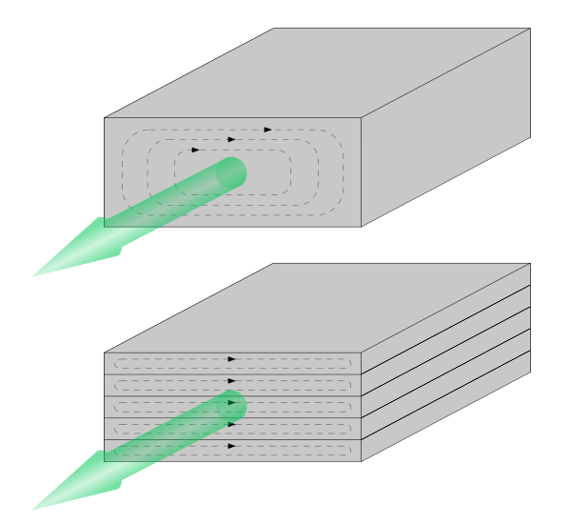

A disk brake works in the same way but repeatedly passes through the magnetic field so will get hotter.

Model 2

Free charge carriers (electrons) are moving to the right with velocity, v. The magnetic field exerts a sideways force on them (Lorentz force: $F=qv×B$). From the right hand rule, force is towards the rear (figure 1) or to the left when facing in the direction of motion. This creates a current, clockwise at the front and anticlockwise at the rear.

Due to Ampere’s circuital law, these circular currents create a counter magnetic field (blue arrows) which (due to Lenz’s law) oppose the change in magnetic field, causing a drag force. Kinetic Energy is dissipated as heat in ohmic heating