(possible) documentation of code to Pseudocode:

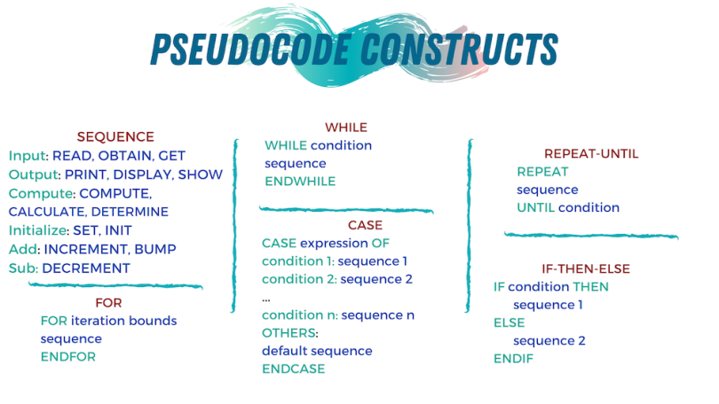
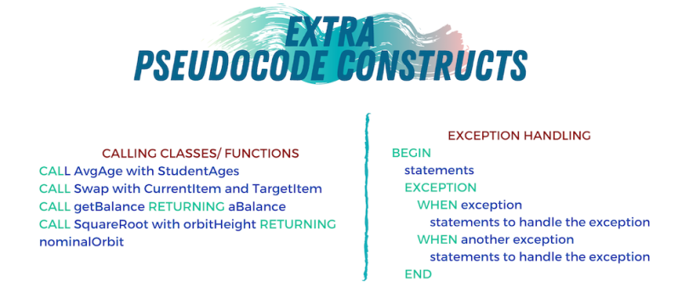
Source: https://builtin.com/data-science/pseudocode#:~:text=At%20its%20core%2C%20pseudocode%20is,and%20IF%2DTHEN%2DELSE

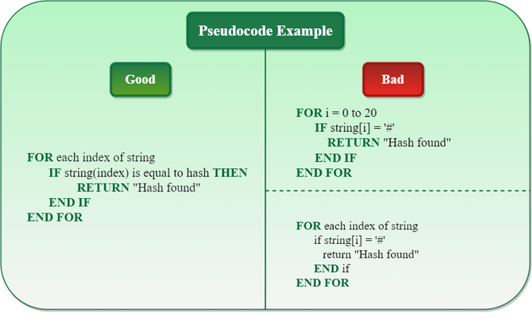
Sources: https://www.geeksforgeeks.org/what-is-pseudocode-a-complete-tutorial/

