In this pseudocode we are trying to imagine how the robot will move depending on the position of the ball, the goal and the other player:
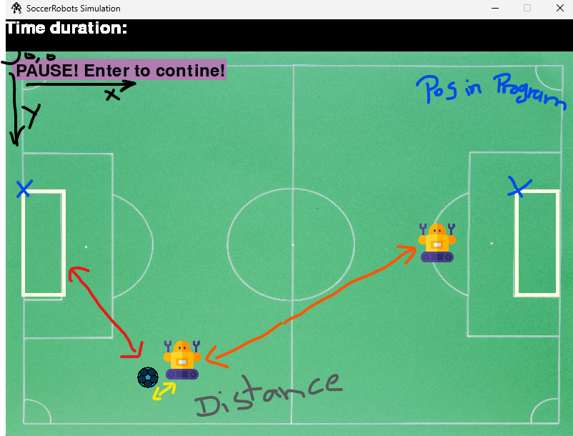
// the direction Variables are saved in constants!!!
kickBall(distanceXPlayerToBall, distanceYPlayerToBall):
nextPossibleMove = 0
IF the absolute amount of distanceXPlayerToBall larger than absolute amount of distanceXPlayerToBall:
IF distanceXPlayerToBall > 0
nextPossibleMove = EAST
ELSE
nextPossibleMove = WEST
END IF
ELSE:
IF distanceYPlayerToBall > 0
nextPossibleMove = SOUTH
ELSE
nextPossibleMove = NORTH
END IF
END IF
Return nextPossibleMove

playersNextChoice(player: SoccerRobot, otherPlayer: SoccerRobot, ball: Ball):
// calculate distance between player and other objects
distanceXPlayerToBall = ball.positionX - player.positionX
distanceYPlayerToBall = ball.positionY - player.positionY

distanceXToOtherPlayer = otherPlayer.positionX - player.positionX
distanceYToOtherPlayer = otherPlayer.positionY - player.positionY

distanceXPlayerToGoal = player.assignedGoal.positionX – player.positionX
distanceYPlayerToGoal = player.assignedGoal.positionY – player.positionY

distanceXBallToGoal = player.assignedGoal.positionX – ball.positionX
distanceYBallToGoal = player.assignedGoal.positionY – ball.positionY

// the distance where the robot should act to doge
actingDistance = player.size * 1.2
playersNextMove = 0
// first the player should try to kick the ball into the goal
// ball is closer to goal
IF distanceXBallToGoal shorter than distanceXPlayerToGoal:
playersNextMove = CALL kickball with distanceXPlayerToBall, distanceYPlayerToBall returning playersNextMove

// player closer to goal, go around ball, before kicking it!!
ELSE

END IF

