Fee Reciept

Name : Aakash Jain

Address : Abu Lane.

Fee : Rs. 500. **(Payment made once will not be refunded**

**: under any circumstance)**

Date : 10 July 2022

**Note:** 1.  [All *judicial* matters are *entertained* only in  high court Allahabad](https://www.google.com/search?q=all+judicial+matters+are+entertained+in+any+high+court+allahabad&spell=1&sa=X&ved=2ahUKEwituoaznqj5AhVUUGwGHcHPCO0QBSgAegQIAhAy).

2. For any misbehave and any misconduct, admission of the ward can be cancelled without any prior notice any time.

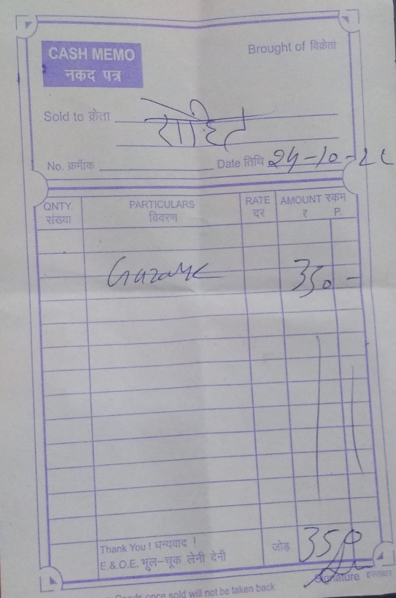

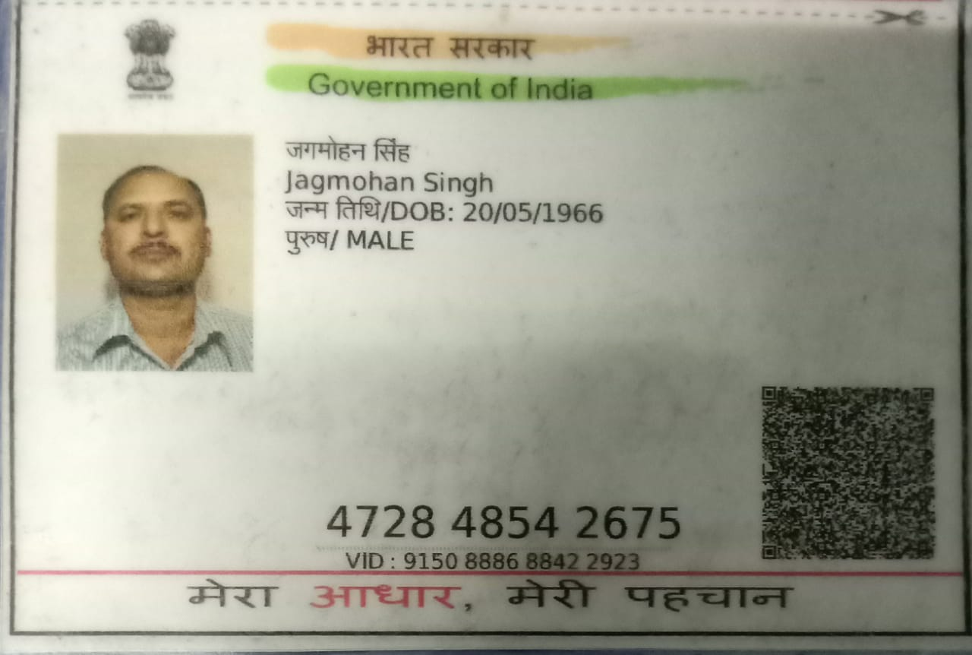

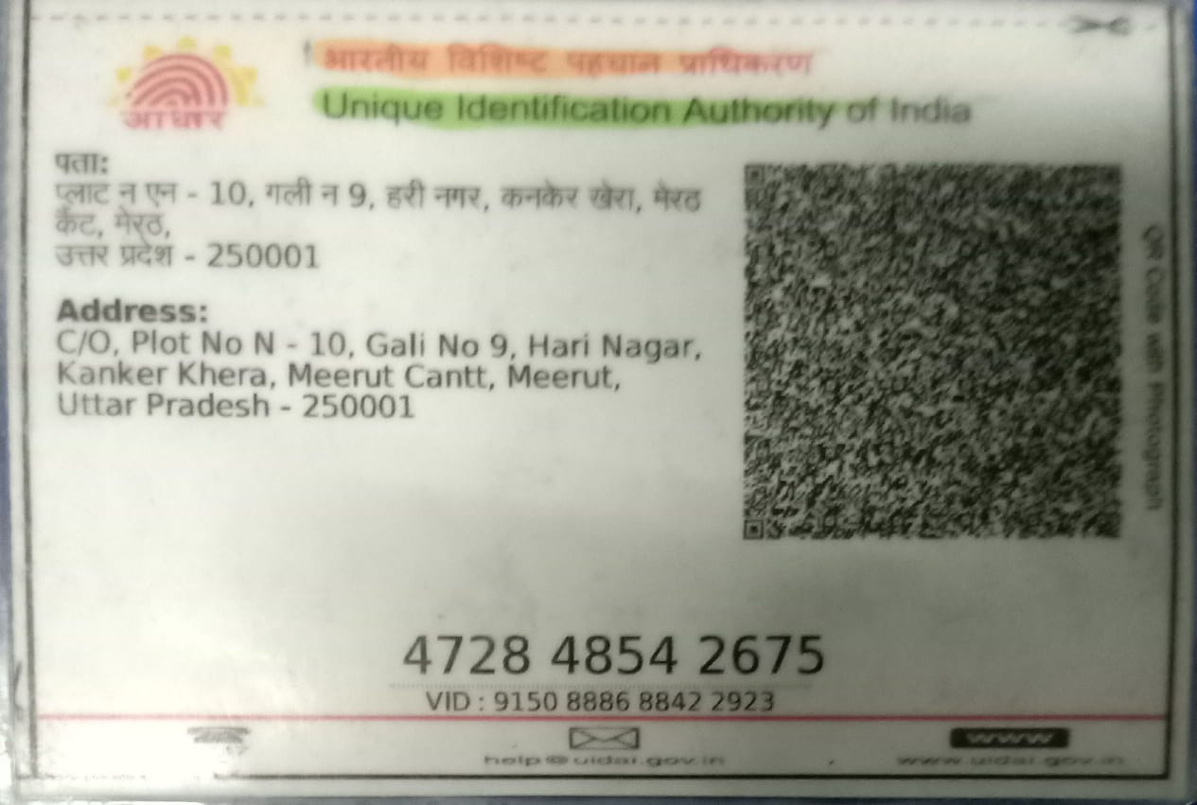

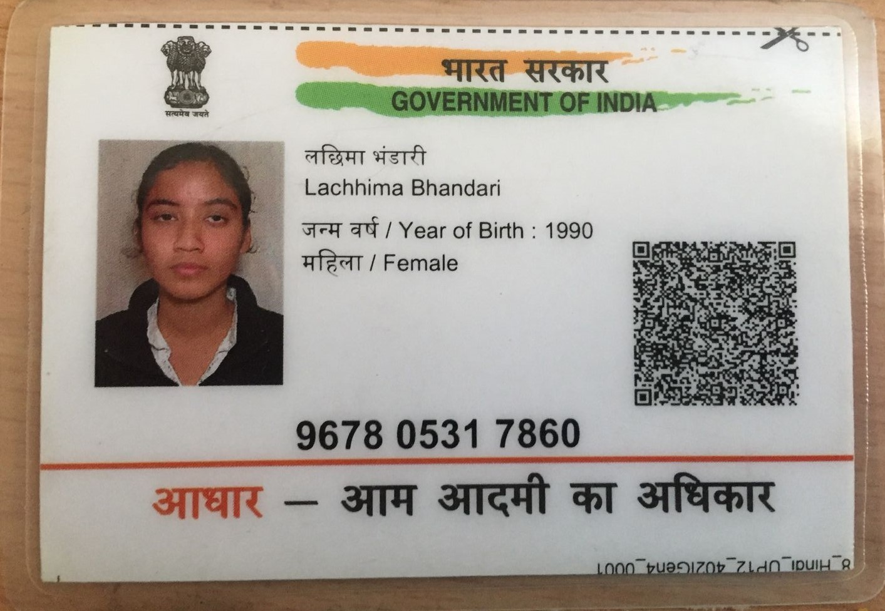

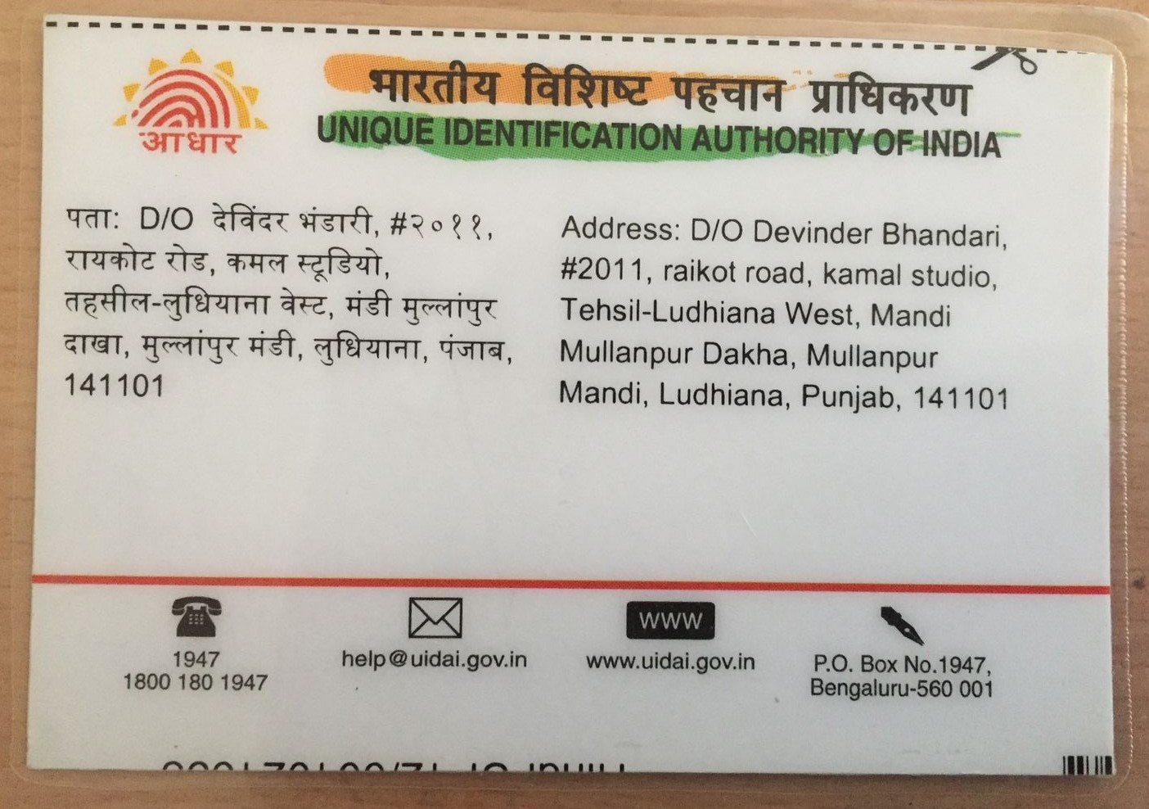

K L M N O P Q R S

T U V W X Y Z

Access Modifier **– default**

**Example for a default Class**:

package vehicle;

class Car {

// Code goes here

}

***Same Package***

package vehicle;

public class TestModifiers {

public static void main(String[] args) {

Car Toyota = new Car();

}

}

***Different Package***

package javaPracticeProgram;

import vehicle.Car;

public class TestModifiers {

public static void main(String[] args) {

Car Toyota = new Car(); //Compile Time Error

}

}

***Example for default Members***:

package vehicle;

public class Car {

String sModel;

int iGear;

int iHighestSpeed;

}

***Same Package***

Package vehicle;

public class TestModifiers {

public static void main(String[] args) {

Car Toyota = new Car();

Toyota.sModel="Camry";

Toyota.iGear = 5;

Toyota.iHighestSpeed = 230;

}

}

***Different Package***

Package javaPracticeProgram;

import vehicle.Car;

public class TestModifiers {

public static void main(String[] args) {

Car Toyota = new Car();

Toyota.sModel="Camry"; //Compile Time Error

Toyota.iGear = 5; //Compile Time Error

Toyota.iHighestSpeed = 230; //Compile Time Error

}

}

***Example for default Method***:

package vehicle;

public class Car {

public String sModel;

public int iGear;

public int iHighestSpeed;

void DisplayCharacterstics(){

System.out.println("Model of the Car: " + sModel);

System.out.println("Number of gears in the Car: " + iGear);

System.out.println("Max speed of the Car: " + iHighestSpeed);

}

}

***Same Package***

package vehicle;

public class TestModifiers {

public static void main(String[] args) {

Car Toyota = new Car();

Toyota.sModel="Camry";

Toyota.iGear = 5;

Toyota.iHighestSpeed = 230;

Toyota.DisplayCharacterstics();

}

}

***Different Package***

package javaPracticeProgram;

import vehicle.Car;

public class TestModifiers {

public static void main(String[] args) {

Car Toyota = new Car();

Toyota.sModel="Camry";

Toyota.iGear = 5;

Toyota.iHighestSpeed = 230;

Toyota.DisplayCharacterstics(); //Compile Time Error

}

}

## Access Modifier - public

package vehicle;

public class Car {

// Code goes here

}

***Same Package***

package vehicle;

public class TestModifiers {

public static void main(String[] args) {

Car Toyota = new Car();

}

}

***Different Package***

package javaPracticeProgram;

import vehicle.Car;

public class TestModifiers {

public static void main(String[] args) {

Car Toyota = new Car();

}

}

***Example for public Members***:

package vehicle;

public class Car {

public String sModel;

public int iGear;

public int iHighestSpeed;

}

***Same Package***

package vehicle;

public class TestModifiers {

public static void main(String[] args) {

Car Toyota = new Car();

Toyota.sModel="Camry";

Toyota.iGear = 5;

Toyota.iHighestSpeed = 230;

}

}

***Different Package***

package javaPracticeProgram;

import vehicle.Car;

public class TestModifiers {

public static void main(String[] args) {

Car Toyota = new Car();

Toyota.sModel="Camry";

Toyota.iGear = 5;

Toyota.iHighestSpeed = 230;

}

}

***Example for a public Method***:

package vehicle;

public class Car {

public String sModel;

public int iGear;

public int iHighestSpeed;

public void DisplayCharacterstics(){

System.out.println("Model of the Car: " + sModel);

System.out.println("Number of gears in the Car: " + iGear);

System.out.println("Max speed of the Car: " + iHighestSpeed);

}

}

***Same Package***

package vehicle;

public class TestModifiers {

public static void main(String[] args) {

Car Toyota = new Car();

Toyota.sModel="Camry";

Toyota.iGear = 5;

Toyota.iHighestSpeed = 230;

Toyota.DisplayCharacterstics();

}

}

***Different Package***

package javaPracticeProgram;

import vehicle.Car;

public class TestModifiers {

public static void main(String[] args) {

Car Toyota = new Car();

Toyota.sModel="Camry";

Toyota.iGear = 5;

Toyota.iHighestSpeed = 230;

Toyota.DisplayCharacterstics();

}

}

## Access Modifier - private

package vehicle;

Private class Car { // Compile Time Error

// Code goes here

}

***Example of private Members***:

package vehicle;

public class Car {

private String sModel;

private int iGear;

private int iHighestSpeed;

public void DisplayCharacterstics(){

System.out.println("Model of the Car: " + sModel);

System.out.println("Number of gears in the Car: " + iGear);

System.out.println("Max speed of the Car: " + iHighestSpeed);

}

}

***Same Package***

package vehicle;

public class TestModifiers {

public static void main(String[] args) {

Car Toyota = new Car();

Toyota.sModel="Camry"; //Compile Time Error

Toyota.iGear = 5; //Compile Time Error

Toyota.iHighestSpeed = 230; //Compile Time Error

}

}

***Example of private Method***:

package vehicle;

public class Car {

public String sModel;

public int iGear;

public int iHighestSpeed;

private void DisplayCharacterstics(){

System.out.println("Model of the Car: " + sModel);

System.out.println("Number of gears in the Car: " + iGear);

System.out.println("Max speed of the Car: " + iHighestSpeed);

}

public void Print(){

DisplayCharacterstics();

}

}

***Same Package***

package vehicle;

public class TestModifiers {

public static void main(String[] args) {

Car Toyota = new Car();

Toyota.sModel="Camry";

Toyota.iGear = 5;

Toyota.iHighestSpeed = 230;

Toyota.DisplayCharacterstics(); //Compile Time Error

Toyota.Print();

}

}

## Access Modifier - protected

package vehicle;

Private class Car { // Compile Time Error

// Code goes here

}

***Example of protected Members***:

package vehicle;

public class Car {

protected String sModel;

protected int iGear;

public int iHighestSpeed;

}

***Without Extending***

package javaPracticeProgram;

import vehicle.Car;

public class TestModifiers {

public static void main(String[] args) {

Car Toyota = new Car();

Toyota.sModel="Camry";//Compile Time Error

Toyota.iGear = 5;//Compile Time Error

Toyota.iHighestSpeed = 230;

}

}

***With Extending***

package javaPracticeProgram;

import vehicle.Car;

class SmartCar extends Car {

public static void main(String[] args) {

SmartCar Toyota = new SmartCar();

Toyota.sModel="Camry";

Toyota.iGear = 5;

Toyota.iHighestSpeed = 230;

}

}

***Example of protected Method***:

package vehicle;

public class Car {

public String sModel;

public int iGear;

public int iHighestSpeed;

protected void DisplayCharacterstics(){

System.out.println("Model of the Car: " + sModel);

System.out.println("Number of gears in the Car: " + iGear);

System.out.println("Max speed of the Car: " + iHighestSpeed);

}

}

***Without Extending***

package javaPracticeProgram;

import vehicle.Car;

public class TestModifiers {

public static void main(String[] args) {

Car Toyota = new Car();

Toyota.sModel="Camry";

Toyota.iGear = 5;

Toyota.iHighestSpeed = 230;

Toyota.DisplayCharacterstics(); // Compile time error

}

}

***With Extending***

package javaPracticeProgram;

import vehicle.Car;

class SmartCar extends Car {

public static void main(String[] args) {

SmartCar Toyota = new SmartCar();

Toyota.sModel="Camry";

Toyota.iGear = 5;

Toyota.iHighestSpeed = 230;

Toyota.DisplayCharacterstics();

}

}