# Barbastelle Bats and their Declining Habitats

26th August 2021

By Tobias Boyington

**During a Dissertation research project for UEA’s Applied Ecology and Conservation (AEC) masters, we studied this endangered bat’s habitat richness by studying bat activity, along with insect and habitat availability, across areas based along the northern outskirts of the City of Norwich, Norfolk – home to the species’ biggest UK colony. How was this study performed? What were its results? And what suggestions are there for the future of protecting this declining species?**

## A Night in The Life

The barbastelle bat (or *Barbastella barbastellus*)is one of 18 species of bats believed to be native to the UK and happen to be quite rare, attributable to multiple factors. While many Chiroptera (bats) have a long lifespan (recently, [the Bat Word Sanctuary commemorated the loss of Statler, a 34-year-old fruit bat](https://batworld.org/rip-statler/)), bats also have a low level of fecundity – averaging with one baby a year, meaning that if conditions are adverse, populations can see rapid declines, with slow recovery rates if recovery is possible at all.

The species’ habitat availability varies widely across the UK; however, their populations are believed to be concentrated within south and central England and Wales. Rather than developing roosts independently, many bats rely on pre-existing structures to protect their colonies, and throughout the time rearing their young, bats have been observed within building crevices and cracks in trees, and once grown, these nursery colonies may disperse, reconvening in late July.

In the meantime, these bats survive winter by hibernating in caves, tunnels, and cellars, as well as between roof timbers, and hollow tree trunks - with Ancient Woodland believed to be among their habitats year-round. Few breeding sites of the Barbastelle are known, so to preserve this species, it’s important that known sites of summer roosting and winter hibernation are well maintained. It’s believed that [the loss of deciduous woodland](https://academic.oup.com/jmammal/article/93/4/1110/959700?login=true) in the UK may be a great influence on the species rarity, along with global warming’s constant impacts on habitats across the globe, and [the use of artificial fertilizer and pesticides](https://www.scielo.br/j/bjb/a/tnNtGd6GfzQFz6yNXNdzJPw/abstract/?lang=en) that may cause indirect poisoning through contaminated water and insects, disrupting insect abundances for foraging.

***(Photo Credits: Tobias Boyington) An example of good woodland used in the Ringland area by bats. The woodland is separated by some farmland, but the distance is well within travel range for a barbastelle bat.***

## Norfolk – The New Transylvania Under Threat

The Norfolk area is home to the largest known colony of barbastellesin the UK, with the only known maternity roost, making this an optimal location to study their natural behaviours.

Following development of the Northern Distributor Road (NDR) around Norwich city, mitigations in the form of gantries and green bridges were developed to assist bats across the dual carriageway, however, [two out of three colonies of barbastellesalong this route have been undetected since](https://www.theguardian.com/environment/2020/mar/20/norfolk-road-report-rewritten-to-remove-warning-of-risk-to-bats). An extension to this road is planned ([the Western Link](https://www.norfolk.gov.uk/-/media/norfolk/downloads/roads-and-transport/nwl/reports-and-appendices-26072021/nwl-interim-bat-report-2020.pdf)), that passes through the Wensum Valley cutting between areas of Ringland and Weston Longville, raising concerns for the barbastellecolonies within that area.

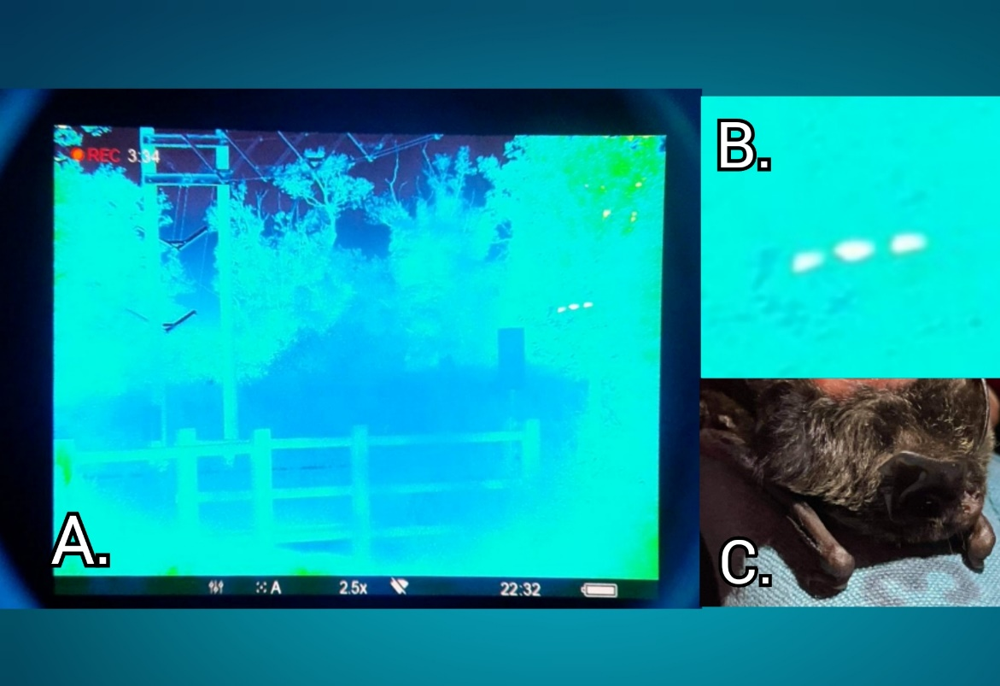

***(Photo Credits: Tobias Boyington) (A.) Thermal Imaging by a gantry at the NDR. (B.) In this picture, a bat can be seen in flight. The video footage reveals the bat flying up to the road and then widely arching away.***

# Listening To Bats (and *Count-*ing Insects)

Bat surveys were made via *Song Meter SM4Bat FS Ultrasonic*, recording continuously, and left at sites overnight between the middle of June and July, with 71 individual survey sites.

These detectors were deployed with two types of microphones, the *SMM-U1 Ultrasonic Microphone*, and the *SMM-U2 Ultrasonic Microphone*, camouflaged amongst the area at a 1-meter height, allowing discreet detection within the bat’s flight path.

The detectors were accompanied by yellow insect card traps at a 1-meter height using metallic garden stakes and protected by a cylindrical net of chicken wire. The traps allowed collection of invertebrate numbers both as a whole and by individual species, and were positioned along hedge rows, treelines, and other natural linear features plausible for bat commutes.

Sites were surveyed for moths via walking transects, using a red LED to maintain night-vision and to avoid unnecessary light disturbance for bats. Transects were performed by walking 50 meters and observing any moth present in 15 feet in all directions.

***(Photo Credits: Tobias Boyington) Examples of equipment used; a* Song Meter SM4Bat FS Ultrasonic *with the* SMM-U1 Ultrasonic Microphone *(left) used to detect the calls of bats, and a suspended sticky-trap encased by chicken wire to determine insect presence (right) within the area.***

The EDINA DIGIMAP Environment provided the *Land Cover Map 2019 for Great Britain (Vector),* including freshwater, suburban and urban landcover data. Ancient Woodland data was provided from Natural England Open Data’s *Ancient Woodland (England)*, scale created in 2013 with revisions made in 2020. All was set to BNG coordinates, scaling at 1:250,000.

## What Did This Information Reveal?

An assessment of landcover was made in each of the surrounding areas of the study sites as shown in the image below using a predictive model based on the data described above and using ArcGIS.

The areas having greater woodland in the west are areas around Ringland and Weston Longville, as well as areas around Lenwade and Alderford. While a gap exists between the western areas, it’s likely that there’s flight between them, making the area between vitally important to conserve - and if possible, to enrich, encouraging the development of barbastelle presence.

As has been previously discussed, plans for a Western Link to the NDR are in development for the area. Current mitigation plans used around Norwich such as the [gantries are not effective](https://journals.plos.org/plosone/article?id=10.1371/journal.pone.0038775), and disruption to a continuous habitat such as this could be devastating to both the foraging and roosting habits of the barbastelle.

Middling habitat areas are concentrated to the west, between Lenwade, Thorpe Marriot, and Ringland, with additional areas in the east, by Spixworth. With effort these areas could be developed to enrich barbastelle presence, however, as much of this area is occupied by main roads and targeted for development of the western link, these habitats are likely to decline if not effectively mitigated and planning stopped.

The lowest suited habitat comprises the rest of the spread-out area. These sites need the most conservation development to ensure a suitable environment for barbastellesto regain a foothold in the current ecosystem but being more spread out makes them difficult to manage effectively, and any increase in urban developments will only worsen their effectiveness.

***(Figure Credits: Tobias Boyington with data from Ordinance Survey) Barbastelle habitat suitability in the Northern outskirts of Norwich. The model produced provides evidence of habitat suitability within these 1 km2 OS grids. Green Squares are rich in woodland and water habitats, giving barbastelles the cover and hydration needed. Yellow habitats have the least amount of woodland and water habitats providing the least benefit.***

## A Summary

In conclusion, the Barbastelle bat has greater presence within woodland areas by water sources, ideal for roosting and keeping hydrated. Greater activities of Barbastelles were found around the Ringland and Weston Longville areas, where woodland was most dense, however, to maintain their presence in these areas, and develop into the surrounding areas, multiple conservation practices need to be implemented, focused on development of woodland and preservation of existing areas (see below). Further study would especially be useful if development of the NDR’s Western link continues - as the largest known barbastellecolony in the UK, a loss this big may mean an irreversible decline for their species here. The habitat suitability model may act as a precursor for a widespread model.

## Future Conservation:

Conservation management for Barbastelle bats must account for surrounding habitats, the communication of which must involve targeted landowners and councils understanding the real risks the species are under in their areas. This study will assist in highlighting areas needing protection and further betterment to these groups in a long-term conservation scheme. Future conservation should account for the following:

* Maintaining presence of important woodland, especially ancient woodland, as crucial roosting sites of multiple species of bats, especially the barbastelle bat.
* Subsidising of farmers to use agricultural environment schemes that encourage less destructive practices to ease any possible strain faced by bats when foraging for insects in these areas.
* Call quantities over site areas can be used to reveal known roost locations. One unexpected site within the Ringland and Weston Longville area paralleled these numbers. While investigations into this site continues, it highlights the plausibility of other roosts in areas that have not been studied and emphasises that a lack of detected presence isn’t the same as an absence. Therefore, destruction of suitable habitats on the basis that no barbastelle bats have been detected should be discouraged, especially if they are known to exist within a wider area.
* Habitat models for the *barbastelles* can be used for alternative mitigation strategies such as a similar approach to Biodiversity Offsetting as the district licencing scheme put in place for Great-Crested Newt, that has been proving effective for developing new habitats in avoidance of common interpretations of ‘no-net-loss’ policies.