**MIDTERM – PART2 ASSIGNMENT**

Below I have attached the screenshots of my submission:

1. Screenshot of login page before enter data

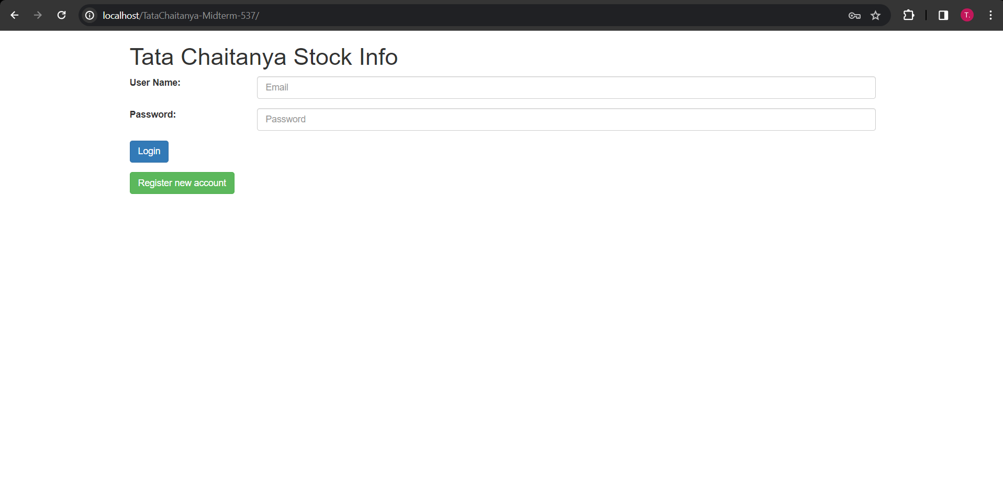

1. Screenshot of login page after enter data but before the login button pressed

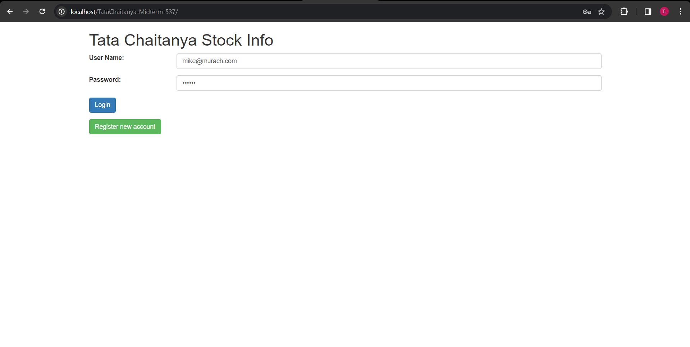

1. Screenshot after Login button pressed

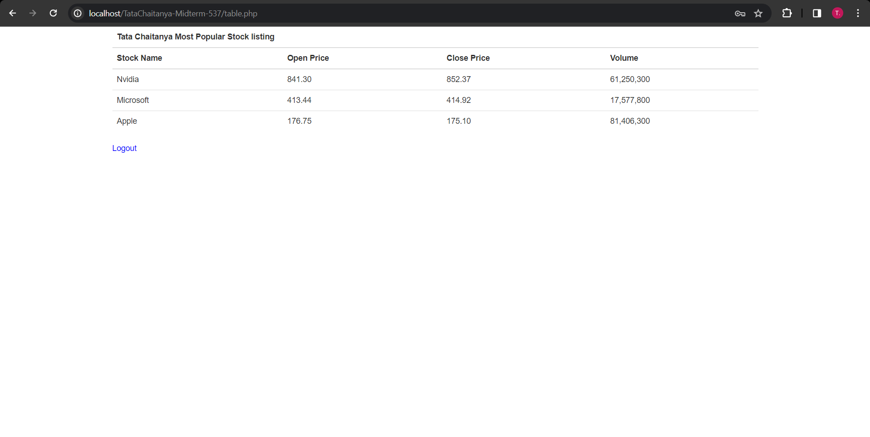

After hover:

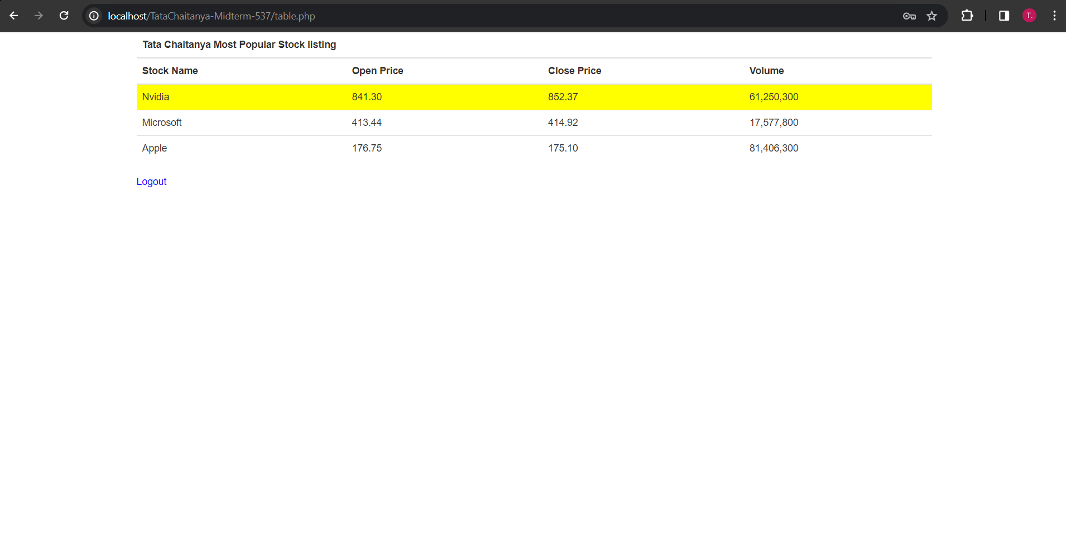

1. Screenshot after Logout button pressed

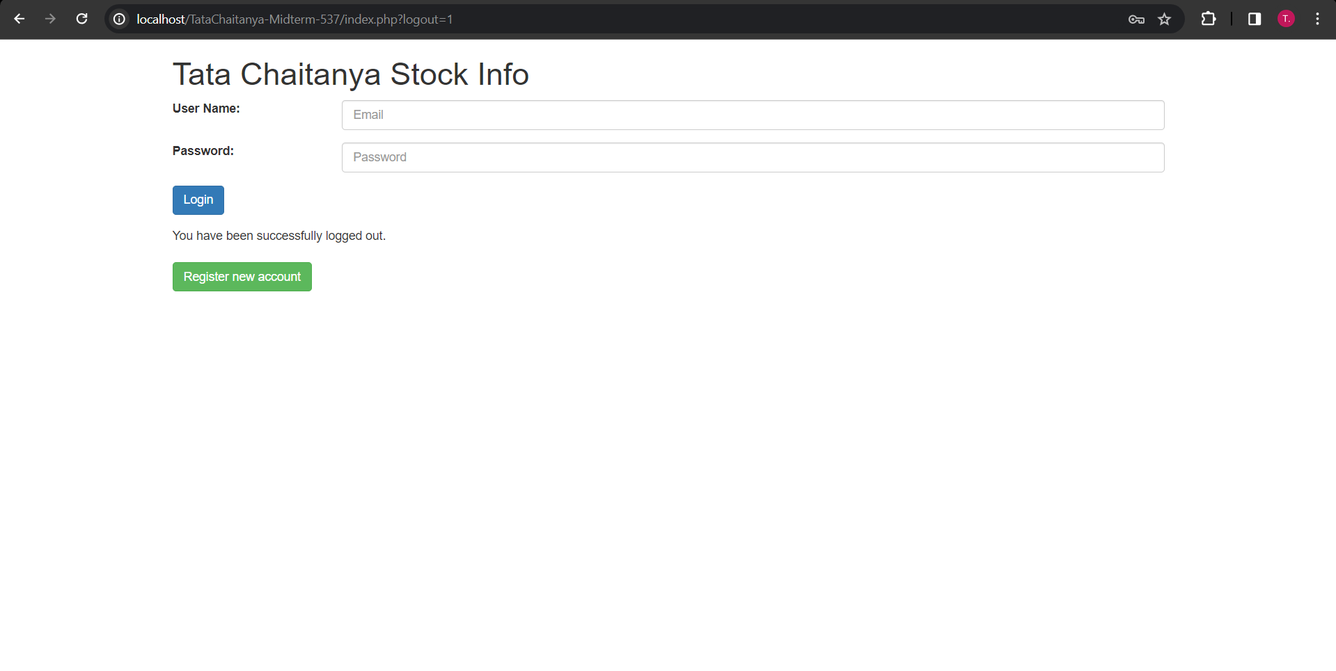

1. Screenshot of your midterm_exam_db administrators table before you register a user

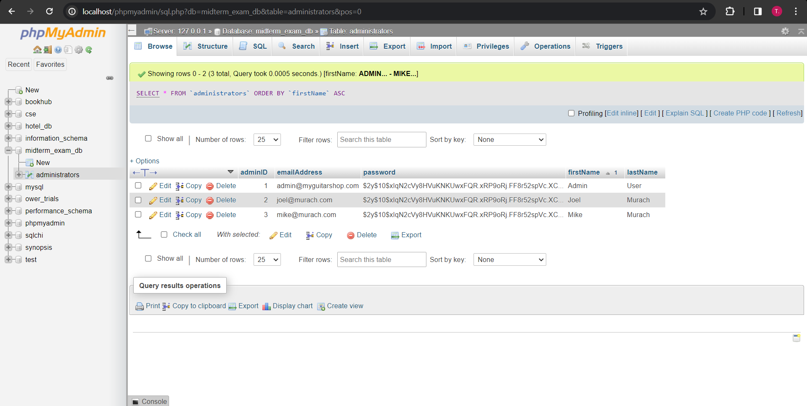

1. Screenshot of your registration page before you enter anything

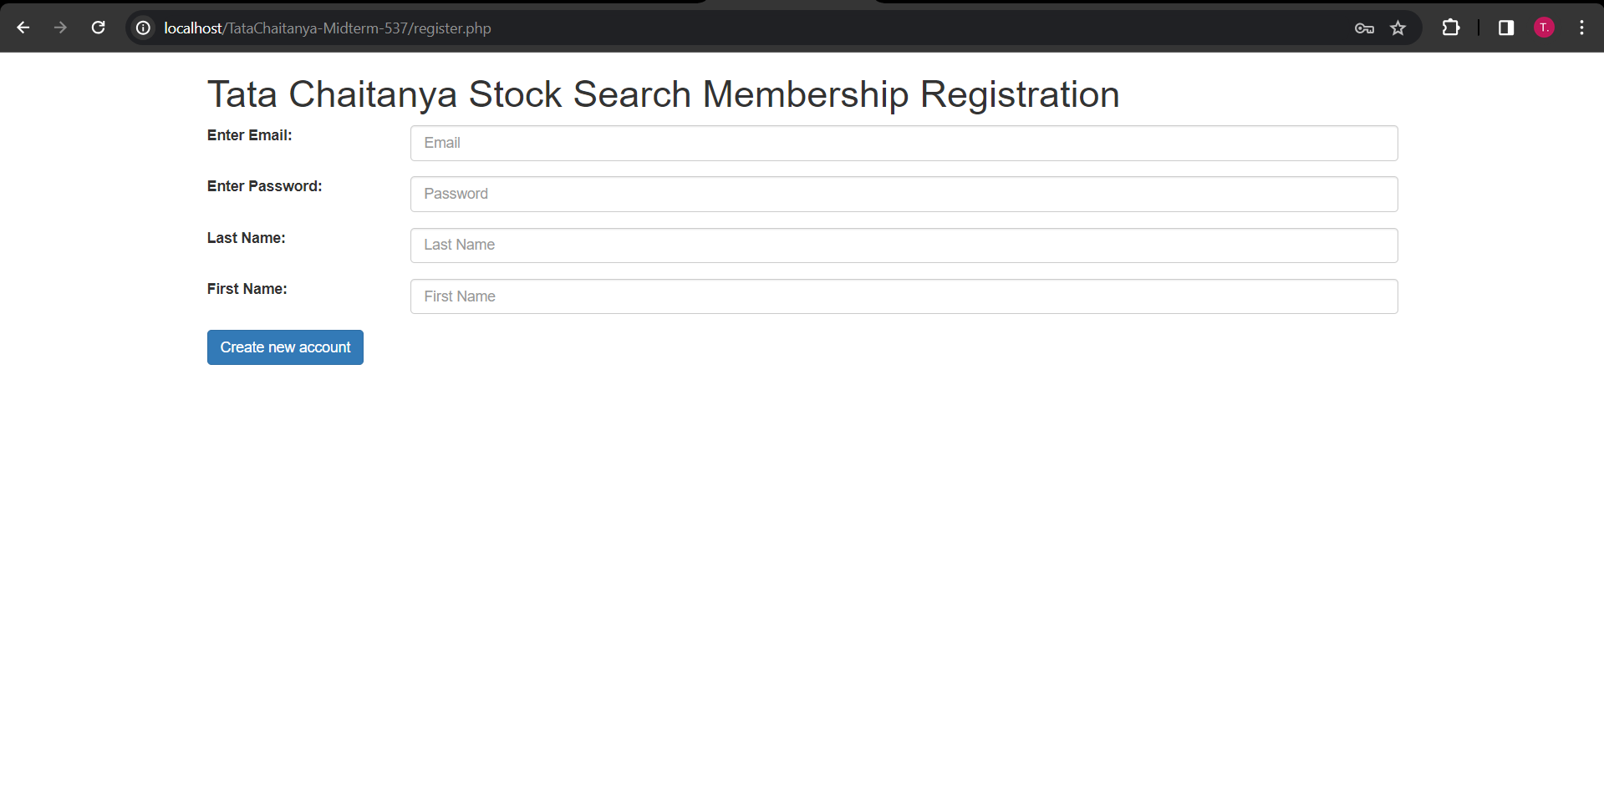

1. Screenshot of your registration page with your-msu-email (use your Montclair email), password, first name, and last name. If your last name has n characters then set your password with n characters. For example, if your last name is called Kumar, then n is 5, so enter 5 characters in your password field (any chars you like but make sure the length of your password is the same length as your last name. NOTE use your real name and email to register.

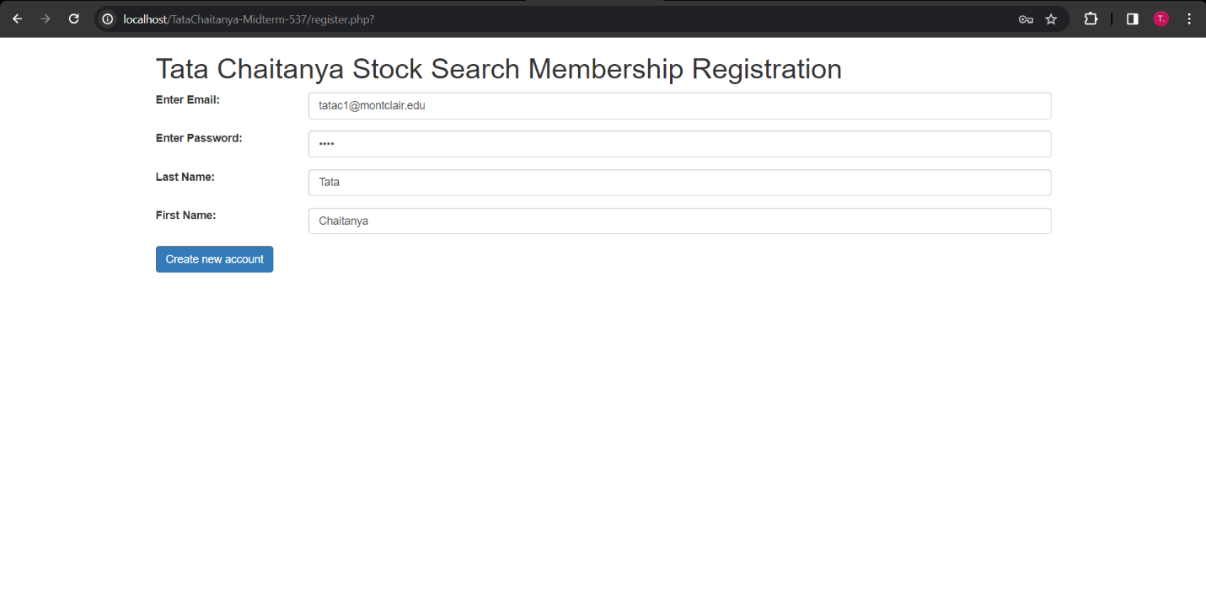

1. Screenshots after you press the 'Create new account' button

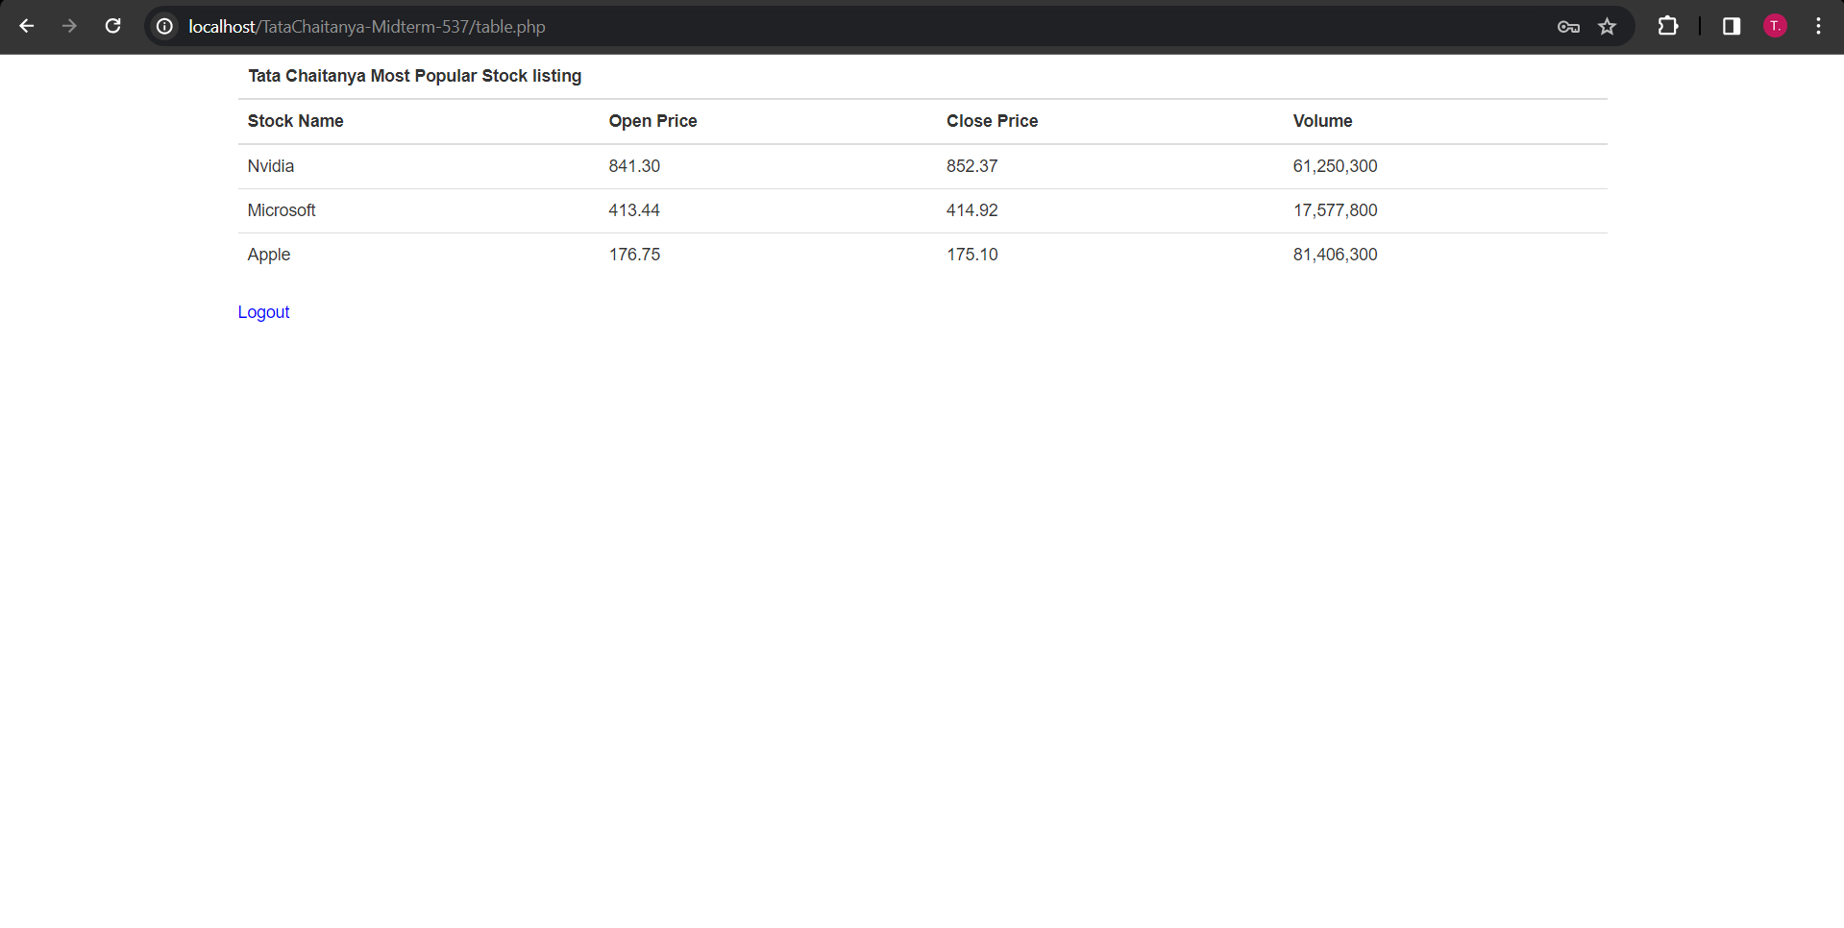

1. Screenshot of your midterm_exam_db administrators table after register a user

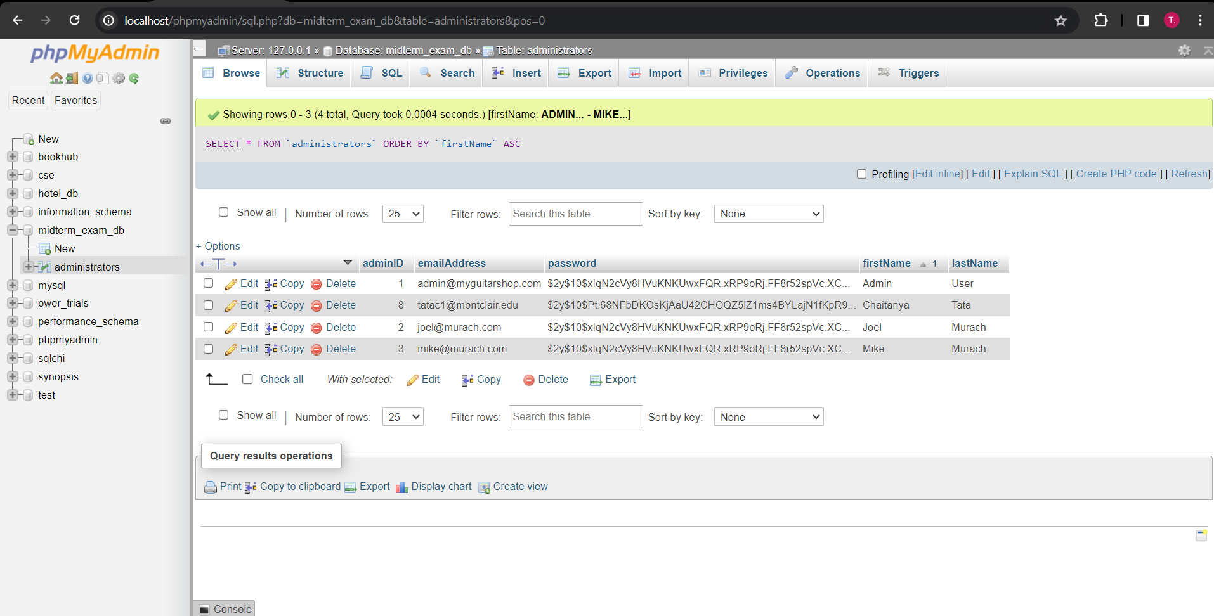

**Responsive Design:**

