Tristan Erney

October 5th, 2021

Intro to Cryptology

Hands on Exercise 5

1)

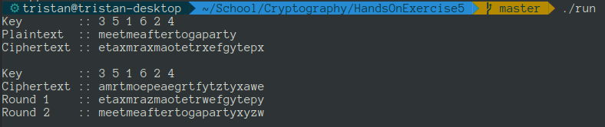

2)

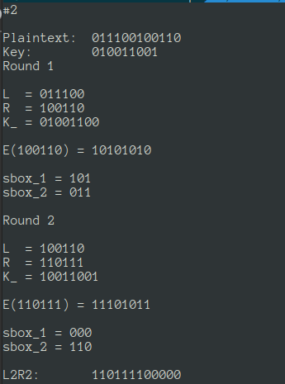

3)

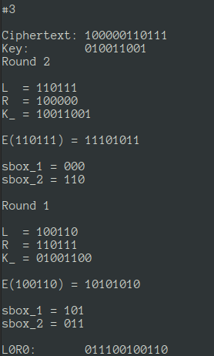

TranspositionCipher.cpp

#include <iostream>

#include <vector>

#include <stdlib.h>

#include <string.h>

// expand string by adding 'x''s to the end if needed

char* expand_string(char* str, int desired_size) {

int str_size = (int)strlen(str);

char* s = (char*)malloc(sizeof(char) * desired_size + 1);

s[desired_size] = 0;

for (int i = 0; i < desired_size; i += 1) {

s[i] = (i < str_size) ? str[i] : 'x';

}

return s;

}

/*

Row Transposition Encryption:

encrypt by building a table of (k_size x (c_size / k_size))

and rebuild a new ciphertext string by reading the table

by column.

meetmeaftertogaparty

key = {3, 5, 1, 6, 2, 4}

TBL:

m e e t m e

a f t e r t

o g a p a r

t y x y z w

-----------

3 5 1 6 2 4

etaxmrazmaotetrwefgytepy

*/

char* row_transposition_encrypt(char* _P, int* K, int k_size) {

size_t p_size = strlen(_P);

size_t pad = k_size - (p_size % k_size);

size_t c_size = p_size + pad;

char* P = expand_string(_P, c_size);

char* C = (char*)malloc(c_size + 1);

C[c_size] = 0;

char** TBL = (char**)malloc(sizeof(char*) * (c_size / k_size));

for (int i = 0; i < (c_size / k_size); i += 1) {

char* p_ptr = P + (i * k_size);

TBL[i] = (char*)malloc(sizeof(char) * k_size);

for (int j = 0; j < k_size; j += 1) {

TBL[i][j] = p_ptr[j];

}

}

int k = 0;

for (int i = 0; i < k_size; i += 1) {

for (int j = 0; j < (c_size / k_size); j += 1) {

C[k++] = TBL[j][K[i] - 1];

}

}

return C;

}

/*

Row Transposition Decrypt:

decrypt by building a table of (k_size x (c_size / k_size))

by reading in the table by each (c_size / k_size) sized chunk

ordered by the key, which is then read into a new plaintext

string by reading the table left-right top-bottom.

key = {3, 5, 1, 6, 2, 4}

#3 #5 #1 #6 #2 #4

amrt moep eaeg rtfy tzty xawe

e t a x m r

a z m a o t

e t r w e f

g y t e p y

etaxmrazmaotetrwefgytepy

*/

char* row_transposition_decrypt(char* C, int* K, int k_size) {

size_t c_size = strlen(C);

size_t p_size = c_size;

char* P = (char*)malloc(p_size + 1);

P[p_size] = 0;

// create table

char** TBL = (char**)malloc(sizeof(char*) * (c_size / k_size));

for (int i = 0; i < (c_size / k_size); i += 1) {

char* c_ptr = C + (i * k_size);

TBL[i] = (char*)malloc(sizeof(char) * k_size);

}

// read data into table

for (int i = 0; i < k_size; i += 1) {

char* c_ptr = C + (i * (c_size / k_size));

for (int j = 0; j < (c_size / k_size); j += 1) {

TBL[j][K[i] - 1] = c_ptr[j];

}

}

int k = 0;

for (int i = 0; i < (c_size / k_size); i += 1) {

for (int j = 0; j < k_size; j += 1) {

P[k++] = TBL[i][j];

}

}

return P;

}

int main() {

{

int key[] = {3, 5, 1, 6, 2, 4};

char P[] = "meetmeaftertogaparty";

char* C = row_transposition_encrypt(P, key, 6);

std::cout << "Key :: ";

for (int i = 0; i < (sizeof(key) / sizeof(key[0])); i += 1) {

std::cout << key[i] << " ";

}

std::cout << "\n";

std::cout << "Plaintext :: " << P << "\n";

std::cout << "Ciphertext :: " << C << "\n\n";

}

{

int key[] = {3, 5, 1, 6, 2, 4};

char C[] = "amrtmoepeaegrtfytztyxawe";

char* R1 = row_transposition_decrypt(C, key, 6);

char* R2 = row_transposition_decrypt(R1, key, 6);

std::cout << "Key :: ";

for (int i = 0; i < (sizeof(key) / sizeof(key[0])); i += 1) {

std::cout << key[i] << " ";

}

std::cout << "\n";

std::cout << "Ciphertext :: " << C << "\n";

std::cout << "Round 1 :: " << R1 << "\n";

std::cout << "Round 2 :: " << R2 << "\n\n";

}

return 0;

}

S_DES.cpp

#include <iostream>

#include <iomanip>

#include <bitset>

#include <stdlib.h>

#include <stdint.h>

void printb3(uint8_t b) {

std::bitset<3> x(b);

std::cout << x;

}

void printb6(uint8_t b) {

std::bitset<6> x(b);

std::cout << x;

}

void printb9(uint16_t b) {

std::bitset<9> x(b);

std::cout << x;

}

void printb12(uint16_t b) {

std::bitset<12> x(b);

std::cout << x;

}

void printb(uint8_t b) {

std::bitset<8> x(b);

std::cout << x;

}

uint8_t sbox1[2][8] = {

{ 5, 2, 1, 6, 3, 4, 7, 0 },

{ 1, 4, 6, 2, 0, 7, 5, 3 }

};

uint8_t sbox2[2][8] = {

{ 4, 0, 6, 5, 7, 1, 3, 2 },

{ 5, 3, 0, 7, 6, 2, 1, 4 }

};

uint8_t E(uint8_t X) {

uint8_t e = 0;

e |= ((0x20 & X) >> 5) << 7;

e |= ((0x10 & X) >> 4) << 6;

e |= ((0x04 & X) >> 2) << 5;

e |= ((0x08 & X) >> 3) << 4;

e |= ((0x04 & X) >> 2) << 3;

e |= ((0x08 & X) >> 3) << 2;

e |= ((0x02 & X) >> 1) << 1;

e |= ((0x01 & X) >> 0) << 0;

std::cout << "E(";

printb6(X);

std::cout << ") = ";

printb(e);

std::cout << "\n\n";

return e;

}

uint8_t F(uint8_t X, uint8_t K) {

uint8_t e = E(X);

uint8_t e_xor_k = e ^ K;

uint8_t sbox_1 = sbox1[e_xor_k >> 7][0x07 & (e_xor_k >> 4)];

uint8_t sbox_2 = sbox2[(0x0f & e_xor_k) >> 3][0x07 & e_xor_k];

std::cout << "sbox_1 = ";

printb3(sbox_1);

std::cout << "\n";

std::cout << "sbox_2 = ";

printb3(sbox_2);

std::cout << "\n\n";

return (sbox_1 << 3) + sbox_2;

}

uint16_t sdes_encrypt(uint16_t P, uint16_t K) {

uint8_t round = 0;

uint8_t max_rounds = 2;

// P = 0bxxxx |oooo oo|oo oooo|

uint8_t L = (uint8_t)(P >> 6);

uint8_t R = (uint8_t)(0x3f & P);

for (round = 0; round < max_rounds; round += 1) {

std::cout << "Round " << round + 1 << "\n\n";

std::cout << "L = ";

printb6(L);

std::cout << "\n" << "R = ";

printb6(R);

std::cout << "\n";

uint8_t K_ = ((K << round) | (K >> 9 - round)) >> 1;

std::cout << "K_ = ";

printb(K_);

std::cout << "\n\n";

uint8_t L_ = R;

uint8_t R_ = L ^ F(R, K_);

L = L_;

R = R_;

}

return (L << 6) + R;

}

uint16_t sdes_decrypt(uint16_t C, uint16_t K) {

int8_t round = 1;

uint8_t max_rounds = 0;

uint8_t R = (uint8_t)(C >> 6);

uint8_t L = (uint8_t)(0x3f & C);

for (round = 1; round >= max_rounds; round -= 1) {

std::cout << "Round " << round + 1 << "\n\n";

std::cout << "L = ";

printb6(L);

std::cout << "\n" << "R = ";

printb6(R);

std::cout << "\n";

uint8_t K_ = ((K << round) | (K >> 9 - round)) >> 1;

std::cout << "K_ = ";

printb(K_);

std::cout << "\n\n";

uint8_t R_ = L;

uint8_t L_ = R ^ F(R_, K_);

L = L_;

R = R_;

}

return (L << 6) + R;

}

int main() {

{

std::cout << "#2\n\n";

uint16_t K = 0x0099; // 0 1001 1001

uint16_t P = 0x0726; // 011100 100110

std::cout << "Plaintext: ";

printb12(P);

std::cout << "\n";

std::cout << "Key: ";

printb9(K);

std::cout << "\n";

uint16_t C = sdes_encrypt(P, K);

std::cout << "L2R2: ";

printb12(C);

std::cout << "\n";

}

{

std::cout << "#3\n\n";

uint16_t K = 0x0099;

uint16_t C = 0x0837;

std::cout << "Ciphertext: ";

printb12(C);

std::cout << "\n";

std::cout << "Key: ";

printb9(K);

std::cout << "\n";

uint16_t P = sdes_decrypt(C, K);

std::cout << "L0R0: ";

printb12(P);

std::cout << "\n";

}

return 0;

}