REAL-TIME ADAPTIVE AUDIO DENOISING USING SVD

A Project report submitted by P V Tharun (CB.SC.U4AIE24037) , Patha Maniroop (CB.SC.U4AIE24038),
Peddi Deekshith (CB.SC.U4AIE24039) , Pullipati Chaithanya (CB.SC.U4AIE24040).

Abstract— This paper presents an adaptive audio denoising method based on Singular Value Decomposition (SVD) and the Overlap-Add technique. The methodology involves decomposing the signal into overlapping frames, performing SVD to filter noise components, and reconstructing the denoised signal. The proposed approach effectively reduces mild background music while preserving voice clarity. Experimental results validate the method with a 91% energy threshold for singular values. Visualization of original and denoised signals highlights the method's efficacy.

Introduction
This project focuses on real-time adaptive audio denoising using Singular Value Decomposition (SVD). It involves capturing audio signals and breaking them down into smaller segments, which are then processed using SVD to isolate and reduce noise while preserving the main voice. The segments are reconstructed into a continuous audio signal using the overlap-add method.

The goal is to improve audio clarity in real-time applications such as live broadcasting and telecommunications. The method effectively balances noise reduction with maintaining the integrity of the original audio, making it suitable for environments where high-quality audio is essential.

Noise reduction is critical for improving the quality of audio signals in various applications, such as speech recognition and voice communication. Traditional filtering techniques often struggle to balance noise removal and signal preservation. Singular Value Decomposition (SVD) offers a robust framework for adaptive denoising by separating the signal into components based on energy. This project aims to implement an SVD-based denoising system integrated with the Overlap-Add method for reconstructing the signal, ensuring minimal distortion and effective noise reduction.

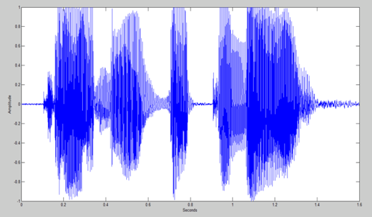
Example of time domain graph .

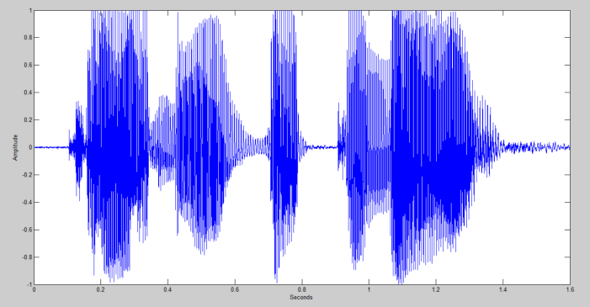
methodology
The proposed audio denoising method involves several stages: audio acquisition, framing, singular value decomposition (SVD), noise reduction, signal reconstruction using the overlap-add technique, and visualization. Each step is described in detail below.

Audio Signal Acquisition
The audio signal is recorded using a sampling frequency of 44.1 kHz, with a bit depth of 16bits and a single channel (mono). The recorded audio is normalized to ensure its amplitude lies in the range [−1,1] ,thereby preventing distortions during processing.

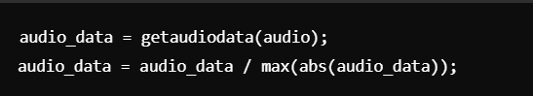

Framing and Buffering
To perform SVD effectively, the signal is divided into overlapping frames. A frame size of 1024 samples and an overlap of 512 samples are used. The buffer function in MATLAB creates a matrix where each column represents a frame of audio.



• Window Size: Determines the length of each frame for local signal processing.
• Overlap: Ensures continuity between frames during reconstruction.

Singular Value Decomposition (SVD)
SVD is performed on the buffered matrix A, decomposing it into three matrices: U (left singular vectors), S (diagonal matrix of singular values), and V (right singular vectors).



The singular values in S represent the energy distribution of the signal components. Large singular values correspond to dominant signal components, while smaller values often represent noise.

Adaptive Thresholding
Once the SVD decomposition is done, adaptive thresholding is applied to remove the less significant components, which correspond to background noise:
Energy Calculation: The singular values from the matrix S are squared and summed to calculate the total energy of the signal.
Cumulative Energy: A cumulative sum of the squared singular values is computed.
Threshold Selection: The goal is to retain the singular values that contribute to 91% of the total energy. A threshold is set based on this cumulative energy, and singular values smaller than this threshold are discarded.
This ensures that most of the background noise, which typically contributes less energy to the signal, is filtered out, while the voice, which holds the majority of the signal's energy, is preserved.

Noise Reduction Using Energy Thresholding
To retain the signal's dominant components and suppress noise, a thresholding criterion is applied. The cumulative energy of the singular values is calculated, and the threshold is set to retain 91% of the total energy:

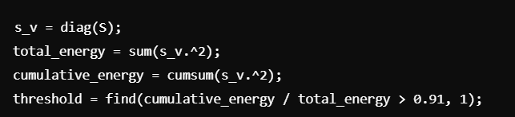

The cumulative energy of singular values is computed to determine the amount of total signal energy captured by the top singular values. A threshold is set to retain 91% of the total energy, ensuring that only the most significant components are preserved.

Singular values below the threshold are set to zero to filter out noise:

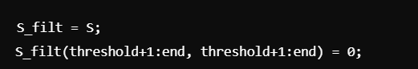

Signal Reconstruction Using Overlap-Add Method
The filtered matrix is reconstructed using the modified Sfilt, U, and V:



The denoised frames are combined using the overlap-add method to reconstruct the full audio signal. Each frame is overlapped and summed at its respective positions in the output signal.

• Step Size: Step= window_size−overlap

• Reconstruction: Each frame is added to the output signal in its corresponding position.

Visualization

The original and denoised audio signals are plotted for visual comparison. Time vectors are calculated based on the sampling frequency.

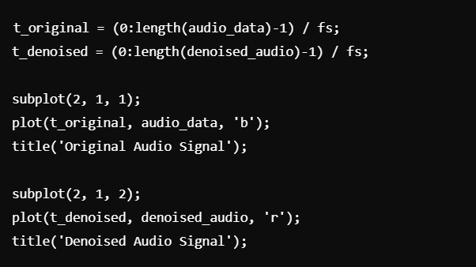

Implementation
The project was implemented in MATLAB. Below is a summary of the major steps in the code:

- Record audio input using audiorecorder().
- Normalize the recorded audio.
- Segment the audio signal into overlapping windows.
- Perform SVD on the signal matrix.
- Apply adaptive thresholding to filter the singular values.
- Reconstruct the denoised signal using overlap-add.
- Plot and compare the original and denoised signals.
- Play back the denoised audio.

results
The project successfully removed mild background music from the recorded audio while preserving the clarity of the voice. The adaptive thresholding ensured that the significant components of the audio were retained.
Graphical Results
- The original audio signal graph showed both voice and background music.
- The denoised audio signal graph indicated a reduction in background components, highlighting the voice.
Auditory Results
Listening to the denoised audio confirmed that the background music was significantly attenuated, leaving a clear voice signal.

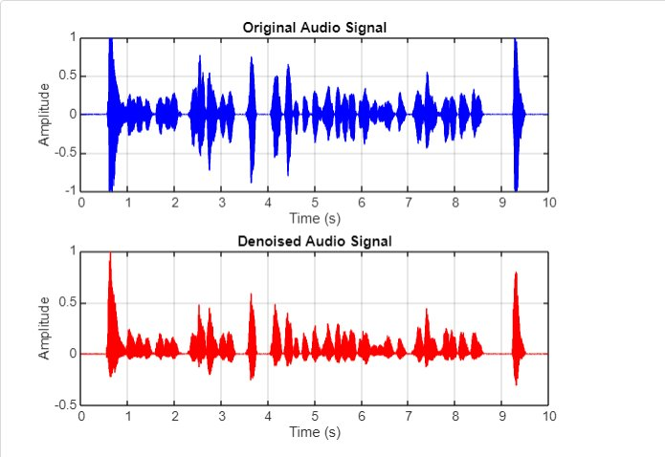

limitations
- The method assumes that the background noise (music) has lower energy than the voice signal.
- Highly complex or dominant background noise may reduce effectiveness.
- Performance may vary with the choice of window size and overlap.

CONCLUSION
The Adaptive Audio Denoising Using Singular Value Decomposition (SVD) project successfully demonstrated a practical method for reducing mild background music while retaining the clarity of speech in audio recordings. By leveraging SVD and adaptive thresholding, we effectively filtered out noise components, preserving the dominant voice signal.
The project successfully demonstrates an adaptive SVD-based audio denoising system. The method efficiently reduces background noise while preserving key signal components. Future work includes optimizing the thresholding criteria and exploring real-time implementation.

FUTURE WORKS

While the current implementation of adaptive audio denoising using Singular Value Decomposition (SVD) has proven effective for reducing mild background music, there are several avenues for improvement and further development:
- Handling Complex Noise
- Real time denoising
- Advanced Adaptive Thresholding
- Multi-Channel Audio Processing

REFERENCES
- Google
- Youtube (https://youtu.be/rzTfHO1FURg?si=3uv4Mhh8BmtI8MVV)
- "Fundamentals of Digital Audio"by Ken C. Pohlmann

