BANGLISH: A TOY PROGRAMMING LANGUAGE AND COMPILER FOR INTRODUCTORY PROGRAMMING EDUCATION
Mahim Shahriar, Tahmina Jannat Liza
Department of Computer Science and Engineering
Leading University, Bangladesh
Course: Compiler Design
September 2026

Abstract
This project presents Banglish, a small toy programming language whose keywords and syntax are based on Bangla words written using the Latin alphabet. The language is designed as a university Compiler Design project and currently supports integer and string data types, arithmetic expressions with operator precedence, assignment, conditional statements, while loops, input, output, comments, and basic syntax-error recovery. The compiler is implemented in C++ and translates Banglish source programs into executable Python source code. The project follows the course requirement to invent a custom Bangla-oriented language, define its formal grammar in BNF, implement a working compiler, and demonstrate its practical relevance. Beyond the current toy compiler, the long-term vision is to evolve Banglish into an introductory programming language that can reduce the linguistic barrier for school-level learners, especially in Bangladesh. This direction is motivated by the familiarity of Romanized Bangla in everyday digital communication in Bangladesh. Existing research has documented the use of Romanized Bangla and Bangla-English code-mixing in online communication, while this project explores a different application: using familiar Romanized Bangla vocabulary as the surface syntax of a beginner programming language.
Keywords— Banglish, Romanized Bangla, programming language, compiler, compiler design, introductory programming, education, Python code generation.

I. Introduction
Learning programming requires students to understand both computational concepts and the syntax of a programming language. For beginners, syntax that is completely unfamiliar can add an additional linguistic and cognitive burden. Banglish investigates whether a small programming language using familiar Romanized Bangla words can provide a more approachable surface syntax while retaining fundamental programming concepts.
The course specification requires each team to design an originally invented Bangla programming language with custom syntax and grammar, build a working compiler, translate programs into executable Java or Python, and present a real-world justification. The specification also requires two data types with type checking, arithmetic with correct precedence, assignment, IF-ELSE, WHILE, basic syntax recovery, graceful handling of invalid input, and valid executable target code.
Banglish uses terms such as 'shongkha' for integer, 'shobdo' for string, 'jodi' for if, 'noilejodi' for else-if, 'noile' for else, 'ghurtethako' for while, 'dekhaw' for output, and 'niyejaw' for input. The current implementation is deliberately a toy compiler rather than a production language.

II. The Pitch

A. Problem and Motivation
The project addresses an introductory programming problem rather than attempting to compete with general-purpose programming languages. A student encountering programming for the first time must learn concepts such as variables, expressions, conditions, and loops while also learning an unfamiliar programming vocabulary. Banglish proposes to make the surface vocabulary more familiar to Bangla-speaking beginners by using Romanized Bangla words that can be read without requiring a Bangla-script keyboard.
Romanized Bangla is already present in Bangladeshi digital communication. Prior work describes Romanization of Bangla as a practice used in texting, social networking, and micro-blogging in Bangladesh, and reports that users commonly write Bangla with Roman letters. [1] A recent study also examined Romanized Bangla and Bangla-English code-switching in social-media communication and reported substantial use within its limited sample. [2] These studies do not establish that Romanized Bangla is universally preferred by every population; instead, they provide evidence that the writing practice is sufficiently visible in digital communication to motivate investigation as an educational interface.

B. Proposed Solution
Banglish retains conventional programming constructs but replaces selected English keywords with Romanized Bangla equivalents. For example:
shongkha boyos = 20;
jodi(boyos >= 18){
dekhaw("Adult");
}
noile{
dekhaw("Minor");
}
The current compiler translates this syntax into Python. Thus, the project demonstrates both language design and compiler construction while keeping the generated target language familiar and executable.

C. Real-World Relevance
The current system should not be presented as proof that Banglish is already suitable for national school curricula. It is a prototype intended to test a direction. Its potential relevance is as an introductory educational layer in which students first encounter programming concepts through more familiar vocabulary and later transition to established languages such as Python, C++, or Java.
A future educational platform could provide an interactive Banglish editor, immediate compiler feedback, visual execution traces, beginner exercises, teacher dashboards, and gradual conversion from Banglish syntax to conventional programming syntax. The language could therefore function as a bridge rather than a replacement for existing programming languages.

D. Long-Term Vision and Future Roadmap
- Develop a browser- or mobile-based Banglish learning environment for school-level programming.
- Introduce lesson-based exercises covering variables, expressions, conditions, loops, functions, and data structures.
- Provide beginner-friendly diagnostics and error messages in Banglish/Bangla.
- Add visual execution and step-by-step tracing so students can see how statements affect program state.
- Support a larger but carefully controlled vocabulary while maintaining simple syntax.
- Investigate optional Bangla-script input alongside Romanized Bangla input.
- Develop teacher-oriented assessment and progress-tracking features.
- Study whether the language improves comprehension or reduces initial syntax-related difficulty through controlled educational evaluation.

III. Literature Review
The significance for Banglish is not that its syntax should imitate Logo or Scratch. Banglish follows a different design direction: it remains a text-based language but replaces selected English keywords with Romanized Bangla vocabulary. The common principle is learner-centered language design. The proposed future platform can build on this principle by combining familiar language, structured exercises, immediate feedback, and gradual progression.
Scratch provides another example of learner-centered language and environment design. Maloney et al. [3] describe Scratch as a visual programming environment aimed primarily at young learners and designed to support self-directed learning, tinkering, and collaboration. These systems demonstrate that an introductory language can intentionally simplify the interface to programming while retaining fundamental computational ideas.
The history of educational programming languages provides an important precedent for Banglish. Solomon et al. [2] describe Logo as a programming language and learning environment explicitly designed for children, with an emphasis on enabling learners to explore mathematical ideas and create projects. The history of Logo illustrates that programming-language design can be influenced by educational goals rather than only by technical expressiveness.

A. Educational Programming Languages and Learner-Centered Design
For Banglish, the implication is that familiar vocabulary may be investigated as one possible way of reducing part of the unfamiliarity surrounding programming syntax. The project does not claim that Romanized Bangla automatically reduces cognitive load; instead, it proposes a testable design hypothesis: familiar linguistic labels may make selected programming constructs easier to recognize and discuss for some Bangla-speaking beginners.
A related line of research has examined how introductory programming languages and environments should be designed for novice learners. Perera et al. [5] systematically reviewed introductory programming languages and identified language design, target learner group, programming concepts, learning materials, and perceived ease of use as important dimensions in educational programming environments. This supports the idea that choosing the surface language is an educational design decision rather than merely a syntactic preference.
Introductory programming is widely recognized as difficult for novices because learners must simultaneously understand programming concepts, syntax, notation, algorithms, and problem-solving processes. Stachel et al. [4] describe how novice programming can create substantial cognitive load because learners have to assimilate syntax together with broader programming concepts. Their work motivates instructional approaches that reduce unnecessary demands while supporting the acquisition of programming knowledge.

B. Beginner Programming Education and Cognitive Load
The educational-language literature also indicates that syntax is only one component of learning. Logo and Scratch demonstrate the importance of the surrounding learning environment, meaningful activities, exploration, and feedback. Consequently, the long-term Banglish vision is not merely a translated syntax. It is an educational platform in which the language, examples, exercises, compiler feedback, visualization, and progression from beginner concepts to conventional programming languages are designed together.
The choice of Romanized Bangla is also deliberate. Shahriar et al. [1] report that Romanized Bangla and English code-switching occurs in Bangladeshi social-media communication and that, within their small sample, typing convenience and audience were important factors. This supports the project's motivation to investigate Romanized Bangla as a familiar digital writing form, but it does not prove that every Bangla-speaking learner will prefer it for programming. Future versions should therefore allow empirical testing of different vocabulary, spelling conventions, and script choices.
The literature suggests that an educational programming language should be designed around the learner rather than around the expressive power of a production language. For Banglish, this means keeping the initial language small, using consistent vocabulary, making syntax predictable, and providing immediate and understandable feedback. The present prototype therefore limits the core language to integer and string data types, arithmetic expressions, assignment, conditional statements, loops, input, and output.

C. Implications for Banglish Language Design
This distinction is important. Banglish is not presented as a proven replacement for Python, C++, Scratch, or other established educational technologies. Instead, the current compiler is a technical prototype that makes the proposed language design concrete. Its future educational claim requires empirical evaluation with appropriate learner groups, comparison conditions, and learning measures.
The reviewed literature establishes three relevant points: Romanized Bangla is an observable form of digital communication in Bangladesh; novice programming can impose substantial cognitive and syntactic demands; and educational programming languages have historically been designed by adapting programming interfaces to learners. However, these areas do not by themselves establish that Romanized Bangla keywords improve programming learning. The present project therefore occupies a specific exploratory intersection: it applies familiar Romanized Bangla vocabulary to the surface syntax of a small text-based programming language while preserving conventional programming constructs and compiling the result to Python.

D. Research Gap and Position of the Present Project
[1] M. M. F. Shahriar, N. B. Basher, and M. Hasan, “Code-Switching Between Romanized Bangla and English: A Sociolinguistic Study of Social Media Practices,” International Journal of Education, Language, and Religion, vol. 8, no. 1, pp. 65–78, 2026, doi: 10.35308/ijelr.v8i1.14906.
[2] C. Solomon, B. Harvey, K. Kahn, H. Lieberman, M. L. Miller, M. Minsky, A. Papert, and B. Silverman, “History of Logo,” Proceedings of the ACM on Programming Languages, vol. 4, HOPL, pp. 1–66, 2020, doi: 10.1145/3386329.
[3] J. Maloney, M. Resnick, N. Rusk, B. Silverman, and E. Eastmond, “The Scratch programming language and environment,” ACM Transactions on Computing Education, vol. 10, no. 4, Article 16, 2010, doi: 10.1145/1868358.1868363.
[4] J. Stachel, D. Marghitu, T. Ben Brahim, R. Sims, L. Reynolds, and V. Czelusniak, “Managing cognitive load in introductory programming courses: A cognitive aware scaffolding tool,” Journal of Educational Computing Research, vol. 17, no. 1, 2013, doi: 10.3233/JID-2013-0004.
[5] P. Perera, G. Tennakoon, S. Ahangama, R. Panditharathna, and B. Chathuranga, “A systematic review of introductory programming languages for novice learners,” IEEE Access, vol. 9, pp. 88121–88136, 2021, doi: 10.1109/ACCESS.2021.3089560.

References

III. Compiler Design

A. Design Goals
- Implement every minimum compiler feature specified by the course.
- Keep the compiler small enough for all team members to understand.
- Use C++ as the compiler implementation language.
- Generate valid executable Python code.
- Use a clear separation between lexical analysis, syntax analysis, semantic checking, and code generation.
- Provide understandable error messages and basic syntax-error recovery.

B. Overall Architecture
The compiler follows a conventional multi-stage pipeline. The Banglish source is first converted into tokens by the lexer. The parser then constructs a simple internal representation of the program. Semantic analysis checks declarations and types using a symbol table. Finally, the code generator translates the checked representation into Python.
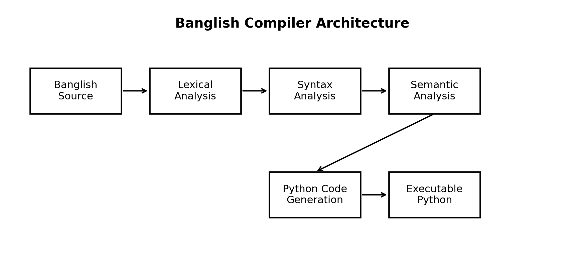
Fig. 1. High-level Banglish compiler architecture.

C. Six-File Implementation
File | Responsibility
main.cpp | Program entry point, source-file handling, phase coordination, errors, and output file writing.
lexer.cpp | Converts source text into tokens and recognizes keywords, identifiers, literals, operators, delimiters, and comments.
parser.cpp | Recursive-descent syntax analysis, expressions, statements, control structures, and basic syntax recovery.
ast.cpp | Simple representation of programs, statements, expressions, and control structures.
semantic.cpp | Symbol table, declaration checking, type checking, and semantic errors.
codegenerator.cpp | Generates executable Python source with correct block indentation.

D. Compiler Workflow
- Read a Banglish source file.
- Perform lexical analysis and create tokens.
- Parse the token sequence using recursive-descent functions.
- Construct the internal program representation.
- Build and consult a symbol table during semantic analysis.
- Reject invalid programs with appropriate diagnostics.
- Generate Python source from a semantically valid program.
- Write the generated Python source to the requested output file.
- Execute the generated Python file separately using Python 3.

E. UML/Class-Oriented Design
Because the project is intentionally small, the implementation does not require an elaborate class hierarchy. The following simplified UML-oriented view identifies the major components and their relationships. It is intended to satisfy the report requirement for a high-level UML representation of the major compiler components.
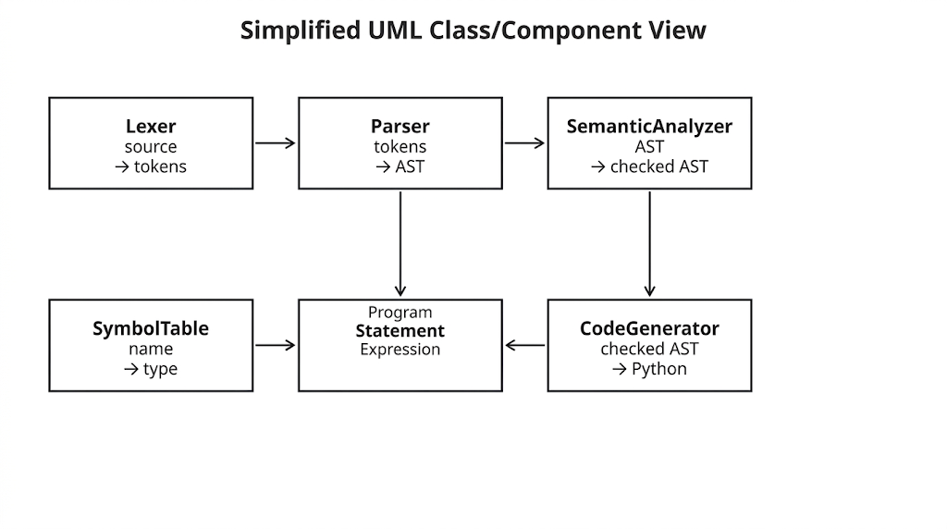
Fig. 2. Simplified UML/component view of the compiler.

F. Error Handling
The compiler is designed to handle invalid input without crashing. Lexical errors include invalid characters or malformed tokens. Syntax errors include missing semicolons, parentheses, braces, and malformed expressions. Semantic errors include duplicate declarations, undeclared variables, and type mismatches. The parser uses basic recovery by skipping tokens until a semicolon or end of line when a syntax error is encountered, allowing subsequent input to be examined where practical. This directly follows the course requirement for basic syntax error recovery and graceful behavior. fileciteturn2file0L28-L40

IV. Language Grammar

A. Lexical Elements
Category | Banglish syntax
Integer type | shongkha
String type | shobdo
If | jodi
Else-if | noilejodi
Else | noile
While | ghurtethako
Output | dekhaw
Input | niyejaw
Comment | # ... end of line
Statement terminator | ;
Block delimiters | { }
Grouping | ( )

B. Data Types and Literals
The current language defines two data types: integer and string. Integer literals are decimal whole numbers. String literals are enclosed in double quotation marks. The current design intentionally does not include double/float as a required type.

C. Operators
Category | Operators
Arithmetic | +, -, *, /
Comparison | >, <, >=, <=, ==, !=
Assignment | =

D. Complete BNF Grammar
<program> ::= <statement-list>

<statement-list> ::= <statement> <statement-list>
| ε

<statement> ::= <declaration> ";"
| <assignment> ";"
| <input-statement> ";"
| <output-statement> ";"
| <if-statement>
| <while-statement>

<declaration> ::= <integer-declaration>
| <string-declaration>

<integer-declaration> ::= "shongkha" <identifier>
| "shongkha" <identifier> "=" <expression>

<string-declaration> ::= "shobdo" <identifier>
| "shobdo" <identifier> "=" <string-literal>

<assignment> ::= <identifier> "=" <expression>

<input-statement> ::= "niyejaw" "(" <identifier> ")"

<output-statement> ::= "dekhaw" "(" <expression> ")"

<if-statement> ::= "jodi" "(" <condition> ")" <block>
<else-if-list>
<else-part>

<else-if-list> ::= "noilejodi" "(" <condition> ")" <block>
<else-if-list>
| ε

<else-part> ::= "noile" <block>
| ε

<while-statement> ::= "ghurtethako" "(" <condition> ")" <block>

<block> ::= "{" <statement-list> "}"

<condition> ::= <expression> <comparison-operator> <expression>

<comparison-operator> ::= ">"
| "<"
| ">="
| "<="
| "=="
| "!="

<expression> ::= <term> <expression-tail>

<expression-tail> ::= "+" <term> <expression-tail>
| "-" <term> <expression-tail>
| ε

<term> ::= <factor> <term-tail>

<term-tail> ::= "*" <factor> <term-tail>
| "/" <factor> <term-tail>
| ε

<factor> ::= <number>
| <string-literal>
| <identifier>
| "(" <expression> ")"

<identifier> ::= <letter-or-underscore> <identifier-tail>

<identifier-tail> ::= <letter-or-digit-or-underscore> <identifier-tail>
| ε

E. Example Program
shongkha boyos = 20;
shobdo name = "Mahim";
jodi(boyos >= 18){
dekhaw(name);
dekhaw("Adult");
}
noile{
dekhaw("Minor");
}

V. Implementation and Target Translation
The compiler is implemented in C++ using a small set of standard-library data structures. The lexer recognizes the Banglish vocabulary and punctuation. The parser uses recursive descent, with separate functions for expressions, terms, factors, declarations, assignments, conditionals, loops, input, and output. Semantic analysis maintains a mapping from variable names to their declared types. Code generation converts the validated program into Python 3 syntax.
For example, the Banglish declaration 'shongkha x = 10;' becomes 'x = 10' in Python. 'dekhaw(x);' becomes 'print(x)', and integer input through 'niyejaw(x);' becomes 'x = int(input())'. Conditional and loop blocks are translated to Python using indentation.

VI. Testing and Expected Behavior
Test | Purpose | Expected result
Arithmetic | 10 + 5 * 2 | 20; verifies precedence.
IF-ELSE | boyos >= 18 | Correct branch executes.
ELSE-IF | marks >= 80 / >= 60 | Correct branch executes.
WHILE | Count from 1 to 5 | 1, 2, 3, 4, 5.
Input | Integer and string input | Values are read and printed.
Type error | shongkha age = "Mahim"; | Type mismatch reported.
Undeclared variable | x = 10; | Undeclared-variable error.
Duplicate declaration | Declare x twice | Duplicate declaration error.
Missing semicolon | shongkha x = 10 | Syntax error and recovery attempt.
The course requires two scheduled project reviews and states that any team member may be asked to explain demonstrated features. It also expects every student to have a basic understanding of the entire codebase. Therefore, testing and presentation should be treated as team-wide responsibilities. fileciteturn2file0L44-L55

VII. Limitations
- The current language is a toy language and does not attempt to replace established programming languages.
- Only integer and string types are included in the current specification.
- The compiler targets Python rather than machine code.
- The syntax and grammar are intentionally small and do not yet cover functions, arrays, objects, or advanced data structures.
- The educational value of the Banglish syntax has not yet been established through a controlled classroom study.
- Romanized Bangla has spelling variation, so future language tooling will need to define and document accepted spellings carefully.

VIII. Future Work
The most important future direction is to move from a compiler-design prototype toward an educational platform. The current language can serve as the core language engine, while future work can add a student-facing environment around it.
- Web-based Banglish IDE with syntax highlighting and live compilation.
- Bangla/Banglish explanations for compiler errors.
- Interactive lessons and exercises for primary and lower-secondary learners.
- Visual execution of variables, conditions, and loops.
- Automatic hints rather than only error messages.
- Progress tracking for students and teachers.
- Optional Bangla-script input and controlled transliteration support.
- A gradual migration mode showing equivalent Banglish and Python/C++ code side by side.
- User studies comparing Banglish-based instruction with conventional beginner programming instruction.

IX. Conclusion
Banglish demonstrates the design and implementation of a small custom programming language with a formal grammar and a working compiler. The prototype satisfies the required compiler features by supporting two data types with type checking, arithmetic and precedence, assignment, conditional and looping constructs, basic syntax recovery, and executable Python generation. The project also provides a practical argument for exploring familiar Romanized Bangla vocabulary as an introductory programming interface. Its long-term value should be evaluated empirically rather than assumed: future classroom studies can determine whether familiar vocabulary actually improves students' understanding, confidence, or progression into conventional programming languages.

X. Requirement and Deliverable Compliance
Course requirement | Banglish implementation
Invented Bangla programming language | Custom Romanized-Bangla syntax and keywords.
Formal grammar | Complete BNF grammar included in Section IV.
Compiler in allowed implementation language | Compiler implemented in C++.
Two data types with type checking | integer and string; semantic type checking.
Arithmetic with precedence | +, -, *, / with recursive-descent precedence.
Assignment | Variable assignment using '='.
IF-ELSE | jodi, noilejodi, noile.
WHILE | ghurtethako.
Basic syntax recovery | Skip toward semicolon or end of line.
Graceful invalid-input handling | Lexical, syntax, and semantic diagnostics without compiler crash.
Executable target | Python 3 source generation.
Presentation pitch | Real-world relevance, problem, and long-term vision included.
Compiler design + UML | Architecture and simplified UML/component diagram included.
Final report | Pitch, compiler design, and complete BNF grammar included.
The course document specifies that the final report must contain The Pitch, Compiler Design including UML diagrams of major classes, and Language Grammar in BNF. The present report incorporates all three required sections. fileciteturn2file0L73-L86

Source and Scope Note
The mandatory project requirements in this report are derived from the course-provided Compiler Design instruction document. The educational vision of using Banglish as a possible introductory programming platform is a project direction supplied by the project team. Claims about Romanized Bangla usage are supported by the external references listed above. The report does not claim that the proposed educational benefit has already been proven; it identifies it as a future research and development objective.

