Revision | Date | Description | Author
0.1 | 20100909 | Initial Version | Michael Gugganig, Stefan Krug
Revision History
Contents
1. Document purpose 4
2. Terms and Abbreviations 4
3. System Overview 4
4. System Architecture 5
4.1 Component View 5
5. Module design 6
5.1 Module “Code generation” 6
5.1.1 Source Code 6
5.1.2 Target compiler 6
5.1.2.1 License 6
5.1.2.2 Distribution 6
5.1.3 Target binary 6
5.1.4 Modified “Target” binary 7
5.2 Module “Customized GDB.exe” 8
5.2.1 GDB 8
5.2.1.1 License 8
5.2.1.2 Distribution 8
5.2.2 GDB extensions 8
5.2.2.1 License 8
5.2.2.2 Distribution 8
5.2.3 Interfaces 8
5.2.3.1 I: Load 8
5.2.3.2 I/O: DLL calls 8
5.2.3.3 I/O: Data 8
5.3 Module “Simulator DLL” 9
5.3.1 License 9
5.3.2 Distribution 9
5.4 Module “IDE” 10
5.4.1 License 10
5.4.2 Distribution 10
6. Acceptance Reviews and Approvals 11
7. Document management 11
7.1 Abbreviations and terminology 11
7.2 Referenced documents 11
7.3 Distribution 11

Document purpose
This document shall give a system perspective overview of the P40 tool chain and the involved components.

Terms and Abbreviations
This chapter gives a list of used terms and abbreviations with elementary explanation.
- Target: This is the name of an external company providing compiler technology solutions for configurable processor technologies.
Further info could be found at http://www.retarget.com/
- GDB: This is the “The GNU Project Debugger” project. The GDB is expandable and configurable to allow simulating and debugging custom processor technologies.
Further info could be found at http://www.gnu.org/software/gdb
- IDE: Integrated Development Environment
- MMU: Memory Management Unit

System Overview

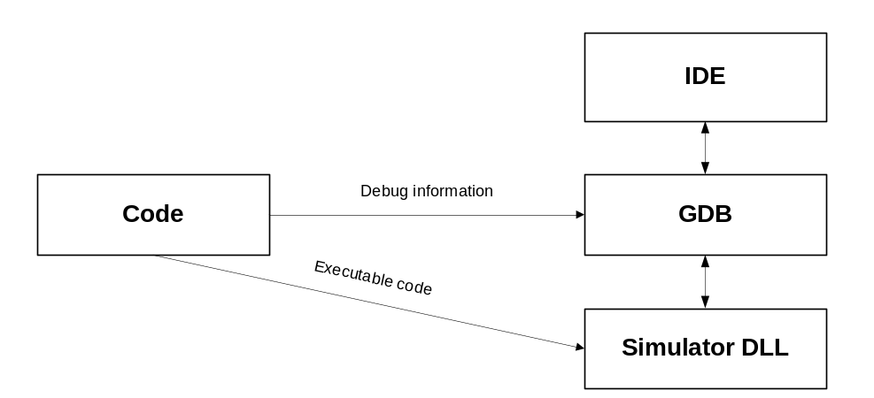

Goal of the tool chain is to provide a development environment that allows developing code for the new controller platform. The main components in the system are listed below.
- IDE: The IDE allows writing code that can be compiled and loaded into the simulation environment. It is used for interactive debugging of the developed code and visualizes the code, data and internal HW related states that are simulated and debugged.
- GDB: The GDB keeps track of debug information and provides facilities for controlling the simulator and for obtaining status information from the simulator. This information is then presented to the user in the IDE.
- Simulator DLL: The simulator is responsible for virtually executing the generated code. It consists of an instruction set simulator which can interpret the executable code. Apart from the CPU simulation, also the MMU of the P40 architecture is included in the simulation. The MMU holds code and data memory and handles memory access requests of the CPU according to defined access control rules.
- Code: This is the source for the simulation to simulate. The code is compiled into a binary format which can be used for simulation and contains debug information.

System Architecture
This chapter gives a detailed view of the component architecture.

Component View

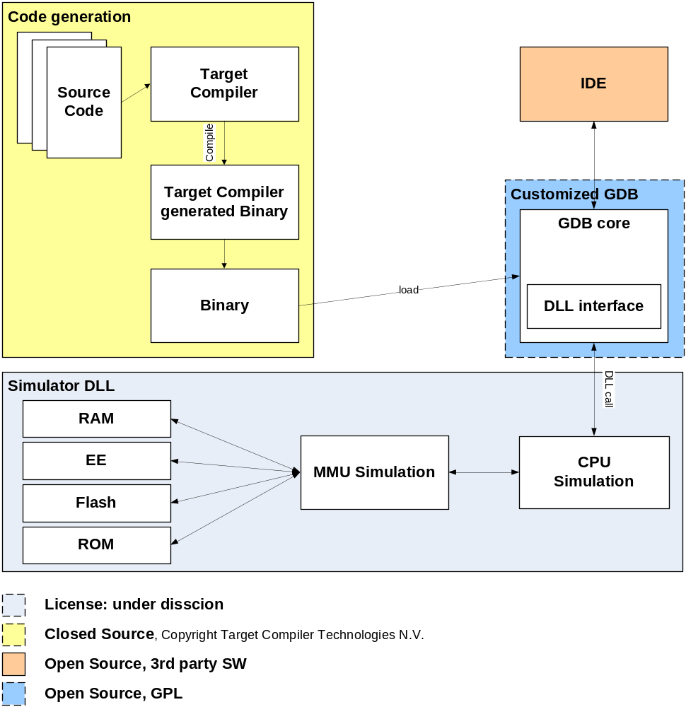

Module design

Module “Code generation”
This module represents the code generation that generates code that can be loaded into the simulator.

Source Code
The source code files.

Target compiler
As mentioned in chapter Terms and Abbreviations, Target is a company name and further details could be found under http://www.retarget.com/
The actual used “Target” compiler for MRK3 is 10R1.3

License
Closed Source.
Copyright© 1996-2010 Target Compiler Technologies N.V.

Distribution
The SW copyright protected by Target Compiler Technologies N.V. and can only be obtained from Target.

Target binary
This is the binary file that is generated by the “Target”-environment. The format is similar to the known ELF format, but has proprietary extensions.
The incompatibilities to the standardized ELF format of the extension are listed below
- Different definitions for e_version
- Target defined memory segment:
Segment with p_type = 0x70123456
- Target defined memory names string table:
Segment with p_type = 0x70123457
- Target defined stack area segment:
Segment with p_type = 0x70123458
- Target defined noinit area segment:
Segment with p_type = 0x70123458
- Target defined RTS info segment:
Segment with p_type = 0x70123459
- Target defined Hosted C-lib segments:
Segment with p_type = 0x70123460
- Target defined specific Dwarf2 attributes:
- Target defined EOL info segment:
Segment with p_type = 0x70123461
- Location lists are stored like this in .debug_loc sections
- Location expressions are stored like this in .debug_info sections

Modified “Target” binary
Due to the fact that “Target” has redefined the ELF magic byte (e_version) format, the “Target” binary cannot be correctly recognized by the GDB environment. Therefore the magic byte is altered to the correct magic byte value of ELF. All other extensions are parse-able by modified GDB.

Module “Customized GDB.exe”
This module represents a custom built GDB.

GDB
www.gnu.org/software/gdb/
The main purpose of GNU Project Debugger is to offer a framework that allows simulating and debugging code created for the P40 platform.

License
Open Source
GPL

Distribution
This SW package is under GPL can be downloaded under http://www.gnu.org/software/gdb/download

GDB extensions
This module provides the ability to understand the debug information generated with the Target compiler and provides an interface to the external simulator. The extensions are modifications of the publically available source code of the GDB and build a customized GDB. The extensions are under development.
The main features of the extension are listed below
- Ability to understand P40 debug information, generated with the “Target” compiler environment
- Implementation of an interface to an external simulator. This simulator is compiled as a Win32 DLL and is accessed from the GDB by calling functions which are exported by the DLL.

License
Developed by NXP. License situation not clear yet.

Distribution
License situation not clear yet, but can be obtained from NXP upon request.

Interfaces
This module has three interfaces for interaction. One interface is for loading code and debug-info into the simulation. The second interface is used for controlling and obtaining status information from the external simulator and a third interface is responsible for providing information to the IDE to visualize the simulation.

I: Load
This interface allows loading a binary file into the memory inside the simulator via the GDB. The symbol information is hold inside the GDB. The binary must be compiled with the “Target Compiler”.

I/O: DLL calls
The simulator DLL is a Win32 DLL that is loaded into the memory of the GDB. The DLL is not mandatory to compile the GDB, but needed to start the GDB executable.

I/O: Data
This interface allows visualization of data and states of a running simulation. The GDB can read and write data into the memory of the simulation. Using an IDE, this functionality can be provided in a more convenient way to the user.

Module “Simulator DLL”
This module implements a instruction set simulator of the P40 architecture.
It is a standard Win32 DLL that exports functions. The exported functions are listed below and are used by the customized GDB to exchange data and/or trigger actions.
- Dll_GetRegisterCount
- Dll_GetRegisterName
- Dll_GetRegisterSize
- Dll_GetMemSpace
- Dll_GetPrologueAnalysis
- Dll_GetDwarf2RegisterNumber
- Dll_SimReset
- Dll_SimResume
- Dll_SimRead
- Dll_SimWrite
- Dll_SimReadRegister
- Dll_SimWriteRegister
- Dll_PrintInsn
- Dll_PrintReport
At the beginning of the simulation the GDB loads data into the simulator by calling Dll_SimWrite. Afterwards the simulation is started by a call to Dll_SimResume. Whenever the simulation is stopped, control is returned to the GDB, which can then examine the state of the simulator and provide this information to the user.

License
Developed by NXP. License situation not clear yet.

Distribution
This module contains confidential information and must not be made publically available. Optionally, a stub DLL without functionality can be made publically available (incl. source code; GPL) so that the GDB executable can be launched.
Module “IDE”
This module represents a visual user interface to interact with the simulator. The actual used IDE is Eclipse with the following used functionalities.
- Edit and generate source code files
- Compile and link the source files into the “Target” binary file format
- Correct “Target” binary file magic byte format
- Load binary file into GDB simulation
- Interface to the GDB debug functionality (breakpoints, read/write variables and memory, …)
- Visualize disassembly

License
3rd party SW solution.

Distribution
Used SW solution not yet defined.

Acceptance Reviews and Approvals
- Reviewers
Name | Role | Location | Date
 |  |  | <YYYYMMDD>
 |  |  | <YYYYMMDD>
- Approvers
Name | Role | Location | Date | Signature  (if required)
 |  |  | <YYYYMMDD>
 |  |  | <YYYYMMDD>

Document management

Abbreviations and terminology
  - Abbreviations and terminology
Abbreviation | Description

Referenced documents
  - Referenced documents
Doc ID | Doc Title | Version | Author | Issue Date
 |  |  |  | <YYYYMMDD>
 |  |  |  | <YYYYMMDD>
 |  |  |  | <YYYYMMDD>

Distribution
  - Distribution
Name | Role | Location

