**Gordo Bot**



*Project Proposal*

Team 6

Zachary Laguna

Raney Ankele

Reid Morse

Cody Nguyen

Thomas “Jake” Rod

Nicholas Soliman

Department of Computer Science

Texas A&M University

February 21, 2022

Table of Contents

Executive summary 2

Introduction 4

Needs statement 4

Goal and objectives 4

Design constraints and feasibility 4

Literature and technical survey 5

Proposed work 7

Evaluation of alternative solutions 7

Design specifications 8

Approach for design validation 11

Engineering standards 11

Project management 11

Schedule of tasks, Pert and Gantt charts 13

Economic analysis 13

Societal, safety and environmental analysis 14

Itemized budget 14

References 15

Appendices 15

Product datasheets 15

Bios and CVs 15

# Executive summary

The Gordo Bot is a tool designed to simplify a user’s experience with the process of cooking or any other form of meal preparation. Since a large portion of individuals have a tendency to resort to eating fast food or processed foods when time is too valuable to waste cooking. Gordo Bot helps incentivize users to cook their meals not only in a timely manner but also with an increase in simplicity. This product is designed to increase the overall healthiness of customers by decreasing the amount of time and difficulty of the cooking process, thus encouraging individuals to create healthy meals in the comfort of their own kitchen. One of the main goals of this project is to have a device that the user can interface with to search for recipes that best suit their preferences. This device will also have the ability to understand the necessary ingredients for the recipe/recipes and properly dispense portions accurately. This feature will allow for users to simply select a meal they would like to make then immediately have all of the ingredients in the correct portions laid out in front of them. Then users can follow an on screen guide on how to go about creating their dish. With just a few taps on Gordo Bot’s on screen display the user will have all the information they need to begin the cooking process.

While the concept of the Gordo Bot may seem simplistic, the steps to actually design and implement this product are quite thorough. The four main components of the Gordo Bot are the user interface display, Raspberry Pi, measuring device, and motorized storage containers for the spices. The user interface is used to select a recipe from a database and pass that information to the device. This information is what will be used to determine the required seasoning as well as the quantity. The Raspberry pi’s purpose is to control any moving parts via GPIO. While the measuring device is used to obtain exact measurements of corresponding ingredients. Finally, the storage containers will store spices and have the ability to rotate to the spice selected by the user. All these components are further explained in the “Design Specifications” in Section 4.2. But the team is well suited for all the challenges that lie ahead. We have a diverse mix of individuals with various specialties. Each member will primarily be focusing on different components of the Gordo Bot but still managing to work as a team to ensure proper synchronization between all of the various components of this project. Our constant communication will ensure that all members are aware of the current status of the project as well as the necessary tasks to be completed in a hierarchical manner of prioritization.

The final product will be a medium-sized kitchen appliance with a simple user interface. The clean and minimalistic design hopefully encourages the user to not be overwhelmed by its various features. The user interface will be easy to understand and navigate allowing the experience to be smooth and without confusion. The main appeal for a customer to purchase this product is to simplify their everyday life by saving time that the user may need. The Gordo Bot will have the ability to technically prepare food faster than any delivery service or by purchasing from a restaurant. Not only will this product save time for the user but it will also inevitably save money since expenses are generally more expensive from a restaurant as opposed to a local grocery store. The Gordo Bot is targeted at individuals who would like to improve their diet as well as free up time and money wasted from purchasing meals from restaurants regularly. Many statistics will be explained thoroughly to justify this statement as well as the logic behind the Gordo Bot itself. The following sections will provide detailed information regarding the need for this project, the goals and objectives, the design, and how the development team will go about creating this product.

# Introduction

Cooking at home has become more appealing these days as covid-19 frightens the populous and healthy, home-cooked meals become an appealing alternative to greasy take-out food. According to a new study by Hunter, a consumer market research firm, 71% of people in the U.S. say that they will continue to cook at home after the end of the pandemic. However, consumer culture has promoted that ordering takeout or using Uber Eats and Door Dash are more efficient methods of procuring sustenance, thus producing sub-optimal cuisine from our stay-at-home chefs. [1]

## Needs statement

The study goes on to find that about 25% of these cooks are learning more and building confidence in the kitchen, and almost another 25% are just as confident as they have always been. The latter could be some that were always confident or some that were never confident, implying that some of these cooks could still struggle with some of the basic steps when cooking at home. Following a recipe with precise and intricate steps can be difficult for new cooks when dishes increase in complexity, and measuring ingredients takes time and practice. What can be done to assist amateur chefs in the kitchen who are intimidated by long recipes and struggle measuring ingredients? [1]

## Goal and objectives

This project aims to assist amateur cooks with prepping and preparing recipes so that the cook can focus on the actual cooking rather than the gathering, measuring, and mixing of ingredients. Tedious parts of cooking should be automated. With this in mind, there are several objectives planned to achieve this goal.

At the minimum, our project should be able to pull and display recipes the user through some interface, whether that is with a screen on the device or a webapp. We would start with hand selected recipes. This should be handled by a Raspberry Pi on the device, communicating with some web server/database or locally hosting this information.

The robot should be able to understand a recipe’s requirements and dispense the ingredients with correct measurements into a container. The ingredient selection will be handled by some servo controlled by the Raspberry Pi, and the measurement of ingredients will be handled by sensors (either by weight and/or flow rate). The robot can be expected to perform this task in a kitchen at a reasonable pace (faster than manually measuring and mixing ingredients).

Ideally, recipes could be scraped from the internet (assuming the recipes are publicly available to use) and stored in a cloud database. These recipes would be parsed and measurements would be formatted for the Raspberry Pi to understand and use as instructions for the various sensors on the device. A search option could be implemented to easily find different recipes. Options could be chosen using voice commands.

There are objectives that are not a top priority such as implementing simple accounts that would allow users to save recipes and provide them with recommendations or keeping track of how much of each ingredient a user has and reminding them to get some more.

## Design constraints and feasibility

The constraint to take into consideration is space. Counter space in a kitchen is limited, so the device should not be larger than the average kitchen appliance. The general goal of the project is achievable with a servo, Raspberry Pi, and sensors, however, the efficiency and accuracy of these devices in our particular application is unknown. Each device will have a range of accuracy that needs to be accounted for. Recipes that require precise/small measurements may not be achievable without higher (expensive) sensors or fine-tuning. Experimenting will need to be done to understand the limitations of the sensors.

Another limitation of the hardware will be the speed to choose, measure, and dispense the ingredients. The weight of all the ingredients will put some strain on the servo, so a servo must be chosen within the budget that can handle the weight of the ingredients.

Powering all the devices must be considered as well, the GPIO of a Raspberry Pi may not be able to handle all the interfacing of the devices, so an external power solution should be considered.

The total cost of the device is not expected outside of the budget, but the time frame this project is produced will limit how much can be done with the device. The minimum objective stated previously should easily be achieved, but the amount of time remaining will dictate the “stretch goals” of the project.

# Literature and technical survey

The main goal for our product is to assist amateur, time-crunched, or simply tired at-home chefs. It’s hard to automate telling when a dish has turned just the perfect color, but it is possible to assist many people to speed up the process by doing some common tasks. A lot of prep time and confusion comes from the measurement ingredients. This is the focus of our product. There are many common measuring tools available, but our product aims to combine and automate them.

1. Common Sets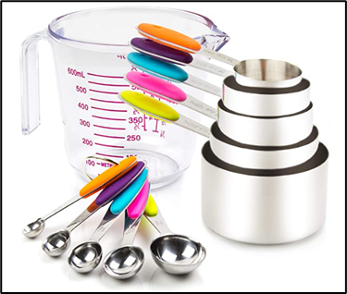

The most common types of measuring tools used are those in sets such as shown to the [left](https://www.amazon.com/Measuring-Stainless-Including-5-Piece-Transparent/dp/B07H2TKNNV/ref=sr_1_2?crid=KVTTFTJUZB3V&keywords=kitchen+measuring&qid=1645377639&sprefix=kitchen+measuring%2Caps%2C102&sr=8-2). They are common because they are simple, affordable, and have a wide application. However, they are often confusing and troublesome to use due to the many pieces involved. They are a pain to clean. They all look the same, making it easy to mistake one for another. The many pieces can take up a lot of space in kitchen cabinets or drawers. Lastly, their small size brings the possibility of losing one or two pieces of a set.

1. Adjustable

To address the issue of easily lost pieces, there has been an invention of adjustable measuring devices. These have a movable divider or plunger which can make a single device able to encompass a similar function as the multiple cup set. These adjustable devices are especially useful for measuring spices, which often require very small portions and each spice typically needs differing amounts.

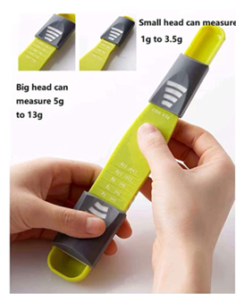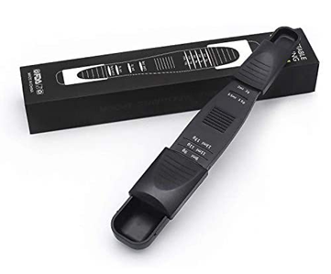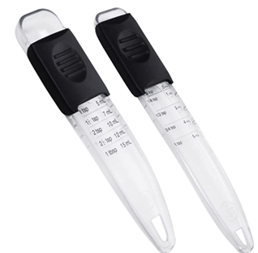

The above are several examples of these kinds of adjustable spice devices ([link 1](https://www.amazon.com/PUZERM-Adjustable-Measuring-Semi-Liquid-Ingredients/dp/B08SHBYJZH/ref=sr_1_46?crid=1SSPUQW0IVH9&keywords=kitchen%2Bmeasuring%2Badjustable&qid=1645377706&sprefix=kitchen%2Bmeasuring%2Badjustable%2Caps%2C87&sr=8-46&th=1), [link 2](https://www.amazon.com/Generic-Adjustable-Measuring-Spoon-Black/dp/B08RDYGLS8/ref=sr_1_47?crid=1SSPUQW0IVH9&keywords=kitchen+measuring+adjustable&qid=1645377706&sprefix=kitchen+measuring+adjustable%2Caps%2C87&sr=8-47), [link 3](https://www.amazon.com/Professional-Adjustable-Measuring-Ingredient-Dishwasher/dp/B09P4K7PR3/ref=sr_1_45?crid=1SSPUQW0IVH9&keywords=kitchen+measuring+adjustable&qid=1645377706&sprefix=kitchen+measuring+adjustable%2Caps%2C87&sr=8-45)). The first two are measured in grams, while the last set is for tablespoons and teaspoons. This discrepancy in units is a problem across all measuring tools, especially for an amateur who may find a recipe online they’d like to try but have conflicts with measurement metrics. With that said, these do minimize space taken up and have fewer pieces to keep track of, but can be more complicated to clean in the grooves of the moving parts. There are also adjustable types made for liquids or larger amounts of dry ingredients, to which the same problems apply, such as shown in the [first picture below](https://www.amazon.com/OXO-Good-Grips-Adjustable-Measuring/dp/B00A2KDAIW/ref=pd_day0fbt_img_2/136-8989450-3561722?pd_rd_w=Yi6AZ&pf_rd_p=bcb8482a-3db5-4b0b-9f15-b86e24acdb00&pf_rd_r=8BPNXFT2KT5W1RV9NGER&pd_rd_r=b03cd237-d979-471a-aa94-414ba4d017b5&pd_rd_wg=GXUmc&pd_rd_i=B00A2KDAIW&th=1). Finally, there are several products that attempt to use creative methods to accept many units of measurement, such as in the [second picture](https://www.amazon.com/Kare-Kind-Adjustable-Measuring-Spoons/dp/B08J4B94Y5/ref=sr_1_38?crid=1SSPUQW0IVH9&keywords=kitchen+measuring+adjustable&qid=1645377706&sprefix=kitchen+measuring+adjustable%2Caps%2C87&sr=8-38), but often end up looking odd.

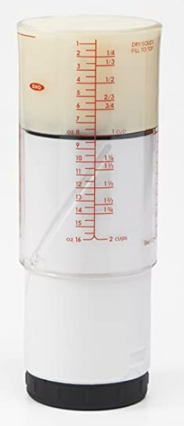 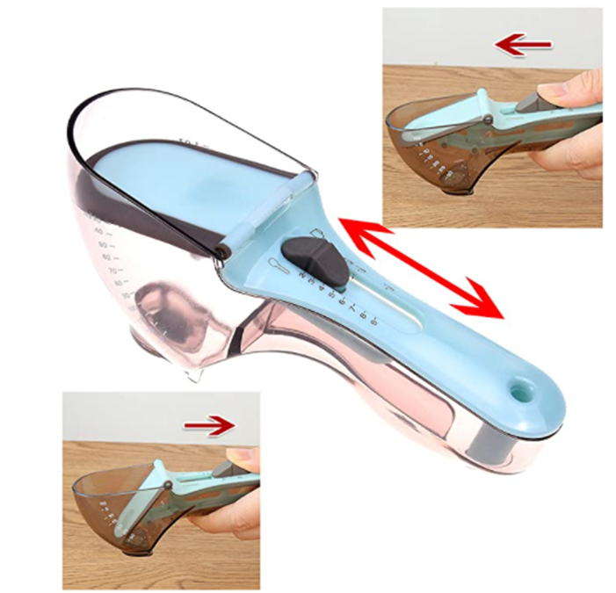

1. Select-A-Spice

The most notable competing product available on the current market is the [Select-A-Spice Auto-Measure Carousel](https://www.amazon.com/dp/B0000VLQTS/ref=as_li_ss_tl?linkCode=ll1&tag=fwautospicedispenseramazonmgandara0120-20&linkId=6283c7feef37ff826604feb0dc2c689d&language=en_US&th=1). It is designed to function as a spice rack made to neatly organize a large variety of small bottles but also doubles as an easy-to-use dispensing tool.

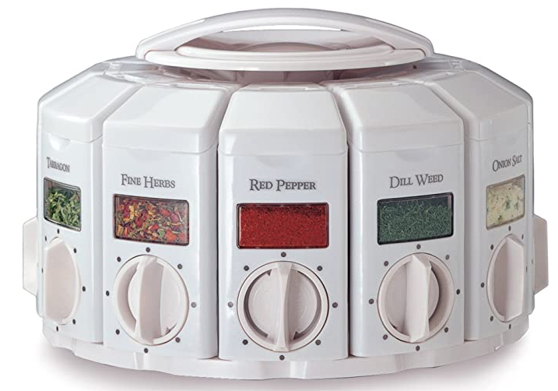 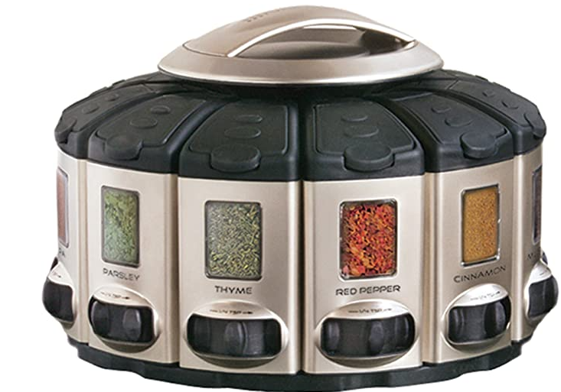

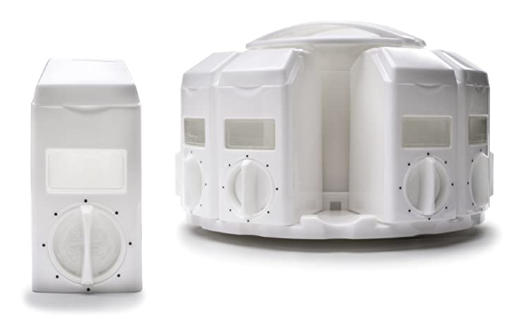 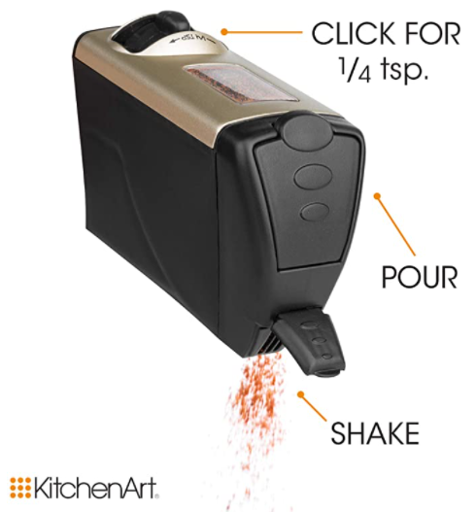

The Select-A-Spice comes in two styles that function the same: white with a dial and satin with a slider. The canisters are removable from the carousel. The spices can be filled in the canisters, then an amount can be selected, allowing the spice canister to shake out this desired amount. There are labels that can be placed to differentiate spices. Multiple carousels can be stacked.

This product does very well in achieving the aim for our product, but it is limited to spices only. Ideally, we would be able to measure any type of substance in any measurement unit. Measurement units have a common conflict between metric and custom U.S. units. There are different measurements for liquids and solids. Finally, there are some measurements that must use a scale. We aim for the ability to measure fluid ounces, liters, milliliters, cups, tablespoons, teaspoons, grams, pounds, mass ounces, etc. for all cooking needs.

1. Miscellaneous

While we are creating this device, it would not be so difficult to add a couple of other low-effort but helpful devices. This may include things like a thermometer or timer, often used in recipes.

# Proposed work

## Evaluation of alternative solutions

To come up with our final design solution, we first needed to draft up a wide variety of solutions and select which would be best for our needs and goals. Some of the other solutions that we initially came up with were the following:

* Linear design

One of our very first designs was similar to what we are currently doing with the Gordo

Bot. However, in this design, the spices were not held in a spherical storage chamber

that rotated. The spices were stored in containers in a linear fashion. While this product

may have been easier to design and implement, it would have taken up significantly

more kitchen space, making it less ideal than our current design. So we figured that

a few extra steps to help build a realistic solution for the customer is what would be

ideal.

* Kitchen All-In-One

This design was an extension of the Gordo Bot in which we got slightly carried away

with the various features. The design consisted of not only a seasonings/spices

automated storage unit, but also things like a thermometer and other sensor used for

cooking to be attached to the main body of the Gordo Bot. However, they were all

wireless tools that could be carried anywhere in the kitchen but they still could

communicate with the main device. While this version of the Gordo Bot seemed quite

impressive and would meet more needs than our current Gordo Bot, it came with a few

cons. Such as, increase in price of the project, as well as an increase in complexity,

which results in requiring more time than we currently have. To keep our solution within

the scope of our project we ensured that our project, wouldn’t consist of unnecessary

extras that would take away from the time to fine tune the base Gordo Bot model.

* Existing products

Of course, the customer could always buy some combination of tools found in the Literature and Technical Survey section. Especially the adjustable liquid measurer and the Select-A-Spice, measuring would be made much easier. These are simpler in design. If something went wrong with one part of our product, it would affect all functions, while separate tools would not have this problem. However, it is usually much more convenient to have all related functions centralized in one place. Furthermore, since we plan to add an interface function with recipes to automate the measuring, the do-it-yourself tools leave a lot to desire compared to our product.

* Rate of Pour measurer

Another of our initial ideas was more similar to the existing products in that it would have been a kitchen tool rather than appliance. The idea was a kind of universal cap which would be placed on the opening of a container. This cap would contain a flow sensor, which would then calculate the amount poured based on this flow speed and area, would determine how much time was needed for the desired amount, and then would close the opening of the container. It sounds like a very good idea, but had more problems the more it was discussed. Firstly, many bottles are of differing sizes. Secondly, tools capable of this calculation would be quite large, cumbersome to place on top of any kind of container. Thirdly, this may have a wide margin of error. Some would be solids, some liquids, some require large amounts, and some require very little. This could cause a lot of bugs in creating the system. Lastly, a device like that would likely require a lot of effort cleaning in between uses and changing containers.

* Speech recognition adjustable

Essentially the same as existing adjustable tools, but made into a smart tool. Some kind of singular tool which can adjust between very small and relatively large sized portions based on set voice commands. Would ideally account for many units of measure. Very useful, but wanted to make a smarter, more automated appliance.

## Design specifications

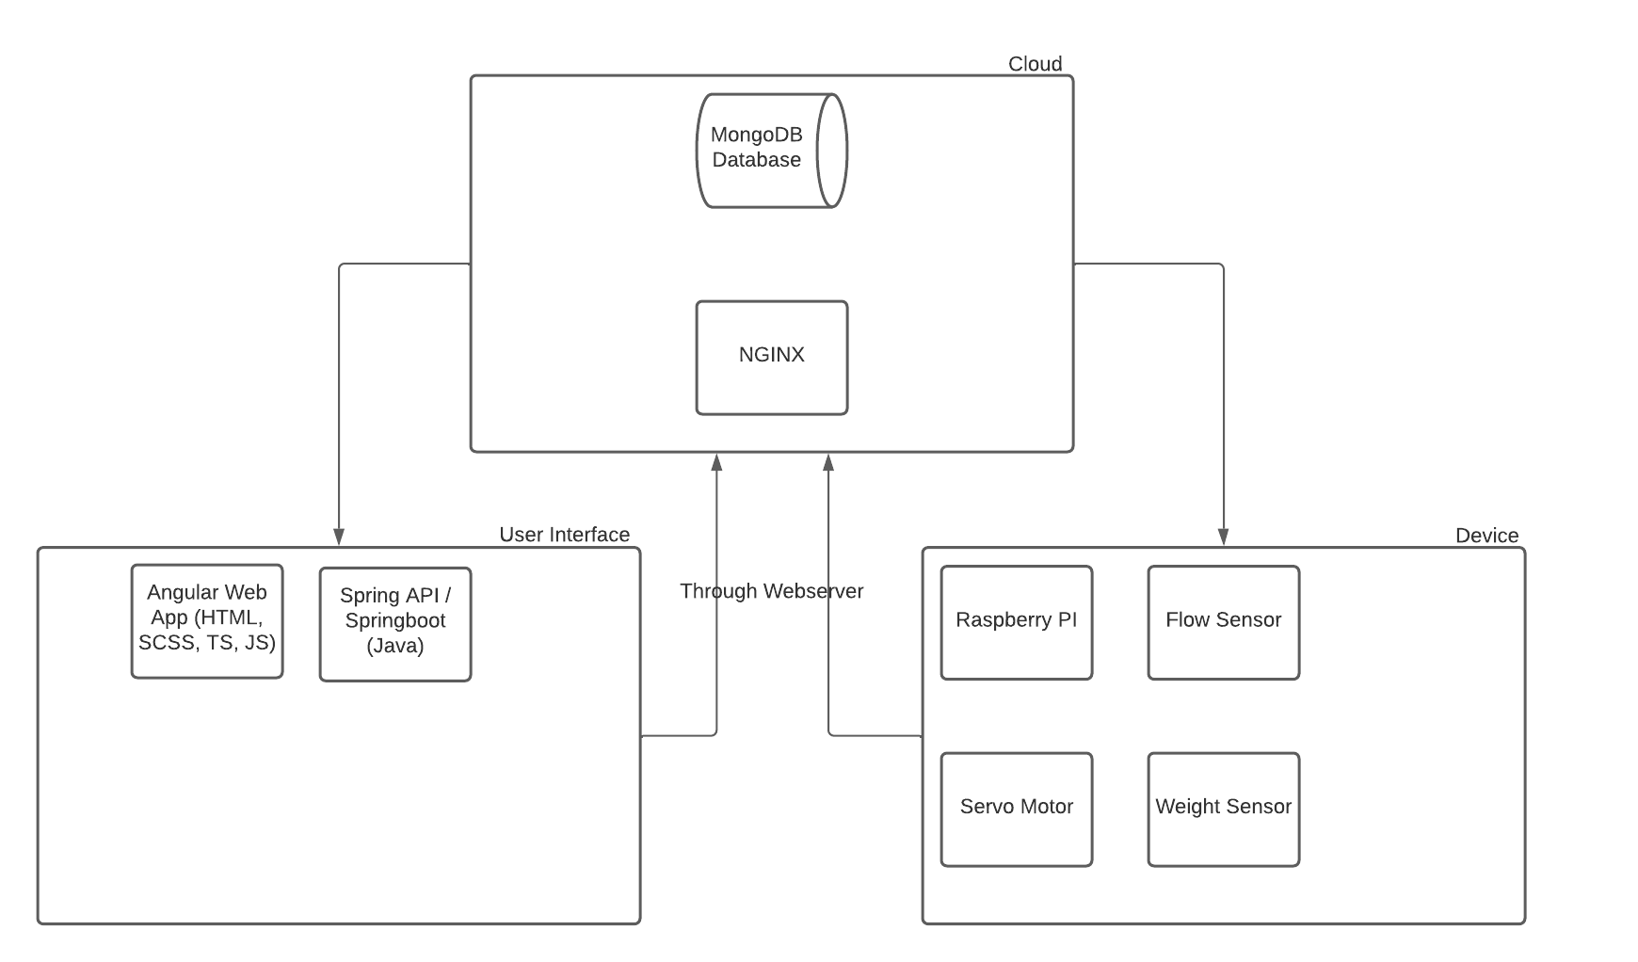

Our design has three main components: the user interface, the cloud, and the device. all three of these parts must work in harmony for our device to execute the desired task of dispensing the correct amount of substance in sync with the current recipe being made.

The user interface will be built in Angular which is a JavaScript framework. Angular uses HTML, SCSS, and a Javascript variant known as Typescript. Angular will be beneficial to use because it decreases the complexity and workload it takes in order to build a web app when compared to designing using purely HTML, CSS and JS. The user interface should be clean, orderly, simple to use and highly functional. This user interface is also usable through a variety of devices through an Angular framework known as Ionic. Ionic is a framework that allows one source code to be deployed across a multitude of devices both IOS and Android. From this user interface, the user will be able to select which recipe they would like to cook or a specific amount of seasoning or liquid to dispense. The user will be able to pull up a variety of recipes on their screen, examine it, and “push play” in order to start the recipe. Each recipe will stop at the parts where fluid / seasoning needs to be dispensed from the device and await an input from either the UI or the button on the physical device.

Once an input is chosen, the data they have entered is passed through an API which is built through spring boot. Spring is a Java API which joins the UI component with the cloud component. The API’s main purpose is to initiate certain functions on the Gordobot by sending signals from the cloud to the onboard Raspberry Pi. The API will pass data through a web server (NGINX) which allows the solution to manage the devices so that Gordobot can be controlled from multiple input sources. The API will also be able to store certain pieces of data into a MongoDB database again going through the web server.

As stated before, the data is passed through a web server that allows multiple devices to be used as input for the device. The webserver will receive all input API calls and will respond to each of the input devices the current status of the physical Gordobot. The webserver will allow multiple devices to track progress of the Gordobot. This web server is implemented through NGINX

Gordobot’s main goal is to dispense the proper amount of liquid / seasoning based on progress in a recipe. It can do this through its physical onboard weight sensor and flow meter. Both these components will serve as data collection to determine when enough product has been dispensed. It will accomplish this by activating and closing a value after a certain threshold has been reached. Put another way, the raspberry pi receives a command to dispense a certain amount which then causes the valve to open and the sensors to start detecting. Once the sensors meet the correct threshold for the calculated amount of product, the valve will close. The physical actions are all controlled by the Raspberry Pi.

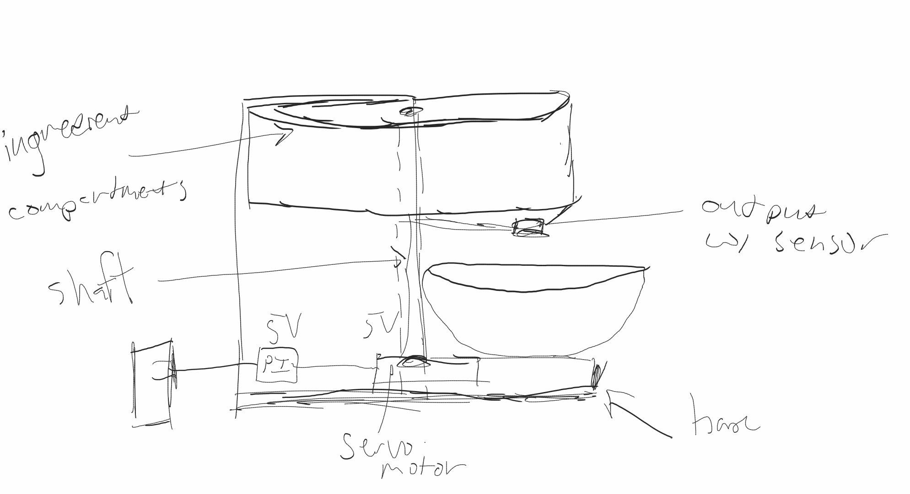

According to the diagram above, the physical device consists of a spinning wheel which is attached to a Servo motor. Within this spinning wheel, there are compartments for different ingredients either solids or liquids. The servo motor will lock into place the desired ingredient slot and will dispense the desired amount of product using a flow sensor and a weight sensor in order to determine the amount of product distributed. The decision for which ingredients light should be activated at any given time is controlled by the Raspberry Pi directly which sources its instructions from the cloud.

The purpose of having two different measurements devices is so that we can cross-check the values and insured to a very precise degree that the correct amount of fluid or so that has been dispensed. additionally, some products work well with different styles of measurement. For example, liquid such as vinegar may be more accurately red through a flow meter rather than a weight sensor.

Each individual storage container is removable and washable. Each container acts as a modular component that is able to be separated from the device and remain functional. The reason for this is so that we can allow products to be stored differently. For example, if a user wants this store a perishable good such as milk they can store the substance in the refrigerator rather than leaving it out on the device.

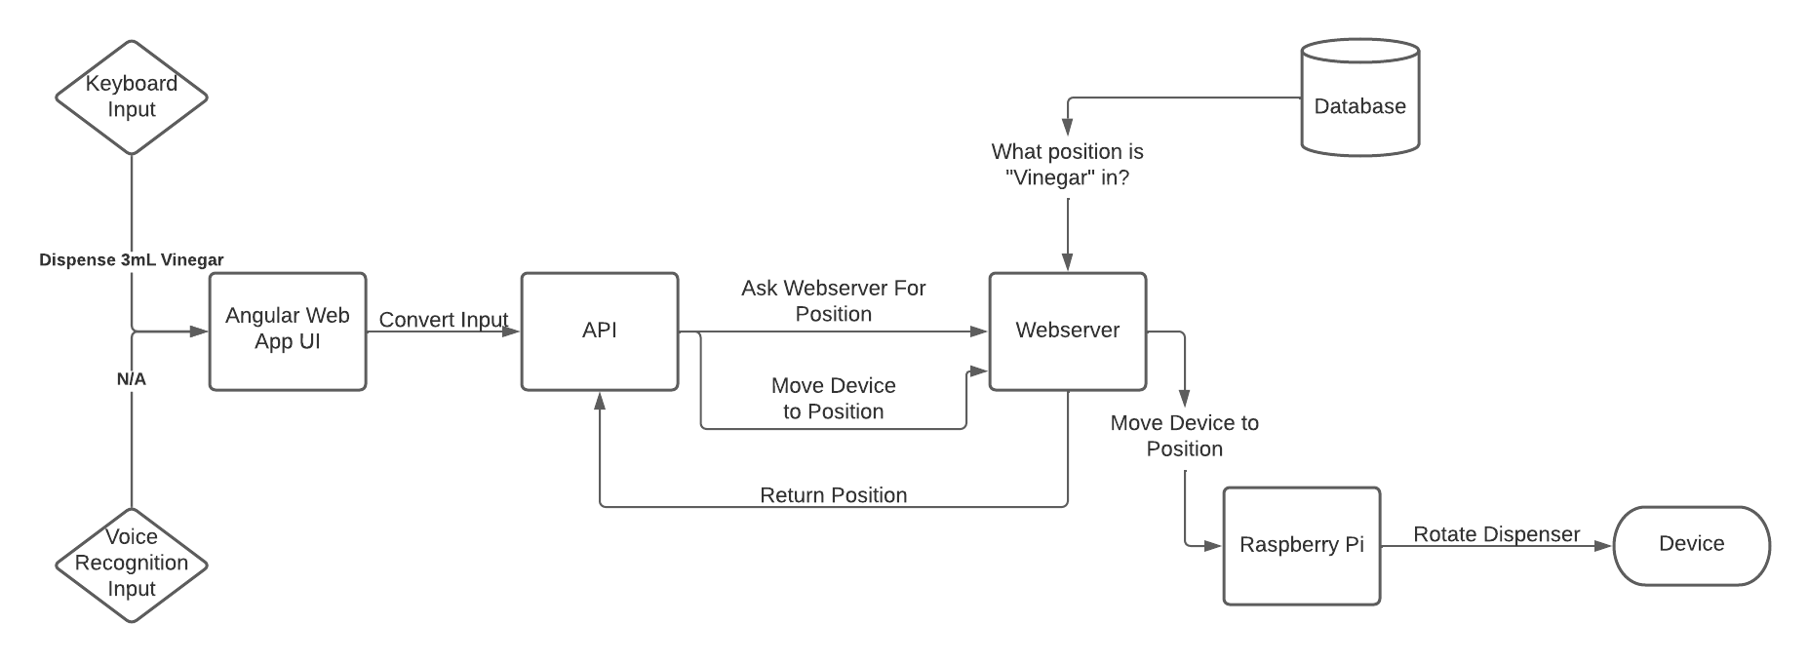

An example control flow for our device is outlined above. In this example, the user asks the device to dispense 3 mL of vinegar. this input is passed from the keyboard into the Angular Web App UI. this user interface should have a section where users can enter in specific settings. This input has been converted into a series of parameters for the API to handle. The API then asks the web server for the position which vinegar is stored in which is retrieved from the database. This information is returned to the API. The API then instructs the Raspberry Pi (through the web server) to move the device to a particular position. This position is then converted into a rotational degree amount corresponding to the correct amount of rotation needed for the servo motor to place the desired dispenser into position.

The purpose of dividing up each of these segments is so that the development phase is easier to contain. We will assign different people particular segments of this project and will merge the individual components at the end. We will also go through a series of test cases to ensure that our project meets the standard which the class demands.

## Approach for design validation

The project is split up between the different components as shown in the design specifications. In the beginning, each component will be individually tested, to ensure that it works correctly in an isolated environment.

The hardware components will be tested and calibrated to ensure each component works as expected. The input and outputs of the sensors and servos will be controlled and directly measured from the Pi. The user interface and cloud components will send and receive requests/data, checking for the expected output from a given input.

Once it is guaranteed that the components of the project work individually, they are combined and new tests are performed. The user interface will send a request to the server to prepare a simple recipe, which in turn will communicate the instructions to the Pi. The Pi should correctly prepare the ingredients at this point. This is the point where the system performs its intended function, and validation beyond this will likely be used to fix any kinks that have come up during the process.

After the simple cases are tested, the edge cases should be tested for the system as a whole. This would include scenarios where the user is missing an ingredient necessary for a recipe, or the user provides the “wrong” input such that the recipe is not actually available. More cases such as these will naturally be found as the device is fine tuned.

# Engineering standards

## Project management

Our team represents a wide range of computer science disciplines as we all have experience in different areas. We gather these experiences through various modes such as internships, projects, research, and class assignments.

Reid- Reid is our expert on microcomputer systems. He has had experience working on a variety of topics such as IO control, machine learning, and software to hardware robotics. Reid will work closely with Cody in order to assemble the device but will mainly focus on the bridge between the cloud and the Raspberry Pi. He needs to translate the signal that comes in from the cloud into a series of commands that will instruct the device to perform a certain action.

Cody - Cody is our expert on sensors and hardware device technology. He will be responsible for assembling the physical device with the help of Reid and installing the sensors to ensure they function correctly with the Raspberry Pi. Cody will essentially be working on the bridge between the Raspberry Pi and the device Hardware.

Jake- Jake is our expert on cloud services technology. He has experience working in class on various different programming projects and knows a multitude of different languages. Although he does not have any experience with this particular task, I am confident he will be able to succeed in it. Jake will be responsible for making sure data flows from the user interface through the web server into the device and vice versa. Essentially, Jake will be managing the cloud services which enables our product to be able to be used simultaneously by multiple devices. Jake will also be responsible for handling the database which stores information about recipes and measurement amounts. Jake is our recorder so he will be responsible for recording any meeting notes.

Raney- Raney is our expert on user interface design. She has had experience working with web programming languages through her class work. She knows a fundamental baseline of HTML, CSS and JavaScript. She will be responsible for designing the user interface maximizing user satisfaction by providing an interface that is easy to use, simple, and spans the entire desired range of function.

Nick- Nick is also our expert on user interface design. Along with Raney, he’s also had lots of class experience in past projects working on web design. He will be responsible for creating the user interface along with Raney. The user interface is probably one of the most complicated parts of our project and multiple hands will be needed in order to construct it within a reasonable amount of time.

Zach- Zach is our expert on API design. He has had a lot of experience working on web development in both school projects and in internships. He has experience working in a variety of programming languages and technologies that are used within this project. For this reason, he will act as the project manager, and will assume any responsibility. He will be responsible for creating the API which translates user input into a signal that is passed into the device through a web server. This layer will make it possible for commands to be translated from the web into a physical device. Non technology-related, he will be responsible for any project management documentation, and any financial statements that must be created pertaining to this project. He will also be responsible for testing different components of the project to make sure they work in congruence with each other.

The strategy that we will use in order to keep our project organized Is Agile development. We will keep track of our progress through a program named Jira which is a tool which enables teams to quickly and efficiently work through an Agile development work cycle. The program code will be stored on a GitHub repository which will have branches that will be updated at the end of each day. Branches that are finalized will be pushed to the master branch. Any documentation will be created and stored on Google Drive.

## Schedule of tasks, Pert and Gantt charts

Below is a schedule of the tasks that will be completed over the semester.

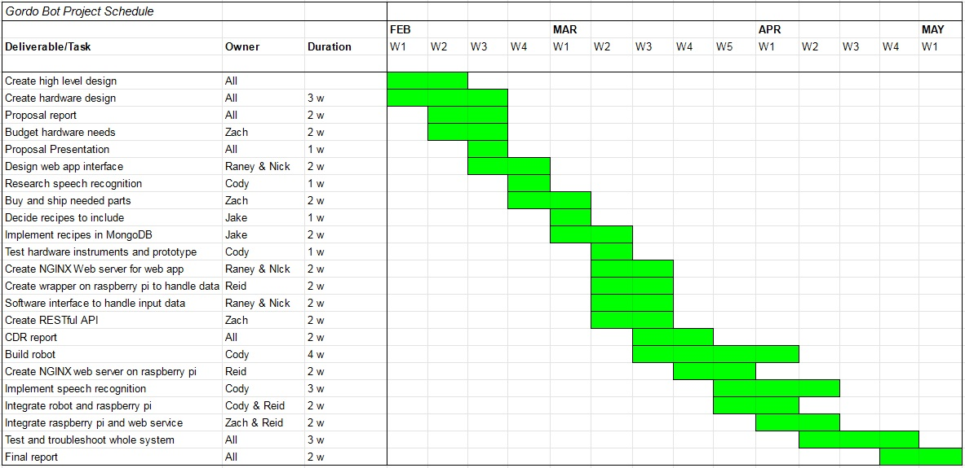.

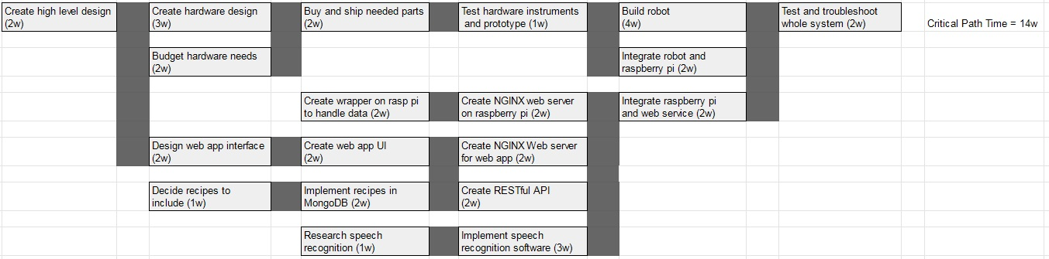

## Economic analysis

Economic Viability

The expected volume production cost is estimated to be about $150 per unit.

Sustainability

Most components that require purchasing are available across multiple vendors. Servos and valves are available from at least 3 different vendors on Amazon, and 3-D printing material is available from at least 2 different vendors. The database and web application will require continued maintenance to ensure the system remains secure and active. The device may require updates to be pushed to it for the software present on the product. It is recommended that the user clean the compartments of the product as needed.

Manufacturability

The measurement error for material regarding the dispensing of ingredients should be small to avoid misalignment of the outputs, which would negatively impact the measurements made by sensors. To decrease the likelihood of this error negatively affecting the performance, one orifice can be larger than the other to increase the availability of error. The worst-case would be if the compartment outputs were +0.5% and the valves were off by -0.5% leading to absurd misalignment and inability to dispense ingredients. Another point of error would be the fabrication of the axle that the servo turns to switch ingredients. So long as the axle isn’t warped in any way, there should be no issue with the axle itself. Any hole that is required for the axle would have to have grooves to hold the axle in place with the wheel of compartments. The grooves must be as exact as possible, but as long as it catches, the alignment of the axle is fine 95% of the time. Assuming that 95% of the products pass production, the expected production yield would be 95 in 100. The accuracy of the product can be tested by running water or salt through it and observing that the amount dispensed is equivalent to the requested amount.

## Societal, safety and environmental analysis

Our product would result in more at-home cooking, which would improve the quality of life as at-home meals are generally healthier than the mass-produced counterparts. Eating at home would also help save money since buying ingredients and cooking at home is cheaper than buying take out due to the labor cost. The reduction of business could hurt the food industry for both large chain restaurants and local shops alike. It is possible that promoting at-home cooking and finding recipes online could also promote cultural diversity in food, in that there would be more options to choose from than the finite possibilities dependent on nearby restaurants. Furthermore, the app will likely track voice commands and keep record of preferred foods. This information will not be shared or sold to others. The food preferences seem negligible in the worst case scenario. Some people dislike speech recognition products such as Alexa, Siri, or Google Home as they are essentially constantly listening to conversations. These are becoming increasingly popular, however, with relatively little consequence, so in the end this is a user preference. Lastly, as with all smart technology, reliance on the product could dull certain skills and critical thinking in the field of cooking; this is not necessarily a bad thing to the average person, who may choose to spend the saved time on other fields instead.

Proper storage of ingredients needs to be taken into consideration. An incorrectly stored ingredient may be a health hazard to the user. This will likely be solved by simply only using shelf stable ingredients within the device, and allowing the individual containers to be washable. Additional measures may be taken to keep track of expiration dates and notify the user if one is approaching expiration.

There should be no sharp tools or hazards involved, but there must be a review to confirm low risk of harm to the user. There will be a fixed range of motion, resulting in minimal loss to facilities. There is a need to review influence to food products processed in order to catch any possible harmful factors.

The device itself should not substantially affect the environment. There naturally may be some for mass-producing factory-made products, if it comes to that in the future. The device will be powered by a home outlet, somewhat reducing waste and hazards from batteries. No inherent functions will contribute to pollution.

## Itemized budget

Below is a detailed budget of all costs expected to be incurred during the project.

| Item | Count | Cost |
| --- | --- | --- |
| Raspberry Pi | 1 | - |
| Servo Motor (high torque) | 1 | $ 17.00 |
| Wires | 1 | $ 12.99 |
| Wire Stripper | 1 | $ 6.99 |
| Plexiglass | 3 | $ 45.00 |
| 3D Print Base |  | - |
| Soldering Kit | 1 | - |
| Lazy Susan | 1 | $ 34.00 |
| Acrylic Cement | 2 | $ 14.00 |
| ProCare® Food Safe Waterproof Fabric (W-443) | 2 | $ 36.00 |
| Flow Meter | 1 | $ 9.00 |
| Weight Sensor | 1 | $ 13.00 |
| Solenoid Valve | 1 | $ 11.00 |

# References

[1] Hunter PR, “America keeps on cooking,” *America Keeps On Cooking*, 14-Jan-2021. [Online]. Available: https://www.prnewswire.com/news-releases/america-keeps-on-cooking-301208005.html?tc=eml_cleartime. [Accessed: 20-Feb-2022].

# Appendices

## Product datasheets

[Raspberry Pi](https://datasheets.raspberrypi.com/rpi4/raspberry-pi-4-datasheet.pdf)

## Bios and CVs

Raney Ankele

Senior Computer Engineering, computer science track major. Not great with physics and designing moving parts, but very good with integrating software and software development. Has more experience in back-end work, though just as capable with the front-end development. Most recent CV is included in picture form below:

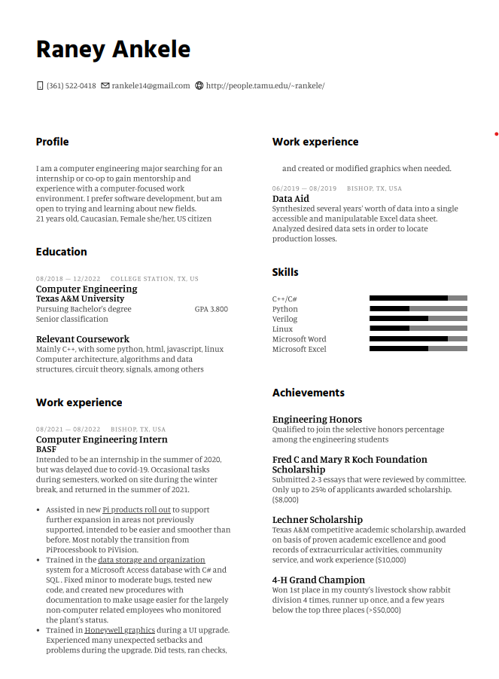

Thomas Rod

A current senior computer engineer at Texas A&M University. Knowledgeable in high and low-level software and hardware design and development. Also experienced in working with teams, leading projects, and technical documentation.

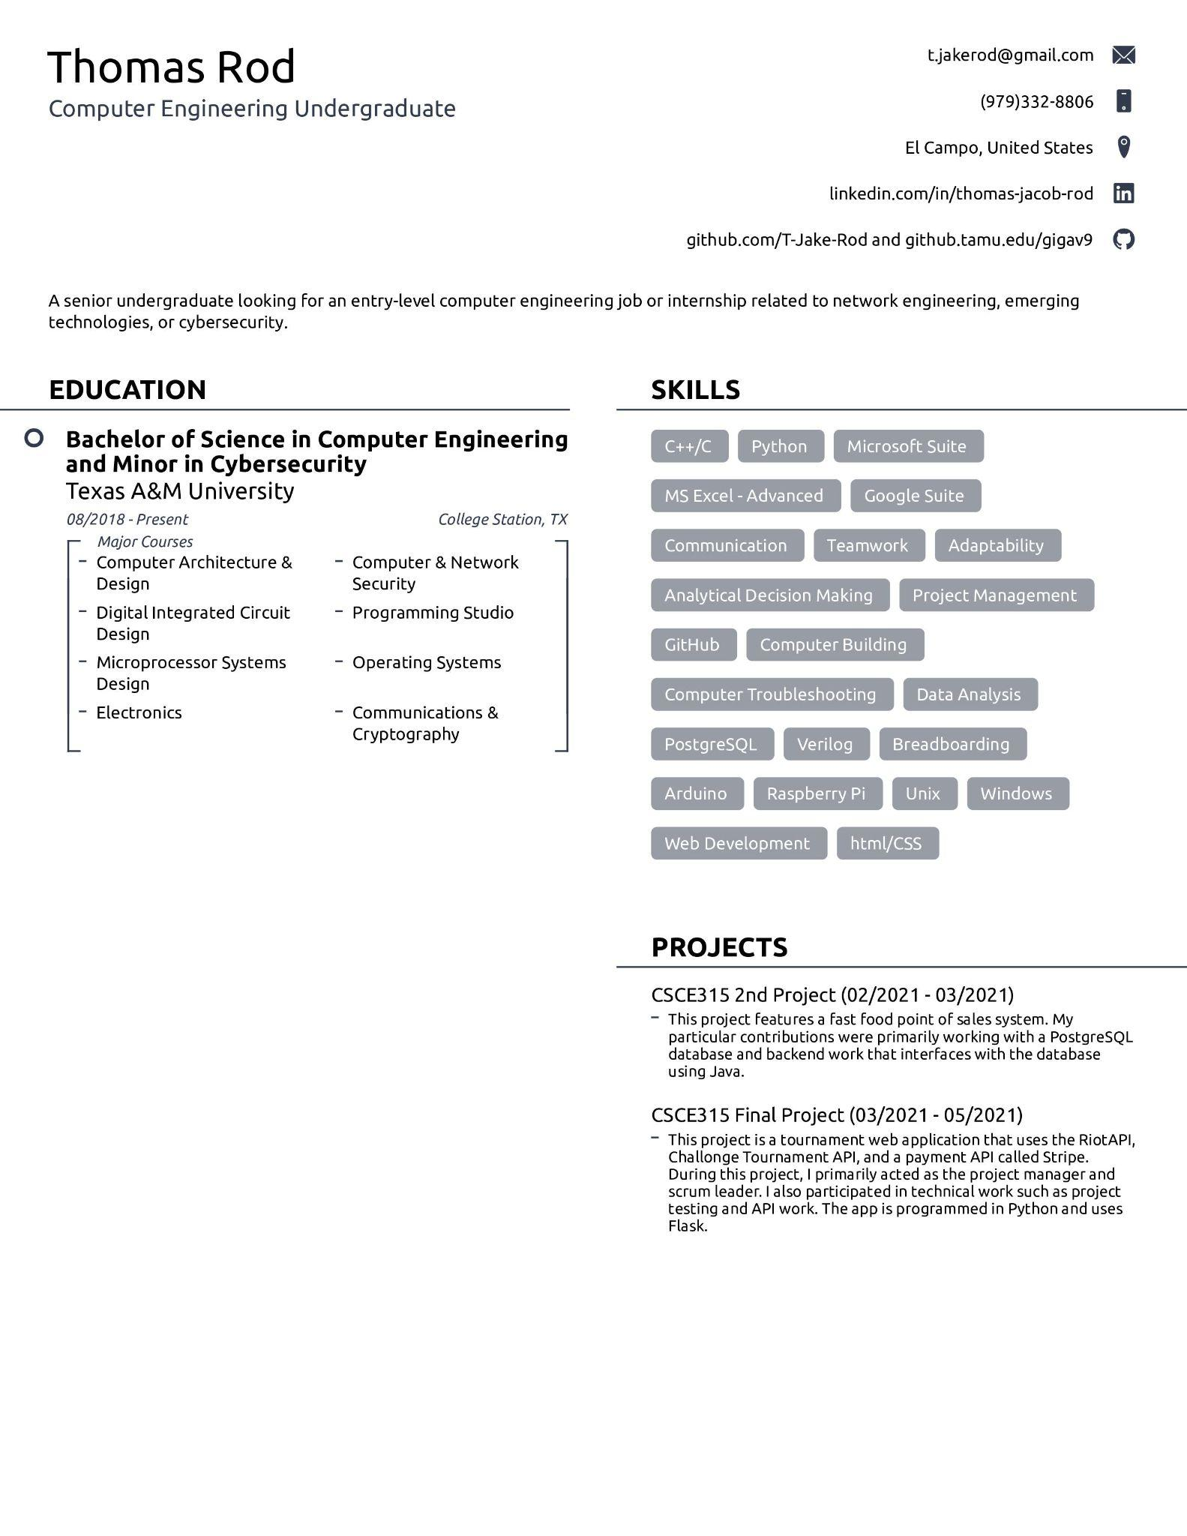

Cody Nguyen

Senior Computer Engineering Student at Texas A&M. Has experience with back-end and some front-end software development along with some hardware design. Currently interning at Intel as a Product Development Engineer.

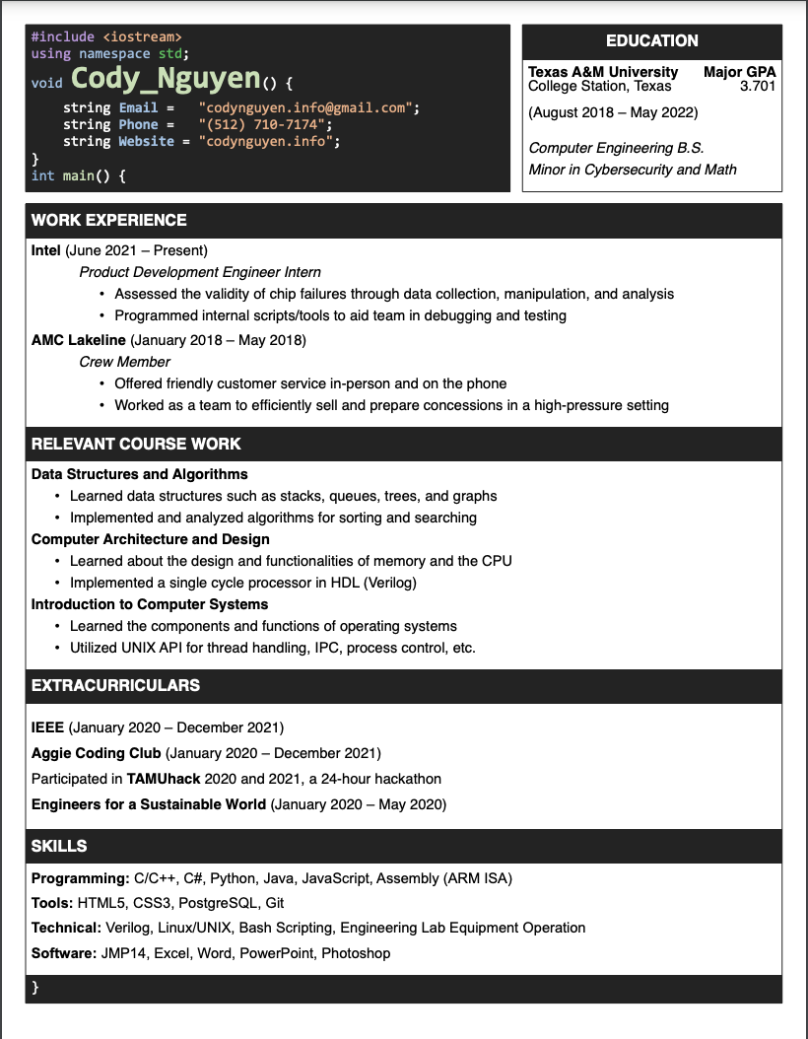

Reid Morse

Computer Engineering student at Texas A&M University. Background ranges from research into deep learning methods for 3D STL objects, network infrastructure, and development of distributed web services.

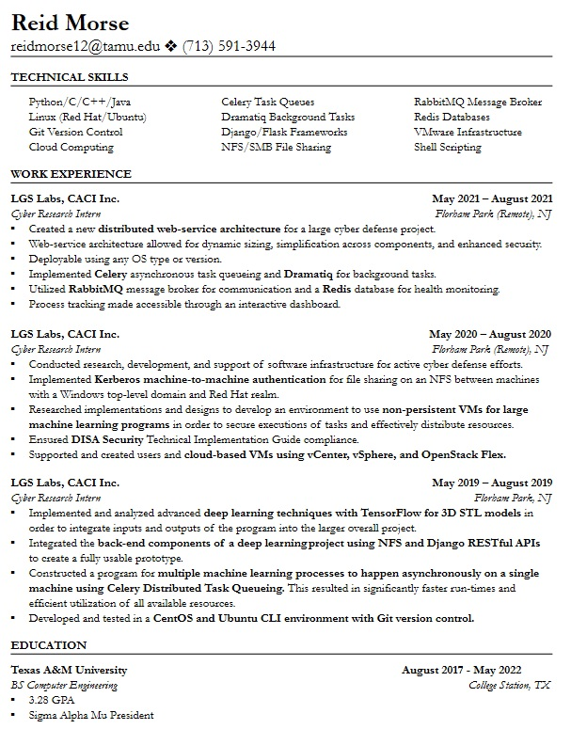

Zachary Laguna

Senior Computer Engineering Student at Texas A&M University. He has background in robotics, web development, API design, database operations, machine learning and software development. He has experience from a variety of sources including classwork, projects, internships, and research.

