Tevyah Hanley
8-30-25
Assignment 5.1

Style Guide – HTML file in folder
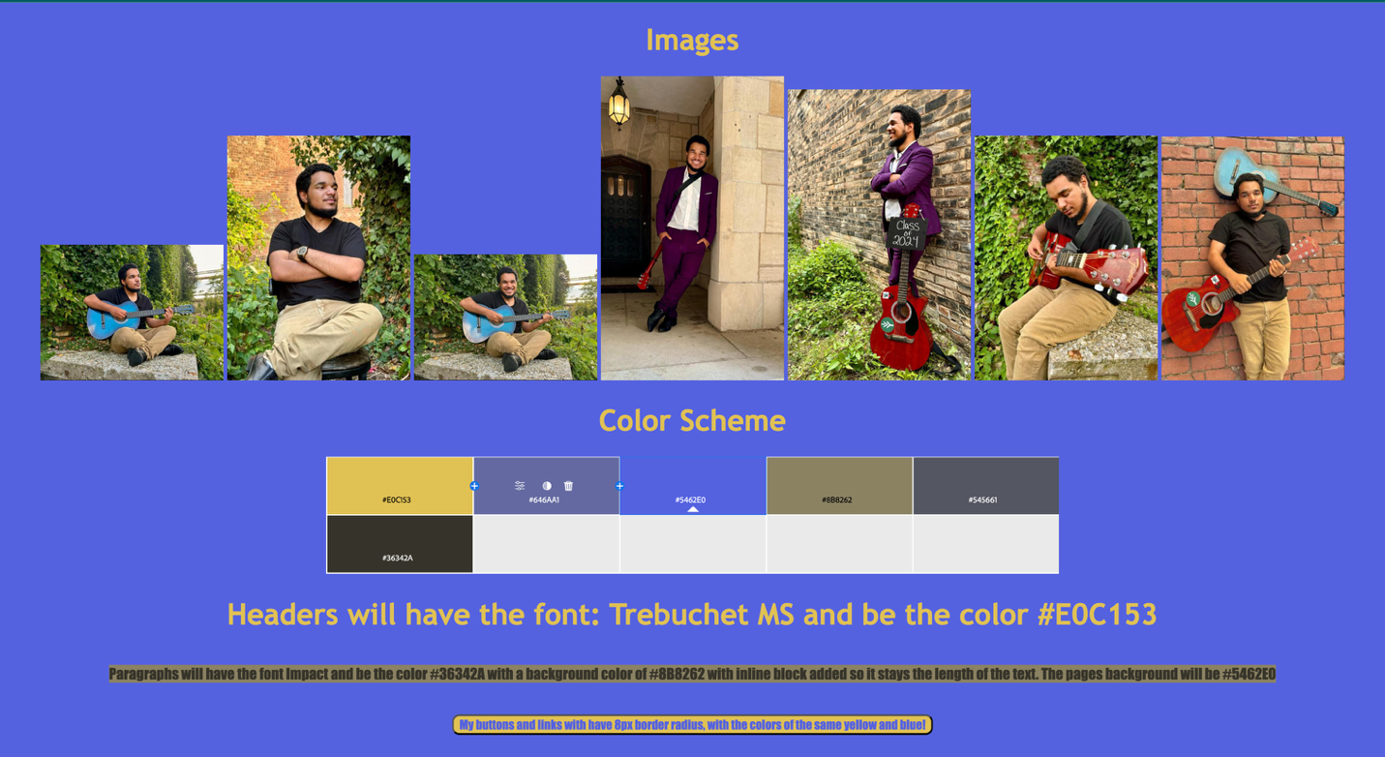

Wireframes – Images in folder
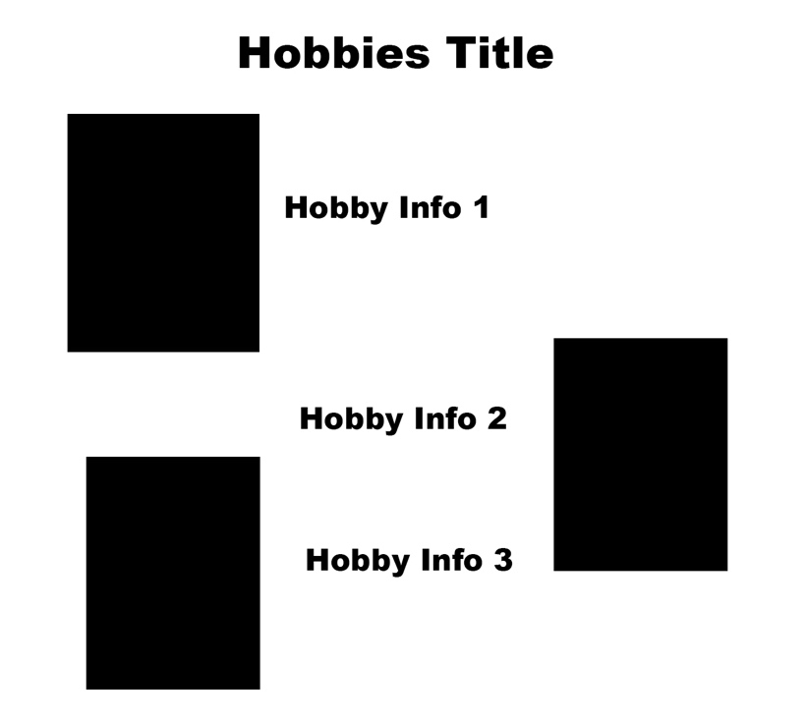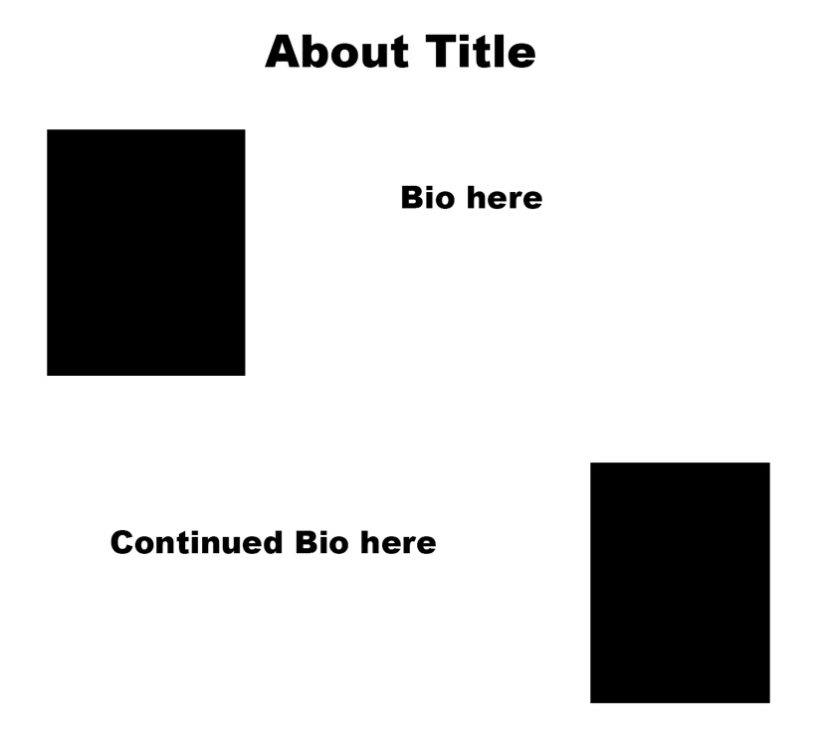
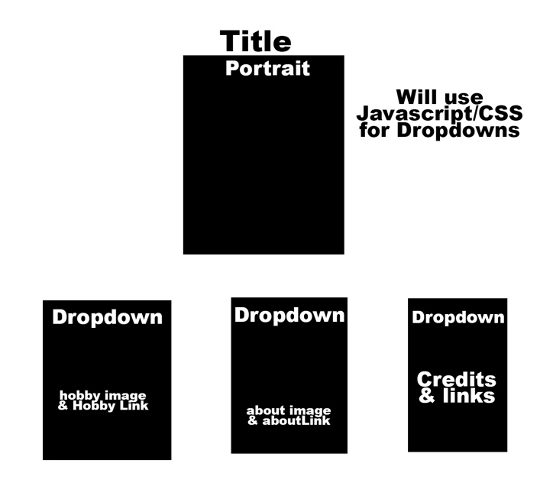

Images for site are also in folder (photos of Dame) are in the folder “Images”.

Tell me about yourself!
A: My name is Dame. I play guitar, write songs, and make content around music. I just graduated high school in 2024, and I’m now studying Psychology in college.

How did you first get into guitar?
A: I picked it up coming up on a year ago. I didn’t expect to love it so much, but I really did. I think I’ve gotten pretty decent, and now I own six guitars and I keep adding more.

What kind of music inspires you the most?
A: I do rap from time to time and I’m inspired by NF for that. When it comes to guitar and singing songs, Powfu is a big inspiration for me.

What role does songwriting play in your life?
A: I do it to portray my emotions and to try and make other people feel seen.

How does making content tie into your music?
A: Content gives me a way to share the process, not just polished songs but little riffs, ideas, and my personality. It makes me feel closer to people who watch.

You just graduated high school in 2024. how did that feel?
A: Honestly, it was exciting. I felt proud, but at the same time it felt like I was already looking ahead at what’s next.

Why did you choose Psychology in college?
A: I want other people to feel seen, because I know what it’s like to feel invisible. I’ve always liked helping people, and Psychology felt like the best way to do that.

What are some of your goals moving forward?
A: I’d love to release an album someday and also help people through psychology, maybe as a counselor. I want both paths to overlap, using music and psychology to help people feel understood.

What do you enjoy most about creating?
A: Being able to know that I helped someone if they related to my song.

If people remember one thing about you, what would you want it to be?
A: That I cared about making people feel heard, valued, and not alone.

Bio:
Dame is a musician and student who has quickly discovered how powerful creativity can be in making others feel understood. He began playing guitar less than a year ago, not expecting it to become such an important part of his life. What started with learning chords and simple songs turned into a passion he now can’t imagine being without. Today, he owns six guitars and is always looking to grow his collection. Alongside guitar, he sometimes explores rap, drawing inspiration from NF, while his singing and guitar-based songs are influenced by Powfu. These different styles give him the freedom to express emotions in ways that resonate with many people.

In 2024, Dame graduated from high school, closing one chapter and opening another as he moved into college. He decided to study Psychology, a choice deeply tied to his values and experiences. Having known what it feels like to be overlooked, Dame wants to help others feel seen. Psychology provides him with tools to understand people on a deeper level, and he hopes to combine that knowledge with his music to support others in both practical and creative ways.

Songwriting for Dame is more than music. It is a way to channel emotions, share stories, and connect with people who might be going through similar struggles. Through his content and his songs, he hopes listeners feel less alone and more understood. For him, success comes down to knowing his work has helped someone, whether through a lyric, a melody, or even a short video clip. Dame continues to build a path where his music and compassion walk side by side.

