**DAILY EXPENSE TRACKER WITH BUDGET ALERTS FOR IOS**

**ABSTRACT:**

Effective personal finance management is essential for individuals seeking to control their daily spending and maintain financial health. This invention, is an iOS-based Daily Expense Tracker with Budget Alerts, provides a comprehensive and user-friendly platform to monitor expenses, categorize transactions, set customizable budgets, and receive real-time alerts. The app simplifies expense tracking by automatically categorizing transactions, offering insightful visualizations of spending patterns, and notifying users when they approach or exceed preset budget limits. By integrating seamless synchronization with manual entry options, the app empowers users to make informed financial decisions, avoid overspending, and cultivate better money management habits. The intuitive interface, combined with personalized alerts and reporting, ensures the app is accessible to users of all financial literacy levels, promoting responsible budgeting and improved financial wellness.

Mrs.T.Lavanya Dr.Sathish Kumar

**THE FIELD OF INVENTION:**

This invention relates to a personal finance application designed for iOS devices, specifically focused on daily expense tracking and budget management. The system enables users to monitor their income and expenditures, categorize financial transactions, set budget thresholds, and receive proactive alerts when approaching budget limits. The invention aims to simplify personal budgeting, improve financial awareness, and prevent overspending through automated notifications and easy-to-use interfaces.

**BACKGROUND OF THE INVENTION:**

Managing personal finances on a daily basis can be challenging due to the variety of small, frequent transactions that accumulate over time. Traditional methods such as manual bookkeeping or generic spreadsheets often fail to provide timely insights or real-time budget monitoring. Existing finance apps may be too complex, expensive, or lack personalized alert systems that notify users before exceeding budget limits. Furthermore, many applications do not offer seamless integration with iOS systems, reducing accessibility and ease of use.

With the increasing reliance on mobile devices for financial management, there is a clear need for an iOS-optimized application that provides a simple yet comprehensive daily expense tracker combined with customizable budget alerts. Such a tool will help users maintain control over their spending habits, avoid unnecessary debt, and achieve financial goals with minimal manual effort.

Mrs.T.Lavanya Dr.Sathish Kumar

**SUMMARY OF THE INVENTION:**

The invention is a Daily Expense Tracker with Budget Alerts designed specifically for iOS devices. The application provides a centralized platform for users to log expenses, categorize spending, set and adjust budget limits, and receive real-time alerts as spending approaches or exceeds those limits. The system integrates automated categorization of transactions, customizable budget settings for various categories, and insightful analytics to help users understand their financial habits and make informed decisions.

**SPECIFICATION:**

* The application enables users to manually enter expenses or sync data from banking institutions to ensure comprehensive expense tracking.
* Users can define budgets for specific categories (e.g., groceries, entertainment, transport) and set daily, weekly, or monthly limits.
* Real-time alerts notify users via push notifications when spending nears or exceeds their budget thresholds, enabling proactive financial adjustments.
* The app includes visual dashboards displaying spending trends, budget utilization, and savings progress over customizable time periods.
* A user-friendly interface optimized for iOS ensures smooth navigation and accessibility for users of all ages and technical skill levels.

Mrs.T.Lavanya Dr.Sathish Kumar

* The system supports exporting reports and data backups to secure cloud storage or email for personal record keeping.
* Budget and alert settings are customizable, allowing users to tailor notifications and expense categories to their financial preferences and lifestyle.
* The application supports multiple currencies and regional settings to accommodate a global user base.

**DESCRIPTION:**

This invention provides a solution for everyday financial management through an iOS application designed to track daily expenses and monitor budgets effectively. Users input transactions manually or connect securely to financial accounts, allowing automatic retrieval and categorization of expenses. The app’s budget alert system uses thresholds set by the user to send notifications before budgets are exceeded, helping prevent overspending.

The visual interface presents clear summaries of expenses versus budgets, enabling users to analyze spending patterns and adjust habits accordingly. Users can set budgets for different time frames and categories, allowing granular control of finances. The application also supports recurring expense tracking, such as subscriptions or regular bills, integrating these into overall budget calculations.

Mrs.T.Lavanya Dr.Sathish Kumar

By combining automation, customization, and intuitive design, this app empowers users to maintain financial discipline with minimal effort, making personal budgeting more approachable and effective on iOS devices.

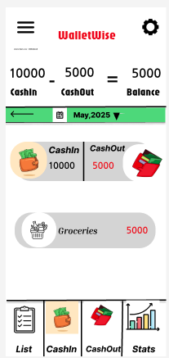 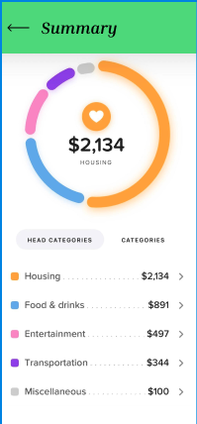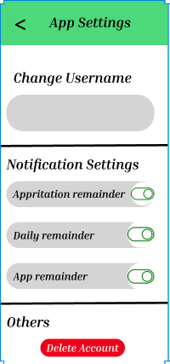

Mrs.T.Lavanya Dr.Sathish Kumar

**WE CLAIM**

1. Claim: The Daily Expense Tracker app empowers users to efficiently manage their personal finances by offering intuitive tracking of daily cash-in and cash-out transactions.
2. Claim: The app provides smart budget alerts, notifying users in real-time when they approach or exceed predefined spending limits across various categories.
3. Claim: With visual insights like daily, weekly, and monthly reports, the app enables users to identify spending patterns and make informed financial decisions.
4. Claim: The Daily Expense Tracker supports recurring transactions, making it easier to track routine expenses like rent, subscriptions, and utility bills automatically.
5. Claim: Built with privacy and simplicity in mind, this iOS app ensures a secure and user-friendly experience without unnecessary complexity or third-party tracking.

Mrs.T.Lavanya Dr.Sathish Kumar