**Project Tracker:** <https://docs.google.com/spreadsheets/d/1JCm0QfJFaJ81P0PdlrIWKgBijbxtFHhk1dyjqsNzsY0/edit?usp=sharing>

**VCS Github link:**

<https://github.com/the-drinksta-dudes>

**Member’s contributions:**

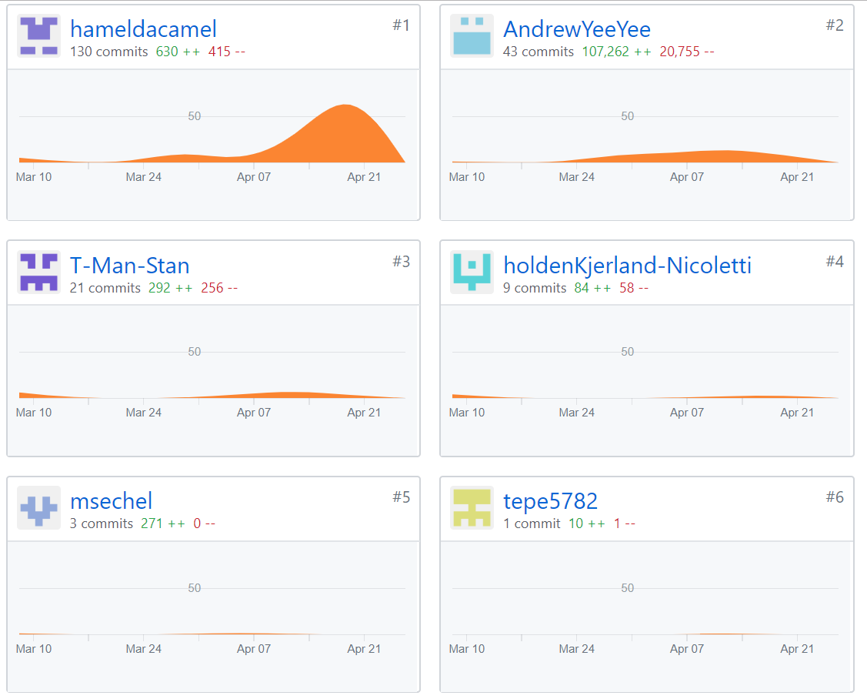

**Deployment Environment:**

<https://dashboard.heroku.com/apps/drinksta>

<https://drinksta.herokuapp.com/>

For developing our app we primarily used our local host and Heroku for development. The app can be accessed and run using the second Heroku link above.