**PROCESS FLOW**

1) To run entire process flow, run startFabric.sh which internally calls byfn.sh up which ideally brings up the entire fabric network based on the configurations provided in yaml files.

cmd: **./startFabric.sh (FabricUsecase/product/)**

--> Configured two organizations with one peer each for this usecase.

(a) crypto-config.yaml - Used to give the count of required peers and users for the network. Cryptogen is used to generate certificates based on the count given in this yaml file.

(b) configtx.yaml - Complete configuration of channel, organizations i.e peer & orderer, respective policies, ACLs and so on. Configtxlator is used to create the genesis block and channel artifacts using this yaml file.

(c) ccp-generate.sh - Used to create connection profiles which are used to connect to the backend Blockchain APIs.

(d) docker-compose-cli.yaml- main container which is used as a parent container to bring up peer , orderer nodes using script.sh (which creates channel, join peers to the channel and so on)

(e) Bring up ca and couchdb containers using docker-compose-ca.yaml & docker-compose-couch.yaml files

(f) Lifecycle of chaincode gets executed i.e packaging, installation, getting approval from required orgs, committing the chaincode to channel.

(g) Enrolling Admin using enrollAdmin.js file

(h) Generating identity for user by admin using registerUser.js

🡪 After running above script, the last lines of logs must be as below,

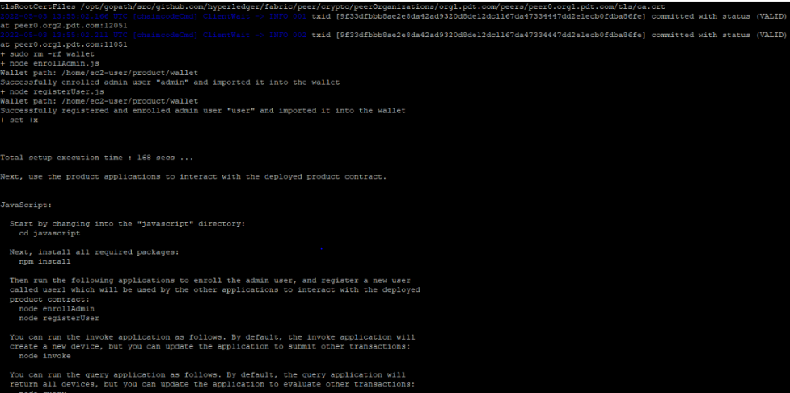

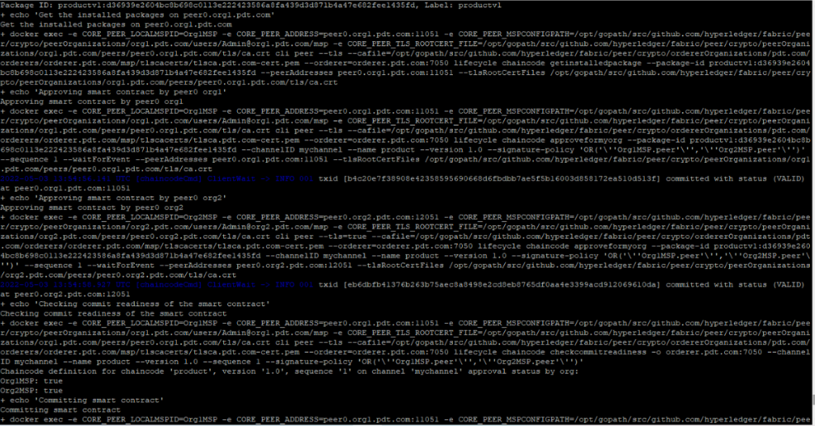

Another screenshot (above)is the lifecycle of chaincode execution where approval from required organizations were signed and satisfied.

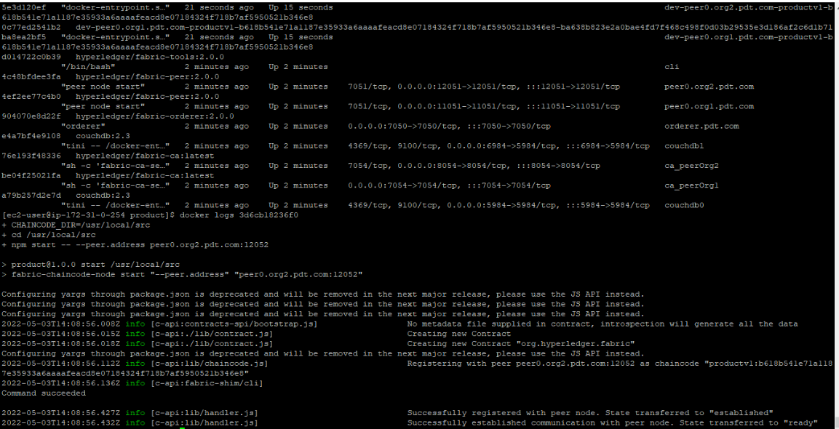

After the execution of chaincode lifecycle, the above are the logs of the peer.

2) Run apiConnect.js to test the APIs.

cmd: **node apiConnect.js** (FabricUsecase/apiConnect/)

* Used nginx to expose the APIs for testing.
* ***Gave ACLs such that only admins can add or remove all products from ledger. User permitted by admin can remove or view a product. (Writers policy is given for only admins in configtx.yaml and also the gateway gets connected to admin identity for add & removeallproducts functionality and gateway connects to user identity(permitted by admin ) for remove or view a product functionality respectively)***

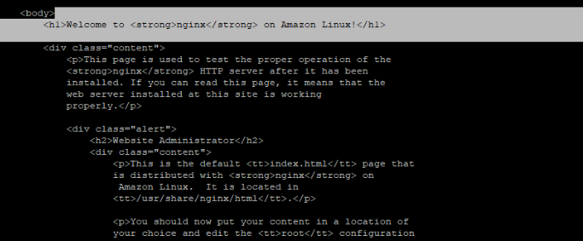

🡪Tested the endorseTran API using CURL command POST request.

Printed a log after successfully the transaction sent to ledger as below.

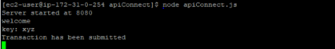

3) Run test.sh to test chaincode execution. In the same script required chaincode functions can be added to test .

cmd**: ./test.sh** (FabricUsecase/apiConnect)