1. Q1

1. Q2Graphical user interface, application

   Description automatically generated
2. 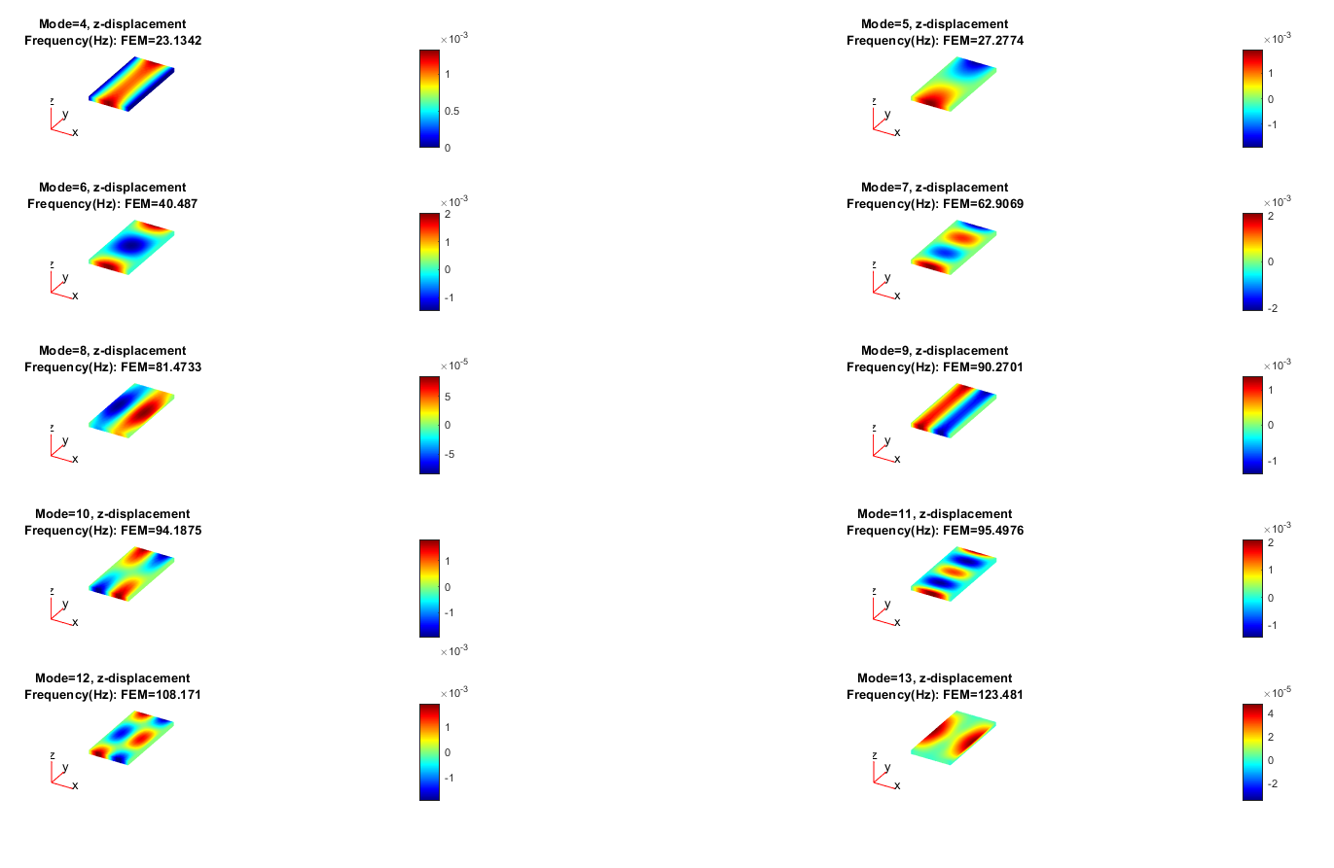
3. A picture containing map

   Description automatically generated

5.

|  |  |
| --- | --- |
|  |  |
|  |  |
|  |  |
|  |  |