SCPI Instrument Toolkit
TA Developer Guide

ESET 453 - Validation and Verification
Texas A&M University

April 26, 2026

Table of Contents
Chapter 1: Architecture Overview
Chapter 2: Development Setup
Chapter 3: Adding a New Instrument Driver
Chapter 4: Adding REPL Commands
Chapter 5: Adding Bundled Examples
Chapter 6: The SCPI Driver Contract
Chapter 7: Writing Tests
Chapter 8: CI/CD and Debugging Failures
Chapter 9: Updating Documentation
Chapter 10: Script Engine Internals
Chapter 11: Releasing New Versions
Chapter 12: The STM32 Bridge (EV2300 Replacement)

Chapter 1: Architecture Overview

The 5-Layer Stack
The toolkit is built in five layers, from hardware at the bottom to user interfaces at the top:
Layer 4: Frontends (CLI REPL, Python API, LabVIEW bridge)
Layer 3: REPL layer (ReplContext, ScriptEngine, CommandHandlers)
Layer 2: Driver classes (HP_E3631A, Rigol_DHO804, etc.)
Layer 1: Transport libraries (pyvisa, ctypes, nidcpower)
Layer 0: Hardware & OS interfaces (NI-VISA, HID, NI-DCPower)
Each layer only talks to the one directly below it. Users interact with Layer 4, and commands flow down through the stack to hardware.

How a Command Flows
When a user types psu set 1 5.0, here is exactly what happens:

1. Shell receives input
InstrumentRepl.do_psu("set 1 5.0") is called by Python's cmd.Cmd framework.
File: lab_instruments/repl/shell.py, the do_psu method.

2. Device resolution
The shell resolves "psu" to a specific device name (e.g., "psu1"):
dev_name = self.ctx.registry.resolve_type("psu")
dev = self.ctx.registry.get_device(dev_name)
File: lab_instruments/repl/device_registry.py

3. Command handler dispatch
The shell delegates to the PSU command handler:
self._psu_cmd.execute("set 1 5.0", dev, dev_name)
File: lab_instruments/repl/commands/psu.py

4. Argument parsing
The command handler parses "set 1 5.0" into command="set", channel=1, voltage=5.0. It resolves the channel number to the driver's channel enum.

5. Driver method call
The handler calls the driver method:
dev.set_voltage(channel_enum, 5.0)
File: lab_instruments/src/hp_e3631a.py

6. SCPI command generation
The driver formats the SCPI command:
self.send_command("APPL P6V,5.0,MAX")

7. PyVISA transport
DeviceManager.send_command() sends the string to the instrument:
self.instrument.write("APPL P6V,5.0,MAX")
File: lab_instruments/src/device_manager.py

8. Hardware response
The instrument receives the SCPI string over USB/GPIB and sets its output to 5.0 V.

Key Components

ReplContext (`lab_instruments/repl/context.py`)
Shared state for the entire REPL session:
- script_vars -- variable storage (dict[str, Any]) - measurements -- MeasurementStore for logged data - registry -- DeviceRegistry managing connected instruments - scripts -- loaded script definitions - Error flags, mode tracking, script state

DeviceRegistry (`lab_instruments/repl/device_registry.py`)
Manages the mapping between friendly names ("psu1", "dmm1") and driver instances. Handles:
- Registering discovered devices - Resolving type-based names ("psu" -> "psu1") - The "active" instrument selection (use psu1)

DeviceManager (`lab_instruments/src/device_manager.py`)
Base class for all SCPI instrument drivers. Provides:
- connect() / disconnect() -- VISA session management - send_command(cmd) -- write a SCPI command - query(cmd) -- write and read response - get_identity() -- *IDN? query - clear_status() -- *CLS command - reset() -- *RST command

InstrumentDiscovery (`lab_instruments/src/discovery.py`)
Auto-detects instruments by:
1. Scanning all VISA resources 2. Querying *IDN? on each 3. Matching the model string against MODEL_MAP 4. Instantiating the correct driver class 5. Assigning a friendly name ("psu1", "dmm1", etc.)

ScriptEngine (`lab_instruments/repl/script_engine/`)
Handles script execution:
- expander.py -- expands for/repeat loops and variable substitutions at compile time - runner.py -- executes expanded lines, handles while/if at runtime - variables.py -- variable resolution utilities

Three Instrument Families
Not all instruments use VISA. The toolkit supports three transport mechanisms:
Family | Transport | Library | Examples
SCPI via VISA | USB/GPIB/Serial | pyvisa | PSU, DMM, AWG, Scope
USB HID | HID reports | ctypes | TI EV2300
NI-DCPower | PXIe bus | nidcpower | NI PXIe-4139

Each family has its own base class or direct implementation, but all present the same interface to the REPL layer.

Where Mocks Fit
Mock instruments (lab_instruments/mock_instruments.py) replace Layer 2 drivers. They implement the same methods but store state internally instead of talking to hardware. The REPL, command handlers, and script engine cannot tell the difference -- this is how --mock mode works.

Chapter 2: Development Setup

Clone the Repository
git clone https://github.com/T-O-M-Tool-Oauto-Mationator/scpi-instrument-toolkit.git
cd scpi-instrument-toolkit

Create a Virtual Environment
python -m venv .venv
source .venv/bin/activate # macOS/Linux
.venv\Scripts\activate # Windows

Install in Development Mode
pip install -e ".[dev]"
The -e flag installs in "editable" mode -- changes to source files take effect immediately without reinstalling.

Verify the Installation

Run the linter
ruff check lab_instruments/ tests/
Must produce no errors.

Check formatting
ruff format --check lab_instruments/ tests/
Must report all files already formatted.

Run tests
pytest tests/ -x --tb=short
All tests must pass. The -x flag stops on first failure.

Full coverage report
pytest tests/ -v --cov=lab_instruments --cov-report=term-missing
Shows which lines are not covered by tests. Target: 80%+ coverage.

The Pre-Push Checklist
Before every git push, run all three checks:
ruff check lab_instruments/ tests/
ruff format --check lab_instruments/ tests/
pytest tests/ -x --tb=short
CI runs both ruff check AND ruff format --check. Forgetting the format check is the most common cause of CI failures.
If formatting is off, fix it with:
ruff format lab_instruments/ tests/

Branch Strategy
- dev/nightly -- active development branch. Work here. - main -- stable releases only. Merged from dev/nightly after review. - Feature branches -- for large changes that need review before merging to dev/nightly.

Project Structure
scpi-instrument-toolkit/
├── lab_instruments/
│ ├── __init__.py # Package entry point
│ ├── enums.py # Shared enumerations
│ ├── mock_instruments.py # Mock devices for testing
│ ├── examples.py # Bundled example scripts
│ ├── src/ # Instrument drivers
│ │ ├── device_manager.py # Base class for SCPI drivers
│ │ ├── discovery.py # Auto-detection logic
│ │ ├── hp_e3631a.py # HP E3631A PSU driver
│ │ ├── rigol_dho804.py # Rigol DHO804 scope driver
│ │ └── ... # More drivers
│ └── repl/ # REPL layer
│ ├── __init__.py # CLI entry point (main())
│ ├── shell.py # cmd.Cmd subclass, dispatch
│ ├── context.py # Shared session state
│ ├── syntax.py # Variable substitution, safe_eval
│ ├── device_registry.py # Device name management
│ ├── measurement_store.py # Log storage
│ ├── commands/ # Command handlers
│ │ ├── base.py # BaseCommand interface
│ │ ├── psu.py # PSU commands
│ │ ├── dmm.py # DMM commands
│ │ ├── scope.py # Scope commands
│ │ └── ... # More handlers
│ └── script_engine/ # Script expansion & execution
│ ├── expander.py # For/repeat loop expansion
│ └── runner.py # Runtime execution (while/if)
├── tests/ # pytest test suite
├── docs/ # MkDocs documentation source
├── scripts/ # Build/validation utilities
├── manuals/ # Standalone DOCX manuals
├── CLAUDE.md # Project conventions for Claude Code
├── CONTRIBUTING.md # Contributor guide
├── pyproject.toml # Package metadata & dependencies
└── mkdocs.yml # Documentation site config

IDE Setup

VS Code (recommended)
Install extensions: - Python (Microsoft) - Ruff (Astral Software)
Settings (.vscode/settings.json):
{
"python.defaultInterpreterPath": ".venv/bin/python",
"editor.formatOnSave": true,
"[python]": {
"editor.defaultFormatter": "charliermarsh.ruff"
}
}

PyCharm
- Set the project interpreter to .venv/bin/python - Install the Ruff plugin - Enable "Reformat code on save"

Working with Claude Code
The project uses Claude Code subagents for common tasks:
- @pre-push-validator -- runs ruff + pytest before push - @debug-issue -- investigates GitHub issues - @scpi-contract-reviewer -- checks driver contract compliance - @driver-test-writer -- generates tests for driver methods - @docs-sync -- keeps docs in sync with code
Run /agents in a Claude Code session to see them in the Library tab.

Chapter 3: Adding a New Instrument Driver
This chapter walks through adding support for a new instrument from scratch.

Step-by-Step Checklist
1. Create the driver file in lab_instruments/src/ 2. Implement the SCPI driver contract 3. Register the instrument in discovery.py 4. Create a mock in mock_instruments.py 5. Add REPL command support in commands/ 6. Write tests 7. Add documentation 8. Open a PR

Step 1: Create the Driver File
Create lab_instruments/src/my_new_instrument.py:
from lab_instruments.src.device_manager import DeviceManager
class MyNewInstrument(DeviceManager):
"""Driver for the My New Instrument model XYZ."""
# Channel mapping (if multi-channel)
CHANNEL_FROM_NUMBER = {
1: "CH1",
2: "CH2",
}
# Allowed values for enum-type parameters
MODES_ALLOWLIST = frozenset({"MODE1", "MODE2", "MODE3"})
def __init__(self, resource_name: str):
super().__init__(resource_name)
self._voltage = 0.0
self._output = False
self._mode = "MODE1"
def __enter__(self):
self.disable_all_channels()
return self
def __exit__(self, exc_type, exc_value, traceback):
self.disable_all_channels()
def connect(self):
super().connect()
self.clear_status()
# --- Setters (always validate, always update cache) ---
def set_voltage(self, channel: int, voltage: float):
if not 0 <= voltage <= 30.0:
raise ValueError(f"Voltage {voltage} out of range [0, 30.0]")
ch_str = self.CHANNEL_FROM_NUMBER.get(channel)
if ch_str is None:
raise ValueError(f"Invalid channel: {channel}")
# Always include the resolved channel identifier in the SCPI command
# so the command targets the correct output.
self.send_command(f"{ch_str}:VOLT {voltage}")
self._voltage[channel] = voltage # update cache atomically after success
def set_mode(self, mode: str):
mode = mode.upper()
if mode not in self.MODES_ALLOWLIST:
raise ValueError(f"Invalid mode '{mode}'. Allowed: {self.MODES_ALLOWLIST}")
self.send_command(f"MODE {mode}")
self._mode = mode
# --- Getters (never hardcode, always return self._attr) ---
def get_voltage_setpoint(self) -> float:
return self._voltage # return cached value
def get_mode(self) -> str:
return self._mode
# --- Measurements (always use query, not write) ---
def measure_voltage(self) -> float:
response = self.query("MEAS:VOLT?")
return float(response)
def measure_current(self) -> float:
response = self.query("MEAS:CURR?")
return float(response)
# --- Output control ---
def enable_output(self, enabled: bool = True):
self.send_command(f"OUTP {'ON' if enabled else 'OFF'}")
self._output = enabled
def disable_all_channels(self):
self.send_command("OUTP OFF")
self._output = False
# --- Error handling (required by contract) ---
def get_error(self) -> str:
return self.query("SYST:ERR?")

Step 2: Register in Discovery
Edit lab_instruments/src/discovery.py:
# In MODEL_MAP, add:
"XYZ123": MyNewInstrument,
# In NAME_MAP, add:
"XYZ123": "mytype", # e.g., "psu", "dmm", "scope", etc.
The discovery system queries *IDN? on each VISA resource and matches the model substring against MODEL_MAP.

Step 3: Create a Mock
In lab_instruments/mock_instruments.py, add a mock class:
class MockMyNewInstrument(MockBase):
def __init__(self):
super().__init__()
self._voltage = 0.0
self._output = False
self._mode = "MODE1"
def set_voltage(self, channel, voltage):
self._voltage = float(voltage)
def get_voltage_setpoint(self):
return self._voltage
def measure_voltage(self, ch=None):
return round(self._voltage + random.uniform(-0.02, 0.02), 6)
def measure_current(self, ch=None):
return round(random.uniform(0.001, 0.5), 6)
def enable_output(self, state=True):
self._output = bool(state)
def disable_all_channels(self):
self._output = False
def set_mode(self, mode):
self._mode = mode
def get_mode(self):
return self._mode
def get_error(self):
return "0,No error"
Key rules for mocks: - Track state (do not return constants) - Add realistic jitter to measurements (random.uniform) - Return exact values for setpoint getters - Implement all methods the driver has
Add the mock to get_mock_devices():
<!-- doc-test: skip reason="pseudocode sketch with ... placeholder, not a complete Python snippet" -->
def get_mock_devices(verbose=True):
devices = {
...
"mytype1": MockMyNewInstrument(),
}

Step 4: Add REPL Commands
If your instrument fits an existing type (PSU, DMM, scope, AWG), the existing command handler may work. If it is a new type, create lab_instruments/repl/commands/mytype.py:
from .base import BaseCommand
class MyTypeCommand(BaseCommand):
def execute(self, arg, dev, dev_name):
args = self.parse_args(arg)
if not args:
self.print_colored_usage([...])
return
cmd = args[0].lower()
rest = args[1:]
if cmd == "set":
self._handle_set(rest, dev, dev_name)
elif cmd == "meas":
self._handle_meas(rest, dev, dev_name)
else:
self.error(f"Unknown mytype command: {cmd}")
def _handle_set(self, args, dev, dev_name):
...
def _handle_meas(self, args, dev, dev_name):
...
Register in shell.py:
<!-- doc-test: skip reason="pseudocode -- method body is a comment placeholder" -->
# In __init__:
self._mytype_cmd = MyTypeCommand(self.ctx)
# Add do_mytype method:
def do_mytype(self, arg):
# ... resolve device, delegate to handler

Step 5: Write Tests
See Chapter 7 for the full testing guide. At minimum:
# tests/test_my_new_instrument.py
class TestSetVoltage:
def test_set_voltage_sends_correct_command(self, fixture):
dev, mock_instr = fixture
dev.set_voltage(1, 5.0)
mock_instr.write.assert_called_with("VOLT 5.0")
def test_set_voltage_out_of_range_raises(self, fixture):
dev, mock_instr = fixture
with pytest.raises(ValueError):
dev.set_voltage(1, 100.0)

Step 6: Add Documentation
1. Create docs/mytype.md with command reference 2. Add to mkdocs.yml nav section 3. Add to docs/instruments.md supported models table 4. Run mkdocs build to verify 5. Deploy with mkdocs gh-deploy --force

Step 7: Open a PR
git checkout -b feature/add-mytype-driver
git add lab_instruments/ tests/ docs/ mkdocs.yml
git commit -m "Add MyNewInstrument driver with tests and docs"
git push -u origin feature/add-mytype-driver
gh pr create --base dev/nightly
Run @scpi-contract-reviewer before opening the PR to catch contract violations.

Chapter 4: Adding REPL Commands

The BaseCommand Interface
All command handlers inherit from BaseCommand (lab_instruments/repl/commands/base.py):
class BaseCommand:
def __init__(self, ctx: ReplContext):
self.ctx = ctx
Key methods provided:
- parse_args(arg) -- splits a command string into tokens using shlex (handles quotes) - parse_channels(ch_str, max_ch=4) -- resolves "all", "ch1", "1" to channel lists - is_help(args) / strip_help(args) -- detect and strip trailing "help" or "?" - error(msg) -- print error with ColorPrinter and set error flag - print_colored_usage(lines) -- print syntax-highlighted help

The Command Handler Pattern
Each instrument type has a command handler class. Here is the PsuCommand pattern from lab_instruments/repl/commands/psu.py:
class PsuCommand(BaseCommand):
def execute(self, arg, dev, dev_name):
args = self.parse_args(arg)
if not args or self.is_help(args):
self._show_help()
return
cmd = args[0].lower()
rest = args[1:]
if cmd == "chan":
self._handle_chan(rest, dev, dev_name)
elif cmd == "set":
self._handle_set(rest, dev, dev_name)
elif cmd == "meas":
self._handle_meas(rest, dev, dev_name)
elif cmd in ("on", "off"):
self._handle_on_off(cmd, dev, dev_name)
elif cmd == "state":
self._handle_state(rest, dev, dev_name)
else:
self.error(f"Unknown psu command: {cmd}")
Each sub-handler parses its specific arguments, validates inputs, calls the driver method, and prints feedback:
def _handle_set(self, args, dev, dev_name):
if len(args) < 2:
self.error("Usage: psu set <channel> <voltage> [current]")
return
channel = self._resolve_channel(dev, args[0])
if channel is None:
return # _resolve_channel already logged the error
try:
voltage = float(args[1])
except ValueError:
self.error(f"Invalid voltage {args[1]!r} -- must be a number.")
return
current = None
if len(args) >= 3:
try:
current = float(args[2])
except ValueError:
self.error(f"Invalid current {args[2]!r} -- must be a number.")
return
try:
dev.set_voltage(channel, voltage)
if current is not None:
dev.set_current(channel, current)
except (ValueError, RuntimeError) as exc:
self.error(f"psu set failed: {exc}")
return
msg = f"Set {args[0]}: {voltage} V"
if current is not None:
msg += f", {current} A"
ColorPrinter.success(msg)

Registering a New Command in shell.py

1. Import the handler
from .commands.mytype import MyTypeCommand

2. Create the handler instance in __init__
self._mytype_cmd = MyTypeCommand(self.ctx)

3. Wire the state callback (if needed)
self._mytype_cmd.set_state_callback(
lambda name, st: self.do_state(f"{name} {st}")
)

4. Add the do_* method
def do_mytype(self, arg):
"""Control mytype instruments."""
dev_name = self.ctx.registry.resolve_type("mytype")
if not dev_name:
ColorPrinter.warning("No mytype found. Run 'scan' first.")
return
dev = self.ctx.registry.get_device(dev_name)
# The command handler owns argument parsing.
self._mytype_cmd.execute(arg, dev, dev_name)

5. Add to help system
In the do_help method or the help text dictionary, add your new command with a description.

Capabilities Flags
Some commands only work on certain models. The capabilities system (lab_instruments/repl/capabilities.py) defines feature flags:
<!-- doc-test: skip reason="config-dict excerpt, not a standalone Python snippet" -->
DRIVER_CAPABILITIES = {
"Rigol_DHO804": {"counter", "dvm", "cursors", "recording", "mask_test", "awg"},
"Keysight_DSOX1204G": {"counter", "dvm", "cursors", "mask_test", "awg", "screenshot"},
"Tektronix_MSO2024": set(), # basic scope only
}
In command handlers, check capabilities before executing:
<!-- doc-test: skip reason="pseudocode fragment showing capabilities-check pattern" -->
caps = get_capabilities(dev)
if "counter" not in caps:
self.error("Counter not supported on this scope model.")
return

Adding Help Text
Each handler should include a help method that shows usage when the user types help mytype:
def _show_help(self):
self.print_colored_usage([
("mytype set <channel> <value>", "Set output value"),
("mytype meas <channel>", "Measure current value"),
("mytype on / off", "Enable or disable output"),
])

Testing Commands
Test commands using the make_repl fixture from conftest.py:
def test_psu_set_prints_success(self, make_repl, capsys):
devices = {"psu1": MockHP_E3631A()}
repl = make_repl(devices)
repl.onecmd("scan")
repl.onecmd("psu1 set 1 5.0")
out = capsys.readouterr().out
assert "5.0" in out

Chapter 5: Adding Bundled Examples

The EXAMPLES Dict
Bundled examples live in lab_instruments/examples.py as a Python dictionary:
<!-- doc-test: skip reason="Python dict literal, not a REPL script" -->
EXAMPLES = {
"psu_dmm_test": {
"description": "Set PSU to a voltage, measure with DMM, log result",
"lines": [
"# psu_dmm_test",
"voltage = 5.0",
"label = vtest",
"",
"psu1 chan 1 on",
"psu1 set 1 {voltage}",
"sleep 0.5",
"{label} = dmm1 meas unit=V",
"log print",
],
# Note: the triple-quoted string must NOT have leading indentation --
# the raw text of the "code" field is written verbatim to <name>.py.
"code": '''\
"""PSU + DMM voltage test -- Python API version."""
import time
psu.set_voltage(1, 5.0)
time.sleep(0.5)
v = dmm.read()
print(f"Measured: {v} V")
''',
},
}

Required fields
- Key: example name (string, lowercase with underscores, e.g., "my_new_test") - "description": one-line summary shown by the examples command - "lines": list of SCPI script lines (the REPL script version)

Optional fields
- "code": Python source code string (the Python API version). If provided, examples load creates both a .scpi and a .py file.

Naming Conventions
- Use lowercase with underscores: voltage_sweep, psu_dmm_test - Keep names short but descriptive - Prefix with the primary instrument type when possible: psu_ramp, awg_scope_check

Writing the Script Lines
Each entry in "lines" is one REPL command:
- Use {var} for variable substitution - Define default values at the top so users can override: voltage = 5.0 - Add comments with # for documentation - Include log print at the end to show results - Use descriptive labels: v_{v} in loops creates v_1.0, v_2.0, etc.

Syncing with docs/examples.md
Every EXAMPLES entry should have a matching section in docs/examples.md:
<!-- doc-test: skip reason="markdown-inside-markdown template with nested fences and placeholder text" -->
## my_new_test
**Description here.**
**Script source:**
# my_new_test
voltage = 5.0
...

Checking sync
Run the validation script:
python scripts/validate_doc_examples.py
This reports: - SYNC -- docs match the EXAMPLES dict - DRIFT -- docs have diverged (first differing line is shown) - MISSING -- example exists in code but not in docs

Running examples in mock mode
The validation script also runs every example with mock instruments:
python scripts/validate_doc_examples.py --run-only
All examples must PASS (exit without uncaught exceptions).

Adding a New Example
1. Add the entry to EXAMPLES dict in examples.py 2. Add the corresponding section to docs/examples.md 3. Run python scripts/validate_doc_examples.py -- should show SYNC and PASS 4. Include the example addition in the same commit as any related feature

Tips
- Test your example in --mock mode before committing - Avoid pause and input in example scripts -- they block non-interactive testing - Use sleep 0.5 for realistic settling times - Include both SCPI (lines) and Python (code) versions when possible - Keep examples under 30 lines -- they should demonstrate one concept clearly

Chapter 6: The SCPI Driver Contract
Every driver in the toolkit must follow these 8 rules. They exist because real bugs were caused when they were violated.

Rule 1: Never Return Hardcoded Values from Getters
Wrong:
def get_voltage_setpoint(self):
return 5.0 # hardcoded!
Right:
def get_voltage_setpoint(self):
return self._voltage # return cached state
Why: If a getter returns a constant, tests pass but the value never reflects what the instrument is actually doing. A student sets 3.3V and the getter still says 5.0V.

Rule 2: Never Use "from time import sleep"
Wrong:
from time import sleep
sleep(0.5)
Right:
import time
time.sleep(0.5)
Why: Tests use monkeypatch.setattr(module.time, "sleep", lambda _: None) to skip delays. If you import sleep directly, the monkeypatch cannot intercept it and tests run slowly.

Rule 3: Always Implement get_error()
Wrong: Omitting get_error() entirely.
Right (if the instrument supports it):
def get_error(self):
return self.query("SYST:ERR?")
Right (if the instrument does not support it):
def get_error(self):
return "0,not supported on MyNewInstrument"
Why: The REPL calls get_error() after failures to provide diagnostic information. If the method is missing, the REPL crashes with an AttributeError.

Rule 4: Use query() for Reads, write() for Commands
Wrong:
def measure_voltage(self):
self.send_command("MEAS:VOLT?") # write, not query!
return float(self.instrument.read())
Right:
def measure_voltage(self):
return float(self.query("MEAS:VOLT?"))
Why: query() handles the write-then-read sequence atomically, including timeout handling and error checking. Splitting into separate write/read calls is error-prone.

Rule 5: Validate Numeric Inputs
Wrong:
def set_voltage(self, channel, voltage):
self.send_command(f"VOLT {voltage}") # no validation!
Right:
def set_voltage(self, channel, voltage):
if not 0 <= voltage <= 30.0:
raise ValueError(f"Voltage {voltage} out of range [0, 30.0]")
self.send_command(f"VOLT {voltage}")
Why: Without validation, students can accidentally send dangerous voltages to instruments, or send out-of-range values that cause SCPI errors that are hard to debug.

Rule 6: Validate Enum Inputs Against an ALLOWLIST
Wrong:
def set_mode(self, mode):
self.send_command(f"MODE {mode}") # accepts anything!
Right:
MODES_ALLOWLIST = frozenset({"DC", "AC", "RES", "FREQ"})
def set_mode(self, mode):
mode = mode.upper()
if mode not in self.MODES_ALLOWLIST:
raise ValueError(f"Invalid mode '{mode}'. Allowed: {self.MODES_ALLOWLIST}")
self.send_command(f"MODE {mode}")
Why: Typos in mode names (e.g., "DVC" instead of "VDC") silently fail on some instruments. The ALLOWLIST catches them immediately with a clear error message.

Rule 7: Always Implement __enter__ / __exit__
Wrong: Omitting context manager methods.
Right:
def __enter__(self):
self.disable_all_channels()
return self
def __exit__(self, exc_type, exc_value, traceback):
self.disable_all_channels()
Why: __exit__ must fire even after exceptions. This ensures instruments are left in a safe state if a script crashes partway through. The with statement pattern depends on this.

Rule 8: Update self._cache Atomically with Every write()
Wrong:
def set_voltage(self, channel, voltage):
self.send_command(f"VOLT {voltage}")
# forgot to update cache!
Right:
def set_voltage(self, channel, voltage):
self.send_command(f"VOLT {voltage}")
self._voltage = voltage # update immediately after write
Why: Getters return cached values (Rule 1). If the cache is not updated after a write, subsequent reads return stale data. The atomic update ensures cache and hardware are always in sync.

Checking Contract Compliance
Run the @scpi-contract-reviewer subagent before any PR that touches driver code:
<!-- doc-test: skip reason="Claude Code subagent @-handle, not Python syntax" -->
@scpi-contract-reviewer
This read-only reviewer checks all 8 rules and reports violations without modifying files.

Summary Table
# | Rule | Prevents
1 | No hardcoded getters | Stale/wrong data in tests and REPL
2 | No `from time import sleep` | Slow tests (monkeypatch cannot intercept)
3 | Always implement get_error() | AttributeError crashes in error handling
4 | Use query() for reads | Race conditions, missed responses
5 | Validate numeric inputs | Dangerous voltages, cryptic SCPI errors
6 | Validate enum inputs | Silent failures from typos
7 | Implement __enter__/__exit__ | Unsafe instrument state after crashes
8 | Update cache atomically | Stale cached values after writes

Chapter 7: Writing Tests

Test Framework
The project uses pytest. All tests live in the tests/ directory.

Key Fixtures (tests/conftest.py)

mock_visa_rm
Patches pyvisa.ResourceManager so no real VISA connection is needed:
@pytest.fixture
def mock_visa_rm(ensure_pyvisa_mocked):
mock_instrument = MagicMock()
mock_rm = MagicMock()
mock_rm.open_resource.return_value = mock_instrument
with patch("pyvisa.ResourceManager", return_value=mock_rm):
yield mock_rm, mock_instrument

Driver fixture pattern
Each driver has a fixture that returns (driver, mock_instrument):
@pytest.fixture
def hp_e3631a(mock_visa_rm):
mock_rm, mock_instrument = mock_visa_rm
from lab_instruments.src.hp_e3631a import HP_E3631A
psu = HP_E3631A("GPIB::5::INSTR")
psu.instrument = mock_instrument
mock_instrument.reset_mock()
return psu, mock_instrument

make_repl
Creates a REPL instance wired to a given devices dict:
@pytest.fixture
def make_repl(monkeypatch):
created = []
def _make(devices):
monkeypatch.setattr(_disc.InstrumentDiscovery, "scan",
lambda self, verbose=True: devices)
repl = InstrumentRepl(register_lifecycle=False)
repl._scan_thread.join(timeout=5.0)
repl.devices = devices
created.append(repl)
return repl
yield _make
for repl in created:
repl.close()
Usage:
def test_something(self, make_repl):
repl = make_repl({}) # no devices
repl = make_repl({"psu1": mock}) # with mock PSU

The State-Tracking Mock Pattern
Mocks must track state, not return constants:
Wrong (constant mock):
<!-- doc-test: skip reason="pytest/MagicMock snippet -- illustrates the anti-pattern we forbid" -->
mock_psu = MagicMock()
mock_psu.measure_voltage.return_value = 5.0 # always returns 5.0!
Right (state-tracking mock):
class MockPSU:
def __init__(self):
self._voltage = 0.0
self._output = False
def set_voltage(self, ch, v):
self._voltage = float(v)
def measure_voltage(self, ch=None):
return self._voltage + random.uniform(-0.01, 0.01)
def get_voltage_setpoint(self):
return self._voltage

One-Test-Per-Method Convention
Each test should verify one specific behavior:
class TestSetVoltage:
def test_sends_correct_scpi_command(self, hp_e3631a):
psu, mi = hp_e3631a
psu.set_voltage(HP_E3631A.Channel.POSITIVE_6V, 5.0)
mi.write.assert_called()
def test_updates_cache(self, hp_e3631a):
psu, mi = hp_e3631a
psu.set_voltage(HP_E3631A.Channel.POSITIVE_6V, 5.0)
assert psu._voltage == 5.0
def test_out_of_range_raises(self, hp_e3631a):
psu, mi = hp_e3631a
with pytest.raises(ValueError):
psu.set_voltage(HP_E3631A.Channel.POSITIVE_6V, 100.0)
def test_invalid_channel_raises(self, hp_e3631a):
psu, mi = hp_e3631a
with pytest.raises(ValueError):
psu.set_voltage(99, 5.0)

Monkeypatch for time.sleep
Always skip sleep in tests:
<!-- doc-test: skip reason="pseudocode with placeholder module my_driver, not a concrete import target" -->
def test_something(self, monkeypatch):
import lab_instruments.src.my_driver as mod
monkeypatch.setattr(mod.time, "sleep", lambda _: None)
This makes tests fast. Never use from time import sleep in driver code (see Driver Contract, Rule 2).

Testing REPL Commands
Use capsys to capture output:
def test_psu_set_success(self, make_repl, capsys):
devices = {"psu1": MockHP_E3631A()}
repl = make_repl(devices)
repl.onecmd("scan")
repl.onecmd("psu1 set 1 5.0")
out = capsys.readouterr().out
assert "5.0" in out
assert "SUCCESS" in out

Testing Variables and Calc
def test_calc_stores_result(self, make_repl):
repl = make_repl({})
repl.onecmd("x = 5")
repl.onecmd("y = 3")
repl.onecmd("result = calc x + y")
assert repl.ctx.script_vars["result"] == 8

Coverage Targets
Target: 80%+ line coverage. Check with:
pytest tests/ -v --cov=lab_instruments --cov-report=term-missing
The --cov-report=term-missing flag shows exactly which lines are not covered.

Running Specific Tests
pytest tests/test_hp_e3631a.py -v # one file
pytest tests/ -k "test_set_voltage" # by name pattern
pytest tests/ -x --tb=short # stop on first failure

The @driver-test-writer Subagent
Use this Claude Code subagent to auto-generate tests for new driver methods:
<!-- doc-test: skip reason="Claude Code subagent @-handle, not Python syntax" -->
@driver-test-writer
It follows the project's state-tracking mock convention and generates one-test-per-method with proper fixtures.

Test Organization
tests/
├── conftest.py # shared fixtures
├── test_hp_e3631a.py # HP E3631A driver tests
├── test_rigol_dho804.py # Rigol DHO804 driver tests
├── test_tektronix_mso2024.py # Tektronix MSO2024 tests
├── test_repl_variables.py # variable/assignment tests
├── test_repl_comprehensive.py # arithmetic, types, logging
├── test_variable_type_edge_cases.py # type system edge cases
├── test_calc_logging_arithmetic.py # calc + log integration
├── test_instrument_measurement_workflows.py # multi-instrument
└── ...

Chapter 8: CI/CD and Debugging Failures

CI Workflows
Four GitHub Actions workflows run automatically:

ci.yml (every push and PR)
Two stages:
1. Lint stage (must pass first):
ruff check lab_instruments/ tests/
ruff format --check lab_instruments/ tests/
Both must be clean. If formatting fails, run ruff format lab_instruments/ tests/ locally and commit the changes.
2. Test stage (runs after lint passes):
pytest tests/ --cov=lab_instruments --cov-report=term-missing
Runs on Python 3.10 and 3.12 in a matrix. Coverage gate: 80% line coverage required.

release.yml (on tag push v*)
Triggered when you push a version tag (e.g., v1.0.17):
1. Validates that the tag matches the version in pyproject.toml 2. Runs the full test suite 3. Builds the package 4. Publishes (if configured)

nightly.yml (daily at 06:00 UTC + manual)
Builds a dev-stamped version from any branch:
gh workflow run nightly.yml --ref dev/nightly
The version is automatically stamped with the date (e.g., 1.0.17.dev20260416).

dependency-review.yml (PRs to main)
Checks for vulnerable dependencies in the PR diff.

Reading CI Failure Logs
When CI fails:
1. Go to the GitHub Actions tab on the repository 2. Click the failed workflow run 3. Click the failed job (lint or test) 4. Expand the step that failed 5. Read the error output

Common lint failures
Unsorted imports:
I001 Import block is un-sorted or un-formatted
Fix: ruff check --fix lab_instruments/ tests/
Formatting mismatch:
Would reformat: lab_instruments/src/my_file.py
Fix: ruff format lab_instruments/ tests/

Common test failures
AssertionError with actual vs expected:
<!-- doc-test: skip reason="pytest output sample, not runnable code" -->
assert repl.ctx.script_vars["x"] == "5"
AssertionError: assert 5 == "5"
This means the test expects a string but the code returns a native type. Update the assertion.
ImportError or ModuleNotFoundError:
ModuleNotFoundError: No module named 'lab_instruments.src.my_new_driver'
The driver file was not committed or is not importable.

Reproducing CI Failures Locally
Always reproduce before trying to fix:
# Run the exact same checks CI runs:
ruff check lab_instruments/ tests/
ruff format --check lab_instruments/ tests/
pytest tests/ -x --tb=short
If a specific test fails:
pytest tests/test_my_file.py::TestMyClass::test_my_method -v --tb=long

The Pre-Push Checklist
Run all three checks before every push:
ruff check lab_instruments/ tests/
ruff format --check lab_instruments/ tests/
pytest tests/ -x --tb=short
Or use the @pre-push-validator subagent which runs all three in one shot.

Claude Code Subagents for CI

@pre-push-validator
Runs ruff check + ruff format --check + pytest in one command. Use before every push.

@debug-issue
Follows a 7-phase methodology to investigate bugs: understand, reproduce, isolate, fix, regression-test, document, report. Mention a GitHub issue number or failing test and it handles the rest.

@scpi-contract-reviewer
Read-only reviewer that checks all driver files for SCPI contract violations. Run before opening a PR that touches lab_instruments/src/.

Fixing a Failed CI Run
1. Read the error in GitHub Actions 2. Reproduce locally with the same command 3. Fix the issue 4. Run the pre-push checklist 5. Commit and push
Do not force-push to bypass CI. Fix the underlying issue.

Chapter 9: Updating Documentation

Documentation System
The docs are built with MkDocs and the Material theme. Source files are in docs/*.md, configured by mkdocs.yml.
Live site: https://t-o-m-tool-oauto-mationator.github.io/scpi-instrument-toolkit/

Editing Documentation

1. Edit markdown files
All doc source files are in docs/. Each instrument type has its own page:
docs/psu.md # Power supply commands
docs/dmm.md # Multimeter commands
docs/scope.md # Oscilloscope commands
docs/scripting.md # Scripting reference
docs/examples.md # Bundled examples

2. Code fence annotations
Always annotate code blocks with a language identifier:
Wrong:
<!-- doc-test: skip reason="nested fence markers -- this block shows markdown syntax about markdown" -->
psu set 1 5.0
Right:
<!-- doc-test: skip reason="nested fence markers -- this block shows markdown syntax about markdown" -->
psu set 1 5.0
Use text for REPL commands/output, python for Python code, bash for shell commands.

3. Variable syntax in docs
- Use {var} (not ${var}) - Use var = value (not set var value) - Use print "message {var}" (with quotes)

4. Update mkdocs.yml nav
When adding a new page, add it to the nav section in mkdocs.yml:
nav:
- REPL:
- My New Page: my_new_page.md

Building Locally
Preview the docs before deploying:
mkdocs build
This builds the site to lab_instruments/site/ (which is gitignored). Check for warnings in the output.
To preview live with hot-reload:
mkdocs serve
Opens a local server at http://127.0.0.1:8000.

Deploying
Deploy to GitHub Pages:
mkdocs gh-deploy --force
This builds and pushes to the gh-pages branch. The site updates within a few minutes.
Always deploy after committing doc changes -- never leave docs undeployed.

Validation Scripts

validate_doc_examples.py
Checks that docs/examples.md stays in sync with the EXAMPLES dict:
python scripts/validate_doc_examples.py
Reports: - PASS/FAIL -- whether each example runs successfully in mock mode - SYNC/DRIFT/MISSING -- whether docs match the code
Run this after changing examples.py or docs/examples.md.

generate_doc_screenshots.py
Regenerates the terminal SVG screenshots in docs/img/terminal/:
python scripts/generate_doc_screenshots.py
Run this after changing any REPL output format or adding new screenshot scenarios. The script runs commands in mock mode and renders the colored output as SVG using the rich library.

The @docs-sync Subagent
Use this Claude Code subagent after any change to docs:
<!-- doc-test: skip reason="Claude Code subagent @-handle, not Python syntax" -->
@docs-sync
It runs a 4-phase process: 1. Audit staleness (finds outdated content) 2. Fix safe issues 3. Validate examples with --mock 4. Build and deploy

Adding a New Documentation Page
1. Create docs/my_new_page.md 2. Add it to mkdocs.yml nav 3. Add code fence annotations (always use language identifiers) 4. Build locally: mkdocs build 5. Fix any warnings 6. Deploy: mkdocs gh-deploy --force

Auto-Generated Reference Pages
Three reference pages are auto-generated from source code:
- Instruments & Capabilities -- generated by scripts/gen_ref_pages.py - REPL Command Reference -- generated from command handler docstrings - Expression Functions -- generated from safe_eval function list
These update automatically on mkdocs build. Do not edit them manually.

Common Documentation Tasks

Adding a new instrument page
1. Create docs/mytype.md with command reference 2. Add tab content for each supported model (use === "Model Name" syntax) 3. Add to mkdocs.yml nav under the REPL section 4. Add to docs/instruments.md supported models table 5. Build and deploy

Adding terminal screenshots
1. Edit scripts/generate_doc_screenshots.py 2. Add a new scenario to the SCENARIOS list 3. Run the script to regenerate all screenshots 4. Embed in docs: ![Title](img/terminal/filename.svg)

Updating the API reference
API reference pages in docs/api/ are auto-generated from docstrings. To update them:
1. Improve the docstring in the driver source file 2. Run mkdocs build -- the reference page updates automatically

Chapter 10: Script Engine Internals

Two-Phase Execution
Scripts execute in two phases:
1. Expansion (compile time) -- expander.py processes for, repeat, array, call, import, export, and variable substitution. Output is a flat list of commands with all loops unrolled.
2. Runtime execution -- runner.py executes the expanded commands. while, if/elif/else, assert, break, continue are handled at runtime because they depend on live values.

The Expander
File: lab_instruments/repl/script_engine/expander.py

Main entry point
<!-- doc-test: skip reason="function signature without body -- illustrative, not runnable" -->
def expand_script_lines(
lines: list[str],
variables: dict[str, str],
ctx: Any,
depth: int = 0,
) -> list[tuple[str, str]]:
- lines -- raw script lines - variables -- current variable values (for substitution) - depth -- recursion depth (for nested call directives) - Returns a list of (command, source_annotation) tuples

For-loop expansion
When the expander encounters:
for v 1.0 2.0 3.3 5.0
psu set 1 {v}
sleep 0.5
end
It:
1. Collects the block between for and end using _collect_block() 2. Splits the value list: ["1.0", "2.0", "3.3", "5.0"] 3. For each value, creates a copy of the variables dict with v set to that value 4. Recursively expands the block with the updated variables 5. Output is 4 copies of the block with {v} substituted
The expanded output looks like:
("__NOP__", "for v 1.0 2.0 3.3 5.0 -> v=1.0")
("psu set 1 1.0", "[v=1.0] psu set 1 {v}")
("sleep 0.5", "[v=1.0] sleep 0.5")
("__NOP__", "for v 1.0 2.0 3.3 5.0 -> v=2.0")
("psu set 1 2.0", "[v=2.0] psu set 1 {v}")
...

Repeat expansion
repeat 3
dmm read
end
Expands to 3 copies of dmm read, each annotated with the iteration number.

Variable substitution
substitute_expand(text, variables) replaces {varname} with the current value. Only brace syntax is supported -- bare variable names are not substituted during expansion.

Call directive
<!-- doc-test: skip reason="requires a saved sub-script named other_script on disk" -->
call other_script
Loads other_script from the scripts library and recursively expands it. Variables are shared between caller and callee (same dict). Depth is incremented to prevent infinite recursion.

Import/Export
<!-- doc-test: skip reason="REPL script-scope directives only valid inside a script, not at onecmd" -->
import var_name # make a variable available from parent scope
export var_name # pass a variable back to parent scope
These control variable visibility when scripts call sub-scripts.

The Runner
File: lab_instruments/repl/script_engine/runner.py
The runner executes the expanded command list. It handles:

While loops (runtime)
<!-- doc-test: skip reason="reference example -- i isn't initialized in this block" -->
while i < 5
i++
end
While loops cannot be expanded at compile time because the condition depends on live values. The runner:
1. Evaluates the condition using safe_eval() 2. If true, executes the body 3. Repeats until the condition is false or break is encountered

If/elif/else (runtime)
<!-- doc-test: skip reason="reference example -- voltage not set in this block" -->
if voltage > 5.1
verdict = "OVER"
elif voltage < 4.9
verdict = "UNDER"
else
verdict = "OK"
end
The runner evaluates each condition in order and executes the first matching branch.

Assert (runtime)
<!-- doc-test: skip reason="reference example -- voltage not set in this block" -->
assert voltage > 0 "voltage must be positive"
Evaluates the condition. If false, stops the script with an error message.

Break/Continue
<!-- doc-test: skip reason="break/continue only valid inside a while/for body" -->
break # exit the innermost while loop
continue # skip to the next iteration

Variable Substitution Functions
Two functions handle variable substitution:

substitute_expand (compile time)
File: lab_instruments/repl/syntax.py
<!-- doc-test: skip reason="function signature only, not a complete Python snippet" -->
def substitute_expand(text: str, variables: dict[str, Any]) -> str:
Used during script expansion. Only replaces {varname} from the expansion-time variable dict.

substitute_vars (runtime)
<!-- doc-test: skip reason="function signature only, not a complete Python snippet" -->
def substitute_vars(text: str, script_vars: dict[str, Any],
measurements: MeasurementStore | None = None) -> str:
Used during command execution. Replaces {varname} from: 1. script_vars (user-assigned variables) 2. Measurement store labels (logged measurements) 3. The last keyword (most recent measurement)

safe_eval
File: lab_instruments/repl/syntax.py
<!-- doc-test: skip reason="function signature only, not a complete Python snippet" -->
def safe_eval(expr: str, names: dict[str, Any]) -> Any:
AST-based expression evaluator. Supports: - Arithmetic: +, -, *, /, //, **, % - Bitwise: &, |, <<, >> - Comparisons: ==, !=, <, <=, >, >= - Boolean: and, or, not - Ternary: a if cond else b - Functions: sqrt, sin, cos, log, round, abs, min, max, int, float, str, etc. - Constants: pi, e, inf, nan, True, False - Containers: [list], (tuple), subscript x[i]
No exec() or eval() -- everything is walked via AST nodes.

Adding a New Directive
To add a new directive (e.g., timeout 5):
1. Add handling in expander.py in the main loop:
<!-- doc-test: skip reason="code fragment inside a markdown numbered-list step -- not standalone" -->
if head == "timeout" and len(tokens) >= 2:
timeout_val = float(tokens[1])
variables["__timeout__"] = str(timeout_val)
expanded.append(("__NOP__", f"timeout set to {timeout_val}s"))
continue
2. If the directive needs runtime behavior, add handling in runner.py or shell.py instead.
3. Add tests for the new directive.
4. Document it in docs/scripting.md.

Chapter 11: Releasing New Versions

Two Release Channels

Stable releases (from main only)
Published versions that students install. Tagged with semver (e.g., v1.0.17).

Nightly builds (from any branch)
Dev-stamped versions for testing. Version is automatically stamped with the date (e.g., 1.0.17.dev20260416).

Publishing a Stable Release

Prerequisites
- You are on the main branch - The branch is clean (no uncommitted changes) - All tests pass - dev/nightly has been merged to main

Steps
1. Bump the version in pyproject.toml:
[project]
version = "1.0.18" # increment patch number
2. Commit the version bump:
git add pyproject.toml
git commit -m "Bump to v1.0.18"
3. Tag the release:
git tag v1.0.18
4. Push the branch and tag:
git push origin main --tags
5. Create the GitHub release:
gh release create v1.0.18 --title "v1.0.18" --notes "Summary of changes"
6. The release.yml workflow will: - Validate that the tag matches pyproject.toml - Run the full test suite - Build the package - Publish (if configured)

Version numbering
- Patch (1.0.X): bug fixes, test additions, doc updates - Minor (1.X.0): new features, new instrument support - Major (X.0.0): breaking changes (rare)
Increment patch for most commits on dev/nightly. Use minor/major only when told.

Publishing a Nightly Build
Nightly builds run automatically from main every night at midnight CST (06:00 UTC).
To trigger manually from any branch:
gh workflow run nightly.yml --ref dev/nightly
No tagging or version bumping needed -- the workflow stamps the version automatically.

Merging dev/nightly to main
1. Ensure dev/nightly is clean:
git checkout dev/nightly
ruff check lab_instruments/ tests/
ruff format --check lab_instruments/ tests/
pytest tests/ -x --tb=short
2. Merge to main:
git checkout main
git merge dev/nightly -m "Merge dev/nightly for v1.0.18 release"
3. Follow the stable release steps above.

Version in pyproject.toml
The version field in pyproject.toml is the single source of truth:
[project]
version = "1.0.18"
Every commit on dev/nightly should bump the patch version so nightly stamps correctly.

What Happens After a Release
Students update with:
pip install --upgrade "git+https://github.com/T-O-M-Tool-Oauto-Mationator/scpi-instrument-toolkit.git@v1.0.18"
Or the REPL's built-in update check tells them to update on next launch.

Hotfix Process
For urgent fixes that cannot wait for the normal release cycle:
1. Branch from main: git checkout -b hotfix/fix-name main 2. Fix the issue, add tests 3. Bump patch version 4. Merge to main: git checkout main && git merge hotfix/fix-name 5. Tag and release 6. Merge the fix back to dev/nightly: git checkout dev/nightly && git merge main

Commit Message Convention
Fix #N: <short description>; bump to X.Y.Z
Examples:
Fix #78: save_waveform_csv now accepts list/tuple of channels; bump to 1.0.9
Add 77 variable type edge-case tests; fix calc names dict bug; bump to 1.0.14
No Co-Authored-By line (project convention).

Chapter 12: The STM32 Bridge (EV2300 Replacement)

Why we built it
The TI EV2300A USB-to-SMBus bridge is the original "TAMU bench standard" adapter students use to talk to the BQ76920 battery-monitor IC on its EVM board. It is discontinued, and replacement units on the secondary market are expensive and inconsistent. To keep ESET 453 lab kits running past the current supply, we built a drop-in replacement out of an Adafruit Feather STM32F405 + a FeatherWing protoboard.
Key properties of the replacement:
- Open hardware, ~$25 in parts per unit, solderable in ~30 minutes. - Enumerates over USB HID with the same semantics the EV2300 driver already speaks. - lab_instruments/src/ev2300.py autodetects both bridges; no REPL or script changes are required. - Firmware is re-flashable via the STM32 DFU bootloader, so any TA can service a unit without vendor tools.

Bill of Materials (per unit)
Part | Qty | Notes
Adafruit Feather STM32F405 Express | 1 | USB-C, SPI/I2C pins broken out on the Feather edge
Adafruit FeatherWing Proto PCB | 1 | Socketed pin grid that mates to the Feather
JST-PH 4-pin right-angle connector | 1 | Mates the ribbon cable that ships with the BQ EVM I2C header
Male pin header strips, 0.1 in | 2 | Cut to length for the Feather edges
22 AWG solid hookup wire (yellow, blue, black) | ~6 in each | SDA, SCL, GND
Heat-shrink, 3 mm diameter | ~50 mm (~2 in) | Strain relief where the JST pigtail meets the board
USB-C cable | 1 | Reuse from bench kit

Cost is ~$25 per kit at current Adafruit pricing.

Soldering the adapter
The build goes in five stages. Take continuity measurements between stages 3 and 5; catching a short before you stack the Feather saves a lot of time.

Step 1 - Bare protoboard and connector
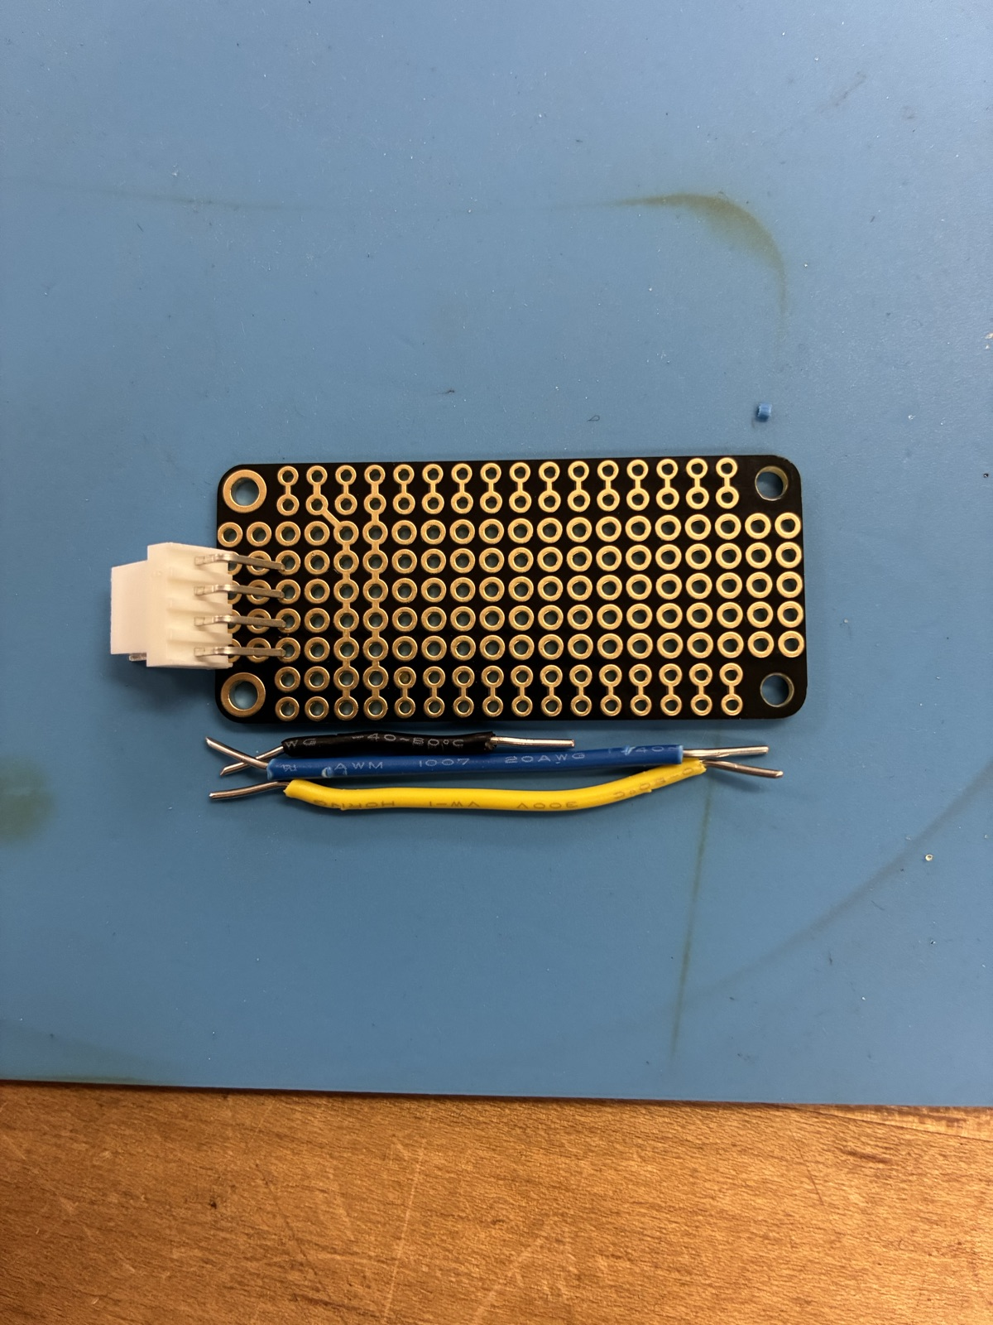
Bare protoboard with JST connector and hookup wires staged next to it
- Position the JST connector on the short edge of the protoboard, keyway facing out so the cable can seat without fighting the Feather body above it. - Pre-cut two lengths of 22 AWG hookup wire for SDA (yellow) and SCL (blue). GND and 3V3 use the two outer JST shell pins and short traces on the protoboard.

Step 2 - Mount in the helping-hand
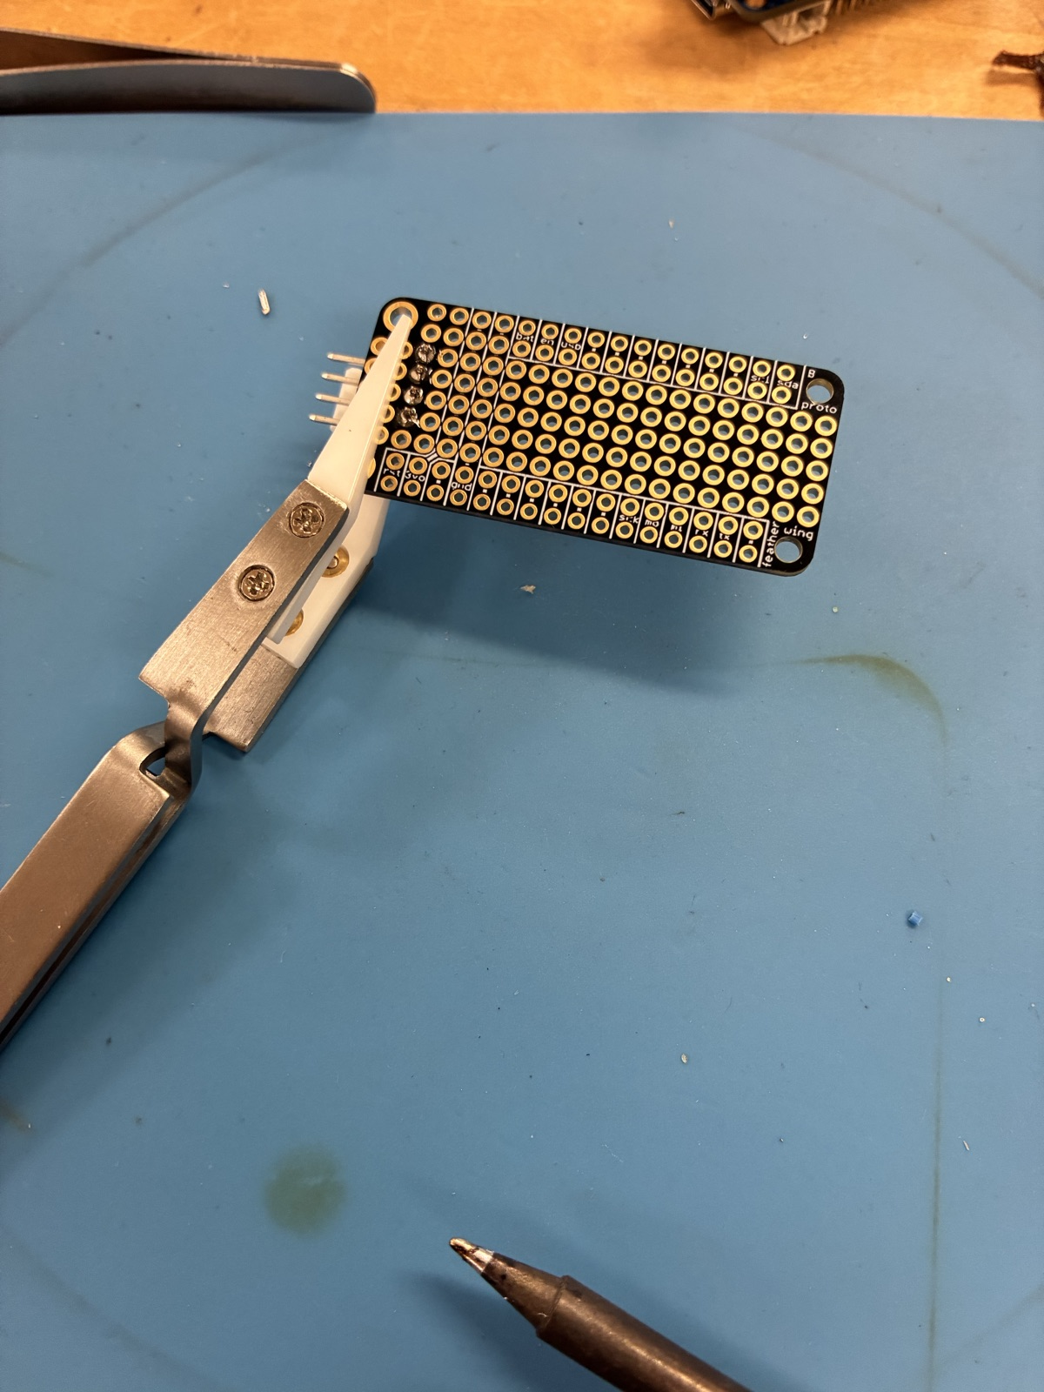
Protoboard held in a helping-hand clamp, ready to be soldered
- Clamp the protoboard close to the JST connector but not on it; the connector body warps if squeezed. - Tack one JST pin first, check that the connector sits flush, then solder the remaining three.

Step 3 - Back-side wiring to the JST
> WARNING - do NOT connect the red wire on the BQ EVM ribbon. > The red wire is a NO-CONNECT. Do not route it to 3V3 - the BQ EVM provides its own logic rail and back-powering the bridge through that pin will fight the Feather regulator, and can destroy either board. Clip and heat-shrink the red conductor before you start wiring.
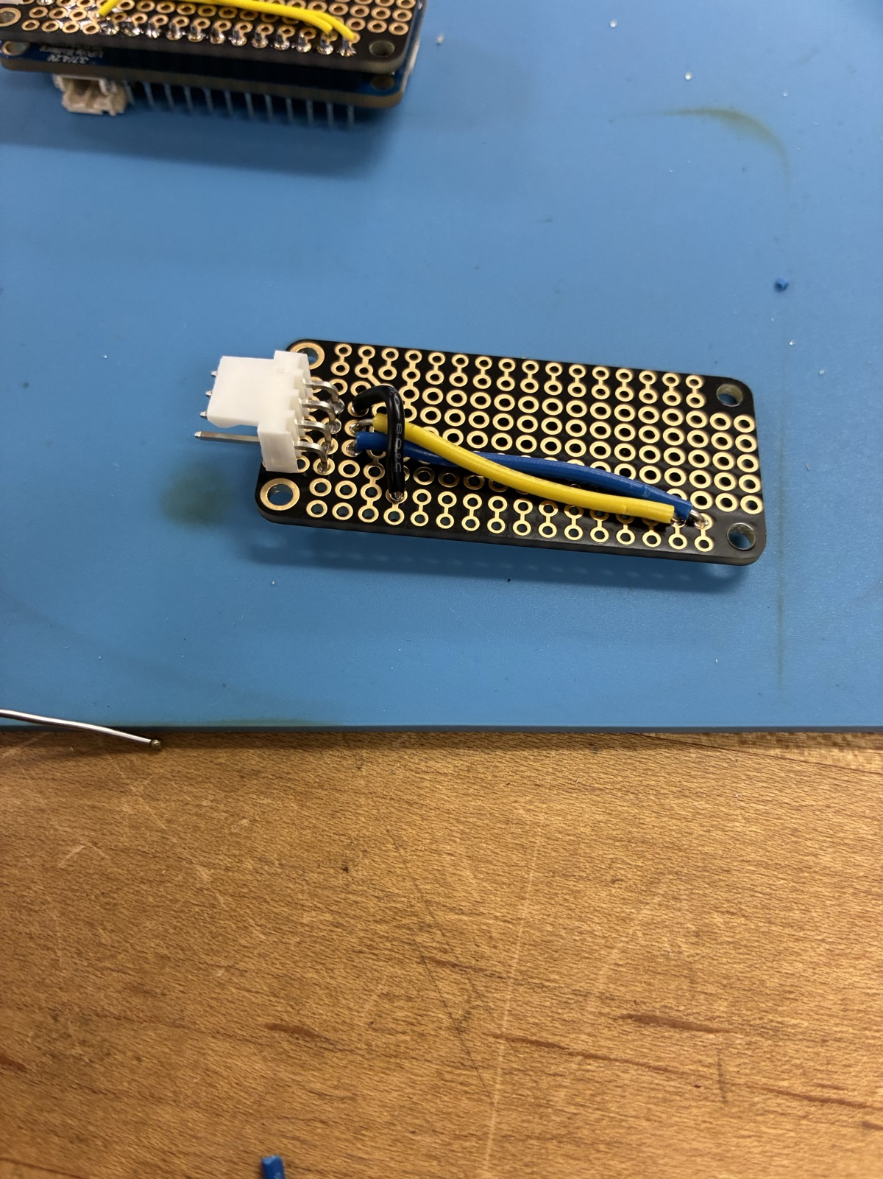
Yellow and blue hookup wires soldered across the back of the protoboard to the JST pins
- SDA pad on the Feather footprint routes to JST pin 2 (yellow). - SCL pad routes to JST pin 3 (blue). - GND pad routes to JST pin 4. - The red wire on the BQ EVM ribbon is a no-connect - see the warning above. - Before stacking, buzz each pad-to-pin trace with a DMM in continuity mode. Any two adjacent pins should read OL.

Step 4 - Headers on the Feather
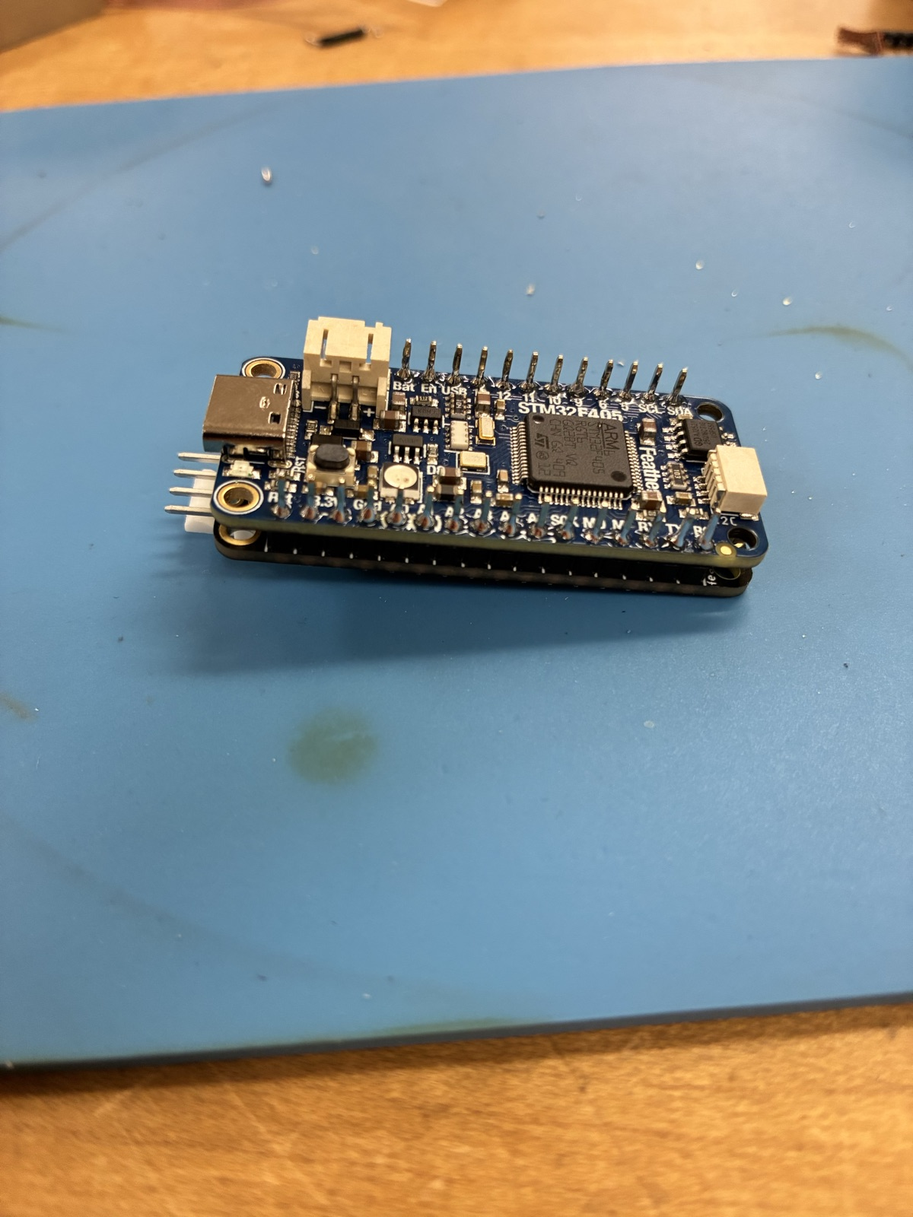
Adafruit Feather STM32F405 with male pin headers installed along both long edges
- Push male headers through the Feather from the top side, long end down. - Use the protoboard itself as a jig: drop the Feather onto it so the headers land straight, then solder the four corner pins before doing the rest. This keeps the two boards coplanar.

Step 5 - Stack and finish
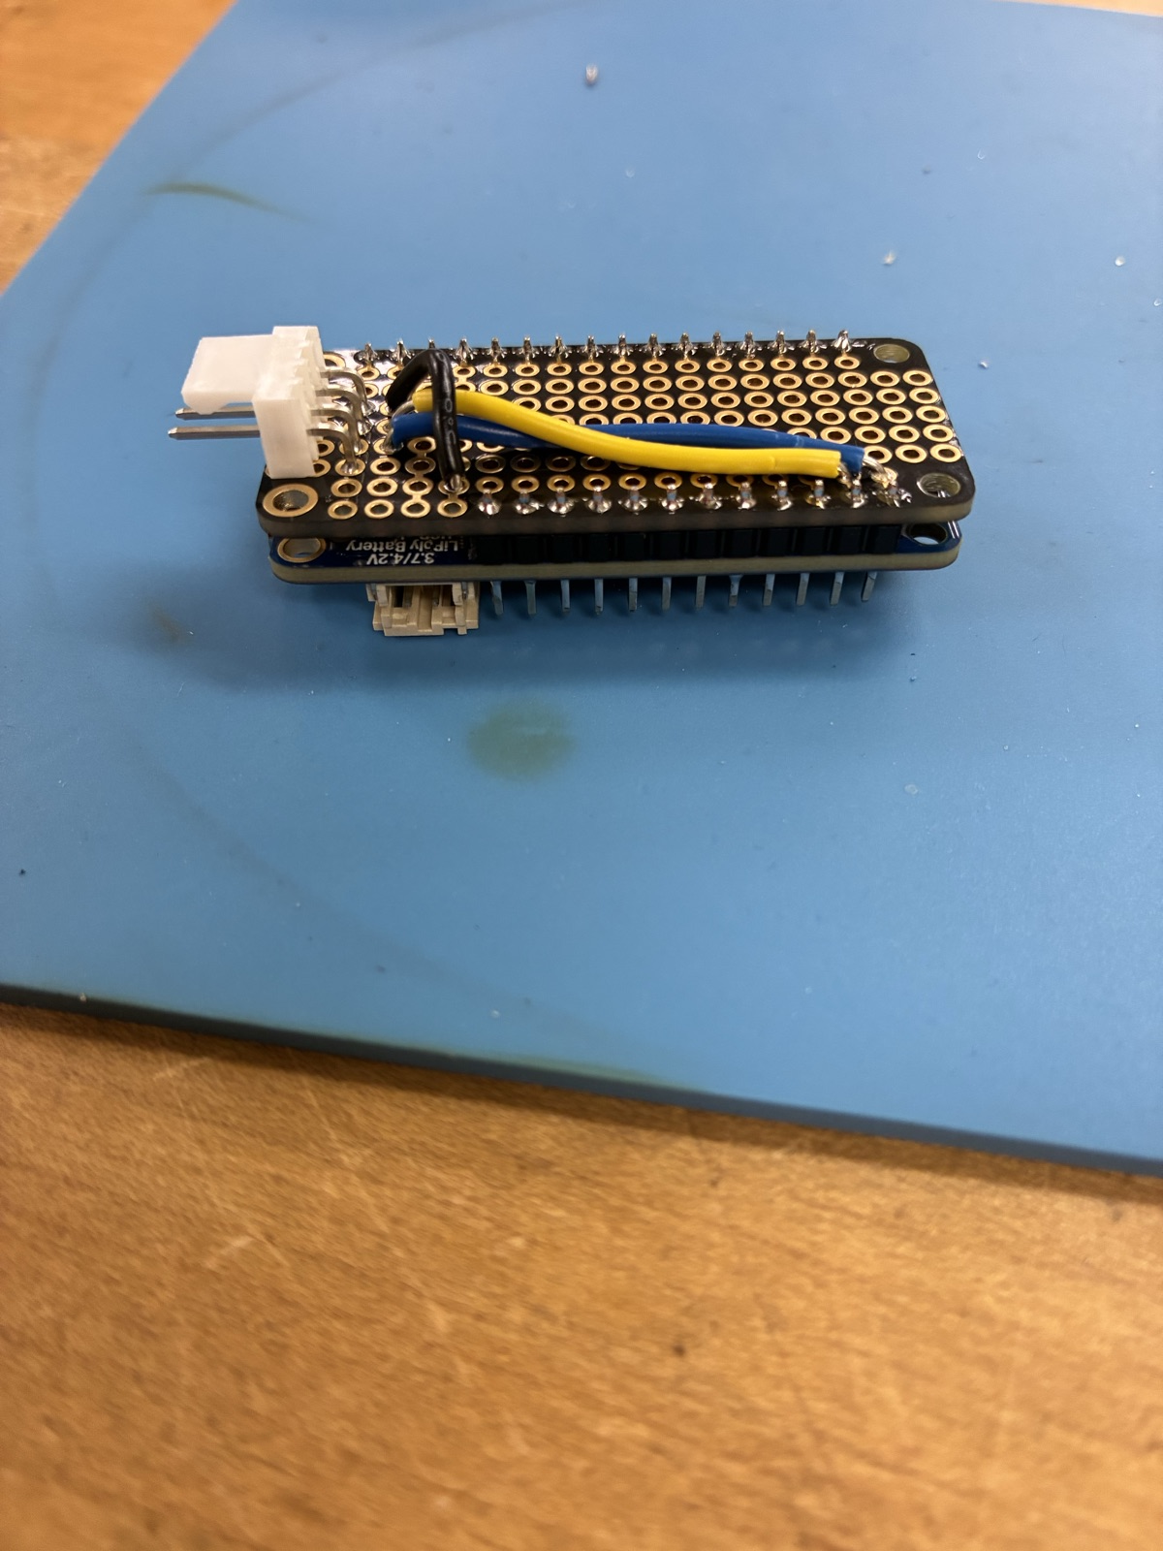
Finished adapter: STM32F405 Feather stacked on the wired protoboard with the JST pigtail exiting the short edge
- Separate the boards, tin the Feather headers, then re-seat and solder each header pin through to the protoboard pads. - Add a 3 mm heat-shrink collar where the JST cable exits the board for strain relief. - Plug the JST cable into the BQ EVM I2C header and a USB-C cable into the Feather.

Firmware
Flash the Feather with the STM32 bridge firmware before handing the unit out.
- Firmware source: the firmware repo is currently private to the course. Ask the course coordinator (or open an issue on this repo) for the build artifact. Do not hardcode a URL in this chapter until the firmware repo is moved to a public home. - Flash path: USB DFU. Press RESET while holding BOOT to enter DFU mode, then use dfu-util or the Adafruit WebDFU page.

USB VID/PID: lab-only reuse
During lab deployment the STM32 firmware currently enumerates with the same USB descriptor as the retired TI EV2300A (VID 0x0451, PID 0x0036). That lets lab_instruments/src/ev2300.py pick the bridge up with zero driver changes.
This reuse is acceptable only on closed lab benches and unit-under-test kits that never touch a commercial product:
- 0x0451 belongs to Texas Instruments; reusing it on hardware we distribute outside the course would violate the USB-IF rules on VID/PID reuse. Do not ship this firmware on anything that leaves the VOAL lab until one of the following is done: - Obtain explicit written authorization from TI for the continued use of their VID/PID on this replacement, or - Rebuild the firmware with a project-owned VID/PID (Adafruit's test-bench range or a pid.codes sublicense are both reasonable options), and update the driver's match table in lab_instruments/src/ev2300.py to add the new descriptor alongside the existing TI one.
Record whichever decision was made in this chapter and in docs/ev2300.md before any external release.
If the bridge comes up in DFU mode (no I2C traffic, scan shows a "bootloader" descriptor), reflash. There is no recovery path from the REPL.

Bench verification checklist
After assembly, run this top-to-bottom before labeling the unit as good:
1. Power the BQ76920 EVM from an 18 V bench supply on the external power input. 2. Plug the STM32 bridge USB into the host computer. 3. Press the BOOT button on the BQ EVM. This clears any stuck I2C state from the last session. 4. Launch the REPL: scpi-repl --no-color. 5. Run scan. Expect ev2300 in the device list within two seconds. 6. Run ev2300 read_word 0x08 0x09. For a nominal 3.3 V cell stack you should see 0x0CE4 (3300) or similar; the exact value depends on the battery state but it must not be 0x0000 or 0xFFFF. 7. Run ev2300 scan 0x08 and confirm you get more than 20 readable registers. 8. Run the regression subset: python -m pytest tests/test_ev2300_driver.py -x.
If any step fails, move to the troubleshooting section below before handing out the kit.

Troubleshooting the bridge

Bridge enumerates but `read_word` returns 0xFFFF
The STM32 firmware retries BQ76920 init every 2 s after a failed startup detection. Usually caused by the EVM being unpowered when the USB was plugged in. Fix: leave USB connected, power the EVM, then call ev2300 read_word ... again. The wait_for_bq helper in lab_instruments/src/ev2300.py polls CC_CFG (reg 0x0B) on both possible I2C addresses until the IC responds, and is the programmatic version of this procedure.

Intermittent `0x46` errors on long sessions
Usually USB noise coupling onto the I2C lines. Fixes, in order of cost:
1. Clip a ferrite onto the JST pigtail close to the adapter. 2. Shorten the JST cable run. 3. Replace the USB cable with a shielded one.

`connect failed` on `scan`
Another process holds the HID handle. Close BQ Studio, then retry.

Board is dead after flashing
The DFU flow leaves the Feather in app mode only after a clean reset. Try the quick recovery first; if it fails, fall through to the full bootloader re-flash.
Quick recovery (no extra tools):
1. Unplug USB. 2. Press and hold BOOT. 3. Plug USB back in while still holding BOOT. 4. Release BOOT once the host enumerates the device (1 - 2 s). 5. Re-run dfu-util / WebDFU with the STM32 bridge firmware binary.
Full recovery (STM32CubeProgrammer + ST-LINK):
Use this when the board does not enumerate at all after the quick recovery:
1. Connect an ST-LINK V2 (or V3) to the Feather's SWD pads (SWCLK, SWDIO, GND, 3V3) - the pads are on the bottom silkscreen. 2. Open STM32CubeProgrammer, select ST-LINK as the interface, and click Connect. 3. Full Chip Erase. 4. Flash the Adafruit STM32F405 bootloader DFU image (tinyuf2-feather_stm32f405_express_*.bin from the Adafruit release page) to 0x08000000. 5. Disconnect ST-LINK, power-cycle the Feather, confirm the Adafruit bootloader enumerates (a USB drive named FTHRBOOT should appear). 6. Drop the STM32 bridge firmware UF2 onto that drive to flash the application image.
If STM32CubeProgrammer still cannot connect, the STM32F405 silicon is likely damaged - retire the unit.

Making another one
This chapter is the build log. BOM, soldering photos, firmware path, and verification checklist are all here - a TA with a soldering iron and a copy of the firmware binary should be able to assemble a replacement unit without any other documentation.

