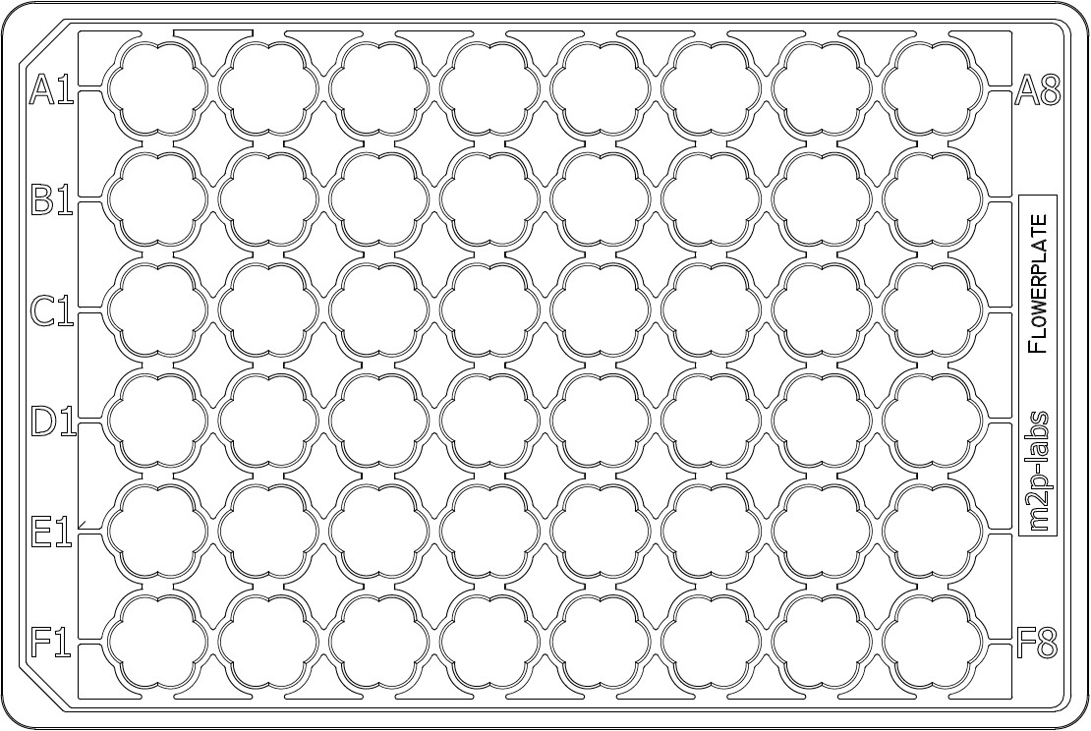



|  |  |  |  |  |  |  |  |
| --- | --- | --- | --- | --- | --- | --- | --- |
| 1-FM91xZ-S: 900 µl  1-FWTA: 100 µl | 1-FMedG1x-S: 150 µl  1-FM91xZ-S: 750 µl  1-FWTA: 100 µl | 1-FMedG1x-S:300 µl  1-FM91xZ-S: 600 µl  1-FWTA: 100 µl | 1-FMedG1x-S: 450 µl  1-FM91xZ-S: 450 µl  1-FWTA: 100 µl | 1-FMedG1x-S: 600 µl  1-FM91xZ-S: 300 µl  1-FWTA: 100 µl | 1-FMedG1x-S: 750 µl  1-FM91xZ-S: 150 µl  1-FWTA: 100 µl | 1-FMedG1x-S:900 µl  1-FWTA: 100 µl | 1-FM91xZ-S: 1000 µl |
| 1-FM91xZ-S: 900 µl  1-FWTA: 100 µl | 1-FMedG1x-S: 150 µl  1-FM91xZ-S: 750 µl  1-FWTA: 100 µl | 1-FMedG1x-S:300 µl  1-FM91xZ-S: 600 µl  1-FWTA: 100 µl | 1-FMedG1x-S: 450 µl  1-FM91xZ-S: 450 µl  1-FWTA: 100 µl | 1-FMedG1x-S: 600 µl  1-FM91xZ-S: 300 µl  1-FWTA: 100 µl | 1-FMedG1x-S: 750 µl  1-FM91xZ-S: 150 µl  1-FWTA: 100 µl | 1-FMedG1x-S:900 µl  1-FWTA: 100 µl | 1-FMedG1x-S: 450 µl  1-FM91xZ-S: 550 µl |
| 1-FM91xZ-S: 900 µl  1-FWTA: 100 µl | 1-FMedG1x-S: 150 µl  1-FM91xZ-S: 750 µl  1-FWTA: 100 µl | 1-FMedG1x-S:300 µl  1-FM91xZ-S: 600 µl  1-FWTA: 100 µl | 1-FMedG1x-S: 450 µl  1-FM91xZ-S: 450 µl  1-FWTA: 100 µl | 1-FMedG1x-S: 600 µl  1-FM91xZ-S: 300 µl  1-FWTA: 100 µl | 1-FMedG1x-S: 750 µl  1-FM91xZ-S: 150 µl  1-FWTA: 100 µl | 1-FMedG1x-S:900 µl  1-FWTA: 100 µl | 1-FMedG1x-S: 900 µl  1-FM91xZ-S: 100 µl |
| 1-FM91xZ-S: 900 µl  1-FWTA: 100 µl | 1-FMedA1x-S: 150 µl  1-FM91xZ-S: 750 µl  1-FWTA: 100 µl | 1-FMedA1x-S:300 µl  1-FM91xZ-S: 600 µl  1-FWTA: 100 µl | 1-FMedA1x-S: 450 µl  1-FM91xZ-S: 450 µl  1-FWTA: 100 µl | 1-FMedA1x-S: 600 µl  1-FM91xZ-S: 300 µl  1-FWTA: 100 µl | 1-FMedA1x-S: 750 µl  1-FM91xZ-S: 150 µl  1-FWTA: 100 µl | 1-FMedA1x-S:900 µl  1-FWTA: 100 µl | 1-FM91xZ-S: 1000 µl |
| 1-FM91xZ-S: 900 µl  1-FWTA: 100 µl | 1-FMedA1x-S: 150 µl  1-FM91xZ-S: 750 µl  1-FWTA: 100 µl | 1-FMedA1x-S:300 µl  1-FM91xZ-S: 600 µl  1-FWTA: 100 µl | 1-FMedA1x-S: 450 µl  1-FM91xZ-S: 450 µl  1-FWTA: 100 µl | 1-FMedA1x-S: 600 µl  1-FM91xZ-S: 300 µl  1-FWTA: 100 µl | 1-FMedA1x-S: 750 µl  1-FM91xZ-S: 150 µl  1-FWTA: 100 µl | 1-FMedA1x-S:900 µl  1-FWTA: 100 µl | 1-FMedA1x-S: 450 µl  1-FM91xZ-S: 550 µl |
| 1-FM91xZ-S: 900 µl  1-FWTA: 100 µl | 1-FMedA1x-S: 150 µl  1-FM91xZ-S: 750 µl  1-FWTA: 100 µl | 1-FMedA1x-S:300 µl  1-FM91xZ-S: 600 µl  1-FWTA: 100 µl | 1-FMedA1x-S: 450 µl  1-FM91xZ-S: 450 µl  1-FWTA: 100 µl | 1-FMedA1x-S: 600 µl  1-FM91xZ-S: 300 µl  1-FWTA: 100 µl | 1-FMedA1x-S: 750 µl  1-FM91xZ-S: 150 µl  1-FWTA: 100 µl | 1-FMedA1x-S:900 µl  1-FWTA: 100 µl | 1-FMedA1x-S: 900 µl  1-FM91xZ-S: 100 µl |



|  |  |  |  |  |  |  |  |
| --- | --- | --- | --- | --- | --- | --- | --- |
| 3-FMedG1x-S: 900 µl  1-FWTG: 100 µl | 3-FMedG1x-S: 900 µl  1-FWTG: 100 µl | 3-FMedG1x-S: 900 µl  1-FWTG: 100 µl | 3-FMedG1x-S: 900 µl  1-FWTG: 100 µl | 3-FMedG1x-S: 900 µl  1-FWTG: 100 µl | 3-FMedG1x-S: 900 µl  1-FWTG: 100 µl | 3-FMedG1x-S: 900 µl  1-FWTG: 100 µl | 3-FMedG1x-S: 900 µl  1-FWTG: 100 µl |
| 3-FMedG1x-S: 900 µl  1-FWTG: 100 µl | 3-FMedG1x-S: 900 µl  1-FWTG: 100 µl | 3-FMedG1x-S: 900 µl  1-FWTG: 100 µl | 3-FMedG1x-S: 900 µl  1-FWTG: 100 µl | 3-FMedG1x-S: 900 µl  1-FWTG: 100 µl | 3-FMedG1x-S: 900 µl  1-FWTG: 100 µl | 3-FMedG1x-S: 900 µl  1-FWTG: 100 µl | 3-FMedG1x-S: 900 µl  1-FWTG: 100 µl |
| 3-FMedG1x-S: 900 µl  1-FWTG: 100 µl | 3-FMedG1x-S: 900 µl  1-FWTG: 100 µl | 3-FMedG1x-S: 900 µl  1-FWTG: 100 µl | 3-FMedG1x-S: 900 µl  1-FWTG: 100 µl | 3-FMedG1x-S: 900 µl  1-FWTG: 100 µl | 3-FMedG1x-S: 900 µl  1-FWTG: 100 µl | 3-FMedG1x-S: 900 µl  1-FWTG: 100 µl | 3-FMedG1x-S: 900 µl  1-FWTG: 100 µl |
| 3-FMedG1x-S: 900 µl  1-FWTG: 100 µl | 3-FMedG1x-S: 900 µl  1-FWTG: 100 µl | 3-FMedG1x-S: 900 µl  1-FWTG: 100 µl | 3-FMedG1x-S: 900 µl  1-FWTG: 100 µl | 3-FMedG1x-S: 900 µl  1-FWTG: 100 µl | 3-FMedG1x-S: 900 µl  1-FWTG: 100 µl | 3-FMedG1x-S: 900 µl  1-FWTG: 100 µl | 3-FMedG1x-S: 900 µl  1-FM91xZ-S: 100 µl |
| 3-FMedG1x-S: 900 µl  1-FWTG: 100 µl | 3-FMedG1x-S: 900 µl  1-FWTG: 100 µl | 3-FMedG1x-S: 900 µl  1-FWTG: 100 µl | 3-FMedG1x-S: 900 µl  1-FWTG: 100 µl | 3-FMedG1x-S: 900 µl  1-FWTG: 100 µl | 3-FMedG1x-S: 900 µl  1-FWTG: 100 µl | 3-FMedG1x-S: 900 µl  1-FWTG: 100 µl | 3-FMedG1x-S: 900 µl  1-FM91xZ-S: 100 µl |
| 3-FMedG1x-S: 900 µl  1-FWTG: 100 µl | 3-FMedG1x-S: 900 µl  1-FWTG: 100 µl | 3-FMedG1x-S: 900 µl  1-FWTG: 100 µl | 3-FMedG1x-S: 900 µl  1-FWTG: 100 µl | 3-FMedG1x-S: 900 µl  1-FWTG: 100 µl | 3-FMedG1x-S: 900 µl  1-FWTG: 100 µl | 3-FMedG1x-S: 900 µl  1-FWTG: 100 µl | 3-FMedG1x-S: 900 µl  1-FM91xZ-S: 100 µl |