Name Terence Henriod Date November 14, 2013
Laboratory 12: Cover Sheet

Section 1001

Place a check mark in the Assigned column next to the exercises your instructor has assigned to you. Attach this cover sheet to the front of the packet of materials you submit following the laboratory.

Activities | Assigned: Check or list exercise numbers | Completed
Implementation Testing | ✓
Programming Exercise 1
Programming Exercise 2
Programming Exercise 3
Analysis Exercise 1
Analysis Exercise 2
 | Total

Name Terence Henriod Date November 14, 2013
Laboratory 12: Implementation Testing

Section 1001

Check with your instructor whether you are to complete this exercise prior to your lab period or during lab.

Test Plan 12-1 (Weighted Graph ADT operations)
Test case |  | Commands | Expected result | Checked

Name Terence Henriod Date November 14, 2013
Laboratory 12: Programming Exercise 1

Section 1001

Test Plan 12-2 (showShortestPaths operation)
Test case |  | Commands | Expected result | Checked

Name Terence Henriod Date November 14, 2013
Laboratory 12: Programming Exercise 2

Section 1001

Test Plan 12-3 (hasProperColoring operation)
Test case |  | Commands | Expected result | Checked

Name Terence Henriod Date November 14, 2013
Laboratory 12: Programming Exercise 3

Section 1001

Test Plan 12-4 (areAllEven operation)
Test case |  | Commands | Expected result | Checked

Name Terence Henriod Date November 14, 2013
Laboratory 12: Analysis Exercise 1

Section 1001

The following graph, for example,
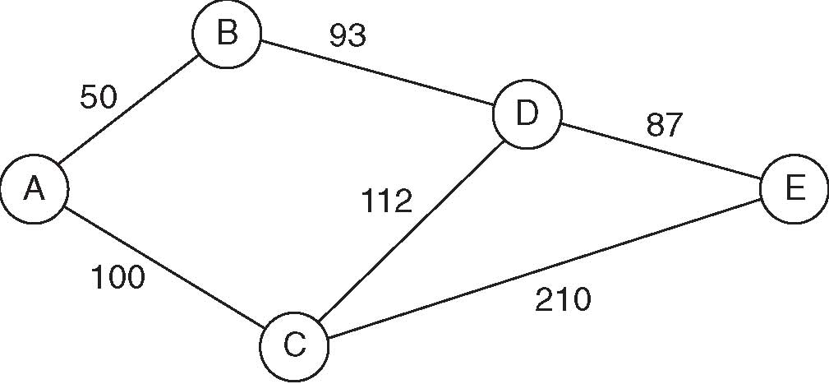
yields the augmented path matrix shown below.
Vertex list |  | Path matrix (cost|second vertex on shortest path)
Index | Label | From/To | 0 | 1 | 2 | 3 | 4
0 | A | 0 | 0|0 | 50|1 | 100|2 | 143|1 | 230|1
1 | B | 1 | 50|0 | 0|1 | 150|0 | 93|3 | 180|3
2 | C | 2 | 100|0 | 150|0 | 0|2 | 112|3 | 199|3
3 | D | 3 | 143|1 | 93|1 | 112|2 | 0|3 | 87|4
4 | E | 4 | 230|3 | 180|3 | 199|3 | 87|3 | 0|4

Entry (0,4) in this path matrix indicates that the cost of the shortest path from vertex A to vertex E is 230. It further indicates that vertex B (the vertex with index 1) is the second vertex on the shortest path. Thus the shortest path is of the form AB...E.
Explain how you can use this augmented path matrix to list the vertices that lie along the shortest path between a given pair of vertices.

Using this augmented path matrix we can reconstruct the shortest path between two vertices, even if the resulting chain is several edges long. In the example above, the actual path is
A->B->D->E. If we follow this path by going to the matrix entry for the shortest path “mutual neighbor”* vertex and the destination iteratively until the matrix states that the mutual neighbor vertex is the destination one, we can reconstruct the path. For example, in the problem above, when considering the path from A to E, we see that B is the mutual neighbor vertex. We can then check the matrix entry for the path between B and E, and we see here that the mutual neighbor is D. Continuing on, we see that the shortest path between D and E is the direct path from D and E. Thus we have reconstructed the shortest path from A to E.

*Note: I have abused the term neighbor, I have used the term to mean a vertex included in the path between two vertices. In actuality, a neighboring vertex is one that is connected to a given vertex by only a single edge.

Name Terence Henriod Date November 14, 2013
Laboratory 12: Analysis Exercise 2

Section 1001

Give an example of a graph for which no proper coloring can be created using less than five colors (see Programming Exercise 2). Does your example contradict the Four-Color Theorem?

The example I will give is “K₅” This graph is precisely 5 colorable. It does not contradict the 4-color theorem. In fact, the presence of a complete K₅ (or K_{3,3}) as a sub-graph of a given graph is the “smallest” graph to not be 4 colorable as stated by Kuratowski’s Theorem (actually, Kuratowski’s Thorem states that no planar graph may contain a K₅ or K_{3,3} sub-graph, but planarity and four-colorability go hand in hand). All the vertices are connected to all other vertices, so none of them may have the same color. Also notice that the graph cannot be represented as a planar graph. There is no way to represent without the edges crossing in the plane. In this graph, the colors are represented by the letters A through E.

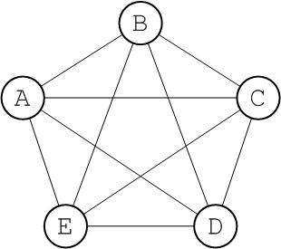

Source: http://fusesource.com/docs/esb/4.3/amq_clustering/Networks-BasicConcepts.html

