Rev Team 08

To: Dana Edberg

From: Terence Henriod, Jorge Santoyo, Raja Singh

Date: 04/28/15

Subject: Replica Toys Database Design Part 02

Modifications To Logical Model

Reference 1

We merged the Registration and purchase entities. This made it clear that this is a post-purchase data model.

Reference 2 & 4

In both of the cases, we reduced the complexity of our “Survey Pattern.” The new pattern uses four entities instead of six. We no longer try to implement “survey versioning” via storing a survey/question configuration in the two dropped tables.

Reference 3

We considered the registration survey attributes gender and age as survey questions. We considered the possibility of the gender question evolving away from one with binary responses to one with other responses than those we currently consider today (maybe this is silly, maybe not); also it just seemed fitting to treat it similarly to other questions with a finite set of responses. As for age, we also treated it similarly to the other survey questions (a question in the Questions table, possible responses in the Options table) and just put ~100 rows in the options table; this was really for uniformity and convenience more than to follow any salient design principles.

Reference 5& 6

The ToyId was a poorly named attribute for the Model entity to refer to the ProductLine entity; it probably should have been named “ProductLineId” or something better. The logic behind this part of the design was that Replica Toys might expand beyond making just ride-ables (maybe playhouses modeled after notable buildings). Either way, it doesn’t matter since we dropped the idea of a ProductLine. We also removed the concept of a vehicle category from the Model entity once we were advised that Replica Toys does not care to categorize their toys at this time.

Reference 7

We merged the Return and Unit entities. Since we are not storing data about every unit made by Replica Toys and only storing data concerning returns, it seemed best to go about things this way. Now we use one entity called “Unit” which will store return-relevant data about returned units only.

Reference 8

We no longer relate a Unit to a Distributor since this is not a purchase tracking system. We now just relate a Unit to a Registration, and a Registration to a Distributor.

Reference 9

This issue was resolved by clarifying the design with our new/modified “Survey Pattern.” By applying this pattern, it is now more capable of handling questions/answers that might be recycled from form to form.

Revised Logical Data Model
See Attachment.

Original Logical Data Model and Markup
See Attachment.

Physical Data Model ERD
See Attachment.

Prototype Database

We stored all of our project’s data in Terence Henriod’s database for the IS675 class. For ease of use, we prefixed all of the table names for this project with ‘a_’.

Database Info

Database name: thenriod

Table Creation Statements

CREATE TABLE a_Location(
ZipCode int NOT NULL,
City varchar(100) NOT NULL,
[State] varchar(2) NOT NULL
CONSTRAINT pk_ZipCode PRIMARY KEY(ZipCode)
);

CREATE TABLE a_Customer(
CustomerId int NOT NULL,
ZipCode int NOT NULL,
FirstName varchar(60) NOT NULL,
LastName varchar(60) NOT NULL,
[Address] varchar(60) NOT NULL,
Email varchar(60) NOT NULL,
PrimaryPhone varchar(60) NOT NULL,
CONSTRAINT pk_CustomerId PRIMARY KEY(CustomerId),
CONSTRAINT fk_ZipCodeCustomer FOREIGN KEY(ZipCode) REFERENCES a_Location(ZipCOde)
);

CREATE TABLE a_Employee(
EmpId int NOT NULL,
ZipCode int NOT NULL,
FirstName varchar(60) NOT NULL,
LastName varchar(60) NOT NULL,
[Address] varchar(60) NOT NULL,
Email varchar(60) NOT NULL,
PhoneNumber varchar(60) NOT NULL,
CONSTRAINT pk_EmployeeId PRIMARY KEY(EmpId),
CONSTRAINT fk_ZipCodeEmp FOREIGN KEY(ZipCode) REFERENCES a_Location(ZipCOde)
);

CREATE TABLE a_Distributor(
DistributorId int NOT NULL,
ZipCode int NOT NULL,
Name varchar(100) NOT NULL,
[Address] varchar(100) NOT NULL,
Email varchar(100) NOT NULL,
PhoneNumber varchar(60) NOT NULL,
CONSTRAINT pk_DistributorId PRIMARY KEY(DistributorId),
CONSTRAINT fk_ZipCodeDistributor FOREIGN KEY(ZipCode) REFERENCES a_Location(ZipCOde)
);

CREATE TABLE a_Model(
ModelNumber int NOT NULL,
MSRP money Not Null,
Description varchar (1000),
CONSTRAINT pk_modelNumber PRIMARY KEY(ModelNumber)
);

CREATE TABLE a_ReasonReturned(
ReasonReturnID int IDENTITY (1, 1) NOT NULL,
ReasonDescription varchar(100)
CONSTRAINT pk_reasonReturnID PRIMARY KEY(ReasonReturnID)
);

CREATE TABLE a_Unit(
SerialNumber int NOT NULL,
ModelNumber int NOT NULL,
ReturnReasonId int,
DateReturned date,
Comments varchar(100),
CONSTRAINT pk_SerialNumber PRIMARY KEY(SerialNumber),
CONSTRAINT fk_ModelNumber FOREIGN KEY (ModelNumber) REFERENCES a_Model(ModelNumber),
CONSTRAINT fk_ReasonReturnId FOREIGN KEY (ReturnReasonID) REFERENCES a_ReasonReturned(ReasonReturnID)
);

CREATE TABLE a_IssueReportProblem(
ProblemID int IDENTITY (1, 1) NOT NULL,
[Description] varchar(100),
CONSTRAINT pk_ProblemID PRIMARY KEY (ProblemID)
);

CREATE TABLE a_ReportMethod(
ReportMethodId int IDENTITY (1, 1) NOT NULL,
Method varchar(60) NOT NULL
CONSTRAINT pk_reportMethod PRIMARY KEY (ReportMethodId)
);

CREATE TABLE a_IssueReport(
IssueReportId int IDENTITY (1, 1) NOT NULL,
ProductSerialNumber int NOT NULL,
DistributorId int,
EmployeeId int,
CustomerId int,
IssueReportProblemId int NOT NULL,
ProblemDescription varchar(1000),
ReportDate date,
ReportMethodId int NOT NULL,
InjuryOccurred bit NOT NULL,
InjuryDescription varchar(1000) NOT NULL,
CONSTRAINT pk_IssueReportId PRIMARY KEY(IssueReportId),
CONSTRAINT fk_ReportMethodId FOREIGN KEY(ReportMethodId) REFERENCES a_ReportMethod(ReportMethodId),
CONSTRAINT fk_ProductSerialNumber FOREIGN KEY(ProductSerialNumber) REFERENCES a_Unit(SerialNumber),
CONSTRAINT fk_DistributorReportId FOREIGN KEY(DistributorId) REFERENCES a_Distributor(DistributorId),
CONSTRAINT fk_EmployeeReportId FOREIGN KEY(EmployeeId) REFERENCES a_Employee(EmpId),
CONSTRAINT fk_CustomerId FOREIGN KEY(CustomerId) REFERENCES a_Customer(CustomerId),
CONSTRAINT fk_TypeofProblem FOREIGN KEY(IssueReportProblemId) REFERENCES a_IssueReportProblem(ProblemId)
);

CREATE TABLE a_TestForm(
TestFormId int IDENTITY (1,1) NOT NULL,
RecommendingTestFormId int,
IssueReportId int NOT NULL,
EmpId int NOT NULL,
TestType varchar(100),
TestDescription varchar(500) NOT NULL,
TestResults varchar(1000),
RecommendedResolution varchar(1000),
TestCompleted bit,
CONSTRAINT pk_TestFormId PRIMARY KEY(TestFormId),
CONSTRAINT fk_RecommendingTestFormId FOREIGN KEY(RecommendingTestFormId) REFERENCES a_TestForm(TestFormId),
CONSTRAINT fk_IssueReportIdTestForm FOREIGN KEY(IssueReportId ) REFERENCES a_IssueReport(IssueReportId),
CONSTRAINT fk_EmpId FOREIGN KEY(EmpId) REFERENCES a_Employee(EmpId),
);

Table Contents

Location Entity:
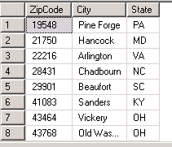

Customer Entity:
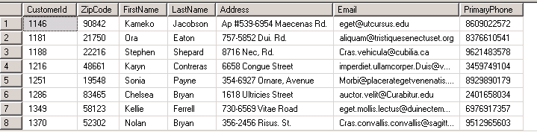

Employee Entity:
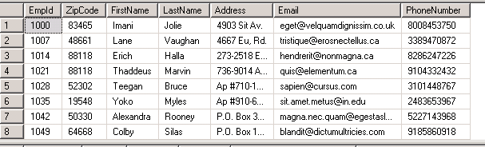

Distributor Entity:
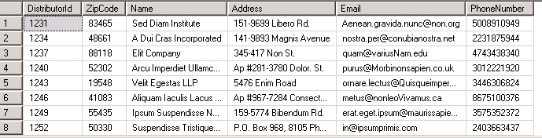

Model Entity:
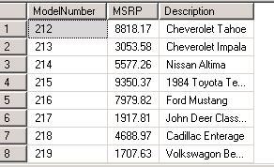

ReasonReturned Entity:
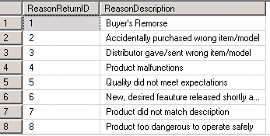

Unit Entity:
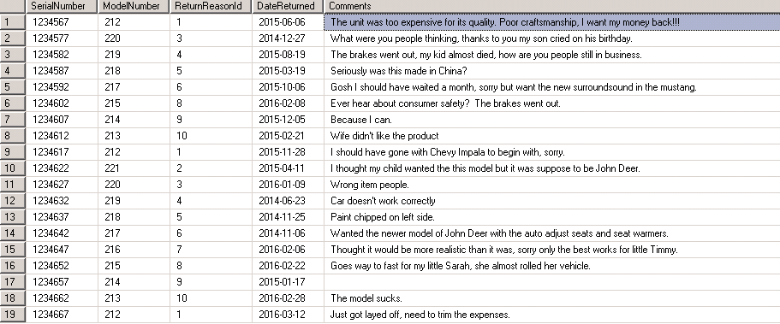

IssueReportProblem Entity:
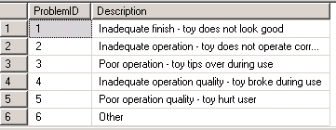

ReportMethod Entity:
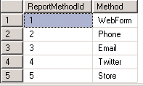

IssueReport Entity (Cropped To fit on page):
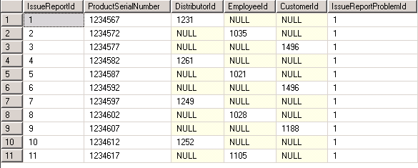

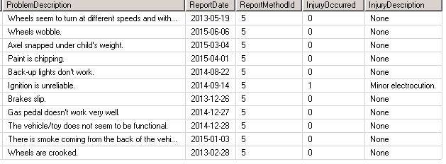

TestForm Entity (Cropped To fit on page):
