**Getting Started with Arduino IDE**

**Board and Programmer Settings**

First, make sure that the “Board:” and “Programmer:” fields are set appropriately. For now they should look like this. You may use different ones for the Hack-a-thon, we’ll cross that bridge when we get there.

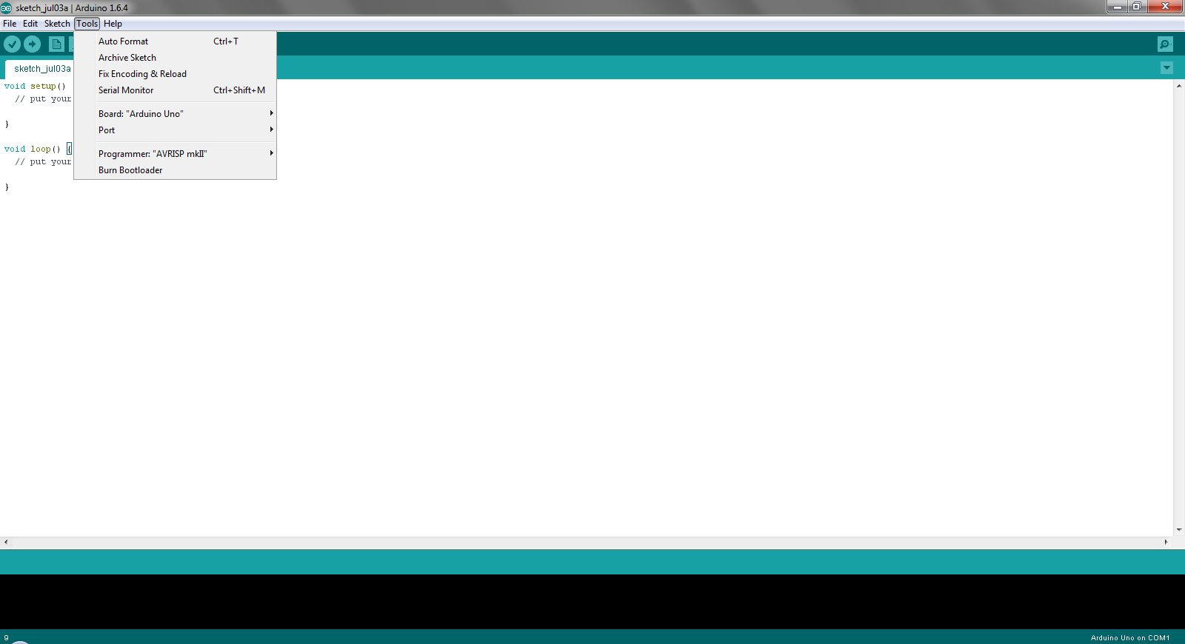

**Setting Up Communication with Arduino**

Now we are going to find out with “COM” port our computer recognizes the Arduino to be on. Start by connecting the Arduino to a USB posrt on the computer. Then open the control panel found in the Start/Windows menu in the bottom-left of the screen.

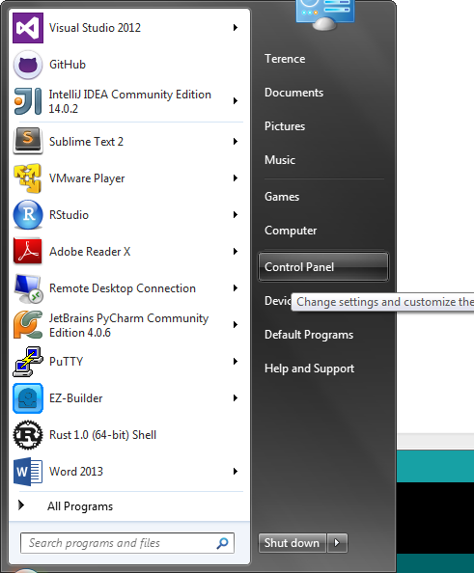

Then click “View devices and printers”.

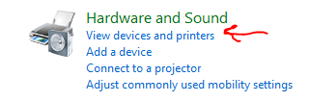

Then near the top of the screen, click on “Device Manager”.

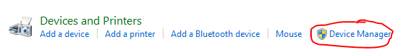

You will see a list of several categories. We are hoping to see an “Unknown device” under “Other devices”. This means that the computer sees the Arduino and is trying to “figure it out”. If you don’t see this, try plugging your Arduino into a different USB port.

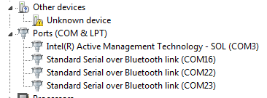

After a little while, you should see a notification indicating that Windows has “figured out” the Arduino, connected to it, and assigned a “COM” port to it so the computer can communicate with it. And you didn’t have to do anything!

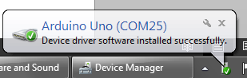

Back in the Device Manager, you should see the Arduino listed with its COM port number. This is where you should look anytime you need to find out what COM port the Arduino is on.



Now, in the Arduino IDE “Tools” menu we indicate how to communicate with the Arduino in the “Port” sub-menu.

